Specification Report of my Web Design
Author: Robert Cook (2015030)

L4 – Introduction to Web and Database Concepts (ACCA4023 + ACCA4018 IT&S)
School of Applied Computing
Wales Institute of Science and Art
Date and Time of submission:

Table of Contents

- Introduction……………………………………………………………………Page3.
- Abstract……………………………………….…………Page3.
- Requirements……………………………………………………………. Page 4.
- Site Diagram………………………………………………………………...Page 5
- Implementation………………………………. Page 6 - Page 16
- Validation…………………………………………………………. Page 17
- Evaluation…………………………………………………. Page 18 – 20
- References………………………………………………. Page 21 – Page 22
- Appendices………………………………………………. Page 23 – Page 66

Introduction
I have designed my website for a new shop that has opened in a local town called Pontypridd. The shop and Website are called “Mikes Bikes”. This report will highlight the requirements I wanted my website to have and how I implemented them to suit my target audience.
This report will showcase my website design and also demonstrate how I used basic HTML and CSS to code the website, and how I styled it for ease of use.
Later, in the report I will look to validate the code using online code evaluators and then I will evaluate my website and see in what areas it could be improved.

Abstract

This document is going to discuss my website design for a company called “Mikes Bikes”. The document will highlight how each page is coded via HTML and how the functionality of the website would work for a potential customer / user.

Requirements

The website is for a local bike shop, that looks to sell and advertise bikes, it targets new and experienced bike riders.
I wanted the website to be easy to look at, I wanted a nice modern background colour – so I decided on a nice shade of grey and then I wanted to use nice imagery of people biking to lift the site up.
The website has a few purposes, across its multiple pages, it informs of opening times, geographical location of the shop – what the ethos of the shop is and allows that customer to rent or purchase a bike of their choice.
There is a dedicated page on the website to inform the customer what the purpose of the shop is and what services they offer so the customer has no confusion about what the shop is.
I wanted the website to be easy to navigate through the header menu and for it to display a continuous user-friendly theme across all 5 pages.
The page that the user is on, is highlighted with a white a clear white background, so it is easy for the user to tell what page they are on.
I wanted the websites content to be responsive so that if you were accessing it on a mobile or smaller screen, the content would re-size. I achieved this by styling widths to a percentage on my CSS file.
I wanted to use a consistent theme throughout the website – maintaining colour scheme and displaying shop logo’s throughout – mainly looking at the header and footer.

Site Diagram
Below I have drawn out the basic navigation of my site to make it easier to understand the flow of my design.
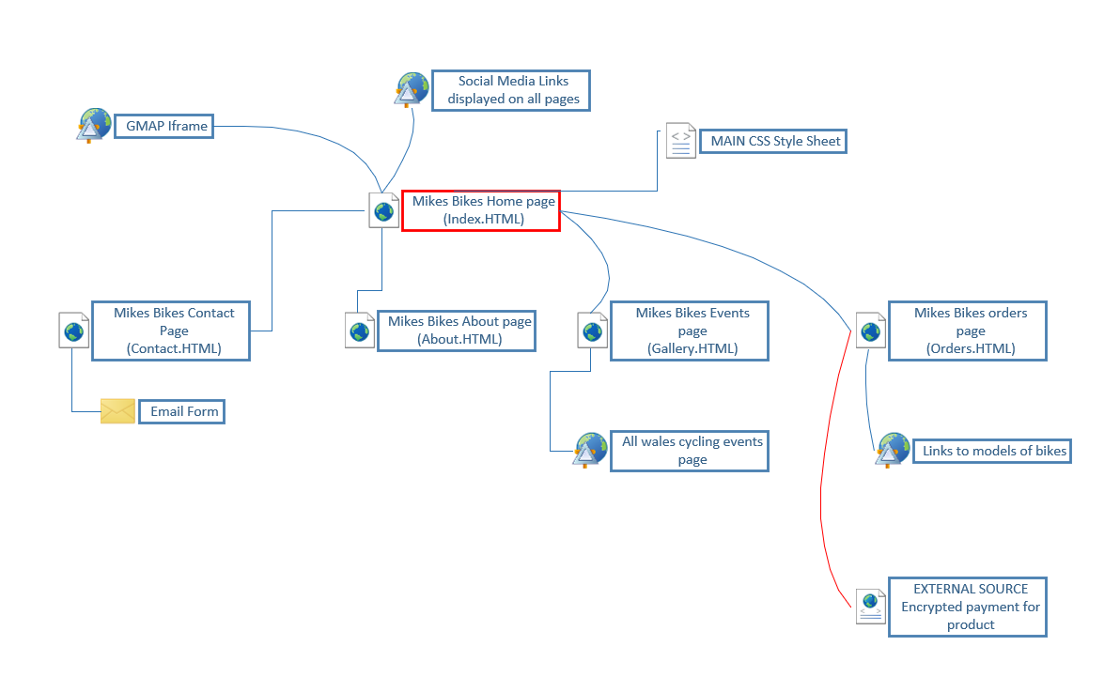
As you can see anything is accessible from the main home page.

Implementation
Home page
Screen 1 or the “home page” is where the customer or user will be placed when they initially access the website.
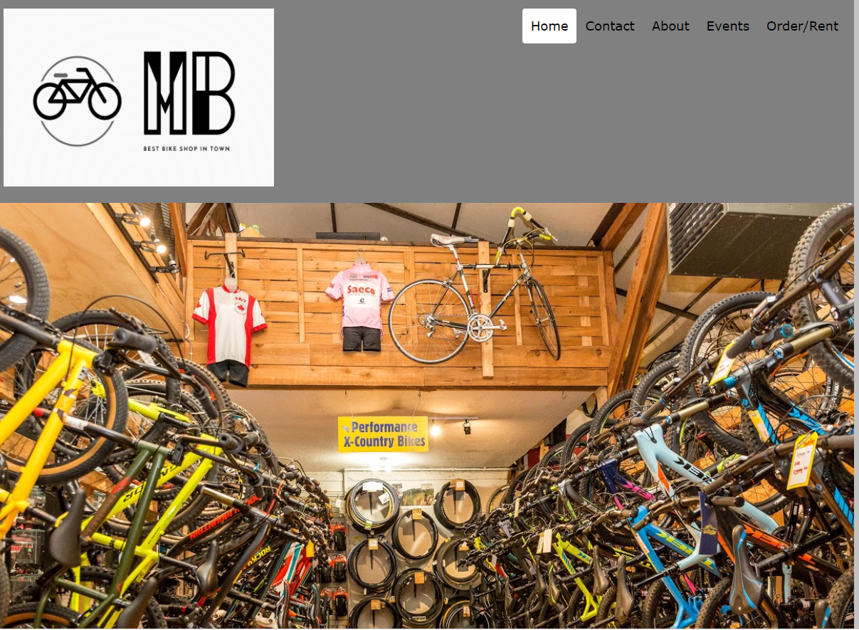

This is the top half of my main page; it contains a header which I have styled to have a Dark grey background.
On the right-hand side of the header, I installed a Navigation menu which takes the user/customer to my other HTML pages.
This initial image on my home screen resizes as you make the window smaller or bigger.
When the user hovers their mouse above a heading – it highlights the text yellow. However, the site/ HTML page that you are on remains “active” and fills with a solid white background.
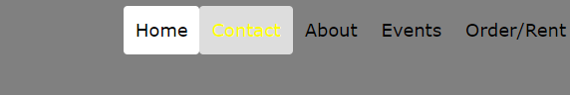
The header also contains the shop logo which I put together – this is consistent throughout the HTML pages.

As you scroll down the home page – the next section I added some large white text with a black background.
Underneath I imported some images relating to my site and set the width on them to be responsive.
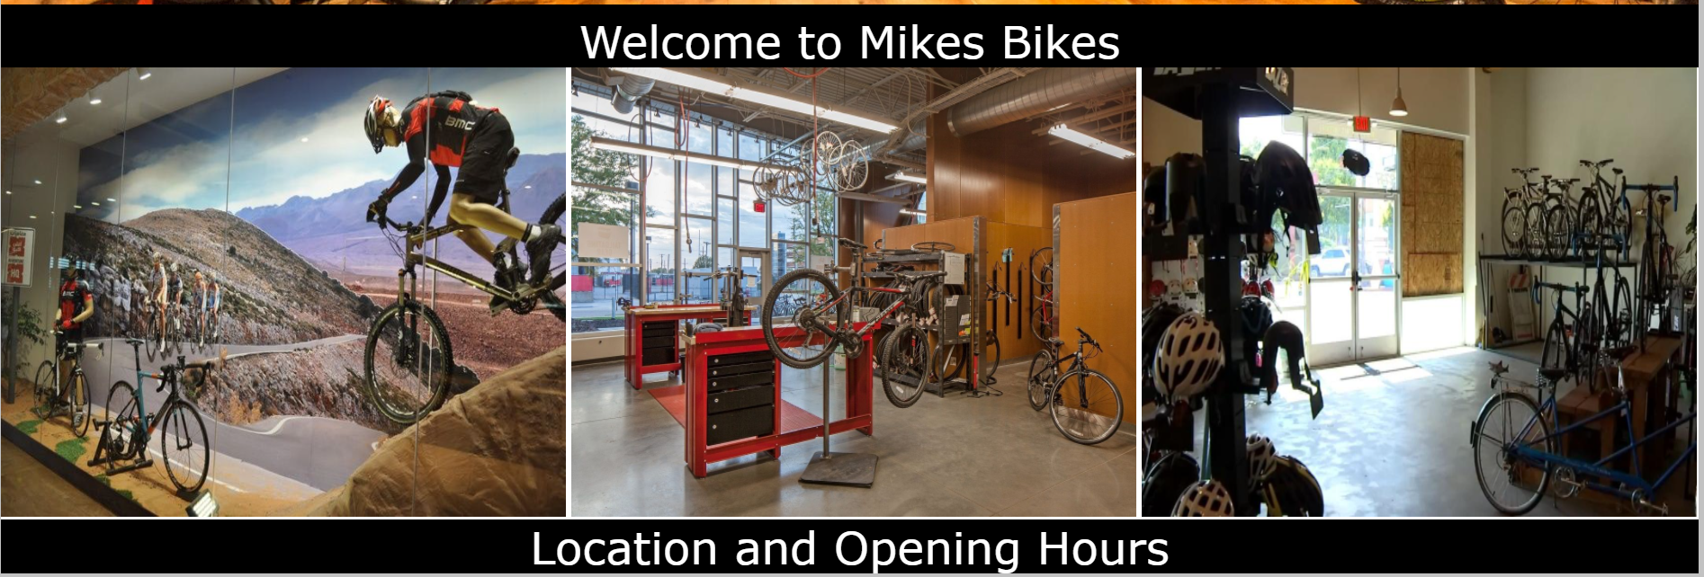

As you continue down the page – there is an iframe link to google maps. This section is all about the shop’s location and its operating hours.
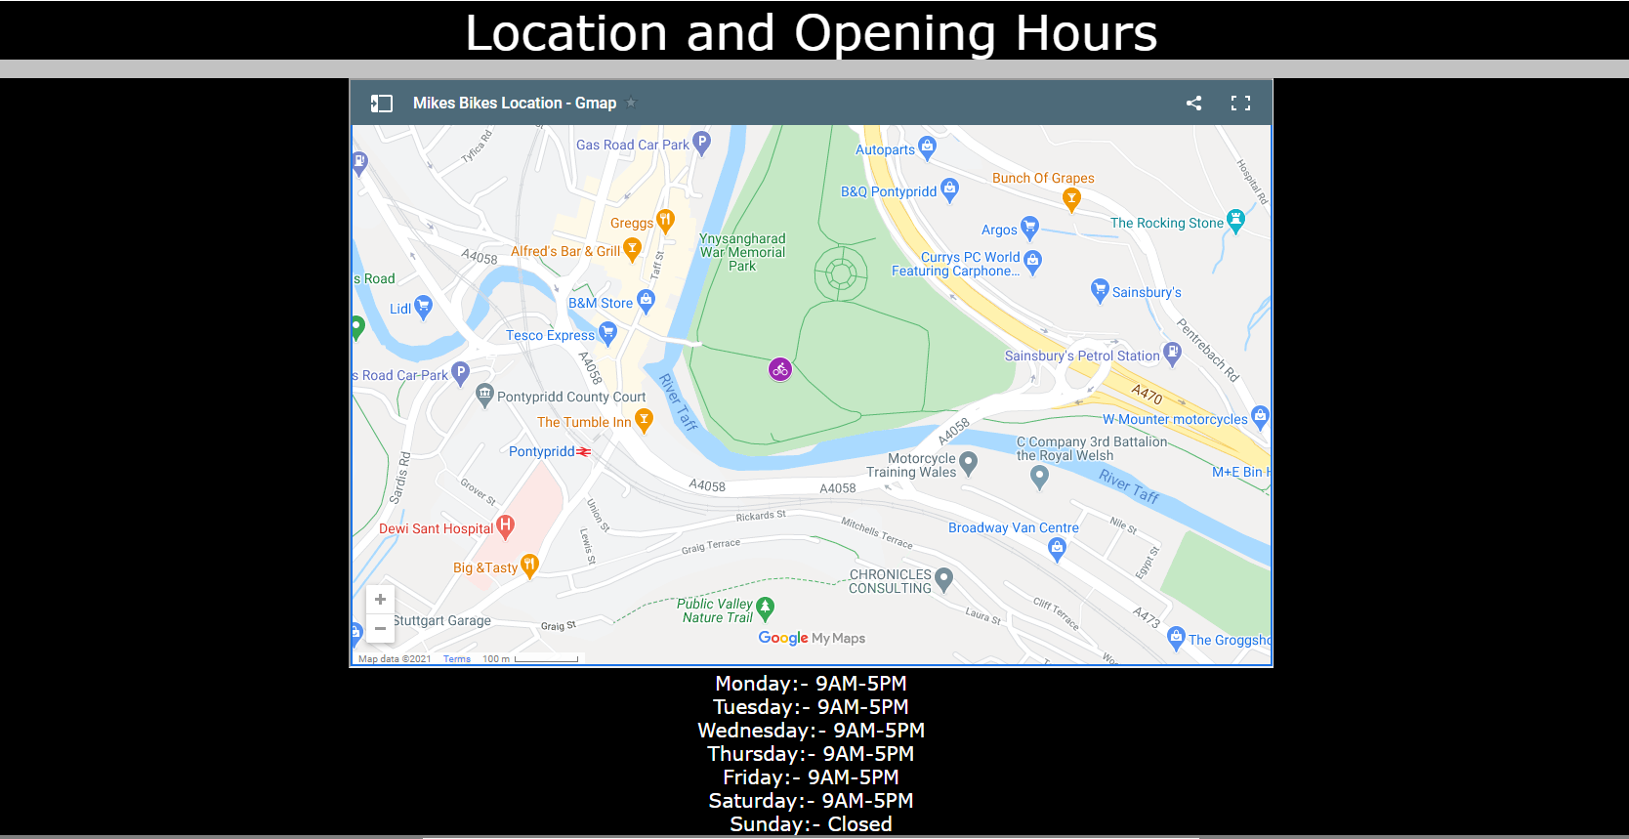
This is to show the location of my shop, the user can interact with this map and drag around to help them find the location.
I marked the shops’ location with a bike symbol by iframing a custom Google map into the site.

This icon can be clicked and will display the name Mikes Bikes.

At the bottom of each page there is my custom “footer”

The shop logo is displayed again – so it becomes familiar for the users of the site.
Just underneath the logo – I have included some links to social media platforms.
For now – I pointed the hyperlinks just to the logon page for each social media platform, but once social media pages are setup for “Mikes Bikes” then they can be re-directed.
The main platforms included are:
      - Facebook
      - Twitter
      - Instagram
      - YouTube
      - Snapchat

Contact page
The second page is all about allowing the customer to make easy contact with the shop for any enquiries.
The same header is maintained.
On the contact page, initially you will notice instructions for the user to read – I styled this in large white text with a black background.
There is a form for the user to complete to contact the shop. (It has some custom messages to help users complete if they are stuck.)
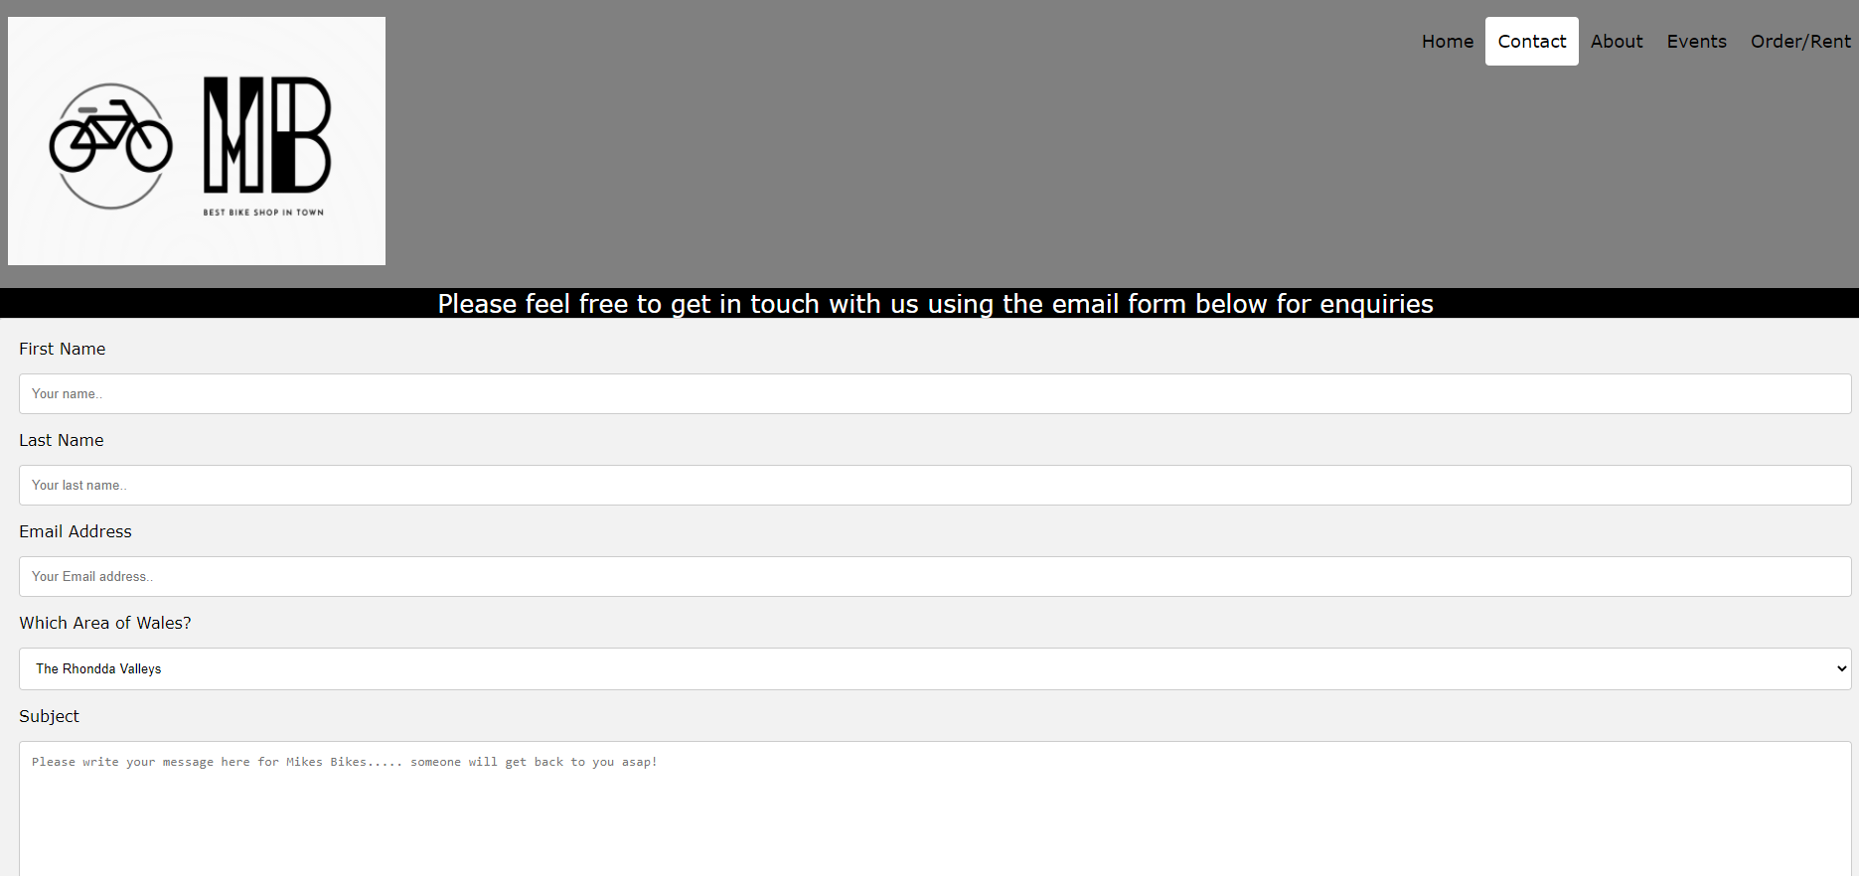

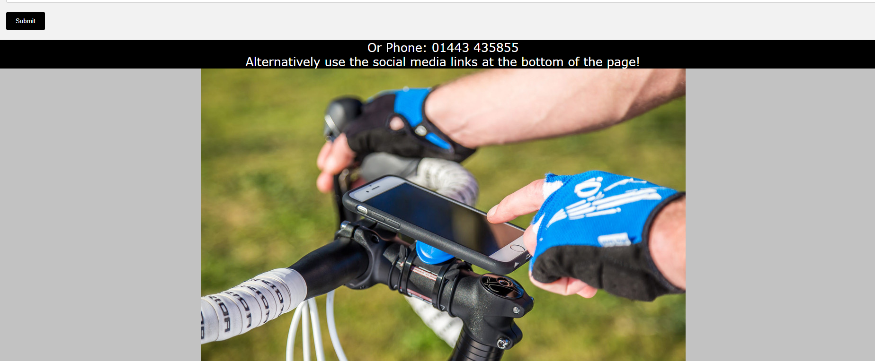
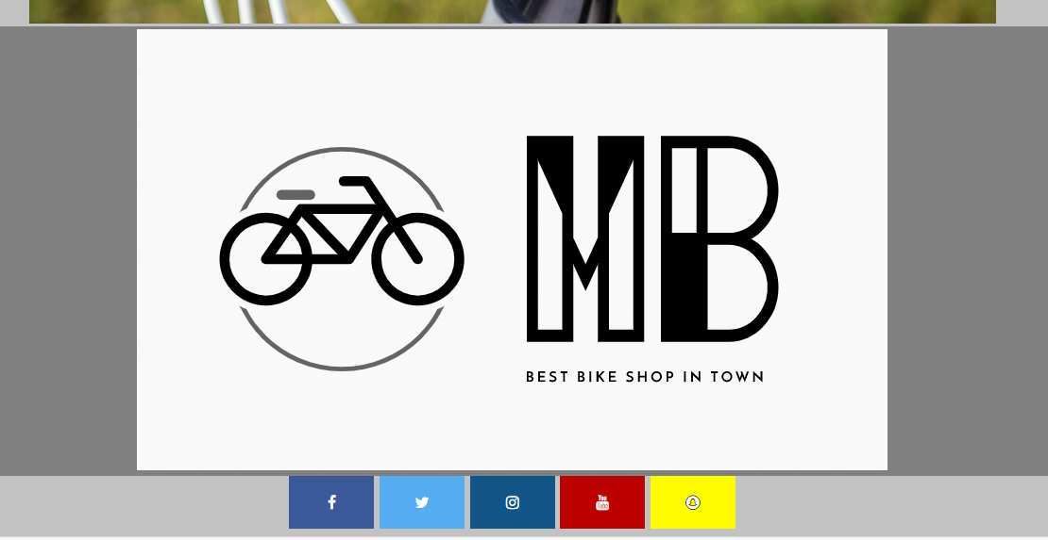

The form can be completed and then the submit button can be pressed to send the message.

About page
The about page gives a brief description of the shop’s functions to the customer, including what services are available.

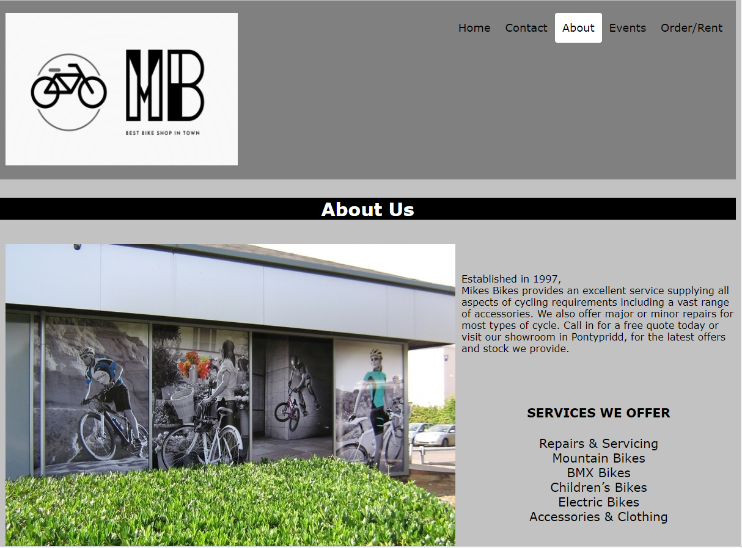
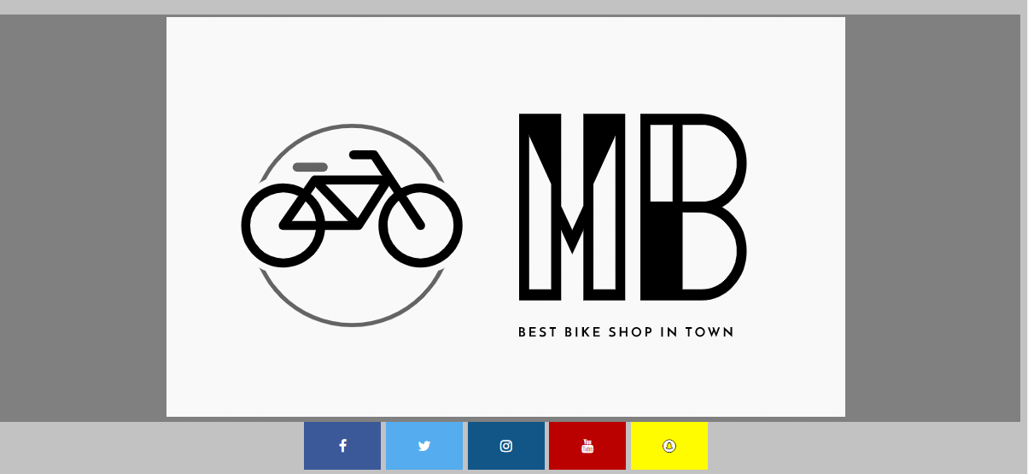

Events page
The events page is targeted at more experienced cyclers. It tries to entice them into going on cycling events across wales.
I used a different style slightly on this page as I wanted it to stand out more. So, I used brighter colours and different font styles.
Hyperlinks are embedded into the images which will take the user to all cycling events wales.
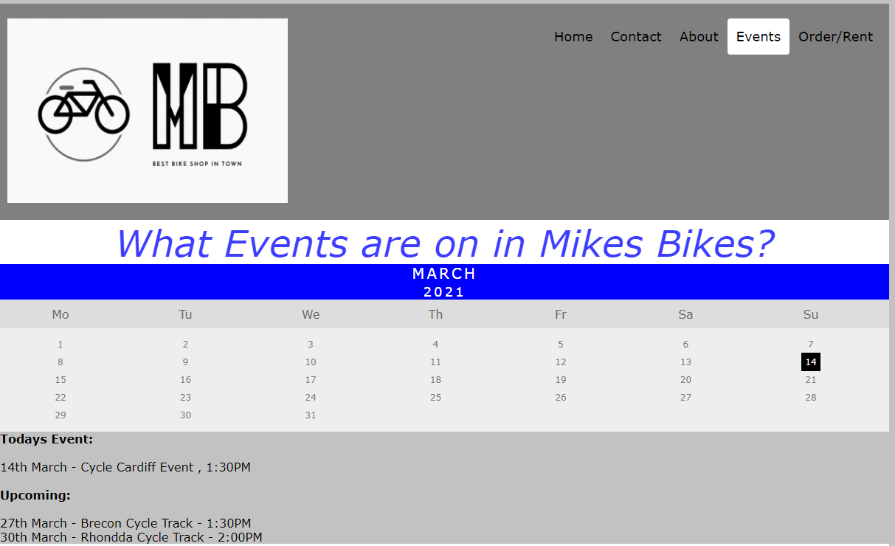
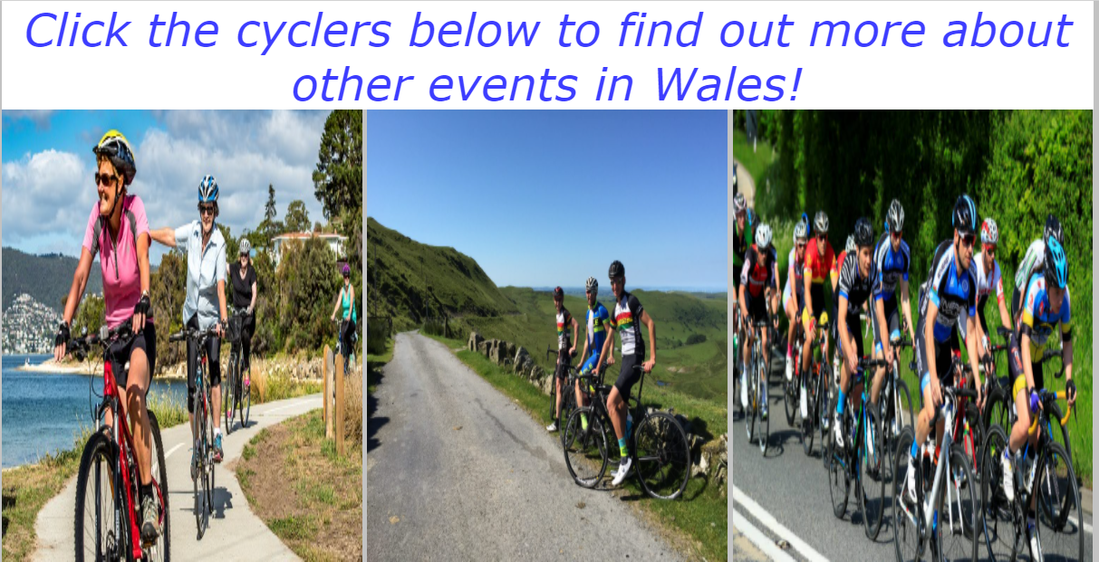
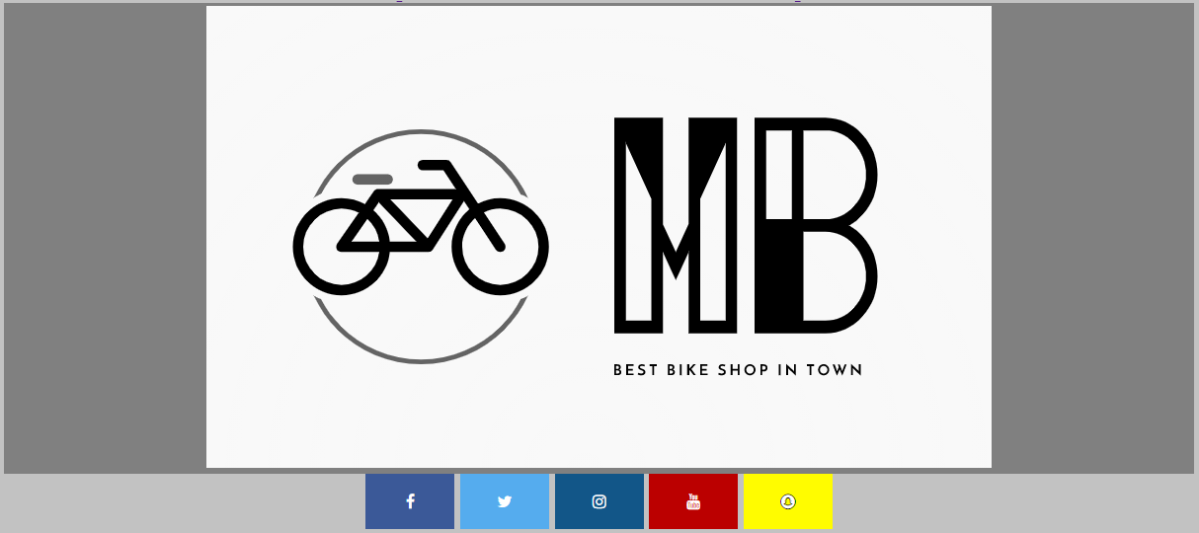

Order/Rent page
This page is intended for a customer to make a purchase of a product from the site.
At the very top there is a Cart section which shows what Items are in “Your Cart”.
Just below that there is a message banner – which informs customers of any delays or restrictions to buying.
It then Includes some images of the Bikes that are sold at the store alongside pricing.
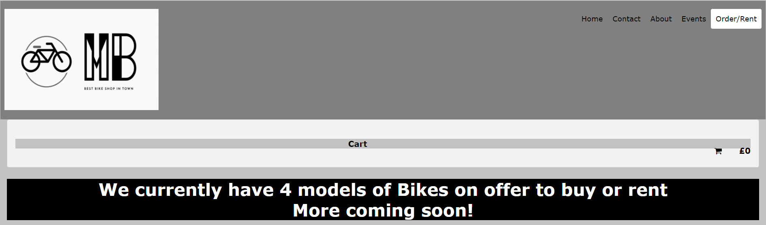
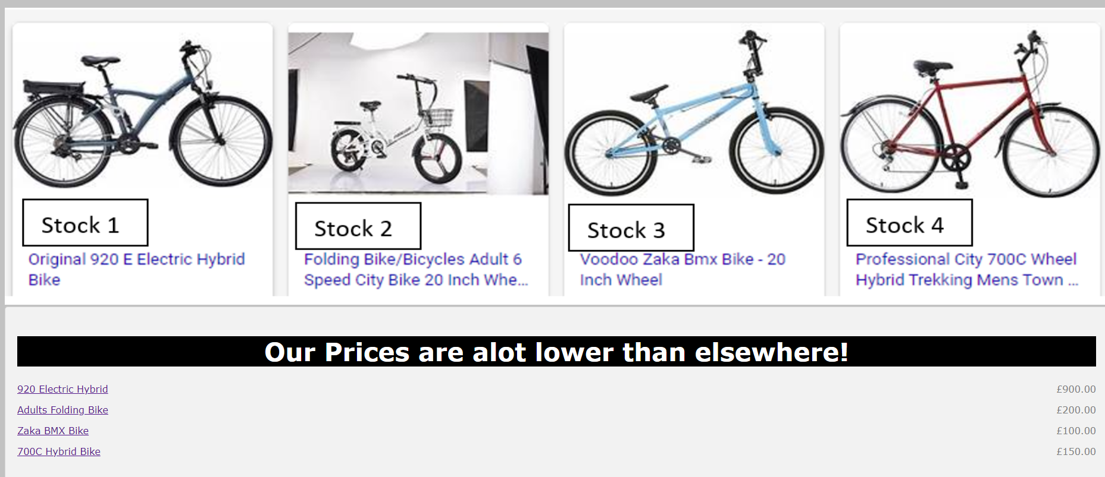
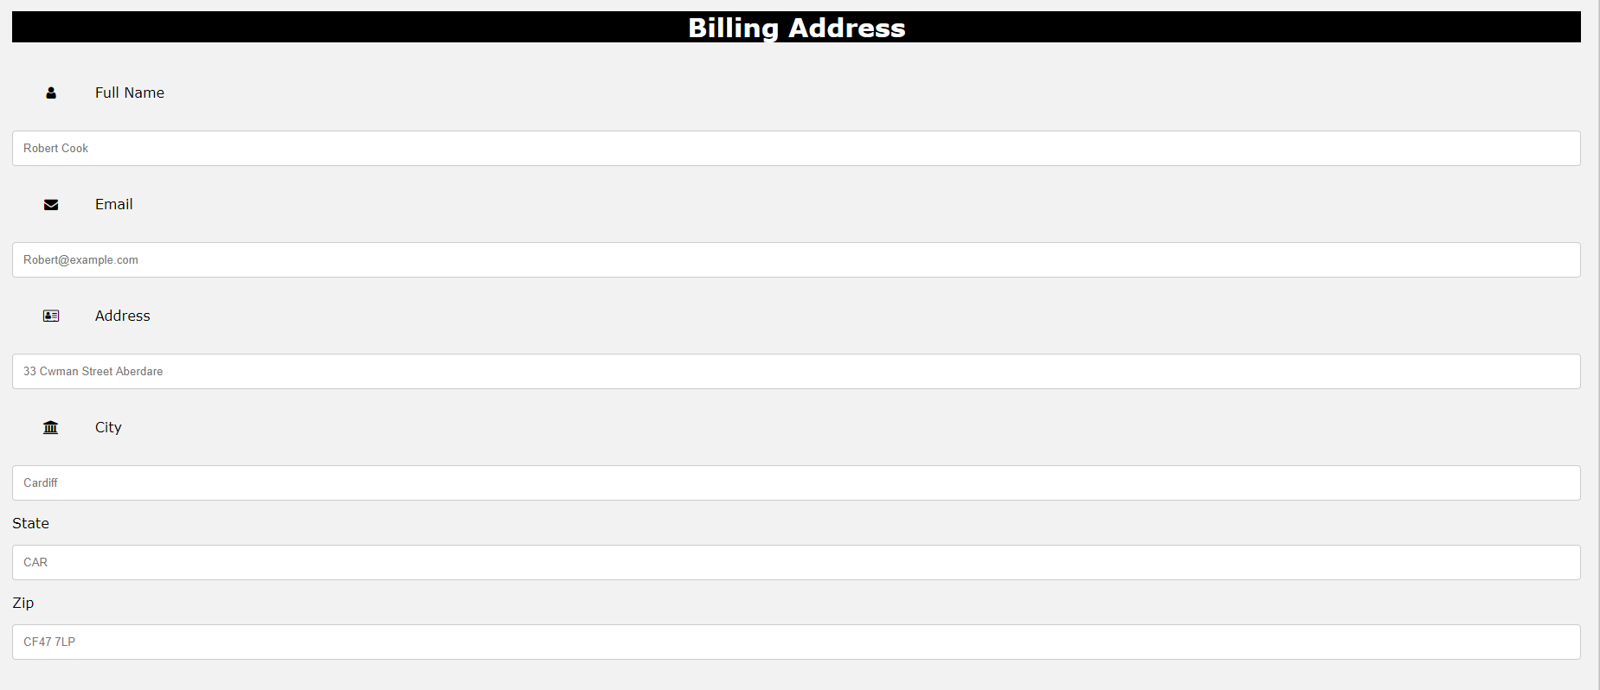
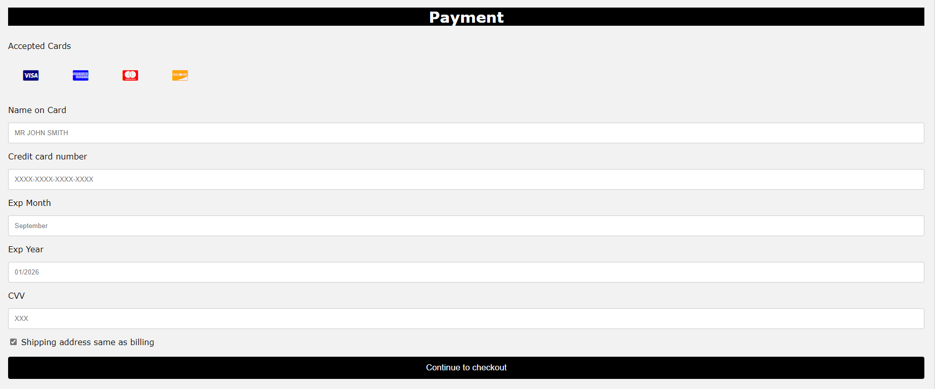


Towards the end of the site is the billing form. With the Help of W3schools I was able to embed this but then style it to my website design.

Validation
Validating my HTML
When validating my home screen HTML document using http://validator.w3.org/
The main error I came across was that the image element needed an “alt” attribute.
When importing some images, I left this attribute out by mistake – it can be useful as if the image cannot load then the site will display text instead.
I corrected this by adding an in an alt attribute and then removing the image too see if text would input instead of the image.

Validating my CSS
When validating my websites CSS document on http://jigsaw.w3.org/css-validator/.
The main error it detected was that it did not like that I was trying to style the font to Comic Sans.
After some researching online – I discovered this happened because I used the wrong field in my css document.
I should of used font-family: then the style I wanted.
I corrected this:
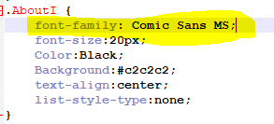
Refreshed my page and the text style changed.

Evaluation

Website Usability –
Website usability measures how easy to use the interface of the website is for the end user of a particular target audience.
It looks at how user friendly a website is and could also look at how responsive someone’s website is – as the website may be used on several devices.
[1]
Website accessibility –
Website accessibility is making your site usable for anyone, specifically for people with disabilities. This could mean designing your site for individuals who have auditory problems or problems being able to see the screen.
It is all about using the new technologies available to help these types of people and incorporating them into your websites.
It is partially also about general use to – so if someone had a very slow internet speed – it could be making your site a little less graphic hungry or have a “light version” mode, so they can access it.
[2]
Search Engine Optimisation –
For any website that has been designed and then published publicly, especially if people need to see your site for you to make a profit, it is worth looking into this.
Big website search engines like google and bing – have bots that scroll through pages on the web and determine their order. These “bots” have an algorithm in place that determines the order.
There are a couple of factors that determine the order – research suggests that google have over 200 factors that their bots consider when prioritising website order.
- Keyword Research – Analysing the types of words and frequency used by prospective customers to find a brands services or products. Understanding their intent and a user’s expectations from their search.
- Technical Auditing – Ensuring the website can be crawled and indexed, is correctly geo-targeted, and is free from errors or user experience barriers.
- Onsite Optimisation – Improving the website structure, internal navigation, on-page alignment and content relevancy to help prioritise key areas and target relevant search phrases.
- User Experience – Ensuring content shows expertise, authority, and trust, is simple to use, fast, and ultimately provides the best possible experience to users against the competition.

[3]

Evaluating my website
Considering this is the first ever site I have written up; I am quite pleased with the outcome.
When looking at my website I think it does offer some of the features listed above, I think it is “useable” and simplistic and I think any person would be able to navigate through the site and get a good understanding of what it is all about.
I think it has a very user-friendly interface with the navigation buttons and this allows easy access to each part of my website. It also uses a good variety of images which are nice to look at and keep you interested.
I would like to modify the header of the site abit more in the future and make it more modern, in line with other bike shop websites that I looked at online. There is abit of space between the company logo and the navigation buttons, I could add abit more design into this space.
The accessibility of my website I would rate quite highly, I used colours that would be easy to read for anyone with any visual problems, for example the text uses a black background with white text. The site also offers no sound, so this would have no impact on people who are hard of hearing. One part I could look at though, is possibly adding in some shortcut keys for navigation for people who may not be able to use a mouse and drag it around a screen, for example if they had a broken arm. They could press “A” to take them to the About section.
The site now is not too resource hungry, so anyone with any device could access it and have a fast experience.
There are unfortunately some aspects of my website that I could not get to function to the next steps, I added an email form and a billing form and on submitting them the website tries to direct to elsewhere, this is something I can work on and hopefully get up and running on the site soon.
My site is currently not publicly published anywhere so not much has been done into search engine optimisation, but this is something I will investigate more for the future, specifically looking at how the wording you use determining the order of your site showing up.

References
[1] | techopedia, “techopedia,” 17 03 2021. [Online]. Available: https://www.techopedia.com/definition/23903/website-usability#:~:text=Website%20Usability.%20Definition%20-%20What%20does%20Website%20Usability,how%20a%20target%20audience%20uses%20an%20online%20site..
[2] | S. L. Henry, “W3C,” w3c, 5 June 2019. [Online]. Available: https://www.w3.org/WAI/fundamentals/accessibility-intro/#:~:text=Web%20accessibility%20means%20that%20websites,%20tools,%20and%20technologies,interact%20with%20the%20Web%20contribute%20to%20the%20Web.
[3] | ScreamingFrog, 17 March 2021. [Online]. Available: https://www.screamingfrog.co.uk/what-is-seo/.

Images used on website.
Image for Home screen:
bike shop - Bing images

Image for second image on home screen:
bikes shop window - Bing images

About page image
bikes shop window - Bing images

Home screen – 3rd image
bikes shop window - Bing images

Contact page image
Bike phones - Bing images

Images on Events page:
Bike-Week-website-image.jpg (470×270) (pcdn.co)
IMG_5095-1024x768.jpg (1024×768) (peloton.wales)
20160605_Welsh_Road_Championships_2016.jpg (1200×675) (britishcycling.org.uk)
Order page images
Original 920 E Electric Hybrid Bike RIVERSIDE - Decathlon
Folding Bike/Bicycles Adult 6 Speed City Bike 20 Inch Wheel White on OnBuy
Voodoo Zaka BMX Bike - 20" Wheel | Halfords UK
Professional City 700c Wheel Hybrid Trekking Mens Town Commute 6 Speed Bike 22" Frame Red: Amazon.co.uk: Sports & Outdoors

Appendices

Index.html
<!DOCTYPE html>
<html>

<head>

<title> Mikes Bikes - Home
</title>
<link rel="stylesheet" href="format.css" />
<head>
<body>

<div class="header">
<img src="MBL.PNG" alt="Logo icon" width="380" height="250">
<div class="header-right">
<a class="first" href="index.html">Home</a>
<a href="Contact.html">Contact</a>
<a href="about.html">About</a>
<a href="Gallery.html">Events</a>
<a href="order.html">Order/Rent</a>
</div>
</div>

<div class="Homescreen">
<img class="image-resize" src="HMSC.JPG" alt="home page">

Welcome to Mikes Bikes
</div>

<div class="Stomach">
<img class="image1" src="Openning.jpg">
<img class="image2" src="Number2.jpg">
<img class="image3" src="Number 3.jpg">
</div>
<div class="Stomachbody">
</div>

<div class="Homescreen">
Location and Opening Hours
</div>
<Br>

<div class="Iframes">
<iframe src="https://www.google.com/maps/d/embed?mid=1jDTmq-hgDK8tBk2KLLnht-HrfQJ-AA6Y" width="50%" height="600px"></iframe>

</div>

<div class="Info">
<li>Monday:- 9AM-5PM </li>
<li>Tuesday:- 9AM-5PM</li>
<li>Wednesday:- 9AM-5PM</li>
<li>Thursday:- 9AM-5PM</li>
<li>Friday:- 9AM-5PM</li>
<li>Saturday:- 9AM-5PM</li>
<li>Sunday:- Closed</li>
</div>

<footer>
<img class="FBL" src="MBL.PNG" alt="txt">
</footer>

<link rel="stylesheet" href="https://cdnjs.cloudflare.com/ajax/libs/font-awesome/4.7.0/css/font-awesome.min.css">

<div class="Links">
<a href="https://en-gb.facebook.com/login.php" class="fa fa-facebook"></a>
<a href="https://twitter.com/" class="fa fa-twitter"></a>
<a href="https://www.instagram.com/" class="fa fa-instagram"></a>
<a href="https://www.youtube.com/watch?v=6Fj6cKRi1qE" class="fa fa-youtube"></a>
<a href="https://www.snapchat.com/" class="fa fa-snapchat"></a>
</div>
<body>
<html>

Contact.HTML
<!DOCTYPE html>
<html>

<head>

<title> Mikes Bikes - Welcome
</title>
<link rel="stylesheet" href="format.css" />
<head>
<body>

<div class="header">
<img src="MBL.PNG" alt="Logo icon" width="380" height="250">
<div class="header-right">
<a href="index.html">Home</a>
<a class="second" href="Contact.html">Contact</a>
<a href="about.html">About</a>
<a href="Gallery.html">Events</a>
<a href="order.html">Order/Rent</a>
</div>
</div>

<div class="Contacts">
Please feel free to get in touch with us using the email form below for enquiries
<br>
</div>

<div class="container">
<form action="action_page.php">

<label for="fname">First Name</label>
<input type="text" id="fname" name="firstname" placeholder="Your name..">

<label for="lname">Last Name</label>
<input type="text" id="lname" name="lastname" placeholder="Your last name..">

<label for="Email">Email Address</label>
<input type="text" id="lname" name="lastname" placeholder="Your Email address..">

<label for="country">Which Area of Wales?</label>
<select id="country" name="country">
<option value="australia">The Rhondda Valleys</option>
<option value="canada">Cardiff</option>
<option value="usa">North Wales</option>
</select>

<label for="subject">Subject</label>
<textarea id="subject" name="subject" placeholder="Please write your message here for Mikes Bikes..... someone will get back to you asap!" style="height:200px"></textarea>

<input type="submit" value="Submit">

</form>
</div>

<div class="Contacts">
Or Phone: 01443 435855
<br>
Alternatively use the social media links at the bottom of the page!
</div>

<div class="Wrapper">
<img src="Bike Phone.jpg">
</div>

<footer>
<img class="FBL" src="MBL.PNG">
</footer>

<link rel="stylesheet" href="https://cdnjs.cloudflare.com/ajax/libs/font-awesome/4.7.0/css/font-awesome.min.css">

<div class="Links">
<a href="https://en-gb.facebook.com/login.php" class="fa fa-facebook"></a>
<a href="https://twitter.com/" class="fa fa-twitter"></a>
<a href="https://www.instagram.com/" class="fa fa-instagram"></a>
<a href="https://www.youtube.com/watch?v=6Fj6cKRi1qE" class="fa fa-youtube"></a>
<a href="https://www.snapchat.com/" class="fa fa-snapchat"></a>
</div>

<body>
<html>

About.HTML
<!DOCTYPE html>
<html>

<head>

<title> Mikes Bikes - Welcome
</title>
<link rel="stylesheet" href="format.css" />
<head>
<body>

<div class="header">
<img src="MBL.PNG" alt="Logo icon" width="380" height="250">
<div class="header-right">
<a href="index.html">Home</a>
<a href="Contact.html">Contact</a>
<a class="third" href="about.html">About</a>
<a href="Gallery.html">Events</a>
<a href="order.html">Order/Rent</a>
</div>
</div>

<h3>About Us</h3>
<div class="AboutW">
<img src="Aboutimg.jpg">
</div>
<div class="AboutT">
<br>
<br>
<br>
Established in 1997,
<br>
Mikes Bikes provides an excellent service supplying all aspects of cycling requirements including a vast range of accessories.
We also offer major or minor repairs for most types of cycle. Call in for a free quote today or visit our showroom in Pontypridd,
for the latest offers and stock we provide.​​
</div>
<br>
<br>
<br>
<h4>SERVICES WE OFFER</h4>

<div class="AboutI">
<li>Repairs & Servicing</li>
<li>Mountain Bikes</li>
<li>BMX Bikes</li>
<li>Children’s Bikes</li>
<li>Electric Bikes</li>
<li>Accessories & Clothing</li>

</div>

<img src="PB2.PNG" width="100%" height="10px">

<footer>
<img class="FBL" src="MBL.PNG">
</footer>

<link rel="stylesheet" href="https://cdnjs.cloudflare.com/ajax/libs/font-awesome/4.7.0/css/font-awesome.min.css">

<div class="Links">
<a href="https://en-gb.facebook.com/login.php" class="fa fa-facebook"></a>
<a href="https://twitter.com/" class="fa fa-twitter"></a>
<a href="https://www.instagram.com/" class="fa fa-instagram"></a>
<a href="https://www.youtube.com/watch?v=6Fj6cKRi1qE" class="fa fa-youtube"></a>
<a href="https://www.snapchat.com/" class="fa fa-snapchat"></a>
</div>
<body>
<html>

Gallery.HTML
<!DOCTYPE html>
<html>

<head>

<title> Mikes Bikes - Welcome
</title>
<link rel="stylesheet" href="format.css" />
<head>
<body>

<div class="header">
<img src="MBL.PNG" alt="Logo icon" width="380" height="250">
<div class="header-right">
<a href="index.html">Home</a>
<a href="Contact.html">Contact</a>
<a href="about.html">About</a>
<a class="fourth" href="Gallery.html">Events</a>
<a href="order.html">Order/Rent</a>
</div>
</div>

<div class="TitleE">
What Events are on in Mikes Bikes?
</div>

<div class="month">
<ul>

<li>March<br><span style="font-size:18px">2021</span></li>
</ul>
</div>

<ul class="weekdays">
<li>Mo</li>
<li>Tu</li>
<li>We</li>
<li>Th</li>
<li>Fr</li>
<li>Sa</li>
<li>Su</li>
</ul>

<ul class="days">
<li>1</li>
<li>2</li>
<li>3</li>
<li>4</li>
<li>5</li>
<li>6</li>
<li>7</li>
<li>8</li>
<li>9</li>
<li>10</li>
<li>11</li>
<li>12</li>
<li>13</li>
<li><span class="active">14</span></li>
<li>15</li>
<li>16</li>
<li>17</li>
<li>18</li>
<li>19</li>
<li>20</li>
<li>21</li>
<li>22</li>
<li>23</li>
<li>24</li>
<li>25</li>
<li>26</li>
<li>27</li>
<li>28</li>
<li>29</li>
<li>30</li>
<li>31</li>
</ul>

<b>Todays Event:</b>
<br>
<br>
14th March - Cycle Cardiff Event , 1:30PM
<br>
<br>
<b>Upcoming:</b>
<br>
<br>
27th March - Brecon Cycle Track - 1:30PM
<br>
30th March - Rhondda Cycle Track - 2:00PM
<br>

<div class="TitleE">
Click the cyclers below to find out more about other events in Wales!
</div>

<div class="Ender">
<a href="http://welshcyclingevents.co.uk/"> <img src="BikeWeek.jpg" height="500px" width="33%"> </a>
<a href="http://welshcyclingevents.co.uk/"> <img src="BikingW.jpg" height="500px" width="33%"> </a>
<a href="http://welshcyclingevents.co.uk/"> <img src="Bike2021.jpg" height="500px" width="33%"> </a>

</div>

<footer>
<img class="FBL" src="MBL.PNG">
</footer>

<link rel="stylesheet" href="https://cdnjs.cloudflare.com/ajax/libs/font-awesome/4.7.0/css/font-awesome.min.css">

<div class="Links">
<a href="https://en-gb.facebook.com/login.php" class="fa fa-facebook"></a>
<a href="https://twitter.com/" class="fa fa-twitter"></a>
<a href="https://www.instagram.com/" class="fa fa-instagram"></a>
<a href="https://www.youtube.com/watch?v=6Fj6cKRi1qE" class="fa fa-youtube"></a>
<a href="https://www.snapchat.com/" class="fa fa-snapchat"></a>
</div>
<body>
<html>

<body>
<html>

order.HTML
<!DOCTYPE html>
<html>

<head>

<title> Mikes Bikes - Welcome
</title>
<link rel="stylesheet" href="format.css" />
<head>
<body>

<div class="header">
<img src="MBL.PNG" alt="Logo icon" width="380" height="250">
<div class="header-right">
<a href="index.html">Home</a>
<a href="Contact.html">Contact</a>
<a href="about.html">About</a>
<a href="Gallery.html">Events</a>
<a class="fifth" href="order.html">Order/Rent</a>
</div>
</div>

<div class="col-25">
<div class="container">
<h4>Cart
<span class="price" style="color:black">
<i class="fa fa-shopping-cart"></i>
<b>£0</b>
</span>
</h4>

</div>

<h1>We currently have 4 models of Bikes on offer to buy or rent
<br>
More coming soon!
</h1>

<img src="StockM.PNG" width ="100%" height="500px">

<div class="row">
<div class="col-75">
<div class="container">
<form action="/action_page.php">

<h1>Our Prices are alot lower than elsewhere!</h1>

<p><a href="https://www.decathlon.co.uk/p/original-920-e-electric-hybrid-bike/_/R-p-325430?mc=8586865&iv_=__iv_p_1_g_1161084533012038_c__w_pla-4576167397886726_n_o_d_c_v__l__t__r_x__y_56861_f_Online_o_8586865-4030297_z_GB_i_EN_j_4576167397886726_s__e__h__ii__vi__&msclkid=1fa85d9f8d0511b0a1a03dd1ce07a838&utm_source=bing&utm_medium=cpc&utm_campaign=Omnia%20-%20PB%20-%20Top%20Products&utm_term=4576167397886726&utm_content=ROAS%20target%20800">920 Electric Hybrid</a> <span class="price">£900.00</span></p>
<p><a href="https://www.onbuy.com/gb/folding-bikebicycles-adult-6-speed-city-bike-20-inch-wheel-white~c12489~p29519532/?exta=bingsh&lid=40547700&stat=eyJpcCI6IjIyOS4wMCIsImRwIjoiMC4wMDAwIiwibGlkIjoiNDA1NDc3MDAiLCJzIjoiMiIsInQiOjE2MTU2MjI0OTQsImJtYyI6IjQuMCJ9&exta=bingsh&msclkid=616a98ac565e1fdef8eef8e2155c1504&utm_source=bing&utm_medium=cpc&utm_campaign=(GB:%20SAD)%20Sports%20&%20Outdoors&utm_term=4575067888506685&utm_content=(GB:%20SAD)%20Sports%20&%20Outdoors%20-%2012">Adults Folding Bike</a> <span class="price">£200.00</span></p>
<p><a href="https://www.halfords.com/bikes/kids-bikes/voodoo-zaka-bmx-bike---20in-wheel-204146.html?cm_mmc=Google+PLA-_-Cycling%3EBikes%3EKids+Bikes-_-Cycling%3EBikes%3EKids+Bikes-_-204146&istCompanyId=b8708c57-7a02-4cf6-b2c0-dc36b54a327e&istFeedId=62b447cf-331e-4fec-a47a-9985ff72d404&istItemId=xiiwmwlmx&istBid=tzpw&_$ja=tsid:94971|cid:367490840|agid:1290826971409932|tid:pla-4584276303636617|crid:|nw:o|rnd:|dvc:c|adp:|mt:e|loc:&msclkid=3e6c4399d9bb146aba4b23d79ab92f1b&utm_source=bing&utm_medium=cpc&utm_campaign=PLA%20-%20KB%20-%20Premium%20Kids%20Bikes%20-%20CSS&utm_term=4584276303636617&utm_content=KB%20-%20Bikes%20-%20Kids%20Bikes">Zaka BMX Bike</a> <span class="price">£100.00</span></p>
<p><a href="https://www.amazon.co.uk/Professional-Wheel-Hybrid-Trekking-Commute/dp/B08Q7XT9QJ/ref=asc_df_B08Q7XT9QJ/?tag=bingshoppinga-21&linkCode=df0&hvadid=&hvpos=&hvnetw=o&hvrand=&hvpone=&hvptwo=&hvqmt=e&hvdev=c&hvdvcmdl=&hvlocint=&hvlocphy=&hvtargid=pla-4583657832588632&psc=1">700C Hybrid Bike</a> <span class="price">£150.00</span></p>

<div class="row">
<div class="col-50">
<h3>Billing Address</h3>
<label for="fname"><i class="fa fa-user"></i> Full Name</label>
<input type="text" id="fname" name="firstname" placeholder="Robert Cook">
<label for="email"><i class="fa fa-envelope"></i> Email</label>
<input type="text" id="email" name="email" placeholder="Robert@example.com">
<label for="adr"><i class="fa fa-address-card-o"></i> Address</label>
<input type="text" id="adr" name="address" placeholder="33 Cwman Street Aberdare">
<label for="city"><i class="fa fa-institution"></i> City</label>
<input type="text" id="city" name="city" placeholder="Cardiff">

<div class="row">
<div class="col-50">
<label for="state">State</label>
<input type="text" id="state" name="state" placeholder="CAR">
</div>
<div class="col-50">
<label for="zip">Zip</label>
<input type="text" id="zip" name="zip" placeholder="CF47 7LP">
</div>
</div>
</div>

<div class="col-50">
<h3>Payment</h3>
<label for="fname">Accepted Cards</label>
<div class="icon-container">
<i class="fa fa-cc-visa" style="color:navy;"></i>
<i class="fa fa-cc-amex" style="color:blue;"></i>
<i class="fa fa-cc-mastercard" style="color:red;"></i>
<i class="fa fa-cc-discover" style="color:orange;"></i>
</div>
<label for="cname">Name on Card</label>
<input type="text" id="cname" name="cardname" placeholder="MR JOHN SMITH">
<label for="ccnum">Credit card number</label>
<input type="text" id="ccnum" name="cardnumber" placeholder="XXXX-XXXX-XXXX-XXXX">
<label for="expmonth">Exp Month</label>
<input type="text" id="expmonth" name="expmonth" placeholder="September">

<div class="row">
<div class="col-50">
<label for="expyear">Exp Year</label>
<input type="text" id="expyear" name="expyear" placeholder="01/2026">
</div>
<div class="col-50">
<label for="cvv">CVV</label>
<input type="text" id="cvv" name="cvv" placeholder="XXX">
</div>
</div>
</div>

</div>
<label>
<input type="checkbox" checked="checked" name="sameadr"> Shipping address same as billing
</label>
<input type="submit" value="Continue to checkout" class="btn">
</form>
</div>
</div>

</div>
</div>

<footer>
<img class="FBL" src="MBL.PNG">
</footer>

<link rel="stylesheet" href="https://cdnjs.cloudflare.com/ajax/libs/font-awesome/4.7.0/css/font-awesome.min.css">

<div class="Links">
<a href="https://en-gb.facebook.com/login.php" class="fa fa-facebook"></a>
<a href="https://twitter.com/" class="fa fa-twitter"></a>
<a href="https://www.instagram.com/" class="fa fa-instagram"></a>
<a href="https://www.youtube.com/watch?v=6Fj6cKRi1qE" class="fa fa-youtube"></a>
<a href="https://www.snapchat.com/" class="fa fa-snapchat"></a>
</div>
<body>
<html>

<body>
<html>

CSS style Sheet
body {

font-family: arial;
}
h1 {
font-size: 42px;
color: White;
background: black;
width: 100%;
text-align:center;

}

html {
background:#c2c2c2;
-webkit-background-size: cover;
-moz-background-size: cover;
-o-background-size: cover;
background-size: cover;
}

.header {
overflow: hidden;
background-color:Grey;
padding: 20px 10px;
}
.header a {
float: left;
color: black;
text-align: center;
padding: 12px;
text-decoration: none;
font-size: 18px;
line-height: 25px;
border-radius: 4px;
}
.header a.logo {
font-size: 25px;
font-weight: bold;
}
.header a:hover {
background-color: #ddd;
color: yellow;
}
.header a.first {
background-color: white;
color: Black;
}
.header a.second {
background-color: white;
color: Black;
}
.header a.third {
background-color: white;
color: Black;
}
.header a.fourth {
background-color: white;
color: Black;
}
.header a.fifth {
background-color: white;
color: Black;
}
.header-right {
float: right;
}
@media screen and (max-width: 500px) {
.header a {
float: none;
display: block;
text-align: left;
}
.header-right {
float: none;
}
}
.image-resize {
height:900px;
object-fit:cover;
object-position: center;
width:100%
}
.Stomach {
background-color: white;
position: center;

}

h3 {
font-size: 30px;
color: white;
Background: Black;
text-align:center;
}
h4 {
font-size: 20px;
color:Black;
Background:#c2c2c2;
font:Comic Sans;
text-align:center;
list-style-type:none;
}
.image1 {
height:500px;
object-position:left;
width:33.3%;
}
.image2 {
height:500px;
object-position:centre;
width:33.3%;
}
.image3 {
height:500px;
width:32.7%;
object-position:right;
}
.Homescreen {
font:Comic Sans;
font-size:50px;
Color:White;
Background:Black;
text-align:center;

}

.Iframes {
text-align:center;
background:Black;

}

.Info {
font:Comic Sans;
font-size:20px;
Color:White;
Background:Black;
text-align:center;
list-style-type:none;

}

footer {
text-align: center;
padding: 3px;
background-color: Grey;
color: white;
}

.fa {
padding: 20px;
font-size: 30px;
width: 50px;
text-align: center;
text-decoration: none;

}

.fa:hover {
opacity: 0.7;
}

.fa-facebook {
background: #3B5998;
color: white;
}

.fa-twitter {
background: #55ACEE;
color: white;
}

.fa-instagram {
background: #125688;
color: white;
}

.fa-youtube {
background: #bb0000;
color: white;
}

.fa-snapchat {
background: #fffc00;
color: white;
text-shadow: -1px 0 black, 0 1px black, 1px 0 black, 0 -1px black;
}
.Links {
text-align:center;
}
.Contacts {
Background:Black;
Color:White;
float:center;
text-align:center;
font-size:25px;
}
.Wrapper {
Background:#c2c2c2;
float:center;
text-align:center;
}
.AboutW {
Background:#c2c2c2;
margin:10px;
float:left;
}
.AboutT {
color:Black;
background:#c2c2c2;
text-align:center-right;
}
.AboutI {
font-family: Comic Sans MS;
font-size:20px;
Color:Black;
Background:#c2c2c2;
text-align:center;
list-style-type:none;
}
.TitleE {
font:Comic Sans;
font-style:italic;
Background:White;
font-size: 50px;
color:#3d3dff;
text-align: center;
}

ul {list-style-type: none;}
body {font-family: Verdana, sans-serif;}

.month {

width: 100%;
background: Blue;
text-align: center;
}

.month ul {
margin: 0;
padding: 0;
}

.month ul li {
color: white;
font-size: 20px;
text-transform: uppercase;
letter-spacing: 3px;
}

.month .prev {
float: left;
padding-top: 10px;
}

.month .next {
float: right;
padding-top: 10px;
}

.weekdays {
margin: 0;
padding: 10px 0;
background-color:#ddd;
}

.weekdays li {
display: inline-block;
width: 13.6%;
color: #666;
text-align: center;
}

.days {
padding: 10px 0;
background: #eee;
margin: 0;
}

.days li {
list-style-type: none;
display: inline-block;
width: 13.6%;
text-align: center;
margin-bottom: 5px;
font-size:12px;
color: #777;
}

.days li .active {
padding: 5px;
background: Black;
color: white !important
}

.Ender {
background:#c2c2c2;

}

.row {
display: -ms-flexbox; /* IE10 */
display: flex;
-ms-flex-wrap: wrap; /* IE10 */
flex-wrap: wrap;
margin: 0 -16px;
}

.col-25 {
-ms-flex: 25%; /* IE10 */
flex: 25%;
}

.col-50 {
-ms-flex: 50%; /* IE10 */
flex: 50%;
}

.col-75 {
-ms-flex: 75%; /* IE10 */
flex: 75%;
}

.col-25,
.col-50,
.col-75 {
padding: 0 16px;
}

.container {
background-color: #f2f2f2;
padding: 5px 20px 15px 20px;
border: 1px solid lightgrey;
border-radius: 3px;
}

input[type=text] {
width: 100%;
margin-bottom: 20px;
padding: 12px;
border: 1px solid #ccc;
border-radius: 3px;
}

label {
margin-bottom: 10px;
display: block;
}

.icon-container {
margin-bottom: 20px;
padding: 7px 0;
font-size: 24px;
}

.btn {
background-color: #4CAF50;
color: Black;
padding: 12px;
margin: 10px 0;
border: none;
width: 100%;
border-radius: 3px;
cursor: pointer;
font-size: 17px;
}

.btn:hover {
background-color: #45a049;
}

span.price {
float: right;
color: grey;
}

@media (max-width: 800px) {
.row {
flex-direction: column-reverse;
}
.col-25 {
margin-bottom: 20px;
}
}

input[type=text], select, textarea {
width: 100%;
padding: 12px;
border: 1px solid #ccc;
border-radius: 4px;
box-sizing: border-box;
margin-top: 6px;
margin-bottom: 16px;
resize: vertical
}

input[type=submit] {
background-color: Black;
color: White;
padding: 12px 20px;
border: none;
border-radius: 4px;
cursor: pointer;
}

input[type=submit]:hover {
background-color: blue;
}

.container {
border-radius: 5px;
background-color: #f2f2f2;
padding: 20px;
}
Word Count: 1956

