
To wHAT EXTENT ARE there DIFFERENCES BETWEEN students’ anxiety levels in both digital online learning and face-to-face classroom learning?
Sharon Langford
MASTERS IN EDUCATION
Faculty of Yr Athrofa


September 20, 2022

Student Number 1705084

Supervisor: Junnine- Thomas-Walters

Declaration

DECLARATION FORM


Name of the Programme of Study:

Name of Student (Capital Letters):

DECLARATION

I certify that the whole of this work is the result of my individual effort, and that all sources have been acknowledged.

Signed ............................................................... (Student)

Date ...............................................................

DECLARATION

I am satisfied that this work is the result of the student’s effort.

Signed .............................................................. (Lecturer)

Date ..............................................................

Acknowledgments
I would like give thanks to my dear friend Donna Morgan who has encouraged and persuaded me to progress within my education studies to undertake a Masters. Together we have entered this journey and have supported each other in more ways than one with certain words of encouragement. You have been an incredible supportive friend and I appreciate your assistance in reading my work and enhancing my writing skills.
Without my previous colleagues this study would not have gone ahead so a big thankyou to Donna Morgan, Ben Duxbury, Karen Hudson, Felicity Peacock, Jayne Parry Griffiths and Joanna Fender who shared my online questionnaire.
Thank you to my supervisor Junnine Thomas-Walters for her guidance.
I would like to give thanks to my nephew Brad Ayers, who has advised me along the way, how times have changed he is now helping me instead of the other way round. Thank you, x,
I would like to say sorry to my abandoned family over the summer of 2022 and to say a huge thank you for your support, cups of tea, dinner and helping out and to say I am almost back as a mum Jack Langford and Lexi Langford and a wife Steve Langford.

Abbreviations
BL Blended learning
CLT Cognitive load Theory
CSE Computer Self-Efficacy
Covid-19 Corona Virus-19
FtoF Face-to-Face classroom learning
ICT Information Communication Technology
IT Information Technology
IO Information Overload
MMR Mixed Methods Research
OL Online Learning
OU Open University
SAD Social Anxiety Disorder
UK United Kingdom

Table of Contents
Acknowledgments
Abbreviations
Abstract
Tables and Figures
Chapter One – Introduction
  - Context
  - Aims and Objectives
  - Rationale
  - Underpinning Literature
  - Summary
Chapter Two – Literature Review
2.1 Literature sources
2.2 Anxiety amongst Higher Education Students
2.3 Oral Speaking Anxiety within a Classroom
2.3.2 Social Anxiety in Higher Education
2.3.3 Group Work Anxiety
2.4 Online Learning in Higher Education
2.4.1 Positives of online learning
2.4.2 Computer Anxiety and IT Skills
2.4.3 Information Overload Anxiety

Chapter Three – Methodology
3.1 Research Aims
3.2 Mixed Method Research
3.2.1 Phenomenology paradigm
3.2.2 Interpretivist Paradigm
3.2.3 Objectivist, Epistemology and Positivist
3.3 Online Questionnaire to collect quantative and qualitative data
3.4 Methods rejected
3.5 Likert Scale, closed and open-ended questions
3.6 Ethics
3.7 Conduct of Research
3.8 Pilot Study
3.9 Sample
3.10 Hypothesis
3.11 Research Analysis Methods

Chapter Four – Analysis of Results
4.1 Programme Respondents
4.2 Level of Academic Study
4.2.1 Academic Courses
4.3 Age of Respondents
4.3.1 Age anxiety to Online and Classroom learning
4.4 Online Learning Anxiety
4.4.2 Rate anxiety levels to Online learning
4.4.3 Information Overload
4.4.4 Less Interaction with lectures
4.4.5 Seeing yourself online
4.4.6 Feelings of Isolation
4.4.7 IT Skills and WIFI
4.4.8 Poor Concentration
4.5 Anxiety within a Classroom
4.5.1 Presenting a topic in front of peers and the lecture
4.5.2 Group work Anxiety
4.5.3 Worried about Covid-19
4.6 Social Anxiety
4.7 Preference of style of Learning
4.8 Blended Learning
Chapter Five – Conclusion and Recommendations
5.1 Conclusion
5.1.2 Aims and Objectives
5.1.3 Limitations of Study
5.4 Personal Development
5.5 Professional Development
5.6 Discussions
5.7 Recommendations
5.7.2 Ways to Support Socially Anxious Students
5.7.3 Ways of improving online teaching whilst preventing Information Overload
5.8
5.9 Future Research

References
Appendices
Appendix 1- Online Questionnaire- Cover Letter
Appendix 2 – Online Questionnaire
Appendix 3 - Online Questionnaire Results
Appendix 4 - Graphs

Contents List of Figures and Tables
Figure:
Figure 1- Clark and Wells (1995) ‘Social Phobia Model’
Figure 2- Rapee and Heimberg (1997) ‘Cognitive Behavioural model of social phobia’
Figure 3- Valcke (2002) Information Overload Vs Cognitive Overload

Table:
Table 1 Number of Participants per Study Level
Table 2 Range of Anxiety over a Range of Academic Levels
Table 3 Theme Analysis of Academic Courses
Table 4 Age of Respondents
Table 5 Average Anxiety Age groups across Online and Classroom Learning
Table 6 Anxiety with Online learning
Table 7 Rated Anxiety levels within Online Learning
Table 8 Anxiety levels in a Face-to-Face Classroom Environment
Table 9 Social Anxiety
Table 10 Preferred Learning Style

UNIVERSITY OF WALES TRINITY SAINT DAVID
ABSTRACT
FACULTY OF YR ATHROFA
Masters in Education
By Sharon Langford
ABSTRACT (250-300) Is not the introduction
- State the type of research that has been carried out
- Purpose
- Methods used
- Focus on major findings and outcomes (what, why, who , when and how)

Anxiety amongst Higher Education students ……
Information overload emerged as the top anxiety trigger amongst students undertaking learning online. Oral presentations and group work figured significantly as anxiety triggers within a classroom environment.
Level four learners demonstrated the highest levels of anxiety in both online and classroom learning environments.
An online questionnaire utilising ‘Microsoft Forms’ was used as the main instrument in a mixed method research approach.

Keywords; Anxiety in Higher Education, student’s anxiety, online, social anxiety, blended learning,

Chapter One
Introduction

This thesis focuses on the emotion anxiety amongst students in higher education, exploring the key themes which contribute to learners’ anxiety within two learning environments (1) online learning and (2) classroom face to face. The emotion anxiety is the fear response to a perceived threat and students can become anxious about education when they view their environment whether it is within a classroom setting or online as a threat to them. It is noted that students may feel anxious socially within their learning environments, they may fear failing exams and their courses, feel anxious towards balancing, student life, work, money worries, homesick with academic struggles (Alkandari, 2021). The number of university students experiencing anxiety within the UK is on the increase and can impact negatively upon student’s attendance, grades and drop out of university rates as a consequence (Ladejo, 2021). This study undertakes an investigation into what themes are considered threats to students within an online learning and classroom environment in order to learn how to support students accordingly.

1.1 Context
This study took place within a Higher Education (HE) organisation within the United Kingdom (UK) and focused on two portfolios delivered at academic levels four, five and six within Health and Social Care Health, Business and an MBA International hotel management. All academic courses currently deliver both online and face-to-face classroom learning.
The author has chosen anxiety and education as a topic for this thesis, as both are passions of hers, as a professional counsellor and as a higher education lecturer, this thesis merges with both professions. The topic of this study relates to current national and global educations systems especially since HE organisations moved teaching on line with the arrival of Corona-Virus 19 (Covid-19) in March 2020. The aim of the study is to investigate, ‘To what extent are there differences between students’ anxiety levels in both digital online learning and classroom face-to-face?’

1.2 Aims and Objectives
In order to collect the data to answer the aims and objectives within this study, an online questionnaire has been devised which was sent out to 50 participants and received 35 recipients. The questionnaire comprised of; three closed questions, two open ended questions and seventeen rating scale questions to evaluate learners’ anxiety levels which were split up into nine rating questions relating to ‘low, medium, or high’ levels of anxiety within online learning and eight questions using a rating scale of ‘low, medium and high’ was used for learners’ anxiety within the classroom. The questions were devised using both the authors own prior knowledge of potential learners’ anxiety and prior research undertaken with the aim to investigate if there were particular themes of anxiety emerging from both learning environments.
- An aim within the study set out by the author is to compare student’s anxiety levels between two learning environments; digital online learning and traditional face-to-face (FtoF) classroom learning. The author’s objectives in turn, were to answer the following five sub-questions all pertinent to the research:
- To highlight the main common factors in both learning environments which have a higher impact on the participants’ anxiety levels.
- To evaluate if there is a particular age category pre-disposed to experiencing higher levels of anxiety.
- To evaluate if there is a particular study level that is pre-dispositioned to experience higher levels of anxiety.
- To conclude a current preference of a learning environment in today’s learners.
- To synthesize if blended learning is the way forward for higher education.

1.3 Rationale
The definition of ‘anxiety’ in this study is categorised as an emotional state, which connects with worried thoughts that negative things can happen in the future, fear of failure and unpleasant physiological conditions such as palpitations, tingling feelings and shallow breathing (Nevid et al, 2005). Anxiety is the body’s response to stress (Legg and Holland, 2020). Alkandari (2021) affirms that anxiety can appear at any time and is a normal part of human reaction patterns to stress or threatening situations. Alkandari (2021) goes on to report that many students will face anxiety when they feel they cannot achieve their academic purpose, but also recognises that all students will cope with anxiety in different ways. It is noted that there are many causes for high levels of anxiety in students such as; curriculum difficulty, exams, learning new languages, social, financial pressure, culture shock, family responsibilities, illness, employment, discrimination and disabilities (Alkandari, 2021; Ameringen et al, 2003). The adverse side effects of anxiety can impact on students’ memory and cognitions in the ability to retain information and think clearly, which affects negatively on academic achievements and is associated with poor student retention, low grades and the prematurity of leaving courses (McKeachie, 1984).
Counter arguing the negative effects of anxiety are; Kumari and Jain (2014) and England et al, 2019) who propose that not all anxiety should be linked to negativity, as prior research has shown that anxiety in learners can increases students’ motivation and sharpen their cognitions. Lakhan et al, (2020) supports this theory and advocates that anxiety for a short span will sharpen the mind and reflexes. Additionally, Yerkes-Dodson law (1908) demonstrates a positive relationship between anxiety and students’ performance, whereby, anxiety increases mental arousal, therefore, increasing performance output. It is clear that bursts of short-term anxiety are productive, yet long term stress or anxiety impacts negatively upon students’ concentration, lower motivation and low self-esteem.
Kuntta (2019) reports that research into students’ mental health studies within Higher Education have been extensively researched since the 1960’s and concludes that results have not altered greatly within HE, it is the students’ attitudes which have changed. This statement is important to this research, as the researcher aims to seek if there are differences between online and classroom learning by exploring learners’ attitude to learning in two different environments (Aim 1). A study by Bayram and Bilgel (2008) demonstrates that anxiety was higher in undergraduate students compared to that of upper-level students, similarly Cook et al, (2006) note that the same learner cohort are prone to experiencing high levels of anxiety throughout their HE experiences; this corresponds with Aims (3 &4).
This study lends itself to the current global and national HE practices of teaching using a blended learning approach. The use of the term ‘blended learning’ (BL) in this research is a mix method approach of using both digital online teaching with the traditional classroom pedagogies (Garrison and Vaughan, 2008). The aim of the study is to evaluate students’ anxiety levels in learning; by comparing OL, also known as distance or remote learning against a traditional classroom set up. In this study OL refers to a learning environment whereby, (1) the learner is physically distant from the lecturer. (2) The learner uses a source of technology to access the learning material and to interact with the lecturer and other learners (Anderson 2011). In 2008, education experienced an explosive growth in online enrolment courses and has ensued a steady climb since. HE’s insight in offering online courses, merging with the boom in the technological age has provided access to HE to a large section of population, offering key benefits of flexibility and convenience for those who were unable to attend campus-based institutions (Martin and Bolliger, 2018; Rekkedal and Qvist-Eriksen, 2004).
The impact of Covid-19 in March 2020, saw education organisations globally evolve overnight to teach using digital platforms. Lecturers with no or limited training in online teaching were thrown into using digital platforms such as; ‘Microsoft Teams’, ‘Moodle’ and ‘Zoom’ in order to connect with their students and teach. Likewise, students who had been disciplined to learning within a face-face traditional classroom environment were forced to use Information Communication Technology (ICT) skills as learning shifted to online. Li et al, (2020) revealed that during the pandemic many teachers and students faced difficulties as they were not fully equipped to cope with the transition due to limited online based teaching. Issues included; problems with sharing files, difficulties in opening documents along with limited access to internet for students living in rural areas as well as the cost of internet provision. Malik & Javed (2021) document that these challenges along with the threat of Covid-19 impacted student psychologically and reported a significant rise in anxiety and Mental Health issues amongst students at this time.
It has been two years since Covid-19 impacted the world and still today the majority of HE organisations have continued to use a BL approach with combining online learning and e-learning alongside face-face taught lectures on campuses. The author hypothesizes that she would expect learners to have a higher level of anxiety with online learning, however, it has since been two years and two objectives within this investigation will seek to illustrate if students have adapted to learning on line and if this is the way forward for the future in higher education linking with aims 5 &6.

1.4 Underpinning Literature
There have been a variety of significant studies since 1930’s on the impact of students’ emotions in learning and students’ performance under anxiety. Psychologists’ have researched the impact of anxiety on learning drawing on behaviourist studies by Skinner (1977), who developed ‘Operant Conditioning’ and is well known for his experimental studies of human behaviour in environments. Behaviours are determined by our environments; therefore, the research seeks to observe if learners’ anxiety levels change depending on environment (Aim1).
The study also draws on the cognitive theory by Bandura (1977) on ‘Self-Efficacy’. Self-efficacy refers to a person’s belief about their ability to carry out a course of action (Bandura, 1986). This theory is important because if student’s do not believe they can understand the course material or have the ability to pass exams then students will experience high anxiety. Bandura (1977) observed that people relied on their somatic and emotional states to rate their self-efficacy and found that individuals interpreted their stress reactions as signs of vulnerability. Using this theory, the author recognises that participants with little knowledge of online learning will have a lower self-efficacy. The authors’ aim is to observe the main causes of anxiety within students so that she can alter her own methods of teaching, either on line or within the classroom, fostering each towards a positive self-efficacy in their education producing self-directed learners.
Social Anxiety Disorder (SAD) research undertaken by authors including Russell & Topham (2012), Clarke and Wells (1995) and Cohen et al, (2019) features significantly into this study since social anxiety impacts negatively on learners’ engagement in both learning environments; thus, tying in a study by Grieve et al, (2020) on students fears of oral presentations and speaking. These studies will be reviewed in more depth within theme one and theme two of the literature review section.
This study features prior research on learners ’anxiety connected with online learning (OL), whilst incorporating the current national and global impact of OL within HE organisations during Covid-19. Anxiety themes extracted from online learning include computer ICT and Information overload (IO). This study draws on research from Bolliger and Halupa (2012), Saade and Kira (2009), Chen et al (2011), Al-Kumaim et al, (2021) and Valcke (2002); this will be discussed more in-depth in the literature themes four and five.

1.5 Summary
The overall structure of this study takes the form of five-chapter headings comprising of; Chapter One: Introduction, Chapter Two: Literature Review, Chapter Three: Methodology, Chapter Four: Analysis of findings, Chapter Five: Conclusion and Recommendations. The thesis will commence with a brief synopsis ‘Abstract section’ about the content of the study.
The introduction section firstly presents the main aim of the study, then moves onto the context of the study, followed by an outline of the main aims and other objectives of the study. This introduction section will go onto demonstrate the rationale background behind the study including the researchers’ interest into students’ anxiety and finally this chapter will illustrate the underpinning literature of the study which will follow into the second chapter of the literature review.
In Chapter Two, the ‘Literature Review’ will evaluate anxiety levels within classroom-face-face and online learning and is composed of five literature themes examining;
- Theme one – Oral presentations and anxiety within the classroom
- Theme two – Social Anxiety Disorder within Higher Education
- Theme three – Group work and anxiety
- Theme four – Computer anxiety and ICT skills
- Theme five - Anxiety linked to Information overload
.
In Chapter Three, ‘Methodology and Methods’ the author will describe her online questionnaire instrument used in a mixed method research approach. The author will explain her phenomenological and interpretivist stance used for the qualitative side of the study and her choices for objectivist and positivism paradigms for the quantitative part of the research. The author will discuss how data is collected and disseminated.
In Chapter Four, the author will analysis this study’s qualitative and quantitative data. Information will be displayed in graph formats with explanations of findings underneath addressing the aims and objectives of the study and will commence with; the academic level of study of participants, followed by the age groups of participants, moving onto anxiety within online learning, then onto anxiety within the classroom, social anxiety, participants’ preference of learning environments and blended learning.
In Chapter Five, ‘Conclusion and Recommendation’ the author will illustrate an overall conclusion to the study, including a discussion about the researchers’ findings into this study, each aim and objective will be answered, limitations of the study will be explored, personal and professional development will be identified, recommendations on ways to support students’ anxiety within both learning environments will be listed and this chapter will close with ideas for future research.
The summary has concluded the introduction chapter and the study will now move onto the Literature review chapter. Chapter Two will commence by illustrating how the resources for this study have been retrieved, followed by prior research statistics of anxiety amongst students within HE. The study will then go on to investigate learners’ anxiety within the HE classroom, focusing on three themes; Oral Speaking, Social Anxiety Disorder and Group Work. Anxiety amongst students within OL will precede with an overview of OL going onto explore two key themes; ICT Skills and Information Overload.

Chapter Two
Literature review

2.1. literature sources
In order to support the topical question along with the aims and objectives of this thesis, a wide range of reading resources were used to obtain information from Journal articles and books from the University’s online library. Only sources written in the English language were considered from both empirical and non-empirical research. The majority of journal articles were externally sourced on electronic data web bases comprising of; Science Direct, Pub Med, Psych articles, Sage journals, Google Scholar Uk, Researchgate, Tandofonline using the key phrases; ‘Anxiety in students’, ‘Higher Education’, ‘e-learning, online learning’, ‘blended learning ’and ‘social anxiety’. Other journal articles were chosen based on a ‘snowball technique’ which is searching relevant works in the Bibliography of journal articles. Originally the author sought relevant papers from 2015 to 2022, however, realised she needed to widen her search when some key lines of enquiry necessitated more historical publications. The outcome of those key phrases produced many articles focused on student anxiety. Popular prior research has been written about anxiety in science-based learning, learning new languages, maths and test examinations. Many articles were retrieved from the United States of America and other middle eastern countries, to find research undertaken in the United Kingdom (UK) and up to date was limited. Much research on Covid-19 and online learning was current, however, conducted within the Middle East, suggesting a lack of current empirical data with the UK.

2.2 Anxiety amongst HE students
There has been much prior research investigating anxiety amongst HE students (Cooper et al, 2018; Ameringen et al, 2003; Alkandari, 2019). Auerbach et al, (2019) propose that HE students are particular vulnerable to mental health disorders such as depression and anxiety. Reinforcing this statement is Nunn (2015) who reports that anxiety disorders are the most frequently experienced mental health disorder today amongst HE students, whilst likewise, Blanco et al, (2008) affirm that college students struggle with higher levels of anxiety than their peers who are not in higher education. Additionally, Flannery (2018) describes anxiety as the tsunami in today’s mental health amongst teenagers, Sivertsen et al, (2018) suggest reasons behinds this, linking to the fact students are generally in a transitional stage within their academic, professional and personal life. Whereas, Cooper et al, (2018) and Misra and McKean (2000) propose that students anxiety levels intensify due to an increased academic work load, competitive environments, fear of failure, large enrolment classes combined with new responsibilities.
Statistics reported by the National Union of Students (NUS) (2021) summarised that 77% of students experienced anxiety throughout their studies; Veiber (2017) considered a study undertaken by Unihealth, a health and wellbeing platform, and reported that 82% out of 1,000 first- and second-year students experienced high levels of stress and anxiety. Research undertaken by Ameringen et al, (2003) highlighted the negative impact of anxiety disorders on educational achievement, concluding that 24% of dropout rates were associated with anxiety as the primary reason for leaving education early. Farokhi and Tahmassian, (2017) affirm that social and test anxiety are the two key main shared anxiety disorders amongst students. This author recognises that test anxiety creates high anxiety amongst students and much to date has been researched into test anxiety especially by Zeidner (1998), Zeidner (2007) and Weiner (2010). This research does not intend to investigate test anxiety but endeavours to set an inquiry into the impact of social learning interactions on learners’ anxiety levels within two learning environments. This literature review will explore the common themes outlined from this study, firstly investigating students’ anxiety within a classroom setting and secondly, review triggers of student’s anxiety levels during online learning.

2.3 Students’ anxiety within a Classroom in a Higher Education Setting
Theme one - Oral speaking and anxiety
Previous research has indicated that students’ anxiety levels peaked during oral presentations and public speaking within the classroom impacting negatively on students’ learning experience (Grieve et al, 2021; Ferreira Marinho et al, 2017; Nash et al, 2016; LeFebvre et al, 2018; Russell and Shaw 2009). Their findings indicate the highest levels of anxiety in students delivering oral presentations, group work, asking questions online and asking questions in a classroom setting.
Speech anxiety is known as gloss phobia, the fear of speaking in public (Sawchuk, 2017). Black (2019) identifies that speech anxiety affects 75% of the population and is also known as stage fright (Daly and Engleberg, 1999). The mind perceives a threat from public speaking, which initiates the fight flight body responses, producing somatic physical symptoms such as; increased blood pressure, heart palpitations, trembling hands, shaky voice or no voice, dry mouth, nausea and sweating (Thomas, 1997; Dwyer, 2012).
The majority of modules within the UK’s HE curriculum require students to verbally engage with peers in groups and students are asked to orally feedback answers, lead discussions and deliver presentations within the classroom in front of peers and the lecturer causing much heightened anxiety to students (Prentiss, 2021; Grieve et al, 2021). Nash et al, (2016) concur that oral assessments are a measurement tool to evaluate the students’ ability to deliver information and include persuasive arguments which are part of the transferable skills for employment. Shah (2013) agrees that students do not always enjoy working in groups or participating in oral presentations due to experiencing high levels of anxiety.
Research undertaken by Grieve et al, (2021) depict the main anxiety themes for students when delivering oral presentations are; ‘fear of standing up in front of a group of people whilst attention is being focusing on them, apprehensive thoughts regarding what people think, concerned that they will be laughed at, or that peers are not interested in their content, that they will forget what they need to say, worried about getting the content wrong and being afraid of making mistakes. Alternatively, Ferreira Marinho et al, (2017) found it is the student’s negative self-perception of their voice in public speaking which causes the highest anxiety.
Current research by Al-Hazami et al, (2020) observed that, during Covid-19 with lectures moving online, students used video blogs for their oral presentations and found they had a reduction in anxiety levels towards speaking. This is an idea to consider for a different assessment compared with the traditional assessment of students standing in front of peers, especially for those students who are more socially anxious. Whilst the author acknowledges this is an alternative way to assess, she challenges the loss of the transferable skill of sharing knowledge between peers enhancing their learning. The author champions peer to peer learning and recognises the importance of students learning from each other but has learnt of an alternative assessment. Speech anxiety according to Grieve et al (2021) links into the next theme of social anxiety.

2.3.2 Theme Two - Social Anxiety in Higher Education
The definition of ‘Social Anxiety Disorder’ (SAD) is characterised by the symptoms of anxiety or fear in situations, where people perceive they are going to be evaluated and judged by others such as; speaking in front of peers or public, meeting new people or answering a question in class (Nimh, 2022). Gilbert and Procter (2006) affirm that self-doubt, low self-worth, fear of being judged and poor interpersonal skills all underpin the label of SAD. Clark & Wells (1995) devised the cognitive behavioural formulation in psychology for SAD; in their social phobia model, they suggest there is a set of beliefs and assumptions of how socially anxious people think they should think and behave in social situations which is shaped by early experiences. Clark & Wells (1995, p82) go on to propose that socially anxious individuals construct a negative representation of themselves by worrying that they are, “boring, not intelligent enough, will embarrass themselves, not be liked or come across as not confident”; they use their negative impressions of self and think others evaluated them the same way.

Figure 1. Clark & Wells (1995) Social Phobia Model
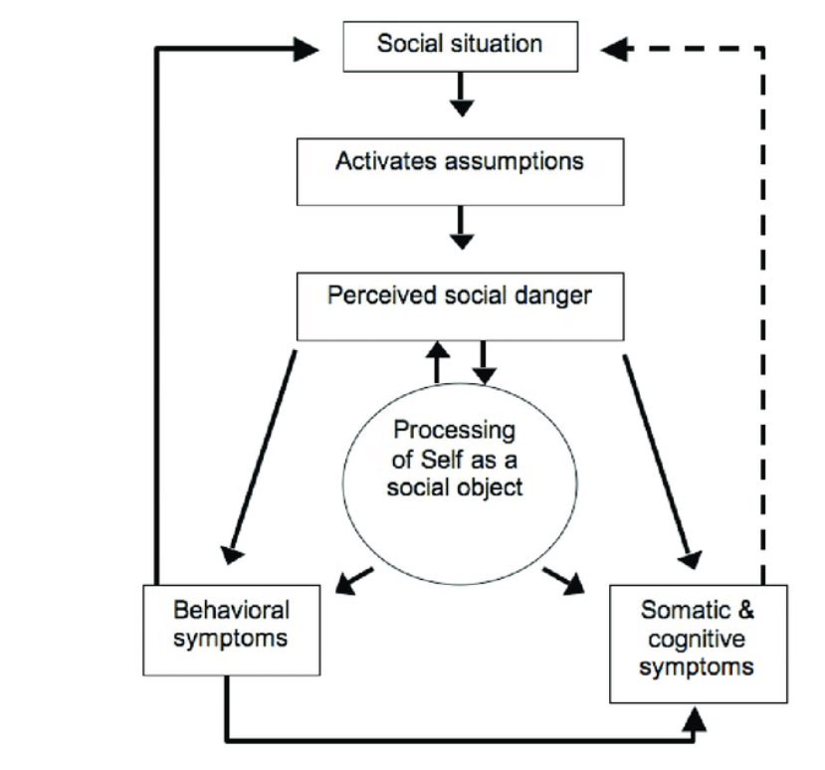

Figure 2. Demonstrates a newer version of the model of social phobia by Rapee and Heimberg (1997).

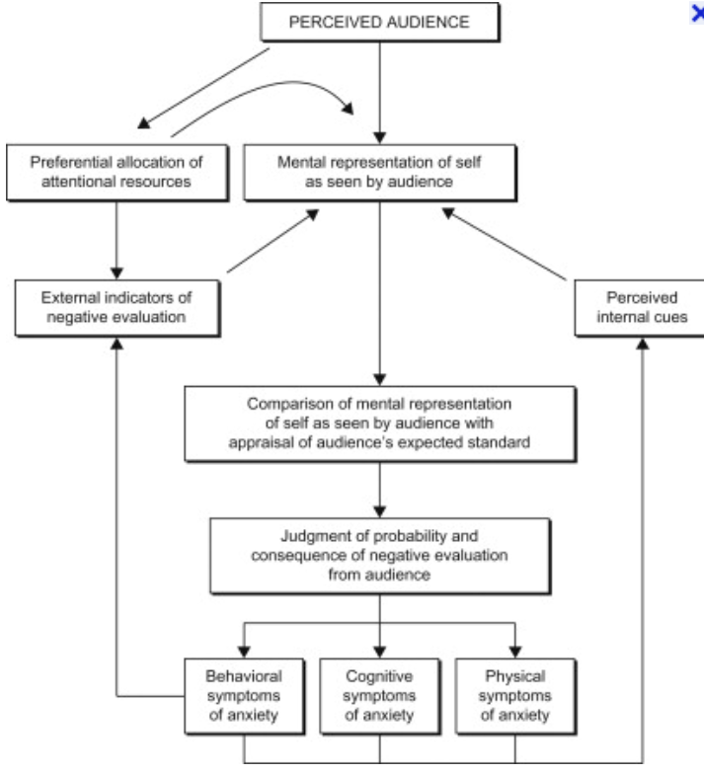
Figure 2 Rapee & Heimberg's (1997) Cognitive Behavioural model of Social Phobia

Rapee and Heimberg (1997) proposes that social anxiety links to individual’s having a distorted view of themselves and are highly concerned with how others perceive them in a social situation, fearing negative evaluation of others. Supporting the theories of Clark and Wells (1995) and Rapee and Heimberg (1997), is Schlenker and Leary (1982, P642) who document that “social anxiety occurs when an individual wants to present a favourable public image, but doubts his or her ability to do so”. These perceptions correspond with how students wish to make a good impression on peers. Students are often encouraged to participate in small group discussions and present back whilst receiving and giving feedback to each other in order to achieve good grades, this according to Schlenker and Leary (1982) creates a high-stake situation which can be all too overwhelming for those students with social anxiety.
Exploring how social anxiety impacts learners has been previously researched by many including, Ameringen et al, (2003), Stein & Kean (2000), Brook and Willoughby (2015), Wetterberg (2004) and Wittchen et al, (1999) who have demonstrated the impact of social anxiety on; lower grades, exam failures, students leaving courses prematurely and a lower likelihood of learners graduating their courses. This is supported by Crozier (2001) who observed that when students who have social anxiety become more anxious, they can engage in avoidance behaviour, which may impact on exam days, presentation days or leaving higher education prematurely. Clark & Wells (1995) conclude that students miss out on learning opportunities by avoiding interactions physically or psychologically. Research within HE demonstrates positivity in communication and interaction with lecturers and peers, which is deeply embedded into active learning pedagogies; peer groups and discussions (Tinto 2000; Dubow et al, (1991). Cohen et al, (2019) observed that there is a lack of literature about socially anxious students and active learning pedagogies, they therefore conducted a research study into associations between social anxiety and student discomfort in the active learning environment. Although research has shown that there is often a positive improvement in performances when students are undertaking active learning instruction such as, working in pairs or small groups in order to problem solve and engage in discussions; they uncovered that socially anxious students found these techniques a great discomfort and would avoid being involved as much as possible (Cohen et al, 2019).
Russell and Topham (2012) are key researchers within the UK investigating social anxiety amongst HE students, they acknowledge that anxiety is accepted as a normal part of the learning process, whereas, their study goes on to recognise the impact of social anxiety on learning for example; seminars, group work and presentations which can inhibit students’ participation and can lead on to negative influences upon their learning experiences and grades. Russell and Topham (2012) conclude in their findings that there is a need for enhanced pedagogic support for those students suffering with social anxiety; their research makes recommendations for teaching staff to reduce any cold calling to those students in class, try graded exposure public speaking by assisting those students to speak for small amount of time, using props to gradually increase the time exposure, and finally placing socially anxious students in small working groups with other peers. Similarly, a recent study on social anxiety in HE by Archbell and Coplan (2021) recommends in order to reduce anxiety, lecturers may consider utilising non-threatening environments such as; using computer-mediated quizzes on line to record students’ answers, online blogs, icebreakers, giving students more time to mentally prepare what they are going to say and incorporate greater engagement between lecturer and students.

2.3.3 Theme Three - Group work and anxiety
Group work is a large part of the active learning process within classrooms, much research promotes the positives of group work affirming the premises of developing skills for employability (Lejk and Wyvil, 1997; McCorkle et al 1999; Livingstone and Lynch, 2000). Benefits of group work allow students to problem solve, permits students to hear and provide diverse opinions (Cooper et al, 2017). A study by Cooper et al (2018) uncovered that 69.2% of students reported group work affected their anxiety levels; reasons revealed links to the above presented literature regarding SAD, whereby, students felt judged, feared negative evaluation by peers or the teacher, feelings of embarrassment if they could not contribute and worried about saying the wrong thing. Yerkes-Dodson law (1908) proposes that a low fear of negative evaluation can in fact motivate students to want to learn more, whereas, a high fear of negative evaluation can shut learners down and increases negative overthinking causing a negative impact upon their self -efficacy.
Previous research on minimizing students’ anxiety levels with group work by both Cooper and Brownell (2016) and Eddy et al, (2015a) suggest allowing students to choose groups or partners to work with and lecturers illustrating the benefits behind group work. This is confirmed by Strauss et al’s, (2011) research who observed 66% of students preferred to pick their peer group with whom they are comfortable with which lowered their anxiety levels.

2.4 Online Learning in Higher Education
Online learning is not as new as we perceive it to be. There has been an Open University (OU) provider in England since the 1969, granted when this organisation was first set up, the digital age was not upon us, but their mission was to be accessible to all people and places delivering higher learning to meet society and people’s needs (Open, 2022). Singh and Thurman (2019) and Azizi et al, (2012) confirm that HE organisations over the last two decades have been offering blended learning and online learning as part of their educational programmes. This style of learning with the explosion of the digital age and increasing access to broadband has pioneered the way forward for online learning. Traditional HE organisations were basic in comparison to OU in their use of technology in order to deliver lectures online until overnight they were forced to adapt very quickly with the arrival of Covid-19 (Allen and Seamen, 2017; Alqurashi, 2016).

2.4.1 Positives to Online Learning
Arribathi et al, (2021) outline the benefits for students with online learning and suggest the following; students can remain in the comfort of their own home, there is a reduction in transport costs and related issues for example buses, trains and parking, child care may not be as problematic, there can be a reduced personal preparation time to attend an online lecture, students can get more house hold tasks completed as online lectures are often less time based. Bao (2020) also saw students expenses cut due to not paying for meals and reported a more manageable work, childcare and study balance.
Learners with depression and social anxiety found online lecturers easy to attend because of less interaction with lecturer or peers, did not have to have the camera on, could catch up on pre-recorded lessons and notes offering a flexible way of learning (Warnes, 2022). Research by Xu and Smith Jaggers (2013) recognised learners faced challenges with adapting to online learning, however, promote online learning as the way forward for HE organisations to provide an expansion of courses to those learners who balance work and study life as the way forward. This author recognises the valuable insights to the benefits outlined above regarding online learning, however, questions this statement wondering if this could be related to the age and culture of the students, whereas younger students are more able to adapt to this style of learning than mature students and a culturally diverse student population.
Prior research into defining the differences between online and face to face learning has had significant theoretical contributions by authors including Keegan (1988), Garrison (1989), Peters (1983) and Moore (1993), whereas, the majority of current studies relating anxiety to online learning appear to focus mainly on the impact of Student’s anxiety during Covid-19. Below the literature review within the online learning theme will be split into two sub-headings and feature, ‘Computer Anxiety and ICT Skills’, and ‘Anxiety Linked to Information Overload’.

2.4.2 Theme four - Computer Anxiety and ICT Skills
Bolliger and Halupa (2012) conclude that computer anxiety has been associated as hugely negativity within online learning. Leso and Peck (1992, p469) define computer anxiety, “as a feeling of being fearful or apprehensive when using or considering the use of a computer”. Hauser et al, (2022) identify a major contributing anxiety factor to E-learning is computer self-efficacy (CSE). Self-efficacy arose out of Social Cognitive Theory by Bandura (1977) and has transferred across into computing linking how people perceive their ability to apply their computer skills to a wide range of tasks (Compeau and Higgins, 1995a, 1995b). Saade and Kira (2007) confirm that 32% of learners taking online classes reported anxiety linked to computer applications; Beckers and Schnidt (2001) and Heinssen, Glass and Knight (1987) highlight the main reasons include student’s negative belief about their ability to use computers, feelings of insecurity, nervousness, intimidation, frustration, confusion, and overall fear of using technology correctly. Much is written about learners with computer anxiety and poor Information Technology (IT) skills, which can be a large stumbling block to online learning for learners (Beckers and Schnidt, 2001; Bolliger and Halupa, 2012). Likewise, Saade and Kira (2009) point out that learners with a high level of computer anxiety are at a disadvantage of learning.
Older prior research has recognised that computer anxiety and poor IT skills may be linked to an increase in learners’ anxiety (Rosen and Weil,1995; Saade and Kira, 2009; Kay, 2008). The author questions how relevant this statement is, as this research indicates it took place over a decade and a half ago, whereas now adays current students are more versed in IT skills as they are taught in school. The author recognises that mature and multicultural students who have had no or limited training in IT would still experience computer anxiety within their courses.

2.4.3 Theme five - Anxiety linked to Information Overload
Al-kumaim et al, (2021) illustrated that during Covid-19 with online learning, 62% students reported too much pressure and feelings of anxiety from having too many online tasks. Reasons for anxiety amongst online learning is highlighted within a study undertaken by Chen et al, (2011) who observed that students found it challenging switching across different conference rooms, deciphering link discussion messages, whilst engaging with online learning activities causing student disorientation. Student disorientation associated with online learning is linked to IO by many researchers including DeStefano and LeFevre (2007), Roselli (1991) and Conklin (1987) who determine this will lead feelings of anxiety in students. Glean (2020) outlines cognitive overload can happen when students are required to simultaneously engaged in listening to the lecturer, whilst watching slides, participating in question and answers or online polls, or monitoring the chat windows for discussion. Cognitive load is the amount of effort being used within the working memory, the working memory is used to manipulate information and processed into the long-term memory, Triandafilide (2020) cautions that if the cognitive load is too much for the working memory, data is lost and is not processed into the long-term memory.
Valcke (2002) correlates IO with cognitive load theory (CLT). Memory and schema are the two key concepts in cognitive load theory connected to how learners process information in order to learn. Valcke (2002) proposes that when the cognitive load which refers to the short-term memory receives high level of stresses, people will find it difficult to focus their attention.

Figure 3. Demonstrates IO can arise within any of the cognitive processes as well as the metacognitive processes impacting negatively on students learning. IO occurs in the attention process and too much load in this environment results in information being lost due to limited capacity within the sensory and working memory.
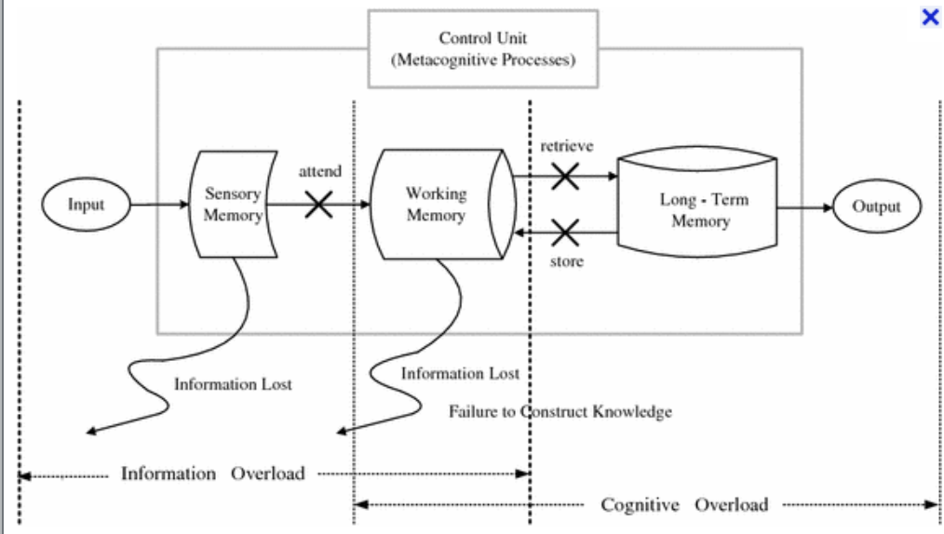
Figure 3. Information overload vs cognitive overload Valcke (2002)

It can be seen from the discussions of the literature above, there has been a number of research studies into students’ anxiety levels within HE. Anxiety is a prominent topic within education and research shows that the impact of anxiety amongst students has been investigated as far back as a century ago and continues to be evaluated and researched to this day. The themes discussed above are the common anxiety themes within current HE. The author chose not to research test or exam anxiety within this study because she recognises, they cause the majority of students high levels of anxiety, instead sought to focus and inquire more on the triggers of students’ anxiety levels within two learning environments within online learning and the classroom.
There was an escalation of available research on the impact of student’s mental health with the arrival of Covid-19 in March 2020 when HE organisations in the Uk were closed and learning moved to online platforms. Even though there was a vast number of studies into students’ anxiety and mental health issues within online learning, the author observed that much of the academic literature in this area linked to the Middle East and USA and there was very limited research undertaken within the UK. This study seeks to fill some of the gaps within the UK literature. Next this thesis leads onto the methodology undertaken for this study in chapter three.

Chapter Three

Methodology

Chapter three will provide an overview of the mixed method research approach exploring the impact of the interpretivism and phenomenological approaches to the qualitative study and the positivist paradigm within the quantitative side of the study. Firstly, this chapter will re-address the study’s’ aims and objectives. This chapter will go on to include; the sample cohort, ethical issues, pilot study, hypothesis, and the instrument used to collect both qualitative and quantitative data exploring reliability and validity of the online questionnaire.

3.1 Research Aims
- To compare which learning environment; online digital learning or face-to-face traditional classroom environment causes the highest impact on students’ anxiety levels in their current learning organisations.
- To highlight the main common factors in both learning environments which have a higher impact on the participants’ anxiety level.
- To evaluate if there is a particular age category that are more pre-dispositioned to higher levels of anxiety.
- To evaluate if a particular study level is pre-dispositioned to experience higher levels of anxiety.
- To conclude a current preference of a learning environment in today’s learners.
- To synthesize if blended learning is the way forward for higher education.

3.2 Mixed Method Research Methods
This research study applies a mixed method research (MMR) approach employing the Epistemology methodology. Creswell and Plano Clark (2011) advocate the mixed method approach suggesting that MMR can generate understandings into the multiple views of phenomenon thereby, increasing the credibility of the results found. Supporting MMR is Denscombe (2014, p160) who proposes that MMR can increase accuracy of data and reliability using triangulation, therefore reducing the bias, providing a more practical and problem-solving approach, whilst collecting a broader and deeper piece of phenomenon than you would get from a single approach. Cohen et al, (2018) affirm that Epistemology methodology seeks to research behaviour, using data that is socially situated and context-related. Every participant’s learning experience is subjective and their experience is individualistic. “Anxiety is a human feeling of worry, unease and fear that can be mild or severe” NHS (2022) and is subjective to each participant. This research endeavours to explore how much learners’ anxiety will change depending on context which links to aim 1. Guba and Lincoln (1994) summarise that the investigator and participants in epistemology research are independent of each other and the investigator should be able to study the phenomena without influencing the study. Denzin and Lincoln, (1994) support this theory and propose the goal is to measure and analyse causal relationships between variables without researchers influence.
3.2.1 Phenomenology Paradigm
A paradigm is a framework design in research which provides the research with a focus point, ensuing there is a consistency between the aim of the research question and the conclusion (Ling and Ling, 2017). The qualitative data of the research is underpinned by interpretivism and phenomenological paradigms. Phenomenology was founded by Edmund Husserl a German philosopher after the second world war, yet it wasn’t until the 1970’s that phenomenology was used as a research method (Stones, 1988). Welman and Kruger (1999, p189) state, “the phenomenologists are concerned with understanding social and psychological phenomena from the perspectives of people involved”. This research data will be grounded in the phenomenological methodology framework and will endeavour to seek the causes behind participants’ anxiety levels against their experiences within two contexts; online digital learning and the traditional face-to-face learning. Affirming that the phenomenological methodology is the best suited framework for this research is Taylor and Bogdan (1984) who asserts that what individuals say and do is a product of how they define their world; phenomenology collects experiential data as a form of knowledge focusing on peoples’ experiences and interactions they have with others and understanding how they perceive others perceive them. This links with questions relating to social aspects of interaction with peers and lecturer within the two learning settings.

3.2.2 Interpretivist Paradigm
The interpretivist view focuses on how people differ from each other (Cohen and Manion, 2018). This will align with aim 1, 3 & 4, whereby, not only does the research aim to compare anxiety levels between two learning environments, but also to compare anxiety levels across age ranges and study levels for a more in-depth insight into anxiety within HE. Guba and Lincoln (1985) and Morgan (2007) go onto summarise the main characteristics within the interpretivist paradigm which include; individual’s belief systems and realities are many, they are socially constructed and that cause and affects are interdependent. The emphasis on this paradigm is understanding the view point of participants not the researchers (Bogdan and Biklen, 1998).
Criticisms surrounding the validity of interpretivism are noted by Erlandson et al, (1993); Hammersley and Foster (2000); Hammersley and Traianou, (2012) who infer, that generalised findings are almost impossible due to its nature in subjectivity and can be open to greater bias from the researcher’s interpretation. Dudovskiy (2018) counter argues supporting its high validity due to participants’ honest, trustworthy attitudes, beliefs and will show similar findings when observed under similar circumstances for example if the same study was carried out time and time again across other portfolios and organisations similar key themes would emerge.

3.2.3 Objectivist, Epistemology and Positivist
The objectivist epistemology section of this research utilises the positivist paradigm for collection of the quantitative data of objects (Kivunja and Kuyini, 2017). The object being observed in this research is the emotion ‘anxiety’, Putman (2012) confirms that objects are not always what you can see in order to collect knowledge, they are also known through the experience of sense. Participants in this study are asked to rate their feelings of anxiety as low, medium or high in a series of Likert rating style questions within two contexts of learning. An excel spread sheet, graphs and pie charts will calculate the number of participants experiencing low, medium or high feelings of anxiety to a series of questions and the closed questions will all form the numerical data for this study. Fadhel (2002) champion the positivist paradigm as a preferred method to interpret observations in terms of facts and measurable entities indicating that quantitative data will interpret trends and patterns. Gray (2021) and Collis and Hussey (2009) inform that Positivist’s conclude there is only one reality, the social work exists outside of the researcher and data is only measured through applied observation. The data from participants within the questionnaire will endeavour to seek out; if there is one learning environment that creates higher anxiety in learners more than the other, if there is one or more academic study level which exhibits higher levels of anxiety out of the four academic levels, if a particular age group is predisposition to experience higher levels of anxiety and what style of learning do the learners prefer.

3.3 Methods of collecting quantitative and qualitative data using an online questionnaire
The researcher considered many ways to choose her mixed method research approach to collecting data and found the best advantage would be to use an online questionnaire survey which could collect both quantitative and qualitative results in a short period of time. The author took into consideration the continual threat of Covid-19 still around and elected an online questionnaire which is she thought would be the safest methods to collect data off numerous students.
Advantages of using online questionnaires are advocated by Nayak and Narayan (2019), Wellman (1999) and Wright (2017) who propose they are the best method in collecting quantitative and qualitative data, the storing of data, the visualisation of data, low cost and its ability in reaching numerous participants in a short period of time. Additionally, Zhou et al, (2021) and Aerney-Perreten et al, (2015) promote online surveys’ effectiveness and efficiency in producing immediate data results and participants accessibility. A main advantage observed by the author and Singh and Sagar (2021). was the instantaneous use of a hyperlink which was easily transferred across to fifty participants via their lectures using web-based platforms which included Moodle and participants’ email addresses which bore no money cost to the researcher or time.
Criticisms of the validity of using an internet-based questionnaire are raised by Couper (2000), Fouladi et al, (2002) and Bauman et al, (2000), who infer internet readers have a tendency to read quicker online, scrolling through information faster using their fingers or mouse to get to the end and not processing the questions accurately and suggest they often appear more inpatient compared to offline readers, who are more inclined to take more time to read a paper questionnaire, use a pen to write the answers, giving more time and thought to the questions. Despite criticism of online questionnaires both Fouladi et al, (2002) and Gosling et al, (2004) promote the validity of using online questionnaires in research supporting the valid reasons stated above by Nayak and Narayan (2019), Singh and Sagar (2021) and Aerney-Perreten et al, (2015). The author concurs that the benefits of collecting data for this study using an online questionnaire and having access to numerous of participants in a short period of time outweighed the negatives for this piece of research.

3.4 Methods rejected
The researcher had considered other methods, firstly she ruled out observations as she is not actively teaching at present and does not have access to classes to observe. Secondly interviews were dismissed due to the same reasons also, as Bryman and Bell (2015) discovered, the author would need a sufficient number of participants, time to prepare and interview participants, along with the volume of deciphering qualitative data which would be time consuming and this the author only had a short window of opportunity to capturing data for this study so this method would not benefit her. A Focus group was highly considered to possibly go alongside the online questionnaire. A Focus group is a form of group interviewing to discuss personal experiences drawing on participants’ attitudes, beliefs and feelings (Morgan and Kreuger, 1993). The researcher recognised that anxiety triggers in participants learning could be investigated in more depth along with understanding what participants needed in how lectures could support the factors raised. Sim and Waterfield (2019) recognise that focus groups take time to facilitate, and take weeks of preplanning questions, organising people to be in the same place at the same time and trying to keep the subject on track and not tangent. Collins and Hussey (2009) question the validity of focus groups indicating that the facilitator could influence their own bias with the data and not all responses are collected as researchers can experience highly vocal members of a group whilst others are passive. Unfortunately, due to limited time and no access to participants directly, an online questionnaire deemed more appropriate at this time.

3.5 Online questionnaire: - Likert scale vs closed and open-ended questions
The online questionnaire for this research comprises of seven multiple-choice closed-ended questions, twenty-one Likert rating scales and two open-ended questions, employing the web platform ‘Microsoft Forms’ which was sent out to fifty participants. Lewis et al, (2005) promote the use of rating questions demonstrating their popularity use in questionnaires in social academic research to collect opinionated data; the Likert empirical measuring scale was created by Renis Likert in 1932 for the measurement of attitudes, and is the most widely used tool today in psychology, and marketing surveys (Treiblmaier and Filzmoser, 2011; Lavrakas, 2008; Huang, 2005). Bertram (2007) propose Likert scales are simple to construct, easy to read for participants and generate a highly reliable scale. Weaknesses include participants avoiding extreme response questions, or agreeing with statements to please the researcher and can consist of limited fixed responses (Carifio and Perla, 2008; Bertram, 2007). All Likert scales have a neutral option; however, the researcher has chosen not to incorporate this in her questionnaire so that participants will have to make a choice in their options. In research a questionnaire containing a Likert scale without a neutral option is often criticized outlining that it forces the participants to make a decision which may reduce reliability and validity as it may not be a true opinion (Babakus and Mangold, 1992). In contrast Nowlis et al, (2002) highlight that neutrality is the path of least resistance, ambivalence and that some participants for an easy option will choose this option, however, does not always accurately portray their true feelings or attitudes towards a topic. Krosnick et al, (2002) and Garland (1991) advocate that when you remove the neutral option it forces participants to cognitively assert their point of an argument and make a decision and this is what the author intended to do in this study.
Likert type scales questions are used within the online questionnaire to rate participants’ low, medium or high levels of anxiety for example: -
Online learning
- IT skills
- WIFI issues
- Social anxiety of asking questions in front of peers
- Seeing yourself online
- Weakness of online teaching
- Feeling isolated learning from home
- Information overload
- Not being able to find the information on the different e-learning platforms
- Lack of interaction with lecturers.
Within the classroom
- Asking questions in the classrooms in front of peers
- Group work
- Being asked to present in front of peers
- Arriving late to the lecture
- Worried about getting covid
- Speaking to lecturers directly
There are a series of multiple choice and closed questions linking participants’ preference to the style of learning, social anxiety inquiry, age and level of study. Advantages of using this style of questions limit the set of responses, which are easier to collect quantitative data, therefore, easier to statically analyse and place in graphs. Other advantages are outlined by Schuman and Presser (1979) who propose that both style of questions is easier and quicker for participants to answer, less articulate participants will not be disadvantaged in answering the questions and the response choices highlight the meaning of the inquiry.
Reja et al, (2003) illustrate a main disadvantage of using closed questions suggesting that participants may feel frustrated if there is not their desired answer, they are then forced to choose an answer that does not represent their true attitude and opinion, therefore not a true representation of the complexity of human behaviour which alters the reliability and validity of the data. Alternatively, Denscombe (2008) promotes the use of closed questions concurring they make it easier to replica the study again, with a different or larger cohort of participants elsewhere and can be used over and over for extended future research.
There is an optional open-ended question at the end of the questionnaire used for this research, whereby, participants can leave feedback on what causes the most anxiety for them, a thematic analysis will code the frequency of words to uncover key themes that participant’s express about their anxiety within the two learning contexts. Open ended questions collect qualitative richer data for more in-depth knowledge into human behaviour and attitudes; Foddy (1993, p127) reports “participants are able to express their opinions and attitudes without being influenced by the researcher, therefore, limited risk to a bias in the research”. One of the main disadvantages of using open-ended questions in research highlighted by Schuman and Presser (1979), (1996), Sudman and Bradburn (1974), and Payne (1980) is the difficulty for the researcher to analyse and code a large quantity of data effectively as there is too much data and inferential statistics which can be difficult to draw a conclusion to the research. Reja et al, (2003) research highlight the drawbacks in using open-ended questions which include; participants requiring longer time and using more cognitive effort to answer open-ended questions, that both paper and web-based questionnaires participants may leave or miss an open-ended question resulting in missing data and have more invalid answers than using closed questions. This statement aligns with the data in this study as only 20 participants out of 35 answered the last open-ended question.

3.6 Ethical issues
This research adheres to the term ‘non-maleficence’ as laid out by British Educational Research Association (BERA, 2018:84) which means to do no intentional harm. An informed consent cover letter of the questionnaire outlines the; intention of the study, states the study is purely voluntary, participants’ have the right to withdraw from the study at any time, the level of anonymity where the researcher or online survey organisation collects no personal identifiable data or IP addresses, answers appear as respondent one, two etc adhering to privacy, confidentiality and anonymity. Included is a definition of the term ‘Anxiety’ so participants have a bench mark on how to respond to the questions. The researcher’s email is included on the cover letter so if participants have queries about the study the researcher can answer any questions. Participants consent to the study by clicking onto the form instead of a written signature and participants can withdraw at any point of the study.
Hammersley and Traianou (2012) promote that no research study should do harm to others and that the risk should be no more than that of an everyday risk. There is no direct physical, legal or financial risk or intentional psychological harm to participants, however, the researcher recognises that perhaps participants may realise that their anxiety levels may be is high and want to know what support they can receive to help them. To mitigate this, a debriefing section is included where students can find emotional support numbers and websites within their organisations along with online self-help websites.

3.7 Conduct of the Research
The researcher originally set out to use two separate higher education organisations, but was unable to obtain the correct ethical research paperwork off a colleague in time for the ethics board meeting and therefore failed that attempt. In light of my colleague unable to know which paper work was needed in a short period of time, the researcher decided to just concentrate on one organisation as there were enough participants to evaluate across all academic levels of study. Another major issued encountered was the lack of time from the ethics board approval to participant’s leaving the higher education organisation for the summer which impacted the numbers of responses that the author was able to obtain.

3.8 Pilot Study
A pilot questionnaire was sent out to six colleagues in teaching to evaluate and feedback. Blessing and Chakrabarti (2009) and Blatch-Jones et al, (2018) advocate the use of a pilot questionnaire in order to improve accuracy of questionnaires and identify any potential problems the researcher may encounter. The overall consensus off colleagues reported the questionnaire is easy to follow and straightforward and didn’t take too long to complete. Feedback included; making certain questions tick boxes for easier collection of data, include a contact email for participants to contact the researcher if they had any questions. Other support included giving me the direct links and contact details of the organisation’s mental health and counselling support team that I did not have access too.
The researcher encountered a few problems with the hyperlink where it worked for some participants’ devices but not all. Lozar -Manfreda, (2001) illustrates the biggest issue with access to online surveys are often due to WIFI issues, download compatibility to devices and the hyper link not pasted or embedded accurately. Fortunately, feedback off the pilot participants and resending the link a few times sorted this issue, however, the researcher is aware this may account for missing participation in the main research.
3.9 Sample
This research uses convenience sampling. The definition of ‘convenience sampling’ is a collection of participants who are convenient and accessible to the researcher (Etikan et al, 2016; Galloway, 2005). The sample participants chosen for this research are not directly linked to the author, they are through prior colleagues’ access to students. For this reason, the researchers’ cohort of 35 participants are linked to; Health and Social Care students undertaking Level four, five and six academic programmes, a level 5 Business and an International Hotel and Management MBA level of study within a single HE organisation. The participants’ age ranges from 18-55 years old. A variety of ages and level of study corresponds with aims 3&4. All participants’ courses incorporate a blended learning approach using e-learning modules, online lectures and face-face taught classroom lectures. The lecturers discussed with the participants about the questionnaire and asked who would like to participate. The hyperlink of the questionnaire was sent out across participants email addresses via Moodle.
Andrews et al, (2003); Dillman (2002) criticise conducting research on line with a sample group, stating the researcher knows very little about the characteristics of the sampling group. Even though there are concerns about the validity of research surrounding convenience sampling having participants that are obtainable to the researcher via friends can often resulting in data that may not always be accurate (Baxter et al, 2015). Edgar and Manz (2017) demonstrates an optimistic view, affirming that they are helpful in obtaining a range of attitudes and opinions where hypothesis of the research can be tested. Bryman and Bell (2015); Denscombe (2008) note that convenience sample often includes a cross sectional of population incorporating ages, demographic and culture, therefore acknowledging a representation of the target demographic.

3.10 Hypothesis
The researcher hypotheses lies that she expects students would have a higher rate of anxiety with online learning especially when students were first faced to continue their studies online. Nevertheless, it has been almost two years since Covid-19 limited students’ access to learning within the classroom and although most courses are now using a blended learning approach of both online e-learning modules and taught face-face lessons, the researcher aims to observe if there are differences in participants’ anxiety level between two contexts and to determine of learning style participants prefer (Aim 1,2, 5 & 6).

3.11 Research Analysis Methods

The data for this study is both quantitative and qualitative, however, mostly qualitative and will utilise ‘Microsoft forms’ the online tool to collect and analysis the comprehensive data off the online questionnaire.
An excel spread sheet will illustrate every piece of data collected which will be used to correlate, identify and extrapolate clear trends and patterns in order to check against each question.
Each question will have an individual interpretation of data; percentage rating, number rating or a group of common theme words. Bar charts will clearly illustrate the overall number or percentage of participants to the question being asked. Rating scales within the main questions of online or classroom learning will demonstrate three levels of anxiety high, medium or low.
Anxiety linking to respondents age and level of study graphs within online and classroom learning have been assigned values; yes/always (3) sometimes (2) Never (1) which allows an overall average.

Chapter Four

Analysis of Results

The study sought out to investigate, ‘To what extend are the differences between students’ anxiety in both Digital Online Learning and Face-to-Face Classroom Learning?’ This chapter will illustrate a breakdown of the qualitative and quantitative data provided from the online questionnaire with a series of graphs and findings. The majority of the questions are rating scales whereby, participants rated their anxiety levels to a series of question by selecting low, medium or high. The questionnaire received thirty-five respondents out of the fifty questionnaires that were sent out.
This section will be firstly laid out listing the participants’ level of study and programmes, followed by an overall graph demonstrating levels of anxiety amongst the levels of study (Aim 4). Secondly, a graph will display the age groups of anxiety levels to compare OL against FtoF connecting with (Aim 3). Thirdly, a graph will illustrate the overall ratings of low, medium and high levels of anxiety to a series of nine questions pertaining to OL (Aim 2). Fourthly, a graph will exhibit a rating scale of low, medium, high, levels of anxiety to a series of eight questions relating to learning within a classroom environment (Aim 2). The next set of graphs will display participants’ anxiety levels towards; social anxiety within OL or FtoF, participants’ preference of learning styles and blended learning (Aim 5,6).

4.1 Programme respondents
- Level four include14 participants on two courses: -
- Nursing studies and Health
- Health and Social care.
- Level five include 12 participants over three courses: -
- BSC Health and Social Care of Children and Young People
- HND Health and Social Care
- HND Business and Accountancy
- Level 6 comprised of four participants on a BSC Health and Social Care
- MBA level in International Hotel and Management included five participant responses.
4.2 Academic levels of study

Table 1. Number of Participants per study level

There are a higher proportion of undergraduate respondents in level four totalling fourteen participants. Level five is close with twelve participants. Both undergraduate levels clearly outweigh level 6 and MBA who together make a total together of nine compared with twenty-six of lower levels. Higher levels of study within higher education often have smaller classes compared to a foundation level (Cooke et al, 2006). The disproportion is accounted for and assigned values in table 2, below to give an overall average.

Table 2. Range of Anxiety levels for level of study

An objective within the study was to observe if there was a particular level of study that was impacted more by higher levels of anxiety (Aim3). This objective was met within this study as illustrated by Table 2, exhibiting that both Level 4 and the MBA level demonstrated a higher proportion of students experienced higher levels of anxiety with online learning compared to the classroom environment. In contrast, Level 5 and Level 6 showed fewer high levels of anxiety overall, nevertheless, the graph demonstrates that higher levels of classroom anxiety impacted these levels more.
Studies by Bayram and Bilgel (2008) and Cooke et al, (2006) support that undergraduate student are prone to general higher levels of anxiety compared with higher levels of study, whereas, this 2022 study has shown that the MBA participants experienced a high level of anxiety, especially with online learning. The author recognises that the majority of MBA students would have been used to a traditional classroom learning environments up until the last few years where Covid-19 drove all student to do their learning online, where there was an unpreparedness amongst students and wonders if this may account for some of the higher levels amongst the MBA students.

4.2.1 What course are you studying?

Table 3. Theme Analysis of participants’ courses
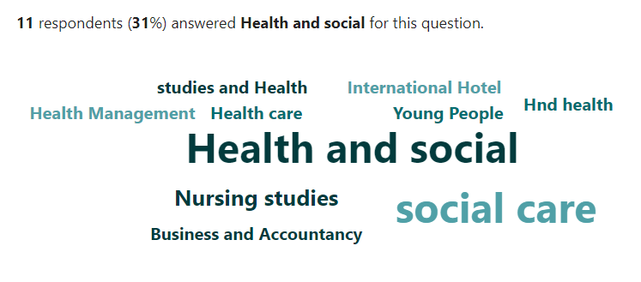
This study used convenience sampling on six programmes covering every academic level of study within two portfolios. Using a theme analysis report, table 3, demonstrates that Health and Social students were the higher group of participants in the study.

4.3 Age Groups of Respondents

Table 4. Age group of Respondents

The age makeup of the sample shows the age ranges between 18 and 55 years old. The 18-20 group accounted for the fewer participants with 11%, whereas, the 41 plus group had the highest respondents with 40% which almost accounts for half of the participants. Health and Social Care along with MBA are traditionally known to have mature students enrolled on their programmes.

4.3.1 Average Anxiety for a Range of Ages, comparing Classroom and Online Learning
Table 5. An illustrative plot of the Average Anxiety for a Range of Ages, comparing Classroom and Online learning.

Table 5, illustrates that the age group 18–20-year-olds experienced higher level of anxiety on line compare to the 41plus group. The author would have hypothesized that the 41 plus group would have a higher level of anxiety online due to IT skills, however, it appears that other factors which will be discussed further in table (7) illustrate the reasons for the higher levels of anxiety with online learning. The data has shown that the 21-30 group felt the greatest anxiety within the classroom learning environment table (8) will illustrate explanations for this.

4.4 - Anxiety and Online learning
Do you feel anxious when learning online?
Table 6. Responses of anxiety learning online

Yes = 34%
No= 37%
Sometimes= 29%

4.4.2 Question five- Rate your current anxiety levels of accessing learning online (1) Low and (5) High

Table 7. Rated anxiety levels of online learning

4.4.3 Information overload
The prominent emerging theme from this study captured ‘information overload’ (IO) as the main form of participants’ highest anxiety levels within online learners, comprising of 51.4% responses. IO being the highest level of anxiety amongst online learners within HE is supported within a similar study by Al-kumain (2021) who’s research during covid-19, observed that more than two-thirds of HE students (69.5%) experienced IO whilst learning online; impacting negatively on students’ stress and increased anxiety levels. Too many online tasks, weak internet connection, inadequate resources and loss of focus due to too much stimuli online were stated as the reasons for information overload by students (Al-Kumain, 2021).
The term ‘information overload’ was coined by Bertram Gross in 1964, and occurs when the amount of input into a system exceeds its capacity for processing. Over a decade ago Chen et al, (2011) identified that using computer-mediated communication (CMC) for online conferences along with utilising online data material made it easier to teach online, however, discovered one of the main issues with this pedagogy is information overload. Chen et al, (2011, p 104) research highlights four areas of IO such as; “limited learner readiness, quantity of information, quality of information and medium interface.” Reinforcing this evidence is Harasim (1987), who illustrates IO occurs when learners are face with learning the technical skills knowledge in order to participate online whilst managing large volumes of course information along with engaging in oral and written discussions.

4.4.5 Less Interaction with Lecturers and anxiety
This study revealed that almost half of participants’ felt higher levels of anxiety with ‘less interaction with lecturers. One of the main reasons highlighted by participants in the open-ended question was that they were not able to get their questions answered or received feedback immediately. 45.7% of participants expressed their anxiety levels were high and 22% experienced a medium level of anxiety with limited interaction with lecturers. Equally, Buelow et al, (2018) observed that regular participation with the lecturer, timely feedback and answering questions immediately contributed to good student engagement and students reported feeling less overwhelmed, anxious or lost. Longhurst et al. (2020) note that 21% of students considered the teacher-student relationship a threat to engagement if not maintained with the online instructor being socially present. Additionally, Dixson (2010) found in her research that communication between students and the lecturer contributed to increased engagement within active learning; and Hew (2016), Wang (2008) and Woo and Reeves (2007) promote social construct of learning engagement focusing on behaviour, cognitive and emotional engagement in order to facilitate learning. The author would have expected high levels of anxiety amongst students with limited access to the tutor from her own professional experience when classes moved online during Covid-19 and advocates the importance of good communication between students and lectures having continual engagement either holding small group, or one to one tutorial’s regular.

4.4.6 Anxiety and seeing yourself online
The third highest levels of anxiety reported by this study revealed 40% of participant reported experiencing high levels of anxiety when seeing themselves online. To date there is a lack of literature research written on this topic, however, there are many online blogs on this topic. Psychologist Schmidt (2020) illustrates that having anxious feelings about seeing yourself online, lies within the Social Anxiety Disorder model (see information on SAD fully within the literature section) whereby, individuals feel self-conscious of being observed by others and fear being negatively judged by how they look and how they sound. Schmidt (2020) affirms that individual’s also feel anxious when they are not able to read; body language, mannerisms, gestures and posture which is largely absent with online connections making it difficult to interpret situations and respond accordingly. Some students turn off their cameras and microphones because their anxiety is so bad during lessons which makes it difficult for the lecturer to know if the student is engaging within the lesson.

4.4.7 Feelings of isolation and online learning
This study demonstrates that 28.6% of participants experienced higher levels of anxiety and additionally, 28.6% experienced medium levels of anxiety making a total of 57.2% which is over half of the participants who have experienced feelings of isolation within online learning. Likewise, Park (2008) reports that 22% of students found they had feelings of isolation learning online and found their studies challenging because of it. Croft et al, (2015) acknowledge that students often experience feelings of isolation due to the physical and temporal separation between tutor and student and between students/peers within online learning. Studying alone requires self-discipline, heightened motivation and time management (Liu 2008; Alexander, 2001). Whiting et al, (2008); Lake (1999); Hartley et al, (2001) report that if learners are more motivated extrinsically (external), classroom led programmes favour this student more whereas, if students are extrinsically led and find themselves attending online learning platforms they can often feel because lost because online learning requires learners to be intrinsically (independently) motivated; and conclude that high dropout rates from students are linked to students feeling of isolation. In order to overcome isolation, Venter (2003) suggests; the tutor creating a sense of belonging within the group, encouraging student participation with online discussion, interacting with peers, creating blogs amongst the students to connect them, setting up peer learning groups and for the tutor to having regular contact with individuals or small groups via telephone, online or email.

4.4.8 IT skills and WIFI
It has been illustrated in prior research that high levels of anxiety with online learning have been associated with poor Information technology skills and low computer self-efficacy (Hauser et al, 2012; Saade & Kira, 2007; Rosen and Weil, 1995; Sun et al, 2008). However, in this research, Table 7, exhibits that only 17.1% participants claimed to have high levels of anxiety in this area, whereas, the majority of 54.3% participants experienced a medium level of anxiety, which reveals participants in 2022 have a higher positive level of computer self- efficacy compared to Hauser et al, (2012) study.

4.4.9 Poor concentration
Poor concentration and lack of focus was a hidden theme that emerged from this study that was not directly asked by a question but came out as a result of an open-ended feedback question. 50% of participants that answered the open-ended question reported they had poor concentration and lacked focus when attending lectures on line which caused them to feel anxious. Comments included; ‘My attention span is higher in the classroom as I am not distracted by my phone or grab a drink or things round the house that need doing’, I get distracted at home with the things I need to do and the comings and goings of my home life’, ‘I focus better in the classroom, where I can have regular breaks and chat with peers/friends which is a supporting. Better communication in the classroom then with online’. This is supported by Al-kumaim (2020) study, who reports 51% of students found it challenging to pay attention to their studies online. Similarly, a study by Pennino (2022) observed that students reported a common theme of finding too many distractions and unsuitable home learning environments as the main cause to; poor concentration, low motivation and higher levels of anxiety to learning online.

4.5 Anxiety within the classroom

Rate your anxiety levels whilst learning in a classroom environment to the following statements

Table 8. Anxiety levels in a face-face classroom environment

4.5.1 Being asked to present to present a topic in front of others
Table 8, demonstrates that there is not one emerging theme indicating high levels of anxiety reported by the participants within a classroom environment, however, ‘Being asked to present a topic in front of others’ came out as the highest with 40% participants experiencing high levels of anxiety and 48.6% reported they experienced medium levels of anxiety in this situation. Russell and Topham (2012) observed that in the UK a survey undertaken within two Universities reported that 80% of students reported high levels of anxiety with oral presentations. Fear of presenting in front of lecturers and peers corresponds with social anxiety, whereby learners are worried about being judged, and fear they are not confident talking in front of others (Russell and Topham, 2012). Supporting this is Cooper et al (2018), who acknowledge that fear of negative evaluation by peers in presentations or group work cause high levels of anxiety. Research by Grieve et al, (2021) illustrate students anxiety levels of oral speaking are also linked to fear of making a mistake, forgetting parts of what they need to say or getting it wrong. Both online and classroom speaking in front of lecturer or peers came out as high levels of anxiety

4.5.2 Student Anxiety and Group work within a classroom environment.
Group work came out as having 37.1% medium levels of anxiety. This co-insides with research undertaken by Cooper et al, (2018) who note that students reported feeling anxious when working with groups due to the fear of being evaluated negatively by peers, students worry about not being able to contribute or sounding stupid. Additionally, research has indicated that student’s anxiety increased when they are required to work with others in groups for assessed assignments Strauss et al, (2011). (Further research into this area can be found in theme three within the literature review section).

4.5.3 Worried about getting Covid-19 within a classroom
This question relates to current educational times whereby, students in HE organisations are slowly being introduced back into classroom for their studies. Recent research by Vilca (2022) exhibited that 52% of students on undergraduate programmes were anxious about catching Covid-19 being around other students. Other global studies undertaken students’ anxiety about catching Covid-19 include; a study in India where 33.3% reported anxiety linking to catching Covid-19 Khan et al, (2020), students and in Germany 27.7% (Karing, 2021). These results are in contrast with this study as only 14.3% participants rated high levels of anxiety being around other students catching Covid-19. There appears to be a significant drop since 2019 to 2022. This could tie into the fact that news media on Covid-19 has eased and the majority of students have either had Covid-19 and have had their Covid jabs.

4.6 Social Anxiety
Question 10. Investigated which environment do students find themselves experiencing the most social anxiety.
‘Social anxiety’ in this study is defined as a term to describe and overwhelming fear of social situations of meeting people, making eye contact with people or speaking to people.

Table 9. Social Anxiety

Table 9. illustrates that the participants in this study experience social anxiety. 26% of participants found they experienced social anxiety within Online learning, while only 11% of participants experienced social anxiety within a classroom environment. However, 20% of participants found they experienced social anxiety in both learning environments, whereas, 43% of participants found they did not experience any social anxiety.
This study differs to Pierce (2009), who found using computer-mediated communication a more comfortable medium of communication for socially anxious students. Likewise, Caplan (2007) notes that socially anxious students found online presentations easier to control their anxiety compared to a classroom setting. Whereas, Grieve et al, (2021) observe that socially anxious students have difficulty in both environments which corresponds with this study whereby, 20% of students found they were socially anxious in both settings.
Social anxiety amongst students is very common. Recent research by Al-Hazmi et al, (2020) revealed that more than 50% of students experienced social anxiety on their academic journey. Prior research undertaken by Schneier (2006) note that social anxiety is a struggle in social or performance situations for students, Bernstein et al, (2008) illustrate that social anxiety impacts on poor classroom engagement, student learning and retention. Furthermore, Russell and shaw (2009) demonstrate that social anxiety is a hidden disability impacting negatively on learning and students’ wellbeing and is often overlooked in education. Ways to help students with social anxiety will be discussed further in chapter 5.

4.7 Which stye of learning do you prefer?

Table 10. Preference of learning

Table 10 demonstrates that 46% of the participants equally preferred classroom only or a blended learning style, whereas, only 8% of participants preferred online learning online.

4.8 Blended Learning as a way forward in Higher Education
The last objective of this research is to observe if students are ready for Blended Learning (BL) as the future for HE learning. BL or often known as a hybrid course combines the elements of face-face classroom learning and distance instruction (Garrison and Kanuka, 2004). This research demonstrates that BL and classroom face-to-face equalized as the students’ preference of learning with 46% of participants preferring BL which illustrates that learners today are happy about moving into this style of learning. Bernard et al, (2014) and Edington and Holbrook (2010) advocate blended learning as the way forward and are excited about a set of new pedagogical possibilities.
There are many styles of BL, ‘Flipped classroom’ blended learning is the most common one utilised where students are introduced to a content at home prior to working on the content in class, enhancing prior knowledge content. The second popular one is ‘Flex’ Blended learning where the back bone of course content is based online and directs students to offline activities, lectures provided face-face support, individual support and group support on a need’s basis (Weitzel, 2021; Future learn, 2021).
Prior research indicates that by combing the strengths of the ICT element of online learning with video tutorials, open content and face-to-face lectures enhances student engagement (Holley and Oliver, 2010; Jefferies and Hyde, 2010; Overbaugh and Nickel, 2011). Similarly, Weitzel (2021) acknowledges student engagement is increased through the use of digital learning and engagement tools whereby, tutors can design more engaging and fun learning environments as opposed to reading off PowerPoint slides. Benefits observed by Khan et al, (2022) conclude that BL fosters a student-centred approach to teaching and learning, whilst aiding students to improve on their ICT skills. Additionally, Khan et al, (2022) proposes that blended learning has been a life support for HE during Covid-19 times. Since Covid-19 the author foresees BL as the future for HE programmes. Covid-19 has played a huge impact in moving HE forward into this way teaching and learning.
Barriers within organisations to implement this pedagogy often lies with lecturers not comfortable working this way or seeing the vision in this area (Collis and Vander Wende, 2002; Garrison, 2011; Fullan, 1999). In order for blended learning to be utilised successfully, Davies and Fill (2007) propose having good technical service support and learning technology specialist are on hand to support teaching staff. According to Garrison and Vaughan (2008) educating teaching staff with their ICT skills is crucial to a successfully implementing blended learning into practice. By HE organisations placing programmes partial online, whilst engaging with minimal face-face teaching saves the HE organisations money, which from an organisation is good business point of view, however, factoring University’s fees, are students happy about this? This is often a stumble block in moving forward with online education (Lim et al, 2019).

4.7 Validity and Reliability of Study
This study relied heavily on one instrument for data utilising an online questionnaire. Predominantly the data collected was qualitative based on participant’s’ phenomenological anxiety experience of learning online or within a classroom. Validity looks at the extent of what the online questionnaire being used matches what is being tested or measured. Bryman and Bell (2015) infer if the instrument used to test and measure is poor than the validity of the research is poor. Measures in designing appropriate and specific questions were carefully considered linking the aims and objectives to a series of Likert rating scale questions, closed questions and open-ended questions to collect statically strong and viable data, Nayak and Narayan (2019) advocate online questionnaires to easily collect, organise and store visible data.
Whereas, reliability is to what extent does the questions in the survey consistently elicit the same results under the same conditions (Brynman and Bell, 2015). The author considers if the online questionnaire was used in a larger study using other Higher Education Organisations than she would expect to see similar results. In order to mitigate any potential bias a clear description was given for anxiety, social anxiety and blended learning so that participants have an understanding of the overall purpose of the research. The researcher has no connection to the participants and they do now know who she is to eliminate other biases.

4.8 Summary of key findings link to final chapter
This study sought to evaluate the differences between digital online learning and classroom learning.
This study also set out to observe key themes within both learning environments that trigger high levels of anxiety amongst HE learners.

Chapter Five:
Conclusion and Recommendation

This chapter will firstly highlight the main findings of the research, and go onto summarise the results set out by the aims and objectives of the study. This chapter will illustrate the limitations of the study, moving into documenting how this research impacts on the researchers’ personal and professional practice. This chapter will list the recommendations for minimizing anxiety in students delivering oral presentations, supporting students with social anxiety and ways to improve online learnings whilst reducing information overload. This chapter will conclude with ideas for future studies within the area of anxiety amongst Higher Education students.

5.1 Conclusion
In light of the study’s data limitations, the study was able to collect enough sufficient quality evidence to meet the aims and objectives of this study. The study set out to investigate, ‘To what extent are there differences between students’ anxiety levels in both digital online learning and face-face classroom learning?’ It is to be noted that the nine Likert scale questions featured specifically for online learning and the eight Likert scale questions for classroom were not the same therefore, comparing the two environments and getting an exact rating was not doable. The questions related to each learning environment individually, which is where the study can extract and investigate the differences in participants’ anxiety levels.
Firstly, the main difference highlighted there were no high levels of anxiety in participants linked to Classroom Learning, whereas, OL demonstrated four areas of high levels of anxiety; IO, less interaction with teacher, seeing yourself online and feeling isolated. Although, there was no areas where participants experienced high levels of anxiety within the classroom, nevertheless they did report experiencing medium levels of anxiety to ‘presenting a topic’ and group work within a classroom.
The study observed that ‘social anxiety’ occurred in both learning environments with 20% of participants reported being affected by social anxiety. Individually 26% of participants reported experiencing social anxiety in OL which differed to only 11% of participants reported experiencing social anxiety within the classroom. The data summarised that the majority of participants reported low levels of anxiety being within a classroom environment and around other students.
‘Information overload’ emerged as the main anxiety trigger to participants in OL within this study. Information overload was hard to observe within the classroom as the question only pertained to online learning. This ties in with the majority of literature written about information overload linking technology used in online learning and communication.
Secondly, 45.7% of participants associated ‘limited or lack of presence of a tutor’ with online learning with high levels of anxiety. Participants reported that not being able to speak to a tutor when needing to get immediate feedback or a question answered increased their levels of anxiety.
The study identified a hidden theme to which triggers participants’ anxiety levels which is, ‘student’s poor concentration levels’ whilst attending online lecturers. There was no direct question on the questionnaire linking this area to learners’ anxiety.
‘Presenting a topic in front of peers and lecturer’ came out as the top trigger of participants anxiety within a classroom setting. Anxiety linked to ‘oral speaking’ and ‘presentations’ featured in both learning environments. ( look at differences)
The participants of the study were primarily in the age category 41 plus which is classed as mature students.

5.1.2 Aims and objectives

Compare which learning environment; online digital learning or face-to-face traditional classroom environment causes the highest impact on students’ anxiety levels in their current learning organisations
A series of questions utilising an online questionnaire were asked about the students’ anxiety levels within two learning environments. Synthesising the data from the study ‘online learning’ was predominately the learning environment which demonstrated an increase in students’ anxiety compared to the traditional classroom learning environment.

To highlight the main common factors in both learning environments which have a higher impact upon the participants’ anxiety level.
This study originally set out to review high levels of anxiety data only. Participants were asked to rate their anxiety levels to a series of questions; low, med and high. This study demonstrated that participant’s experienced higher levels of anxiety to; ‘information overload, poor concentration, less interaction with the lecturer, WIFI, IT skills, feelings of isolation and seeing yourself on line’ as the main triggers within online learning. In comparison, there were no high levels of anxiety reported by the participants connecting to learning within the classroom, therefore, the study chose to review participants medium levels of anxiety and observed that ‘Being asked to present a topic and group work’ came out as the top medium levels of anxiety for the participants.
Is there is a particular age category that are more pre-dispositioned to higher levels of anxiety?
18-20 age group demonstrated the highest level of anxiety with online learning, whereas, the 41 plus group illustrated the highest levels of anxiety within a classroom learning environment.

Is there a particular study level is pre-dispositioned to experience higher levels of anxiety?
Level four participants exhibited the highest levels of anxiety to both online and the classroom learning environments.
What is the current preference of a learning environment in today’s learners?
This study outlined 46% of participants preferred classroom traditional learning environment, equally, 46% of the participants preferred a blended learning approach.

Is Blended learning the way forward for higher education?
Abstracting the results from participants in this study, 31% said ‘yes’ and 37% said ‘Don’t mind’, additionally, 46% of participants stated they preferred this method of learning. The author deciphers this information as a yes.

5.2 Limitation of the study
This study was a small study, comprising of a limited convenience sample size within one Higher Education organisation within the United Kingdom, comprising only of Social Sciences, Hospitality degree programmes and one business and management, whilst excluding STEM, Education and Art portfolios which contribute to the majority of degree programmes offered by this HE organisation. This study did not take into account gender, prior mental health, or race. The sample was made up of adults 18 plus, there were no school children participants. Perhaps incorporating the whole of the HE organisation the author could have investigated if anxiety levels across different portfolios differed.
Due to the limited convenience sample size and qualitative nature, it was hard to extrapolate any meaningful results because there was very little variable control due to the nature of this study. The study relied heavily upon one method to collect data, an online questionnaire, that provided the study with mostly qualitative data which proved difficult to challenge the study’s validity and reliability. The author recognises she was unable to do stat analysis as she would have had to assign the values which could have been achieved if she had used a numbered pain scale. The use of the questionnaire, led participants to answer certain questions regarding triggers to their anxiety within the two learning environments, yet if interviews, or focus groups had been used perhaps the study would have uncovered other causes of learners’ anxiety unknown the author or research.
The study was undertaken near the end of the second semester therefore, the author realises that data may have been different if the study was started at the beginning of the participants first semester and then perhaps used the same questionnaire at the end of the second semester in order to compare anxiety levels for a comparison data.

5.3 Personal development
The author intends to re-evaluate her way of disseminating information to students learning online and to not feel pressured that she need to give them everything in one lesson. The author now recognises that when lectured online learning during Covid-19 for the first time, she thought she had to put everything on at once onto Moodle and into the lessons so that students felt they had all the information they needed to have to finish their assignments. There is an assumption held by students that they want as much knowledge and information off their lecturers which can feel very demanding at times. Getting this balance right is a constant reflective practice skill.
The author has not delivered lessons within the last year due to a job change, but aims to return into teaching in the near future. She recognises that she would need to do further courses on delivering online lecturers and do further research into the best methods of delivering online. Even though this study has highlighted a gap in her knowledge, the study has provided her with new ideas from researching and has given her a different understanding of how learners’ take on information within an online lecture and how she can support students’ learning.

5.4 Professional development
The author recognise that she needs to attend further development training in the delivery of online learning in order to deliver quality information not quantity to reduce information overload.
5.5 Discussions
Responses by some of the participants within the study left feedback on the questionnaire, asking ‘how can they manage their anxiety’? Anxiety is subjective and is the body’s response to threat, therefore, the question lies as a lecturer how can you manage each and every student’s anxiety levels. The author recognises that by having an awareness of certain anxiety triggers within the active learning environment, then you can support students accordingly by minimizing stressors including sign posting students to wellbeing forums and the HE organisations counselling and wellbeing support team. Following on are a list of recommendations on support anxious students.

5.6 Recommendations: -
Ways to minimize anxiety relating to oral presentation for students could include;
- The lecturer demonstrating how to do an oral presentation either by his/herself or watching videos on You Tube how to do a presentation or public speaking.
- Include Public speaking learning within the curriculum.
- Allocating students more time to practice in front of one or two people to build their confidence.
- Give student strategies such as; where to look, breathing techniques and coping strategies
- Send in a video blog
- Adequate student support from wellbeing services
- Tsang (2020) identified students’ self-perceived competence as a relationship between oral presentations and students’ anxiety and suggests building learners self-perception with positive re-enforcement focusing on their strengths and guiding them.

5.6.2 Ways to Support Socially Anxious Students.
Wells (2000) found that social anxiety amongst individuals is maintained through a negative feedback loop comprising of poor self-expectations, cognitive impairment and poor performance which reinforce their set of negative beliefs. Building a positive relationship between lecturer and student is important whilst providing a positive environment with supportive peers is equally important.
Other recommendations include;
- Helping students get to know each other better, better integration of student within the classroom using ice-beakers, quizzes and fun activities. Yorke and Longden (2008) promote the importance of social integration as part of student retention.
- Lecturers having more of an understanding of the difference between general anxiety and social anxiety.
- Sign post to wellbeing and counselling support
- Tutors could support these students in less challenging situations so changing the context of where the student delivers their presentation (Topham and Russell, 2012).
- More rehearsal time for students to have a few attempts at oral speaking.
- Use technology for students to upload their responses on polls or quizzes and using video blogs or audio technology to upload oral speeches.

    - Ways of improving online digital learning whilst preventing Information Overload

- There needs to be an emphasis on lecturers investing in professional development into online pedagogy and giving more time to creating on line material up front before courses commence.
- Find ways to reduce information overload when teaching online by sourcing good quality material not quantity.
- Improve teacher student interaction to have live synchronous (live) classes and host live tutorial sessions to support sessions (O’Flaherty and Laws, 2014; McBrien et al, 2009).
- The topic is of sufficient interest to students to capture their attention’, ‘students can listen to and absorb continual flow of information for 50 mins only.
- Sufficient breaks are more important online than classroom as learners tire quickly with looking at a screen, engaging visually, audially, whilst engaging in tasks and reading discussion boards.
- It is important that Students have sufficient background and vocabulary prior to following the lecture.
- Teach student the importance of note taking so they; “(1) can prioritise information immediately, (2) hold information to be followed up when time permits, (3) to be noted and filed for future reference and (4) information that needs to be discarded and ignored” (Wilson, 1995, p.46).
- Timely feedback from lecturers improves student engagement and reduces anxiety and low motivation (Martin and Bolliger, 2018).

5.7 Evaluation/suggestions for future research
This current study featured within the health sciences in one organisation, the research could be undertaken on a larger scale employing other departments such as Education, Arts, and STEM. In order to compare anxiety levels within digital online and traditional classroom a research study could be undertaken to observe students’ anxiety levels by comparing open university courses against university courses.

References
Aerney-Perreten, N., Dominguez-Berjon, M. F., Esteban-Vasallo, M. D., & Garcia-Riolobos, C. (2015). Participation and factors associated with late or non-response to an online survey in primary care. Journal of Evaluation in Clinical Practice, 21, 688-693.
Alexander, S. (2001). E-learning developments and experiences. Education and Training, 43(4/5), 240-248.
Al-Hazami, B. H., Sabur, S. S., & Al-Hazmi, R. H. (2020). Social anxiety disorder in medical students at Taibah University, Saudi Arabia. Journal Family Medicine and Primary Care Review, 9(8), 4329-4332.
Alkandari, N. Y. (2021). Anxiety Disorders The New Achievements. IntechOpen. Retrieved May 12th, 2021
Al-Kumaim, N. H., Alhazami, A., Mohammed, F., Gazem, N., Shabbir, M. S., & Fazea, Y. (2021). Exploring the Impact of the COVID-19 Pandemic on University Students'Learning Life: An Integrated Conceptual Motivational Model for Sustainable and Health Online Learning. Sustainability, 13(5), 2546.
Allen, E., & Seaman, J. (2017). Digital learning Compass: DIstance education enrollment report . Online Learning Consortium.
Alqurashi, E. (2016). Self-effiacy in online environments: A literature review. Contemporary Issues in Education Research, 9(1), 45-52.
Ameringen, M. V., Mancini, C., & Farvolden, P. (2003). The Impact of anxiety disorders on educational achievement. Journal of anxiety disorders, 17(5), 561-571. doi:10.1016/S0887
Anderson, T. (2011). Towards a theory of online learning. In T. Anderson, The theory and practice of online learning (2nd ed., pp. 45-74). Edmonton: Athabasca: University Press.
Andrews, D., Nonnecke, B., & Preece, J. (2003). Electonic survey methodology: A case study in researching hard-to-involve Internet users. International Journal of human-computer interaction, 16(2), 185-210.
Archbell, K. A., & Coplan, R. J. (2021, December 30). Too Anxious to Talk: Social Anxiety, Academic Communication and Students' Experience in Higher Education. Journal of Emotional and Behavioural Disorders.
Arribathi, A. H., Rosyad, A. M., & Mulyati, D. S. (2021). An Analysis of Student Learning Anxiety During Covid-19 Pandemic :A study in HIgher Eduction. The journal of continuing Higher Education, 69(3), 192-205.
Auerbach, R., Mortier, P., Bruffaerts, R., Alonso, J., Benjet, C., Cuijpers, P., . . . Kessler, R. (2019). Student project: Prevalence and Distribution of Mental Disorders. Journal of Abnormal Psychology, 127(7), 623-638.
Azizi, Z., Rezai, A., Namaziandost, E., & Tilwani, S. A. (2022). The Role of Computer Self-Efficacy in High School Students' E -Learning Anxiety: A Mixed-Methods Study. Contemporary Educational technology, 14(2), 356.
Bandura, A. (1977). Social Learning Theory. New York: General Learning Press.
Bandura, A. (1986). Social foundations of thought and action: A social Cognitive theory. Englewood Cliffs , NJ: Prentice-Hall.
Bao, W. (2020). COVID-19 and online teaching in higher education: A case study of Peking University. Human Behavior and Emerging Technologies, 2(2), 113-115.
Bauman, S., Jobity, N., Airey, J., & Atak, H. (2000). Invites, intros and incentives: Lessons from a Web survey. Paper presented at the 55th Annual Conference of American Association for Public Opinion Research. Portland, Oregon.
Baxter, K., Courage, C., & Caine, K. (2015). Understanding your Users: A practical Guide to User Research Methods (2nd ed.). Science Direct :Elseviere Inc .
Bayram, N., & Bilgel, N. (2008). The prevalence and socio-demographic correlations of depression, anxiety and stress among a group of university students. Social Psychiatry and Psychiatric Epidemiology: The International journal for Research in Social and Genetic Epidemiology and Mental Health Services, 43 (8), 667-672.
Becker, J. J., & Schmidt, H. G. (2001). The structure of computer anxiety: A six factor model. Computers in Human Behaviour, 17, 35-49.
BERA. (2018). ETHICAL GUIDELINES FOR EDUCATIONAL RESEARCH: Fourth edition. Retrieved January 8th, 2022, from BERA: https://www.bera.ac.uk/researchers-resources-publications/ethical-guidelines-for-edcucational-research-2018
Bernard, R. M., Borokhovski, E., Schmid, R. F., Tamim, R. M., & Abrami, P. C. (2014). A meta-analysis of blended learning and technology use in higher education: From the general to the applied. Journal of Computing in Higher Education, 26(1), 87-122.
Bernstein, G. A., Bernat, D. H., Andrew, A. D., & Layne, A. E. (2008). Symptom presentation and classroom functioning in a noncliical sample of children with social phobia. Depression and Anxiety, 55(9), 752-760.
Bertram , D. (2007). Likert Scales are the meaning of life. Retrieved May 25, 2022, from Academia.edu: Https://www.academia.edu/8160815/Likert_Scales_are_the_meaning_of_life
Betram, G. M. (1964). The Managing of Organizations. London: Collier-Macmillan Ltd.
Black, R. (2019, May 22). Glossophobia (Fear of public speaking): are you glossophobic? Retrieved 2022, from Psycom: Http://www.psycom.net/glossophobia-fear-of-public-speaking
Blanco, C., Okuda, M., Wright, C., Hasin, D. S., Grant, B. F., Liu, S. M., & Olfson, M. (2008). Mental health of college students and their non college-attending peers: Results from the National Eipdemiologic Study on Alcohol and Related Conditions. Archives of General Psychiatry, 65(12), 1429-1437.
Blatch-Jones, A. J., Pek, W., Kirkpatrick, E., & Ashton-Key, M. (2018). Role of feasibility and pilot studies in randomised controlled trials: a cross sectional study. BMJ open, 8(9), 222-233.
Blessing, L. T., & Chakrabarti, A. (2009). DRM, a Design Research Methodology. London: Springer.
Bogdan, R. C., & Biklen, S. K. (1998). Qualitative research in education: An Introduction to theory and methods (3rd ed.). Needham Heights MA: Allyn & Bacon.
Bolliger, D. U., & Halupa, C. (2012). Student perceptions of satisfaction and anxiety in an online doctoral program. Distance Education, 33(1), 81-98.
Brook, C. A., & Willoughby, T. (2015). The Social Ties That Bind: Social Anxiety and Academic Achievement Across the University Years. Journal of Youth and Adolescence, 44, 1139-1152.
Brynman, A., & Bell, E. (2015). Buisness Research Methods. Oxford : Oxford University Press.
Buelow, J. R., Barry, T., & Rich, L. E. (2018). Supporting learning engagement with online students. Online learning, 22(4), 313-340.
Caplan, S. E. (2007). Relations among loneliness, social anxiety and problematic Internet use. Cyberpsychology & Behavior: The Impact of the Internet, Multimedia and Virtual Reality on Behavior and Society, 10(2), 234-242.
Carifio, J., & Perla, R. (2008). Resolving the 50-year Debate Around using and Misusing likert Scales. Medical Education, 42(12), 1150-1152.
Chen, C. Y., Pedersen, S. J., & Murphy, K. L. (2011). Learners' Perceived Informtion Overload in Online Learning Via Computer-mediated Communication. Research in Learning Technology, 19(2), 101-116.
Clark, D. M., & Wells, A. (1995). A cognitive model of social phobia. In M. Heimberg, D. A. Liebowitz, D. A. Hope, & F. R. Schneier, Social Phobia (pp. 69-93). New York: Guildford Press.
Cohen, L., Manion, L., & Morrison, K. (2018). Research Methods in Education (Eighth ed.). Abingdon, Oxon: Routledge.
Cohen, M., Buzinski, S. G., Armstrong-Carter, E., Clark, J., Buck, B., & Reuman , L. (2019). Think, pair, freeze: The association between social anxiety and student discomfort in the active learning environmnet. Scholarship of Teaching and Leanring in Psychology, 5(4), 265-277.
Collis, B., & Van der Wende, M. (2002). Models of technology and change in higer education: An international comparative survey on the current and future use of ICT in higher education. The Netherlands: Centre for Higher Education Policy Studies, University of Twente.
Collis, J., & Hussey, R. (2009). Buisness Research: A practical Guide for Undergraduate and Postgraduate Students (3rd ed.). Basingstoke: Palgrave Macmillian.
Compeau , D., & Higgins, C. (1995a). Application of social cognitive theory to training for computer skills. Information Systems Research, 6(2), 118-143.
Compeau, D., & Higgins, C. (1995b). Computer Self-Efficacy: Development of a measure and inital test. MIS Quarterly, 19(2), 189-211.
Conklin, J. (1987). Hyper: An introduction and survey. IEEE Computer, 20(9), 17-47.
Cooke, R., Bewick, B. M., Barkham, M., Bradley, M., & Audin, K. (2006). Measuring, monitoring and managing the psychological well-being of first year university student. British Journal of Guidance and Counselling, 34(4), 505-517.
Cooper, K. M., & Brownell, S. E. (2016). Coming out in class: challenges and benefits of active learning in a biology classroom for LGBTQIA students. Sciences Education, 15(3).
Cooper, K. M., Downing, V. R., & Brownell, S. E. (2018). The Influence of active learning practices on student anxiety in large-enrollment and college science classes. International Journal of STEM education, 5(23).
Cooper, K., Smith, L. G., & Russell, A. (2017). Social identity, self-esteem and Mental Health in Autism. European Journal of Social Psychology, 47(7), 844-854.
Couper, M. P. (2000). Web surveys: A review of issues and approaches. Public Opinion Quarterly, 64, 464-495.
Creswell , J., & Miller, D. (2000). Determining Validity in Qualitative Inquiry. Theory into Practice, 39(3), 124-30.
Creswell, J. W., & Plano Clark, V. L. (2011). Designing and Conducting Mixed Method Research (2nd ed.). Sage: Thousand Oakes.
Croft, N., Dalton, A., & Grant, M. (2015). Overcoming Isolation in Distance Learning; Building a Learning Community through Time and Space. Journal for Education in the Built Environment, 5(1), 27-64.
Crozier, W. R. (2001). Shyness, self-perception, and reticence. In R. J. Riding, & S. G. Rayner, Self perception (pp. 53-76). Ablex Publishing.
Daly, J., & Engleberg, L. (1999). Coping with Stagefright. United States: Harvard Management communications.
Davies, H. C., & Fill, K. (2007). Embedding blended learning in a university's teaching culture: Experiences and reflections. British Journal of Educational Technology, 38(5), 817-828.
Denscombe, M. (2014). The Good Research Guide (4th ed.). Maidenhead. UK: Open University Press.
Denzin, N. K., & Lincoln, Y. S. (1994). Introduction: Entering the field of qualitative research. In N. K. Denzin, & Y. S. Lincoln, Handbook of Qualitative research (pp. 1-17). Thousand Oakes: CA: Sage.
DeStefano, D., & LeFevre, J. (2007). Cognitive load in hypertext reading: A reveiw. Computers in human behavior, 23(3), 1616-1641.
Dillman, D. A. (2002). Survey nonresponse in design, data collection, and analysis. Survey nonresponse, 3(26).
Dixson, M. D. (2010). Creating effective student engagement in online courses: What do students find engaging? Journal of the Scholarship of Teaching and Learning, 10(2), 1-13.
Dubow, E. F., Tisak, J., Causey, D., Hryshko, A., & Reid, G. (1991). A Two-Year Longitudinal Study of Stressful Life Events, Social Support, and Social Problem-Solving Skills: Contributions to Childrens' Behavioral and Academic Adjustment. Child Development, 62(3), 583-599.
Dudovskiy, J. (2016). The Ultimate Guide to Writing a Dissertation in Buisness Studies: A Step-by-Step Assistance. Retrieved April 10th, 2022, from Https://research-methodology.net/about-us/ebook
Dwyer, K. K. (2012). Conquer speech anxiety. Omaha; NE: KLD Publications.
Eddy, S. L., Brownell, S. E., Thummaphan, P., Lan, M. C., & Wenderoth, M. P. (2015a). Caution, student experience may vary: social identities impact a student's experience in peer discussions. CBE Life Sciences Education, 14(4), 45.
Edgar, T. W., & Manz, D. O. (2017). Research Methods for Cyber Security. Elsevier Inc.
Edington, A., & Holbrook, J. (2010). A Blended Learning Approach to Teaching Basic Pharmacokinetics and the Significance of Face-to-Face Interaction. American Journal of Pharmaceutical Education, 74(5), 88-95.
England, B. J., Brigati, J. R., Schussler, E. E., Chen, M. M., & Eddy, S. L. (2019). Student Anxiety and Perception of Difficulty Impact Performance and Persistence in Introductory Biology Courses. CBE-Life Sciences Education, 18(2), 1-23.
Erlandson, D., Harris, E. L., Skipper, B. L., & Allen, S. D. (1993). Doing naturalistic inquiry: A guide to methods. London: SAGE.
Etikan, I., Alkassin, R. S., & Musa, S. A. (2016). Comparison of Convenience Sampling and Purposive Sampling, 5(1), 1-4. doi:10.11648/j.ajtas.20160501.11
Fadhel, K. (2002). Positivist and Hermeneutic Paradigm, A Critical Evaluation under their Structure of Scientific Practice. The Sosland Journal, 21-28.
Farokhi, N. A., & Tahmassian, M. (2017). Predicting the Social Anxiety Based on Stress and Timidity in University Students. Quarterly of Clinical Psychology, 7(28), 95.
Ferreira Marinho, A. C., Mesquita de Medeiros, A., Cortes Gama, A. C., & Caldas Texixeira, L. (2017). Fear of Public Speaking: Perception of College Students and Correlates. Journal of Voice, 31(1), 7-11.
Flannery, M. E. (2019, March 28). The Epidemic of Anxiety Among Today's Students. Retrieved from National Education Association : https://www.neatoday.org/2019/03/28/the-epidemic-of-student-anxiety/
Foddy, W. (1993). Constructing Questions for Interviews and Questionnaires: Theory and Practice in Social Research. Cambridge: University Press.
Fouladi, R. T., McCarthy, C. J., & Moller, N. P. (2002). Paper-and Pencil or Online? Evaluation Mode Effects on Measures of Emotional Functioning and Attachment. Assessment, 9(2), 204-215.
Future Learn. (2021, April 16th). Everything you need to know about blended learning. Retrieved from Futurelearn.com: https://www.futurelearn.com/info/blog/everything-about-blended-learning
Galloway , A. (2005). Encyclopedia of Social Measurement. In K. Leonard- Kempf, Encylopedia of social Measurement . Texas : Elsevier .
Garland, R. (1991). The Mid-Point on a Rating Scale: Is It Desirable? Marketing Bulletin, 2, 66-70.
Garrison, D. R., & Vaughan, N. D. (2008). Blended learning in Higher Education: Framework, principles and guidelines. John Wiley & Sons.
Garrison, R. D. (1999). Will distance disappear in distance studies? A reaction. Journal of Distance Education, 14(2), 10-13.
Garrison, R., & Kanunka, H. (2004). Blended learning: Uncovering its transformative potential in higher education. The Internet and Higher Education, 7, 95-105.
Gilbert, P., & Procter, S. (2006). Compassionate mind training for people with high shame and self-criticism: overview and pilot study of a group therapy approach. Clincal Psychology & Psychotherapy, 13(6), 353-379.
Glean. (2020, April 17). Cognitive overload: Adapting to remote learning. Retrieved from Glean.co.uk: https://glean.co/blog/remote-learning-and-cognitive-overload?hs_amp=true
Glean. (2020, April 17). Remote learning and cognitive overload. Retrieved from Glean.co: https://glean.co/blog/remote-learning-and-cognitive-overload
Gosling, S. D., Vazire, S., Srivastava, S., & John, O. (2004). Should we Trust Web-Based Studies? American Psychology, 59(2), 93-104.
Gray , D. (2021). DOING RESEARCH IN THE REAL WORLD (5th ed.). Thousand Oakes, CA: SAGE Publishing.
Grieve, R., Woodley, J., Hunt, S. E., & Mckay, A. (2021). Student fears of oral presentations and public speaking in higher education: a qualitative survey. Journal of Further and Higher Education, 45(9), 1281-1293.
Guba, E. G., & Lincoln, Y. (1994). Competing paradigms in qualitative research. In N. K. Denzin, & Y. S. Lincoln, Handbook of Qualtative research (3rd ed., pp. 105-117). Thousand Oakes: SAGE.
Guba, E. G., & Lincoln, Y. S. (1989, December). What is This Constructivist Paradigm Anyway? Fouth Generation Evaluation, pp. 79-90.
Hammersley, M., & Foster, P. (2000). Case Study Method: 12 CASE STUDY AND THEORY. SAGE Research Methods, 1(16), 1-37. doi:10.4135/9780857024367.D17
Hammersley, M., & Traianou, A. (2012). Ethic in Qualative Research: Controversies and Contexts. London: Sage.
Harasim, L. (1987). Teaching and Learning On-Line: Issues in Computer-Mediated Graduate Courses. Canadian Journal of Educational Communication, 16(2), 117.
Hartley, S., Gill, D., Walters, K., Bryant, P., & Carter, F. (2001). Twelve tips for potential distance learners. Medical Teacher, 23(1), 12-15.
Hauser, R., Paul, R., & Bradley, J. (2012). Computer Self-Efficacy, Anxiety and Learning inOnline Versus Face to Face Medium. Journal of Information Technology Education Research, 11.
Health, N. I. (2022, April 23). Social Anxiety Disorder. Retrieved from nimh.nih.gov: https://www.nimh.nih.gov/health/statistics/social-anxiety-disorder
Heinssen, R. K., Glass, C. R., & Knight, L. A. (1987). Assesing computer anxiety: Development and validation of the computer anxiety rating scale. Computers in human behavior, 3(1), 49-59.
Hew, K. F. (2016). Promoting engagement in online courses: What strategies can we learn from three highly rated MOOCS. British Journal of Educational Technology, 47(2), 320-341.
Holley, D., & Oliver, M. (2010). Student engagement and blended learning: portraits of risk. Computers and Education, 54(3), 693-700.
Huang, M. H. (2005). Web-Performance Scaled. Information and Managment, 42(6), 841-852.
Jefferies, A., & Hyde, R. (2010). Building the future students' blended learning experiences from current research findings. Electronic Journal of e-learning, 8(2), 133-140.
Karing, C. (2021). Prevalence and predictors of anxiety, depression and stress among university students during the period of the first lockdown in Germany. Journal of Affective Disorders, 5, 100-174.
Kay, R. H. (2008). Exploring the relationship between emotions and tha acquisition of knowledge. Computers and Education, 50, 1269-1283.
Keegan, D. (1988). Concepts: Problems in defining the field of distance education. American Journal of distance education, 2(2), 4-11.
Khan, A. H., Sultana, M. S., Hossain, S., Hasan, M. T., Ahmed, H. U., & Sikder, M. T. (2020). Journal of Affective disorders. Journal of Affective Disorders; The impact of COVID-19 pandemic on mental health and wellbieng among home-quarantined Bangladeshi students: A cross-sectional pilot study, 227, 121-128.
Khan, N. B., Erasmus, T., Mthiyane, P., & Jali, N. (2022). Is blended learning the way forward? Students' perceptions and attitudes at a South African Unviersity. African Journal of Health Professions Education, 13(4), 219-221.
Kivunja, C., & Kuyini, A. B. (2017, September 5th). Understanding and Applying Research Paradigms in Educational Context. International Journal of HIgher Education, 6(5), 26-41. doi:10.5430/ijhe.v6n5p26
Krosnick, J. A. (2002). The Causes of No-opinion Responses to Attitude Measures in Surveys: They are Rarely What They Appear to Be. In R. M. Groves, D. A. Dillman, J. L. Eltinge, & R. J. Little, Survey Nonresponse (pp. 64-85). New York : Wiley.
Krosnick, J. A., Holbrook, A. L., Berent, M. K., Carson, R. T., Hanemann, W. M., Kopp, R. J., . . . Smith, K. V. (2002). The Impact of "No Opinion" Response Options on Data Quality: Non-Attitude Reduction or an Invitation to Satisfice? Public Opinion Quarterly, 66(3), 371-403.
Kumari, A., & Jain, J. (2014). Examination stress and anxiety: A study of college students. Global Journal of Multidisciplinary Studies, 4(1), 31-40.
Kunttu, K. (2019, July 2019). "Studying is not what's causing mental disorders", says student health expert. Retrieved from Helsinki Times: https://www.helsinkitimes.fi/finland/finland-news/domestic/16557-studying-is-not-what-is-causing-mental-health-problems-says-student-health-expert.html
Ladejo, J. (2021, December 9th). A Thematic Analysis of the Reported Effect Anxiety Has on University Students. Education and Urban Society.
Ladejo, J. (2021, December 9). A Thematic Analysis of the Reported Effect Anxiety Has on University Students. Education and urban Society: SAGE Journals.
Lake, D. (1999). Reducing isolation for distance students: An online Initiative. Open learning, 14(3), 14-23.
Lakhan, R., Agrawal, A., & Sharma, M. (2020). Prevalence of depression, anxiety, and stress during COVID-19 pandemic. Journal of neurosciences in rural practice, 11(4), 519-525.
Lavrakas, P. J. (2008). Encyclopedia of survey research methods. Thousand Oakes: Sage Publications .
LeFebvre, L., LeFebvre, L. E., & Allen, M. (67). Training the Butterflies to Fly in Formation: Cataloguing Student Fears about Public Speaking. Communciation Education, 67(3), 48-362.
Legg, T. J., & Holland, K. (2020, September 3). Everything You Need to Know About Anxiety. Retrieved 11 10, 2021, from Healthline.com.
Lejk, M., & Wyvill, M. (1997). Group learning and group assessment undergraduate computer courses in the U.K: Results od a survey. Assessment and Evaluation in Higher Education, 22(1), 81-91.
Lejk, M., Wyvill, M., & Farrow, S. (1997). Group learning and group assessment on undergraduate computing courses in higher education in the UK: Results of a Survey. Assessment and Evaluation in Higher Education, 22(1), 81-91.
Leso, T., & Peck, K. L. (1992). Computer anxiety and different types of computer courses. Journal of Educational Computing Research, 8(4), 469-478.
Lewis, B. R., Templeton, G. F., & Byrd, T. A. (2005). A Methodology for Construct Development in MIS Research. European Journal of Information Systems, 14(4), 388-400.
Li, S., Wang, Y., Xue, J., Zhao, N., & Zhu, T. (2020). The Impact of COVID-19 epidemic declarion on psychological sequences: A study on active Weibo users. International Journal of Environmental Research and Public Health, 17(6).
Likert, R. (1932). A Technique for the Measurement of Attitude. Archives of Psychology, 140(22), 3-55.
Lim, C. P., Wang, T., & Graham, C. (2019). Driving, sustaining and scaling up blended learning practices in higher education institutions: a proposed framework. Innovation and Education, 1(1), 1-12.
Lincoln, Y. S., & Guba, E. S. (1985). NATURALSTIC INQUIRY. Thousand Oaks: SAGE.
Ling, L., & Ling , P. (2017). Methods and Paradigms in Education Research . Hershey, PA: IGI Global.
Liu, S. (2008). Student interaction experiences in distant learning courses: A phenomenological study. Online Journal of Distance Learning Administration (online), 11(1).
Livingstone, D., & Lynch, K. D. (2000). Group Project Work and Student-Centred Active Learning: Two different experiences. Studies in Higher Education, 25(3), 325-345.
Longhurst, G. J., Stone, D. M., Dulohery, K., Scully, D., Campbell, T., & Smith, C. F. (2020). Strength, Weakness, Opportunity, Threat (SWOT) Analysis of the Adaptations to Anatomical Education in the United Kingdom and Republic of Ireland in Response to the Covid-19 Pandemic. Anatomical Sciences Education, 13, 298-308.
Lozar Manfreda, k. (2001). Web Survey Errors. Faculty of Social Sciences, University of Ljubljana.
Madzlan, N. A., Seng, G. H., & Kesevan, H. V. (2020). Use of Video Blogs in Alleviating Public Speaking Anxiety among ESL Learners. Journal of Education and e-learning Research, 7(1), 93-99.
Malik, M., & Javed, S. (2021). Perceived stress among university students in Oman during COVID-19-induced e-learning. Middle East Current Psychiatry. doi:https://doi.org/10.1186/s43045-021-00131-7
Martin, F., & Bolliger, D. U. (2018). Engagement matters: student perceptions on the importance of engagement strategies in the online learning environment. Online Learn, 22, 205-222.
McBrien, J. L., Cheng, R., & Jones, P. (2009). Virtual Spaces: Employing a synchronous online classroom to facilitate student engagement in online learning. Open Distr Learn, 10(3).
McCorkle, D. E., Reardon, J., Alexander , J. F., King, D., Harris, R., & Vishwanathan Iyer, R. (1999). Undergraduate Marketing students, group projects, and team work: The good, bad, and the ugly? Journal of Marketing Education, 21(2), 106-117.
McKeachie, W. J. (1984). Does Anxiety disrupt information processing or does poor information processing lead to anxiety? Applied Psychology, 33(2), 187-203.
Misra, P., & Mckean, M. (2000). College students'academic stress and it's relation to their anxiety, time management,and leisure satisfaction. American Journal of Health Studies, 16(1), 41.
Moore, D. S. (1993). The place of video in new styles of teaching and learning statistics. The American Statistician, 47(3), 172-176.
Morgan, D. L. (2007). Paradigms Lost and Pragmatism Regained: Methodological Implications of Combining Qualitative and Quantative Methods. Journal of Mixed Methods Research, 1(1), 48-76. doi:Https://doi.org/10.1177/2345678906292462
Morgan, D. L., & Krueger, R. A. (1993). When to use Focus Groups and Why. In D. L. Morgan, Successful Focus Groups: Advancing the State of the Art (pp. 3-9). Newsbury Park, CA: Sage Publications.
Nash, G., Crimmins, G., & Oprescu, F. (2016). If First-Year Students are Afraid of Public Speaking Assessments What Can Teachers Do To Alleviate Such Anxiety? Assessment & Evaluation in Higher Education, 41(4), 586-600.
Nayak, M. S., & Narayan, K. A. (2019). Strengths and Weaknesses of online surverys. Journal of Humanities and Social Sciences, 24(5), 31-38.
Nevid, J. S., Spencer, R. A., & Rathus, B. G. (2005). Abnormal Psychology in a changing world (5th ed.). Erlangga: Prentice Hall Press.
Ng, Y. M., & Peggy, P. L. (2020). Coronavirus disease (COVID-19) Prevention: Virtual classroom education for hand hygiene. Nurse Education in Practice, 45.
NHS. (2022, January 03). Overview - Generalised anxiety disorder in adults. Retrieved from www.nhs.uk: https://www.nhs.uk/mental-health/conditions/generalised-anxiety-disorder/overview/
Nowlis, s., Kahn, B. E., & Dhar, R. (2002). Coping with Ambivalence: The Effect of Removing a Neutral Option on Consumer Attitude and Preference Judgements. Journal of Consumer Research, 29(3), 34-319. doi:10.1086/344431
Nunn, K. P. (2015). Anxiety. Journal of Paediatrics and Child Health, 51(3), 285-286.
NUS. (2021, February 23rd). National Union of Students. Retrieved from nus.org.uk: https;//www.nus.org.uk/articles/mental-health
O'Flaherty, J. A., & Laws, T. A. (2014). Nursing student's evaluation of a virtual class-room experience in support of their learning bioscience. Nurse Education Pract, 14, 654-659.
Overbaugh, R. C., & Nickel, C. E. (2011). A comparison of student satisfaction and value of academic community between blended and online sections of a university-level educational foundations course. The Internet and Higher Education, 14, 164-174.
Park, C. (2008). The taught postgraduate student experience: Overview of a Higher Education Academy Survey. The Higher Education Academy.
Payne, S. L. (1980). The Art of Asking Questions. Princetown NJ: University Press.
Pennino, E., Ishikawa, C., Hajra, S. G., Singh, N., & McDonald, K. (2022). Student Anxiety and Engagement with Online Instruction across Two Semesters of COVID-19 Distruptions. Journal of Microbiology and Biology Education, 23(1).
Peters, O. (1993). Understanding distance education. Distance education: New perspectives, 10-18.
Pierce, T. (2009). Social anxiety and technology: Face-to-face communication versus technological communication among teens. Computer in Human Behaviour, 25(6), 1367-1372.
Prentiss, S. (2021). Speech Anxiety in the Communication Classroom During the COVID-19 Pandemic: Supporting Student Success. Frontiers in Communication.
Putman, H. (2012). How to Be a Sophisticated "Naive Realist" In "Philosophy in an Age of Science". Cmabridge, Mass: Harvard University Press.
Rapee, R. M., & Heinberg, R. G. (1997). A cognitive-behavioural model of anxiety in social phobia. Behaviour Research and Therapy, 35, 741-756.
Reja, U., Lozar, K., Valentina, H., & Vehovar, V. (2003). Open-ended vs Close-ended questions in Web questionnaires. Develpoments in Applioed Statistics .
Rekkedal, T., & Qvist-Eriksen, S. (2004). Support Service in E-learning- an Evaluation Study of Students' Needs and Satisfaction. European Journal of Open and Distance Learning, 7(1).
Roselli, T. (1991). Control of User Disorientation in Hypertext Systems. Education Technology, 21(12), 42-46.
Rosen, L. D., & Weil, M. M. (1995). Computer anxiety: A cross-cultural comparison of University students in ten countries. Computers in Human Behaviour, 11, 45-64.
Russell, G. C., & Shaw, S. (2009). A study to investigate the prevalence of social anxiety in a sample of higher education students in the Uk. Journal of Mental Health, 18(3), 198-206.
Russell, G., & Topham, P. (2012). The impact of social anxiety on student learning and well-being in higher education. Journal of Mental Health, 21(4), 375-385.
Saade, R. G., & Kira, D. (2009). Computer Anxiety in E -Learning: The Effect of Computer Self-Efficacy. Journal of Infrormation Technology Education, 8.
Saade, R. G., Kira, D., & Mak, T. (2017). Anxiety and Performance in online learning. Informing science and IT Education Conferences, 147-157.
Sawchuk, C. N. (2017, May 26). Fear of public speaking: how can I overcome it? Retrieved 2022, from Mayoclinic.org.uk: https://www.mayoclinic.org/diseases-conditions/specific-phobias/expert-answers/fear-of- public-speaking/faq-20058416
Schlenker, B. R., & Leary, M. R. (1982). Social anxiety and self-presentation: A conceptualisation and model. Psychological Bulletin, 92(3), 641-669.
Schmidt, M. (2020, May 15). A Psychologist Explains How to Cope with Video Chat when You're Socially Anxious. Retrieved from DiscoverMagazine.com: http://www.discovermagazine.com/technology/a-psychologist-explains-how-to-cope-with-video-chat-when-youre-socially
Schneier, F. R., Blanco, C., Antia, S. X., & Leibowitz, M. R. (2002). The social anxiety spectrum. Psychiatric Clinics of North America, 25(4), 757-774.
Schuman , H., & Presser, S. (1979). The open and closed question. American Sociological Review, 44, 692-712.
Schuman, H., & Presser, S. (1996). Questions ans Answers in Attitude Surveys. New York: Academic Press.
Shah, S. Z. (2012). The Use of Group Activities in Developing Personal Transferable Skills. Innovations in Education and Teaching International, 50(3), 297-307.
Sim, J., & Waterfield, J. (2019). Focus group methodology: some ethical challenges . Quality and Quantity , 3003-3022.
Singh, V., & Thurman, A. (2019). How many ways can we define online learning? A systematic literature review ow definitions of online learning (1988-2018). American Journal of Distance Education, 33(4), 289-306.
Sivertsen, B., Vedaa, O., Harvey, A. G., Glozier, N., Pallesten, S., Aaro, L. E., . . . Hysing, M. (2018). Sleep pattenrs and insomnia in young adults: A national survery of Norwegian university students. Journal of Sleep research, 28(2).
Skinner, B. F. (1977). THE EXPERIMENTAL ANALYSIS OF OPERANT BEHAVIOUR. The New York Academy of Sciences, 291(1), 374-385.
Stein, M. B., & Kean, Y. M. (2000). Disability and quality of life in social phobia: Epidemiologicv findings. American Journal of Psychiatry, 157(10), 1606-1613.
Stones , C. R. (1988). Research: Towards a phenomenological Praxis. In D. Kruger, An Introduction to phenomenological Psychology (2nd ed., pp. 141-156). Cape town, South africa: Juta.
Strauss, P., U-Mackey, A., & Young, S. (2011). I know the type of people I work well with: student anxiety in multicultural group projects. Studies in Higher Education, 36(7), 815-829.
Sudman, S., & Bradburn, N. (1974). Response Effecys in Surveys: A Review and Synthesis. Chicago: Aldine.
Sun, P., Tsai, R. J., Chen, Y., & Yeh, D. (2008). What drives a successful e-learning? . An empircal investigations of critical factors influencing learner satisfaction Computers & Education, 50, 1183-1202. doi:10.1016/j.compedu.2006.11.007
Svinicki, M. D. (1985). It Ain't Necessarily So. Uncovering Some Assumptions About Learners and Lecturers. Professional and Organizational Development Network in Higher Education.
Taylor, S. J., & Bogdan, R. (1984). Introduction to qualitative research methods: The search for meanings. New York: John Wiley & Sons.
Thomas, L. T. (1997). Public speaking anxiety: how to face the fear. Ohio: Wadsworth.
Tinto, V. (2000). Taking student retention seriously: Rethinking the first year of college. NACADA journal, 19(2), 5-10.
Treiblmaier, H., & Filzmoser, P. (2011). Benefits from Using Continuous Rating Scales in Online Survey Research. Thirty Second International Confernece on Information Systems . Shanghai.
Triandafilide, J. (2020, October). Online teaching: preventing the risk of cognitive overload. Retrieved from Cambridge.org.uk: https://www.cambridge.org/elt/blog/2020/10/09/online-teaching-preventing-the-risk-of-cognitive-overload/
Tsang, A. (2020). The Relationshi[p between Tertiary-levle Students' Self-perceived Presentation Delivery and Public Speaking Anxiety: A Mixed-methods Study. Assessment & Evaluation in HIgher Education, 45(7), 1060-1072.
University, O. (2022, January 04). open.ac.uk. Retrieved from About The Open University: Mission: https://www.open.ac.uk/about/main/policies-and-reports/mission
Valcke, M. (2002). Cognitive load: Updating the theory? Learning and Instruction, 12(1), 147-154.
Veiber, L. (2017, August 31st). 82% of students suffer from stress and anxiety. Retrieved from The National Student.com: https://www.thenationalstudent.com/Student/2017-08-31/82_of_students_suffer_from_stress_and_anxiety.html
Venter, K. (2003). Coping with isolation: The role of culture in adult distance learners' use of surrogates. Open Learning, 18(3), 271-287.
Vilca, L. W., Chavez, B., & White, M. (2022). Impact of the fear of catching COVID-19 on mental health in undergraduate students: A predicitve Model for anxiety, depression and insomnia. Current Psychology.
Wang, Q. Y. (2008). A generic model for guiding the integration of ICT into teaching and learning. Innovations in Educational and Teaching Interantional, 45(4), 411-419.
Warnes, S. (2022). How virtual leaning classrooms help students with anxiety and other mental health issues succeed. Retrieved from teachwire.net: https://www.teachwire.net/news/how-virtual-learning-classrooms-help-students-with-mental-health-issues-succeed/
Weiner, B. (2010). The Development of an Attribution-Based Theory of Motivation: A History of Ideas. Educational Psychologist, 45(1), 28-36.
Weitzel, A. (2021, January 11). 8 Advantages of Blended Learning Programs. Retrieved from Coursekey.com: https://coursekey.com/blog/7-advantages-of-blended-learning-programs/
Wellman, J. C., & Kruger, S. J. (1999). Research methodology for the buisness and administrative sciences. Johannesburg, South Africa: International Thompson.
Wells, A. (2000). Modifying social anxiety: A cognitive approach. In W. R. Crozier, Shyness: Development, consolidation and change (pp. 186-206). New York: Routledge.
Welman, J. C., & Kruger, S. J. (1999). Research methodology for buisness and administrative sciences. Johannesburg, South Africa: International Thompson.
Wetterberg, L. (2004). Social Anxiety in 17-year olds in Stockholm, Sweden - a questionnaire survey: orginal article. African Journal of Psychiatry, 7(2).
White, P. J., Marston, H. R., Shore, L., & Turner, R. (2020). Learning from Covid-19: Design, age friendly technology,hacking and mental models. Emerald Open research, 2(21), 21.
Whiting, M. J., Lui, J., & Rovai, A. P. (2008). Distinguishing sense of community and motivation characteristics between online and traditional college students. The Quarterly Review of Distance Education, 9(3), 285-295.
Wilson, P. (1995). Unused relevant information in research and development. Journal of American Society for Information Science, 46(1), -45.
Wittchen, H. U., Stein, M. B., & Kessler, R. C. (1999). Social fears and social phobia in a community sample of adolescents and young adults: prevalence, risk factors and co-morbidity. Psychological Medicine, 29, 309-323.
Woo, Y., & Reeves, T. C. (2008). Meaningful interaction in web-based learning: A social constructivist interpretation. The Internet and Higher Education, 10(1), 411-419.
Wright, K. B. (2017). Researching Internet-Based Populations: Advantages and Disadvantages of Online Survey Research, Online Questionnaire Authoring Software Packages, and Web Survey Services. Journal of Computer-Medicated Communication, 10(3).
Xu, D., & Smith Jaggars, S. (2013). The Impact of Online Learning on Students' COurse Outcomes: Evidence from a Large Community and Technical College System. Economics of Education Review, 37, 46-57.
Yerkes, R. M., & Dodson, J. D. (1908). THE RELATION OF STRENGTH OF STIMUL,US TO RAPIDITY OF HABIT-FORMATION. Journal of Comparative Neurology and Psychology, 18, 459-482.
Yorke , M. (2002). Formative assessment and its relevanceto retention. Higher Education Research and Development, 20(2), 115-126.
Yorke, M., & Longden, B. (2008). The first year experience of education in the UK. The Higher Education Academy. Retrieved from http://www.heacademy.ac.uk/assests/documents/resources/publications/FYEFinalReport.pdf
Young, J. R. (2002). 'Hybrid' teaching seeks to end the divide between traditional and online instructions. Chronicle of Higher Education, 33.
Zeidner, M. (1998). Test Anxiety: The State of the Art. Springer Science & Buisness Media.
Zeidner, M. (2007). Test Anxiety in Educational Contexts: Concepts, Findings and Future Directions. In P. A. Schultz, & R. Pekrun, Emotion in Education (pp. 165-184). Boston:MA: Elsevier Academic Press.

Appendix 1 – Online Questionnaire- cover letter

You are invited to participate in a research study titled, 'What are the differences in students' anxiety levels between online digital learning and face to face classroom learning?'. This study is being conducted by Sharon Langford at the University of Wales Trinity Saint David Swansea Campus.
The aim of the research is to collect data on two current learning environments to determine if one learning environment impacts greater on students' anxiety levels over the other one.
The Definition of 'Anxiety' for this research is to feel 'worried, nervous or feel tension in your body about your current learning experience', not a Mental Health Disorder. Anxiety is the body's natural response to a stressful situation.
In this study you will be asked to complete an electronic survey.
Your participation in this study is voluntary, and you are free to withdraw your participation from this study at any time. The survey comprises of 11 questions and should approximately take 5 minutes to complete.
If you have any questions regarding the survey on this research project in general, please contact Sharon Langford via email on 1705084@student.uwtsd.ac.uk or my supervisor Junnine.thomas-walters@uwtsd.ac.uk
While you will not experience any direct benefits from participation at this point, Students' welfare is paramount, and collecting the data of this research will highlight current issues that organisations need to address going forward in order to help reduce students' anxiety.
The survey collects no identifying information of any participants. All responses in this survey will be recorded anonymously.
By completing and submitting this survey, you are indicating your consent to participate in the study. Your participation is appreciated.
Researcher :- Sharon Langford, Masters in Education, University of Wales Trinity Saint David
Supervisor:- Junnine Thomas-Walters, University of Wales Trinity Saint David, Athrofa department.
Please click on the survey link below and provide us with your feedback no later than ....July 2022...................
support services:-
UWTSD
You can seek help for your mental health wellbeing with student services on hwb@uwtsd.ac.uk or https://www.uwtsd.ac.uk/student-services/
Free 24 hour confidential helpline 0800 028 3766
Via your smart phone - www.healthassuredeap.co.uk user name 'wellbeing' password - 'LoopMindTram'
Download 'My Healthy Advantage' app from Google play or App store
www.socialanxiety.org.uk
Swansea campus counselling service - 01792 481 206
https://www.silvercloudhealth.com/signup CBT online 12 week course free (18 Plus).

Appendix 2 – Online Questionnaire
1

Which level of educational study are you undertaking
*

 Level 4

Level 5

Level 6 MBA

2

What course are you studying? *

Enter your answer

3

Which age group category are you?
*

18-20

21-30

31-40

41 plus

4

Do you feel anxious when learning online?

Yes
No
Sometimes

5

Rate your current anxiety levels of accessing learning online. (1) low (5) high
*

1 2 3 4 5
6.Rate your anxiety levels to the following statements: -
*

low moderate High

IT skills/ WIFI Issues
Seeing
yourself online

Fearful of
Asking questions

Complex
home environment

Weakness of online teaching infrastructure

Feeling isolated

Less
interaction with teacher

Information overload

Not being able to find required information and resources on learning

Anxiety levels with Face-Face Classroom learning
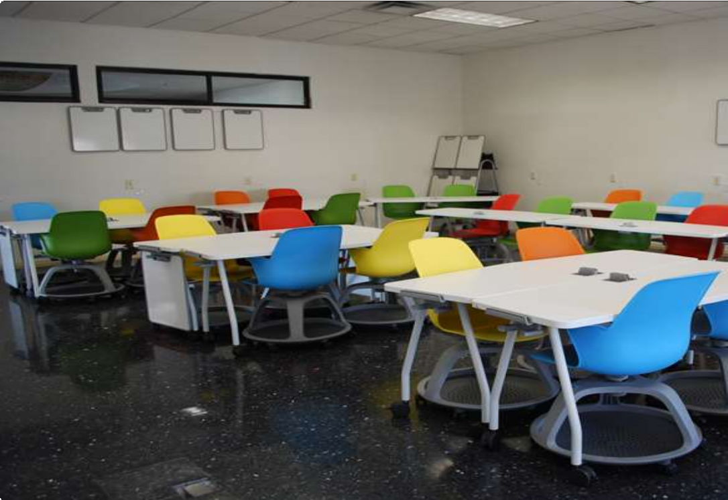
7

Rate your anxiety levels for attending a face-to-face lecture in a classroom environment.
(1) Low and (5) High
*

1 2 3 4 5

8

Do you feel anxious attending a face-to-face lecture in a classroom environment
*

 Never

Sometimes Always

9

Rate your anxiety levels to the following statements: -
*

Low Moderate High

Asking questions in
the classroom
in front of peers

Being asked to present a topic in front of others

Group work in class

Taking notes in the class

Arriving to
the lecture on time

Sitting in a room with other students

Worried about getting
Covid-19
from other students.

Speaking to the lecturer directly in class
10

'Social anxiety' is a term used to describe an overwhelming fear of social situations of meeting people, making eye contact with people or speaking to people.

Which learning environment do you find yourself experiencing the most social anxiety?
*

Classroom Online
Both Neither

11

'Blended learning' is a term used to describe a mixed methods of learning by combing digital online learning with traditional classroom methods.

Do you prefer this learning style?

Yes No
Don't mind

12

Which style of learning do you prefer?

Online digital learning only

Classroom face to face learning Blended learning

13

Please feel free to feedback anything your organization can do to reduce your anxiety levels towards online learning or within the classroom.

(Not mandatory, but would like to hear feedback for this research study if you have time and would like to get some points across).

Appendix
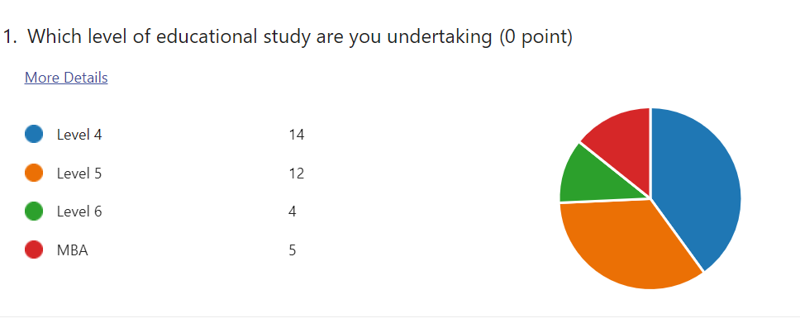
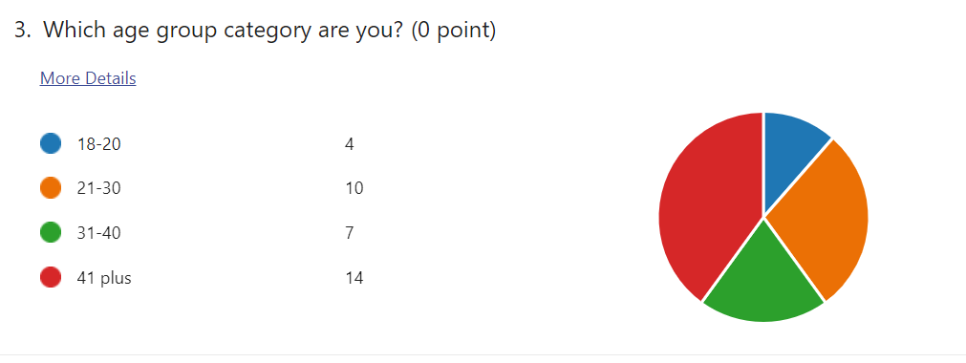
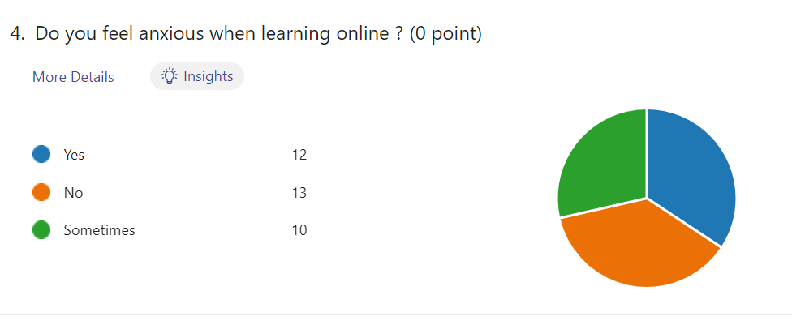
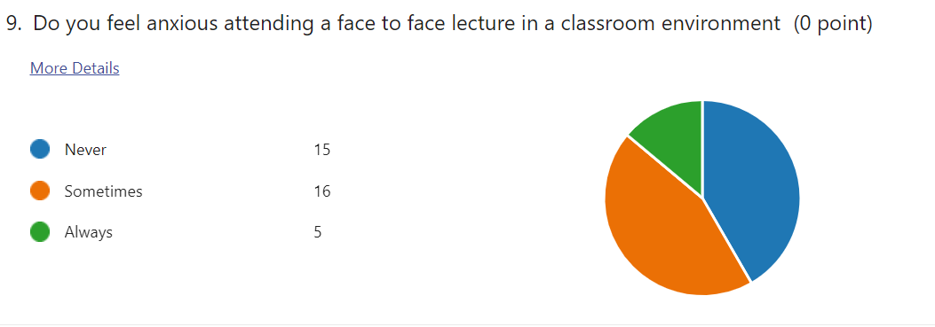

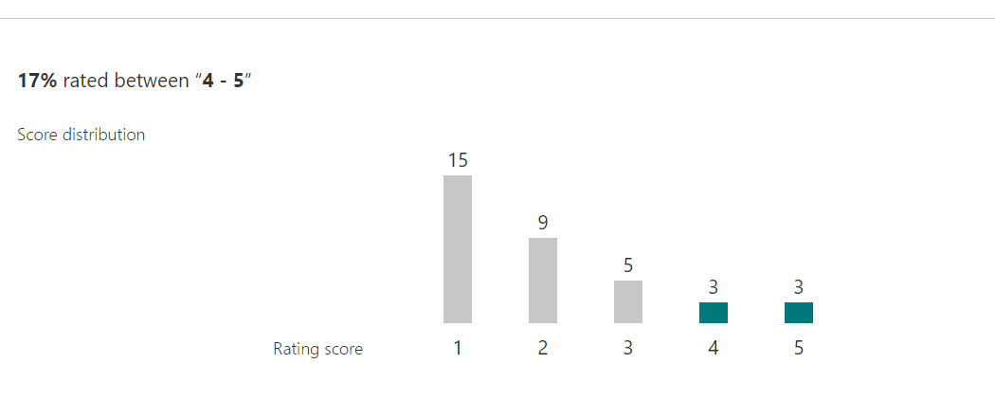
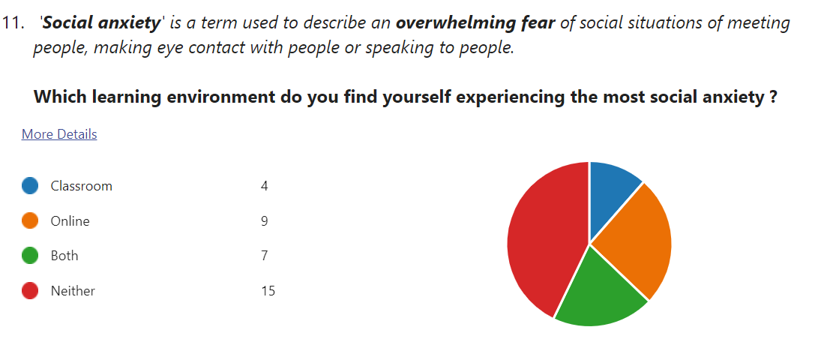

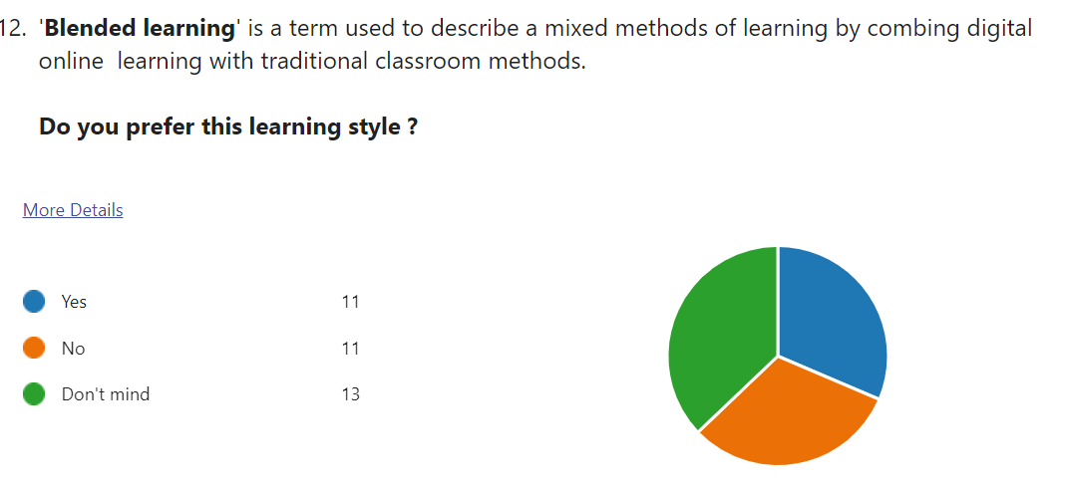

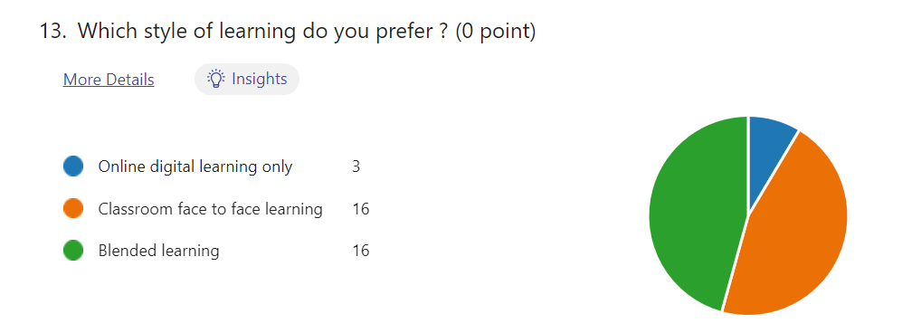

Appendix 3 Assigning values to determine anxiety levels between ages and levels of study.
18-20 | 2 | 3 |  | L4 | 2 | 3
21-30 | 1 |  |  | L5 | 2
31-40 | 2 |  |  | L6 | 0
41 plus | 0 |  |  | MBA | 1
18-20 | 3 | 2 |  | L4 | 4 | 2
21--30 | 5 |  |  | L5 | 8
31-40 | 2 |  |  | L6 | 1
41 plus | 5 |  |  | MBA | 1
18-20 | 0 | 1 |  | L4 | 7 | 1
21-30 | 3 |  |  | L5 | 3
31-40 | 4 |  |  | L6 | 3
41 plus | 7 |  |  | MBA | 1
Averages | classroom
18-20 | 21-30 | 31-40 | 41+ |  | Level 4 | Level 5 | Level 6 | MBA (7)
2.4 | 1.777778 | 1.75 | 1.416667 |  | 1.615385 | 1.923077 | 1.25 | 2
1 | 2 | 3 | 4 |  | 1 | 2 | 3 | 4
18-20 | 3 | 3 | Level 4 | 7 | 3
21-30 | 1 |  | Level 5 | 4
31-40 | 2 |  | Level 6 | 0
41 plus | 5 |  | MBA | 1
18-20 | 1 | 2 | Level 4 | 5 | 2
21-30 | 3 |  | Level 5 | 3
31-40 | 1 |  | Level 6 | 2
41 plus | 5 |  | MBA | 1
18-20 | 0 | 1 | Level 4 | 2 | 1
21-30 | 5 |  | Level 5 | 7
31-40 | 4 |  | Level 6 | 2
41 plus | 4 |  | MBA | 3
Averages | Online
18-20 | 21-30 | 31-40 | 41+ |  | Level 4 | Level 5 | Level 6 | MBA (7)
2.75 | 1.555556 | 1.714286 | 2.071429 |  | 2.357143 | 1.785714 | 1.5 | 1.6
Averages | Level 4 | Level 5 | Level 6 | MBA (7) |  | 18-20 | 21-30 | 31-40 | 41+
Offline | 2.4 | 1.777778 | 1.75 | 1.416667 |  | 1.615385 | 1.923077 | 1.25 | 2
Online | 2.75 | 1.555556 | 1.714286 | 2.071429 |  | 2.357143 | 1.785714 | 1.5 | 1.6

Appendix 4

