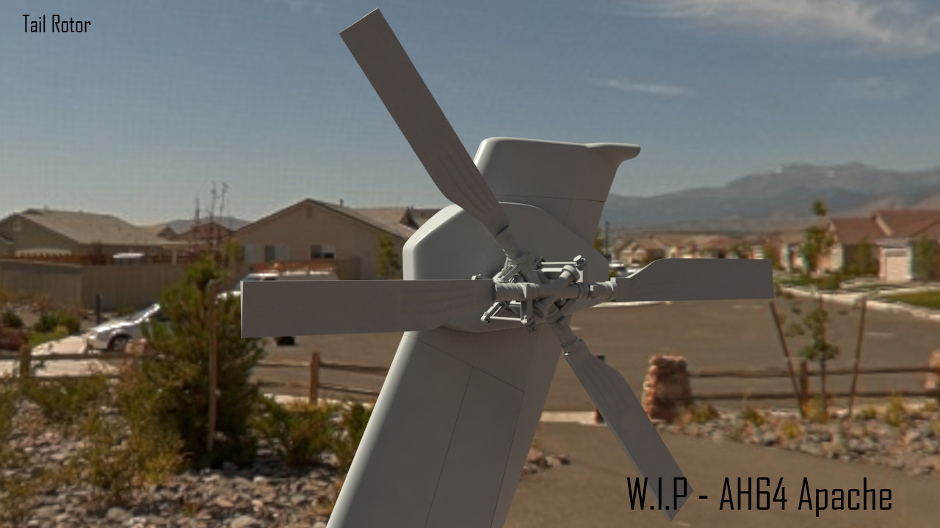
Daniel Ward (1504426)
[Email address]
Advanced Computational methods
M6X00408

Executive summery
A Sold body of a rear rotor blade has been analysed using advanced computational methods, it calculates and predicts the forces acting on the blade and completes 3 static analysis’s and a frequency analysis.
The report discusses why specific assumptions are made and how they may affect the end results. It evaluates and scrutinises the results, explaining why some results are neglected. It looks at the computational fixing of the component verses the actual part fixing possibilities and why the mesh sizes have been chosen.
it also critiques the model which was provided and gives reasoning why the report can not be used as a means of giving any relevance to the real Apache helicopter.

Table of Contents
Executive summery 1
Introduction 3
Main body 5
Assumptions 5
Fixtures 6
Loading 6
Calculations 7
Mesh 9
Simulations 10
Static Simulation 10
Frequency Simulation 12
Conclusion 14
Report critique 14
References 15

Introduction
The Boeing Apache AH-64 helicopter took its first flight in 1971 and went into production in 1984, it boasted a 284km/h max cruse speed which uses two T700-GE-701 turboshaft engines producing 1265kW each. Today’s machine still utilises the t700-ge-701 but is an upgraded Version D, these engines have 1491shp each and can reach speeds of almost 300kph.
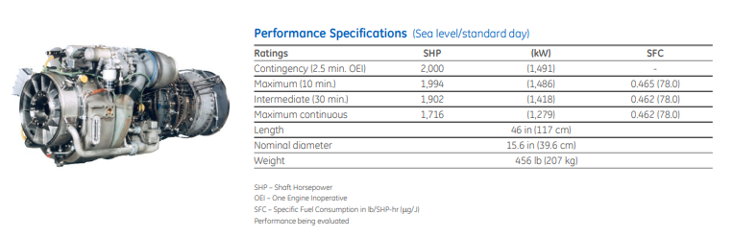
Figure 1. – T700-GE-701 D Engine performance specification
It comprises of 4 main blades and 4 tail rotor blades which were the first to be offset by 55° with 2 adjacent 125° blades. This was done to fit the offset the blades so that the delta-3 hinge could be fitted which allowed the blades to flap and feather simultaneously. At the time Boeing found out that this also reduced sound. (Swopes, 2019)
Tail rotors are used to stabilise the aircraft and stop the torque created by the main rotor shaft rotating the helicopter in the opposite direction to the movement of the blades, sometimes called an anti-torque system. This means that the rear rotor blades need to create an equal and opposite force in relation to the main rotor blades (Prouty, 1998)
Apache rear rotor blades are made up of composite spares and shell and either a titanium or stainless-steel leading edge to reduce the erosion and has been ballistically tested (Boeing, 2004). As the model that’s been provided is homogeneous blade design and although Solidworks supports laminated fibre reinforces polymers (FRP) a single material has been used for this analysis. This option has been used as the report specification asked to analyse the models provided. The component given was a single solid piece of material.
For an accurate analysis the material that’s being used needs to be somewhat comparable in terms to mechanical properties but it would be very difficult to match the material properties of carbon fibre as there are numerous variations of the material. So, a different material needs to be used in the simulations so that the analysis generates tangible results, otherwise this report will have no resemblance to realistic data.
Therefore, a quick examination of what properties is desirable when constructing and analysing a helicopter rear rotos blade using solid works.

Main body

Assumptions
For this assignment a number of assumptions need to be made. When loading the blade, the first assumption is that gravity will not affect the blade due to the high centrifugal force on the blade.
The model provided is a scaled down version of the real thing. The real helicopter weights almost 6000Kg, the Solidworks Mass Properties feature shows that the mass is almost 29kg (Figure 2). Therefore, a power to weight ratio has been calculated to try and balance the forces. This will help the program perform more efficiently and wont force it to use “Large Displacement” calculations.
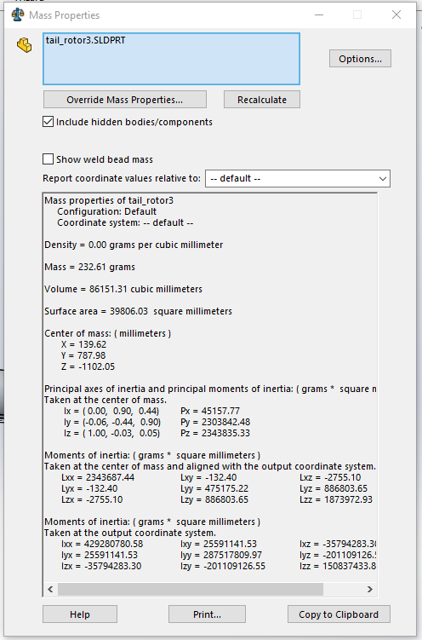
Figure 2 – Mass Properties window from solidworks
Other forces which are not going to be calculated in the project are aerodynamic drag because of the word limitations set out in the word specification.
Solidworks is a linear solver (Kurowski, 2019), this means that is uses Youngs Modulus to calculate stress and strain and to determine yield strength. If a component is excessively malleable, highly brittle or the test exceeds the materials yield strength it will not be able to accurately forecast its repose to the loading conditions. If the yield strength is exceeded another software package will need to be utilised to carry out the analysis (King, 2019).
The material must be light weight and strong enough to withstand the forces the component is subject too. The highest force the blade will be subject to high tensile loading from the Centrifuging forces (Henry E. Jones, 2001). Aluminium 6061-T6 alloy has been chosen as it is light weight and was used on earlier helicopters (Mike Tooley, 2009) (Mikael Amura, 2014). At this point it’s also worth noting that the model of the blade provided is made of a single, solid piece of material. Rotor blades are typically hollow or filled with Aluminium Alloy foams to help maintain strength and reduce weight (Mikael Amura, 2014).
The main rotor spin rate is 315 rpm. The tail rotor spin rate 1530 rpm (V. Giurgiutiu, 2001)
This report assumes that there are no mechanical loses, through gearing or shaft stiffness, therefore the power value used will be higher than actual power. This means that actual forces will be lower than calculated and less stress/strain will be acting on the blade (Henry E. Jones, 2001).
Due to the complexity of aerodynamics and the word restrictions of this report, the force created by drag have not been calculated.
Although drag force and mechanical loses act on different directions, it’s possible that they balance one-another.

Fixtures
The initial fixture is the fixed geometry, this has been used so that the part can be loaded rather than get moved through digital space.
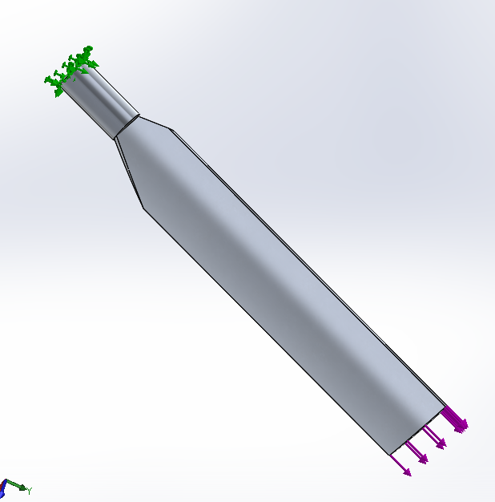
Figure 3 – the position at which the blade is fixed in the model.
Fixing this edge may be problematic as it could increase the calculated maximum stress and strain as the nodes in the very edge would be fixed in space creating very large strain. As this is foreseen, it can be hypothesised that the maximum value will need to be considered as false and further analysis will need to be executed to determine the correct maximum stress.
In reality the component will be fixed via another method such as a coupling sleeve or a bolt. Either of these methods of fixing the blade would dramatically increase the surface area of the load and reduce the stresses and strain applied.

Loading
Before the rotor blade can be loaded a number of calculation’s need to be made. They include the power to weight ratio to determine realistic valve for the torque applied at the main rotor shaft (Padfield, 2007).

Power to weight ratio
As the model provided is a scaled down model it seemed necessary to scale the power output. This was done by working out the power to weight ratio.
GE Advertise each engine has a maximum power of 1491kW (figure 1), the Boeing apache has 2 of these engines so a max power of 2982kW was used in the calculations, in reality there would be an element of power loses due to gearing but no information was found. The Boeing show a primary mission gross weight for the apache is 6838kg. this equates to a power to weight ratio of 0.436kW/kg, therefore, the power of the engines and be assumed to be 12.96Kw.
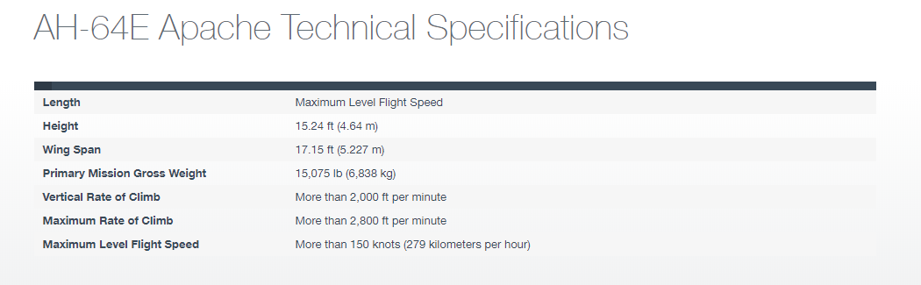
Figure 5 – AH-64E Apache Technical Spec. (Boeing, 2019)
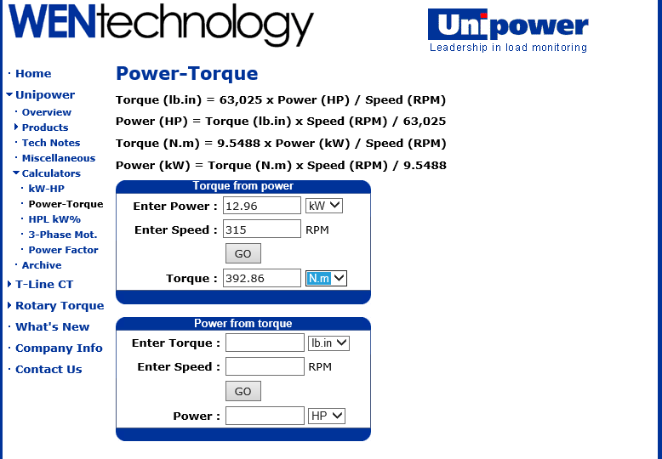
Figure 4. – Image of calculation found from WEN Technology.

The mass of the model given was taken as 29725.25g or 29.725kg (Figure 5). Given the calculated power to weight ration that was calculated, the model’s power would be 12.96kW.

Calculations
The next points which need addressing are the loading conditions, there are two main loading conditions. The first to be calculated will be the centrifugal force. It’s caused by the weight of the blade while its rotating around the central axis.
In reality other forces would be applied but as they are predicted to negligible in comparison to centrifugal force and lift it will not be included in the analysis.

Centrifugal force
Figure 6 – image showing the direction and placement of centrifugal force.
The centrifugal force of the rear rotor blade can be calculated using the speed at which the rear rotor blade rotates around its central axis at 1530rpm (V. Giurgiutiu, 2001), the mass of the object and the distance of the object is away from the point at which it’s been rotated around. Again, due to the shape of the object this isn’t quite as straight forward as it seems in this situation due to the blade shape and the orientation of that blade as it spins.
F | Force | $$F=\frac{mv^{2}}{r}$$
m | Mass of the blade | $$F=\frac{mv^{2}}{r}$$
v | Velocity | $$F=\frac{mv^{2}}{r}$$
r | Distance of the centre of gravity to the axis in which the blade is rotating around | $$F=\frac{mv^{2}}{r}$$
Figure 7 – Centrifugal force Equation (Emerson, 2010)
To simplify this the blades central point of gravitation mass has been distinguished as being 0.148m from the point at which the blade is attached to the rotor shaft. Which is 40mm its central axis meaning r is 187.86mm.
The mass of the blade was determined as 232.61 grams (Figure 2) and the speed was found online to be 1530rpm (V. Giurgiutiu, 2001).
$$F=\frac{(232.61)*{(1530rpm)}^{2}}{\begin{aligned}\left(187.86mm\right) \\ \\ F=1121.8N\end{aligned}}$$

The centrifugal force has been applied to the end of has been applied as a tensile force to the very end of the blade. This method was utilised because occurred when using the centrifugal force command on Solidworks which could not be rectified.

Torque
The other force which needs to be calculated is the force necessary to oppose the torque created by the main rotor blades.
When the aircrafts main rotor revolves around its central axis it creates a torque. This needs to be found so that the force needed to counter-act it can be calculated.
$$Torque=\frac{9.5488*Power(kW)}{Speed(rpm)}$$
$$Torque=\frac{9.5488*12.96}{315}$$
$$Torque=392.86N.m$$

Lift force
The helicopter has four blades each blade rotates creating the necessary force to stop its spinning around due to the torque created by the main rotors. The force needed is calculated by dividing the torque by the distance from the centre-point of the main rotor blades to the centre-point of the tail rotor blades.
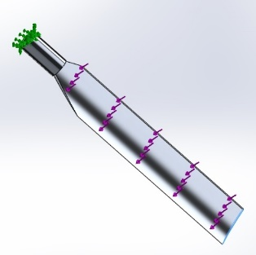
Figure 8 – Image showing the direction of applied lift force.
$$Force\left(N\right)=\frac{Torque(N.m)}{Distance(m)}$$
$$Force\left(N\right)=\frac{392.86}{2.314}$$
$$Force\left(N\right)=169.78 N$$
That then is divided by four to give the load produced to counteract the torque force.
$$\frac{169.78}{4} = 42.44 N$$

Mesh
During this project the mesh has be altered numerous times accordingly to offset the time it takes to run a study and the quality of the results. the table below shows that the smaller the mesh size the longer the test takes to perform. Small mesh sizes

Simulations

Static Simulation
A static simulation shows how quasi-static loading of a model create stress and strains and highlight areas in which become most affected (Hoppensteadt, 1994). This gives designers an opportunity to see any area which may fail under loaded conditions and rectify an issue that may arise before building a real-life model (Simionescu, 2015).
Test (Mesh Size) | No. of Nodes | No. of Elements | No. of DOF | Time | Stress  (GPa) - von Mases | Displacement  (mm) | Strain
Test 1 (4.8mm) | 13544 | 7371 | 40524 | 00:00:06 | 60.75 | 2.254 | 6.096e-4
Test 2 (2.4mm) | 70046 | 41884 | 209940 | 00:00:37 | 76.60 | 2.276 | 8.693e-4
Test 3 (1.2mm) | 452331 | 297627 | 1356615 | 00:03:00 | 140.2 | 2.286 | 1.095e-3
Figure 9 – a table produced from the information of three static simulations using three different mesh sizes, as the mesh size halves the No. of nodes, elements and the time taken multiplies by 6.

Both Figure 10 and Figure 11 show a small area near the base of the blade is subject to forces which are far greater than the rest of the blade.
This may be due to there being a sharp point at which can give rise to tearing or it may be down to the way the system computes the models stress. The high stress and strain values that are seen at Test 3 are those which were hypothesised when discussing the fixing of the component. When using the Iso Clipping tool. Figure 10 shows the high stress points in red which are located on the very edge of the cylinder.
Figure 11 shows the Iso Clipping tool is used to show results of Test 3 but only the areas of the material are under the stress shown on Test 2 (76.6GPa), it is clear that this result is also misleading. On further inspection, it can be noticed that it’s not until the stress value is further reduced to 65.6MPa more material is present in that area which would be considered to be under the most amount of stress and/or strain.
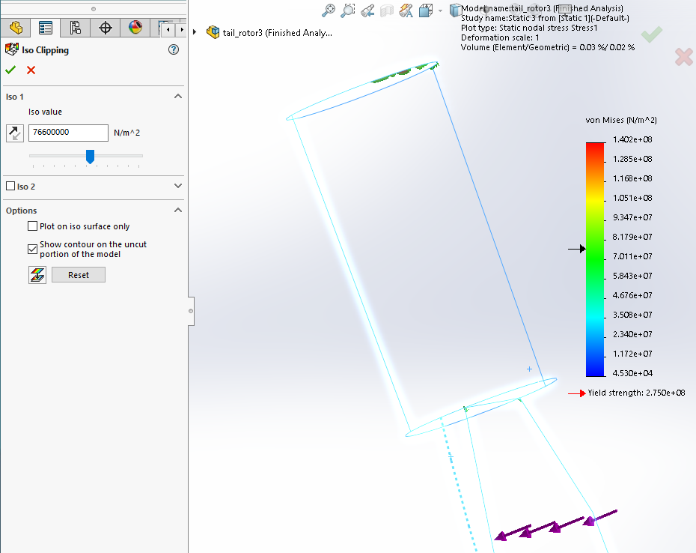
Figure 11 – A view of Test 3. Using the Iso Clipping tool to only show the material that is under 76.6GPa or more.
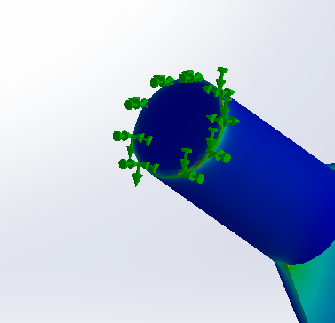
Figure 10 – the red areas in the image represent the areas of highest stress concentration.
To the left in Figure 12, shows another image of an Iso Clipped rendition which shows the material which is under 65GPaThis figure can also be lower as in reality there would not be any sharp edges, all edges would have a radius therefore spreading the stress over a larger area and reducing the risk of creating a stress raiser (Akin, 2010).
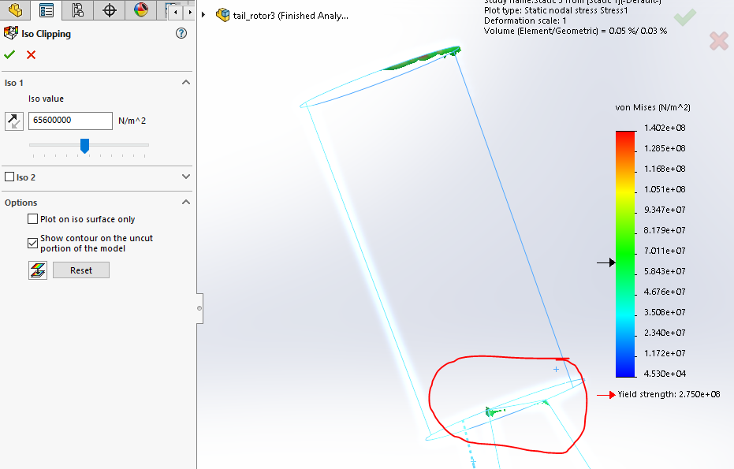
Figure 12 - Shows the material under 65.6 MPa of stress using the Iso Clipping tool.

Frequency Simulation
This type of simulation is used to find the natural frequency for a structure under is normal load conditions. This is important because if the blade is excited at its natural frequency it can cause it oscillate more vigorously. This in turn could cause vibrations which could affect the usability of the aircraft or even manifest premature failure due to fatigue.
This test was also performed 3 times using 3 different mesh values but the results did not differentiate significantly enough to be relevant to this report. Instead the 5 mode results were analysed, the results of each mode are shown in figure 13.
It should be noted that the test was run twice with different methods of fixing, the first was fixed using the Fixed Geometry feature and the second using a Spring Connection but the difference was very small so the second test has not been critiqued(Figure 13-14).
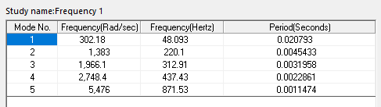
Figure 13 – Results from Frequency study 1 (fixed as in Figure 3)
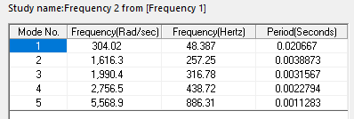
Figure 14 – Results from Frequency study 2 (fixed using springs)
The component being tested is said to be rotating at 1530rpm, there are 0.0666667 Hz per 1 RPM this means the rotor blade is moving at a rate of 25.5Hz. Due to the martial stiffness of the part the blade is attached too is relatively high, both sets of results are similar, this may not be the case if there are high tolerances
As shown in both studies the blades normal working frequency will be much lower than its natural frequency, which implies that it will not be excited under normal working conditions. This however could be misleading as other parts of the helicopter may cause the part to be excited. To prevent this each part will need to go through the same testing procedure and placed into an assembly to verify that this does not happen. This report is unable to touch upon any of this because the model provided is a solid body.
Also, loose connections between components would reduce the natural frequency of the bald which could bring it to be excited.

Conclusion
The report will need more time and data to make an accurate conclusion of the part. There are too many assumptions made regarding the applied forces. The blades speed, weight and the power output has been taken from Boeing and GE webpages. This is not ample as there may have been various models and upgrades produced by both manufacturers.
The construction of the bade id very different from the real thing, as explained above the model provided is a solid piece of aluminium 6061-T6, the real blade has been constructed using Steel or titanium spars, FRP shell/skin with a stainless or titanium leading edge. This will affect the mass and gravitational canter of mass, which, both used to calculate the centrifugal force.

Report critique
This report was limited by lack of data, time restriction, word count, hardware and software limitations.
To perform a more thorough analysis the blades would need to be modelled up to actual size as a or more data would need to be issued with regards to the actual forces produced by the blades, air resistance and aerodynamic calculations would need to be produced.
Due to the time and wordcount limitations a fatigue analysis wasn’t carried out. This will need to be part of a secondary report as the part would be subject to cyclic loading.
A different model, which closer resembles the geometry and material properties would need to be used along with software which is capable of computing the relationships between the components and material used in the real aircraft would need to be utilised. It would also need to need to include CAD features such as the Radius feature on corners to reduce the risk of manifesting inaccurate results.

References
Akin, J. E., 2010. Finite Element Analysis Concepts: Via SolidWorks. 1st ed. Singapore: World Scientific Publishings.
Boeing, 2004. Boeing-Developed Composite Rotor Blade Spins Forward. [Online]
Available at: https://boeing.mediaroom.com/2004-05-10-Boeing-Developed-Composite-Rotor-Blade-Spins-Forward
[Accessed 15 11 2019].
Boeing, 2019. AH-64 Apache. [Online]
Available at: https://www.boeing.com/defense/ah-64-apache/
[Accessed 10 11 2019].
Emerson, W., 2010. The Laws of Centripetal and Centrifugal Force (1969). 1st ed. London: Kessinger Publishing.
Henry E. Jones, D. L. K., 2001. Comprehensive Modeling of the Apache in CAMRAD II, Hampton, Virginia : U.S. Army Aeroflightdynamics Directorate AMRDEC, U. S. Army Aviation and Missile Command NASA Langley Research Center .
Hoppensteadt, F. C., 1994. Analysis and Simulation of Chaotic Systems. 1st ed. New York: Springer-verlag.
King, R. H., 2019. Finite Element Analysis with SOLIDWORKS Simulation. 1st ed. Boston: Cengage.
Kurowski, P., 2019. Engineering Analysis with SOLIDWORKS Simulation 2019. 1 ed. Warsaw: SDC Publications.
Mikael Amura, L. A. M. C. F. D. P. M. B., 2014. Failure of a helicopter main rotor blade. Procedia Materials Science, 3(1), pp. 726-731.
Mike Tooley, A. F. T. M. M. V. C. P. W. C. E. L. H. D. W. L. R. J. J. M. F. D. F. J. W. P. G. H. D. C., 2009. Aerospace Engineering Desk Reference. 1st ed. London: Elsevier.
Padfield, G. D., 2007. Helicopter Flight Dynamics: The Theory and Application of Flying Qualities and Simulation Modelling. 2nd ed. Oxford: Blackwell.
Prouty, R. W., 1998. Raymond W. Prouty. London: Krieger Publishing Company.
Simionescu, P. A., 2015. Computer-Aided Graphing and Simulation Tools for AutoCAD Users. 1st ed. USA: CRC Press.
Swopes, B. R., 2019. 30 September 1975. [Online]
Available at: https://www.thisdayinaviation.com/tag/ah-64-apache/
V. Giurgiutiu, e. a., 2001. Helicopter Health Monitoring and Failure Prevention ThroughVibration Management , USA: International Journal of Condition Monitoring .

