

PROFESSIONAL CAREER DEVELOPMENT : LCHS4005
Part 2

Lecturer Name:Lloyd Beharry

Student Name: Yetunde Adeoti Akinyemi

Student Id: 2133596

Table of Contents

Career path 3
Current Skills 3
Gap in Skills 4
A systematic approach to Skills acquisition 5
Recruitment and Selection 6
Conclusion and Recommendation 8
Reference List 9
Appendix 1: Interview Question 11
Appendix 2: PCD Job Application Form 12

Career path
This is mainly a career reporter containing a personal reflection on the role play and the personal career development planning with the application of a reflective cycle. The report will mainly demonstrate an understanding of the skills and knowledge which contribute to working effectively with a personal understanding of strengths and weaknesses for further development. Based on the interview, the chosen career is that of a support worker. As a support worker, my chosen career is focused on providing assistance and support to individuals who require help in their daily lives. This may include people with disabilities, the elderly and those with mental health issues. As a support worker, my primary goal is to promote independence and enhance the quality of life for the clients. This includes various duties, which include helping with personal care, meal preparation, house responsibilities, and offering emotional assistance. Additionally, I may additionally help clients with attending appointments, running errands, and participating in social activities. To be successful in this career, I want to have excellent communication and interpersonal skills, as I could be working closely with people from all backgrounds for a long time (Koprowska, 2020). I need to actually have a compassionate and empathetic approach to my work, with a willingness to adapt to the unique needs and preferences of the clients
Overall, working as a support worker can be a challenging yet rewarding career path. It allows me to make a high-quality effect on the lives of individuals that may require more support and assistance, and it is a career that offers an experience of fulfilment knowing that I am making a difference in the lives of others.

Current Skills
I as a personal human being have various skills and qualities which are essential for success in different roles. I have previously worked as a care assistant working with the mental health of young adults so have the experience to work in the healthcare sector. Personally, I have good written and communication skills. I am good at time management and can manage time very well. I am a dynamic and sincere person who can work under pressure. I have active listening skills and am considered a good listener in reality. I always try to have a positive approach in life and I can handle patients with quiet care and have the ability to reason with the clients. I am quite cooperative and collaborative in my approach and have the skills to work in a team. I have critical thinking and problem-solving skills. This is quite an effective skill as a support worker as I have to face various challenges in the work for example managing difficult and stubborn behaviours, dealing with difficult situations and finding creative solutions to meet the needs of the client. Effective communication is vital in the role of support workers (Stonehouse, 2014). I have excellent written and verbal communication skills which will enable me to build positive relationships with clients, families and other healthcare professionals. I can't even communicate effectively with individuals from diverse backgrounds and be able to listen actively and emphatically so that I understand the needs and requirements of the clients. Empathy and compassion are critical skills for the support worker's role and they enable me to understand and respond appropriately to the client's emotional needs (Wagaman et al. 2015). I have the natural ability to be empathetic and compassionate towards others which provides my clients with emotional support when they need it. As I have time management skills I will be excellent for the role of support workers. I need to manage my time effectively and ensure that I meet the needs of the clients on time. Due to the possession of excellent time management skills, I will be able to plan and prioritise tasks effectively, Ensuring that I deliver effective care and support to the clients. Working as support workers requires a great deal of patience and it can be challenging and demanding at times. I have a naturally patient disposition which enables me to remain calm and composed in complex situations. This quality will help me to provide reassurance and support for what they need. Flexibility and adaptability are important skills for me and they are fit for my chosen career as a support worker as I need to be adaptable and flexible in my approach (Diamantidis, and Chatzoglou, 2019). I will be able to adjust to different situations so that the clients can receive the highest quality of care and support. I have the skill to pay attention to detail which is also crucial for the role of the support workers as it ensures that I am providing correct and higher quality care. I always have to keep an open eye on the needs and the significant changes of the clients which will help me to respond quickly.

Gap in Skills
Besides the skill I have stated, there is also a requirement for some other skills and they need to be developed with time. Based on personal evaluation and analysis of the role of a support worker as a chosen path there is a requirement for leadership skills, digital literacy, cultural competence and self-care and awareness skills. Support workers need to be culturally competent to understand and respect the clients of diverse backgrounds and values (Selman et al. 2020). The workers must be aware of the cultural difference and how they may impact the client's care and support needs. The technology is being widely used in the healthcare industry and with the increasing use of digital advancement, the workers or the healthcare professionals need to adapt to the latest technologies. Support workers need to possess the basic digital literacy skills to use electronic health records, medical devices and communications tools effectively. Support workers also need to manage themselves which is managing and controlling their personal emotions, feelings and health and mental states (Labrague, 2021). These are essential for the choice of career path as possessing the self-awareness skills one will be able to manage their physical and emotional well-being and provide effective care to the clients. They need to prioritise self-care activities which are regular exercise, a healthy diet and taking breaks to prevent job dissatisfaction and burnout. Leadership is an important quality for support workers and must be developed with time as the support workers have to work in collaboration with other teams or healthcare professionals (Morley and Cashell, 2017). So they must have strong leadership qualities to handle teams and maintain effective communication with the internal stakeholders. This will help them to avoid conflicts and failure of short projects. With the position the skills, the support worker will be able to meet the unique needs of the clients and provide tailored support and improve their quality of life of them.

A systematic approach to Skills acquisition
Digital Literacy:
Step 1: Assess the present-day degree of digital literacy and identify areas for development. Step 2: Create a plan to expand your digital literacy abilities, such as online courses, tutorials, or workshops. Step 3: Practise the usage of digital tools and software to enhance proficiency. Step 4: Seek comments from colleagues, mentors, or friends to evaluate development and become aware of areas for development. Step 5: Stay up to date with emerging technology and tendencies with and following social media accounts.
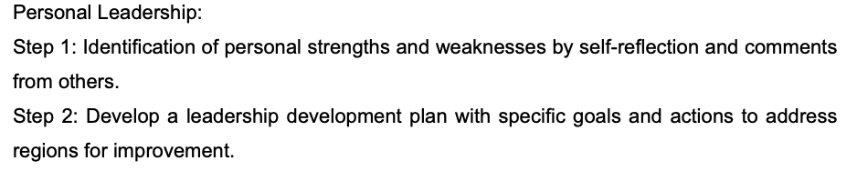
Step 3: Seek mentorship or education from experienced leaders to gain insights and guidance. Step four: Practice leadership skills regularly, such as communication, decision-making, and problem-solving. Step five: Continuously evaluate and regulate your leadership style to be powerful in complex situations.

Self-attention:
Step 1: Engage in a reflection regularly to identify values, strengths, weaknesses, and areas for improvement. Step 2: Seek feedback from others, such as colleagues, mentors, or friends, to gain a complete understanding of strengths and regions for improvement. Step 3: Develop a plan to improve regions for improvement and leverage your strengths. Step four: Practice mindfulness and emotional intelligence skills to improve self-focus and self-regulation (Kazanjian, 2022). Step five: Regularly examine development towards attaining the dreams and modify the approach as essential.
Cultural Competence:
Step 1: Increase understanding of cultural differences and how they can affect conversation and care delivery. Step 2: Engage in self-reflection to identify personal biases or assumptions which can impact your capacity to offer culturally competent care. Step 3: Seek out possibilities to examine and engage with individuals from diverse backgrounds. Step 4: Practising active listening and communication skills to understand and respect clients' unique needs and values. Step 5: Continuously evaluate and reflect on personal cultural competence and discover areas for improvement.

Recruitment and Selection
The Gibbs reflective approach is utilised for reflecting on the job interview role play and from the personal perspective.
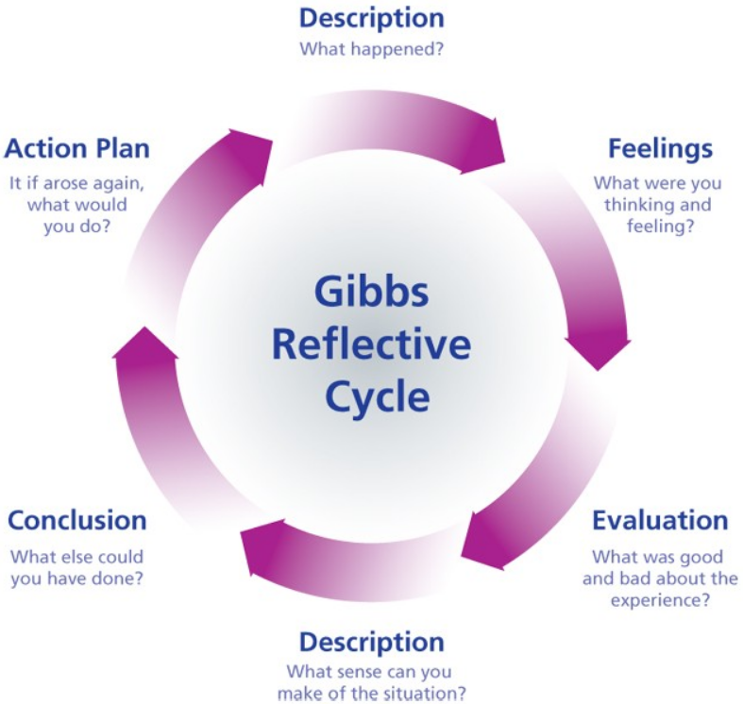
Fig: Gibbs Reflective Cycle (Rivera, 2015).
Description
The job interview was for the role of support worker for a company in the UK, I was interviewed by the interviewer based on the role. I was asked about the education and training I have for the job role and the qualifications I possess. I was also asked about my previous job experiences and the history of my employers. I was asked to focus on my personal strengths and weaknesses and what was the inspiration for choosing the career path.
Feelings
I was quite elated with the job interview with the interviewer as I was quite interested in joining the organisation (Rivera, 2015). The job interview had a positive and negative impact on me as I was going to work as a support worker in the organisation. I had the feeling that the interviewer will ask about the skills, qualifications and experiences of work. So I was well prepared to answer the question and I had a positive approach and thought That I am going to present myself in such a way that the employer is satisfied with my answers to his questions.
Evaluation
Evaluating the interview session, the thing which went right is that there was a professional conversation between me and the interviewer. I explained with the experience and the skills I possess will help me to serve the company better (To, 2022). I did not have much bad experience as the interviewer made me feel comfortable with the questions and presented welcoming and positive behaviour while listening to the answers to my questions. I gained a positive experience of gaining insights and expressing myself in the right way to the employer.
Analysis
From the interview session, I have learned that I have different skills to work as a support worker in the company. I have experience of 12 years working in a company named Choice Support Ltd. I have the capability to work with people who are vulnerable and require full support. With the experience I have and the duration, I have been working in the previous company and this sector. I will be able to serve the company which I am going to join.
Conclusion
In the interview, I came to know from the interviewer I had some skills which are essential for the role of the support worker but also lacked some which needs to be developed in time. I could have developed the skills within the years of my service and presented myself fully to the employer. I am a little unaccustomed to the present technology and devices, which need to be developed in time. The employer also requested me to develop the same.
Action plan
The skills which have been pointed out must be developed with time and if I have to face some other interviews then I will search more on my career and strengths and weakness and present myself with greater confidence.

Conclusion and Recommendation
In the conclusion I have pointed out the skills and experience which I have and what needs to be done to improve my career. I have to care for the vulnerable and people with disabilities. I have to improve my skill with time and make myself competent for the upcoming job role.

Reference List
Diamantidis, A.D. and Chatzoglou, P., 2019. Factors affecting employee performance: an empirical approach. International Journal of Productivity and Performance Management, 68(1), pp.171-193.

Kazanjian, C.J., 2022. Mindfulness diligence: Supporting the culturally relative self-actualization processes of diverse groups of youth. The Humanistic Psychologist, 50(2), p.234.

Koprowska, J., 2020. Communication and interpersonal skills in social work. Communication and Interpersonal Skills in Social Work, pp.1-248.

Labrague, L.J., 2021. Psychological resilience, coping behaviours and social support among health care workers during the COVID‐19 pandemic: A systematic review of quantitative studies. Journal of nursing management, 29(7), pp.1893-1905.

Morley, L. and Cashell, A., 2017. Collaboration in health care. Journal of medical imaging and radiation sciences, 48(2), pp.207-216.

Rivera, L.A., 2015. Go with your gut: Emotion and evaluation in job interviews. American journal of sociology, 120(5), pp.1339-1389.

Selman, L.E., Chao, D., Sowden, R., Marshall, S., Chamberlain, C. and Koffman, J., 2020. Bereavement support on the frontline of COVID-19: recommendations for hospital clinicians. Journal of pain and symptom management, 60(2), pp.e81-e86.

Stonehouse, D., 2014. Communication and the support worker. British Journal of Healthcare Assistants, 8(8), pp.394-397.

To, D.G., 2022. Interviewing.

Wagaman, M.A., Geiger, J.M., Shockley, C. and Segal, E.A., 2015. The role of empathy in burnout, compassion satisfaction, and secondary traumatic stress among social workers. Social work, 60(3), pp.201-209.

Appendix 1: Interview Question
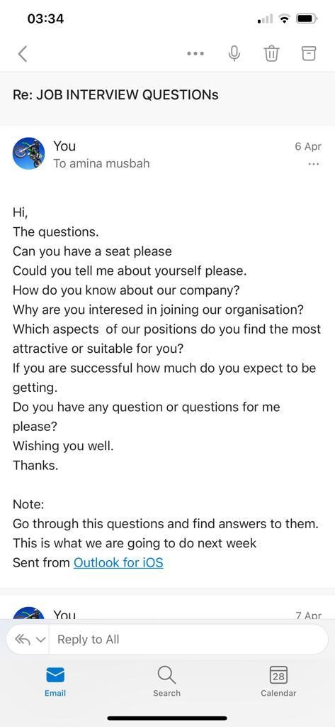

Appendix 2: PCD Job Application Form

Job application form

Application for [job title] – Support Worker

Your details

Name:
Yetunde Akinyemi

Education and training
Please give details:

Primary Education.Primary School Leaving Certificate 1982

Gcse 1995

Teacher's training College 1999

Level 3 Care certificate

Mannual Handling Certificate

First Aid Certificate

Medication

Health and Safety

Safeguarding

Food and Hygiene.

Qualifications
Please give details:

Primary School Crrtificate

GCSE

GCSE

Care Certificate (Level 2)

Care Certificate (level 3)

Employment history

Your current or most recent employer

Name of employer:

Job title:Choice Support Ltd

Length of time with employer:12years.

Reason for leaving: The Companyis folding up very soon.

Duties:

Care for vulnerable people

Care People with learning disabilities and autism

Giving the vulnerable people full support as they required.

Previous employers
Please tell us about other jobs you have done and about the skills you used or learned in those jobs.

I was once a care assistant working with mental health young adults in the past.

I have good written and reading communication rapour

I can manage my time well

I can work under pressure

I am a good listener.

I am a patient care worker with ability to reason along with the clients.

I like working with people as a team.

Supporting statement
Please tell us why you applied for this job and why you think you are the best person for the job.

I am applying for this job because the Company is folding up anytime from now and I nee a new job for my sustainability.
With my experience and the yearrs I have been working in this field,I th I shoud be able to do well under your company.

Right to work in the UK
Do you need a work permit to work in the UK? No please.

References
Please give the names and contact details of 2 people who we can ask to give you a reference. We may ask them before an employment offer is made. We will not ask your current employer until we get your permission.

Declaration
I confirm that to the best of my knowledge the information I have provided on this form is correct and I accept that providing deliberately false information could result in my dismissal.

Name:Yetunde

SignatureYA

Date:30/3/23

