INTRODUCING THE MODERN WORKPLACE

Table of Contents
Introduction 3
Report 4
Conclusion 7
References 8
Appendix 9

Introduction
As per the prerequisites of a store manager, this report will help highlight the difference of logistics of Amazon’s physical organizational structure, and performance with the online structure, and performance. This also will include how the organization in each aspect will be likely to use distinctive approaches to upkeep the performance of its structure from those that are directly involved, and report to the structure. This could be achieved from the skills and techniques that will be denoted, and discussed throughout the text.

Report
Amazon’s physical organisational structure
The physical organisational structure that the company has firstly acquired has exponentially grown. That allowed many to have the physical convenience to buy several desired items. Customers were allowed to purchase several categories. This specifically included groceries, toys, books, and other facilitated items. This mainly included distinctive departments as compared from how facilitated has become through its online methods. The physical organisational structure comprises the bookstore services that provided to its customers at one beginning. Yet, its performance was quite vast in perspective of distinctive customers. For example, how simple was for customers to purchase books at the comfort of their homes as a contemporary innovation. This signifies how Amazon was able to deliver books. The contemporary performance and success that amazon had was not only based from the customers the services that they have built. But also, for the extensive control that amazon has led on their global e commerce operations. The characteristics of contemporary business environment derived from the organisational structure are also used to expand their market reaches. This may benefit the evolvement that the corporate structure may encounter from transition. This includes how Amazon as an organisation would physically add more products through the ability of encouraging its appeal from diversification (Wu and Gereffi, 2018). That would be subject of making the organisation liable, and eligible to withstand the physical availability of near, and direct competitors that would stand within the market of the organisation.
Although this would also include how its corporate structure would add the appropriate control to undermine the pressures of competitors. If each department of the structure is willing to add initiatives that could enhance the effective execution of strategic management. This may be done from the effects that direct competitors like Walmart, google, and Microsoft may implicate. As the competition that differ was likely to be highly aggressive. That offsets the structural characteristics that the contemporary organisational structure, and performance. These are core, and the main principal characteristics that may be considered for growth. To add the necessary resilience to continue the e-commerce operations perceived by each manager, and employee that encounter the same belief, and common ground values.
The contemporary success that the organisational structure of amazon has achieved has helped to constantly devote the success that the company has undertaken (Emerson, 2019). To attain to reach the rapid, and efficient levels of deploying each of their managerial activities. However, the growth is yet critical. As the company’s key to success would yet require the sufficient flexibility, and responsiveness to widen its scope in its online operations. So that its performance is liable to make Amazon’s capacity to fix the current issues and implications that are faced from the common physical, and ground values.

Amazon’s online organisational structure
The current, and remote organisational structure that amazon has been developing since the pandemic started has increased from the differences that physical organisational structure has acquired. This includes how the organisation has added flexibility from the growth of the organisation in terms of its remote size. Ever since the organisation has adapted new mechanisms to determine the transition of its performance, it has encouraged frequent changes to facilitate the ability of reaching distinctive, and wider online markets. The resilient part of the organisational structure of amazon adheres with creating an extensive operation to make global e-commerce operations (organimi.com, 2021.). For instance, as per how it creates in making the efficiency of managing the emerging markets worldwide, especially where amazon operates within the United Kingdom.
The advantage of upkeeping the performance of the online organisational structure includes from how it creates in enhancing other markets. For instance, the international growth. By expanding, and growing its many areas of operations as compared to someone had previously. This would be accessible and facilitated for distinctive stakeholders that would contribute in different geographic locations to adapt with the conditions, and undermine the challenges encountered, and faced from the implications of different challenges in each department. The strongest differences between the performance of both organisational structures are benchmarked according to the basis of business functions (Bustinza et al., 2018). And how each dedicated group of this structure could efficiently adhere the optimisation of the previous, and current operations that are undertaken by amazon’s retailing. This includes the cutting edge resources that e- commerce has brought in the growing globalization amidst a pandemic. The performance of this structure is meticulously based from how it adds distinctive divisions at a worldwide level. By making several geographical groups, and divisions comply the ability to accurately address, and revert challenges into opportunities in terms of the operations held by the growing, and diversification of operations of thus organisation. Moreover, despite the current performance. Amazon yet uses the similar strategic advantage that it once had. By putting into the example of Amazon’s growing size, and creating several predetermined divisions in each country that it operates. This includes the type of hierarchical structure according to the cultural conditions that are faced in different facets. That derive the growing optimisation of the performance of the activities conducted by each role of the organisational chart, and bring such portrayal towards the effectiveness needed to grow both ends exponentially.

Conclusion
This report highlighted the differences that both organisational structures of the growing organisation has added from the example of transitional growths that are required to revert, and create new opportunities. That are discarded from the notorious challenges. The report also analysed the organisational structures that are available. For instance, the hierarchical structure, and the performance that is devoted by using both ends into execution. For instance, the difference of cultural structures in online, and physical aspects to determine the ultimate performance as whole.

References
Bustinza, O.F., Vendrell-Herrero, F., Gomes, E., Lafuente, E., Opazo-Basáez, M., Rabetino, R. and Vaillant, Y., 2018. Product-service innovation and performance: unveiling the complexities. International journal of business environment, 10(2), pp.95-111.
Emerson, K.Y., 2019. From Amazon's Domination of E-Commerce to Its Foray into Patent Litigation: Will Amazon Succeed as the District of Amazon Federal Court. NCJL & Tech., 21, p.71.
organimi.com, 2021. Organimi [Online] Amazon’s organisational structure Available at: < https://www.organimi.com/organizational-structures/amazon/> [Accessed on 29 December 2021]
Wu, X. and Gereffi, G., 2018. Amazon and Alibaba: Internet governance, business models, and internationalization strategies. In International business in the information and digital age. Emerald Publishing Limited.

Appendix
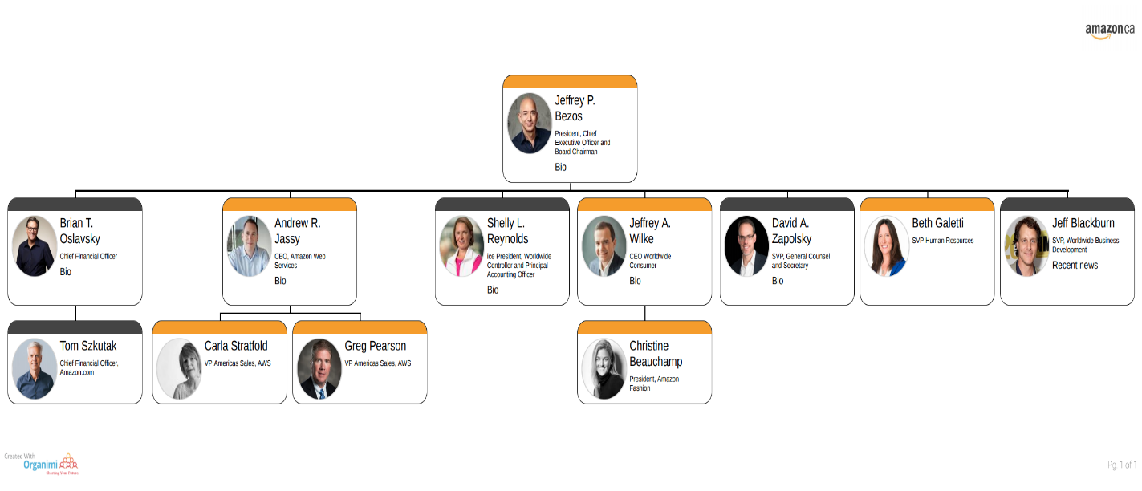
Amazon’s organisational structure
[Interactive chart]
(Source: organimi.com, 2018)


Amazon’s physical products sold Via e-commerce
Source: Amazon.com, 2021

