University of Wales Trinity Saint David
Powertrain Technology (ACHA4029)
Engine Performance Characteristics
Evan Williams
2500733
Submission Date: 21/3/26
Word Count: 1925

Contents
Introduction 3
Method 4
Results 6
Graphs and Analysis 11
SFC compared to Engine Speed 11
Torque compared to Engine Speed 12
Brake Power compared to Engine Speed 13
Conclusions Found 14
Evaluation 15
Conclusion 16
Reference List 17

Table 1- First Results Table 6
Table 2- First Results Table continued 7
Table 3 - First Results Table continued 7
Table 4- Second Results Table 8
Table 5 - Second Results Table continued 9
Table 6- Second Results Table continued 9
Table 7 - Facts contributing to the Dyno session 10

Figure 1 - SFC at different Engine Speeds 11
Figure 2 - Torque generated at different Engine Speeds 12
Figure 3 - Power generated at different Engine Speeds 13

Introduction
This assignment revolves around collecting and processing results from a dynamometer session and finding a number of figures like the Power and Torque generated, Specific Fuel Consumption and the Overall Thermal Efficiency of the engine tested as well as plotting graphs from the results to gain a better understanding of the engine.

Method
The engine that was used in this test was a 2000/2001 Honda 1.6L VTEC that was likely from a Jazz or CRX, it is an import model which meant lower power generated and there are coolant temp, fuel flow meter and lambda sensors on the engine. This engine has been self-contained onto a board by the engine and is controlled by senser recording modules that feed results back to the computer in the control room as well as the throttle actuator box that has been mounted onto the dynamometer itself.
On the wall next to the engine there is a fuel supply board where fuel is extracted from the main supply and pumped up through a filter via a fuel flow meter to the secondary swirl pot which feeds the fuel pump that is controlled via the regulator. If the engine was to return some of the fuel then it is fed back through a cooling plate and to the secondary swirl pot that is placed after the fuel flow meter so we can know how much fuel is being used in the engine rather than what’s currently in it.
For this test we used the Schenck WS230 dynamometer. This dynamometer is limited to 10,000rpm and has a maximum load of 230kW. It is bolted directly onto the engines crankshaft which allows for a more accurate reading of the rpm. There is up to 2000 different sensers that can be used on the dyno like the coolant temperature and the speed the engine is running at. The dynamometer that was used is an eddy current dyno which means that it has an inner core that spins freely from the engine and has an outer casing that gets fed with current and produces an electromagnetic feed. This electromagnetic feed puts a load on the engine and making it want to slow down however this causes the outer casing to try and turn which is attempted to be stopped by a string gauge that sends a signal to the computer in the control room of 0-10V. This 0-10V figure is showing load on the system, the system is calibrated with an arm either side of the dyno to do so which are 0.815m in length which neutralise the other. One arm is then loaded with weight on a hook so that the torque of the engine can be worked out. There is cooling pipes going in and out of the dyno that are kept at certain temperatures at all times by using radiators and fans where necessary.
In the control room there is a computer controlling the dynamometer where it can pick between three settings that the dyno runs on, the first is manual. In manual mode there is 2 dials, one is engine which controls the rpm and the other is dynamometer which controls the current being fed. There is three screens connected to the computer which shows a visual representation of the dials with the exact figures they are on and on the main screen the trends of the engines running’s with up to five different values on either side of the trend graph. The dials can then be configured to find out whatever information is required at the time of testing, for example seeing how a certain torque impacts the engine at different rpms. The next method is test sequences where the computer is put in charge of running the test, with the operator entering in parameters that needs to be tested and for how long for before running the next part of it.
The third test is a step test, there are two methods for this which is a step or sweep test. The step test is similar to the previous one where it allows you to enter parameters to be tested and the different steps it will take to complete the test and will produce a table at the end to show you what the results were, an example of this could be going at 50% or 100% throttle and see what the outcome is at certain rpm steps. The sweep test is very similar again and performs almost the same however it doesn’t stop at the rpm steps, just going from start to finish, this does however mean that the test may not be 100% accurate as the dynamometer is effectively trying to play catchup and log every figure as quick as it can.

Results
The results that were gained from the dyno session as well as calculations made are shown below.
Table 1- First Results Table
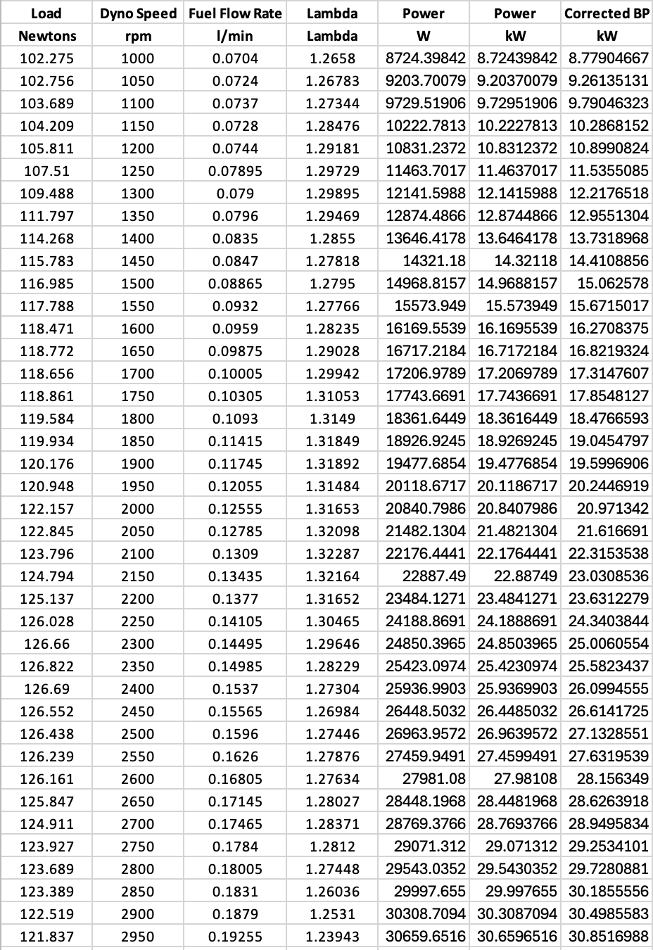
Table 2- First Results Table continued
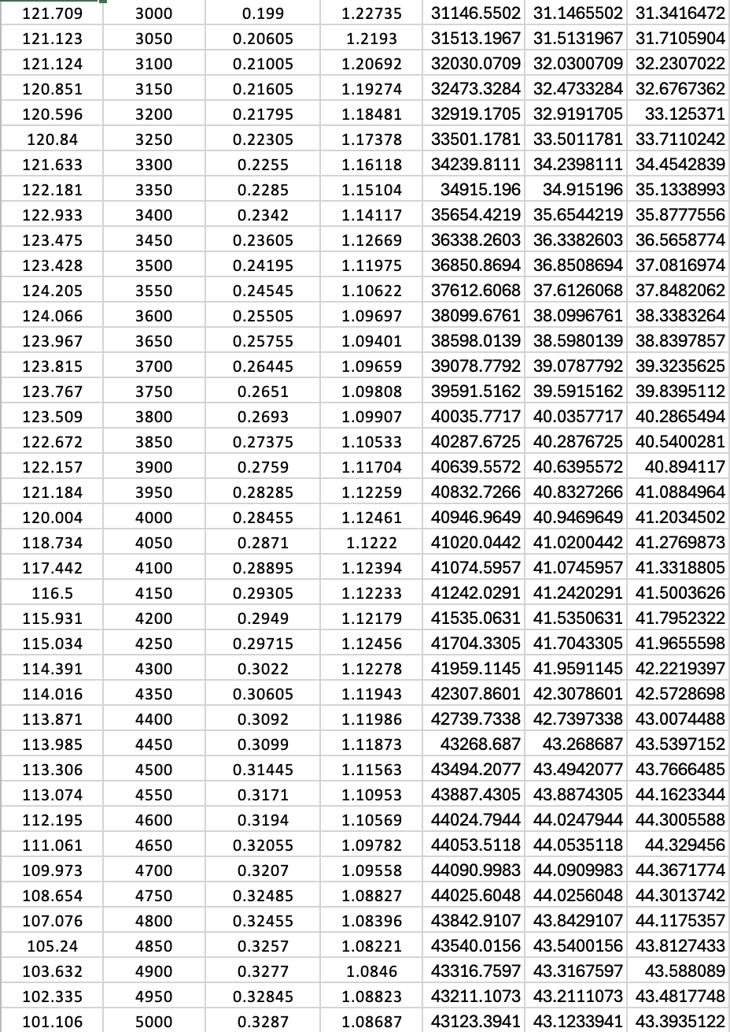
Table 3 - First Results Table continued
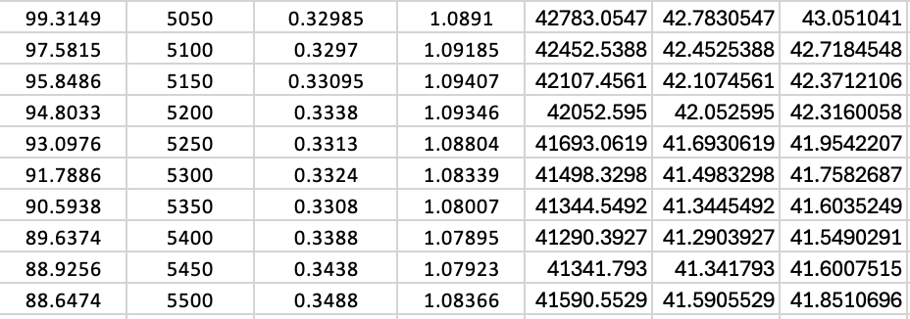
Table 4- Second Results Table
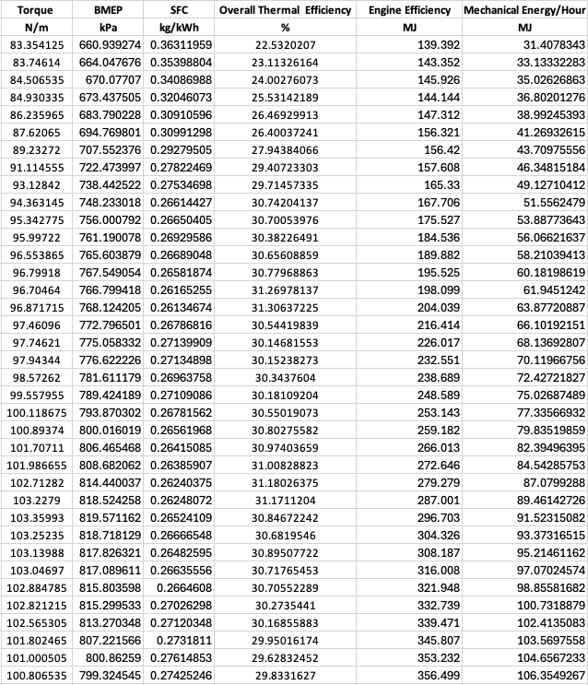
Table 5 - Second Results Table continued
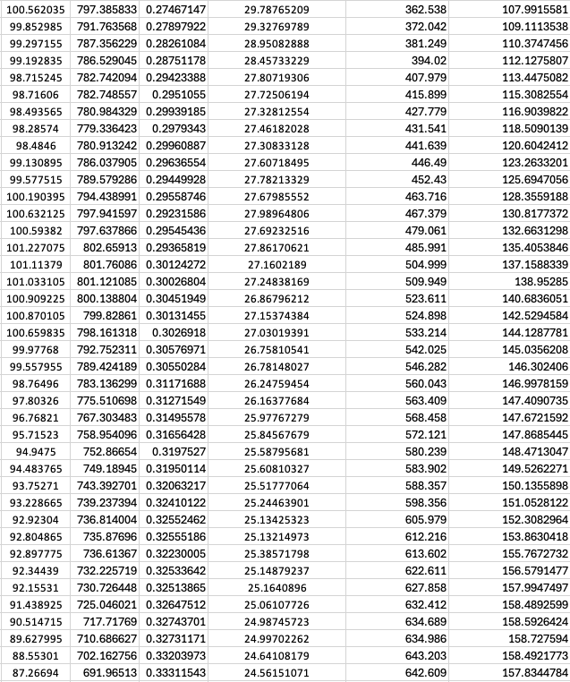
Table 6- Second Results Table continued
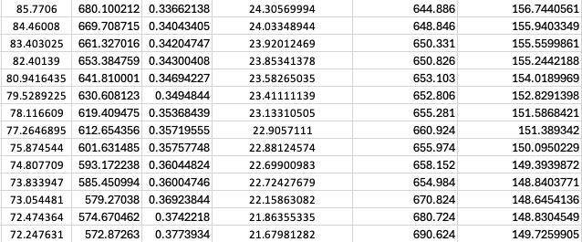
Table 7 - Facts contributing to the Dyno session
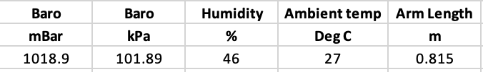

Graphs and Analysis
From the data that was gathered during the session I have created a few graphs to gain a better insight to how the engine performs.

SFC compared to Engine Speed

Figure 1 - SFC at different Engine Speeds
The graph above shows the SFC of the engine at different speeds which as you can see the SFC is higher when at low rpm, is lower in the middle and increases with high rpm. It is high when at low rpms as combustions is longer with the pistons moving slower meaning that the air fuel mixing isn’t as efficient and more heat is lost as more time is given in each cycle, leading to more fuel being consumed. In the middle where the SFC is at its lowest this is because the combustion timing is a lot better leading to less heat lost and more consistent fuel air mixtures and the crank angle is also at a much more ideal angle allowing for better downforce and pressure generated. The SFC then increases when high rpm is reached due to the volumetric efficiency dropping as the intake time decreases and restricts the air and fuel going into the system and friction can increase because of issues like lubrication shearing meaning more fuel is used to overcome this. For this I have used the formula given in the class notes by Andrew Harrison (2020), converting for the figures I have, which was the Fuel Flow Rate in l/min and using Highland Fuels (2017) figure for the specific gravity of fuel and is as follows:
$$SFC= \frac{Fuel Flow Rate*0.75*60}{Power}$$

Torque compared to Engine Speed

Figure 2 - Torque generated at different Engine Speeds
The graph above shows the Torque that has been generated while the engine is at different speeds, it shows that the torque rises while at lower rpm to hitting its peak at around 2300rpm and slowly declines as the rpm increases. The first and main reason this varies is because of the volumetric efficiency in the cylinders, with low rpm drawing out the cycles which results in airflow being slower making the fuel air mixture incomplete. When torque hits its peak the cycles are better timed making the fuel air mixture being correct and maximum torque being generated. As the rpm then gets higher the cycles have less time for air to enter making the torque start to lower. Combustion is another reason that the torque varies, and for similar reasons mentioned for the volumetric efficiency. While at lower rpm the cycles are slower leading to less efficient combustion, in the middle when the rpm hits the peak torque everything is aligned as it should be leading to maximum pressure and then when high rpm is reached there is less time to complete combustion making the torque lower. To work out the figure for Torque I used the equation given in the class notes by Andrew Harrison (2020), which goes as follows:
$$T=Load*Arm Length$$

Brake Power compared to Engine Speed

Figure 3 - Power generated at different Engine Speeds
The graph above shows the power generated at different engine speeds, it follows a fairly linear line until its peak and then it drops off slightly. The equation for power used for the graph above is taken from the class files by Andrew Harrison (2020), and is as follows:
$$\frac{2π*RPM*T}{60}$$
This shows the power that generated is due to the rpm getting higher as the torque stays in between roughly 70-105 throughout and does not fall off too quickly after hitting the maximum. Torque is produced on every cycle the engine runs so as the rpm starts to rise the power starts to rise as well until hitting its peak at roughly 4700rpm.

Conclusions Found
From the dynamometer session completed there were a number of conclusions to be found. Firstly, the Torque settles between 70-105N/m, peaking at roughly 2300rpm showing it will be quite responsive and can deliver at the lower speeds consistently. Second, the Power generated throughout follows a positive linear line when compared to the engine speed, peaking at around 44kW and does not fall off quickly. The SFC lowest between 1300-3000 rpm showing it’s efficiency at the lower rpm and increases until it reaches its highest when the rpm goes over 5000 showing the inefficiencies in place with the fuel consumption under higher loads and rpm.
The Lambda of the engine is lean for the majority but starts becoming Stoichiometric under higher rpm which is the ideal Lambda figure showing that the engine is running quite efficiently. The Overall Thermal Efficiency is of the engine is similar to the Torque produced in the way that it is least efficient while at lower rpm, peaks at roughly 2300rpm and slowly decreases while the rpm increases. This is what’s expected from the engine as efficiency lowers while there is more loss in the system and while its running at its peak there is less loss and improves the efficiency. Overall, the engine performs best across the board between 2000-3000rpm with the majority of figures peaking in that region.

Evaluation
As the dynamometer was out of commission when it was needed for results, this meant I was not able to undertake the session and collect the results myself and I have had to use slightly older data that was collected and given to me before it was broken. This sadly means that I do not know how I performed or how I would have performed while taking part in the session to collect the results. I was however given a YouTube video of how the data was collected by UWTSD WISA Workshops, meaning I have knowledge on how the session would have been carried out just not the physically doing it side. This is where I believe the investigation overall could’ve been improved. As instead of having up to date data and carrying the session myself, I have had to use old data that may not be the exact figures that the engine runs now and not having the knowledge of carrying out the session myself with just watching a video of how it’s done.

Conclusion
To conclude the chapters above have successfully met the aims and objectives that the introduction set out by processing results from a dynamometer session and finding out a number of values and producing graphs to gain a clearer understanding of the engines performance.

Reference List
Highland Fuels (2017). Unleaded Petrol Specification. https://www.highlandfuels.co.uk/uploads/documents/Unlead-Petrol-Specification.pdf [Accessed 17/3/26]
Andrew Harrison (2020). Handout Master 2020 Part 1. Handout Master 2020 Part 1.doc [Accessed 17/3/26]
UWTSD WISA Workshops (2020). Engine Dynamometer testing. https://www.youtube.com/watch?v=VD9OPoaAcJU [Accessed 21/3/26]

