UWTSD MBA (May/Nov 2019 intakes)
HKBM 7012 – Marketing Management

Assignment Title:
Consultancy Report – A study to develop a comprehensive 3-year marketing plan for Target Insurance Company, Ltd. to promote the General Insurance products.
“I, Jeffery Chan (student no. 1912529), certify this work is the result of my own investigations, except where otherwise stated. All references have been duly cited”


Signed: _____________________

Date: 29th June 2020

Executive Summary

This consultancy paper is carrying out a study to develop a Comprehensive 3-years marketing plan to boost up the sales volume of the general insurance products for Target Insurance Company, Ltd.
First, the PEST analysis will be conducted to identify and analyse the key drivers of change on the external business environment. This is to help Target to assess the client segmentation as well as understand (1) Where (2) When (3) What & (4) How to get the business under the current economic situation.
Second, we need to understand the Strength and Weakness of Target Insurance in the past and present mode. We are going to use the Case Study Approach – Problem-oriented method to identify the issues and problem of the marketing plan Target Insurance has been implementing. Combined with the SWOT analysis and then STP (Segmentation, Targeting & Positioning) of Target Insurance can be developed. We can then formulate the business strategy of the company and develop the new 3-years marketing plan with the newly identified/established 4ps (product, place, price and promotion) for the business acquisition of the company.

Table of Contents
Executive Summary 2
Introduction 4
The Company Background 4
Hong Kong General Insurance Market Overview 5
Study Area (Problems to be addressed and Opportunity to develop) 7
Situation Analysis 7
Insurance SWOT Analysis for the Recent Market Development 7
Micro Findings - TIHL’s Annual Report 2017 to 2019 (case study approach) 9
Existing Marketing Mix Strategy 10
Recommendation & Conclusion 11
Segmentation 11
Targeting 11
Marketing Mix (4ps) 12
The Promotion Plan 13
Advertising Channel Distribution 14
Marketing Action Plan focus on Products & Services promotion campaigns 14
Reference 15

Introduction

The Company Background

Target Insurance Company, Limited (“Target Insurance”) is a Hong Kong incorporated company wholly owned by TIHL. The principal activities of Target Insurance are accepting general insurance policies including motor insurance in Hong Kong. Target Insurance (Holdings) Limited thereafter “TIHL” is a public listed company in Hong Kong with stock code “6161” (TIHL Annual Report, 2019).
Before 2016, Target Insurance just have had the class licenses for Motor, Accident, Road Liability and Goods in Transit. Therefore, before 2016, Target Insurance focused to accept Motor Insurance especially Taxi and Public Light Bus. After Anglo Starlite Insurance Co. Ltd. was ordered to go liquidated on 8 May 2009 following an investigation of the Hong Kong Insurance Authority. Most of the Taxi and Public Light Bus insurance of Anglo Starlite was picked up by Target and hence the substantial growth of Target since then. The premium income of motor insurance has been increased substantially then and was ranked “number one” with its motor insurance premium income in 2010, and thereafter it was able to maintain the top three position in these years. Subsequently, Target Insurance become the market leader of the Taxi insurance book which is occupying around 55% of the market share in terms of gross premium written by year end of 2019 (TIHL Annual Report, 2019).
Target is striving to diversify the book of business since they are listed in the Stock Market in Hong Kong as stated in their prospectus for IPO. In Jan 2017, Target applied and successfully obtained the all other classes licenses and developed the non-motor business e.g. Property, Third Party Liability, Accident and Health, Employee’s Compensation & etc. This was to diversify the business book of business which was concentrated on Taxis and Public Light business.

Hong Kong General Insurance Market Overview

Hong Kong is the world's 43rd largest non-life market. In 2019, Hong Kong has 91 pure General Insurers and 21 composites (with both GI and Life licences) insurers. The market is largely foreign-owned. The leading non-medical insurers are AXA General, China Taiping and Zurich. Market concentration is unusually diffuse, giving the top five insurers a collective share over 40% in 2019 (AXCO, 2018)
Figure 1 – Gross Non-life premium, 2018 to 2024 (forecast), HK Insurance Report 2020 2Q Forecast (Fitch Solutions,2020)
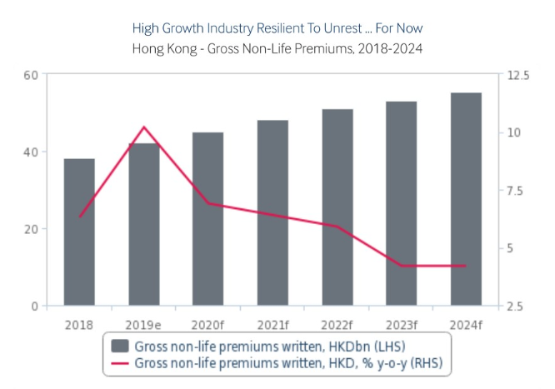
Source: HK Insurance Report 2020 2Q Forecast, Fitch Solutions 2020
Figure 2 – Non-life premiums will rise by 6.9% in 2020, following an estimated growth of 10.2% in 2019. Premiums will rise by 5.5% annually over the 2020-2024 period given HK’s overall per capita income level, non-life penetration is much lower than life sector – at around 1.6% GDP whilst with 16.4% in the life sector, HK Insurance Report 2020 2Q forecast (Fitch Solutions,2020).
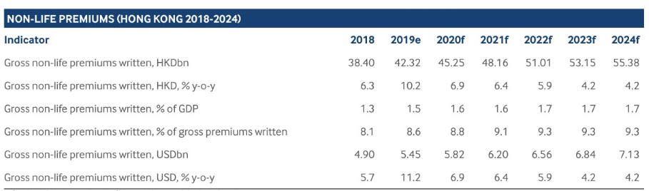
Source: HK Insurance Report 2020 2Q Forecast, Fitch Solutions 2020

Figure 3 – Health & Personal Accident account for 41.5% of premium written and then General Liability account for 25.4%, HK Insurance Report 2020 2Q forecast (Fitch Solutions,2020).
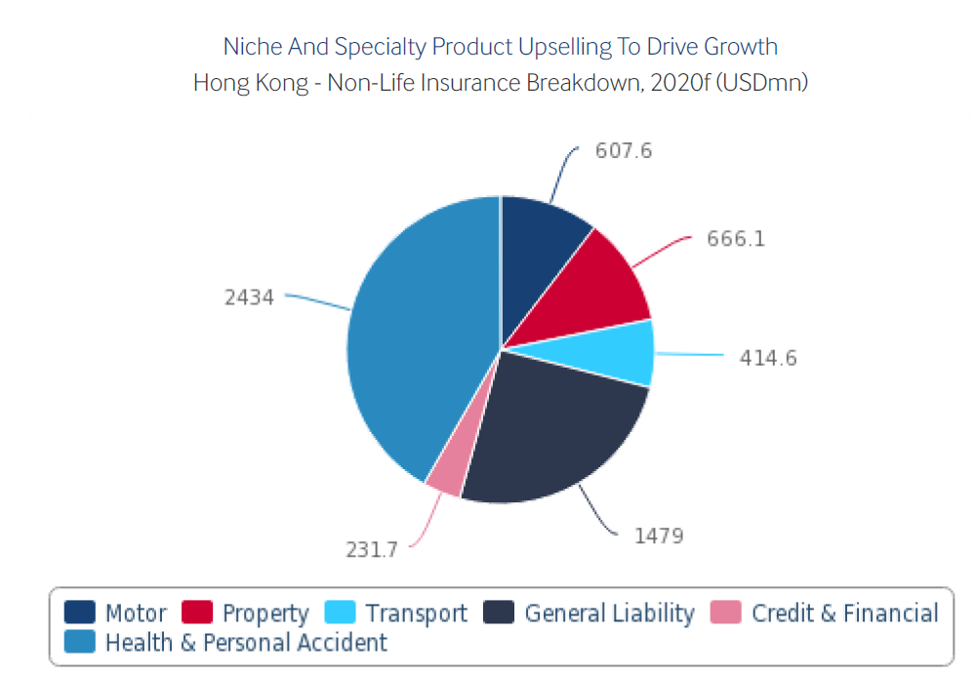
Source: HK Insurance Report 2020 2Q Forecast, Fitch Solutions 2020

Study Area (Problems to be addressed and Opportunity to develop)

Situation Analysis
(Analyse the existing environment and forecast the likely effect/impact in the coming 3 years.)

Insurance SWOT Analysis for the Recent Market Development
Since June 2017, Hong Kong Insurance Industry has entered a new era with the second commencement date of the Insurance Companies (Amendment) Ordinance 2015 was 26 June 2017. This was the date when the Independent Insurance Authority took over as the insurance regulator and when the Insurance Companies Ordinance was renamed the Insurance Ordinance (AXCO, 2018).
Figure 4 – Insurance SWOT Analysis, HK Insurance Report 2020 2Q forecast (Fitch Solutions,2020).
Strengths | Opportunities
Major Insurers are good established global/regional multinationals with better position enjoying economies of scale | Innovation in terms of product development or digital distribution is an ongoing opportunity.
Leading insurers can bring in overseas experience for the innovation in product development. | Sales of products to mainland visitors could be increased over the long term after the COVID-19 pandemic.
Multinational players are giving access to a broad range of expertise to Hong Kong | Health and Personal Accident insurance presents a significant growth opportunity, given the ageing demographics, increasing demand for private healthcare and growing penetration.
Hong Kong has special status to provide good connection between Chinese demand and global supply. | Reinsurance is a growing sector as promoted by Hong Kong Insurance Authority.
Hong Kong's standing as a finance/logistics/commercial centre of global importance boosts demand for many-corporate-related insurance lines. | Further sales and distribution of MPF and wealth management products would bring good advantages.
Although both the life and non-life segments are very sophisticated and developed by most metrics, premium continue to grow steadily and both areas remain profitable. | Hong Kong is attractive to multinational insurers to set up branch / subsidiary and target the Asian region particulary China.
The regulatory environment is world class with the establishment of Hong Kong Insurance Authority in 2016 (1)Developing the new risk-based capital (“RBC”) regime for Hong Kong. (2) Implementing the new direct licensing regime for insurance intermediaries. (3) Working with industry stakeholders in facilitating the implementation of the new policyholders protection scheme (AXCO, 2018). | Insurance Authority launched two pilot schemes to facilitate the development of "insurtech" in Hong Kong. "Insurtech Sandbox" and "Fast Track" speed up the development of new applications and the authorisation of digital-only insurers respectively (AXCO, 2018).
 | The introduction of the amendment bills to strengthen Hong Kong’s position as a global risk management centre and regional insurance hub. (Hong Kong Insurance Authority, 2020)
 | Product innovation and strong upselling are crucial drivers of strong growth in life and non-life cover.
 | New regulations that mandate liability cover benefit insurers
 | Insurance Authority are promoting Hong Kong Insurance company to develop insurance-related initiatives announced in the Outline Development Plan for the Guangdong-Hong Kong-Macao Greater Bay Area. (Hong Kong Insurance Authority, 2019)
 | Claims incurred out of the protesting events may happens again in 2020. It is understood that Civil Commotion and Riot coverage are not common in Hong Kong and a recent QBE study has shown that four-in-five SMEs hold coverage plans may not provide adequate protection to specific business needs and potential disruptions. (Lau, 2019).
 | COVID – 19 is another implication to the Hong Kong Insurance market in 2020. It let us aware that if the current insurance coverage is enough for protection as well as the catalyst to use/derive digital means for the communication between insurer and policyholders/customers. We are expecting the transformation is undergoing for more digitalisation.
Cont’d figure 4 - Insurance SWOT Analysis, HK Insurance Report 2020 2Q forecast (Fitch Solutions,2020).
Weakness | Threats
There are comparatively low retention ratios in the non-life sector. | Volatility in financial markets could deter savers.
A projected rise in chronic non-communicable diseases and therapidly ageing population, will result an increase of medical claims | The slowing down of the mainland economy as well as the tightening of credit in China may see a rise in claims in certain insurance lines
Some areas of non-life cover are naturally constrained by the territory's geographic limitations. | There could be an increase in the regulatory burden following the establishment of the IA that hinder the flexibility of acquiring new business
Real GDP growth in 2019 and 2020 will remain depressed. | Social unrest and potential developments in the relationship between Hong Kong and Beijing could harm the scope for an influx of demand from the mainland.
Non-life claims in 2019 and 2020 likely to spike significantly owing to property related damages due to the protests and severe climate conditions. | Singapore competes with Hong Kong in the bid to become the Asian hub of choice for multinational insurers.
 | Relations with mainland China remain at an all-time low. The conflicts are increasing as the political confrontation uprising.
 | Small to medium sized local insurance companies are facing the costing implication to follow the world class regulatory environment e.g. new risk-based capital. The number of insurers may be reduced in the coming five years.
Claims incurred out of the protesting events in the second half year of 2019 was roughly estimated to reach almost HK$600 million (Lau, 2019).
The social unrest may occur again in 2020 and may cause more claims for Hong Kong Insurance Industry.
 | COVID – 19 caused serve implication to the Hong Kong Insurance market in 2020. The outbreak has weakened the economy e.g. closing of SMEs, unemployment, and health care burden. The pandemic situation may worsen after the summertime.

Micro Findings - TIHL’s Annual Report 2017 to 2019 (case study approach)

Figure 5 - The breakdown of gross premium by classes from 2017 to 2019. (TIHL, Annual Report 2019). The taxi book of business as shown below around HK$245 million remains the main truck of the total book of business. Although the new products (other than taxi i.e. the grey and yellow bars) also growing rapidly from HK$72 million to HK$111 million on the other motor vehicles as well as other classes from HK$2 million to HK$96.8 million from 2016 to 2019.

Source: TIHL, Annual Report 2017 to 2019
This demonstrates that the growth of the new products needed to be accelerated to catch up the premium volume of Taxi so that the adverse result of Taxi will be diluted more prominently to help the current situation.
Figure 6 - showing the trending movement of the net insurance claims by classes of business / type of vehicles (TIHL, Annual Report 2019).
Source: TIHL, Annual Report 2017 to 2019
We can see that the insurance book of Taxi business is continuously in deficit (the Liner (Taxi) in blue colour) as the Net Insurance Claim increased significantly from less than HK$200 million in 2017 to more than HK$300 million in 2019.

Existing Marketing Mix Strategy
(Analyse and comment on the effectiveness of the existing marketing mix that it used to its target market.)
Given the concentration of Target Insurance in Motor business for the past 40 years, it has always been the intention of the TIHL/Target Insurance to explore opportunities to diversify and maintain a better spread of business given the situation as mentioned above. However, the growth of other general insurance products is not growing at the expecting speed to achieve the balance.
- To let the public aware that Target has been developed into a full General Insurance provider i.e. not just provide insurance for Taxi and Public Light Bus and hence bring up the brand name of Target in the market.
- To increase the competitiveness of Target amongst the other market players
- To review the marketing strategy of Target from 2016 to 2019 and do necessary revamping of the next 3 years from 2020 to 2022.
Objectives
- To re-position “Target Insurance” with a new image into Hong Kong market
- To announce the launch of full license in Jan 2017
- To increase brand awareness in the market and strengthen customers’ confidence level
- To facilitate the selling process in various distribution channels
The existing market plan has not been carried through in the past three years since 2017 as the focus is rebranding and re-position. There is no specific effort put on the new products and their features although it has said that some products such as travel insurance and home protection can be purchased online. There is no clear target client segmentation and the 4ps has not been clearly identified.

Recommendation & Conclusion
(Write a summary of the findings and a general assessment of the situation. Realistic and feasible recommendations supported by an empirical study must be provided)

According to the Insurance SWOT analysis, the findings of Target Insurance by the case study approach as well as the study on its marketing plan from 2017 to 2020 till mid-year.

Segmentation
- Age
- Salary – earning capability
- Social status – middle class looking for quality services
- Geographic location: Hong Kong local vs Greater Bay Area

Targeting
- Younger generation on the new products on personal protection especially on Travel Insurance, medical (hospitalisation and critical illness) and home protection
- Small medium size enterprise owner particular new start up needs insurance protection for cyber risk, losses due to social unrest, natural catastrophe loss and other unexpected risk so that the company can up & running after these events occurred
- Potential clients from the Greater Bay Area who demand better products & services in Hong Kong.

Marketing Mix (4ps)

Products | Place
- A series of new GI products with best coverage at competitive price to fit Hong Kong and Greater Bay Area  - Health Care Insurance to ease healthcare cost burden to face another round of pandemic of infectious disease  - Insurance for Home & Shop to face social unrest, civil commotion, riot and malicious damage.  - Excellent services including Customer care services, Claims services | - Offering Travel Insurance Through Facebook Messenger Chatbot  - Target’s online purchase platform (6161.com.hk)  - Walk in to Target’s office in Central  - Call in Target’s hotline and services will be provide by our Customer Service from 9am to 5:30pm, Monday to Friday.  - Through our intermediaries  - Through our corporate clients – affiliate group  - Through our services providers

Price | Promotion
- 20% discount for two products to be purchased  - 20% discount for two years’ period i.e. new policy plus one year’s renewal to be purchased in the first year  - Comparative to the market players in the HK market | - A new GI business unit with professional and seasoned team from the industry  - Brand Characters: Energetic, Passionate, Valiant, Moving forward, Keep going, Fast, Responsive, Reliable, Expert

The above 4Ps approach is a set of controllable variables that Target Insurance are going to use to influence the buyer’s responses (Singh, 2012)

The Promotion Plan

Advertising Channel Distribution
- Above the line advertising - Newspaper, Magazine, MTR, Bus, Taxi, Radio, outdoor
- Below the line advertising - Corporate kit, Sales kit, notification letter, marketing collaterals, promotion leaflet, souvenirs, email marketing, Advertorial, Promotion booth.
- Through the line advertising (digital) - Corporate website, SEM, Display ad, YouTube, Facebook, Instagram, Linkedin, WeChat and Google Search.

Marketing Action Plan focus on Products & Services promotion campaigns
- Advertising via mass media
- Product kits for intermediaries
- E-commerce platform
- Promotions for different distribution channels
- Trial program to build customer pool & gain customer experience
- Ongoing brand exposure to build up the brand awareness and customer confidence level
- Product launch (Phase 2 & 3…)
- Ongoing Products promotions for distribution channels
- Cross selling & Upselling activities on existing customers
- More effort to build direct market
- Enhance brand image – E.g. social responsible, environmental friendly company

Reference

- The Target Insurance (Holdings) Limited, Annual Reports 2019, 2018, 2017, 2016, 2015 & 2014.
Available at: http://www.targetinsholdings.com/en/reports.php

- Hong Kong Insurance Authority, Annual General Business Statistics, 2019.
Available at : https://www.ia.org.hk/en/infocenter/statistics/annual_general_business_statistics.html

- Hong Kong Insurance Authority, Quarterly Release of Provisional Statistics for General Business, 2019 to 2013
https://www.ia.org.hk/en/infocenter/statistics/quarterly_release_of_provisional_statistics_for_general_business.html

- Hong Kong Insurance Report - Q2 2020. 2020. London: Fitch Solutions Group Limited.

- Olano, G. (2020) Hong Kong insurance industry posts significant growth in premiums. Available at: https://www.insurancebusinessmag.com/asia/news/breaking-news/hong-kong-insurance-industry-posts-significant-growth-in-premiums-216841.aspx (Accessed: 2 June 2020)

- Yvonne, L. (2019) Hong Kong’s insurers hit by US$76.5m of protest claims. Available at : https://insuranceasianews.com/hong-kong-insurers-see-hk600m-of-protest-claims/ (Accessed date : 27 May 2020)

- AXCO (2018), Insurance Market Report, Hong Kong: Non-Life (P&C)
- PANDYA, S., 2017. Improving the learning and developmental potential of SWOT analysis: introducing the LISA framework. Strategic Direction, 33(3), pp. 12-14.

- Dolnicar, S., Grün, B., & Leisch, F. (2018). Market segmentation analysis. In Market Segmentation Analysis (pp. 11-22). Springer, Singapore.

- ZHOU, C. and AMANDA LEE , , Apr 11, 2019-last update, China's middle class still seeking protection in Hong Kong's insurance market despite forex crackdown [Homepage of South China Morning Post Publishers Limited], [Online].

- Four Steps to Client Segmentation. 2017. Wealth Management, .

- R, K.B. and GUPTA, D., 2018. Essentials of Marketing Management in LIS. Library Philosophy and Practice, , pp. 1.

- Singh, M. (2012). Marketing mix of 4P'S for competitive advantage. IOSR Journal of Business and Management, 3(6), 40-45.

- VERMA, Y. and SINGH, M.R.P., 2017. MARKETING MIX, CUSTOMER SATISFACTION AND LOYALTY: AN EMPIRICAL STUDY OF TELECOM SECTOR IN BHUTAN. Indian Journal of Commerce and Management Studies, 8(2), pp. 121-129.

- Londhe, B. R. (2014). Marketing mix for next generation marketing. Procedia Economics and Finance, 11(1964), 335-40.

- CHAN, O., 2019, Sep 06. Going virtual - insurance on the bandwagon. China Daily, 8.

- Anonymous2018, Sep 10. Bay area provides insurers potential. M2 Presswire.

- Anonymous2019, Feb 17. Starr Insurance Offering Travel Insurance Through Facebook Messenger Chatbot in Hong Kong. PR Newswire Asia.

- Anonymous2019, Feb 08. Hong Kong's reinsurance industry boosted by favourable mainland Chinese regulation: Preferential rules have helped Hong Kong firms expand quickly and fend off global competition. South China Morning Post. ISSN 10216731.

