NOX MODEL
IBRAHIM MULAHELLA

M3X8824
Malcolm Mcdonald

Contents
Introduction 2
Formation of NOx 3
NOx model on Excel 4
Boundaries 4
Enthalpy equations 4
Enthalpy and temperature calculator 5
Flame temperature with increasing pressure 6
NOx Parts Per Million 7
EGR 9
Analysis 11
References 11
Appendix 12

Introduction
Nitrogen Oxides (NOx) are air pollutants produced by internal combustion engines. The term NOx is used to describe molecules containing a single nitrogen atom and one or more oxygen atoms, namely Nitric Oxide (NO) and Nitrogen Dioxide (NO2). NOx gasses contribute to the formation of acid rain and smog.
This report discusses the construction and calculation of NOx particles produced by an engine running lean and on low load. The effects of adding EGR (exhaust gas recirculation) will then be analysed.

Formation of NOx
The Formation of NOx is dependent on a series of reactions. As temperatures increase during a combustion, CO2 and H2O molecules become more active and vibrate. When the vibration energy exceeds the bond energy, the molecules become dissociated and release their O atoms which become radicalized.
$$H2O=H2+O$$
$$CO2=CO+O$$
As the O atoms are radicalized and unstable, they attack the N2 molecules. The following reactions can go both ways.
$$N2+O=NO+N$$
$$N+O2=NO+O$$
$$N+OH=NO+H$$
Zeldovich suggested the importance of the first two reactions and later Lavoie, Heywood and Keck added the last reaction of Nitrogen and Hydroxyl radical to the Zeldovich mechanism which makes a significant contribution to the formation of NOx.
The Zeldovich mechanism states that the production of NOx in the burned zone of a combustion is controlled by reactions between N2 molecules and O atoms. The reaction rate can be calculated using chemical kinetics and Temperature:
$$\frac{d\left[NO\right]}{dt}=4.17×{10}^{13}×\left[N2\right]×{\left[O2\right]}^{0.5}×exp×(-\frac{67837}{T})$$
The formula shows that $\frac{d\left[NO\right]}{dt}$ depends greatly on the exponential number and the temperature. A higher burn temperature produces more radical O atoms and therefore increases the rate of formation of NOx.

NOx model on Excel

Boundaries
The production of NOx was to be conducted on a given engine the specifications:
- 1600cc four cylinder, naturally aspirated.
- Engine speed is at 1800 RPM
- Volumetric efficiency is 40%
To allow the calculations to be made, the following assumptions were used:
- Universal gas constant is 8316 J/KMOL/K
- Polytropic index for burned zone up to peak pressure is 1.2
- Homogeneous mixture in the cylinder.
- Starting flame temperature is adiabatic (all heat released is used to warm up products)
- $PV^{n}=constant$ as pressure rises in burned zone
The calculations carried out were for the following instances:
- NOx concentration levels ([NOx] – KMOLS/m³) is to be calculated for a fuel equivalence ratio (ф) on the lean side from ф = 0.6 to 0.95 with 0.05 steps and from ф = 0.95 to 0.99 with 0.01 steps.
- The calculations made are from the start of combustion with a cylinder pressure of 10 BAR and increasing in a linier pattern with an increase of 2BAR per degree up to 50BAR.
- The addition of EGR will be calculated at ф = 0.95 from 0% - 30% in increments of 1%.

Enthalpy equations
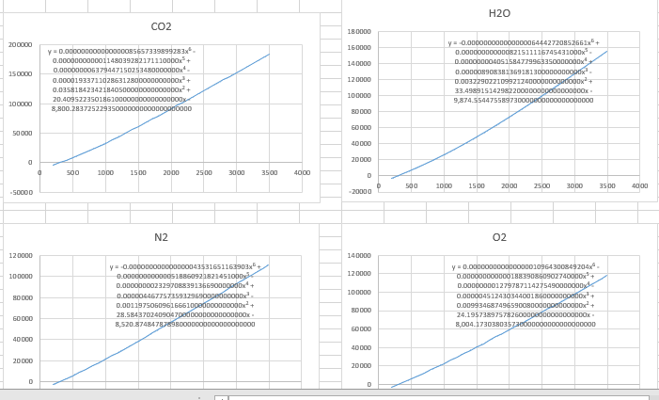
To accurately calculate the temperature on an Excel spreadsheet, the NASA Tables values were graphed and an equation was derived from the curve. This equation was then used to calculate the enthalpy required per degree of temperature.
Figure 1, enthalpy equations

Enthalpy and temperature calculator
To easily calculate the products produced at each fuel equivalence ratio, a calculator was constructed whereby the products of a reaction can be calculated instantly by changing the ф value.
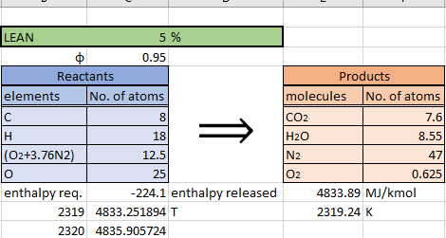
The products results can then be used to calculate the enthalpy released and then the adiabatic flame temperatures. The enthalpy required value used was taken from the standard enthalpy of formation table.
By using the net enthalpy released value, the flame temperature could be found on the table created using Excel’s index and match funtions.
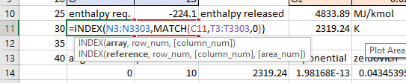

The values were then interpellated to calculate the exact flame temperature.
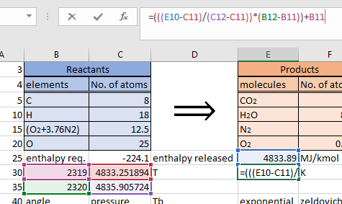
The adiabatic flame temperatures calculated for each fuel equivalence ratio are as follows.
φ | Temp (K)
0.6 | 1671.343
0.65 | 1770.879
0.7 | 1867.853
0.75 | 1962.428
0.8 | 2054.743
0.85 | 2144.917
0.9 | 2233.052
0.95 | 2319.24
0.96 | 2336.252
0.97 | 2353.189
0.98 | 2370.052
0.99 | 2386.843
1 | 2403.561
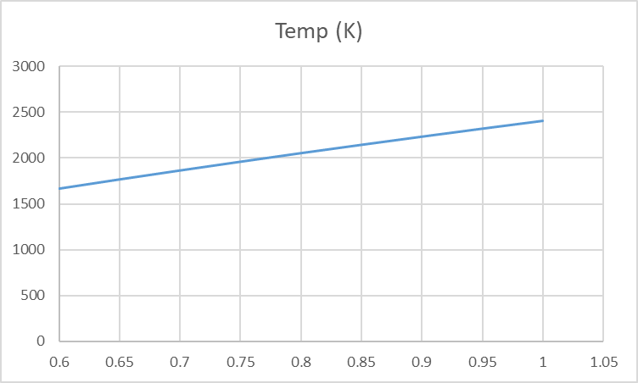

Flame temperature with increasing pressure
The temperature increase per degree of crank angle is calculated by using the formula
$$T2=T1×{\left(\frac{P2}{P1}\right)}^{n-\frac{1}{1}}$$
Where ‘n’ is the polytropic index of 1.2. Bellow are the flame temperatures for ф =0.85

NOx Parts Per Million
To calculate [N₂] and [O₂] in the burned zone, the formulas used are:
$$\left[N2\right]=\frac{α×47}{Vcyl}$$
$$\left[O2\right]=\frac{α×X}{Vcyl}$$
Where:
- X = Free O₂
- Vcyl = cylinder volume assuming burned volume is 40cc
- α = multiplying constant (n/number of KMOL)
The number of KMOLS in the engine is calculated using the ideal gas law:
Where Ru = 8316 J Kmol⁻¹ K⁻¹
$$PV=n×Ru×T$$
$$n=\frac{PV}{Ru×T}$$
$$n=\frac{({10}^{5}×160×{10}^{-6})}{(8314×293)}=6.57×{10}^{-6}$$
The results can then be used to calculate the amount of NOx produced per degree of crank rotation

The total sum of the NOx parts per million is calculated by
$$NOx PPM=\frac{total KMOLS}{(KMOLS exhaust×α)}×10^{6}$$
The results were put in a table as follows
φ | PPM
0.6 | 50.5669161
0.65 | 281.163043
0.7 | 1232.89635
0.75 | 4428.63309
0.8 | 13369.5685
0.85 | 34365.6989
0.9 | 74692.6285
0.95 | 128096.428
0.96 | 135423.811
0.97 | 138193.272
0.98 | 132552.688
0.99 | 109785.051
1 | 0

EGR
Exhaust gas recirculation is used to reduce the amount of NOx produced. The added EGR reduces the burn temperature by adding mass to the reaction
$$PV=mRT$$
$$T=\frac{PV}{mR}$$
By increasing the mass, the total temperature calculated will reduce which results in less NOx being produced.
The results of adding EGR to the reaction can be seen in the NOx PPM and flame temperature.
EGR | PPM | Temp (K)
0.00% | 133580.069 | 2323.462317
1.00% | 111511.067 | 2305.38221
2.00% | 93150.3181 | 2287.643104
3.00% | 77864.2543 | 2270.23525
4.00% | 65129.3416 | 2253.149261
5.00% | 54512.6617 | 2236.376101
6.00% | 45655.9807 | 2219.907074
7.00% | 38262.6393 | 2203.733784
8.00% | 32086.8164 | 2187.848161
9.00% | 26924.6603 | 2172.242406
10.00% | 22607.0171 | 2156.909014
11.00% | 18993.4213 | 2141.84073
12.00% | 15967.1586 | 2127.030568
13.00% | 13431.1773 | 2112.471765
14.00% | 11304.7307 | 2098.157823
15.00% | 9520.58471 | 2084.082436
16.00% | 8022.72538 | 2070.239523
17.00% | 6764.45548 | 2056.623213
18.00% | 5706.81887 | 2043.22783
19.00% | 4817.29668 | 2030.047884
20.00% | 4068.72637 | 2017.078058
21.00% | 3438.40598 | 2004.313218
22.00% | 2907.34969 | 1991.748403
23.00% | 2459.66884 | 1979.378798
24.00% | 2082.05967 | 1967.199754
25.00% | 1763.37522 | 1955.206755
26.00% | 1494.27061 | 1943.395438
27.00% | 1266.90699 | 1931.761579
28.00% | 1074.70461 | 1920.301074
29.00% | 912.137845 | 1909.00996
30.00% | 774.563005 | 1897.884371

Analysis
The results of the calculations show that the formation of NOx increases as the temperature increases. The NOx particles increase and peak just before the stochiometric point. This is because there is more free O2 and a slower burn time allows more reactions to take place.
By adding EGR to the reaction, the NOx reduces as the EGR adds mass to the combustion reactants which in turn reduces the flame temperature and the chances for NOx to form.

References
Heywood, J. B. (1988). Internal Combustion Engine Fundementals . McGraw-Hill Education.
Sorathia, H. R. (2012). EFFECT OF EXHAUST GAS RECIRCULATION (EGR) ON NOx . International Journal of Advanced Engineering Research and Studies.
Stone, R. (1992). Introduction to internal combustion engines. The Macmillan Press Ltd
https://en.wikipedia.org/wiki/NOx

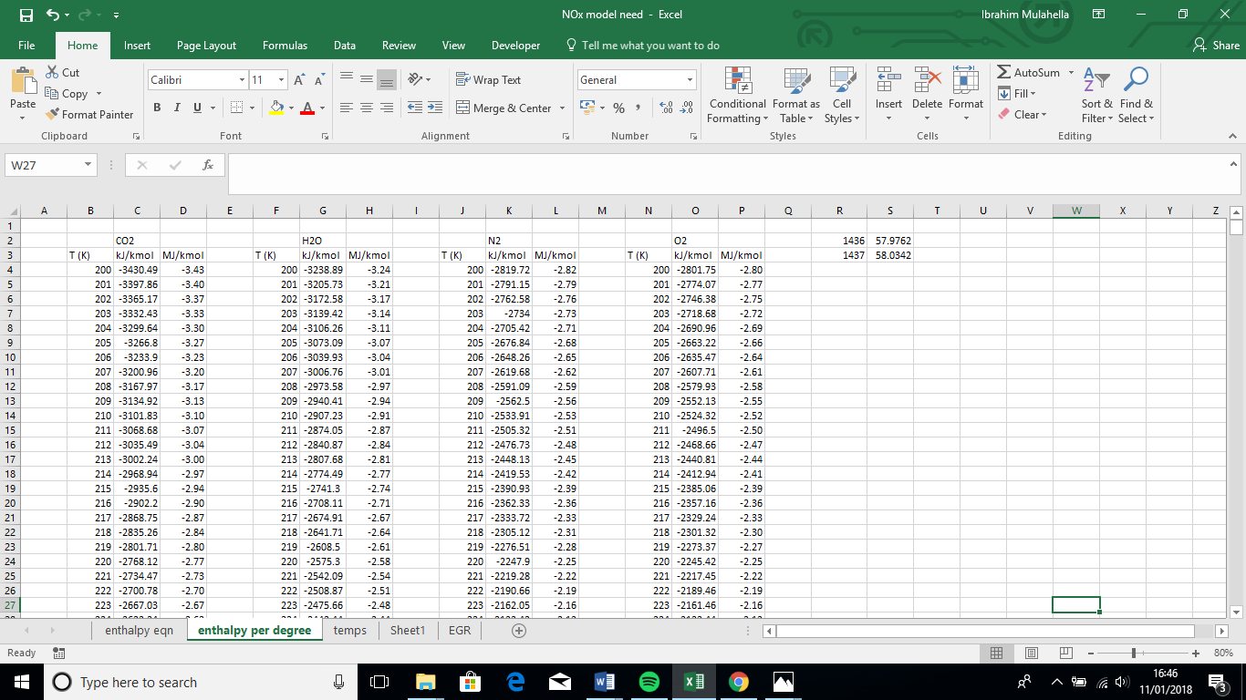
Appendix


