Matthew Hope (2509337)

Computer architecture and operating systems

Introduction

This report looks at the main features and uses of operating systems, focusing on both Windows and Linux. It explains the key functions of operating systems and shows how command line interfaces (CLI) and scripting can be used to manage systems and automate tasks. The report includes examples of commands and scripts, supported by screenshots and explanations. It also uses information from different sources to support understanding.

Contents
Introduction 1
Key functions of an operating system 3
Use of Windows OS CLI commands 4
Use of Linux OS CLI commands 9
Use of windows OS Scripts 12
Use of Linux OS scripts 15
Online certified course 18
Conclusion 19
References 20

Key functions of an operating system

There are many different operating systems in use on a day-to-day basis. An operating system is software that manages computer hardware and software resources. [1] The operating controls and ensures that the software and hardware work together efficiently in the system. Without the operating system the computer would not be able to function properly.
An Operating System (OS) is software that acts as a bridge between the user and the computer hardware. It provides an environment where users can execute programs efficiently and conveniently.[2] An operating system includes process management, memory management, file management, and device management.
Process management allows the operating system to control the execution of multiple programs at the same time. Memory management ensures that each program gets sufficient memory while preventing conflicts between programs. File management helps organize, store, retrieve, and protect data on storage devices. Device management controls input and output devices such as keyboards, printers, and monitors.
There are many ways to check the operating system on a device. Bellard.org is one way to check. It provides you with details of what is currently running on the system and with the use of batch commands. This tool gives you the opportunity to view diagnostics on the current system alongside other information with the entry of certain batch commands.
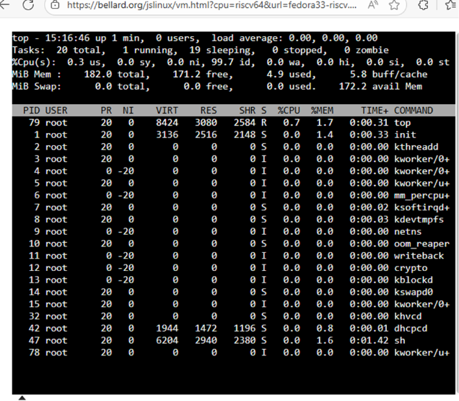
Figure 1:

Another way of checking the operating system is by going into the task manager. The same concept as Bellard.org, however you can see which app is currently in use, its effect on the system and on the components.
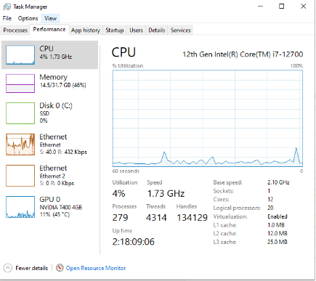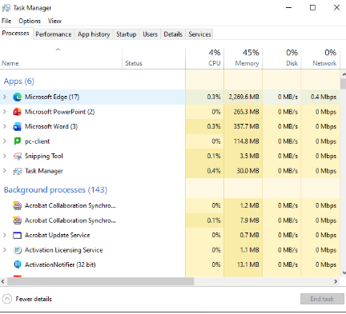
Figure 2 Figure 3

The most common operating systems used are the batch operating system, time sharing operating system, real time operating system and the network operating system. A batch operating system is created to process jobs in groups without user interaction. It collects similar jobs stores them in a queue and executes them one by one.
A time-sharing operating system allows multiple different users to use the system at the same time. A time-shared operating system uses CPU scheduling and multi-programming to provide each user with a small portion of a shared computer at once.[3]

A real time operating system was created to respond quickly. It is used in critical applications such as medical equipment, CCTV, and motor vehicle navigation. A real-time operating system (RTOS) is a specialized operating system designed to handle time-sensitive tasks with precise timing constraints, ensuring predictability and stability.[4]

A network operating system (NOS) is a specialized operating system for a network device such as a router, switch or firewall.[5] It allows computers connected through a network to communicate, share files, printers, and other resources. A network operating system also provides security, user authentication, and access control. It is commonly used in offices, schools, and organizations to manage multiple computers efficiently over a network.

Single-user systems support one user, while multi-user systems support many users simultaneously. They are essential for efficient, secure, and reliable computer system operation in modern technology.

Use of Windows OS CLI commands
This section shows different Windows CLI commands using Batch and/or PowerShell. The commands cover areas like process management, file and directory management, network testing, user management, and task scheduling. Each command includes a screenshot and a short explanation to show how it works.

Figure 4 “Dir” batch command
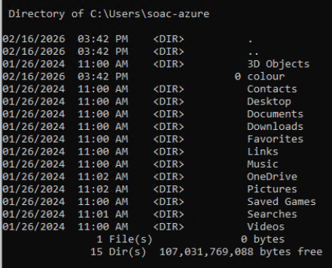
The dir command is used to display a list of files and folders in a directory. It shows information such as file names, sizes, and dates in the current or specified folder.
Figure 5 “Color fc command”
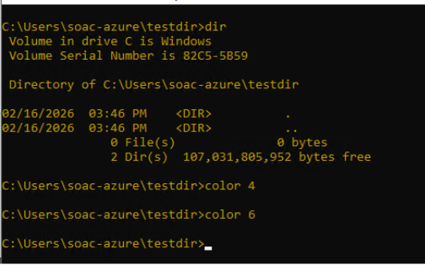
The color command changes the text and background color of the Command Prompt window, and the fc command compares two files and displays the differences between their contents.
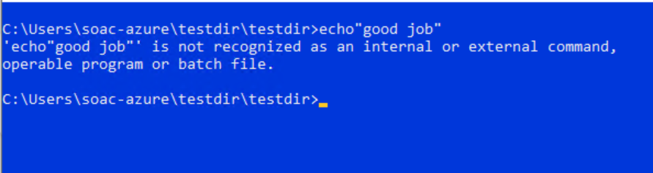
Figure 6 “Echo command”

The echo command is used to display messages or text on the command prompt screen and to turn command echoing on or off.
Figure 7 “Tasklist command”
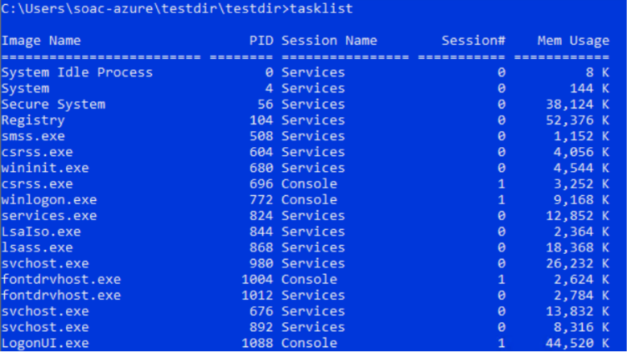
The tasklist command is used to display a list of all currently running processes on the system, including their process names, process IDs and memory usage.
Figure 8 “Ping command”
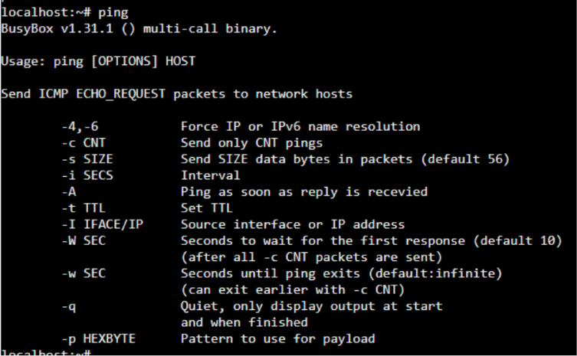
The ping command is used to test network connectivity by sending packets to a specified IP address or domain and reporting response times and packet loss. It tests network connectivity between two devices by sending ICMP echo requests. [6]

Figure 9 “IP configuration command”
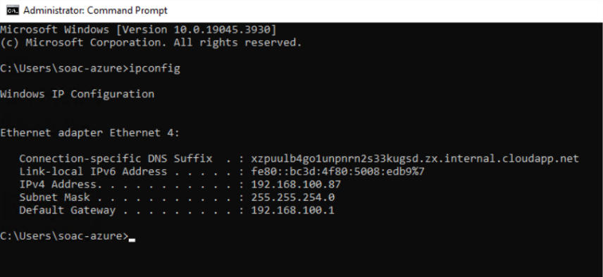
The ipconfig command is used to display a computers TCP/IP configuration. You can display the IP info for a single or all network cards installed on a computer. [7]
Figure 10 “Netstat command”
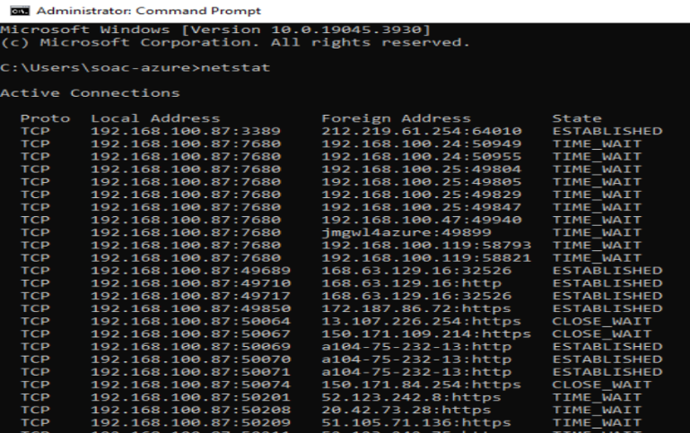
The netstat command is used to display active network connections, listening ports, and network statistics on the computer.
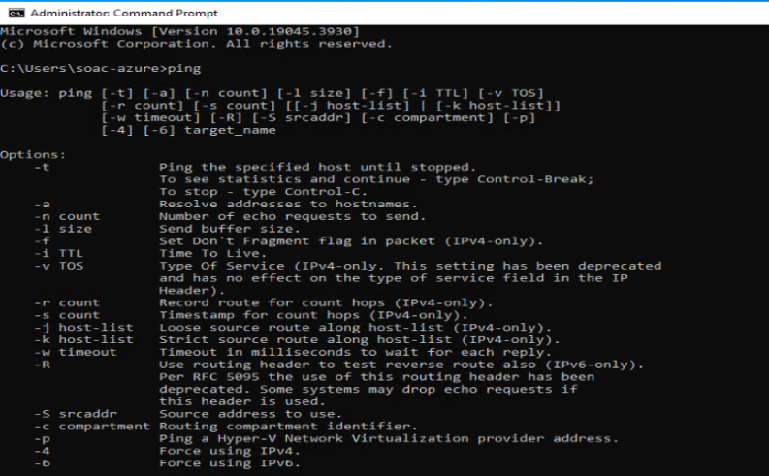
Figure 11 “Ping command”

The ping command is used to check the connectivity between your computer and another device or server by sending test packets and reporting response time and packet loss.

Figure 12 “Wmic process command”
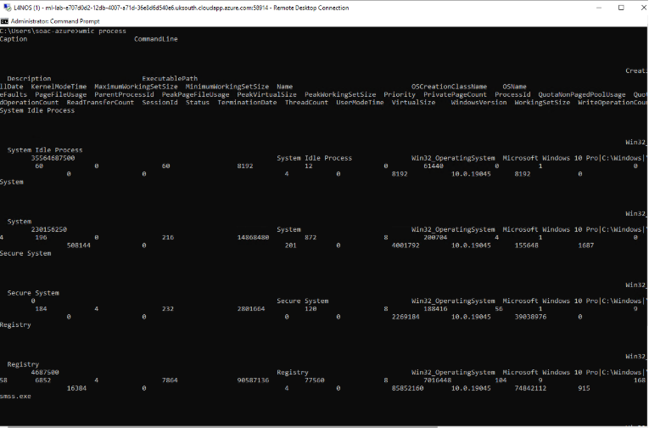
The wmic process command is used to display detailed information about running processes, such as process ID, name, memory usage, and status, and can also be used to manage processes from the command line.
Figure 13 “Tracert command”
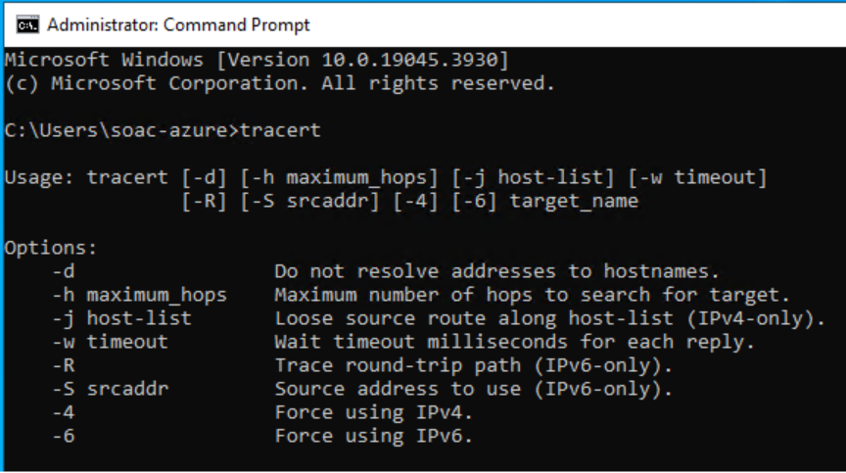
The tracert command in Microsoft Windows is used to trace the route that packets take from your computer to a destination IP or domain, showing each hop along the network path and helping identify network delays or failures.

These commands demonstrate how Windows Command Line can be used for a variety of system tasks. They allow users to manage files, monitor running processes, and adjust the appearance of the terminal. They also provide tools for checking network connections and diagnosing issues by tracking routes, testing connectivity, and viewing IP details. Overall, they highlight how the CLI can support both system management and basic troubleshooting in a simple, text-based environment.

Use of Linux OS CLI commands
The Linux Bash command line is a text-based interface used to control the system and perform tasks efficiently. It allows users to manage files, run processes, and monitor system activity using simple commands instead of a graphical interface. This section demonstrates several common Linux commands and their options. [8]
Figure 14 “Ps aux bash command”
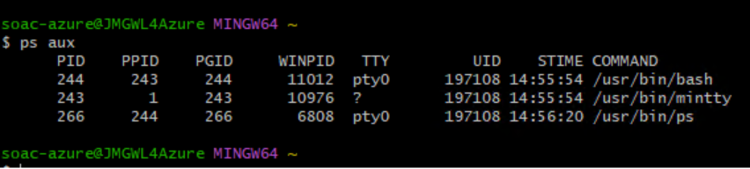
The Ps aux command shows a list of all currently running processes on your system, including their IDs, CPU usage, and who started them.
Figure 15 “ls pwd command”
The ls pwd command lists the files and folders in the current directory. It helps you see what is inside a folder. And prints the full path of the current working directory (shows where you are in the system).
Figure 16 “Less command”
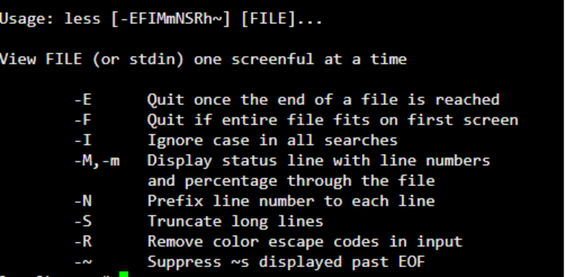
The less command in Bash is a terminal pager used to view text files or command output one screen at a time. It displays file contents in a scrollable interface and lets you move forward and backward and is efficient for viewing large files without loading everything at once.

Figure 17 “ip a command”
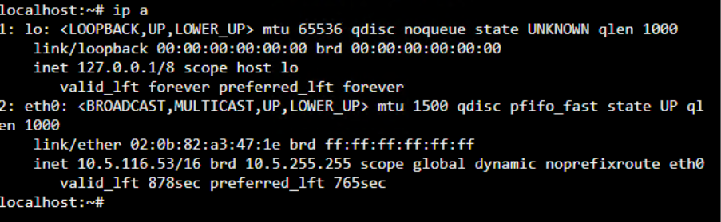
The command ip a (short for ip address) is used in Linux to display network interface and IP address information.
Figure 18 “Top bash command”
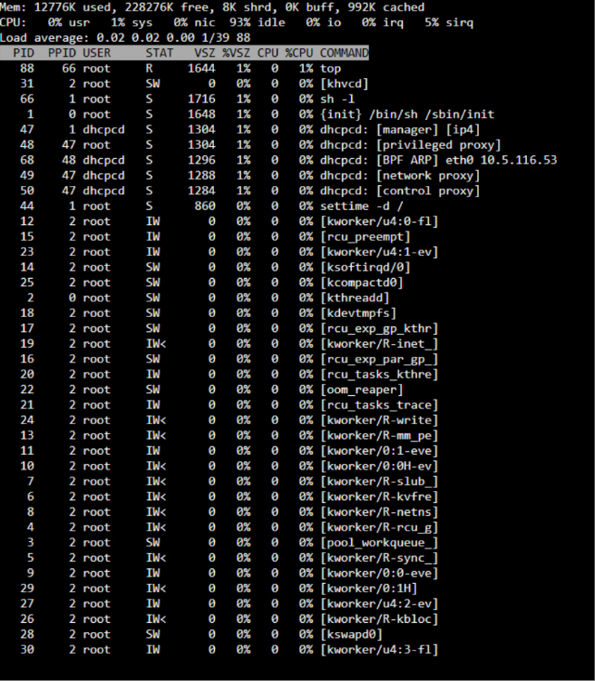
The top command in Bash is used to monitor system processes and resource usage in real time. It shows a continuously updating view of what’s happening on your system like live task manager.
Figure 19 “free-h command”
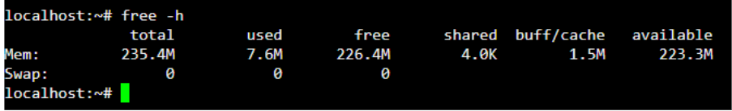
The free -h command in Bash is used to display the system’s memory usage in a human-readable format. It shows how much RAM and swap space is used, free, and available.
Figure 20” mp stat command”
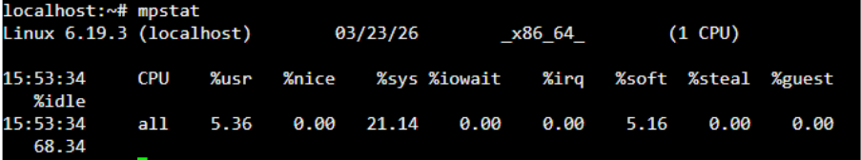
The mpstat command in Bash is used to report CPU usage statistics for each processor on a system.

Figure 21 “uname-a command”
uname -a prints all available system information in one line including the kernel name, hostname, kernel release, kernel version, machine hardware name, processor type, hardware platform, and operating system.
Figure 22 “free command”
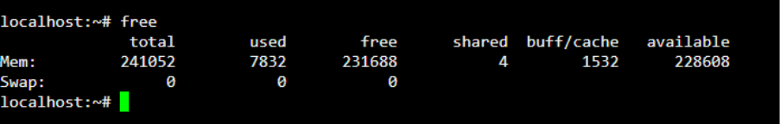
The free command in Linux displays how much memory your system has, how much is used, how much is free, and how much is tied up in buffers and cache.
Figure 23 “wget command”
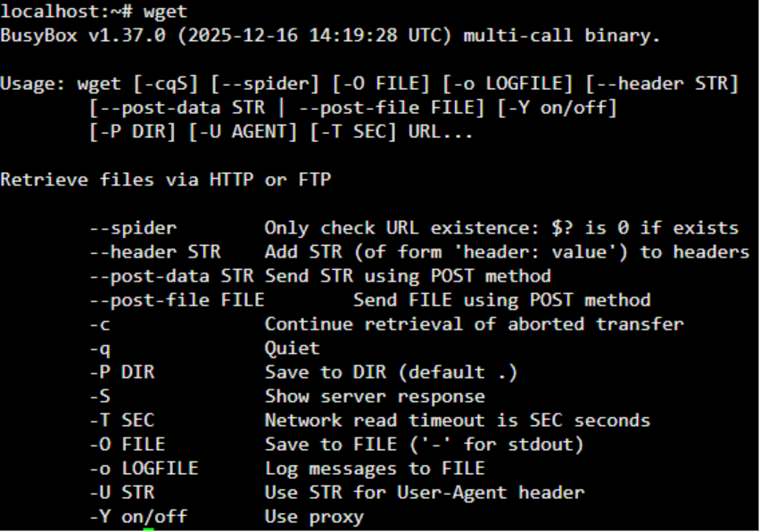
Wget is a command‑line tool used to download files from the internet using HTTP, HTTPS, or FTP. It’s non‑interactive, meaning it works even when you’re not logged in, making it perfect for scripts, servers, and automation.
These Linux Bash commands show how the terminal is used to manage files, monitor system activity, and view system and network information. They also include tools for checking performance, memory, and downloading files, highlighting how the command line supports efficient system control and administration. [9]

Use of windows OS Scripts
Windows OS scripting using Batch lets users automate simple tasks on a computer. It can run commands, take user input, and make decisions automatically. This section shows how a Batch script works using football teams as an example.
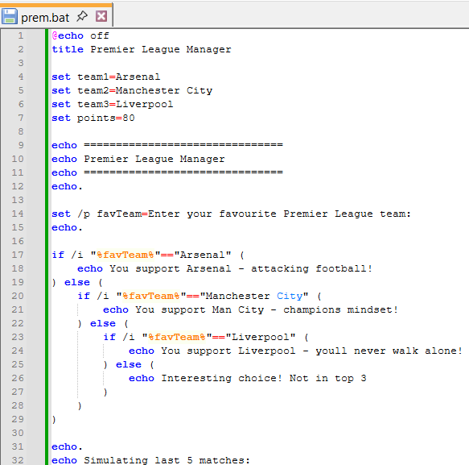
Figure 24 (Created Script screenshot)

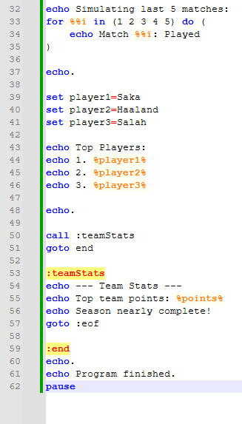

Figure 25 (Created script screenshot part 2)

This script starts with @echo off, which just makes the screen cleaner by not showing every command as it runs.
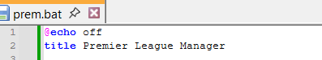
Figure 26

The script uses variables like team1, team2, and team3 to store football team names such as Arsenal, Manchester City, and Liverpool. Variables are useful because they let you store information and use it later in the script. [10]
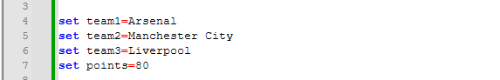
Figure 27
The script also uses set /p, which lets the user type in their favourite team. The answer is saved in a variable called favTeam, making the script interactive.
Figure 28
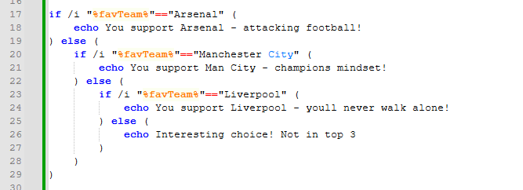
An IF statement is used to check what the user typed. For example, if the user enters “Arsenal”, the script prints a message about Arsenal. IF statements are used to make decisions in scripts based on conditions. [11]

Figure 29

The script also uses a FOR loop, which repeats a task several times. In this case, it shows 5 match messages. Loops are useful because they save time and avoid repeating code manually.[12]
Figure 30
There is also a simple function using a label called: teamStats. This is called later using call, and it shows extra information like team points.
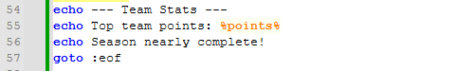
Figure 31
Overall, this script is at a basic level of Batch scripting, designed for beginners. It uses simple commands like variables, input, IF statements, loops, and labels. The script is not advanced but shows how Windows Batch can still perform useful tasks like taking user input, making decisions, and repeating actions. It helps demonstrate the core ideas of programming in a simple and easy way before moving on to more advanced scripting like PowerShell or more complex Batch programs.
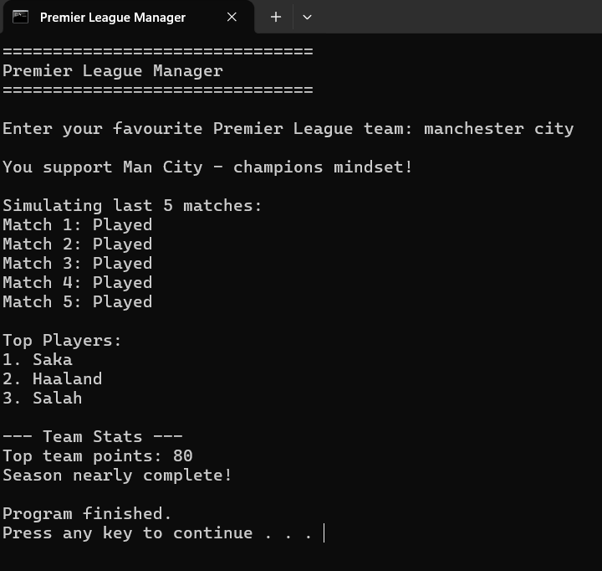

Figure 32

Use of Linux OS scripts
Bash scripting is a way of automating tasks in Linux by writing commands into a script file instead of typing them manually. This makes processes faster and more efficient.[13] In this task, a simple weather-based Bash script is used to demonstrate key features such as variables, functions, user input, conditional statements, and loops.
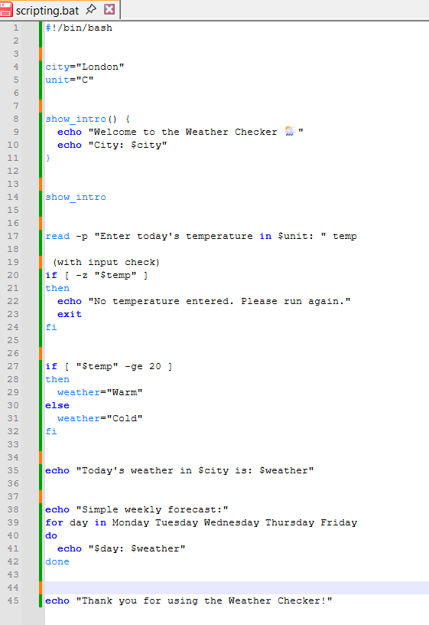

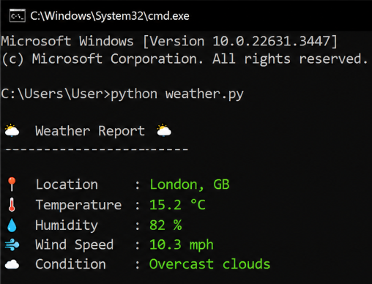
Figure 33 (Weather script) Figure 34 (Script running)



Figure 35
The script starts by defining variables. The variable city="London" stores the location used in the script. This means the city name can be reused without typing it again. The variable unit="C" represents the temperature unit (Celsius), making the script clearer for the user. Variables help keep the script organised and easy to change. [14]


Figure 36
A function called show_intro () is used to display a welcome message. Functions group commands together so they can be reused. In this case, it prints a message and shows the city name using the variable. This improves readability and reduces repetition in the script.
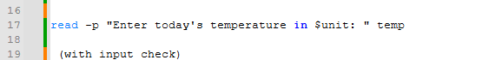
Figure 37
The read command is used to take input from the user. The script asks the user to enter the temperature and stores it in the variable temp. This makes the script interactive because the output changes depending on what the user enters.
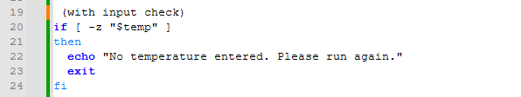
Figure 38
An if statement checks if the user has entered a value. If nothing is entered, the script stops using the exit command. Another if statement checks if the temperature is greater than or equal to 20.
If it is, the script displays a message saying the weather is warm; otherwise, it displays a message saying the weather is cold. This allows the script to make decisions based on input.[15]

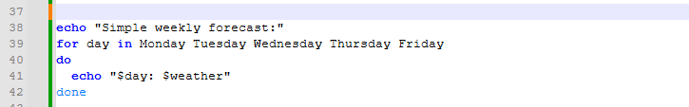
Figure 39
A for loop is used to repeat a message a set number of times. For example, it may print a weather update three times. Loops are useful for repeating tasks without rewriting the same code.

Overall, this Bash script demonstrates basic Linux scripting features including variables, functions, user input, if statements, and loops. These features help automate tasks and make scripts more efficient and reusable.

Online certified course

Course completed: Labex.io: Linux for Beginners: Basics in 10 Quick Labs
Figure 40

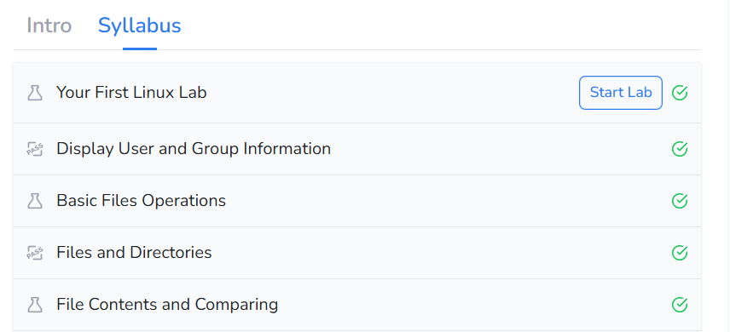
Figure 41

Conclusion
This report explained the main functions of operating systems and how Windows and Linux are used to manage computer systems. It covered important features such as process management, memory management, file management, and device management, along with different types of operating systems including batch, real-time, time-sharing, and network operating systems.

The report also demonstrated how CLI commands can be used in both Windows and Linux to manage files, monitor processes, and troubleshoot networks. In addition, the Batch football script and Bash weather script showed how scripting can automate tasks using variables, user input, loops, and IF statements.

Overall, the report showed that operating systems, command line tools, and scripting are important for managing and controlling computer systems efficiently.

References
[1] ChatGPT, “ChatGPT,” accessed Apr. 29, 2026.
[2] GeeksforGeeks – Functions of Operating System, accessed May 3, 2026.
[3] GeeksforGeeks – Time Sharing Operating System, “Time Sharing Operating System,” accessed Apr. 30, 2026.
[4] IBM – What is a Real-Time Operating System (RTOS)?, “What is a Real-Time Operating System (RTOS)?,” accessed May 5, 2026.
[5] Wikipedia – Network Operating System, “Network operating system,” accessed May 1, 2026.
[6] Active Directory Pro – 50 Basic Windows Commands with Examples, “50 Basic Windows Commands with Examples,” accessed Apr. 28, 2026.
[7] Active Directory Pro – 50 Basic Windows Commands with Examples, “50 Basic Windows Commands with Examples,” accessed May 6, 2026.
[8] LinuxVox – Mastering Linux CLI Tools: A Comprehensive Guide, “Mastering Linux CLI Tools: A Comprehensive Guide,” accessed May 2, 2026.
[9] DigitalOcean – 150+ Essential Linux Commands, “150+ Essential Linux Commands: A Comprehensive Guide,” accessed Apr. 27, 2026.
[10] SS64 – IF Command, “IF command,” accessed May 4, 2026.
[11] SS64 – FOR Command, “FOR command,” accessed Apr. 30, 2026.
[12] Microsoft Learn – SET Command, “set,” Microsoft Learn, accessed May 7, 2026.
[13] The Linux Foundation – Introduction to Bash Scripting, “Introduction to Bash Scripting,” accessed May 1, 2026.
[14] GeeksforGeeks – Bash Scripting Tutorial for Beginners, “Bash Scripting Tutorial for Beginners,” accessed May 6, 2026.
[15] IBM – Shell Scripting Basics in Linux, “Shell scripting basics in Linux,” accessed May 2, 2026.

