University of Wales Trinity St David
School of Engineering

Combustion Chemistry Calculations

Powertrain and Sustainability
Malcolm Mcdonald

Phillip Bristow P144394

09/11/2017

Contents
Figures iii
Tables iii
1 Mass Percentages iv
1.1 Molecular Formulas iv
1.2 Atomic Mass iv
1.3 Molecular Mass iv
1.4 Mass Percentage iv
2 Air:Fuel Mass Ratio v
2.1 Air Mass v
2.2 Fuel Mass v
2.3 Air/Fuel Ratio v
3 Enthalpy of Formation vi
4 Calculating Lower Heating Value using Enthalpy of Formation vii
5 Higher and Lower Heating Values viii
6 CO₂ Mass Produced ix
7 Ideal Fuel x
7.1 High Octane Rating x
7.2 High Laminar Flame Speed x
7.3 Low Mass x
7.4 Low Pollution x
7.5 High Ratio of Specific Heats (ɤ) x
7.6 Conclusion xi
8 References xii
9 Bibliography xiii
10 Appendix – Periodic Table xiv

Figures
Figure 1: Enthalpy of Formation Diagram (Goodger, 2000) vi
Figure 2: Periodic Table (Science Notes, 2017) xiv

Tables
Table 1: Atomic Masses iii
Table 2:Stoichiometric Fuel Molecular Quantity Calculations iv

Mass Percentages

Molecular Formulas
Ethanol Molecular Formula – $C_{2}H_{5}OH$
Iso-Octane Molecular Formula – $C_{8}H_{18}$
(Heywood, 1988)

Atomic Mass
Element | Symbol | Atomic Mass
Hydrogen | H | 1.008
Carbon | C | 12.011
Nitrogen | N | 14.007
Oxygen | O | 15.999
Table 1: Atomic Masses

Molecular Mass
$Mass of Ethanol=\left(12.011×2\right)+\left(1.008×6\right)+\left(15.999×1\right)$ = 46.069

$$Mass of Isooctane=\left(12.011×87\right)+\left(1.008×18\right)=114.232$$

Using a 1:1 molar composition, the total mass is:
$$Total Mass=160.301$$

Mass Percentage
$$Mass Percentage Ethanol= \frac{Ethanol Mass}{Total Mass}=\frac{46.069}{160.301}$$
$$Mass Percentage Ethanol=0.287=28.7\%$$

$$Mass Percentage Isooctane= \frac{Isooctane Mass}{Total Mass}=\frac{114.232}{160.301}$$
$$Mass Percentage Isooctane=0.713=71.3\%$$

Air:Fuel Mass Ratio
Assuming stoichiometric combustion, the quantity of molecules within the fuel blend can be calculated in table 2.
Reactants | Products
C₈H₁₈+C₂H₅OH+X(O₂+3.76*N₂) | a*CO₂ + b*H₂O + c*N₂
Number of Carbons [C] | a = Number C = 10
= 8+2 = 10
Number of Hydrogen [H] | 2b = Number H = 24
= 18+5+1 = 24 | b= 12
Number of Oxygens [O] /(X) | Number of O = 2a+b = 2*(10)+12
= 2(X)+1 = 32 | = 32
= 2(X) = 31
= X = 31/2 = 15.5
Table 2:Stoichiometric Fuel Molecular Quantity Calculations
Therefore, the formula for stoichiometric combustion is:
$$C_{8}H_{18}+C_{2}H_{5}OH+15.5 ×(O_{2}+\left(3.76×N_{2}\right))→\left(10×CO_{2}\right)+\left(12×H_{2}O\right)+(58.28×N_{2})$$

Air Mass
$$Air= 15.5 ×(O_{2}+\left(3.76×N_{2}\right))$$
$$Mass of Air=15.5 ×((15.999×2)+\left(3.76×2×14.007\right)$$
$$Mass of Air=2128.65$$

Fuel Mass
$$Fuel= C_{8}H_{18}+C_{2}H_{5}OH$$
$$Mass of Fuel=\left(\left(12.011×8\right)+\left(1.008×18\right)\right)+\left(\left(12.011×2\right)+\left(1.008×6\right)+\left(15.999×1\right)\right)$$
$$Mass of Fuel=160.292$$

Air/Fuel Ratio
$$Air:Fuel Ratio=\frac{Mass of Air}{Mass of Fuel}$$
$$Air:Fuel Ratio= \frac{2128.65}{160.292}$$
$$Air:Fuel Ratio=13.3$$

Enthalpy of Formation
The Enthalpy of Formation of a compound is the energy, or the increase in enthalpy, needed to form 1 mole of the compound from its base elements at a constant pressure of 1 bar and a constant temperature of 298.15K (Heywood, 1988). This means that a material is in a stable state or energy trough until there is enough energy to raise them out of the trough and to the next level, this is shown in figure 1 (Goodger, 2000). The base elements Oxygen, Carbon, Nitrogen and Hydrogen are assigned an Enthalpy of Formation value of 0.
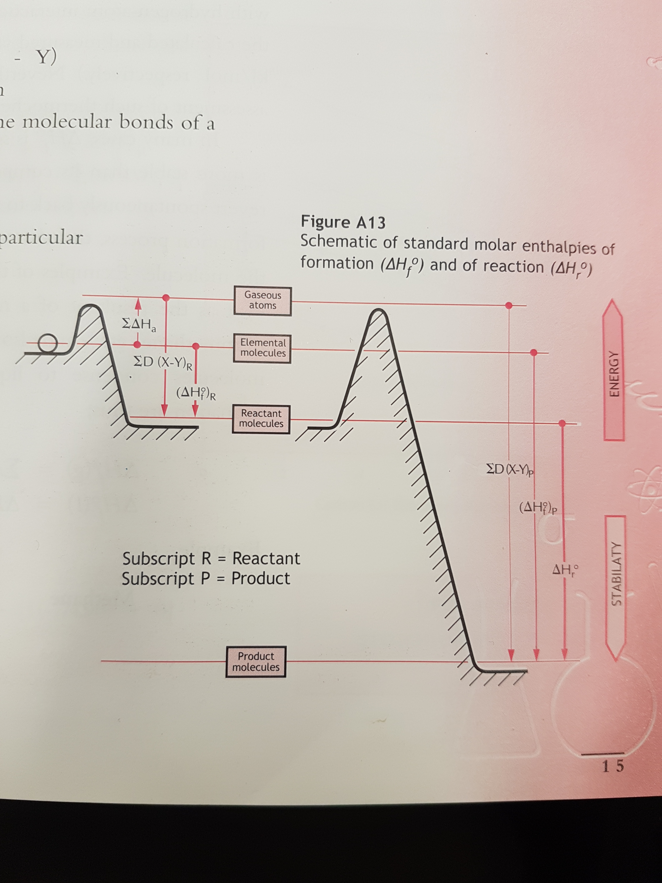
Figure 1: Enthalpy of Formation Diagram (Goodger, 2000)

Calculating Lower Heating Value using Enthalpy of Formation
Reactants | Products
C₈H₁₈+C₂H₅OH+X(O₂+3.76*N₂) | 10*CO₂ + 12*H₂O + 58.28*N₂
Enthalpy needed to reach 0 level | Enthalpy released from 0 level
C₈H₁₈ (Gas) = -224.1 MJ/mol  C₈H₁₈ (Liquid) = -259.28 MJ/mol | CO₂ = -393.5 MJ/mol
C₂H₅OH (Gas) = -234.6 MJ/mol C₂H₅OH (Liquid) = -277.0 MJ/mol | H₂O (Gas) = -241.8  H₂O (Liquid) = -285.8
O = 0 | N = 0
N = 0
Gas = (-224.1) + (-234.6)  Gas = -458.7 MJ/mol | Gas = (10*(-393.5))+(12*(-241.8))  Gas = -6836.6 MJ/mol
Liquid = (-259.28) + (-277.0)  Liquid = -536.28 MJ/mol | Liquid = (10*(-393.5))+(12*(-285.8))  Liquid = -7364.6 MJ/mol
Net Enthalpy Released (Gas) = (-458.7)+(6837.16)
Net Enthalpy Released (Gas) = 6377.9 MJ/mol
Net Enthalpy Released (Liquid) = (-536.28)+(7365.28)
Net Enthalpy Released (Liquid) = 6828.32 MJ/mol
1kmol Fuel (Gas) releases 6377.9 MJ/mol Heat Enthalpy
1kmol Fuel (Gas) releases = (12.011*8)+(1.008*18)+(12.011*2)+(1.008*6)+(15.999*1)
1kmol Fuel (Gas) = 160.292 Kg
1kg Fuel (Gas) releases = 6377.9/160.292 Mj
Lower Heating Value = 39.789 Mj

Higher and lower heating values
Heating values are used to quantify the amount of heat produced by a fuel during combustion and what happens to the water vapour that is produced. The Higher Heating Value (HHV) also known as the Gross Heating Value, considers the energy produced by the condensation of the water vapour, while the Lower Heating Value (LHV) also known as the Net Heating Value does not consider this. (Green, 2016)

CO₂ Mass produced
1 molecule of C₈H₁₈+C₂H₅OH makes 10 molecules of CO₂

$$\left(10×C\right)+\left(24×H\right)Kg Fuel →10 ×\left(C×2×O\right)$$

$$∴\left(10×12.011\right)+\left(24×1.008\right)Kg Fuel →10 ×\left(12.011×2×15.999\right)$$

$$144.302 kg Fuel →440.09 Kg CO_{2}$$

$∴1Kg Fuel → \frac{440.09}{144.302} kg →3.049kg CO_{2}$

Ideal Fuel
There are many characteristics of an ideal fuel. A few are listed below;

High octane rating
The octane rating of a fuel is its resistance to ‘knock’ or autoignition (Exxon Mobil, 2017). The higher the value, the higher the resistance. An ideal fuel would have a high octane rating to allow for an increase in the compression ratio of the engine which would increase the power and efficiency of the engine.

High laminar flame speed
An ideal fuel would have a high laminar flame speed. The laminar flame speed is the speed that the flame spreads into the region of unburned gas under adiabatic conditions (Colin R Ferguson, 2001). If the fuel has a faster rate of combustion, then there is less time there is for heat transfer/loss and therefore a higher engine efficiency. A faster rate of combustion also lowers the chance of knock.

Low mass
An ideal fuel should have a low mass. The lighter the particles are, the faster it moves, the faster it moves the more collisions it will have with other particles and therefore promotes a faster combustion.

Low pollution
Real fuels need to pass the real driving emissions tests such as the Portable Emissions Measuring System (PEMS) tests. These systems are attached to the exhaust and accurately measure the cars emissions. In 2016 the fleet CO₂ average was 130 g/Km and by 2020 it is expected to reduce to 95 g/Km (Mahle Powertrain, 2017). An ideal fuel would have no CO₂ emissions or other pollutants caused by incomplete combustion. It is possible to largely reduce these emissions by running the engine lean (Heywood, 1988).

High ratio of specific heat (ɤ)
An ideal fuel would have a high ratio of specific heat, which would improve its efficiency. The ratio of specific heat of a fuel is calculated using the following formula;
$$ɤ=\frac{Cp}{Cv}$$
Where;
ɤ = Ratio of Specific Heat
Cp = Constant Pressure
Cv= Constant Volume

Therefore, the ratio of specific heat is higher if the fuel has a low Cv value. By having a higher specific heat ratio, the efficiency of the engine would increase as can be seen in the formula below;
$$Ƞ=1-\frac{1}{{CR}^{ɤ-1}}$$
Where;
CR = Compression Ratio
ɤ = Ratio of Specific Heats
To prove this, an engine with a compression ratio of 10 would give the following results with 2 different specific heat ratios;
- Using a ratio of specific heat of 1.2
$Ƞ=1-\frac{1}{{10}^{1.2-1}}$ = 0.37 =37% Efficiency
- Using a higher ratio of specific heat of 1.4
- $Ƞ=1-\frac{1}{{10}^{1.4-1}}$ = 0.6 =60% Efficiency

Conclusion
In conclusion, the ideal fuel would have a high-octane rating allowing higher pressures and an increased compression ratio within the engine. This would allow a faster combustion and therefore less time for heat loss, making the engine more efficient and more powerful. The ideal fuel would be able to have a high/fast combustion rate while the engine runs lean. This would mean that the density within the cylinder would be lower than when running rich, so a light, high energy particle with a high laminar flame speed would promote fast combustion. The fast rates of lean combustion would also mean that less waste products would be produced, making the fuel environmentally friendly.

References
Class Zone, 2017. ES0501 Reading the Periodic Table. [Online]
Available at: https://www.classzone.com/books/earth_science/terc/content/investigations/es0501/es0501page06.cfm
Colin R Ferguson, A. T. K., 2001. Internal Combustion Engines. In: Internal Combustion Engines. New York: John Wiley & Sons, Inc, p. 256.
Exxon Mobil, 2017. Octane ratings. [Online]
Available at: https://www.exxon.com/en/octane-rating
Goodger, E. M., 2000. Enthalpy of Formation. In: Transport Technology: Mobility for the Future. Norwich: Landfall Press, p. 15.
Green, A., 2016. HHV vs LHV - Energy Basics. [Online]
Available at: http://adgefficiency.com/energy-basics-hhv-versus-lhv/
Heywood, J. B., 1988. Internal Combustion Engine Fundametals. In: Internal Combustion Engine Fundametals. New York: McGraw-Hill Inc, p. 9113.
Mahle Powertrain, 2017. PEMS testing service now available. [Online]
Available at: http://www.mahle-powertrain.com/en/news-and-press/press-releases/pems-testing-service-now-available-23104
Science Notes, 2017. Printable Periodic Tables. [Online]
Available at: https://sciencenotes.org/printable-periodic-table/

Bibliography
Class Zone, 2017. ES0501 Reading the Periodic Table. [Online]
Available at: https://www.classzone.com/books/earth_science/terc/content/investigations/es0501/es0501page06.cfm
Colin R Ferguson, A. T. K., 2001. Internal Combustion Engines. In: Internal Combustion Engines. New York: John Wiley & Sons, Inc, p. 256.
Exxon Mobil, 2017. Octane ratings. [Online]
Available at: https://www.exxon.com/en/octane-rating
Goodger, E. M., 2000. Enthalpy of Formation. In: Transport Technology: Mobility for the Future. Norwich: Landfall Press, p. 15.
Green, A., 2016. HHV vs LHV - Energy Basics. [Online]
Available at: http://adgefficiency.com/energy-basics-hhv-versus-lhv/
Heywood, J. B., 1988. Internal Combustion Engine Fundametals. In: Internal Combustion Engine Fundametals. New York: McGraw-Hill Inc, p. 9113.
Mahle Powertrain, 2017. PEMS testing service now available. [Online]
Available at: http://www.mahle-powertrain.com/en/news-and-press/press-releases/pems-testing-service-now-available-23104
Science Notes, 2017. Printable Periodic Tables. [Online]
Available at: https://sciencenotes.org/printable-periodic-table/

Appendix – Periodic Table
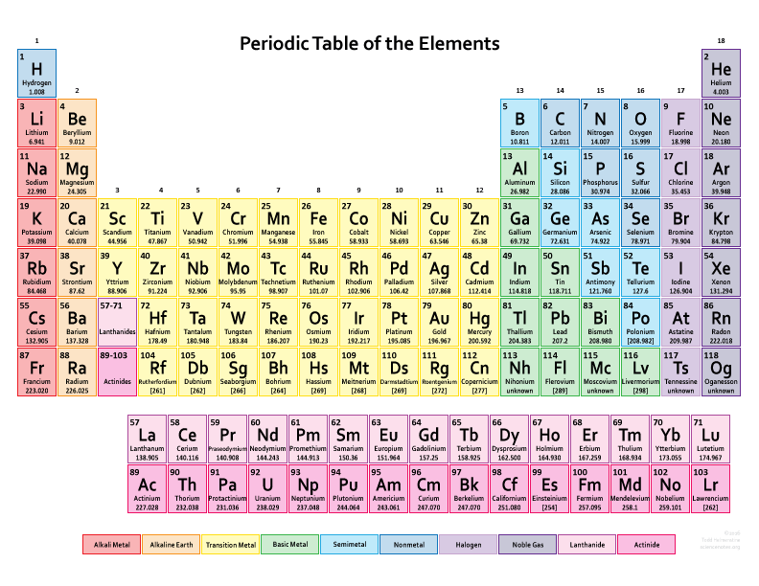
Figure 2: Periodic Table (Science Notes, 2017)

