Abstract
In the digital era, organizations like NatureGarden (NG) face a complex array of cybersecurity challenges, exacerbated by their extensive reliance on digital technologies and global connectivity. This paper provides a comprehensive overview of the security frameworks and practices essential for safeguarding an organization's digital assets in this interconnected environment. It begins with an introduction to NG's reliance on cloud computing and wireless networks, outlining the inherent security risks associated with its vast online presence and the integration of personal devices into its network. A survey of key security frameworks, including the Information Technology Infrastructure Library (ITIL), ISO 27000, and Control Objectives for Information and related Technology (COBIT), is conducted to demonstrate their relevance in fortifying NG's cybersecurity posture. This paper critically analyzes these frameworks, emphasizing their strengths in aligning with business objectives, managing risks, and providing structured approaches to security and governance. The main problems in NG's current data security management are categorized and addressed, ranging from network security and infrastructure challenges to policy and compliance issues. An optimization scheme for NG's data security management is proposed, focusing on enhancing legal and ethical compliance, and integrating robust security practices into all facets of the organization. Finally, the paper concludes with reflections on the importance of agile and responsive cybersecurity strategies in today's digitally-integrated world, highlighting the need for continuous improvement and adaptation to emerging threats and technologies. This comprehensive approach aims not only to address NG's immediate security concerns but also to provide a blueprint for other organizations navigating similar challenges in the digital landscape.

I. INTRODUCTION
In a world increasingly interconnected by the digital landscape, NatureGarden (NG) has emerged as a global leader in promoting healthy living through its sought-after product range. With its vast global footprint, NG harnesses the power of cloud computing to deliver essential IT services to its diverse workforce and a growing international clientele. Notably, nearly all of NG's network infrastructure is wireless, underscoring a commitment to technological agility and accessibility.

However, NG's expansive online and social media presence, essential for modern commerce and community engagement, also exposes the company to heightened cybersecurity risks. The convenience of mobile technology has led to significant pressure to accommodate personal devices within the company's network, amplifying concerns around data security for both staff and clients. The safeguarding of personal information and the protection of NG's valuable intellectual properties, worth billions, are paramount, demanding a strategic and robust approach to information security.

Despite the clear prioritization of data integrity, NG finds its security protocols in a state of flux, with no concrete policy currently established to govern the security of its intricate network. This lack of structured security strategy represents a critical vulnerability—one that the company must address to safeguard its assets, maintain consumer trust, and uphold its esteemed position in the market for healthy living products.II. SURVEY OF SECURITY FRAMEWORKS

II. SURVEY OF SECURITY FRAMEWORKS

Information Technology Infrastructure Library (ITIL)
The ITIL framework stands at the forefront of IT service management, offering structured and flexible practices tailored to align IT services with the broader goals and strategies of businesses [4]. Initially developed by the UK government, ITIL has been adopted globally across various sectors, demonstrating its versatility and applicability in diverse IT environments [5].

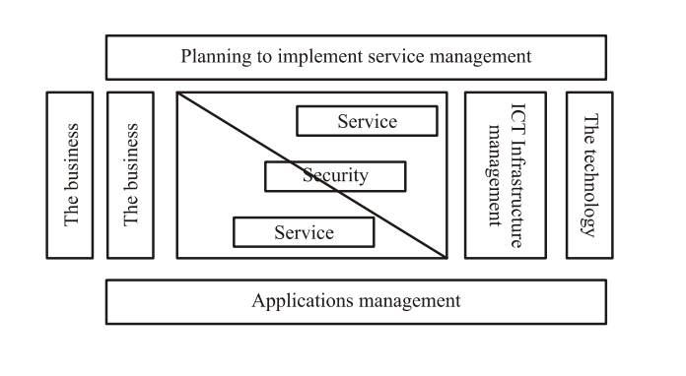
The first diagram represents an ITIL-based framework, showing the interaction between business needs, IT infrastructure management, and application management. Here's a breakdown of each module:

The Business: This module signifies the business layer where strategic goals and objectives are set. It is the driver for IT service management planning.

Planning to Implement Service Management: This central module indicates the planning phase where IT services are aligned with the business's strategic goals. It involves defining the service management strategy and designing processes that meet business needs.

Service: These blocks represent the various IT services that are designed and managed to meet the specific requirements of the business.

Security: Embedded within the services, this indicates that security measures are integral to the service delivery, ensuring the protection of data and systems.

IT Infrastructure Management: This module represents the physical and hardware aspects of IT that support service delivery, such as servers, storage, and network infrastructure.

Applications Management: Situated below the central planning module, this indicates that application management is foundational and supports the overarching service management plan, focusing on the software applications that are used to process business transactions.

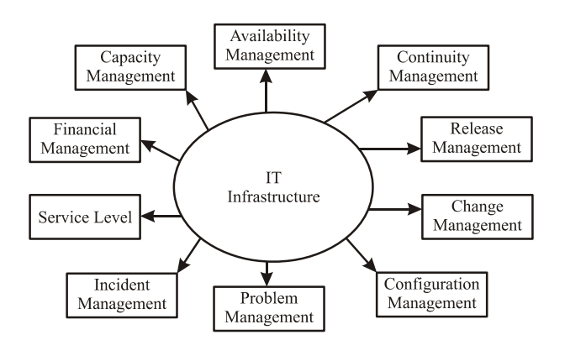
The second diagram illustrates the ITIL service support structure, centering on IT Infrastructure as the hub of various management processes:

IT Infrastructure: The core of the diagram, signifying the central role of IT infrastructure in supporting all service management processes.

Service Level Management: Ensures that all IT service management processes meet the agreed-upon levels of service.

Financial Management: Oversees the budgeting, accounting, and charging requirements for IT services.

Capacity Management: Ensures that the IT infrastructure is capable of meeting current and future service levels and performance requirements.

Availability Management: Focuses on ensuring that IT services are available as agreed upon.

Continuity Management: Deals with planning for disaster recovery to ensure services can continue after a major incident.

Release Management: Manages the process of releasing new changes or updates into the live environment.

Change Management: Ensures that changes are made in a controlled and coordinated manner.

Configuration Management: Deals with the management of technology configuration and changes, ensuring that the IT infrastructure is known, managed, and reliable.

Incident Management: Focuses on returning service to normal as quickly as possible after an incident.

Problem Management: Aims to minimize the adverse impact of incidents and problems on the business, preventing recurrence of incidents related to errors.

ISO 27000
The ISO 27000 series of standards, developed by the International Organization for Standardization (ISO), provides a comprehensive framework for establishing, implementing, maintaining, and continually improving an Information Security Management System (ISMS) [2]. This document offers an in-depth overview of the ISO 27000 series, emphasizing its significance in reinforcing information security in organizations across various sectors. It delves into the series’ core principles, structure, and the practical implications of its adoption.
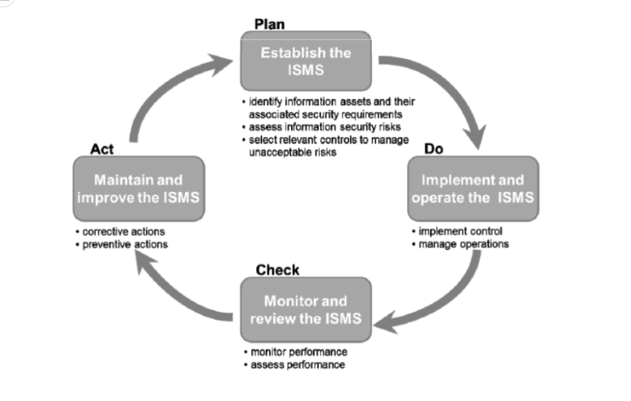

The image you've provided depicts the Plan-Do-Check-Act (PDCA) cycle as it applies to the Information Security Management System (ISMS) in the context of the ISO 27000 series standards [1]. The PDCA cycle is a core component of many ISO standards, including ISO/IEC 27001, which is a part of the ISO 27000 family of standards. Here’s an explanation of each phase:

Plan: Establish the ISMS

Identify information assets and their associated security requirements.
Assess information security risks to those assets.
Select relevant controls to manage unacceptable risks.
Do: Implement and operate the ISMS [3]

Implement control measures to mitigate identified risks.
Manage operations related to the controls.
Check: Monitor and review the ISMS

Monitor performance of the ISMS based on a set of predefined metrics.
Assess performance against the security objectives and report on the effectiveness.
Act: Maintain and improve the ISMS

Take corrective actions to address any non-conformities or weaknesses.
Implement preventive actions to avoid recurrence of issues.

C. Comparative Analysis:
Both frameworks prioritize alignment with business objectives, which is vital for NG to ensure that its security measures do not impede its operational goals.

- ITIL provides a service-oriented approach, which might be more intuitive for NG's service management team to integrate into their current practices.

- ISO 27000 provides a risk management approach, emphasizing the importance of identifying and managing security risks, which is crucial given NG's large customer and staff base accessing its network.

- ITIL's modular structure aligns closely with service design and delivery, which can be beneficial for NG in managing its IT services lifecycle.

- ISO 27000's PDCA cycle offers a systematic approach for continuous improvement, aligning well with NG's need to adapt to the evolving cybersecurity landscape.

- ITIL's inclusion of specific processes like Incident and Problem Management is practical for NG's operational needs, providing clear guidelines for handling security incidents.

- ISO 27000's comprehensive controls and the structured implementation process provide NG with a robust framework to secure its extensive network and cloud infrastructure.

To tailor these frameworks to NG’s specific security concerns, a hybrid approach can be taken, integrating ITIL’s strong service management processes with ISO 27000’s robust risk management and control framework. This would ensure that NG’s IT services are not only aligned with its business objectives but also secured against potential threats in a systematic and proactive manner.

Diagrams, such as the ITIL service lifecycle and the ISO 27000 PDCA cycle, can be utilized to illustrate the flow and integration of these practices within NG's security strategy. This visual aid would help stakeholders understand how these frameworks can work in tandem to enhance NG's security posture while supporting its business operations.

Control Objectives for Information and related Technology (COBIT)
As organizations increasingly rely on information technology to facilitate their operations, the need for a robust framework to govern and manage these technologies becomes paramount. COBIT, developed by the Information Systems Audit and Control Association (ISACA), is designed to provide a comprehensive approach to IT governance and management. This section introduces COBIT and its importance in the current digital era.[8]

1. The Evolution of COBIT:
This section outlines the historical development of COBIT, from its initial release in the 1990s to its latest version[9]. The evolution reflects the changing dynamics of IT management and the growing complexities of technological integration in business processes.

2. Core Principles of COBIT:
COBIT is built on a set of key principles that guide its application in enterprise IT. This section explores these principles, which include aligning IT with business goals, delivering value through technology, managing risk, and optimizing resources.

3. Structure of COBIT:
COBIT's structure comprises several components, including processes, control objectives, management guidelines, and maturity models. This section breaks down each component and explains how they collectively contribute to effective IT governance and management[10].

4. Implementing COBIT in Organizations:
Implementing COBIT requires a strategic approach tailored to an organization's specific needs. This section discusses the steps involved in adopting COBIT, from assessing current IT management practices to integrating COBIT’s framework into everyday IT processes.

5. COBIT in Relation to Other IT Governance Frameworks:
COBIT does not exist in isolation; it often complements other IT governance frameworks like ITIL and ISO/IEC 27001. This section compares COBIT with these frameworks, highlighting their unique features and how they can be used in conjunction to achieve comprehensive IT governance.

III. MAIN PROBLEMS IN CURRENT NATUREGARDEN DATA SECURITY MANAGEMENT
Certainly! Based on the identified issues at NatureGarden (NG), they can be categorized under broader themes with appropriate subheadings for better clarity and organization. Here’s how they can be structured:

1. Network Security and Infrastructure:

Wireless Network Vulnerabilities: Addressing the inherent risks associated with a predominantly wireless network.
Integration of Cloud Services: Managing security challenges in the use of cloud services for IT operations.
2. Data Management and Privacy:

Data Security and Privacy Compliance: Ensuring adherence to international data protection laws like GDPR.
Protection of Intellectual Property: Safeguarding NG's intellectual property from cyber threats.
3. Device and Access Management:

Challenges in Personal Device Usage: Managing risks associated with BYOD (Bring Your Own Device) practices.
User Access Control: Implementing stringent access control measures for both staff and customers.
4. Policy and Compliance:

Lack of Established Security Policy: Developing a comprehensive security policy to govern NG's network.
Legal and Ethical Compliance: Navigating the complexity of adhering to diverse international legal and ethical standards.
5. Strategic Challenges:

Adaptation to Evolving Cyber Threats: Keeping pace with the rapidly changing landscape of cyber threats.
Technological Agility and Maintenance: Ensuring continuous technological updates and maintenance for operational efficiency.
Serving an International Customer Base: Addressing the diverse security requirements and regulations of an international clientele.

IV. OPTIMIZATION SCHEME OF NATUREGARDEN DATA SECURITY MANAGEMENT
In the rapidly evolving digital landscape, the importance of robust legal and ethical compliance in business operations cannot be overstated. For NatureGarden (NG), a leader in the global health and wellness industry, aligning its operations with stringent legal and ethical standards is not just a regulatory requirement but a cornerstone of its corporate integrity. This document delineates a comprehensive strategy to reinforce NG's commitment to these standards, particularly focusing on data protection and privacy laws.

Formation of a Compliance Unit:
The establishment of a dedicated Compliance Unit marks the first step in NG's strategic approach. This unit, comprised of legal experts and seasoned compliance officers, will serve as the fulcrum for all compliance-related activities. Its primary responsibility is to ensure that NG's operations adhere to both international and local regulations, including the General Data Protection Regulation (GDPR) and other relevant data protection laws.

Bi-Annual Legal Audits:
To maintain alignment with various legal frameworks, NG will conduct bi-annual legal audits. These audits are designed to meticulously evaluate NG's compliance with applicable laws and regulations, ensuring that all operations, from data handling to marketing practices, are within legal bounds. The objective is to proactively identify and rectify any areas of non-compliance, thereby mitigating the risk of legal repercussions.

Development of a Data Protection Policy:
In response to the growing concerns over data security, NG is committed to developing a comprehensive data protection policy. This policy will encompass key areas such as data collection, storage, processing, and sharing, aligning with global best practices in data management. The policy aims to fortify the protection of personal and sensitive information of both customers and employees, thereby reinforcing NG's stature as a trustworthy brand.

Continuous Training and Awareness Programs:
Recognizing that compliance is not solely a legal obligation but also a cultural ethos, NG will implement an ongoing training program for all its employees. This program will cover critical areas such as data protection, privacy laws, and ethical conduct. The purpose is to embed a culture of compliance and awareness across the organization, ensuring that every team member understands and values their role in upholding these standards.

Compliance Monitoring and Anonymous Reporting:
To ensure the efficacy of the compliance program, NG will establish a robust monitoring mechanism. This will include regular assessments of the compliance strategies and an anonymous reporting system for ethical concerns or violations. This dual approach will not only facilitate early detection of potential compliance issues but also foster an organizational culture that values transparency and ethical conduct.

Extending Compliance to Third Parties:
In today's interconnected business environment, ensuring compliance extends beyond the confines of the organization. NG will, therefore, extend its compliance requirements to all third-party vendors and partners, particularly those handling NG's data. This initiative aims to ensure that all external entities engaged with NG operate in compliance with the same high standards of data security and legal adherence.

Regular Policy Review and Updates:
In keeping with the dynamic nature of legal standards and industry best practices, NG will conduct annual reviews of its compliance policies. This will enable the integration of any new legal developments or changes in best practices, ensuring that NG's compliance framework remains current and robust.

Integration with Business Processes:
A critical aspect of NG's strategy is the integration of compliance considerations into other business processes, including product development, marketing, and human resources. This holistic approach ensures that compliance is not a siloed function but an intrinsic part of NG's operational fabric.

Documentation and Record-Keeping:
To maintain transparency and facilitate any potential legal or regulatory reviews, NG will keep detailed records of all compliance activities. This documentation will include records of audits, training sessions, policy updates, and any compliance-related incidents, providing a clear trail of NG's commitment to legal and ethical standards.

By implementing this multifaceted compliance strategy, NG is set to not only fortify its defenses against legal risks but also to enhance its reputation as a socially responsible and ethically conscious enterprise. This commitment to compliance is a testament to NG's dedication to its customers, employees, and the broader community, solidifying its position as a leader in the global health and wellness market.

V. INFORMATION SECURITY IN A DIGITALLY-INTEGRATED WORLD
The digitization of business processes and the widespread use of internet technologies have revolutionized how companies operate. However, this digital integration brings with it inherent risks and vulnerabilities. In this environment, the protection of sensitive data, intellectual property, and digital assets is not just a technical issue but a strategic imperative. This paper explores the challenges and strategies associated with maintaining robust information security in a digitally-integrated world, using NatureGarden (NG) as a case study.

1.The Evolution of Cybersecurity Threats:
As technology evolves, so do the nature and sophistication of cybersecurity threats. From ransomware to sophisticated phishing attacks, businesses must contend with a constantly changing threat landscape. This section analyzes the evolution of these threats in the digital era and their impact on organizations like NG.

2. Information Security Challenges for NatureGarden:
NG's digital integration, characterized by its extensive reliance on cloud computing and a predominantly wireless network, presents unique information security challenges. This section categorizes NG's primary security challenges into network security and infrastructure, data management and privacy, device and access management, policy and compliance, and strategic challenges.

3. Strategies for Enhancing Information Security:
This section outlines the strategies NG can adopt to address its information security challenges. It delves into the implementation of advanced security measures, the development of comprehensive security policies, and the importance of aligning these strategies with the company's business objectives.

4. The Role of Regulations and Compliance:
In a world where data breaches can have significant legal and reputational consequences, adherence to regulations and compliance standards is crucial. This section discusses the importance of compliance with international data protection laws and how NG can navigate these requirements.

VI. CONCLUSION
In summary, the comprehensive strategy outlined for NatureGarden (NG) addresses crucial aspects of cybersecurity in the context of its global operations and digital infrastructure. This strategy encompasses a holistic approach, integrating diverse elements such as compliance, governance, risk management, and the adoption of established security models like ITIL and ISO 27000. The plan is designed not only to fortify NG’s defenses against evolving cyber threats but also to ensure that these security measures are in harmony with the company's business objectives and operational dynamics.

The critical analysis presented highlights the indispensable need for dynamic regulations and standards in cybersecurity, given the rapidly changing nature of cyber threats and technological advancements. By adopting a strategy that is agile and responsive to these changes, NG positions itself to effectively manage and mitigate the risks inherent in the digital landscape. The comparison between ITIL and ISO 27000 frameworks provides NG with insights into how a combination of service-oriented and risk management approaches can be tailored to meet its unique security needs.

The proposed compliance strategy emphasizes the importance of aligning NG's operations with both legal and ethical standards. This alignment is crucial not just for regulatory adherence but also for building trust with customers and stakeholders. By establishing a dedicated compliance unit, conducting regular audits, and developing a comprehensive data protection policy, NG demonstrates its commitment to upholding high standards of data security and privacy.

Incorporating these strategies into NG’s existing business model will ensure a robust and resilient cybersecurity posture. Regular reviews and updates to the security policies and practices will allow NG to adapt to new challenges and protect against emerging threats. This proactive approach to cybersecurity is essential for safeguarding NG’s valuable assets, maintaining consumer trust, and upholding its esteemed position in the health and wellness market.

The journey towards a secure digital environment is continuous and requires a commitment to ongoing improvement. As NG implements these strategies, it will not only enhance its security infrastructure but also set a benchmark in the industry for how to effectively integrate cybersecurity into business operations.

REFERENCES
[1] Meriah, I. and Rabai, L.B.A., 2019. Comparative study of ontologies based iso 27000 series security standards. Procedia Computer Science, 160, pp.85-92.

[2] Hamdi, Z., Norman, A.A., Molok, N.N.A. and Hassandoust, F., 2019, December. A comparative review of ISMS implementation based on ISO 27000 series in organizations of different business sectors. In Journal of Physics: Conference Series (Vol. 1339, No. 1, p. 012103). IOP Publishing.

[3] Brenner, J., 2007. ISO 27001 risk management and compliance. Risk management, 54(1), pp.24-29.

[4] Dabade, T.D., 2012. Information technology infrastructure library (ITIL). In Proceedings of the 4th National Conference (pp. 25-26).

[5] Potgieter, B.C., Botha, J.H. and Lew, C., 2005, July. Evidence that use of the ITIL framework is effective. In 18th Annual conference of the national advisory committee on computing qualifications, Tauranga, NZ.

[6] Disterer, G., 2013. ISO/IEC 27000, 27001 and 27002 for information security management. Journal of Information Security, 4(2).

[7] ISO., I.E.C., 2017. ISO. International Standards Organisation.

[8] Ridley, G., Young, J. and Carroll, P., 2004, January. COBIT and its Utilization: A framework from the literature. In 37th Annual Hawaii International Conference on System Sciences, 2004. Proceedings of the (pp. 8-pp). IEEE.

[9] De Haes, S., Van Grembergen, W., Joshi, A., Huygh, T., De Haes, S., Van Grembergen, W., Joshi, A. and Huygh, T., 2020. COBIT as a Framework for Enterprise Governance of IT. Enterprise Governance of Information Technology: Achieving Alignment and Value in Digital Organizations, pp.125-162.

[10] De Haes, S., Van Grembergen, W., Joshi, A., Huygh, T., De Haes, S., Van Grembergen, W., Joshi, A. and Huygh, T., 2020. COBIT as a Framework for Enterprise Governance of IT. Enterprise Governance of Information Technology: Achieving Alignment and Value in Digital Organizations, pp.125-162.

