  Component One: Student Journal (learning log) 750 words +/- 10%  Contribution to Overall Module Assessment: 25% | Student No: | 2027750
 | Module Title: | Hotel Administration and front office
 | Module Code: | BHIH4004
 | Lecturer: | Muhammad Cassamo
As a student deeply passionate about the hospitality industry, I've been fortunate to gain practical experience in hotel administration and front office operations, specifically at ibis Hotel. This journal entry is dedicated to reflecting on my experiences, gaining an understanding of key skills in this field within the unique context of ibis Hotel, addressing departmental issues, and appreciating the significance of work-based key skills within the hotel industry. The definition of the hospitality industry can be found in the Cvent guide (Cvent, 2020).

Working within hotel administration and front office operations at ibis Hotel, I've been exposed to various departments, each with its unique functions and requirements. Here's an overview of the key skills and practical experience gained in each department:

I've honed efficient guest check-ins and check-outs, reservations, handling guest inquiries and complaints, mastery of booking systems, and payment processing. My time at the ibis Hotel Reception has been invaluable in mastering guest check-in and check-out procedures, handling reservations, and effectively addressing guest inquiries and concerns.

I've developed in-depth knowledge of local attractions, restaurants, and services, a strong customer service orientation, personalisation of guest experiences, and assistance with guest requests. Working in the Concierge department at ibis Hotel, I've had the opportunity to assist guests in exploring the local area, provide personalised recommendations, and enhance the overall guest experience.

I've become efficient in handling telephone systems and communication tools, call management, and message-taking. My role in the Switchboard department at ibis Hotel has enhanced my ability to manage telephone systems, handle incoming and outgoing calls, and efficiently communicate with guests.

I now understand financial processes related to guest billing and payments, proficiency with the hotel's financial management system, and handling financial transactions while maintaining accurate records. At ibis Hotel, I've gained a deep understanding of guest billing and payment processes, including mastering the financial management system used by the hotel.

Reflecting on my experiences in these various departments at ibis Hotel, I've encountered a range of emotions. My readings from "Hospitality Management: A Comprehensive Guide" (Goodreads.com, 2010) have emphasised the importance of a positive attitude and emotional intelligence in the hospitality industry. This insight aligns with my own experiences, as I've realised that maintaining a friendly and empathetic demeanour is essential in providing an exceptional guest experience.

I recall a particularly busy day at Reception, where I had to manage a long line of guests waiting to check in. While it was a demanding experience, it was also a moment of pride as I efficiently processed each check-in, maintaining a professional and courteous demeanour (Johnson, 2018). However, the challenge of multitasking during such peak periods has highlighted the need for continuous improvement.

In assessing my journey in hotel administration and front office operations at ibis Hotel, I can confidently state that the experience has been predominantly positive. Practical experience has been the most effective way to internalise key skills and understand their critical role in the hotel industry, particularly within the specific context of ibis Hotel.

My role in the Finance department at ibis Hotel has provided a unique perspective on the financial aspects of the hotel's operation. Understanding the intricacies of guest billing and payment processes has not only broadened my skill set but also deepened my appreciation for the importance of accuracy and financial accountability in the hotel industry. According to Yvanovich (2018), the finance team in a hotel plays a crucial role in managing financial processes.

Analysing my experiences at ibis Hotel, I have identified strengths and areas for improvement,
My strengths include effective communication, problem-solving, and a strong customer service orientation. These skills have been essential in providing a seamless guest experience at ibis Hotel. For instance, my ability to handle guest inquiries professionally and address any concerns has led to positive guest feedback and satisfaction scores.

I recognise that there is room for improvement in multitasking and maintaining attention to detail, especially during busy periods in departments such as Reception at ibis Hotel. These skills are crucial in ensuring the smooth operation of the hotel. My experience has taught me that, especially during peak check-in times, managing multiple tasks simultaneously can be challenging. I've learned the importance of staying organised and focused to ensure an efficient and stress-free guest experience (Edit Kővári, 2011).

Within each department at ibis Hotel, I have encountered specific challenges and issues that relate to resource allocation, marketing, management styles, organisational culture, health and safety, and industry-specific problems. These issues are vital to departmental and overall hotel efficiency at ibis Hotel.

For example, in the Switchboard department, a recurring issue has been ensuring timely Taxi calls for guests. This involves effective scheduling and communication with guests who have specific timing requirements. Learning to manage this challenge efficiently has required better coordination and streamlined communication, both of which are key skills in the context of a hotel known for its efficiency.

By closely working with departmental supervisors and managers at ibis Hotel, I've gained valuable insights into the unique challenges they face. The interaction of resource allocation, management styles, and organisational culture has a significant impact on the efficiency of each department at ibis Hotel.

For instance, I've observed that the efficiency and simplicity that ibis Hotel is known for are not just sayings but integral aspects of the hotel's organisational culture. The streamlined approach requires all team members to be adaptable and responsive, ensuring that guest needs are met promptly and efficiently.

I've been proactive in proposing and implementing improvements in processes and procedures within the departments I've worked in at ibis Hotel. These improvements have contributed to a smoother workflow and better guest experiences.

An example of this proactive approach is in the Concierge department, where we've introduced a digital information system that provides guests with real-time updates on local attractions, dining options, and services. This not only enhances the guest experience but also aligns with ibis Hotel's commitment to providing efficient and accessible information to guests.

In conclusion, my journey in hotel administration and front office operations at ibis Hotel has highlighted the importance of work-based key skills. These skills are not only crucial for personal success but also contribute significantly to guest satisfaction and the overall reputation of ibis Hotel, a brand known for its efficiency and simplicity (Suh, West and Shin, 2012).

My experiences at ibis Hotel have provided me with a deeper appreciation for the hotel industry, and the importance of every detail in ensuring guest satisfaction. I've come to understand that whether it's a smooth check-in experience, personalised recommendations from the Concierge, or accurate billing in the Finance department, key skills play a fundamental role in creating memorable guest experiences at ibis Hotel.

To continue my growth in hotel administration and front office operations at ibis Hotel, I have outlined an action plan:
Develop Multitasking Skills with Efficiency: I will actively seek opportunities to enhance my multitasking abilities, with an emphasis on efficiency, time management, and simplifying processes, all while maintaining the core values of ibis Hotel. This will involve training exercises to improve task-switching and efficient time allocation, ensuring that even during peak periods, I can handle multiple responsibilities effectively.

Enhance Attention to Detail with Precision: I will make a concerted effort to enhance my attention to detail, ensuring that all tasks are executed with precision, even during busy periods, aligning with the streamlined approach of ibis Hotel. Regular self-checks and peer reviews will help me maintain a high level of attention to detail in all aspects of my work.

Stay Informed About Industry Trends at ibis Hotel: I will stay updated on industry trends and best practices, with a particular focus on challenges and strategies within the hotel administration and front office field, always considering the unique ethos of ibis Hotel. Regular attendance at industry conferences and workshops, as well as subscribing to relevant industry publications, will help me stay informed and adaptable.

This reflective journal at ibis Hotel has provided a comprehensive view of my experiences, growth, and recognition of the significance of work-based key skills in hotel administration and front office operations. It's been a journey of learning, adaptation, and personal development, and I look forward to further enhancing my capabilities in this dynamic and rewarding field at ibis Hotel, where efficiency and simplicity are not just ideals but lived experiences that make a difference for guests every day.

Component Two
Contribution to Overall Module Assessment: 25%
Trip Advisor Review Response 150 words +/-10%
We greatly appreciate your positive feedback about your recent stay at ibis Hotel. We're thrilled to hear about your fantastic experience and your enjoyment of our spacious rooms, comfortable beds, and clean bathrooms. Your satisfaction is our top priority, and we're dedicated to maintaining these high standards.

Your insights into various aspects of the ibis hotel administration and front office operations are invaluable to us. Understanding work-based key skills and examining areas like resource allocation, marketing, management styles, and culture are essential elements of our commitment to excellence.

We eagerly await your return to ibis Hotel. If you have any specific requests or preferences, please don’t hesitate share them with us we would be happy to assist. Your feedback is highly valuable and contributes to our continuous efforts to improve our services. Thank you for choosing ibis Hotel ("IBIS LONDON STRATFORD £169 (£2̶9̶9̶) - Updated 2023 Prices & Hotel Reviews - England").

Screen shot of referenced Trip Advisor review used:
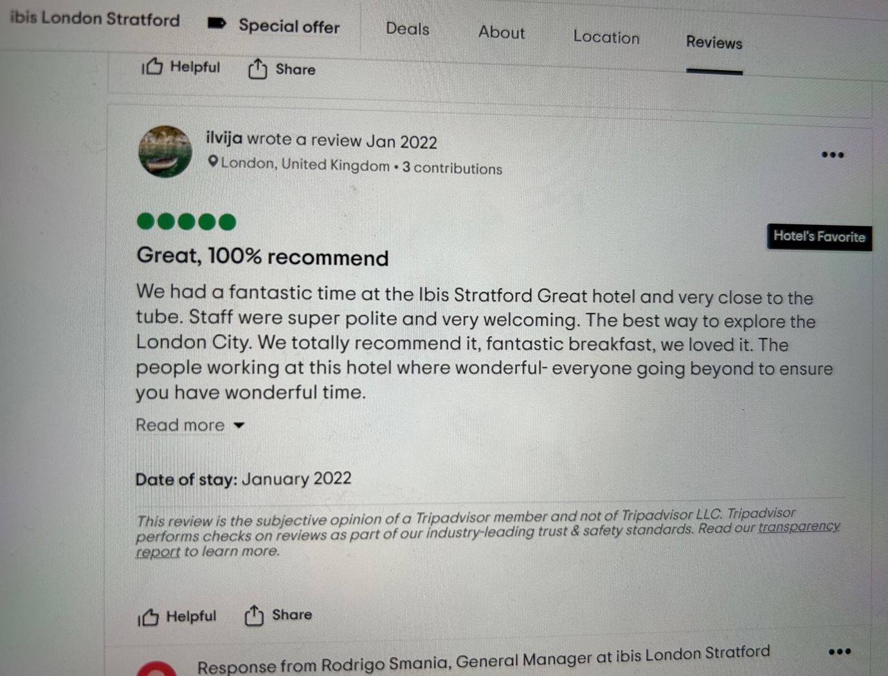
Letter of complaint response 500 words +/- 10-%
Krystal Gardner
Ibis Stratford
1A Romford Rd,
London E15 4LJ
4th November 2023

Mr. Ronald Federick
17 Trinity Court
Swansea
SA1 2AR

Subject: Resolution to Your Recent Concerns

Dear Mr Frederick,

I hope this letter finds you in good health. I am writing in response to your recent correspondence regarding your stay at our hotel on August 26th, 2023, in room 205. I want to extend my sincerest apologies for the inconveniences you experienced during your visit and to express our gratitude for your valuable feedback.

Your feedback resonates deeply with our commitment to efficiently undertake various positions within hotel administration and front office operations while gaining an appreciation of the importance of work-based key skills in this area of hotel operation. It underscores our continuous efforts to deliver key administrative and operational duties required within Hotel Administration and Front Office departments, including Reception, Concierge, Switchboard, and Finance.

I understand your dissatisfaction with the quality of our breakfast. Cold and unappetising food is certainly not the experience we aim to provide. We have initiated a comprehensive review of our breakfast service to ensure that all our guests enjoy a warm and delicious meal. Your comments remind us of the importance of maintaining high dining standards, a key element of our operations.

I apologise for the inconvenience caused by noise from a neighbouring room. We are actively improving our room allocation and guest communication to prevent such disruptions.

The cleanliness concerns in room 205 are unacceptable and deviate from our standards. Immediate action has been taken to rectify our housekeeping procedures. Hygiene is a top priority, and we are committed to upholding high cleanliness standards.

Your feedback is vital in our continuous evaluation of resource allocation, marketing strategies, management styles, organizational culture, and department-specific health and safety.

In an effort to address your concerns more comprehensively, I would like to share our approach to ensuring a delightful experience for all our guests. We are actively taking steps to improve various aspects of our hotel operations, aligning with your feedback and our commitment to excellence.

We understand that actions speak louder than words, and we want to assure you that these changes are already in progress. We are committed to delivering an exceptional experience to every guest who walks through our doors.

In addition to the complimentary stay we've offered; we would like to provide you with a special voucher for use in our dining facilities. This way, you can experience firsthand the improvements we are making to our food service.

Once again, thank you for taking the time to share your concerns. We believe that feedback is a gift, and we are determined to make the changes necessary to provide a superior experience for our guests. If you have any further comments or questions, please don't hesitate to contact me directly at 02075223466.

We eagerly await the opportunity to welcome you back and demonstrate the improvements we've made. Your comfort and satisfaction are of the utmost importance to us, and we want to ensure your next stay is truly exceptional.

Sincerely,

Krystal Gardner
Assistant Manager
Ibis Stratford
02075223466

Component Three:
Contribution to Overall Module Assessment: 50% (1000 words +/- 10%)
Writing in essay format

Element 1 – Pre-Arrival

As part of the ibis Hotel team, I've not only understood but also experienced the pivotal role of the pre-arrival stage in shaping the guest experience.

Efficient reservation handling is more than a process; it's about building trust and reliability (Oaky, 2023). I recall a specific instance when a guest had a last-minute change to their reservation. Through clear and concise communication, we swiftly adapted to their needs, providing an updated confirmation and ensuring they arrived hassle-free (Coursera, 2023).

I remember a guest's special occasion at ibis Hotel. It was their birthday, and we went the extra mile to personalise their room with a treat box, bottle of prosecco and a personalised note. They later raved about how our attention to detail made their stay truly exceptional. The ibis mobile app, which I've personally used, allowed the guest to tailor their room settings, request special amenities, and even provided them with local restaurant recommendations before their arrival (How to meet – and exceed – guest expectations, 2022).

In my view, pre-arrival management at ibis Hotel is the canvas for creating guest satisfaction. The key elements include efficient reservation handling, clear communication, and the ability to provide a personalised experience (Sharma, 2018). Through personal experiences like these, I've witnessed how ibis Hotel excels in these aspects, ensuring guests feel not just well-prepared but genuinely welcomed, setting the stage for a comfortable and memorable stay

Element 2 – Arrival

Whilst on placement and being a part of the ibis Hotel team, I've come to understand just how critical the arrival stage is in the hotel guest cycle. It's during this phase that I have the first face-to-face interaction with the guests, and it sets the tone for their entire stay.

I would always try to make sure guest have a smooth check-In, I've seen firsthand how a seamless and efficient check-in process is key to a great arrival experience. At ibis Hotel, I took steps to simplify and expedite this process, in keeping with the reputation for simplicity and efficiency. I've witnessed how this approach genuinely enhances their overall experience.

When guest arrive a warm welcome is one thing that stands out in the arrival management is the warmth and personalisation of the welcome. I also made sure I place a strong emphasis on creating a friendly and welcoming atmosphere, ensuring that the guests feel appreciated right from the moment they step through the doors. I noticed the dedicated and well-trained staff members extend a heartfelt welcome to the guests, I made sure I providing the guest with all the information and assistance they need for a comfortable stay. This personal touch is integral to the arrival management strategy, and I've had the pleasure of seeing how it contributes to a hospitable and inviting environment.

I believe that ibis Hotel's arrival management is a crucial factor in determining the overall guest experience. The key components, such as a kind and individualised greeting and a quick and hassle-free check-in process, have a significant impact. By combining this personal touch with our commitment to simplicity and efficiency, always ensure that the guests feel appreciated and valued right from the moment they arrive. It's an essential part of our dedication to providing a truly exceptional and memorable stay (Sharma, 2018).

Element 3 – Duration of stay

During my placement at ibis Hotel, I understand the critical role of the duration of a guest's stay in the hotel guest cycle. This phase is where I must continuously pay attention to guest needs and preferences to ensure their comfort and enjoyment throughout their visit (altaf, 2021).

One thing I've learned during my time at ibis Hotel is the significance of providing ongoing personalised services to enhance the guest experience during their stay. I took pride in tailoring the services to individual guest preferences. Whether it's adjusting room settings, providing specific amenities, or offering personalised dining recommendations, I soon realised the commitment to customisation ensures that the guests have a comfortable and enjoyable stay. I've had the pleasure of witnessing how these personalised touches genuinely make a difference in the guests' experience, making their stay more enjoyable and memorable.

Another aspect that I've personally been involved in is efficiently addressing guest concerns during their stay. At ibis Hotel, I adopted a proactive approach to problem-solving, and was shown how to always be ready to resolve issues promptly. By promptly addressing any challenges or requests, I ensure that the guests have a smooth and enjoyable stay, even when unexpected issues arise. It's a proactive approach that reflects the commitment to guest satisfaction and comfort, and I've seen how it puts the guests at ease.

I strongly believe that effective duration of stay management at ibis Hotel is instrumental in ensuring guest satisfaction throughout their visit. These key elements, such as continuous personalisation of services and proactive problem-solving to address guest concerns, have a significant impact. The dedication to these aspects, which I've personally witnessed, guarantees that the guests enjoy a comfortable and trouble-free stay, contributing to their overall satisfaction.

Element 4 – Departure

I have gained a deep appreciation for the departure stage in the guest cycle. It's that pivotal moment when a guest's stay concludes, and it's essential to ensure they depart with a positive impression and a sense of satisfaction.

During my time at ibis Hotel, I've noticed that many guests highly value the convenience of express check-out options. These options allow them to swiftly settle their bills and check out, saving them precious time and effort. I've had the privilege of being involved in implementing ibis Hotel's streamlined express check-out process, which perfectly aligns with our principles of simplicity and efficiency. It's rewarding to see how this approach significantly contributes to guest satisfaction. In fact, I've received firsthand feedback from departing guests, expressing their appreciation for my quick and hassle-free check-out process (Revinate, 2022).

Departure isn't the end of the guest journey. At ibis Hotel, I've actively engaged in the post-departure trend. I conducted post-stay surveys to gather feedback and improve. Additionally, I offered departing guests inviting discounts for future stays, fostering lasting guest relationships (YourWelcome, 2021).

In my view, effective departure management at ibis Hotel is integral to concluding a guest's experience on a positive note. The key elements, such as providing an express check-out option to simplify the departure process and post-departure engagement strategies to foster guest loyalty, are crucial. The dedication to simplicity, efficiency, and ongoing guest interaction ensures that our guests leave with a strong sense of satisfaction and are wholeheartedly encouraged to return for future stays (SiteMinder, 2020). It's an essential part of our commitment to delivering exceptional guest experiences, and I've personally witnessed the positive impact it has on both our guests and our hotel (Sharma, 2018).

References

altaf (2021) THE GUEST CYCLE IN THE HOTEL | HOTELIER LIFE www.hotelierlife.com. 31 January 2021 (Online). Available from: https://www.hotelierlife.com/the-guest-cycle-in-the-hotel/. (Accessed 7 November 2023).

Coursera (2023) 22 ways to improve your communication skills in the workplace, Coursera. (Online) Available at: https://www.coursera.org/articles/communication-skills. (Accessed 5 November 2023).

Cvent. (2020). "What Is the Hospitality Industry? Your Complete Guide." Cvent Blog. (Online)Available at: https://www.cvent.com/uk/blog/hospitality/what-is-the-hospitality-industry (Accessed 4 November 2023).

Edit Kővári (2011) The importance of hotel managers’ emotional intelligence, ResearchGate. unknown.(Online) Available at: https://www.researchgate.net/publication/215653002_The_importance_of_hotel_managers. (Accessed 4 November 2023).

Goodreads.com. (2010). Hotel Management and Operations. (online) Available at: https://www.goodreads.com/book/show/389800.Hotel_Management_and_Operations (Accessed 30th Oct. 2023).

How to meet – and exceed – guest expectations (2022) Cloudbeds. (Oline) Available at: https://www.cloudbeds.com/articles/guest-expectations/. (Accessed 5 November 2023).

Oaky (2023) What to include in your hotel pre-arrival email, Insights. (Online) Available at: https://insights.ehotelier.com/insights/2023/02/03/what-to-include-in-your-hotel-pre-arrival-email/ (Accessed: 5 November 2023).

Revinate (2022) How to Adopt Express Check-in at Your Hotel Revinate. 28 February 2022 (Online). Available from: https://www.revinate.com/blog/how-to-adopt-express-check-in-at-your-hotel/ (Accessed 7 November 2023).

Sharma, U. (2018) 4 Successful Pre-Arrival Email Tips for Hotels, Medium.(Online) Available at: https://medium.com/@udbhav.sharma/4-successful-pre-arrival-email-tips-for-hotels-a8022acbc8c0 (Accessed: 5 November 2023).

SiteMinder (2020) Guest experience in hotels: How to achieve complete customer satisfaction SiteMinder. 6 August 2020 [online]. Available from: https://www.siteminder.com/r/trends-advice/hotel-guest-experience/guest-experience-hotels-customer-satisfaction/. (Accessed 7 November 2023)

Suh, E., West, J.J. and Shin, J. (2012) Important competency requirements for managers in the hospitality industry. Journal of Hospitality, Leisure, Sport & Tourism Education [online]. 11 (2), pp. 101–112. https://www.sciencedirect.com/science/article/abs/pii/S1473837612000068 (Accessed 7 November 2023)

Tourism Education, 11(2), pp. 101–112.(Online) Available at: https://doi.org/10.1016/j.jhlste.2012.02.005. (Accessed 4 November 2023)

‌TripAdvisor. (No date). "IBIS LONDON STRATFORD £169 (£2̶9̶9̶) - Updated 2023 Prices & Hotel Reviews - England." (Online) Available at: https://www.tripadvisor.com/Hotel_Review-g186338-d219544-Reviews-Ibis_London_Stratford-London_England.html (Accessed: 4 November 2023).

‌YourWelcome (2021) Improving Your Guest Departure Experience YourWelcome. 23 March 2021 (Online). Available from: https://www.yourwelcome.com/guest-departure-experience-strategy-tools/ (Accessed 7 November 2023),

‌Your Own Experiences Are the Best Form of Learning’ (2022) Exploring your mind. 1 February 2022 (Online). Available from: https://exploringyourmind.com/your-own-experiences-are-the-best-form-of-learning/ (Accessed 7 November 2023).

Yvanovich, R. (2018). "What are the Functions of a Hotel’s Finance Team?", TRG International Blog.(Online) Available at: https://blog.trginternational.com/boosting-finance-with-accounting-software-for-hotels (Accessed 4 November 2023).
‌

