09/12/2025
RAM20849142 (Nariman Amjad Ramadhan)

Group project
Guardian trace

Contents
Introduction 1
Team organisation and role explanation 2
My role: 3D design & health and safety lead 3
Other team members role: 3
Background research 4
Design and consideration (reliability, safety, simplicity) 5
Reflection (Gibbs’ Reflective Cycle – 300 Words) 9
appendix 10
appendix A 10
Appendix B 13
References 14

Introduction
This project focuses on the design and development of an assistive tracking device to enhance the safety, independence, and well-being of individuals with disabilities. Many people with cognitive, physical, or communication difficulties rely on technology daily for support, mitigation of risk, and reassurance for family members or carers. Most currently available devices offer only single features, for example, basic tracking or a simple alert system.
Our project fills this gap by consolidating all functions into one compact, affordable, and user-friendly device. It combines Bluetooth and GPS tracking, an emergency SOS button, audio alerts, and visual indicators into one lightweight 3D-printed enclosure that is tailored for comfort and everyday use. This project shows how embedded systems, enclosure design, and considerations related to health and safety can be combined to make a solution that is assistive, yet functional and accessible.
This report outlines the research, design process, hardware and software development, enclosure creation, health and safety considerations, and team collaboration that contributed to the final prototype. In this way, the project hopes to demonstrate how considerate engineering can support disabled individuals while encouraging independence and security in everyday living. Along with the development of a physical device Guardian Trace, the project also hopes to create in the future a companion mobile phone application that would make it easier to use the device and to monitor in real-time the location of an individual. The project has a base budget of £100, which in turn creates limitations within the deployment of software. It takes a one-off developer charge of £25 to publish an application on the Google Play Store, while doing so on the Apple App Store takes a far more significant annual charge of £79. Since that cost would be out of budget for the project, the app will be designed to work on Android devices only. However, the codebase behind this can be changed for iOS at a later point in time, allowing scalability and interoperability in later stages of development.

Team organisation and role explanation
The Guardian Trace was a collaborative project developed with a three-member team, and each member had clearly defined responsibilities. This structure provided the conditions for efficient progress, consistent communication, and workload balance between hardware, software, and design components of the prototype. On this basis, weekly meetings, shared documentation, and collaborative problem-solving formed the foundation of our working approach. To see the group contract go to appendix A
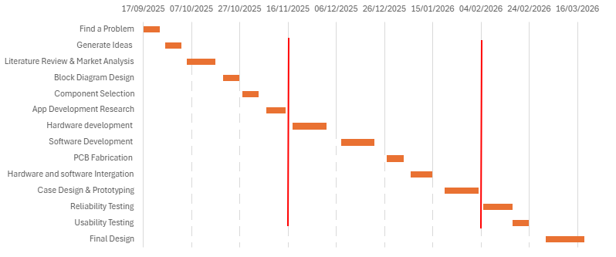the red line is hard deadline

My role: 3D design & health and safety lead
I designed the 3D-printed enclosure for the device and managed health and safety. As a 3D Designer, I created the compact, lightweight case by measuring components, planning the layout, modelling in CAD, and testing printed prototypes. The process also considered future improvements: waterproofing and better ergonomics. As the Health & Safety Lead, I ensured that the device was safe to build and operate through a detailed risk assessment related to batteries, wiring, heat, sharp edges, and materials. It confirmed operation at low voltages and had other safety features like BLE pairing and the SOS button. My part in the development added reliability and comfort, making it suitable for everyday use.

Other team members role:
Yacob Alkarim: Product manager, Hardware Developer.
As the main responsibility Delegation,
Relations between team members,
Process improvement and Hardware development.

Amani Mohsin: Collaboration plan and software development
As part of the collaboration plan, the software lead worked closely with the hardware and design team members to make sure all features integrated successfully.

Team Summary
Each member focused on their responsibility —hardware, software, or 3D design and safety—while working together to build a fully functional prototype of the Guardian Trace device.

Background research
Assistive tracking technologies have been widely studied for disables users, including those with cognitive or mobility impairments. Backed by 20 years of experience, Litum (litum, 2025) delivers Real-Time Location Systems (RTLS) that help industries and hospitals cut risks, recover time, and make smarter moves, every day. It’s not just tracking. It’s transformation you can measure.
Numerous studies have established the feasibility of wearable tracking devices in promoting safety and autonomy for disabled or cognitively disabled persons. (Doyle, 2024) contrasted GPS tracking devices for individuals with disabilities and established that real-time location tracking enhances autonomy and caregiver confidence.
(cullen, 2022) also evaluated wearable GPS devices for monitoring individuals with dementia and mild cognitive impairment, which identified their usefulness in mobility assessment and risk prevention.
Speech- and sound-based interfaces are at the heart of making users with communication or mobility disabilities more accessible. (Semary, 2024) specifically discussed voice technologies as empowerment tools, asserting the feasibility of including a microphone and speaker in assistive wearables.
Most systems under review until now are either tracking or communication, yet not at once. Literature does not provide examples of combined, bidirectional devices that provide real-time tracking and voice interaction within one device for individuals with disabilities. The designed Air-Tag-style device bridges this gap by combining BLE/UWB tracking, audio input/output, and assistive alerting into a single miniature, accessible system.

Design and consideration (reliability, safety, simplicity)
As the 3D Designer, I created a compact, ergonomic enclosure in TinkerCAD secures all components while maintaining comfort and accessibility for persons with disabilities. I added internal supports for stability using precise measurements, rounded the edges to avoid safety hazards, and kept the weight between 40–70 g. The layout is kept simple with a large SOS button, a clear LED window, and a smooth exterior. The design is not fully waterproof but allows for upgrades to make it water-resistant. This enclosure is safe, very reliable, and easy to use.

Step 1 — Understand the Requirements
Before designing anything, we make sure we know exactly what the device must do. What size should it be, what features must it have, who is using it and where will it be used.
According to (Behfar, 2025), ultra-comfortable, soft, flexible, and even stretchable wearable electronics solutions need to be developed that can be worn as smart patches. The project will help the disables and solve big problem for the carers.
Step 2 — List All the Components
Arduino Nano
Neo-6M GPS module
max9814 microphone module
Speaker 4Ω-8Ω
LED Light
Push button
3.7V 500mAh LiPo Battery
USB cable to USB C
This step will tell us how big the enclosure must be, how much space each component needs, where must ports and buttons go and how much weight the final device might be.

Step 3 —3D Design (TinkerCAD)
I designed the enclosure for the Guardian Trace using Tinkercad, creating a simple two-part case consisting of a base and a removable lid. The base includes rounded edges for comfort, built-in strap slots, and a side cut-out for the charging port. The internal space was shaped to securely hold the Arduino board, battery, and other components while keeping the overall design compact and easy to 3D print. This is not the final design, and it may be updated or refined later as the project evolves, and further testing is carried out.
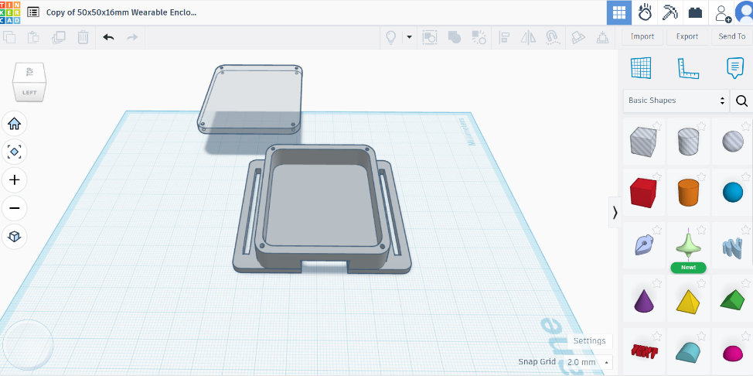

Step 4— Export and 3D Print a Prototype
Next, export the Tinkercad model and print a basic prototype to test the enclosure. It will confirm the component fit, wall thickness, and spacing, and overall size is comfortable to use daily. It will also allow evaluation of the speaker grill to make sure audio isn’t blocked. This early print supports an iterative design process, showing any adjustments that need to be made before the production of the final enclosure.
Step 5 — Assemble the Electronics
The next step will be to assemble the electronics inside the final 3D-printed case: solder the components, organize the wiring, securely mount the Arduino, battery, speaker, and any other modules. The internal layout will be checked to ensure nothing is strained and that the SOS button and LED window align properly with the enclosure openings. This step confirms that the hardware fits the design and allows for any final tweaks before full testing.

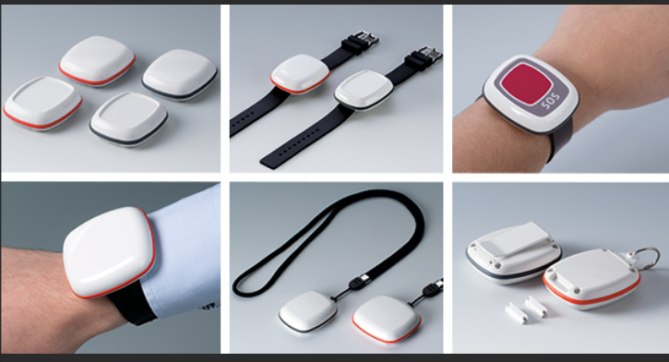

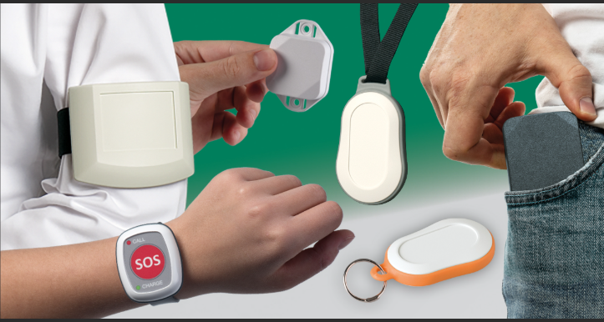
For the final version of Guardian Trace, the aim is to achieve a design similar in style to modern commercial wearable safety devices, such as the examples shown above.

Reflection (Gibbs’ Reflective Cycle – 300 Words)
The challenges were manifold, many of which deal with my role as the 3D Designer and Health & Safety lead at the start of the Guardian Trace project. First of all, it was hard for me to actually see how our ideas would translate into a physical enclosure, due in part to my inexperience with CAD tools. Equally perplexing was how all the electronic components would actually fit inside a small, wearables design. This instilled a degree of uncertainty and significantly slowed down our development process in the opening stages.

Emotionally, I was a bit overwhelmed and concerned my design skills would hold the team back. But at the same time, I was motivated to improve and contribute to the project effectively. This pressure was reduced in collaboration: the hardware and software leads provided measurements, explanations, and feedback that contributed positively to my progress.

Through the evaluation process, I assessed my early attempts and determined that my initial enclosure designs were too rudimentary, simply without full consideration of accessibility issues, safety features, or an internal component layout. When considering this, I thought through the need to adopt a more formalised design process and thus continued researching principles in wearable enclosure design and UK health and safety legislation to underpin my knowledge and confidence.

This analysis taught me that good design is very much a process of planning, iterating, and communicating effectively among team members. It also made clear that when designing for vulnerable users, safety, simplicity, and comfort have to be paid extra attention to. With these realizations, I redesigned the enclosure with rounded edges, improved internal supports, and clearer openings for the button and LED.

From this, I learned to be patient, obtain feedback, and continuously improve. In the production of the next prototype, I intend to apply these lessons by conducting more detailed tests and further refinement of the enclosure so that the user requirements are fully met.

appendix

appendix A
Group Contract
Project Title: Guardian Trace (AirTag)
Team Members: Yacob Alkarim, Amani Mohsin, Nariman Ramadhan
- Purpose
This contract defines how the Guardian Trace project team will work together effectively, maintain professional conduct, and ensure accountability. It provides clear expectations about communication, deadlines, responsibilities, and quality of work.
The project focuses on developing an assistive device ('Guardian Trace') designed to help individuals with disabilities through tracking, microphone, and speaker-based assistive technology.
- Group Goals
- Successfully design, develop, and test the Guardian Trace prototype.
- Submit all project milestones, reports, and documentation on time.
- Ensure the final deliverables meet academic, ethical, and technical standards.
- Maintain effective teamwork, inclusivity, and problem-solving throughout the project.
- Meeting Schedule and Communication
- The team will meet weekly (in person or online) to review progress and assign new tasks.
- If a member cannot attend, they must notify the group at least 24 hours in advance.
- The team will maintain communication through a group chat (e.g., WhatsApp or Teams).
- Meeting minutes will be recorded to track progress, decisions, and upcoming tasks.
- Each member must check messages daily and respond within 24 hours to maintain workflow.
- Roles and Responsibilities
Yacob Alkarim – Project Manager & Hardware Development - Coordinate project timeline, meetings, and deliverables.1
- Develop the hardware components and integration.
- Create and maintain the Gantt chart and project plan.
- Monitor team performance and ensure milestones are met.
Amani Mohsin – Software Developer & Documentation Lead - Design and program the Guardian Trace application.
- Write and organize project documentation, including this contract.
- Maintain version control and ensure all files are up to date.
- Support testing and integration between software and hardware.
Nariman Ramadhan – Health & Safety Officer & product design
- Ensure all project activities follow health and safety guidelines.
- Product design
All members will share responsibility for research, presentation preparation, and final report editing.
- Group Rules and Expectations
- Respect: Treat all members fairly and courteously; allow equal input and ideas.
- Accountability: Each member is responsible for their tasks and deadlines.
- Quality: Work must meet high academic and technical standards.
- Punctuality: Meetings and deadlines must be attended or communicated promptly.
- Participation: Each member must contribute actively to discussions and tasks.
- Decision-Making: Decisions will be made by consensus; if unresolved, majority vote will apply.
- Academic Integrity: All work must be original; plagiarism or fabrication will not be tolerated.
- Support: Members will assist one another when technical or academic difficulties arise.
- Conflict Resolution
- Minor conflicts should be discussed privately and respectfully within the group.
- If an issue continues, it will be addressed during a scheduled team meeting.
- Persistent unresolved issues will be escalated to the project supervisor for mediation.
- Accountability and Consequences
- Missed deadlines without communication will result in a warning from the team leader.
- Repeated failures to contribute or attend meetings will be documented and shared with theinstructor.
- Tasks may be reassigned to ensure project progress.
- Peer assessment scores may reflect unequal participation.
- Agreement and Signatures
Initial Agreement (Start of Project)
Name | Signature | Date
Yacob Alkarim | ___________________ | ___________
Amani Mohsin | ___________________ | 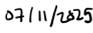___________
Nariman Ramadhan | ___________________ | ___________

Appendix B
Health and safety
Health and safety are a key priority for the Guardian Trace project, especially as the device is intended for disabled and vulnerable users. All work on the prototype must comply with relevant UK legislation. The project follows the (Health and Safety at Work etc. Act 1974, 1974), which requires that all equipment is designed and used safely. Because the device contains electrical components, the design also aligns with the requirements of the (The Electricity at Work Regulations 1989, 1989), ensuring that the system operates at a safe low voltage (3.3–5 V) and that wiring is properly insulated to prevent electric shock or short circuits.
The rechargeable Li-Po battery is handled in accordance with the (The Provision and Use of Work Equipment Regulations 1998, 1998), which require safe use and inspection of equipment that could pose a risk if damaged. To support this, a TP4056 charging module with built-in protection will be used to reduce hazards associated with overcharging, overheating, or battery failure.
The enclosure design considers user safety under the (The General Product Safety Regulations 2005, 2005), using rounded edges, non-toxic PLA/PETG materials, and a lightweight structure to avoid injury or discomfort. The SOS button is positioned for accessibility but designed to reduce accidental activation. As the device uses Bluetooth and location tracking, the development process also keeps in mind data protection expectations under the UK GDPR, ensuring responsible handling of personal location data.
Overall, the project aims to ensure that Guardian Trace is safe to build, safe to use, and appropriate for everyday use by disables individuals, in line with UK health and safety legislation.

References
Behfar, M. H. (2025). Wearable electronics solutions. Retrieved from vttresearch: https://www.vttresearch.com/en/ourservices/wearable-electronics-solutions?msclkid=cdbc0911a25d11976ebb60264da69296&utm_source=bing&utm_medium=cpc&utm_campaign=2025-CO117-Wearables-MSADS-Search&utm_term=wearable%20technology%20in%20healthcare&utm_content=2
cullen, a. (2022, 04 26). MDPI. Retrieved from www.mdpi.com: https://www.mdpi.com/1424-8220/22/9/3336?utm_source=chatgpt.com
Doyle, M. (2024, 04). national laibrary of medicine . Retrieved from pmc.ncbi.nlm.nih: https://pmc.ncbi.nlm.nih.gov/articles/PMC11290024/?utm_source=chatgpt.com
Health and Safety at Work etc. Act 1974. (1974, 07 31). Retrieved from legislation.gov.uk: https://www.legislation.gov.uk/ukpga/1974/37
litum. (2025). Retrieved from litum: https://litum.com/
Semary, H. (2024, 01 05). scienceopen. Retrieved from www.scienceopen.com: https://www.scienceopen.com/hosted-document?doi=10.57197%2FJDR-2023-0063&utm_source=chatgpt.com
The Electricity at Work Regulations 1989. (1989, 04 07). Retrieved from legislation.gov.uk: https://www.legislation.gov.uk/uksi/1989/635/introduction/made
The General Product Safety Regulations 2005. (2005, 06 30). Retrieved from legislation.gov.uk: https://www.legislation.gov.uk/uksi/2005/1803/contents/made
The Provision and Use of Work Equipment Regulations 1998. (1998, 09 15). Retrieved from legislation.gov.uk: https://www.legislation.gov.uk/uksi/1998/2306/contents/made

