
Proffesional Career Development


June 17, 2022
Ovidiu Ioan Paulencu
1816786

Contents
Introduction 2
Personal SMART goal 3
Personal SWOT Analysis 3
Skills Audit 4
Learning Styles 5
Personal Development Plan 6
Conclusion 7
Reference: 8
Anex 1 10
Anex 2 11

Introduction
It is impossible for each person to perceive or comprehend the notion of personal growth in the same way since it is unique to them. According to Stella Cottrell (2021) The process of figuring out what it is that we really want – our aspirations for ourselves – and what it is that we need to do to accomplish that goal is referred to as personal development. The depth of that process, as well as the outcomes it produces, are entirely dependent on the contributions made by each of us individually. Professional development is career-related training and education. Professional development helps you stay current on trends and build new skills for employment or career progression.
Personal and Professional Carrer development starts with Self-Awareness. Short definition of Self-awareness is knowing your emotions, thoughts, and behaviours. Self-awareness involves knowing how others view you. Self-aware people know their strengths and weaknesses.
I will talk about how I gained self-awareness by creating a Personal Development Plan (PDP), doing a SWOT analysis, implementing the SMART goal, and describing two different learning styles. Conversion tactics will be used by me to transform my strengths, shortcomings, and potential dangers into opportunities.

Personal SMART goal
Setting goals is a powerful way to think about your ideal future and get motivated to make that future a reality. Set goals if you want to be successful. George Doran introduced SMART goals in a 1981 paper titled “There’s a S.M.A.R.T. way to write management goals and objectives”. The letters in the word "Smart" stand for the words "Specific, Measurable, Achievable, Relevant, and Time Bound." For example: By the end of the year, I want to get a grade of 70 percent in university for the higher education certificate.
I am motivated to change my current situation because of safety needs. According to Maslow’s Theory of Human Motivation (1943), the safety of needs is the urge to feel comfortable and secure in the knowledge that one's fundamental requirements will, in fact, be met in the future as well. Maslow was of the opinion that people go through several stages based on their five basic needs. Safety needs is the second stage. In simple words is theory of motivation in psychology. When it comes to making choices that impact our lives, we do all in our power to keep ourselves safe. I have a family which I need to support, to take care of, and I need to change my life to make it possible.

Personal SWOT Analysis
Albert Humphrey, a researcher at the Stanford Research Institute (SRI) in the 1960s and early 1970s, is credited with developing the method that would later become known as the SWOT framework. SWOT is an acronym for Strengths, Weaknesses, Opportunities, Threats. It is accurate to state that SWOT analysis is a method that focuses on the aspects of our life that are most important to us. It is built on a series of analyses that allow you to find your strengths, help you identify, improve, and capitalise on any new abilities that may come into your growth, and allow you to discover your strengths.
Strength  - Confident  - Decision making  - Involved  - Management experience | Weaknesses  - Time management  - English written skills  - Stubborn  - Emotional
Opportunities  - Admitted to University  - Multilanguage speaker  - Take advantage on someone else’s absence  - Meet new people | Threats  - Work part-time  - Lack of flexibility  - Lack of time  - Lack of patience

Tows Analysis helps to devise strategies from a SWOT.
S-O
I am confident and I am taking good decision which helps me feel happy even when working with different people from different environment. Being involved and having already management experience would help me build strong and trustworthy relationship within personal life (friends) as well as in business field.
W-S
Being stubborn and emotional does not help me in difficult situation. I will attend the course dealing with emotional problems, and how to look at the problem from different perspective. When I am trying to do a lot of things in a short period of time, it means I can not plan everything correctly. I would make a daily plan, trying to be in a good relationship with time. I took courses to improve my written skills. This course will help me to finish university and to manage projects.
T-O
It is difficult to obtain what you want in life with a lack of time, and lack of flexibility. Working part-time gives me the opportunity to attend the university. Without time and flexibility is hard to find a balance in life. Instead of spending time doing non-important things, is much more important to spend the right time with family. Sometimes not being patience gives you the opportunity to notice that in life everything has to be in the right place at the right time.

Skills Audit
“Employability skills are those basic skills necessary for getting, keeping, and doing well on a job.” (2016). These abilities, attitudes, and behaviours help workers get along with co-workers and superiors and make smart judgments.
In 1955, Joseph Luft and Harry Ingham developed a psychological instrument which they named the Johari window after their collaborator Johari. By using this straightforward yet really helpful tool, one may have a better understanding of how evolution and personality development work. I separated the information I have gathered about my employability skills and the information I already know about my employability skills into four categories: what I know and what I do not know about me, what others know and what they do not know about me, and what others know but do not know about me.
I will be utilising a model that is known as The Johari Window. This kind divides one's inner consciousness in four different ways, which may be compared to a window that has been cut into four quadrants labelled "hidden," "unknown," "blind," and "open."

Known to self Unknown to self
- Problem Solving | - Public Speaking
- Leadership | - Teamwork

Known to others

Unknown to others

Public Speaking is an employability skill that I did not know I do have. We use it every day, including making presentations, dealing with clients, and participating in meetings. People who are good at speaking in front of a group are in high demand for the many jobs that require this skill. Employers value people who can speak well and are well-prepared. Having these skills can even help you get leadership positions and other important roles. Public speaking skills that are effective reflect a person's inventiveness, critical thinking skills, leadership ability, composure, and professionalism, all of which are attributes that are extremely valued in the job market. Having these qualities may help a person develop in their career.

Learning Styles
The learning-styles notion is popular among educators, parents, and the public. This acceptance is likely not unexpected given suppliers offer various exams, assessment devices, and internet technologies to assist instructors determine their students' learning patterns and alter their educational techniques. (Pashler, H, et al., 2008).
Fleming and Mills (1992) described 4 student-teacher experiences. Visual, Aural, Read/Write, and Kinaesthetic are VARK learning modes.
I complete the VARK questionnaire to determine how I research and utilise knowledge. (Appendices 1).
Looking at my results from questionnaire, I can say that I have Aural Study Strategy. It suits me because I like to hear the information. Attending tutorials and using tape recorders to play back learning sessions helps me more to gather and understand the information. What does not suit me is Kinaesthetic strategies because through this strategy I need to learn through experience and practice. I like to start learning with theory, at the beginning.
I use different methods to figure out what something means. I noticed that I can quickly remember a picture or the face of someone. I'm good enough with my eyes to be able to see details. I like to work with maps and pictures. Taking notes makes it easier for me to remember things. When I colour different parts of information a different colour, it helps me put them into groups.

Peter Honey and Alan Mumford (1986a) found that people learn in four different ways, based on their own preferences. Honey and Mumford made a questionnaire (Honey and Mumford, 1986b) that can help you figure out how you prefer to learn.
Using the Learning Styles Questionnaire, I found that there are four different ways to learn: being an activist, a theorist, a reflector, or a pragmatist. This shows how well Honey and Mumford organised the different ways people learn. Referring to Appendices 2, the result shows that I am a Reflector-Theorist. Being a reflector means taking information from many different places and analysing it carefully before deciding. At the same time, to be a theorist means to know what's going on behind the scenes. Both of them suits me perfectly.

Personal Development Plan
A PDP is a form of self-evaluation and self-reflection that is typically used in higher education and the workplace. (Putter, 2021).
Development Objectives | Specific Action | Blockers and how they will be removed | Support required | How will I know I have achieved the objective
Management skills | - Attend Management Course  - Spend time more with people with managing skills | -Work (take some time off)  -family (ask them to help me with housework) | -Wife support  -My manager supports | In 1 year, time, I will finish my course, attending 2 days per week, gathering all necessary information.
Critical Thinking | - Consider the consequence of your opinions  - Break down the ideas | -stubborn (learn how to let my stubbornness aside) | -My family supports  - online guidance | Make research and I will gather information using questionnaire in 4 months’ time to improve my Critical Thinking regarding work and social life.

Conclusion
A personal development plan is critical since it helps you build the talents you'll need throughout your life. To be successful in life, you need a strategy to make your ambition a reality. A solid PDP will assist you in turning your goals into action plans. Learning opportunities that are available on a continuous basis are a key aspect of motivation. People are inspired to perform by the development process, and development plans enable them to be better equipped than ever to contribute to the workplace.
When it comes to personal growth, the word "results" comes to mind. There won't be any more, and there won't be any less! Only you have the power to choose what you want to accomplish with your life. Be conscious that the outcomes, not the potential, are the truest sign of how excellent you are on the path of life! Self-awareness is the first stage towards personal growth. Then we assess our skills and flaws, work to improve them, and make goals.
It is critical to be clear about the region in which we wish to expand before considering how we might improve the situation.
To better understand the continuous cycle of our personal development, we begin by getting to know ourselves, where we are going, continuing to plan and develop a strategy to achieve fixed goals, and then continuing to improve the skills that will help us achieve our final goal, as well as our self-confidence.

Reference:

- Cottrell, Stella. Skills for Success: Personal Development and Employability, Macmillan Education UK, 2021. ProQuest Ebook Central, http://ebookcentral.proquest.com/lib/trinity/detail.action?docID=6577749.
- Ellieys, A., 2001. Adult learning Styles. [online] Available at: <https://d1wqtxts1xzle7.cloudfront.net/43334119/4018.pdf-with-cover-page-v2.pdf?Expires=1655386874&Signature=Q-w8xAG6kpj08JisomruID~0TAhDWoxodwlS7tCsynlq~ksPf789F47mn~EaGw0gb2CZQaB8l88soyWjJH-RW0pa7~HvjhqOqVvUA7HSCnpo4Xm7WkMfwoAG2cQJBG~wBk3mvWDk-bUAvSwXWajevXwwk4H0xwTSocWu9xKWvxbhuH4l0T~XwD~0HD63nG5SuO73ByXEYUBeK9f0Geb0TIYC0pSkX8dPXOr2poe2HEdvIz~Qhl8qcUlpj3SgTzgbsqTtbxb8Oe4Ac7zXB8VbBqYep-gFwGLH~xEAPr5UutxCM7wZtl3~1QfYphYsY8-c2czNCRvzTJ0tdOU1yYWzVw__&Key-Pair-Id=APKAJLOHF5GGSLRBV4ZA> [Accessed 7 June 2022].
- Fleming, N., and Baume, D. (2006) Learning Styles Again: VARKing up the right tree!, Educational Developments, SEDA Ltd, Issue 7.4, Nov. 2006, p4-7.
- Honey A, Mumford P. A manual of learning styles. Maidenhead: Peter Honey Learning; 1992.
- Kenayathulla, H., et al., 2019. Gaps between competence and importance of employability skills: evidence from Malaysia | Emerald Insight. [online] Emerald.com. Available at: <https://www.emerald.com/insight/content/doi/10.1108/HEED-08-2019-0039/full/html#:~:text=Employability%20skills%20are%20those%20essential,acquiring%20and%20maintaining%20a%20job.> [Accessed 13 June 2022].
- Kolb DA. Experiential learning experience as a source of learning and development. London: Prentice Hall; 1984.
- Needleman, E. C. (1995). Preparing Youth for Employable Futures. Washington, DC: National 4-H Council Secretary’s Commission on Achieving Necessary Skills (no date). Skills and Tasks for Jobs. A SCANS Report for America 2000. Washington, DC: U.S. Department of Labor.
- P. Robinson, D., 2000. The Workplace. [online] Face.edu. Available at: <https://www.face.edu/cms/lib/CA01000848/Centricity/Domain/189/employability-skills.pdf> [Accessed 9 June 2022].
- Pashler, H. et al. (2008) ‘Learning Styles: Concepts and Evidence’, Psychological Science in the Public Interest, 9(3), pp. 105–119. doi: 10.1111/j.1539-6053.2009.01038.x.
- Personal development planning: guidance for institutional policy and practice in higher education. The Quality Assurance Agency for Higher Education (QAA), February 2009.
- Piercy, Nigel, and William Giles. (1989) Making SWOT Analysis Work, Marketing Intelligence & Planning p5-7.
- Sarsby A. (2016) SWOT Analysis: A guide to SWOT for business studies students. [online]. Available from: https://books.google.co.uk/books?id=Yrp3DQAAQBAJ&printsec=frontcover&dq=swot+analysis&hl=en&sa=X&ved=0ahUKEwjF67DtgeviAhVDrHEKHb2nDEMQ6AEIKjAA#v=onepage&q=swot%20analysis&f=false
- Valley K. Learning styles and courseware design. Assoc Learn Tech J 1997; 5:42-51.

Anex 1
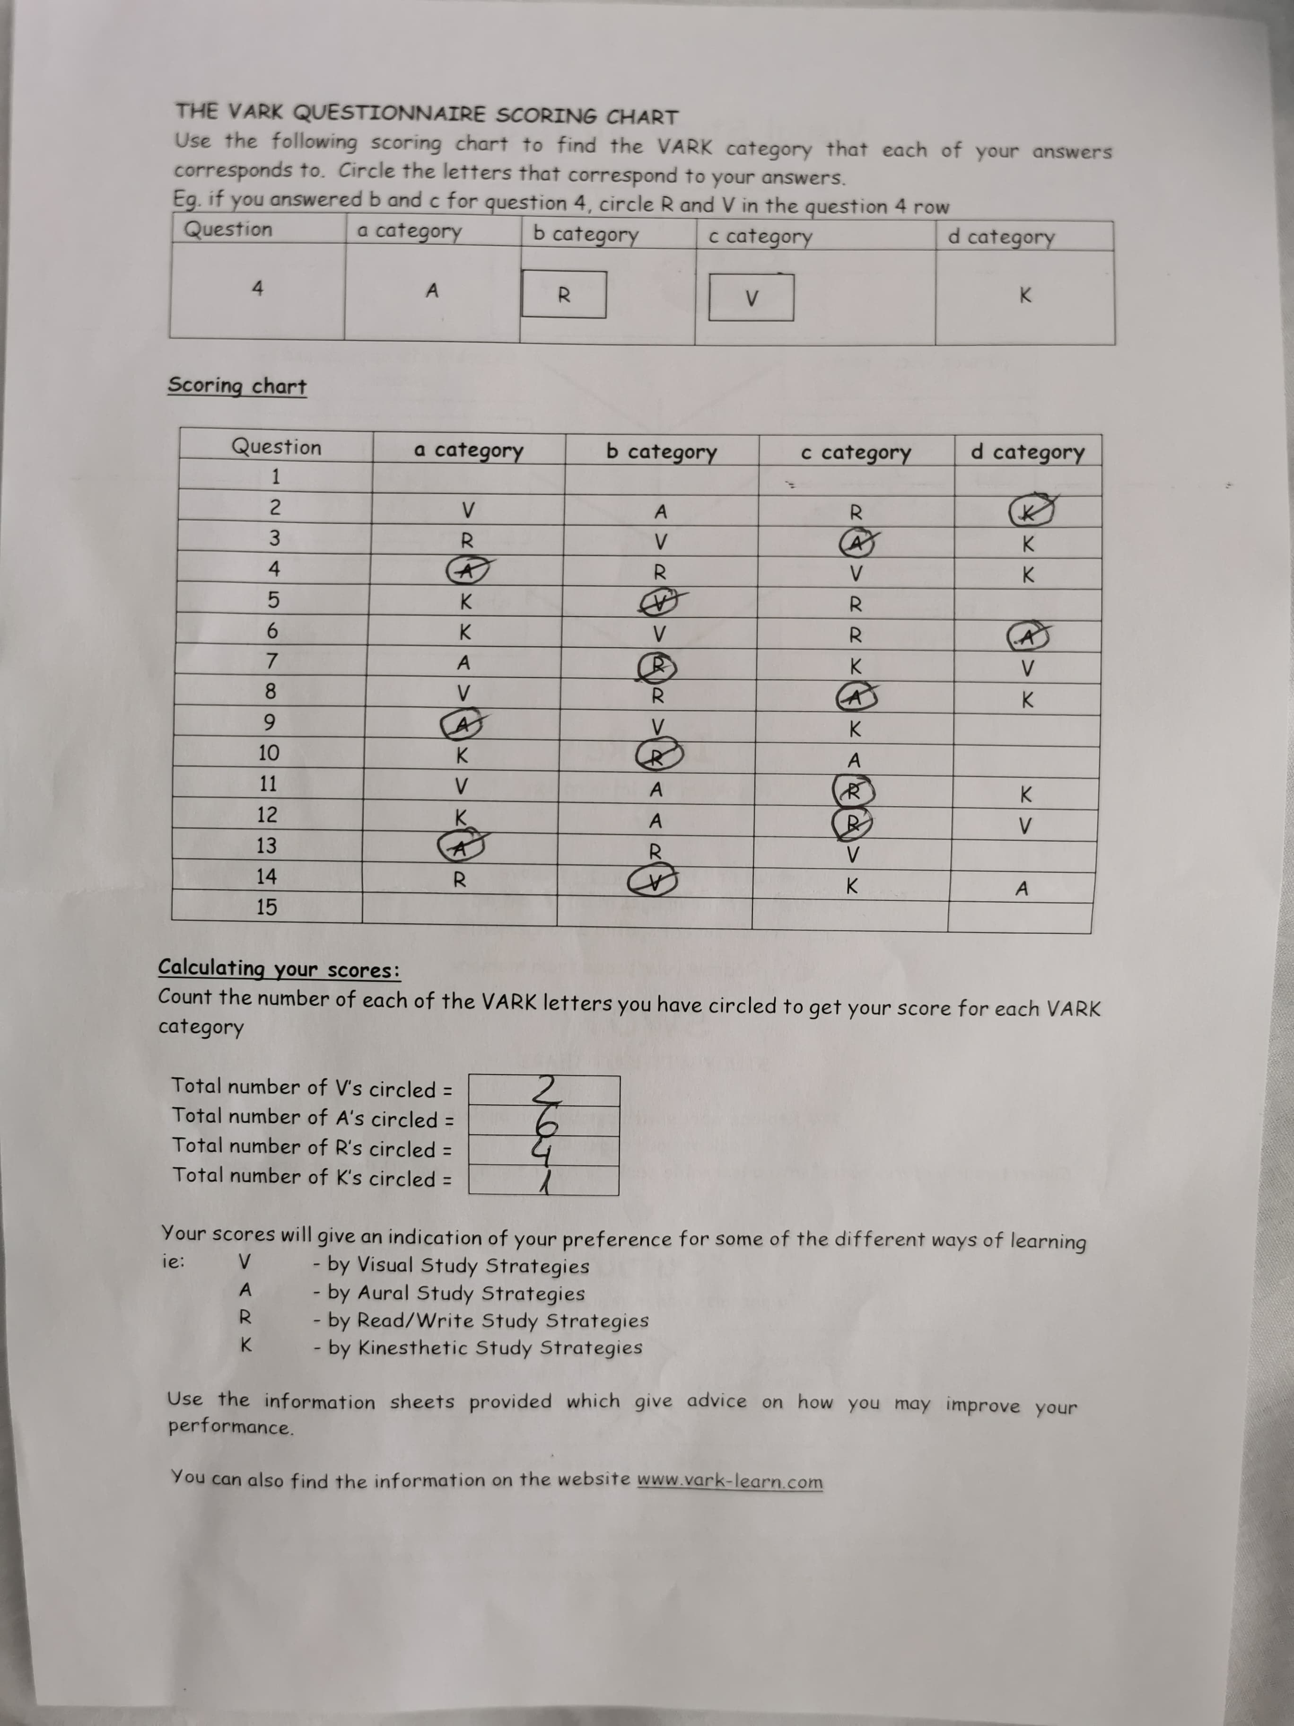

Anex 2

