Introduction to Physiology
Module code: BMHP5003
Assessment 1 – Individual Academic Poster Presentation
Student’s Name: Fatima Al Hassan
Student’s Number:2129080
Lecturer’s Name: Gillian Weaver

Mouth
Food enters digestive system through the mouth (Sensoy, 2021). Food mixes with enzymes contained in saliva. Teeth breaks food into small pieces.
The Digestive System
Esophagus
Peristalsis occur here to carry food from the mouth to the stomach (Li et al., 2020).
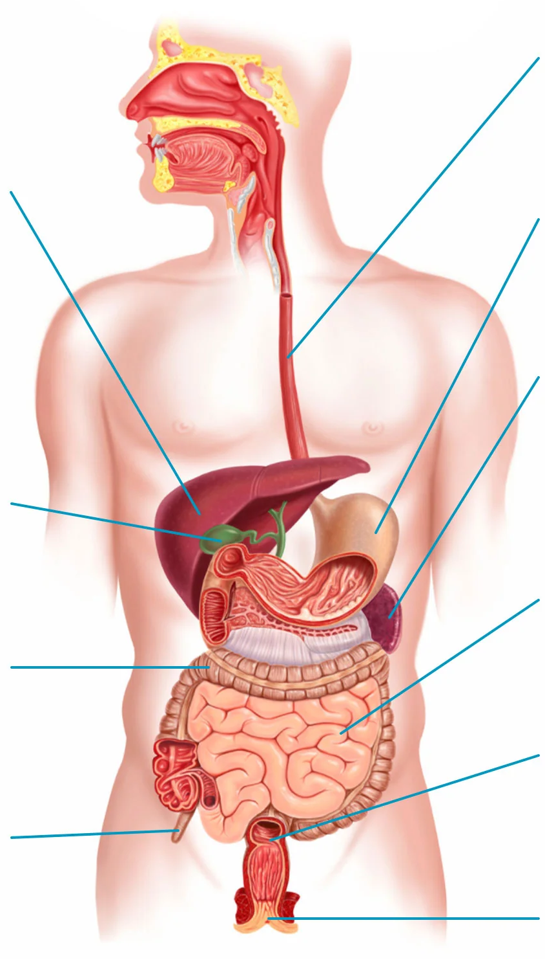

Liver
This is the largest organ of the digestive system (Smidge, 2023). It releases bile into small intestine which breaks down fat and some vitamins.
Stomach
This hollow container holds food for sometime. In the stomach, food mixes with stomach acid and enzymes released by the stomach lining (Sensoy, 2021).

Pancreas
This gland releases enzymes that break down protein, fats, and carbohydrates (Zhang et al., 2022).
Gallbladder
The bile made in the liver is stored here. The gallbladder then secretes the bile into small intestine to break down fat and some vitamins (Rajab et al., 2020).

Small Intestine
Food mixes with enzymes released by the pancreas, bile, and the liver. The 22-foot muscular tube is divided into three sections which are duodenum, ileum, and jejunum (Zhang et al., 2022).

Large Intestine
Also referred to as colon. It is a 6-foot tube connecting small intestines and the rectum. Here water and sodium are absorbed from food waste (Nightingale & Spiller, 2023).

Rectum
It is the lower part of the colon connecting the colon with the anus. It is 8 inches long and its function is to store waste before it is removed through the anus (Zhang et al., 2020).

Appendix
It is a pouch-like structure attached to the colon. It has no function in the digestive system as human body can function normally when this structure is removed through a clinical procedure (Vitetta, 2022).

Anus
Removes food waste from the body after digestion (Sulastri et al., 2022).

References
Li, C., Yu, W., Wu, P., & Chen, X. D. (2020). Current in vitro digestion systems for understanding food digestion in human upper gastrointestinal tract. Trends in Food Science & Technology, 96, 114-126.
Nightingale, J. M., & Spiller, R. (2023). Normal intestinal anatomy and physiology. In Intestinal Failure (pp. 13-33). Cham: Springer International Publishing.
Rajab, I. M., Majerczyk, D., Olson, M. E., Addams, J. M., Choe, M. L., Nelson, M. S., & Potempa, L. A. (2020). C-reactive protein in gallbladder diseases: diagnostic and therapeutic insights. Biophysics Reports, 6, 49-67.
Sensoy, I. (2021). A review on the food digestion in the digestive tract and the used in vitro models. Current research in food science, 4, 308-319.
Smidge, (2023). How your digestive system works. Available at https://www.getsmidge.com/pages/how-digestion-works (Accessed 13 October 2023).
Sulastri, A., Badruzsaufari, B., Dharmono, D., Aufa, M. N., & Saputra, M. A. (2022). Development of science handouts based on critical thinking skills on the topic of the human digestive system. Jurnal Penelitian Pendidikan IPA, 8(2), 475-480.
Vitetta, L. (2022). The vermiform cecal appendix, expendable or essential? A narrative review. Current Opinion in Gastroenterology, 38(6), 570-576.
Zhang, F., Zhao, R., Hou, T., Ren, F., Liu, X., Zhang, Y., & Zhang, X. (2020, August). Staging of Rectal Cancer Based on Radiomics. In The International Conference on Natural Computation, Fuzzy Systems and Knowledge Discovery (pp. 1017-1024). Cham: Springer International Publishing.
Zhang, Z., Tanaka, I., Pan, Z., Ernst, P. B., Kiyono, H., & Kurashima, Y. (2022). Intestinal homeostasis and inflammation: Gut microbiota at the crossroads of pancreas–intestinal barrier axis. European Journal of Immunology, 52(7), 1035-1046.

