ACCA5033 – Changemakers: creativity and value creation – Assignment 2
Ashley Rees 2009258

Table of Contents
1. Introduction 2
2. Task 2 4
3. Task 3 6

Introduction

Please click the web view link to open in a browser, click the Task Name to open in OneNote.

https://uowtsd-my.sharepoint.com/:o:/g/personal/2009258_student_uwtsd_ac_uk/EsmBysEEECJGs0a_Gk8YclEBKSuZ_bMRgy387rS6h2PPsA?e=mlhBVW

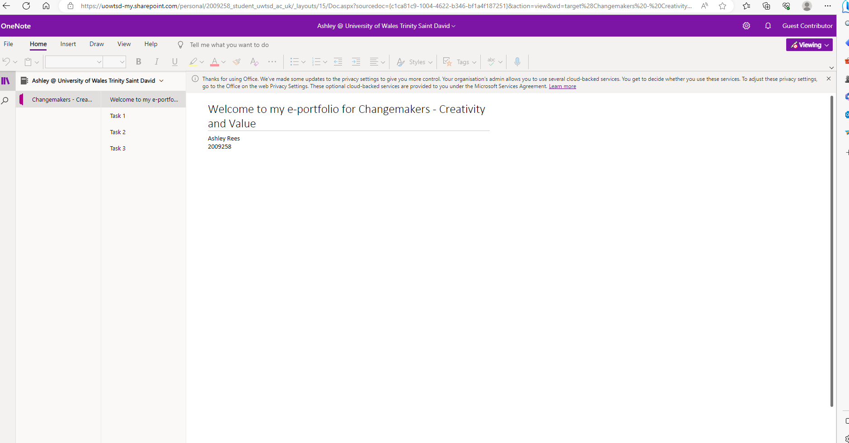

Task 1
https://uowtsd-my.sharepoint.com/:o:/r/personal/2009258_student_uwtsd_ac_uk/_layouts/15/doc2.aspx?sourcedoc=%7Bc1ca81c9-1004-4622-b346-bf1a4f187251%7D&action=edit&wd=target(Assignment%202%20-%20Task%201.one%7CF78CD9B7-4773-4694-9C5B-EADE454BC903%2F)

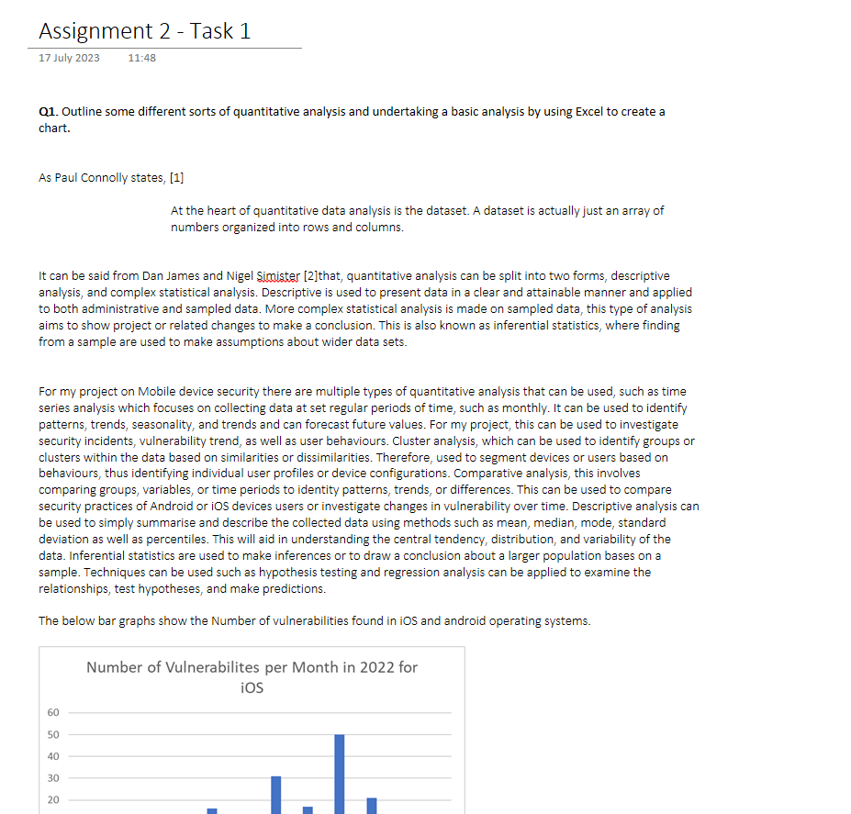

Task 2

https://uowtsd-my.sharepoint.com/:o:/r/personal/2009258_student_uwtsd_ac_uk/_layouts/15/Doc.aspx?sourcedoc=%7Bc1ca81c9-1004-4622-b346-bf1a4f187251%7D&action=edit&wd=target(Assignment%202%20-%20Task%202.one%7C55E815A5-D1B5-4A88-B8BE-0484F3EF8BE4%2F)

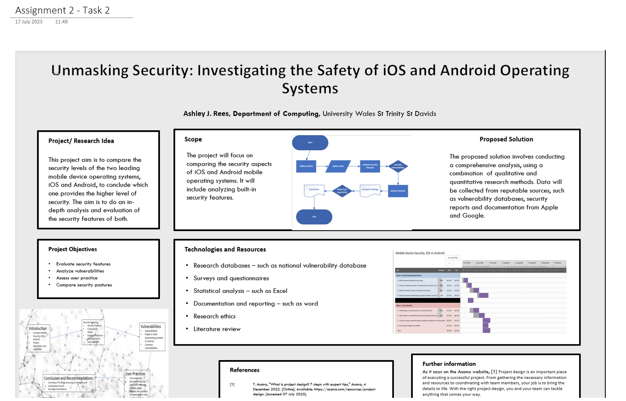

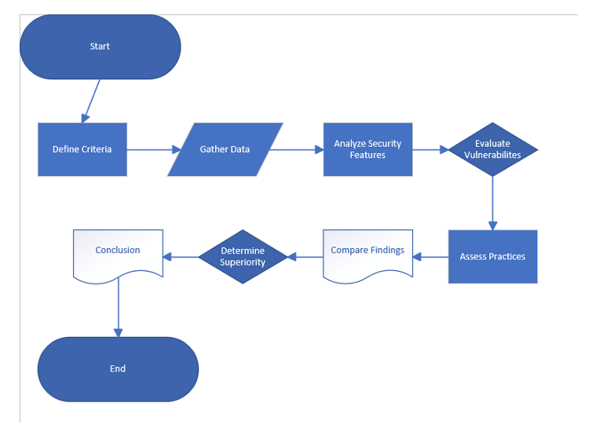
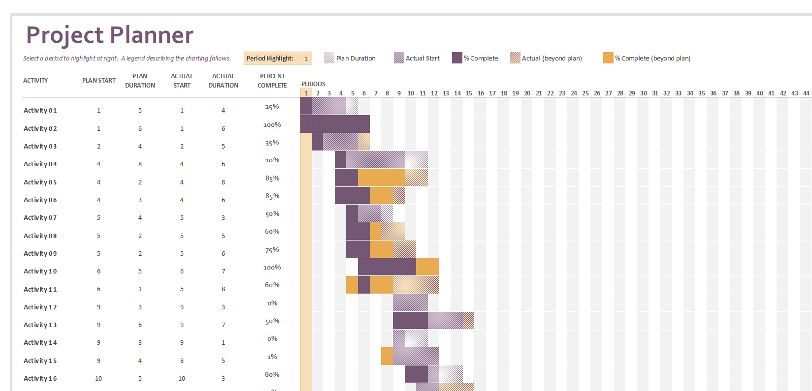
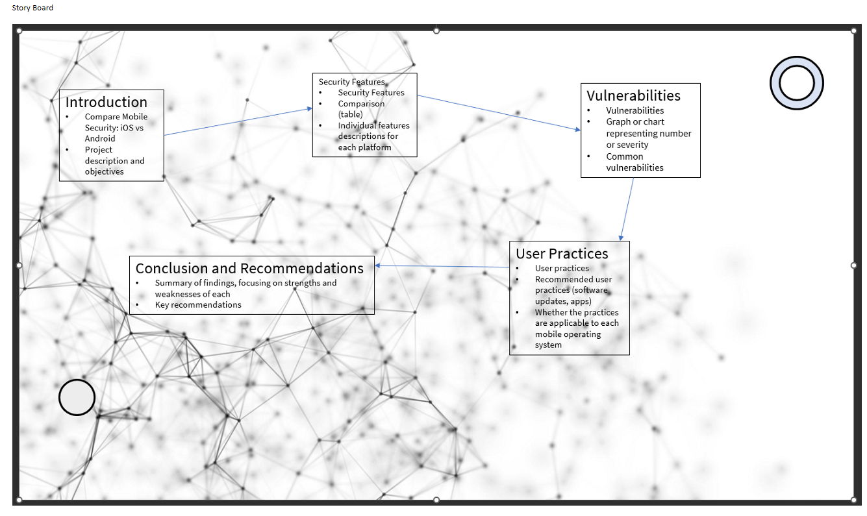

Task 3
https://uowtsd-my.sharepoint.com/personal/2009258_student_uwtsd_ac_uk/_layouts/15/Doc.aspx?sourcedoc={c1ca81c9-1004-4622-b346-bf1a4f187251}&action=edit&wd=target%28Assignment%202%20-%20Task%203.one%7C137e2ba3-444a-465e-b093-d10b2f7ade24%2FAssignment%202%20-%20Task%203%7Ce017d75b-e84d-409a-855d-cc913a7ed8eb%2F%29&wdorigin=NavigationUrl



