Name- Vishal Choudhary
Student id- 2412600
Subject— International Marketing: Principles and Practices
Code— LCMB7026
Professor name— Tushara Balendran
Title: “A Comparative Analysis of Starbucks’ International Marketing Strategies in the United Kingdom and India”

Table of Contents
Introduction 3
History of International Marketing 3
Reasons why Starbucks was selected 3
Rationale behind the choice of UK and India 3
Aim, Objectives and Structure of the Report 4
Starbucks in Global and Local Context Brand Overview 4
International History and Starbucks Positioning 4
Strategy Brand Values and Competitiveness. 4
Tata Alliance as an entry strategy in India. 5
Business Model and International Expansion Strategy. 6
Socio-cultural and Macro Environment PESTLE (Comparison) 6
PESTLE Analysis- United Kingdom 6
PESTLE Analysis – India 8
Strategic Impact and Critical Comparison 10
Comparison of Segmentation, Targeting and Positioning (STP) 10
STP Strategy in United Kingdom. 10
STP Strategy in India 12
Comparative Assessment of STP Effectiveness. 13
Comparison of marketing mix (7Ps) Strategies 14
Product 14
Price 15
Place 15
Promotion 16
People 16
Process 17
Physical Evidence 17
Comparative Summary Table (UK vs India) 18
Marketing Performance Assessment 19
Assessment of Marketing Ethics Practices 20
Strategic Recommendations & conclusion 21
Strategic Recommendations 21
Conclusion 22
Reference List 23

Introduction

History of International Marketing
International marketing is a set of actions performed by organisations to plan, price, promote and distribute products and services across the national borders (Kotabe and Helsen, 2022). In the contemporary international economy, the businesses are becoming more and more international as businesses are expanding beyond their home markets because of globalisation, technological growth, global trading agreements and Internet connection. Although the international expansion presents tremendous growth opportunities, it presents the companies with complicated issues like culture diversity, political unrest, laws, economic swings, and variations in consumer behaviour (Sudirjo, 2023). Consequently, global marketing initiatives should sit on the fence between global brand uniformity, and the necessity to adapt to the local market to realize long-term success.

Reasons why Starbucks was selected
This study has chosen Starbucks as it is considered to be among the most successful and recognisable brand of premium coffeehouse in the world. The company has a presence in over 80 countries and it exhibits high capacity in maintaining global brand consistency and adjusting its products in accordance with the local market demands.

Rationale behind the choice of UK and India
United Kingdom and India are the comparative markets chosen due to the difference in the economic, cultural and consumer environment (Gonzalez et al., 2022). UK is a mature market and economy with an existing cafe culture, high consumer spending power and competition in the industry. Conversely, India is an emerging economy with a high growth and traditionally, tea is the sole product that is consumed and a coffee culture is yet to be established.

Aim, Objectives and Structure of the Report
This report is meant to critically discuss and compare Starbucks marketing strategies in UK and India. The goals are to analyze the macro-environment with the help of PESTLE, compare and contrast the differences between STP and 7Ps marketing mix, analyze the marketing performances and ethical behaviors, and offer the strategic recommendations. The report is designed in such a way that it starts by providing the overview of the brand then the comparison analysis, assessment of performance and ethics, and finally the recommendations.

Starbucks in Global and Local Context Brand Overview

International History and Starbucks Positioning
Starbucks is one of the largest chains of coffeehouses in the world that was established in 1971 in Seattle, the United States as a specialty coffee retailer (Starbucks, 2025). The company was originally intended to sell high quality roasted coffee beans but shifted to a business model of a cafe that sells hand crafted beverages and an experience to the customer. Starbucks has grown exponentially in global markets over the decades, and is currently spread over 80 countries all over the world (Starbucks, 2025). The brand is internationally positioned as a high quality coffeehouse that sells high quality products, customised drinks and a third place experience in between home and work. Such steady premium positioning has helped Starbucks to have a good brand equity and international recognition.

Strategy Brand Values and Competitiveness.

Strategic Area | Key Details
Core Brand Values | Starbucks’ core values focus on quality, customer experience, ethical business practices, and community engagement (Starbucks, 2024).
Ethical Sourcing | The Coffee and Farmer Equity (C.A.F.E.) Practices ensure fair trade, sustainable farming, and environmental responsibility (Starbucks, 2024).
Experiential Retail Strategy | Starbucks stores function as “third place” environments that are warm, social, and experience-driven rather than purely transactional (Starbucks, 2023).
Digital Innovation | Mobile ordering, loyalty programmes, and personalised digital marketing strengthen customer engagement and retention (Patov, 2024).
Global Competitive Advantage | Starbucks’ sustainable competitive advantage comes from its combination of product quality, emotional brand connection, ethical sourcing, and technological leadership (Starbucks, 2024; Patov, 2024).
UK Market Entry | Starbucks entered the UK market in 1998 as one of its earliest international expansions (Starbucks, 2023).
UK Market Characteristics | The UK represents a mature coffee market with strong café culture and high consumer demand (Starbucks, 2023).
UK Growth Strategy | Rapid outlet expansion across high streets, transport hubs, and major city centres supports market penetration (Starbucks, 2023).
Local Adaptation (UK) | Starbucks has adapted through local product offerings, sustainability initiatives, and digital payment and loyalty systems (Starbucks, 2023).
Overall UK Competitiveness | The brand’s premium American image combined with localisation sustains strong competitive positioning in the UK (Starbucks, 2023).

Tata Alliance as an entry strategy in India.
Starbucks made its entry into India in 2012 by way of a strategic joint venture with Tata Global Beverages, which is referred to as Tata Starbucks Private Limited (Starbucks Stories Asia, 2019). This alliance gave Starbucks the chance to leverage on the extensive expertise in supply chain, local market knowledge and good brand image enjoyed by Tata in India. India is an emerging market with a culture that is traditionally characterized by the use of tea as the leading beverage, a low per capita consumption of coffee, and a high price sensitivity. Starbucks took a slow strategy of expansion with high end urban outlets like Mumbai, Delhi and Bengaluru (Starbucks, 2024b). The company highly localised its product line by launching Indian flavours, vegetarian food options, culturally-relevant design of the stores, which shows a powerful strategy of adapting to this new market.

Business Model and International Expansion Strategy.
Starbucks has a hybrid business structure which consists of a company owned stores, franchise stores, and joint ventures based on the market environment. Starbucks is mainly using company-owned as well as licensed stores in developed markets like the UK to ensure that operations are under control and that all the stores follow the same branding (The Strategy Institute, 2024). Conversely, in the emerging markets such as India, strategic alliances and joint venture are the favored approach in order to minimize market entry risk and local responsiveness. The Starbucks international expansion strategy entails management styles of selective market penetration, premium positioning, experience retailing, digitalization and ethical sourcing. This moderate strategy of standardisation globally and adaptation locally will help Starbucks to continue with the long-term growth in the various international markets.

Socio-cultural and Macro Environment PESTLE (Comparison)

PESTLE Analysis- United Kingdom
Political
The UK has a fairly stable democratic political environment which offers a predictable business environment to multinational businesses like Starbucks. Even with the political uncertainty, which persists in the UK after Brexit, the country is still enjoying good trade relations and investor-friendly policies (Iqbal, 2025). The policies of sustainability, job security, and food safety by the government has direct impact on sourcing, labour and compliance in Starbucks operations. Immigration policy also affects the availability of workforce in the hospitality sector.
Economic
UK is a high income and a developed economy and has high consumer purchasing power. The coffeehouse industry would still stand firm despite inflation and interest rate changes that have been experienced in the past few years, affecting discretionary spending (Valaskova et al., 2021). Starbucks enjoys high-end consumer segments that are ready to pay a high price to experience brands. Nonetheless, increasing operating expenses, rent, wages and raw materials are still straining profitability and necessitate effective pricing and cost-management measures.
Social
UK has a well established coffee culture especially among the urban professionals, students, and remote workers. Consumers are gradually using cafes as workplaces and places of socialization, which is closely related to the third place concept proposed by Starbucks. Consumer health, sustainability, and ethical consumption are also increasingly becoming popular. The demand in the plant-based products, low-sugar drinks, and socially responsible brands have a significant impact on the product development and the promotion messages applied by Starbucks in the UK.
Technological
UK is an extremely digital market, where smartphones are prevalent, there is an internet connection, and digital payment tools are widespread. Starbucks has the advantage of high-order mobility, loyalty applications, AI-based personalisation, and delivery collaborations. Technological innovation enhances customer convenience, operational efficiency as well as data-driven marketing, which reinforces the competitive position of Starbucks (Ullagaddi, 2024).
Legal
Starbucks will have to adhere to the UK strict regulations related to food safety, hygiene, health and safety, employment rights, data protection (GDPR) and consumer rights. The employment protection laws and the National Minimum Wage have a major impact on the structure of costs in staffing. Promotional claims are also governed by standards of advertising, where it is mandatory that promoters be transparent on environmental and health related promotions.
Environmental
Sustainability of the environment is a chief issue in UK. The polices of governments promote the reduction of carbon, waste management, and recycling (Ramasubramanian et al., 2023). Consumers are becoming more demanding about their brands using less plastic and less carbon footprint. To manage its ethical brand, Starbucks is under pressure to initiate reusable cups programs, sustainable packaging, and supply chain transparency programs to sustain its brand image.
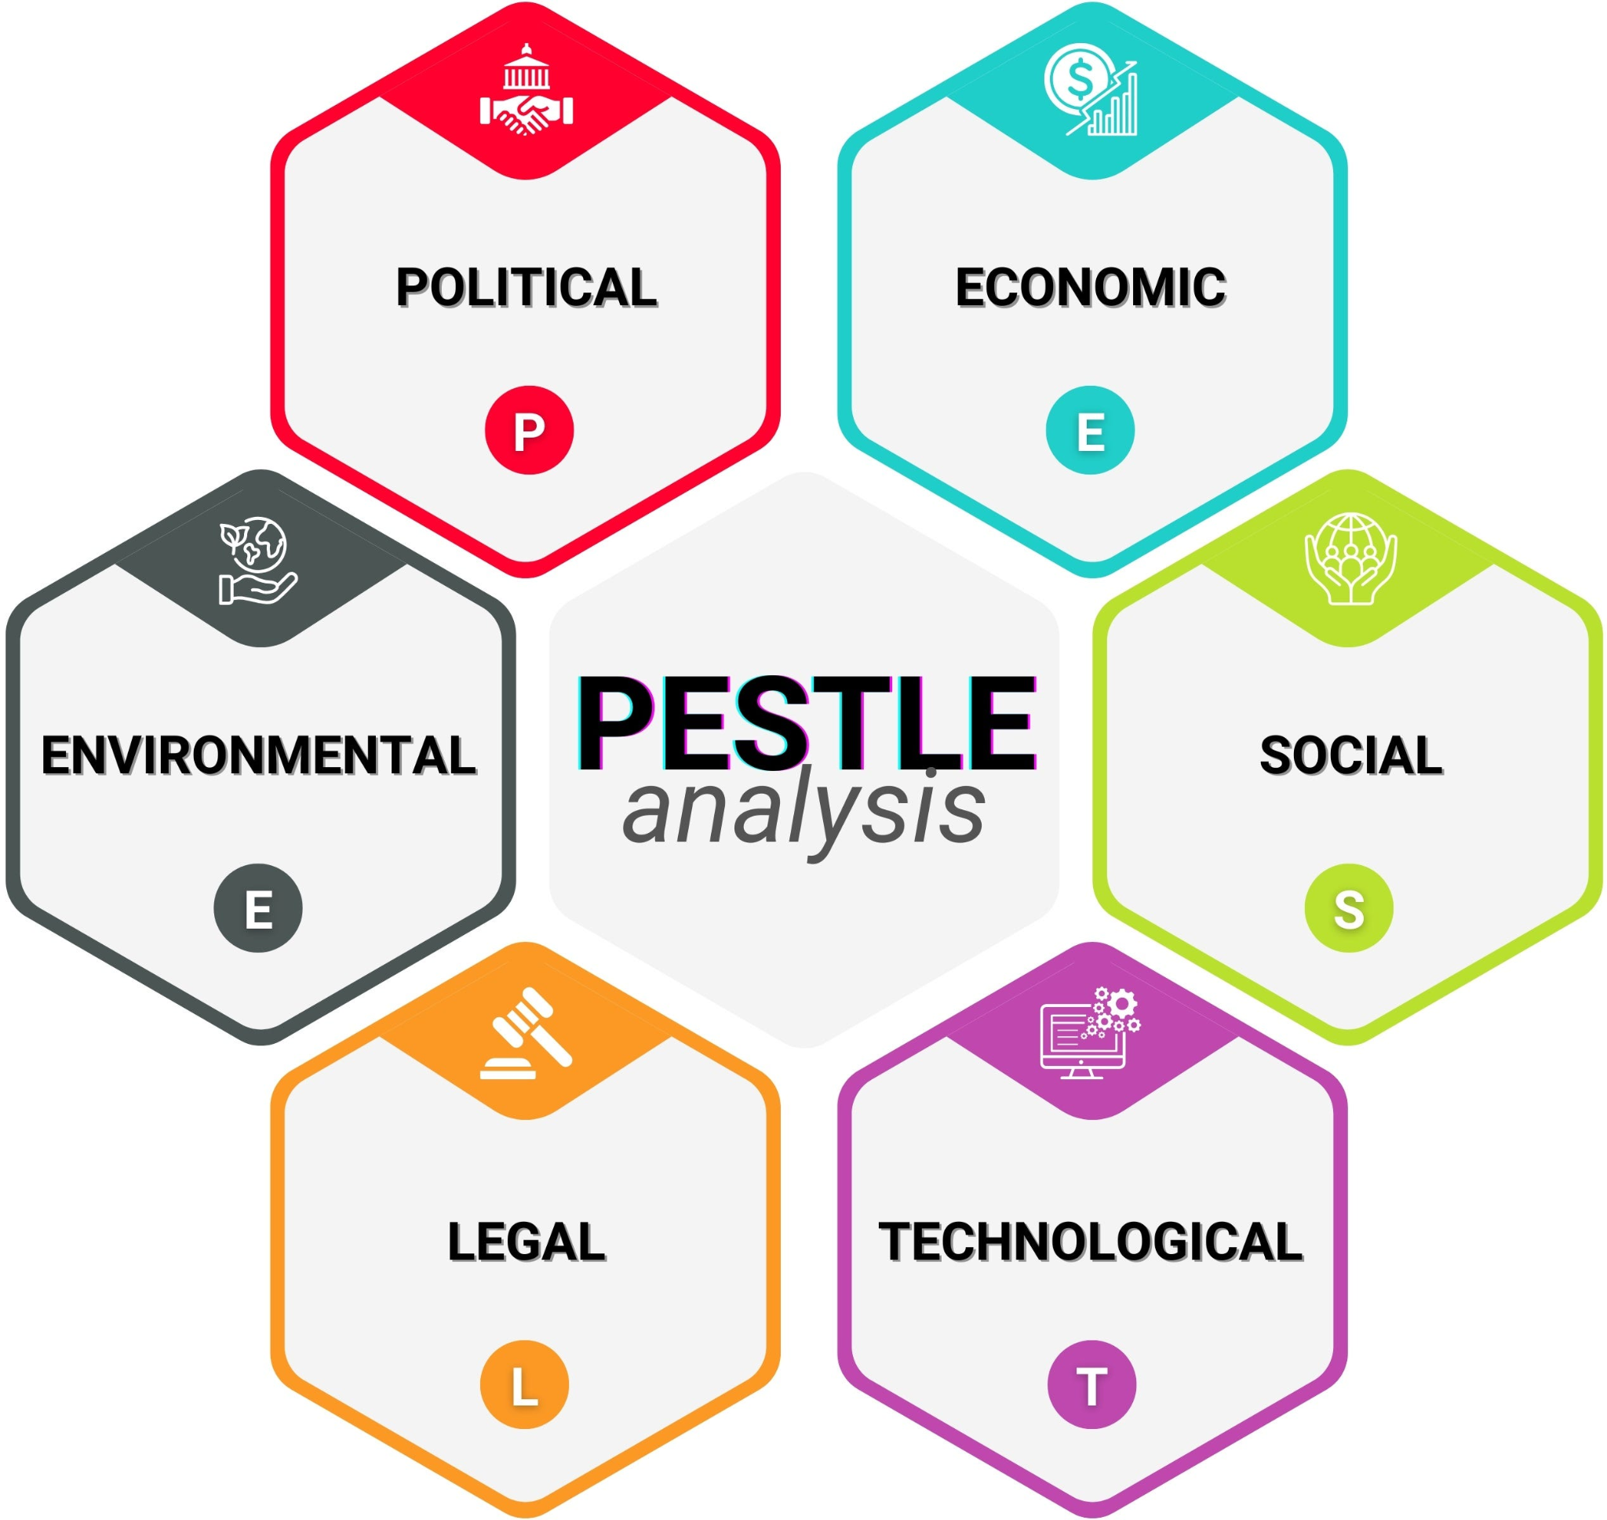
Figure 1: PESTLE Analysis
Source: (Iqbal, 2025)

PESTLE Analysis – India
Political
The Indian politics is stable on democratic front and the pro-business regulatory scene is very dynamic (Iqbal, 2025). International brands are encouraged by government programs like make in India and the liberalization of foreign direct investment (FDI). There are however differences in state laws, tax systems (GST), and bureaucracy complications which may pose operational challenges to Starbucks in various states.
Economic
India is an emerging economy that is rapidly growing and the disposable incomes of the population are increasing particularly the urban middle and upper-middle classes. Nonetheless, the level of income inequality is high, and the market is very price sensitive. Starbucks is a premium brand and this hinders penetration into the mass-market but enhances aspirational appeal (Bensalem and Benouhiba, 2025). Fluctuations in currency, cost of supply chain and real estate in urban cities affect profitability and pricing policies.
Social
India has a collectivist culture, which is diversified and highly social and family oriented. The culture of tea consumption is traditionally the dominant part of the beverage consumption, and the coffee culture is still concentrated in metropolitan regions. The young professional and student generation are embracing the western coffee culture at a rapid pace as Starbucks is being used as a social and lifestyle place. Food tastes need to be highly localised, namely vegetarian dishes and non-feeding on beef- and pork-based food.
Technological
Digital transformation in India has driven a speedy transformation in digital technologies by using mass adoption of smartphones, digital wallets and e-commerce systems (Behera, 2021). Mobile payments, apps, and food delivery applications are important in the customer engagement strategy of Starbucks. Nonetheless, Full-scale technological standardisation cannot be done due to infrastructure consistency that is less consistent in urban and semi-urban regions.
Legal
The Starbucks needs to abide by the Indian food safety laws (FSSAI), labour laws, tax laws, and data protection. Legal complexity is created by licensing processes, importation taxes on coffee equipment and adherence to local sourcing regulations. Dissimilarities in employment laws by different states also affect management of the workforce.
Environmental
India is a country with a big environmental problem, the main ones being waste management, water shortage and pollutants (Sharma et al., 2024). There is growing awareness on sustainability but is still uneven among segments of consumers. Starbucks encourages sustainable sourcing and sustainable packaging, but the application is limited by recycling facilities and the cost factor.

Strategic Impact and Critical Comparison
The macro-environmental variations between the United Kingdom and India are determinants of the strategic decisions of Starbucks in major marketing dimensions (Hong, 2025). Regarding the product offerings, the developed coffee culture in the UK and high health consciousness have led to the launch of low-sugar drinks, alternatives of plant-based milk, and products with sustainability in mind. However, in India, where the culture of drinking tea is deeply and vegetarians are very strong, Starbucks has had to localise its menu to include masala chai, regional flavours as well as vegetarian-only food offerings as part of socio-cultural and religious influences.
The economic conditions are the biggest determinants of pricing strategies. In UK, the disposable income is relatively high and Starbucks can enjoy a premium pricing that is not too sensitive to price variations (Carter et al., 2023). Nevertheless, in India, a higher income inequality and price elasticity compel Starbucks to defend its upscale positioning with inspirational branding and targeted the selection of urban areas, which restricts the access of the mass market.
Social and economic factors dictate store formats. In the UK, the outlets target the busy city consumers by offering convenience-based destinations like the high street, transport centres and office areas. Indian stores on the contrary are majorly located within luxury shopping centers and commercial business areas to strengthen the perception of high end brands and appeal to well-off consumers.

Comparison of Segmentation, Targeting and Positioning (STP)

STP Strategy in United Kingdom.
Psychographic and Behavioural Segmentation and Demographic
The segmentation strategy the Starbucks uses in the United Kingdom is a multi-dimensional approach that combines the demographic variables, the psychographic ones, and the behavioural variables (Allen, 2020). On the demographic, the brand is mainly aimed at consumers between the age of 18 and 45 with an emphasis on students, young professionals, and middle-income to high-income earners that have enough spare cash to buy high-end drinks. Psychographically, Starbucks caters well to the consumers who emphasize on lifestyle experiences, convenience, ethical consumption, and social connectivity. Such customers are generally brand conscious, ecologically conscious and digitally conscious.
On behavioural front, Starbucks focuses on coffee drinkers, commuters, remote workers, and socialisers who desire consistency, quality and convenience. The utilisation of loyalty cards, mobile ordering, and the need of tailor-made beverages are also strong in the UK market, which allows Starbucks to further enhance the interaction by providing repeat purchase behaviour that is characterised by digital personalisation and rewarding (Aminuddin et al., 2021).
Targeting : City Professionals and Student
The main customers of Starbucks in the UK are urban professionals and students at the university. The group has a high purchasing power, time constraint, and high demand of the quick-service premium products. Starbucks stores found in most office areas, transportation centers and college campuses cater to this market directly (Roll, 2021). The presence of Wi-Fi, comfortable chairs and social setting appeal to the students whereas professionals cherish convenience, speed of service and consistency of products. This is a dual targeting strategy which enables Starbucks to get the weekday commuter traffic and the long in-store occupancy during off-peak.
High-End Convenience Positioning.
Starbucks competes in UK as a high quality but convenient lifestyle brand. Although its products are more expensive than those of independent cafes and fast food competition, the brand compensates this higher price with the high quality of services, customisation, ethical sourcing, and brand experience. The third place positioning is still at the heart with Starbucks stores acting as informal gathering places to work, study, and socialize (Rosenbaum and Dickens, 2025). Such positioning is very much aligned to the urban British consumer lifestyles and Starbucks will be able to retain a high level of brand equity in a mature and competitive coffee market.
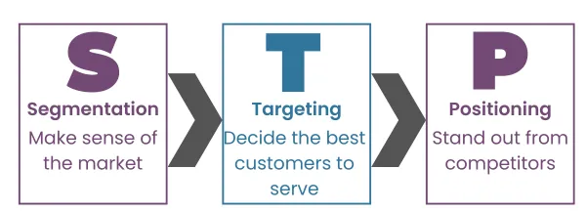
Figure 2: STP Analysis
Source: (Allen, 2020)

STP Strategy in India
Focus on the young demographic of the Upper-Middle-Classes
Starbucks in India uses a very limited and focused approach in targeting strategies than in the UK. The target market is mainly urban upper-middle-class consumers aged between 18 and 35 years, especially the students, young entrepreneurs and professionals working in metropolitan cities such as Mumbai, Delhi, Bengaluru and Pune (Kostopoulos and Dhosi, 2025). This segment has an increasing disposable income, good exposure to the world culture and aspirational consumption behaviour. Starbucks does not target the market on a mass-market penetration like the UK, but rather targets small niche premium urban consumers in India.
Café as a Social Status Symbol
Starbucks has strongly associated its status consumption with lifestyle symbolism in India. Going to Starbucks is believed to be linked with modernity, getting exposed to foreigners, and social status, especially among young people. The cafe is not just a consumption place; it is also a social identity platform where consumers meet and celebrate as well as create digital contents. This symbolic brand strength consolidates the aspirational power of Starbucks and warrants its high prices in a market that is very price conscious.
Indian Taste Preferences Customisation
Starbucks has also been practicing an effective product customisation in India to suit its local taste preferences, cultural habits, and religious sensitivities. Indian menu, in contrast to the one of the UK, also contains masala chai, drinks with cardamom flavour, snacks based on paneer, eggless desserts, and masses of vegetarian cuisine (Karmakar et al., 2022). The firm has also modified the level of spices and sweetness intensity to Indian taste. This localisation approach increases cultural approval without sacrificing the main Virgin attribute of premiums which is part of Starbucks.

Comparative Assessment of STP Effectiveness.
Success in cultural Adaptation.
Starbucks has a high level of cultural adaptation in both UK and India, however, the manner of the adaptation is quite different. In the UK, the changes in adaptation are mainly based on health-modifying products and branding based on sustainability, which is in line with the mature, Western consumer demands. In India, the adaptation is more structural, cultural, which includes menu localisation, religion sensitivity and aspirational branding (Alamuri and Aluvala, 2024). This reaffirms the capability of Starbucks to dynamically employ the psychographic and behavioural segmentation among the opposite socio-cultural frameworks, contributing to brand relevance and acceptance of the product in both of the markets.
Market Positioning Effectiveness in the two Markets.
The approach of premium convenience in Starbucks has been very successful in the UK because consumers have a high consumption of coffee, advanced digital usage, and purchasing power was at par. This is because the brand is able to differentiate based on experience, consistency and integration with digital even when competition is stiff. Nevertheless, operational cost pressure and saturation threaten profitability in the long-run.
The aspirational luxury positioning is still working in niche upper-middle-class segment of Starbucks in India. The cafe-as-a-status-symbol position enhances emotional brand value and helps to justify premium pricing. Yet the targeting is very narrow, which restricts volume growth and geographic expansion outside of metropolitan regions. Although the brand has a high level of loyalty in its niche, its market penetration in the general market is limited due to income differences and high competition with the cheaper domestic brands of cafes (Lang et al., 2023).
Overall STP Assessment
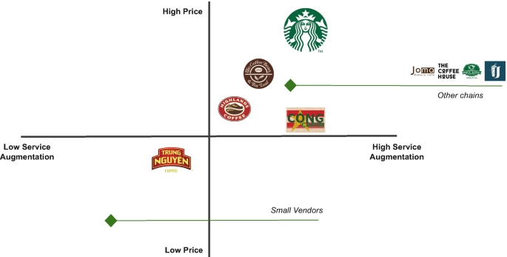
Figure: Positioning map of starbucks
Source: Self created
In general, the STP strategy of Starbucks shows high strategic fit to the macro-environment and consumer behaviour of each country. The UK depicts a wide premium mass-market strategy which is led by lifestyle convenience and India depicts niche premium strategy which is led by aspiration and social identity. Such a two-market STP structure underscores the strategic flexibility of Starbucks and strengthens the success of its global-local marketing adaptation strategy.

Comparison of marketing mix (7Ps) Strategies

Product
Starbucks in the United Kingdom has applied its global standardised product strategy to a large extent. Its main product range comprises of espresso drinks, cold brew, teas, frappuccinos and baked goods. Regularity, quality assurance and customisation of products are the key aspects of the UK product and customers can customise the drinks on the basis of milk type, level of sweetness and flavour shots (Hamed et al., 2025). Moreover, the rise in health awareness has led to the increase in plant-based products like oat, almond, and soy milk, sugar-free products, and low-calorie drinks.
The Indian product strategy, on the other hand, exhibits a high level of localisation. Although Starbucks does not lose its beverage status worldwide, food and flavour range is highly localized to fit the Indian tastes and cultural standards. Social and religious sensitivities are overcome by including masala chai, paneer rolls, tandoori-inspired snacks, eggless desserts and vegetarian-only food counters. The Indian menu also includes increased level of spices and sweetness. The hybrid product strategy will enable Starbucks to preserve its luxurious global image and at the same time gain cultural relevance in a conventionally teas-based market.

Price
Starbucks pursues a high-end pricing strategy in the UK, which focuses on the middle and high-income groups ready to pay an additional price to experience the brand, convenience, and product customisation (Hanlon, 2023). The price-sensitivity of the UK consumers is low, but the high level of cafe culture, as well as the experiential consumption orientation, lower the price sensitivity. The pricing of Starbucks is very competitive to other high-end chains like Costa and Pret hence it can maintain its wide accessibility in the market but maintain a premium brand perception.
Starbucks uses a premium-plus pricing strategy in India as it places it much higher than the local coffee chains and street vendors. Because India is highly price elastic and has a high income inequality, this market mix has narrowed the target group of Starbucks to the high-income elites living in the cities. Prices have been inflated based not just on the expense of importation and complexity in supply chain, but also on Starbucks aspirational positioning, intentionally as an international luxury brand of cafe. This strategy reinforces brand status and limits mass-market usage and geographic reach outside the large cities.

Place
Starbucks has a very convenience-based place strategy in the UK. The stores are situated in key locations throughout high streets, railway stations, airports, business districts, shopping centres, and university locations. This has a wide physical distribution facilitating footfall, impulse buying and commuter traffic. The high number of its outlets makes the brand more accessible and visible in everyday life in the city.
Starbucks in India adheres to the selective-placement strategy which lays great emphasis on luxury shopping centres, high-end business centres as well as IT parks and posh neighbourhoods. Starbucks does not target residential areas in the mass-market because of its premium pricing and relatively expensive rates. Rather, it focuses on the high-income consumption areas, which strengthen aspirational brand imagery. This bias placement enhances brand exclusivity but restrains nationwide penetration.

Promotion
Starbucks promotional communication in the UK focuses on sustainable, ethically sourced and lifestyle brand. Reusable cup programs, lessening carbon footprint, sourcing fairly, and seasonal drinks are regularly the focus of campaigns (Vu, 2023). The promotional strategy of Starbucks is dominated by digital promotions, promotion through apps, and rewarding loyalty, which is highly adopted in the UK.
The promotional approach of Starbuck is highly aligned with the festival-related marketing, engagement with the youth, and partnering with the influencers in India. During Diwali, Valentine, and Independence day, campaigns also include cultural symbolic and limited edition products. Influencers on social media, bloggers, and food vloggers will become essential in the creation of brand aspirations among Indian young people. In comparison to the sustainability-oriented promotion of the UK, promotion in India is more emotion-oriented and celebration-centered.

People
In the UK, Starbucks has a high service standardisation and the staff work with well-structured training programmes, manuals of work and brand service procedures. It is centered on speed, efficiency, product knowledge and accuracy of personalisation. Customers are characterized by the professional and transactional interactions with customers, which fits the fast-paced urban life.
The service component in India is more emotionally warm and inter-relational, which is corresponding to the cultural norms of hospitality and personalised attention (Alam and Mulla, 2025). Starbucks employees in India receive training to not only provide services on their product but also relationship-building services by offering polite service, assisting people in tables and guiding them on various customer issues. This service adaptation that is integrated into the culture would increase experience and emotional brand attachment by the Indian consumers.

Process
Starbucks operations in the UK are digitalised and efficiency-based operations. The customer journey is dominated by mobile ordering, cashless payments, integration of loyalty apps, click-and-collect services and delivery alliances. These operations save waiting time, increase convenience and allow personalisation of customers based on data.
Starbucks also has digital ordering and mobile payments in India, which is supported by the fast development of digital wallets and food-delivery applications. Non-homogenous digital infrastructure and customer technological familiarity however put a limit on complete digital standardisation. Therefore, in India, Starbucks adheres to a hybrid process model which combines a high-tech digital process with the simple counter-based services models.

Physical Evidence
Starbucks retail outlets are a combination of international brand standardisation and contemporary minimalism in the UK. The interiors are usually wooden textured, open seating, digital menu boards as well as store environmentally conscious messages. The layout of the store is oriented to both immediate take away and protracted stay of the customers.
Starbucks aligns its physical environment to the local aesthetics of the cultures in India and mostly includes Indian art, local material, subtle lighting and generous seating layout (Starbucks Stories Asia, 2022). Such localisation augments local identity but maintains the global brand uniformity by Starbucks. The physical setting in India is more effective in enhancing Starbucks as a high end lifestyle store, not as a convenience store.
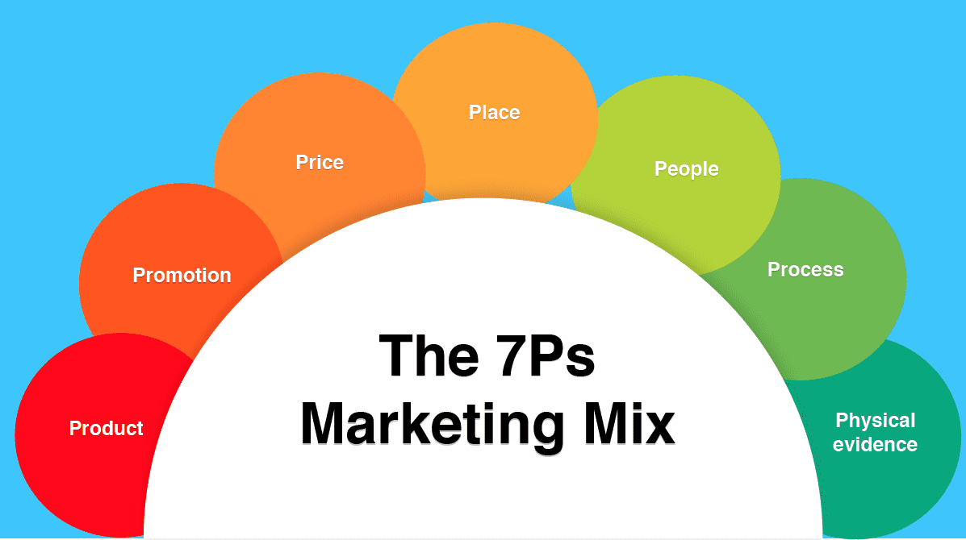
Figure 3: Marketing 7Ps Marketing Mix
Source: (Hanlon, 2023)

Comparative Summary Table (UK vs India)
7Ps Element | United Kingdom | India
Product | Global menu with plant-based, low-sugar options | Localised menu with masala chai, paneer rolls, vegetarian focus
Price | Premium pricing | Premium-plus aspirational pricing
Place | High streets, stations, airports, university zones | Luxury malls, IT parks, premium commercial districts
Promotion | Sustainability, digital engagement, lifestyle branding | Festival marketing, influencer campaigns, youth focus
People | Standardised service, efficiency-driven | Hospitality-driven, relationship-focused service
Process | Fully digitalised ordering, loyalty apps, click-and-collect | Hybrid digital and traditional service processes
Physical Evidence | Modern global design, sustainability visuals | Locally inspired premium design, cultural aesthetics

Marketing Performance Assessment
The performance of Starbucks in the United Kingdom and India in the market in terms of marketing indicates two different phases of international markets development; one of a mature and saturated market, and another of a high-growth but high-risk market. Comparison of store network size, market share, revenue contribution, brand awareness, digital engagement, customer loyalty and growth trends shows the success and restriction of global marketing strategies of Starbucks in the two countries (Nkegbe and Abor, 2023).
In terms of market share, Starbucks has a strong competitive standing in the branded coffeehouse market segment in the UK, which competes well with Costa Coffee and Pret A Manger. The UK coffee shop market is so saturated, but Starbucks still remains with a large share because of its digital ecosystem, customisation, and uniform brand experience (Ferreira et al., 2021). Starbucks has a presence of about 8-10 percent in branded coffee restaurants in India although the market of the whole hot drink is dominated by tea. This means that Starbucks has been able to gain leadership in the niche of the premium cafes, yet it has a low share in the overall beverage market.

Assessment of Marketing Ethics Practices
Sustainability in sourcing coffee and Farmer.
Starbucks conducts a vigorous ethical coffee sourcing practice in its global Coffee and Farmer Equity (C.A.F.E.) Practices and ensures fair wages, safe working conditions in addition to environmentally sound farming. The program contributes to the sustainability of the farmers in the long run as farmland is sustainable in terms of crop quality, environmental degradation, and stability of farmer income. Ethical sourcing is highly visible in marketing campaigns in the UK and its role in brand trust among sustainability oriented consumers is positive (Tanveer et al., 2021). In India, Starbucks obtains some coffee beans regionally, utilizing Tata Coffee, but consumers have not yet mastered awareness of ethical sourcing, capping the reputational gain of such actions.
Environmental Packaging
One of the major ethical issues that Starbucks has got worldwide is environmental responsibility. The pressure exerted on Starbucks by government regulations and consumers who are environmentally conscious in the UK has forced the company to market reusable cups, recyclable packaging materials and carbon reduction objectives. Nevertheless, there is still a negative feedback concerning the use of single-use plastics that are still used. Sustainability programs in India are there, but there are infrastructural obstacles in the form of inadequate recycling systems and of increased costs of sustainable packaging. Consequently, the packaging of the Starbucks products has also been a subject of ethical concern especially in the city waste disposal systems.
Young people and Health issues.
Starbucks is also aggressively marketing to younger consumers via digital, influencer marketing and lifestyle branding. Although this works well in business, there are ethical issues surrounding the advertisement of drinks with high sugar content to the young people. Regulatory review and increased health-consciousness in the UK have promoted Starbucks to diversify low-sugar and plant-based options (Gupta et al., 2024). However, in India, there is still an uneven health awareness and the market of indulgent drinking, which is promoted to younger consumers, creates the concerns regarding obesity, heavy sugar consumption, and lifestyle diseases.
Labour Practices
Starbucks enhances ethical labour practices including fair wages, training of employees, workplace diversity, as well as mental health. The UK has stringent employment codes which guarantee adherence to labour norms. Starbucks adheres to global HR standards in India, though, the ethical risks are still present, as the wider informal labour market of the retail and hospitality sector ensures that issues of wage gaps and job security are challenges of the industry within and without the company (Petrova et al., 2024).
Digital Data Privacy
As the reliance on mobile applications and online payments as well as loyalty solutions grows, the issue of data security and consumer privacy has become more ethically troubling. Transparency and user consent are also at a high level in the UK as individuals are bound by stringent data protection regulations. This is because, in India, shifting data protection laws and swift digital transformation pose a persistent ethical threat on the matter of customer data security, surveillance marketing, and the abuse of personal information.

Strategic Recommendations & conclusion

Strategic Recommendations
According to the comparative analysis of Starbucks marketing strategies in both the United Kingdom and India, some strategic suggestions are tabled to enhance future internationalization and sustainability in competitiveness especially in the Indian market.
Tiered Pricing for India:
Starbucks needs to implement a differentiated pricing approach in India to grow out of the existing upper-middle-income market. Although higher prices aid brand equity, by launching a smaller selection of less expensive beverages and snack packages, aspirational middle-income consumers may be reached without undercutting key brand equity (Nordhagen and Demmler, 2023). Footfall, affordability and outlet-level profitability might be enhanced by a value-specials menu in non-peak hours.
Regional Product Innovation:
Despite the achievements made by Starbucks in menu localisation, more localization in products that are regional is necessary. The food culture in India is very regional based on the states and the addition of local flavours like South Indian filter coffee blends, regional dessert, spices infused beverages would foster more local appeal. This business approach would also improve the level of customer interaction by promoting novelty and familiarity with culture.
Localisation of Sustainability on a deeper level:
Starbucks can more locally implement its global sustainability strategy in India by collaborating with local recycling organizations, extending reusable cup incentives, and more visibly educating consumers on the importance of ethical sourcing in store. Enhancing the sustainability communication of the local area would enhance the environmental appeal in a market where awareness is at a nascent stage.

Conclusion
Starbucks is a company in a mature, competitive coffee market in the UK and pursues the premium mass-market strategy, which is based on convenience, sustainability communication, and sophisticated digital integration. Its high concentration of stores, built loyalty platform and routine consumption behavior produces consistent revenue and high brand awareness. Nonetheless, the environment in the UK market is saturated and operational costs are on the increase, which restrains the high-growth potential.
Conversely, Starbucks India positioning indicates a selective luxury premium positioning which focuses on urban upper-middle-class youth. By tailoring products to customer needs, adapting to the culture and offering products based on social identity, the brand has managed to create high aspirational value. Though India has a high growth potential in the long run, profitability has been hampered by the premium affordability, cost pressures, and low penetration in the mass market.

Reference List
Alam, M.M. and Mulla, F., 2025. Bridging Borders: A Qualitative Exploration of Trust Towards Foreign Influencers in India. https://www.theseus.fi/bitstream/handle/10024/891344/Alam_Mulla.pdf?sequence=2
Alamuri, S. and Aluvala, R., 2024. Glocalization: an analysis into it’s conceptual and strategic underpinnings. Brazilian Journal of Development, 10(5), pp.e69567-e69567. https://ojs.brazilianjournals.com.br/ojs/index.php/BRJD/article/download/69567/49191
Allen, A. (2020). Finding the right customers with the STP model. [online] Oxford College of Marketing Blog. Available at: https://blog.oxfordcollegeofmarketing.com/2020/06/24/finding-the-right-customers-with-stp-model/.
Aminuddin, M.A., Abdullah, N.F., Mazlan, N.A., Mohd Idris, A.A. and Mustafa, A.N., 2021. Starbucks Coffee Company: coffee cafe company. https://ir.uitm.edu.my/id/eprint/66898/1/66898.pdf
Behera, J.K., 2021. Digital transformation and its impact: An analytical study. In Digitization of economy and society (pp. 27-49). Apple Academic Press. https://www.researchgate.net/profile/Nilanjan-Ray/publication/367889425_Digitization_of_Economy_and_Society_Emerging_Paradigms/links/66504c2322a7f16b4f47b183/Digitization-of-Economy-and-Society-Emerging-Paradigms.pdf#page=58
Bensalem, S. and Benouhiba, N., 2025. The Impact of Marketing Strategy on Cultural Values: Analyzing the Consumer-Brand Relationship from a Socioeconomic and Cultural Perspective. https://digibug.ugr.es/bitstream/handle/10481/103940/Jett_02%5B1%5D.pdf?sequence=1&isAllowed=y
Carter, D.B., Warren, R. and Steinhoff, A., 2023. The anatomy of tragedy: Starbucks as a politics of displacement. Accounting, Auditing & Accountability Journal, 36(1), pp.146-176. https://repository.essex.ac.uk/32474/1/The_Anatomy_of_Tragedy%20-%20AAAJ%20-%20Dec%202021.pdf
Ferreira, J., Ferreira, C. and Bos, E., 2021. Spaces of consumption, connection, and community: Exploring the role of the coffee shop in urban lives. Geoforum, 119, pp.21-29. https://pureportal.coventry.ac.uk/files/40388663/Binder1.pdf
Gonzalez, C., Agrawal, V., Johansen, D. and Hooker, R., 2022. Green supply chain practices: The role of institutional pressure, market orientation, and managerial commitment. Cleaner Logistics and Supply Chain, 5, p.100067. https://www.sciencedirect.com/science/article/pii/S2772390922000403
Gupta, P., Srivastava, R., Jain, S. and Jain, S.P., 2024. The Ethics of Unhealthy Food and Beverage Advertising to Children: A Bibliometric Analysis and Future Research Agenda. American Business Review, 27(2), p.14. https://digitalcommons.newhaven.edu/cgi/viewcontent.cgi?article=2907&context=americanbusinessreview
Hamed, A.M., Galli, B., Hogan, S.A., Abdel‐Hamid, M. and Romeih, E., 2025. Adaptive and predictive approaches to mitigate the impact of milk seasonality on composition, processing technologies and quality of milk powders. International Journal of Dairy Technology, 78(1), p.e13148. https://onlinelibrary.wiley.com/doi/pdf/10.1111/1471-0307.13148
Hanlon, A. (2023). How to Use the 7Ps Marketing Mix. [online] Smart Insights. Available at: https://www.smartinsights.com/marketing-planning/marketing-models/how-to-use-the-7ps-marketing-mix/.
Hernani-Merino, M., Lazo Lazo, J.G., Talavera Lopez, A., Mazzon, J.A. and López-Tafur, G., 2021. An international market segmentation model based on susceptibility to global consumer culture. Cross Cultural & Strategic Management, 28(1), pp.108-128. https://www.researchgate.net/profile/Jose-Mazzon/publication/343191254_An_international_market_segmentation_model_based_on_susceptibility_to_global_consumer_culture/links/5f3f1f6aa6fdcccc43de02bf/An-international-market-segmentation-model-based-on-susceptibility-to-global-consumer-culture.pdf
Hong, T.K., 2025. Guide to Developing an International Marketing Strategy Report. https://www.researchgate.net/profile/Kwan-Hong-Tan/publication/391636636_Guide_to_Developing_an_International_Marketing_Strategy_Report/links/68203dd1bd3f1930dd70682f/Guide-to-Developing-an-International-Marketing-Strategy-Report.pdf
Iqbal, A. (2025). PESTLE Analysis: The CEO’s Guide to Future-Proofing a Business. [online] Medium. Available at: https://medium.com/techno-preneurship/pestle-analysis-the-ceos-guide-to-future-proofing-a-business-877e6c4e20ea.
Karmakar, M., Jana, D., Manna, T., Banik, A., Raul, P., Guchhait, K.C., Mondal, K.C., Panda, A.K. and Ghosh, C., 2022. Immunostimulant properties of some commonly used Indian spices and herbs with special reference to region-specific cuisines. Plants and Phytomolecules for Immunomodulation: Recent Trends and Advances, pp.191-249. https://www.researchgate.net/profile/Tuhin-Manna-2/publication/363099185_Immunostimulant_Properties_of_Some_Commonly_Used_Indian_Spices_and_Herbs_with_Special_Reference_to_Region-Specific_Cuisines/links/64608bec4353ba3b3b632d42/Immunostimulant-Properties-of-Some-Commonly-Used-Indian-Spices-and-Herbs-with-Special-Reference-to-Region-Specific-Cuisines.pdf
Kee, D.M.H., Faheem, M., Al-Anesi, S.A.L., Imran, M.Y., Hazrul, M. and Khairi, A.A., 2021. Navigating through the COVID-19 crisis: A Case study of Starbucks. International Journal of Accounting & Finance in Asia Pasific, 4(1), pp.24-36. http://download.garuda.kemdikbud.go.id/article.php?article=3008997&val=27194&title=Navigating%20Through%20the%20COVID-19%20Crisis%20A%20Case%20Study%20of%20Starbucks
Kostopoulos, I. and Dhosi, P., 2025. Product gentrification and its implications for consumers and communities. European Journal of Marketing, 59(11), pp.2585-2606. https://researchonline.ljmu.ac.uk/id/eprint/27352/1/Product%20%20gentrification%20and%20its%20implications%20for%20consumers%20and%20communities.pdf
Kotabe, M.M. and Helsen, K., 2022. Global marketing management. John Wiley & Sons. https://studentebookhub.com/wp-content/uploads/2024/preview/9781119563112.pdf
Lang, L.D., Behl, A., Guzmán, F., Pereira, V. and Del Giudice, M., 2023. The role of advertising, distribution intensity and store image in achieving global brand loyalty in an emerging market. International Marketing Review, 40(1), pp.127-154. https://www.researchgate.net/profile/Le-Dang-Lang/publication/362088370_The_role_of_advertising_distribution_intensity_and_store_image_in_achieving_global_brand_loyalty_in_an_emerging_market/links/62d61366bf4b98532233d448/The-role-of-advertising-distribution-intensity-and-store-image-in-achieving-global-brand-loyalty-in-an-emerging-market.pdf
Nemmaniwar, P., 2022. Case Study on Starbucks. Available at SSRN 4301032. https://papers.ssrn.com/sol3/Delivery.cfm?abstractid=4301032
Nkegbe, F. and Abor, Y., 2023. The role of social media in enhancing customer engagement and brand loyalty. Journal of Policy Options, 6(3), pp.26-34. http://resdojournals.com/index.php/jpo/article/download/305/775
Nordhagen, S. and Demmler, K.M., 2023. How do food companies try to reach lower-income consumers, and do they succeed? Insights from a systematic review. Global Food Security, 37, p.100699. https://www.sciencedirect.com/science/article/pii/S2211912423000299
Pandey, R., Ganatra, V., Jamnik, S., Goel, P., Goyal, P., Xuan, C.L., Kee, D.M.H., Mein, H.H., En, L.X. and Zen, L.J., 2021. An empirical study on customer satisfaction, perception, and brand image in Starbucks Coffee in India, Asia. International Journal of Tourism and Hospitality in Asia Pasific, 4(1), pp.53-63. https://pdfs.semanticscholar.org/3e4f/680cb977da469759749480cab24edde45ed8.pdf
Patov, A. (2024). How Starbucks Builds Loyalty and Enhances Customer Experience (CX) with Rewards Programs. [online] Renascence. Available at: https://www.renascence.io/journal/how-starbucks-builds-loyalty-and-enhances-customer-experience-cx-with-rewards-programs.
Petrova, A., Karintseva, O., Tarasenko, S. and Wojciech, H., 2024. Business ethical aspects for sustainability: contemporary analysis and assessment. http://srd.pgasa.dp.ua:8080/bitstream/123456789/12626/1/Petrova.pdf
Putrevu, J. and Mertzanis, C., 2024. The adoption of digital payments in emerging economies: challenges and policy responses. Digital Policy, Regulation and Governance, 26(5), pp.476-500. https://papers.ssrn.com/sol3/Delivery.cfm?abstractid=4558978
Ramasubramanian, B., Tan, J., Chellappan, V. and Ramakrishna, S., 2023. Recent advances in extended producer responsibility initiatives for plastic waste management in Germany and UK. Materials Circular Economy, 5(1), p.6. https://link.springer.com/content/pdf/10.1007/s42824-023-00076-8.pdf
Roll, M. (2021). The secret to Starbucks’ brand success . [online] Martin Roll. Available at: https://martinroll.com/resources/articles/strategy/secret-starbucks-brand-success/.
Rosenbaum, M.S. and Dickens, J.M., 2025. Commentary: the social impact of third places on business, communities and well-being. Journal of Social Impact in Business Research, 1(2), pp.70-78. https://www.emerald.com/jsibr/article-pdf/doi/10.1108/JSIBR-11-2024-0049/10054771/jsibr-11-2024-0049en.pdf
Sharma, K., Rajan, S. and Nayak, S.K., 2024. Water pollution: Primary sources and associated human health hazards with special emphasis on rural areas. In Water resources management for rural development (pp. 3-14). Elsevier. https://www.researchgate.net/profile/Soumya-Nayak-10/publication/376397739_Water_pollution_Primary_sources_and_associated_human_health_hazards_with_special_emphasis_on_rural_areas/links/657a9f726610947889c71c5a/Water-pollution-Primary-sources-and-associated-human-health-hazards-with-special-emphasis-on-rural-areas.pdf
Sriram, V.P., Shaikh, A.A., Sumana, B.K., Kumar, A., Dhiman, V. and Naved, M., 2022, June. Consumer behaviour on digital marketing platforms—Specifically in terms of consumer loyalty using machine learning. In Proceedings of Second International Conference in Mechanical and Energy Technology: ICMET 2021, India (pp. 377-386). Singapore: Springer Nature Singapore. https://www.researchgate.net/profile/Samrat-Ray/publication/361568484_Using_Machine_Learning_and_Data_Mining_to_Evaluate_Modern_Financial_Management_Techniques/links/62c57f9334fb7352793940b7/Using-Machine-Learning-and-Data-Mining-to-Evaluate-Modern-Financial-Management-Techniques.pdf#page=366
Starbucks (2023). Starbucks celebrates 25 years of coffee in the UK and in the Europe Middle East and Africa region. [online] Starbucks Stories EMEA. Available at: https://stories.starbucks.com/emea/stories/2023/25-years-of-coffee-in-the-uk-and-emea/.
Starbucks (2024a). C.A.F.E. Practices: Starbucks Approach to Ethically Sourcing Coffee. [online] Starbucks. Available at: https://about.starbucks.com/press/2024/cafe-practices-starbucks-approach-to-ethically-sourcing-coffee/.
Starbucks (2024b). Starbucks. [online] Starbucks Coffee Company. Available at: https://www.starbucks.in/.
Starbucks (2025). Starbucks – The Best Coffee and Espresso Drinks. [online] Starbucks Coffee Company. Available at: https://www.starbucks.com/.
Starbucks Stories Asia. (2019). Tata Global Beverages and Starbucks Form Joint Venture to Open Starbucks Cafes across India : Starbucks Stories Asia. [online] Available at: https://stories.starbucks.com/asia/stories/2012/tata-global-beverages-and-starbucks-form-joint-venture-to-open-starbucks-ca/.
Starbucks Stories Asia. (2022). A part of every neighborhood’s story: Exploring the Starbucks third place experience through local art in Asia. [online] Available at: https://stories.starbucks.com/asia/stories/2022/a-part-of-every-neighborhoods-story-exploring-the-starbucks-third-place-experience-through-local-art-in-asia/.
Sudirjo, F., 2023. Marketing strategy in improving product competitiveness in the global market. Journal of Contemporary Administration and Management (ADMAN), 1(2), pp.63-69. https://journal.literasisainsnusantara.com/index.php/adman/article/download/24/39
Tanveer, M., Ahmad, A.R., Mahmood, H. and Haq, I.U., 2021. Role of ethical marketing in driving consumer brand relationships and brand loyalty: A sustainable marketing approach. Sustainability, 13(12), p.6839. https://www.mdpi.com/2071-1050/13/12/6839
The Strategy Institute (2024). Starbucks International Strategy - A Case Study for Global Success. [online] The Strategy Institute. Available at: https://www.thestrategyinstitute.org/insights/starbucks-international-strategy-a-case-study-for-global-success.
Ullagaddi, P., 2024. From Barista to bytes: How Starbucks brewed a digital revolution. Journal of Economics, Management and Trade, 30(9), pp.78-89. https://www.academia.edu/download/120286427/Ullagaddi3092024JEMT123567.pdf
Valaskova, K., Durana, P. and Adamko, P., 2021. Changes in consumers’ purchase patterns as a consequence of the COVID-19 pandemic. Mathematics, 9(15), p.1788. https://www.mdpi.com/2227-7390/9/15/1788
Vu, L., 2023. Reducing single-use cup consumption: a marketing plan for encouraging the use of reusable cups among coffee drinkers. https://www.theseus.fi/bitstream/handle/10024/816035/Vu_Linh.pdf?sequence=2

