Best known for his provocative depictions of mental health violence and sexuality on screen,

Introduction (416)

Initial Inspiration - Zdzislaw Beksinski - Exploring the themes of their work (416)
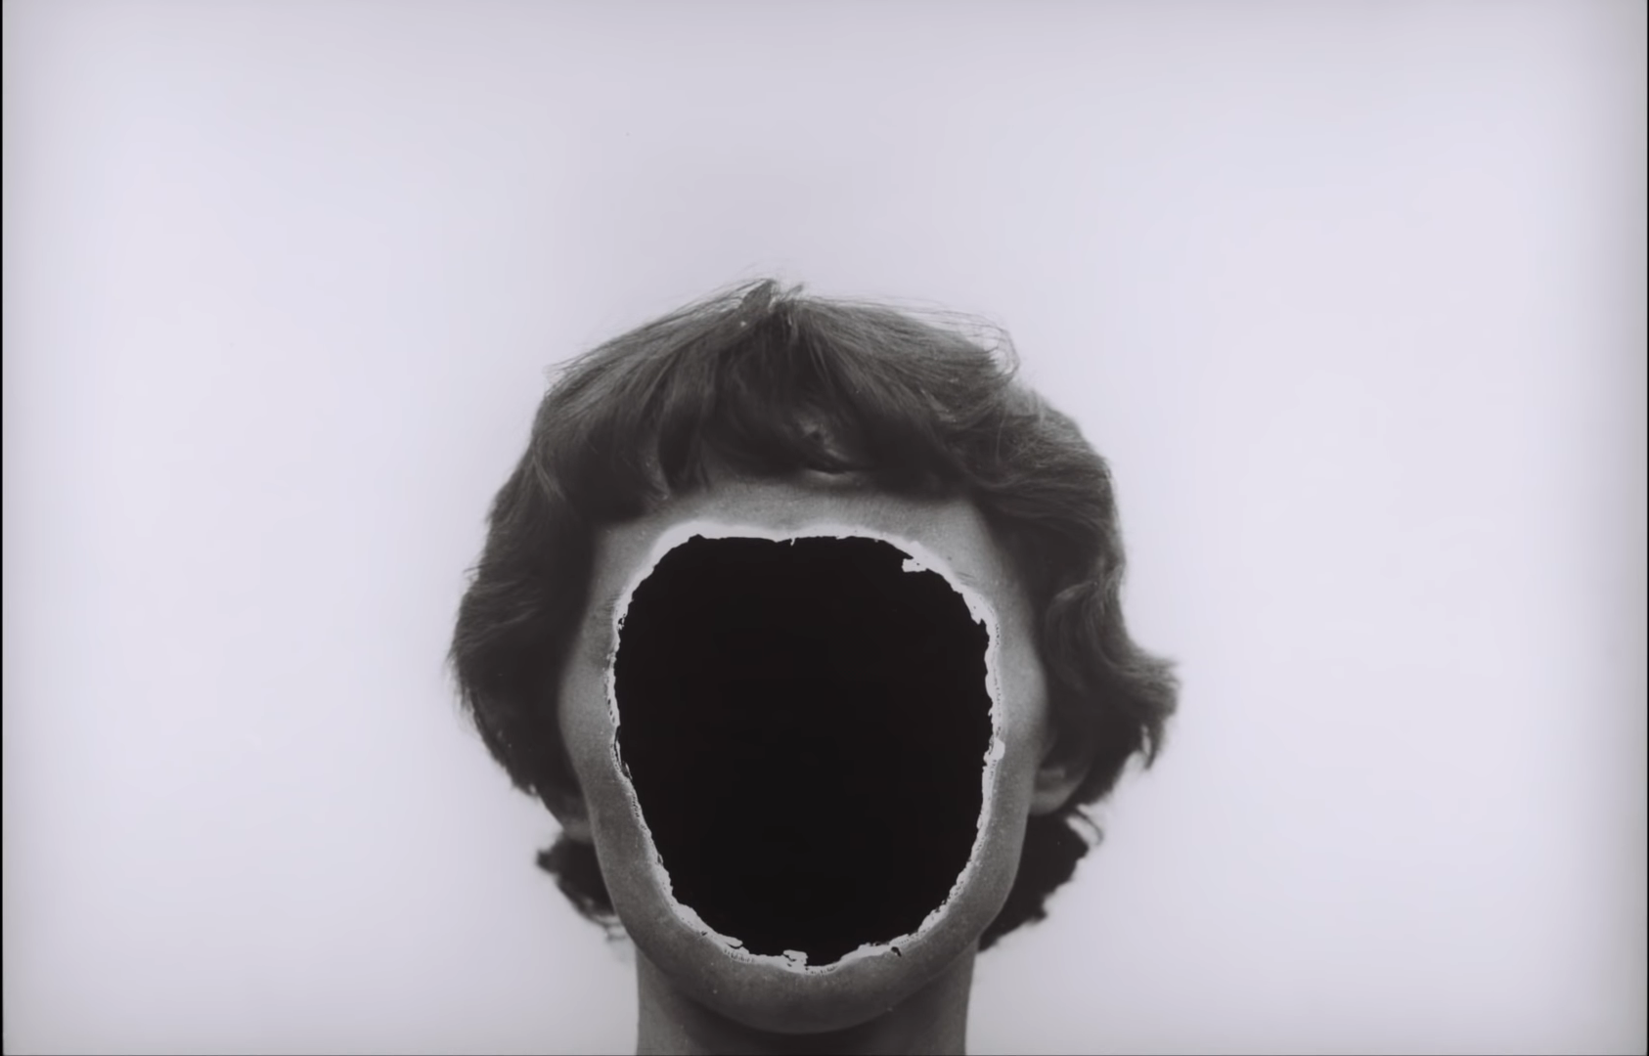
These are photographs by Zdzislaw Beksinski. Throughout his 50-year art career, he would materialize dreams and nightmares onto canvas and celluloid, bring a global eye to Polish art and would help to define the modern heavy-metal aesthetic.
Born in 1929, his birthplace, Sanok, had one of the largest populations of Jewish people in all of Poland in the lead-up to World War two, roughly 30 per cent of the city. Moreover, in 1940 the Zaslaw concentration camp was created just on the outskirts and would remain functional for three years.
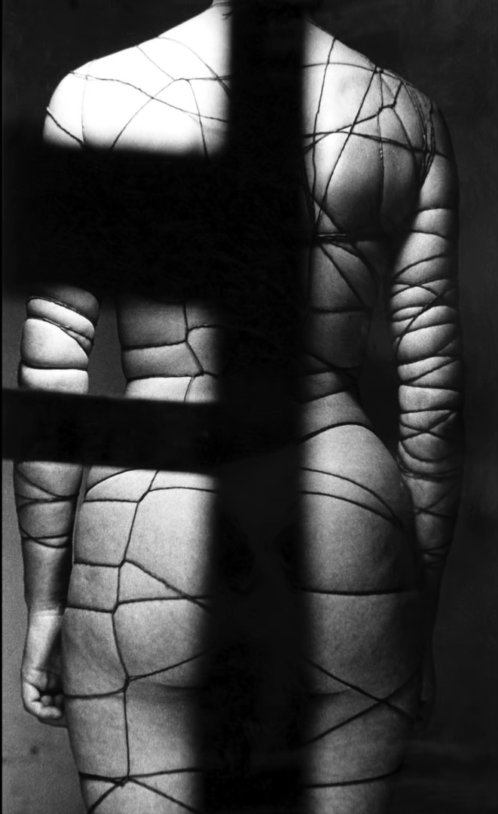
After the war, Beksinski began to photograph the world he saw around him during the Soviet occupation of his country. It is undeniable that the horrors he experienced through his entire adolescence would later play a massive role in the mindset of the works he would create.
Although not formally trained in art in 1955, he would study architecture and develop drafting skills that would later help him in more than one way. As well as training his hand, he would also learn the history and symbolism of architecture that would allow him to make social commentary through his paintings.
Continuing to experiment more with his photography, Beksinski began incorporating objects he found at a construction site into his pictures.
Deciding as a side project to his career that he would become a part-time photographer. In 1957 Beksinski immediately disrupted the art world with his earliest photography works.
When Beksinski unveiled his photograph 'Sadists Corset' in 1957 there was an immediate backlash to its stylized posed nature that rejected the traditional photography of the time.
Facing the figure away from the camera cropping out the head and legs and a rigid non-sexual standing position.
Photography critic Alfred Ligocki publicly criticized the photograph saying that "surrealist photography should not be acknowledged because it did not correctly represent the subject as it was." claiming that Beksinski's work was ‘anti-photography’.
Beksinski then responded to this publicly in a photography magazine with an article titled 'The Crisis of Photography and The Perspective To Overcome It'. Saying that the pervasive style of 'pure photography' did not allow for artistic expression.
This philosophy can be seen in all of his early photographic works. The subjects are all manipulated, directed and posed in particular ways and were always obscured in some fashion. The out-of-focus chair in the foreground segments the subject of 'Sadists Corset' into pieces.
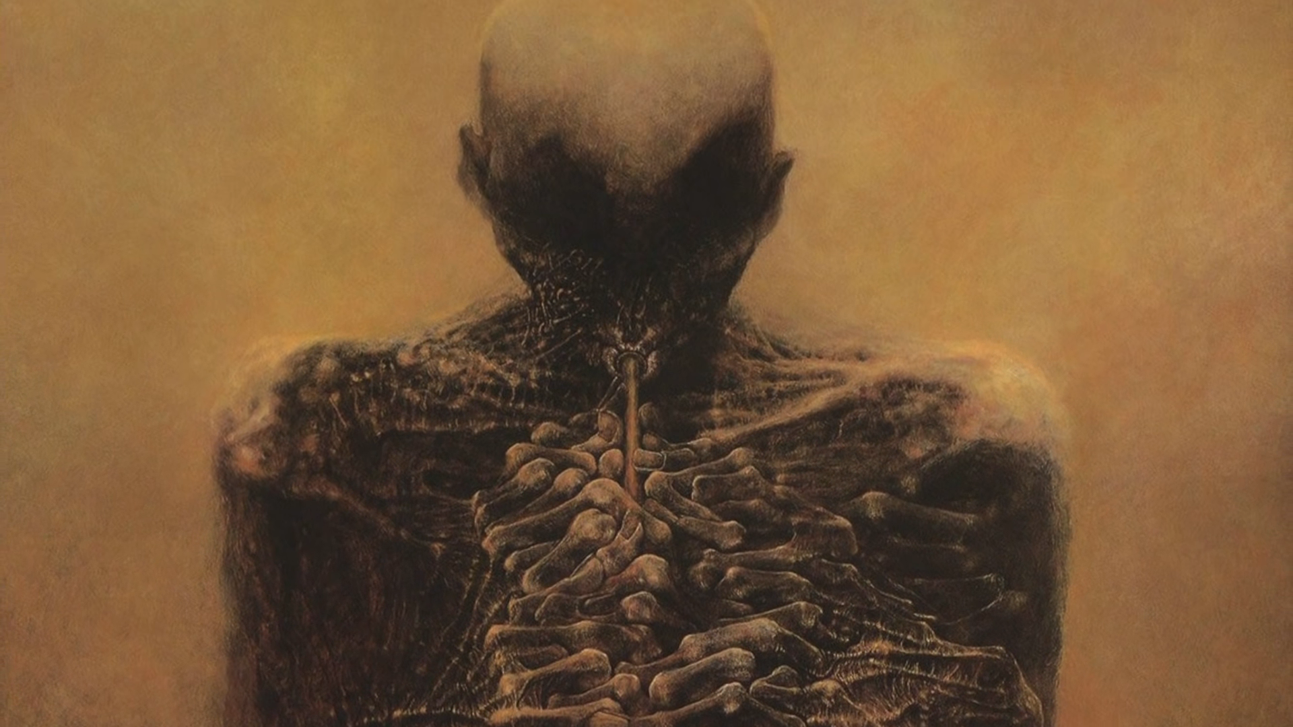
In some of Beksinski's other works, mirrors disrupt the natural symmetry of the body subjects are cropped and photographed as silhouettes purposefully shown out of focus. Shadows make faces ambiguous and confusing to look at.
By the early 1960s, despite being a renowned photographer, Beksinski quit working within the medium entirely and donated all of his photographs to the historical museum in Sanok, stating that the art form limited his imagination.
From the early 1960s to the mid-1980s, Beksinski would become known for the 'Fantastic' series. A series of paintings which melded architecture, spiritualism, eroticism, war and dream logic into a hellscape of paintings.
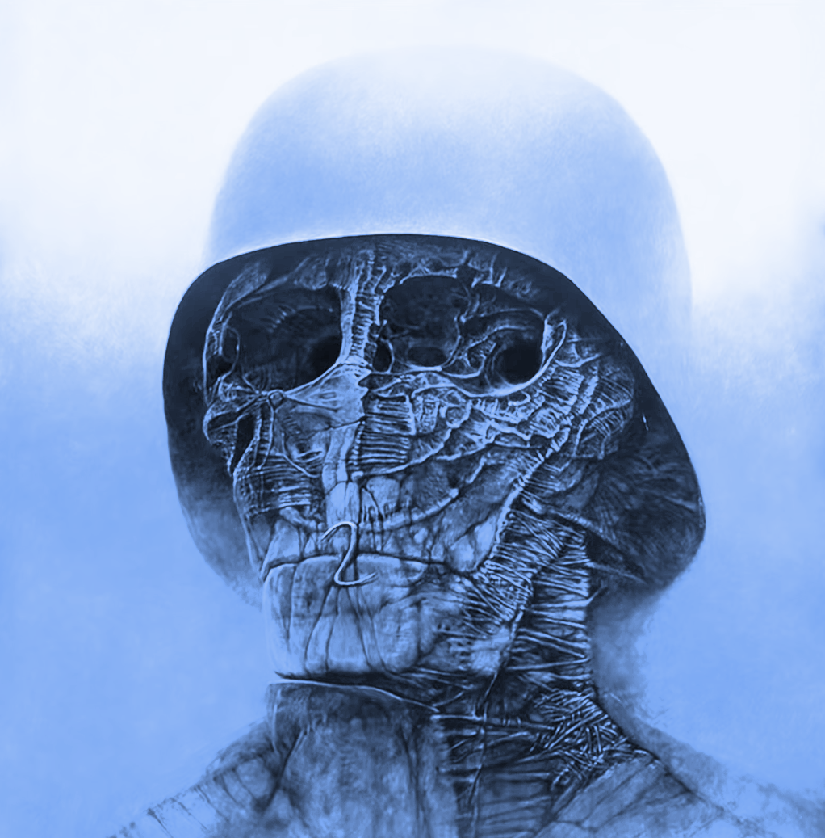
Every work of art from this period in his career was untitled, he didn't like the concept of titling art because of the possibility of creating a misconstrued meaning or perceived interpretation of the work from the artist to the observer.
Beksinski explained in a 2002 interview that, in his opinion, interpretation is imposed by others; speaking immodestly, paintings are to be admired or contemplated. Admired without asking what it means. "If I had something to say, I would write it down or say it. I don't need painting for that." Beksinski did not like the concept of people interpreting his work and wanted them to stand independently, free of individual interpretation.
Despite Beksinski adamantly claiming that his works possess no deeper meaning, there are common visual motifs throughout his works that mirror his real life. The most obvious is his use of old war helmets.
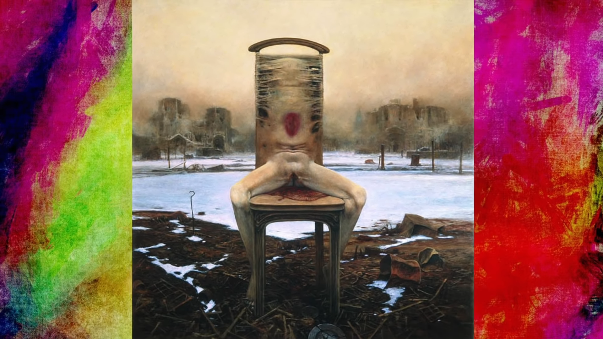
Said helmets are often depicted in tandem with corpses, decaying bones or other similar visuals. Burning buildings, destruction and chaos reign in his worlds. The colour blue is significant in these scenes. Prussian blue is named after the prussic acid used to produce that colour in paint, and Prussic acid is also known as hydrogen cyanide. While the paint itself today is not toxic despite being created with a form of cyanide, other products, such as the pesticide Zyklon-b that the Nazis and gas chambers would use during World War two, are extraordinarily deadly. Moreover, they are known to leave a blue residue on surfaces in frequent contact with the substance.
The nature of the bodies in Beksinski's work is never typical and are almost always blending into something, else stretching and obscuring the original form. Many bodies form a new creature, faces bloom into nature, and buildings are constructed out of bodies. Possibly be a critique of the Nazi’s victims being allegedly turned into household objects such as soap or lampshades.
Zdzislaw Beksinski is undeniably the symbol of the birth of modern Polish art. His work also represents a reaction to a particularly chaotic time in world history from a perspective that lived through it and saw it unfold as it all happened. He took these things in through war travesty, occupation, and totalitarianism. He held on to them before they exploded into a purely emotional, visceral reaction to the horrors of life at that time.

1,350 words left - next documentary practitioner

Documentary inspiration - documentary directors - thematic elements (416)

How these directors influenced my final work (416)

Problems during production how I overcame them (416)

Conclusion - what I learned (416)

