The Use of GIS in Comparing Carbon Footprints
Jennifer Roper
1704516
Environmental Conservation
University of Wales Trinity Saint David

Contents
Introduction 3
The Carbon Issue 4
Data Collection 5
What Will the Data Show? 5
Data Analysis 13
GIS Usage 24
References 26
Appendices 28

Introduction

Geographical Information systems (or GIS for short) have developed in the last 50 years from a mere concept, to a whole scientific tool, hosting a massive platform of modern planning and understanding of data. Its commercialization in the early 1980s means that currently GIS plays a massively important role in data communication solutions and has a strong place hold in the future of mapping as its importance continues to escalate, due to intensifying climate problems. (ESRI, Unknown). The use of GIS is becoming an integral part of managing issues.
GIS combines the power of databases with the map allowing data to be gathered, managed and analysed visually. Raw data alone can be difficult to place and spots trends in as the human eye is not trained in picking out data from a simple spreadsheet, instead, when displayed in locational form it becomes much simpler to identify hotspot locations and trends from the map or legend ranges accompanying the map. Deeper insights into the data, in terms of patterns and relationships can aid in the programme user to develop a better conclusion and plan from the data where they wouldn’t have been able to before, or at least, not as rapidly. (Ordnancesurvey, 2018).
GIS has been newly adopted by many different organisations globally, across varying fields of study. From healthcare, telecommunications, manufacturing and even insurance the usage of GIS has allowed for specialist data to be condensed, simplified and visually defined in order to increase efficiencies in data sharing across departments.
The functionality of GIS includes the ability to identify problems, monitor the change in those problems, manage and respond to particular events, forecast, set priorities and understand trends. It does not require professional knowledge in order to utilise, however it does take some practise with the programme in order to fully understand how to navigate the software efficiently and effectively.
For the following data set GIS software MapInfo Pro™ v16.0 64-bit was used in order to visually compile the data. (Expanded on in methodology).

The Carbon Issue
A carbon footprint, based off of the concept of the ecological footprint, is the total amount of greenhouse gases produced in both directly and indirectly supporting human activities, displayed in the equivalent tons of carbon dioxide (CO2) (timeforchange.org, unknown). The footprint is the sum of all emissions of CO2 produced by the persons activities per annum, due to this carbon footprints can be calculated fairly easily by answering a general lifestyle quiz that explores into all of the factors that can contribute to lowering or raising an individual's carbon footprint. Almost every activity people do, will contribute to their carbon footprint. Thing life travel, food choices, consumption of products and even the house you live in will all contribute to your carbon footprint score. Calculating an individual’s carbon footprint is useful, as it highlights areas of concern to the individual and allows them to make moves towards changing their habits and reducing their personal emissions. (Carbon Trust, 2020). Carbon footprint calculators are available widespread online for free, however, in this particular paper, REAP Petite software was used.
By now, it is a well-known fact that greenhouse gases contribute to climate change and policies are being put in place in order to try and tackle that. According to the CCC, 40% of the UK’s carbon emissions arise from households and in order to meet carbon reduction goals, households must individually work on their emissions. The Climate Change Act of 2008 was amended (2019) for a net-zero or 100% reduction in carbon emissions by the UK by 2050. (Committee on Climate Change, 2016).

Data Collection
Data for this research was collected through the use of REAP Petite (Resources and Energy Analysis Program). The software provides a selection of pre-made questions in a visually appealing format, that is then linked to the survey respondents. The survey is compiled of various questions delving into lifestyle choices, habits and facilities, income and spending, travel, consumption and many other topic areas along these lines. The survey automatically calculates a carbon footprint for the household based off of the answers and even compiles the results into graphs and charts for easy viewing, as well as allowing the data to be exported directly into an excel file without having to individually extract the data. Across the UK, over 100 respondents filled out the survey, however they have mostly been centralized in Wales and so the following data has been directed in this way. REAP petite calculates both the carbon footprint and the ecological footprint of the household but only the carbon footprint was considered for this study.

What Will the Data Show?

The data collected from these surveys will allow for a comparison in changes from pre-pledge activities carbon footprints, to post-pledge carbon footprints. In the survey, there is provided suggestions on the easiest ways for that household to reduce its carbon footprint, based off of previous answers and scores, the respondent then is allowed to ‘pledge’ if they are able to do the things (such as reduce travel, cut down on meat consumption etc.) and a ‘new’ post-pledge score is calculated should they follow these simple reductions in lifestyle indulgences.

The data can be related back to the following statements:
- Housing use is responsible for approximately 80% of household carbon emissions. Household consumption results in ‘direct’ emissions from combustion of primary energy and ‘indirect’ consumption of goods and services (Long, et al., 2019).
- Improvements in the energy efficiency of homes can save money and bring with it health benefits. The NHS has estimated the cost of illnesses in relation to cold homes to be approximately £1.3 billion annually (Age UK, 2012).
- The top 10% richest in Great Britain are responsible for 24.22 tonnes of CO2, almost five times as much as the bottom 40%.
- Since 1972, disposable income has been rising in the UK (ONS, 2016).
- Primarily research had been focused on direct emissions, however ,increasingly indirect emissions from households have been shown to have a significant impact (Buchs & Schnepf, 2013).
- Emissions from transport and travel, including flight emissions are seen as major influencing factors to increased carbon footprint. Secondary factors including shopping habits (consumerism), activities and food consumption are also contributory factors to carbon footprint (Saner, et al., 2016).

Methodology

In order to visualise the data in MapInfo, a few steps were taken in both prepping the data and in converting it.
The survey was distributed to the respondents and the replies automatically collected and compiled by the software.
Initially, the data had to be extracted from REAP Petite, this was made simple as it extracts directly into a excel file and so no additional movement of data is required. Then the data required a small amount of tweaking in order to make it compatible with MapInfo, this meant checking all numbers were registered as so and not ‘floats’ and filling in, or removing data where necessary (in the case of refusal to supply things such as income or gaps due to unknown answers). The excel spreadsheet is then converted into .xls format for compatibility.
Once in MapInfo, the ‘Open table’ option is selected and the excel spreadsheet imported, assuring to select ‘use row above selected range for column tiles’ when prompted as this allows for the titles already available to be used, making sql selection later on much easier.
for the titles already available to be used, making sql selection later on much easier.
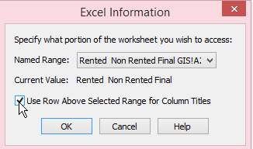
Once ‘OK’ has been clicked, the data will open in a new browser, if it opens in the form of a map, the new browser tab must be selected manually.
From here, the SQL Select option allows for the data to be narrowed down in whatever way the user wishes, optionally select from specific columns, but from the master table (original excel spreadsheet name) and select the relevant conditions. For example, if the data were to be separated by the number of adults in the household (1,2,3 or 4+) the condition would be as follows, condition: adults = 1. If the data is non numerical, quotation marks can be used to separate. E.g Sex = ‘male’.
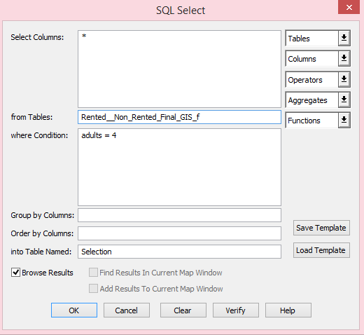
Once ‘OK’ has been selected a new browser will load, this time with only the data with the relevant conditions selected.
Then, using the create points tool and inserting the longitude and latitude relevant to their columns in the browser, mapping points for all of the data, or a specific set, can be created.

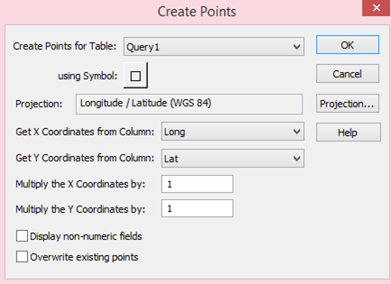

Once the map is loaded, using a Bing license key, add a base map to the points in order to provide both background and locational context for those looking at the map. In order to display both the Bing base map and the points on the same map, the relevant browser must be dragged up to the map layer and placed above the Bing map. As shown;
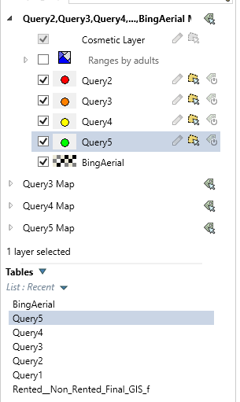
From this sidebar, the colour, name and shape of the points can be changed with a simple right click. This method creates a basic map.
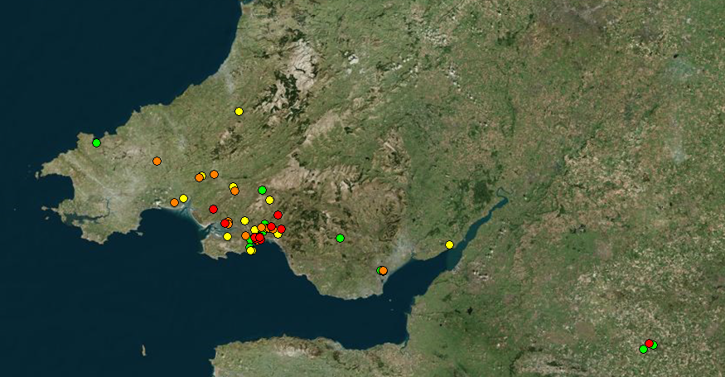
For a more complex map, using legends, the same initial steps apply, however this time, once the map has been added to the same layer, the ‘add theme’ button is selected.
Select a theme, and then chose the relevant table and field that is wished to be displayed e.g the total carbon footprint and then rearrange the ranges, titles or order as desired.
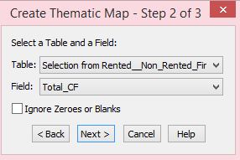
For this data, comparable fields such as ‘housing_CF’ and ‘new_housing_CF’ range scales were altered in order to match, making the data more easily compared. This is not relevant to be done for each map however it is beneficial for maps wishing to be directly compared as it makes the data easier to digest.
The legend in this instance, is perhaps more vital than the visual displays, as the changes in numbers of households that fall within a range can clearly be seen, where they were not before.
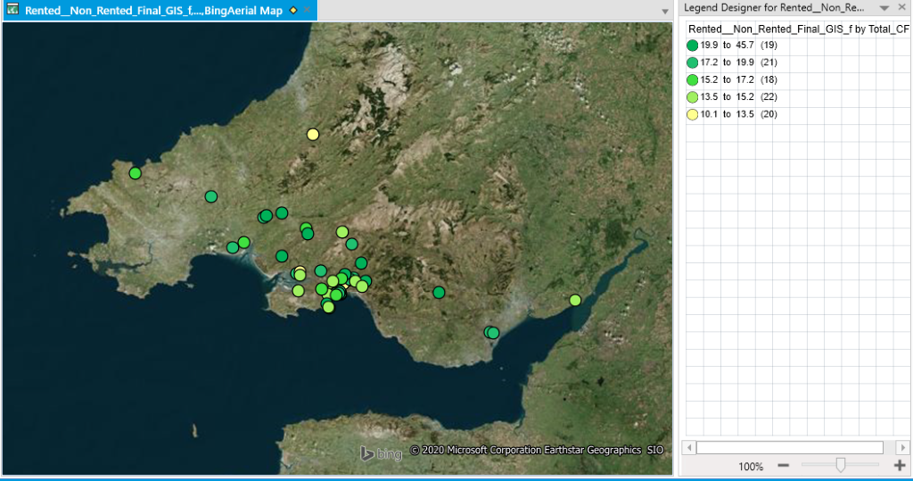
The process of obtaining these maps and legends can of course be repeated as many times as necessary or desired and can be overlapped also.

Data Analysis

For comparison purposes, the data has been highlighted for Wales only, as only a few households fall outside of this perimeter. The data is also limited to carbon footprint only.

Household Composition Stats:
Adults in home
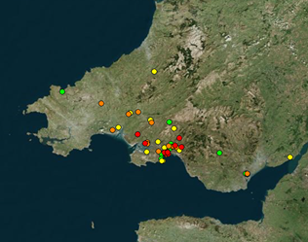
Red – 1 Adult
Orange – 2 Adults
Yellow – 3 Adults
Green – 4+ Adults

The data alone does not show much but in comparison with carbon footprint data, it can highlight areas where individuals living alone are producing as much as people with numerous adults in the home.

Age
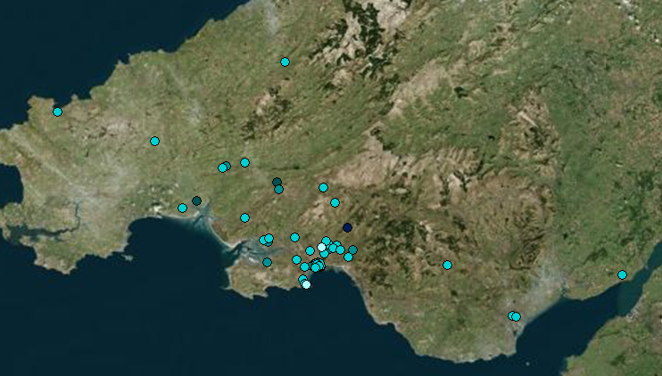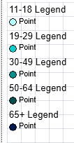
Again, the data is only relevant when compared with carbon footprints, however it displays nice usage of legends.

Income
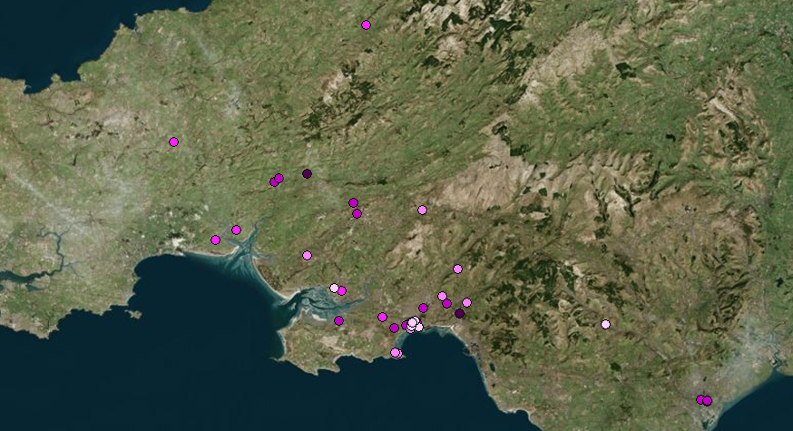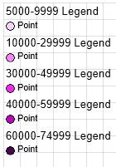

Same as above.

Total CF
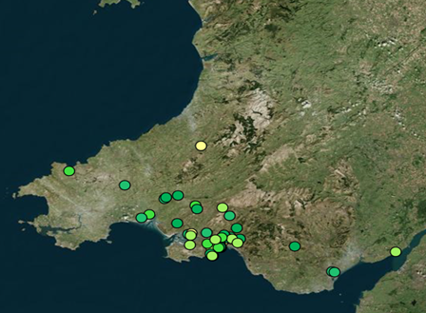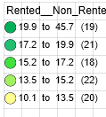

Compared directly with ‘new total CF’ below.

New Total CF
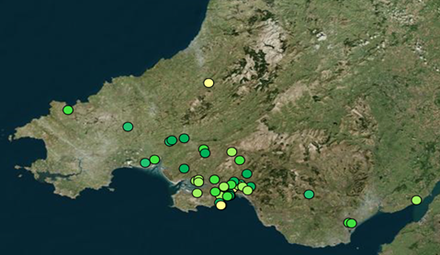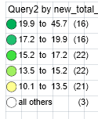

Though visual changes in the map can be determined, the best indication of lowered CF levels are through the legends, which display that 3 households, post-pledge, have slipped below the lowest levels previously stated, and with changes clearly visible in every category.

Housing CF
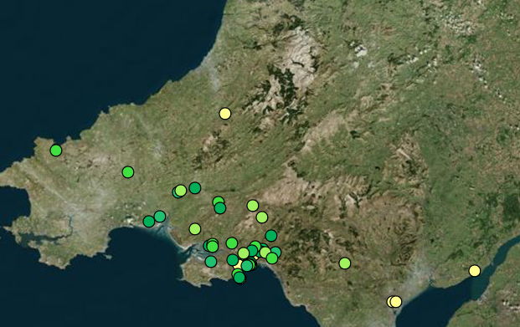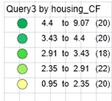

Compared directly with ‘new housing CF’.

New Housing CF
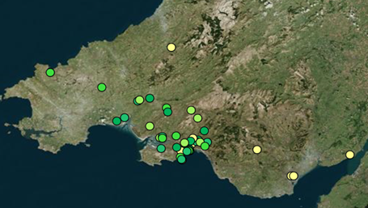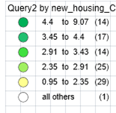
There is a significant decrease in carbon footprint based off of housing facilities as people pledge to switch facilities in their home.

Food CF
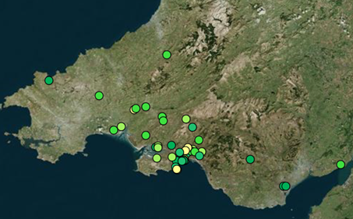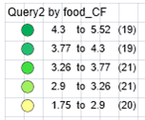
Compared directly with ‘new food CF’.

New Food CF

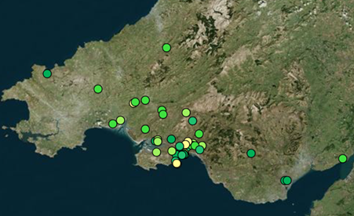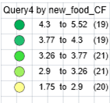

There is no change in food cf, perhaps due to people's reluctance to change dietary habits, especially for reduced meat consumption or purchase of local / organic foods due to inconvenience.

Travel CF
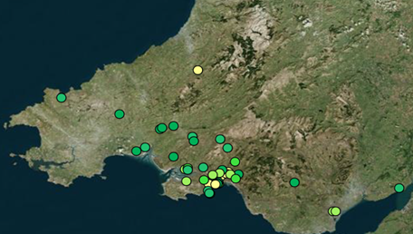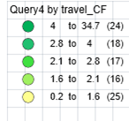

Compared directly with ‘new travel CF’.

New Travel CF
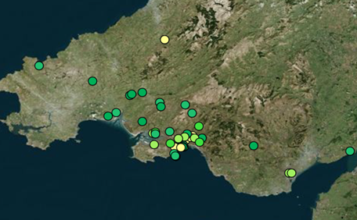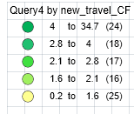
Again, there is no change in travel, potentially again due to habit and reluctance to give up convenience (of travelling to work) and luxury of holiday travels.

Consumer CF
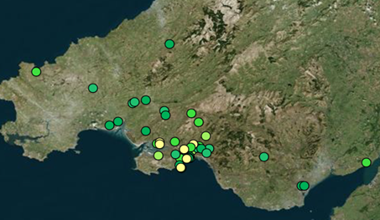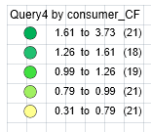

Compared directly with ‘new consumer CF’.

New Consumer CF
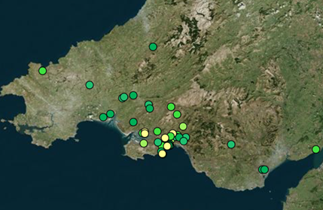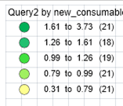

Consumption shows no change. People potentially feel the need to validate their work with material possessions and are not yet ready to sacrifice the luxury in this area.

Activities CF
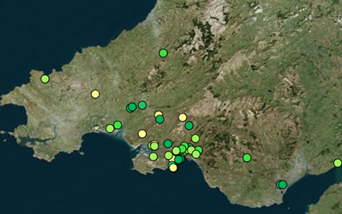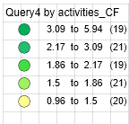

Compared directly with ‘new activities CF’.

New Activities CF

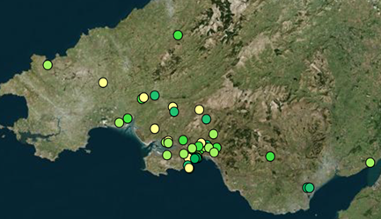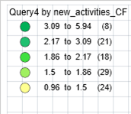

Reductions in spending on unnecessary or undesirable luxuries, such as cigarettes or the lottery, showed more positive results.

GIS Usage

The use of GIS in order to analyse data is evidently a highly valuable tool and despite its complications with Mapinfo, GIS as a concept has the capabilities to process a vast amount of data and condense it into a visual and aesthetically pleasing presented form.
Mapinfo Pro does require reasonably advanced knowledge of GIS in order to achieve the desired function, making the programme more difficult to use than is strictly necessary, as in many cases, only knowledge of how to navigate the programme is needed. In MapInfo’s case, to create the maps, data had to be pulled from external sources and uploaded individually by the user, leaving room for error through upload, data loss, or incorrect / irrelevant data selection. Additionally, these external sources used are often protected by paywalls or subscription services or can be difficult to navigate making access limited for some. Though there is an in-programme option for background maps provided by Bing, those also require a license key in order to access.
Other issues with the programme include the inability to edit or reduce file clutter without risking corrupting the entire workspace. The lack of an undo button means that any change is almost final, leading to a lot off clutter, especially since individual layers cannot be removed from the map once added, simply hidden. In the case of adding lots of similar data, this can quickly get confusing and the workspace can become overwhelmed with new browsers and maps that open each time you add new points. In this study, the workspace had to be closed and reopened each new data set to avoid easy confusion. Additionally, each workspace consists of numerous duplicates of the same file in various locations but any attempt to remove or relocate apparent duplicates will leave the whole workspace corrupted and all the work will be lost unless the data is moved back to where it was before, as MapInfo cannot search for the files used automatically, and this has to be completed manually upon reopening. This unforgiving layout can lead to increased frustrations and lead to a confusing number of files per data set due to a fear of removing any in case of a completely in-operable workspace as a result. It also means progress is being repeatedly saved in several different locations due to this same reason.
Many businesses have transitioned to other programmes with much more forgiving and user-friendly layouts like Arc Info and QGIS. The problems faced with using Mapinfo, can easily be overcome with a frequent utilisation of the programme and a build in experience. However, other programmes such as QGIS may offer better support for beginners in the industry.
In order to create a visually effective map in Mapinfo, it is necessary that the design is simplistic, using a standard background map or a regional outline map is most effective to avoid clutter. Filtering and sticking to relevant data also aids in creating a visually effective map.

References

Age UK, 2012. The cost of cold: Why we need to protect the health of older people in winter. [Online]
Available at: https://www.ageuk.org.uk/Documents/EN-GB/Campaigns/The_cost_of_cold_2012.pdf?dtrk=true

Buchs, M. & Schnepf, S., 2013. UK Households’ Carbon Footprint: A Comparison of the Association between Household Characteristics and Emissions from Home Energy, Transport and Other Goods and Services. Discussion Paper No. 7204, IZA(Germany).
Carbon Footprint Limited, 2020. Carbon Footprint Calculator - Individual. [Online]
Available at: https://www.carbonfootprint.com/calculator.aspx

Carbon Trust, 2020. Carbon footprinting guide. [Online]
Available at: https://www.carbontrust.com/resources/carbon-footprinting-guide
CarbonIndependent.org, 2020. Carbon footprint calculator and climate change information. [Online]
Available at: https://www.carbonindependent.org/index.html
Committee on Climate Change, 2016. Fifth Carbon Budget – Infographic. [Online]
Available at: https://www.theccc.org.uk/2016/07/20/fifth-carbon-budget-infographic/
Cook, J. et al., 2016. Consensus on consensus: a synthesis of consensus estimates on human-caused global warming. Environmental Research Letters, 11(4).
Explorers against Extinction , 2020. Carbon for Conservation. [Online]
Available at: https://explorersagainstextinction.co.uk/carbon-for-conservation/?gclid=Cj0KCQiAkKnyBRDwARIsALtxe7hncp5dzaF4ciCG3g_Yr09yCUSmt7avNTh89SUigeR2oVhna9699B0aAmxeEALw_wcB
Future Generations Commissioner for Wales, 2020. Simple Changes #68. [Online]
Available at: https://futuregenerations.wales/aop/calculate-and-understand-your-organisations-carbon-footprint/
Howe, S., 2019. Budget shows signs of improvement but is some way off the investment needed to tackle the climate and nature crisis says Future Generations Commissioner for Wales. [Online]
Available at: https://futuregenerations.wales/news/budget-shows-signs-of-improvement-but-is-some-way-off-the-investment-needed-to-tackle-the-climate-and-nature-crisis-says-future-generations-commissioner-for-wales/
Buchs, M. and Schnepf, S. (2013). UK Households’ Carbon Footprint: A Comparison of the Association between Household Characteristics and Emissions from Home Energy, Transport and Other Goods and Services. [online] Ftp.iza.org. Available at: http://ftp.iza.org/dp7204.pdf

Swansea City Council (n.d.). Swansea - Population. [online] Swansea.gov.uk. Available at: https://www.swansea.gov.uk/population

ONS (2018). UK private rented sector - Office for National Statistics. [online] Ons.gov.uk. Available at: https://www.ons.gov.uk/economy/inflationandpriceindices/articles/ukprivaterentedsector/2018

Swansea City Council (n.d.). Swansea - Labour market statistics. [online] Swansea.gov.uk. Available at: https://www.swansea.gov.uk/labourmarketstatistics

Swansea City Council (n.d.). Swansea - Tackling Poverty Strategy. [online] Swansea.gov.uk. Available at: https://www.swansea.gov.uk/povertystrategy

Swansea City Council (2014). Poverty Profile of Swansea. Swansea: City and County of Swansea Council.

Hope, A. and Booth, A. (2014). Attitudes and behaviours of private sector landlords towards the energy efficiency of tenanted homes. Newcastle upon Tyne: Northumbria University, Newcastle Business School.

Long, Y. et al., 2019. City-level household carbon footprint from purchaser point of view by a modified input-output model. Applied Energy, 236(15 February 2019), pp. 379-397.
Saner, D. et al., 2016. FoodPrints of households.. Int J Life Cycle Assess 21, pp. 654-663.
Stats Wales, 2019. Dwelling stock estimates by local authority and tenure. [Online]
Available at: https://statswales.gov.wales/Catalogue/Housing/Dwelling-Stock-Estimates/dwellingstockestimates-by-localauthority-tenure
Swansea Council, 2020. 1,000 new energy efficient council homes promised in Swansea. [Online]
Available at: https://www.swansea.gov.uk/article/55092/1000-new-energy-efficient-council-homes-promised-in-Swansea
Tipper, H., 2019. Senedd Research: Wales declares a climate emergency. [Online]
Available at: https://seneddresearch.blog/2019/05/09/wales-declares-a-climate-emergency/
Welsh Government, 2019. Wales accepts Committee on Climate Change 95% emissions reduction target. [Online]
Available at: https://gov.wales/wales-accepts-committee-climate-change-95-emissions-reduction-target
WWF UK, 2020. Footprint Calculator. [Online]
Available at: https://footprint.wwf.org.uk/#/questionnaire

Appendices

Age

FEMALE RESPONDANT

MALE RESPONDANT

Age

Income

Total CF

Total ef

New total cf
New total ef

HOUSING EF

New housing ef

House cf

New housing cf

Food ef

Food cf

New food cf

Travel ef

Travel cf

New travel cf

Consumer ef

Consumer cf

New consumer cf

Activites ef

Activities cf

New activities cf

