Professional Career Development Report
Ahmed ALI
1913515

UNIVERSITY OF WALES TRINITY SAINT DAVIDS

Contents.

Introduction – p. 3.
Main Body – p.4.
Conclusion – p.10
References – p.11

INTRODUCTION.

Throughout this report I am going to talk about professional career development. I am going to give examples of theories and models and how I can be applied to my own life.
It is said by McMahon, (2006) talks about the growing interest in career development. Career development is considered important for several reasons it gives a person a chance to grow in a chosen industry, this benefits the company by the person knowing the basis and values of the company. An employer will always want an employee that has as much passion for his or her business as possible. Career development for the correct employee is essential. In the broadest sense you want them to add value to the business when you hire an employee. It will also make the employee feel proud the have achieved growth within in a chosen industry.
For the intents of this report the following phrases will be defined as follows. Self-awareness according to Cambridge, (2020) online dictionary is “good knowledge and judgment about yourself” (Cambridge Dictionary, 2020).
Self-assessment definition, also according to Cambridge, (2020) is making a judgement upon yourself about your different skills, abilities or previous actions.
There are many methods, theories and models that a person can use to assess themselves. I will list them in the main body of the report and give examples from my own personal life and career development.

MAIN BODY.

The first mode I am going to talk about is my own personal favourite. I feel it has given me a great understanding of my self-awareness by using a self-assessment tool. This is the SWOT tool. The model that can be used to understand someone’s self-awareness, is the SWOT model. The SWOT model consists of four categories, S- Strengths. W – Weakness. O – Opportunities. T -Threats.
It has given me a great understanding of my self-awareness. I have included a SWOT diagram also.

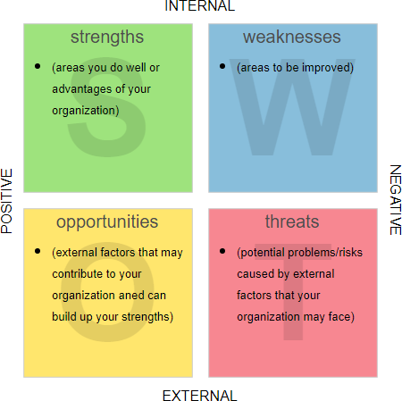

Strengths –
- working in a team – For some time I have worked in a restaurant with many different people in a small strong teams. I have been lucky enough to work multiple roles within this restaurant. I serve the food to the customers, we have to serve, clear and set the tables by working as a team and also working together achieving great customer service.
- Listening – I find that I am a good listener, my family and friends often tell me that “I have a good ear for problems”
- Cleaning - I find in my spare time I have a passion for keeping my home clean. It gives me a sense of pride.
- Support network – I am blessed to have a wonderful partner, beautiful son, good friends and a large strong family unit around me to support me in any good decisions I make.
- Cooking - I have recently taken time to learn to cook in the restaurant I work in and believe this is a good skill to help me in the future.
- Caring – I show concern and kindness to others which I believe is a strong asset to have in business and I believe in future it will help my staff trust me.
- Honest – within in work I am honest I am trustworthy in work more than other I believe this is why I have had multiple roles within the restaurant.
- Self-control – due to being brought up in a Muslim family, it has taught me all aspects of self-control.
- Humble – again due to religious backgrounds I quietly appreciate all things in life and struggle to talk about my achievements.

Weaknesses –
- Lacking attention – sometimes I find it hard pay attention especially when I am learning something new.
- Confidence – I find it hard speaking to a large of group of people and will often make an excuse not to be do it.
- Nervous – I find it difficult speaking to new people I like to keep myself to myself.
- Asking for help – I won’t ask for help so I don’t seem like I am struggling and worry people will think negative of me.
- Patience – I don’t have a lot of patience I get agitated when I am waiting around so I try to stay busy.
- Saying no – I agree to most things even if I do not want to do something and find it hard saying no to friends and family.
- Driving – At the moment, I don’t drive so I use public services for transport so this places some restrictions of my ability to travel.
- Time management – I find it difficult to prioritise the urgency of tasks.
- Humour – I often use humour in situations I find difficult (new people, large crowds) which sometimes can upset people.

Opportunities –
- Learn - I can learn, now that I have enrolled into university.
- Confidence building - I can build my confidence by getting to know people in my course and being outside of my comfort zone and building my confidence.
- Career development - I have the opportunity further my career.
- Technology – I have access to the internet enabling me to access online resources.
- Resources – I can access physical libraries in university and local council libraries.
- Support network – I now have a stronger support network such as lectures and study support sessions.
- Family business – the restaurant I work in is owned by close family members, giving me the opportunity to learn how the business is run.
- Concentration – whilst completing my assignments and attending class I will have the opportunity to improve my ability to concentrate.
- Driving - I am currently taking driving lessons, so I will have the opportunity to be able to travel further when I have my own transport.

Threats –
- Finance – As I have a family to financially support, if my lectures or a volunteer overrun with my shifts in work, I would have to choose work.
- Economic Climate – Over the past few months, the restaurant I work in has had a loss in business, management think is because of an increase in popularity in online takeaway platforms such as Just Eat and Deliveroo.
- Work – if custom does not improve within the restaurant, cut back on staff may happen resulting changes between my team and I.
- Concentration – If my confidence is certain situations does not improve, I will not be able to complete my journey the way I would like it.
- Pride – If I do not ask for help when I need it, I may risk doing things wrong and failing assignments.
- Time management – If I do not improve my time management, I may risk missing deadlines.
- Confidence – if my confidence does not improve, I may not be able to successfully get to my end goal.
- Health – My asthma has strong impacts on my physical and mental health, because I get embarrassed to tell people I have asthma and do not feel confident taking my pump in front of people.
- Weather – due to the location of the restaurant being on the sea front, the recent bad weather had structurally damaged the building, mean in the foreseeable future the business will have to temporally close for essential repairs.

There are many people unintentionally waste their life between meaning less jobs or spend too much time trying to accomplish something but in reality, get very little completed. (Mind Tool, 2020) I have learnt that in order to combat that, the use of a SMART tool is appropriate. SMART Goals can be used in personal or business life.
The smart goals can help you become more organized and help you sort out your priorities. They give you a sense of focus and purpose that is highly motivating giving you a timescale on achieving your goals and meeting deadlines of where and when, how long it will take to achieve these goals.
The smart goal tool has helped me have a sense of focus and has given me a reason and has motivated me enabling me to set a timeline on achieving these goals. The tool has given me a visual aid as to where I am currently and how long it will take me to achieve these goals. A SMART diagram is available below.

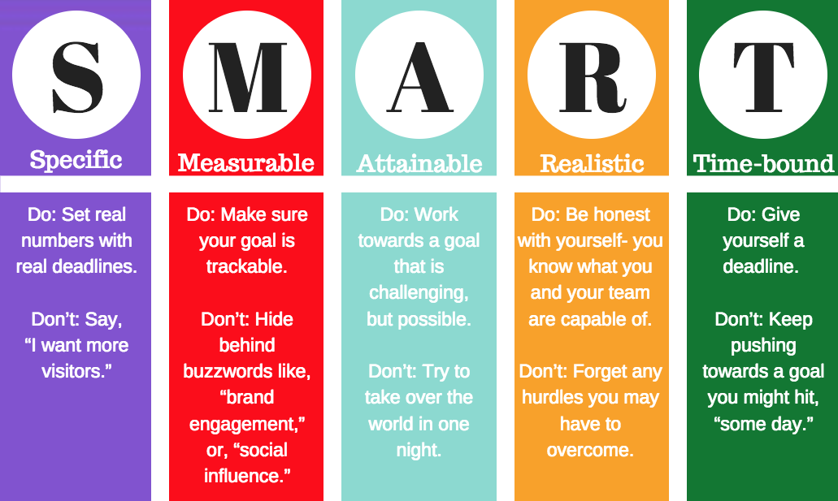

Specific - Owning a successful business doing music that does well by building a strong
clientele base that will bring in more people who would like to have a music career within
my business.
Measurable - Attending business courses and music classes, the business course will be a
fulltime 1-year course and after that course is finished, I will start attending music classes
for a period of 2 years
Attainable – after finishing the business course I would have achieved half of what I need to have
successful music business and going around building up my fanbase and music career.
Realistic – once I have done both the 1-year business course and 2 years of music classes and I have
Quite a large music clientele base I can move forward with my business.
Time-bound - now Ive given myself 2 years to achieve all my goals in order to have a successful
music business.

Over time many professionals have developed careers that are theorist. A theorist is a person who spends a lot of time researching a certain topic or area and develops a theory from it, mostly through observation and study. I am going to discuss three theorists in this report – Stephen covey, Maslow and the Johari Window theory.
To begin with throughout my business development, I intend to adopt the Seven Habits. The Seven habits are a theory from Stephen Covey. Stephen Covey an American man born in 1932 and passed in 2012. Covey firmly believed that all peoples doings are because of their pasts. He said that in order to be successful one must change large parts of their life’s. Covey developed a management theory and set out seven habits one must follow in order to be successful. They are as follows:
- Being proactive not reactive
- Beginning something with the end in mind whilst thinking of the future
- Whilst adopting the motivational theory and being able to “put first things first”
- Think win and take into consideration everyone’s needs.
- Seek first to understand, then to be understood
- Synergize
- Sharpen the saw and continue to grow (Cramer, 2010).

The Johari window model developed by two men names Harrington Ingham and Joseph Luft. The Model talks about the relationships and understandings between people in a group.

Pragmatists –
This theory says that I am a Pragmatists that are keen on trying out ideas, theories and techniques to see if they were work in practice. They positively search out new ideas and take the first opportunity to experiment with applications. They are the sorts of people who return from management courses brimming with new ideas that they want to try out and in practice. They like to get on with things and act quickly and confidently on ideas that attract them. They tend to be impatient with ruminating open-ended discussions. They are essentially practical, down to earth who like making practical decisions and solving problems. They respond to problems and opportunities “as a challenge” their philosophy is: “there is always a better way” and “if it works its good”.

The theory also says I am a
Theorists –
Theorists adapt and integrate and adapt observations into complex but logically sound theories. They think problems through in a vertical, step by step logical way. Assimilate disparate facts into coherent theories. They tend to be perfectionists who won’t rest easy until things are tidy and fit into a rational scheme. They like analyse and synthesis. They ae keen on basic assumptions, principles, theories models and systems thinking. Their philosophy prizes rationally and logic. “if its logical its good” questions they frequently ask are: “does it make sense?” “how does this fit with that?” “what are the basic assumptions?” they tend to be detached, analytical and dedicated to rational objectivity rather than anything subjective or ambiguous. Their approach to problems is constantly logical. This is their “mental set” and they rigidly reject anything that doesn’t fit with it. They prefer to maximise certainty a feel uncomfortable with subjective judgments, lateral thinking and anything flippant.
Personnel development plan
I will Get along with people and start working well with other people, with my communication skills and other interpersonal skills. I will be reliable and dependable by doing what I say I will by the deadline I have agreed, and turning up when I’m meant to be there and have a willingness to learn new skills, whether those are job-specific or more general. I will also use the SMART goals to achieve my goals.

CONCLUSION
Throughout this report I have attempted to explain how I am going to develop my employability and academic by explaining how models and theories can be applied in situations to help me and by giving clear examples.
To conclude since beginning to analyse my own personal career I have learnt that there are many tool kits available enabling me to simplify my goals and targets, making bitesize information to easier to digest. Since starting university, I have learnt about SMART goals and a SWOT analysis and other theorists. I can use my personality as strengths in future business. I can continue to learn to skills needed to be able to have my own business in the future making a future for my family and my children.

References.
McMahon, M. (2006) CAREER DEVELOPMENT: A PROJECT FOR THE 21st CENTURY. Available at: https://journals-sagepub-com.ezproxy.uwtsd.ac.uk/doi/pdf/10.1177/103841620601500304 (Accessed 20.02.2020)
Cambridge Dictionary, (2020) self awareness definition. Available at: https://dictionary.cambridge.org/dictionary/english/self-awareness (Accessed 20.02.2020)
Cambridge Dictionary, (2020) self assessment definition. Available at: https://dictionary.cambridge.org/dictionary/english/self-assessment (Accessed 20.02.2020)
Mindtool. (2020) Available at: https://www.mindtools.com/pages/article/smart-goals.htm (Accessed 21.02.2020)
Cramer, M. (2010) Better your business using the Covey seven habits of highly effective people. Available at: https://www.business.com/articles/management-theory-of-stephen-covey/ (Accessed 21.02.2020)

