

Research Proposal
(LCMB7020)
NAME - NAYANKUMAR BIPINBHAI PATEL
STUDENT ID - 2243076
Lecturer – Dr Liyanage Sampath Rodrigo
TOPIC - A Study Evaluating the Impact of Covid-19 Restrictions on the Operations of the Airlines Industry in the UK - A Case of British Airways

Table of Contents
Introduction 3
Background 3
Research Problem 3
Overall idea about research content 3
Specific problem 4
Research Aim and Objectives 4
Research Questions 4
Literature Review 5
Methodology 8
Risk 12
Timeline 13
Reference List 14

Introduction

Background
The COVID-19 restrictions have assured the security and safety of the citizens of different countries (Melas and Melasova, 2020). However, it enhances the problematic situation for the operational management in the UK airline industry. The international level instruction during the pandemic has influenced the basic but important operational activities of the UK aviation industry (Suk and Kim, 2021). However, different organisations in the UK aviation industry did not fail in the management of the situation. They have adopted different tools and technologies to maintain the situation of the pandemic. The contribution and approaches of British Airways were especially appreciable.

Research Problem
Different changes have been made during COVID-19 restrictions (Hamawandy et al., 2021). Collecting and focusing on those operational changes at one time is a challenging task. That is why, it is crucial to identify and analyse the impact of the Covid-19 instructions on the UK aviation industry through the help of specific examples (Suk and Kim, 2021). Customer loyalty and expectations of BA has been affected in the pandemic due to unmanaged operations. Then it will also help in focusing on the strategies and ideas to improve the operational management in British Airways. So, identifying of Impact of COVID-19 restrictions on the operations of the airline industry in the UK through British Airways is crucial.

Overall idea about research content
The research content will try to focus on the challenges faced by the airline industry during the pandemic and their restrictions. Collecting real-life evidence through better visualisation and clarification will be done. Identification of the main challenges in the operational activities of British Airways will be done during the time of the pandemic. After collecting the thoughts and points of view of the different researchers, it will be easy to provide effective strategic planning, which will help in the development and growth of the operational performances of British Airways. Additionally, there will be evacuations for the tools and technologies adopted by British Airways for business operations at Covid-19 restrictions in the UK airline industry.

Specific problem
The revenue of British Airways has been reduced drastically during COVID-19 restrictions (Hamawandy et al., 2021). So, operational challenges and their effects have influenced the customer expectations in the society. Due to unmanaged operational management in the organisation, the organisation has faced multiple challenges including a decrease in customer satisfaction (Amankwah-Amoah, 2021). The customer engagement of British Airways has been reduced drastically during the pandemic in the UK (Suk and Kim, 2021). So, the management procedures and approaches of British Airways will be measured in the research.

Research Aim and Objectives
The main aim of the research is to evaluate the Impact of COVID-19 restrictions on the operations of the airline industry in the UK through British Airways (BA). The research objectives are listed below.
- To focus on the COVID-19 restrictions on the Operations of British Airways.
- To identify the issues that emerged in the operations of British Airways due to COVID-19 restrictions.
- To highlight the tools and technologies adopted by British Airways to manage Covid-19 restrictions in the UK airline industry.

Research Questions
- What were the COVID-19 restrictions on the Operations of British Airways?
- What issues have emerged in the operations of British Airways due to COVID-19 restrictions?
- Which tools and technologies adopted by British Airways to manage Covid-19 restrictions in the UK airline industry?

Literature Review
Overview
The section is going to focus on the collected data for the research topic. Evaluation of data will be done through the help of the different articles and journals. Then it will be easy to highlight the contrasting and argumentary thoughts of different researchers.
Significance of Operational Management in the Aviation Industry
According to the discussion of Amankwah-Amoah (2020), operational management helps in ensuring the safe and seamless travelling of passengers in the aviation industry. As per the arguments of Loo (2021), whether it is the airline industry or any other industry, there will always be a high requirement for managing operational activities. Otherwise, it will be difficult to connect with the customers in the market. There are different requirements of managing operational management in the aviation industry which are going to be focused on below:
- Ensuring Customer Satisfaction: According to the discussion of Amankwah-Amoah (2020), it helps in managing delays and availability of the airlines. So, ensuring customer satisfaction could be done. In contrast, according to the discussion of Sobieralski (2020), the travel experiences and satisfaction of the customers matter a lot in the airline industry. Additionally, it helps in managing resources and minimising disruption in different activities.
- Cost Saving: As per the arguments of Loo (2021), cost saving and cost management are easy if there is an effective and efficient plan for operational management. It helps in the optimization of flight schedules, and streamlining of processes. So, operational costs could be maintained.
- Security Measures: According to the discussion of Amankwah-Amoah (2020), the security and safety of the passenger matters in the airline industry. In against as per the view of Adrienne, Budd and Ison (2020), with the help of well-maintained operational activities, it becomes easy to secure the travel experiences of the customers in the airline industry. The same thing has been done by British Airways in their journey.

Operational Management Challenges during COVID-19 Restriction
As per the arguments of Shen (2022), the COVID-19 restrictions have directly influenced the operational management of the UK aviation industry. The situation is going to be evaluated with the help of focusing on the condition of British Airways.
- Scheduling Management: As per the view of Adrienne, Budd and Ison (2020), due to the high restrictions of the pandemic, it becomes difficult to schedule the work among the crew members. So, work decorum could be maintained. According to the discussion of Sobieralski (2020), British Airways started to face labour shortages as well for the management of operational activities. In contrasting, as per the arguments of Shen (2022), employees have to maintain the measures and regulations which have been instructed by the government. As per the arguments of Macilree and Duval (2020), 37% of the employees in British Airways failed to do so which created stacking of the other activities of the organisation.
- Cost Management: According to the discussion of Garrow and Lurkin (2021), the high measures and restrictions during the pandemic enhanced the security and safety concerns for the organisation. So, they have to invest more during the pandemic. As per the arguments of Adrienne, Budd and Ison (2020), it can be easily figured out with the help of the seat offered capacity and loss of airline revenue in 2020-2021.
- Uncertainty in the Availability of Airlines: As per the arguments of Macilree and Duval (2020), it becomes near impossible to believe the timing of flights as there is so much uncertainty in the situation. So, delays in the flight have also been measured in British Airways (icao.int, 2024).
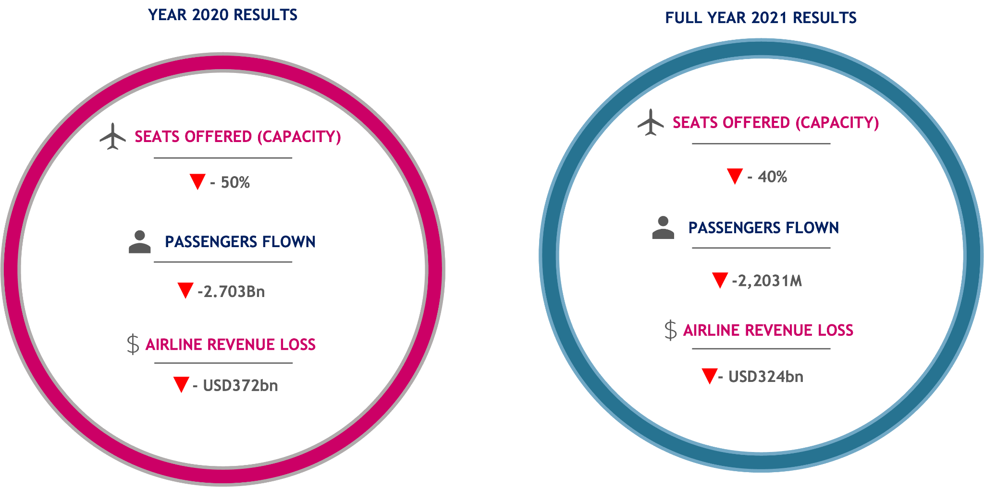
Figure 1: Results of aviation industry for 2020-2021
(Source: icao.int, 2024)
Operational Management by British Airways
According to the discussion of Garrow and Lurkin (2021), for better management of the operational activities in the organisation, British Airways has adopted these steps in their operations.
Volume- According to the discussion of Abate, Christidis, and Purwanto (2020), they never adjusted to the quality and quantity of foods and other services provided by the organisation. According to the discussion of Farooq et al., (2021), quality of life has been promoted by the organisation.
Variety- As per the arguments of Adrienne, Budd and Ison (2020), they are continuously working on the improvement of the variety of services provided by them.
Variation- According to the discussion of Abate, Christidis, and Purwanto (2020), variation in flexibility, routine, and changing capacity has been promoted by BA among their employees.
Visibility- As per the view of Garrow and Lurkin (2021), customer perception and satisfaction were influenced by the high visibility of the services provided by BA in the UK airline industry.
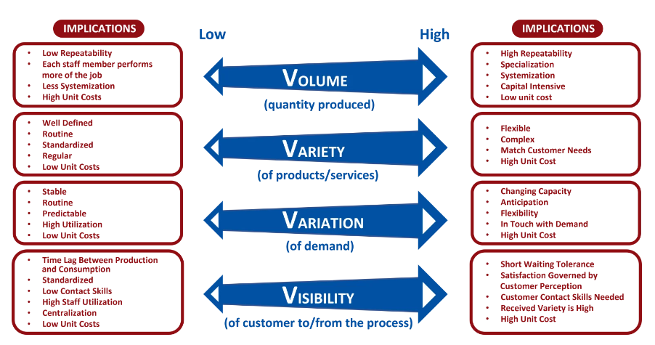
Figure 2: 4Vs of Operations Management
(Source: The ‘4vs’ – the 4 dimensions of Operations, 2024)
Literature Gap
The overall impact on the operations of British Airways due to COVID-19 restrictions did not focus on any specific and clear data. That is the reason why readers might face problems and confusion while reading the research (Amankwah-Amoah, 2021). Research could not be successful until and unless there is the proper evidence and real-life data. This might impact the probability of success of the research.
Summary
The section has efficiently provided detailed information with critical and argumentative sentences. There was the reviewing of the different peer-reviewed papers. So, in-depth knowledge and information about the chosen topic could be given to the readers.

Methodology
Overview
The section will reveal the proposed pathways of the research. To gain in-depth knowledge about the research, the researcher has planned the pathways, which are going to be shown in this section. It will be easy to evaluate through the help of the research onion Saunders. Then, the peeling of each step will be done.
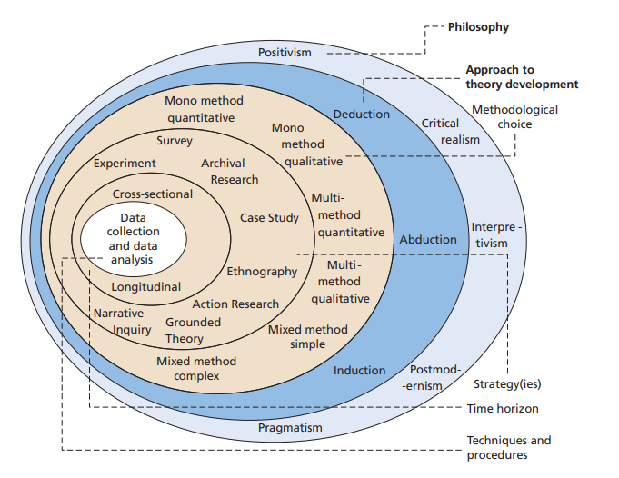
Figure 3: Research Onion by Saunders
(Source: Saunders, Lewis and Thornhill, 2007)
Research Philosophy
The research philosophy helps in providing the details for collecting, analysing and interpreting the data in the research. There are two segments in the research philosophy which include ontology and Epistemology. In ontology, the researcher will focus on “Descriptive evaluation”. There are different types of research philosophy in epistemology which include positivism, interpretivism, realism, and pragmatism (Pandey and Pandey, 2021). The researcher will adopt an "Interpretivism research Philosophy'' in their research. So, it will be easy to focus on the real scenario for the research. The interpretivism research philosophy will help in focusing on the social and existing phenomena. Then it will be easy to provide the evidence and examples to the readers. Additionally, it will provide in-depth knowledge and understanding of the topic.
Research Approach
The research approach helps in providing the details for in-depth knowledge about the study in experimental and theoretical ways. So, the type of research approach matters in the research (Pandey and Pandey, 2021). There are two types of approaches in the research methodology which are deductive and inductive approaches. The researcher will follow an “Inductive research approach” in their consideration. So, analysing information from real-life evidence will help in the development of theory in the study. It will be easy to provide in-depth knowledge and understanding to the readers by providing details of the conflicting ideas of the researcher.
Methodological Choice
It helps in providing the details of whether the information will be descriptive or precise (Pandey and Pandey, 2021). The research is trying to provide non-numerical data and information to the readers. Thus, a focus on collecting “mono-method” data will be done focusing both Qualitative data only.
Research Strategies
The research strategy helps in making a baseline to go further in the research. The researcher will adopt a "Case-Study strategy'' in their research. So that fluctuated, but real data and information could be collected in the research. It will also foster the collection of community-based knowledge.
Research Design
The research design helps in designing the ethical pathway, which will help in studying the time and cost of the research (Li et al., 2021). There are different types of research design which include Experimental Design, Exploratory, Grounded Theory, and Descriptive. So, the researcher will adopt an "Exploratory Research Design'' in their consideration. Then it will be easy to maintain time, energy and costs in the research. Exploratory research design will help in the fostering of the collection of data with effective time management. So, meeting the deadline will be possible in the research.
Time Horizon
Time horizon helps in the intended time for the completion of a project. There are two types of time horizons in the research methodology which include Longitudinal and Cross-sectional (Nayak and Singh, 2021). To not invest prolonged periods in collecting the data in research, the researcher has decided to follow a “Cross-sectional time horizon” in the research. Then there will be a limited time to collect and analyse the data. It will be easy to give details for the specific points of the topic in a short duration.

Data Collection
The way of collecting the data decides the duration for the analysis and evaluation of data. There are two types of methods to collect the data which include secondary and primary data collection methods. The collection of data will be done through “secondary sources”. For the secondary research, there will be a collection of data from different, articles, and journals, websites and peer-reviewed papers. Those websites will include “Google Scholar, Scopus, web of Science, and UWTSD”. So that data could be publicly available. “Systematic Literature Review” will be done.
Then it will be easy to analyse the data in the research (Nayak and Singh, 2021). Additionally, it will help in enhancing the accuracy and speed of the research. The data might fluctuate and it will consume time. The researcher is deliberately trying to provide in-depth knowledge about the selected topic.

Data Analysis
This is the last and foremost important method during research on any topic. There are different types of analysis for the primary and secondary collection of data. The secondary data sources will follow “Thematic qualitative analysis” of data in the research. Then, conveying the main content will be easy. “Systematic Literature Review” will be done to analyse the collected data. Then it will be easy to focus on the thought of different researcher on the selected topic.
Then, conveying the main content will be easy. With the help of the thematic analysis, it will be easy to answer each research question (Nayak and Singh, 2021). Additionally, meeting objectives will be possible. The probability of the success of the research will be enhanced if there is be evaluation of the non-numerical data and information. It will help in enhancing the visualisation and clarification for the readers.
Ethical Consideration
There will not be the collection of any harmful and personal data. There will be a preference as to the online open websites. The research will be undertaken with prior informed consent and will be protected as per the Data Protection Act 1998. So, storing personal data will be secured with a strong password. Then it will be easy to ensure the security and safety of collected data.

Risk
The research can have certain number of risks. Limitation of secondary sources can limit the data and information. At the same time, protection, and security of data collected from the secondary research needs to be maintained, if not maintained can hamper other process. Additionally, contrasting thought of the researcher might confuse the readers. It might affect the visualisation and clarification of the readers.
Timeline Gantt Chart

Figure 5: Final Gantt chart
(Source: Self-generated)
Timeline
Table 2: Final Timeline for Research

Activity Name | Start Date | Duration | End Date
Topic Selection | 03-02-2024 | 4 | 06-02-2024
Selecting necessary Literature | 07-02-2024 | 9 | 15-02-2024
Proposal Submission | 16-02-2024 | 1 | 16-02-2024
Ethics Form Submission | 16-02-2024 | 1 | 16-02-2024
Starting Final Dissertation | 17-02-2024 | 20 | 07-03-2024
Completing analysis and evaluation | 08-03-2024 | 35 | 11-04-2024
Findings and Discussion | 12-04-2024 | 8 | 19-04-2024
Conclusion and Recommendations | 20-04-2024 | 13 | 02-05-2024
Final Submission | 03-05-2024 | 1 | 03-05-2024

Reference List
Abate, M., Christidis, P. and Purwanto, A.J., (2020). Government support to airlines in the aftermath of the COVID-19 pandemic. Journal of air transport management, 89, p.101931.https://www.ncbi.nlm.nih.gov/pmc/articles/PMC7489892/
Adrienne, N., Budd, L. and Ison, S., (2020). Grounded aircraft: An airfield operations perspective of the challenges of resuming flights post COVID. Journal of Air Transport Management, 89, p.101921. https://www.ncbi.nlm.nih.gov/pmc/articles/PMC7470860/
Adrienne, N., Budd, L. and Ison, S., (2020). Grounded aircraft: An airfield operations perspective of the challenges of resuming flights post COVID. Journal of Air Transport Management, 89, p.101921. https://www.ncbi.nlm.nih.gov/pmc/articles/PMC7470860/
Amankwah-Amoah, J., (2020). Stepping up and stepping out of COVID-19: New challenges for environmental sustainability policies in the global airline industry. Journal of Cleaner Production, 271, p.123000. https://www.ncbi.nlm.nih.gov/pmc/articles/PMC7315957/
Amankwah-Amoah, J., (2021). COVID‐19 pandemic and innovation activities in the global airline industry: A review. Environment International, 156, p.106719. https://www.sciencedirect.com/science/article/pii/S016041(2021)003445
Farooq, M.U., Hussain, A., Masood, T. and Habib, M.S., (2021). Supply chain operations management in pandemics: A state-of-the-art review inspired by COVID-19. Sustainability, 13(5), p.2504. https://www.mdpi.com/2071-1050/13/5/2504/pdf
Garrow, L. and Lurkin, V., (2021). How COVID-19 is impacting and reshaping the airline industry. Journal of Revenue and Pricing Management, 20, pp.3-9. https://link.springer.com/article/10.1057/s41272-020-00271-1
Garrow, L. and Lurkin, V., (2021). How COVID-19 is impacting and reshaping the airline industry. Journal of Revenue and Pricing Management, 20, pp.3-9.https://link.springer.com/article/10.1057/s41272-020-00271-1
Hamawandy, N.M., Ali, R., Bewani, H.A.W.A., bdulmajeed Jamil, D., Rahman, S.K. and Othman, B.J., (2021). The financial Impacts of (COVID-19) on financial reporting quality Airlines Companies: British Airlines. Journal of Contemporary Issues in Business and Government Vol, 27(2). https://www.researchgate.net/profile/Nawzad-Hamawandy/publication/351094640_The_financial_Impacts_of_COVID-19_on_financial_reporting_quality_Airlines_Companies_British_Airlines/links/6085f49b2fb9097c0c0ce172/The-financial-Impacts-of-COVID-19-on-financial-reporting-quality-Airlines-Companies-British-Airlines.pdf?_sg%5B0%5D=started_experiment_milestone&origin=journalDetail&_rtd=e30%3D
icao.int (2024) Economic impacts of covid-19 on Civil Aviation &nbsp; // , Economic Impacts of COVID-19 on Civil Aviation. Available at: https://www.icao.int/sustainability/Pages/Economic-Impacts-of-COVID-19.aspx (Accessed: 07 February 2024).
Li, S., Zhou, Y., Kundu, T. and Zhang, F., (2021). Impact of entry restriction policies on international air transport connectivity during COVID-19 pandemic. Transportation Research Part E: Logistics and Transportation Review, 152, p.102411.https://www.ncbi.nlm.nih.gov/pmc/articles/PMC8220963/
Loo, M., (2021). When do we fly again? Managing Airlines in a Pandemic: Challenges and Recommendations. Turkish Journal of Computer and Mathematics Education (TURCOMAT), 12(3), pp.4959-4978. https://www.turcomat.org/index.php/turkbilmat/article/download/2009/1740
Macilree, J. and Duval, D.T., (2020). Aeropolitics in a post-COVID-19 world. Journal of Air Transport Management, 88, p.101864. https://www.ncbi.nlm.nih.gov/pmc/articles/PMC7386483/
Melas, D. and Melasova, K., (2020). The early impact of COVID-19 pandemic on the aviation industry. Acta Avionica, 22(1), pp.38-44.https://pdfs.semanticscholar.org/d665/4a463416e41f42e408295b6474a693767d36.pdf
Nayak, J.K. and Singh, P., (2021). Fundamentals of research methodology problems and prospects. SSDN Publishers & Distributors. http://dspace.vnbrims.org:13000/jspui/bitstream/123456789/4653/1/Fundamentals%20of%20Research%20Methodology_Nayak.pdf
Pandey, P. and Pandey, M.M., (2021). Research methodology tools and techniques. Bridge Center. http://dspace.vnbrims.org:13000/jspui/bitstream/123456789/4666/1/RESEARCH%20METHODOLOGY%20TOOLS%20AND%20TECHNIQUES.pdf
Saunders, M., Lewis, P.H.I.L.I.P. and Thornhill, A.D.R.I.A.N., (2007). Research methods. Business Students 4th edition Pearson Education Limited, England, 6(3), pp.1-268. https://www.researchgate.net/profile/Mark-Saunders-10/publication/330760964_Research_Methods_for_Business_Students_Chapter_4_Understanding_research_philosophy_and_approaches_to_theory_development/links/5c53056f299bf12be3f0e2cf/Research-Methods-for-Business-Students-Chapter-4-Understanding-research-philosophy-and-approaches-to-theory-development.pdf
Shen, Z., (2022, December). Analysis of British Airway's Hedging Strategies. In 2022 2nd International Conference on Economic Development and Business Culture (ICEDBC 2022) (pp. 307-311). Atlantis Press. https://www.atlantis-press.com/article/125983809.pdf
Sobieralski, J.B., (2020). COVID-19 and airline employment: Insights from historical uncertainty shocks to the industry. Transportation Research Interdisciplinary Perspectives, 5, p.100123. https://www.sciencedirect.com/science/article/pii/S2590198220300348
Suk, M. and Kim, W., (2021). COVID-19 and the airline industry: crisis management and resilience. Tourism Review, 76(4), pp.984-998. https://scholar.archive.org/work/wjqjf6w2qbfsxjijn273uxz6wa/access/wayback/https://www.emerald.com/insight/content/doi/10.1108/TR-07-(2020)-0348/full/pdf?title=covid-19-and-the-airline-industry-crisis-management-and-resilience
The ‘4vs’ – the 4 dimensions of Operations (2024) Rowtons Training. Available at: https://rowtonstraining.com/the-4vs-the-4-dimensions-of-operations/#:~:text=What%20are%20the%204Vs%20of,strengths%2C%20weaknesses%20and%20different%20approaches.(Accessed: 29 January 2024).

