Problem Solving and Decision Making

Student Name: Vladimir Rebrik
Student Number: (1914780)
Module Title: Problem Solving and Decision Making
Assignment Title: (BMSW4004_LON)
Lecturer: Hossein Shokri

Table of Contents

Table of Content.............................................................2
1.Introduction..................................................................3
2.Problem........................................................................3
3.PESTLE analysis.........................................................3
4.Fishbone Analysis........................................................5
5.Personal SWOT analysis.............................................6
6.Suggested solutions......................................................7
7.Monitoring & Evaluation.............................................7
8.Conclusion....................................................................8
9.Referencees..................................................................8

Introduction
This semester, within the framework of studying under the Problem Solving and Decision-Making module, we conducted a roleplay to develop P.S.&D.M. tools and technics. My Role-Play's partner Barbara provided me with information describing her current work situation and the problem she had facing. Under the terms of Role Play, Barbara turned to me as an independent manager-consultant with a request to analyse her problem and find and propose to her an acceptable solution. This report concerns identifying this problem and searches for its solution.
Problem
Barbara is working as a member of catering staff at Delicious catering Ltd. The company provide food and table set-ups around London. Barbara has been working there for over two years; she began as a primary crew member, she helped set up the tables and the settings and prepare food events. However, Barbara's boss started to trust her, and she has been taking on more jobs. Today she is the person who coordinates with clients about headcount, food preferences and other organisational issues. But she has been not promoted, and her salary remains the basic rate. Barbara has received the offer from another catering company, but it is outside London. Barbara prefers to stay with her current company, but it will be hard if they don't want to promote her and increase her salary.
With the information received and the request itself, I can identify the main problem. Barbara wants to get a higher salary in the same company or find a similar job with a higher payment within the desired location. My task is to analyse her situation, using different Problem-Solving tools, and advise several options for solving the problem. First of all, I decided to analyse using PESTEL analysis the key factors influencing her and her company from the outside.
PESTLE analysis
The Pestel analysis is a universal, situational method for business evaluation purposes, usually to analyse the external business environment. PESTEL is acronyms means Political, Economic, Social, Technological, Environmental, Legal external factors. (Yuksel,2019).
The traditional steps of PESTLE analysis are as follows:
Step 1 - Make a List of external PESTLE factors for the company.
Step 2 - Identify the involvement of each PESTLE elements on the business.
Step 3 - Assess the impact and probability.
Step 4 - Further action (other methods of analysis, or scenario building). So, what we have here:
Political factor
For almost 50 years, the UK's food industry has been intrinsically linked to its membership of the European Community. Accordingly, the Brexit has brought to this industry the most noticeable challenges and opportunities. The Brexit timeline, the difficulties of negotiations, and the political pressure to sign new trade deals could lead to hasty decisions, affecting the companies' work and profits (Chatham House – International Affairs Think Tank, 2019).
Economic factors:
The global recession caused by Covid-19 is slowing down the growth, increase in unemployment, and minimising profit for many business organisations, including the Food industry. So, companies trying to save their money.
Social factors:
In our time, more employees are feeling replaceable by companies. They thinking companies don't care about their loyalty (Nathanson, 2019). In fact, HR looking for new talents even when they don't need to replace staff. The loyalty of employee’s links to the way they identify within a team and contribute to the company. To reach mutual goals, they must feel as though they are a part of the organisation—employee retention relies on the employees' identification with companies processes (Monster Employer Resources | Monster.com, 2010).
‌Technological factors:
In that case, technologies are beneficial in communication with management or employers. With using new mobile or digital technologies, employees can reach even top management to negotiate the contract terms, including payment.
New mobile technologies also make it possible to speed up and ease finding a new job if necessary (Nibusinessinfo.co.uk, 2021).
Environmental factors:
The Food industry and restaurant business have been hit especially hard by the effects of Covid - 19. The accommodation and foodservice experienced the largest decrease in working hours of any sector (HBS Working Knowledge, 2020).
Legal factors.
Employment law or labour law determines the wages, working hours, work environment relationships of employees working on a business. This law protects employees, workers' rights to get the increase they deserve and how they should be treated. Employment law prohibits discrimination based on colour, gender, race, etc. That's why companies and employees must learn about employment law to avoid unnecessary legal issues (Global Legal Group, 2020).
Based on the PESTEL analysis, I can draw the following conclusions:
•The current 2020 for Delicious catering Ltd. and food industry providers have the worst economic situation in decades.
•The company is most likely experiencing financial problems due to covid-19 and is under government support.
•In this crisis economic situation, raising wages can only be satisfied in the case of precious workers, or these issues will be moved later.
Fishbone Analysis
After PESTEL analysis, I performed a Fishbone analysis focused on Barbara's main job problem. Fishbone Analysis diagram, also known as cause-and-effect diagram, is one of the problems solving and fault-finding tools, which ease the thought process in breaking an issue or problem into a standard, visible parts from which observer can think of possible grounds the problem. Few tips to make the Fishbone diagram:
•Accept the problem statement. Put it at the mouth of the
"fish." Be clear and specific.
• Write major categories of causes of the issue as branches from the central arrow.
•Brainstorm all the potential reasons for the case.
•Put sub-causes branching off the cause branches.
•Continue asking "Why?" and bring deeper causes and put them under-connected causes or categories.
It will allow you to identify and then eliminate root causes to prevent problems (Kane and Kane, 2014).

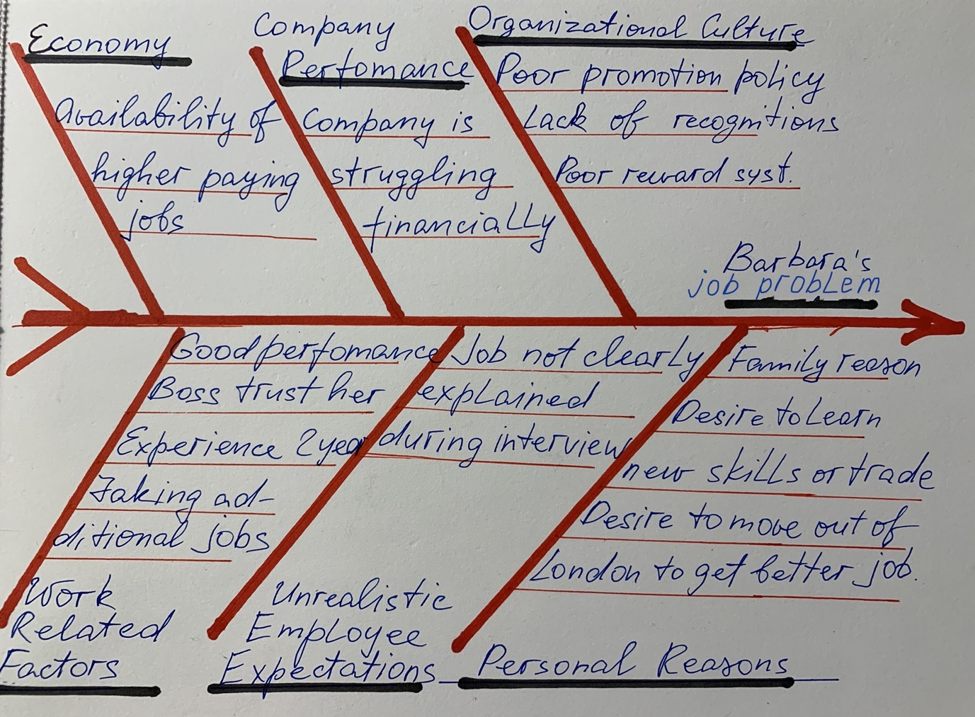

After analysing the Fishbone Diagram, I can say that Barbara's problem depends on many factors, both directly dependent on her and not directly dependent on her:
• financial stability of the company
• low promotion and reward policy in the company
• the existence of a choice of similar jobs in the job market
• Barbara's desire to learn and grow professionally
•A problem with high expectations which was not clearly discussed in the Job interview.
• Barbara's job performance
Personal SWOT analysis
I decided to help Barbara conduct a Personal Professional SWOT (Strength, Weakness, Opportunity, Threat) analysis to assess her professional prospects and opportunities in the job market. A personal SWOT Analysis is a self-assessment research work you apply to yourself, to analyse and better understand your strengths and weaknesses, opportunities and threats and support your personal and professional development (Cottrel,2010).
Barbara's professional personal SWOT analysis:
Strengths
•Professional experience in catering (only with this company - two years).
•Good communication skills
•Good skills in Customer service
•Detail oriented
•Good in digital skills
•Ability to work under pressure
•Good Time management and organisation skills
•Initiative and willingness to take on extra work
Weakness
• Might be the lack of confident and shy to present herself and regularly ask about payment rising.
•There is no data on her passing any courses to improve her professional qualifications.
•She can't move out of London to work for a better-paying company.
Opportunity
•Further work for this company can bring her benefits in the form of a better understanding of this organisation. And it might be a promotion because of using the skills and knowledge acquired while studying at our university.
Threats
•The situation with payment in the company will not change for the better.
• If the management of the company does not respond to the dissatisfaction of its workers.
After studying SWOT analysis, I can say that Barbara is a highly professional and competitive employee in the catering market.
Suggested solutions
After examining the results of all my research, I can offer several solutions for Barbara. Each of which can potentially lead to a solution to its main problem - increasing income. But in my opinion, I would advise her to apply a combination of these solutions and multiply and accelerate the probability of the desired result.
•Accept the psychological fact and not get tired of reminding herself that she is one of the leading and unlikely replaceable employees of the company at the moment. Also, remind herself of the second important fact that the company's management underestimated Barbara in remuneration.
•Improve and increase communication with managers of the company at different levels to defend the legal right to increase salary in connection with the performance of a larger volume of work and increasing responsibility.
•To improve communication and search for information, apply, and if necessary, learn to use all the latest technological methods of communication, including instant messengers, email, social networks, web search, telephone communication, etc.
•Create a professional CV and constantly research the job market for a better paying job, located in London. While applying the latest job search methods, including mobile applications in employment with the ability to accept offers and send your resume instantly.
•Consider the possibility and desire to continue a career in the company as a chef with a subsequent salary increase. To do this, she needs to do the necessary information search and take qualified cook courses.
•Consider the desire and possibility of starting a career in the company's management with a subsequent increase in salaries and bonuses. To do this, continue studying at the UWTSD at one of the management courses.
Monitoring & Evaluation
Monitoring is an organised and routine gathering of information from projects. Evaluation measures, systematically and objectively a completed project or some phase (Macbeth, McGlynn,2004). I suggest Barbara link all the actions I proposed above to a specific time frame in this situation.
•All learning and self-development activities need to be transferred to the personnel development plan (PDP), which involves regular monitoring and self-evaluation.
•Keep a record of all communications with company management regarding the request for a salary increase. Set deadlines and repeat calls and sending emails every month or two. Check logs to monitor and evaluate changes of the situation.

Conclusion
As can be seen from this report, the situation with a problem at the unsatisfied employee workplace was initially given. Additional information was collected, and the situation around the company and the employee were analysed using problem-solving and decision-making tools. And also, optimal solutions were found, in my opinion. Since the case seems to be quite real and the problem is urgent, I hope these solutions can bring the expected result.

References:
•Chatham House – International Affairs Think Tank. (2019). Food Politics and Policies in Post-Brexit Britain. [online] Available at: https://www.chathamhouse.org/2019/01/food-politics-and-policies-post-brexit-britain [Accessed 6 Jan. 2021].
• Cottrell, S. (2010). Skills for Success: Personal Development and Employability.2nd ed. London: Palgrave Macmillan.‌‌
•Global Legal Group (2020). Employment & Labour Laws and Regulations - the United Kingdom. International Comparative Legal Guides International Business Reports. [online] Available at: https://iclg.com/practice-areas/employment-and-labour-laws-and-regulations/united-kingdom [Accessed 4 Jan. 2021].
•HBS Working Knowledge (2020). Restaurant revolution: Haw the Industry Is Fighting to Stay Alive. Forbes. [online] 10 Aug. Available at: https://www.forbes.com/sites/hbsworkingknowledge/2020/08/10/restaurant-revolution-how-the-industry-is-fighting-to-stay-alive/?sh=4f33538bf1eb [Accessed 4 Jan. 2021].
•Kane, R. and Kane, R. (2014). How to Use the Fishbone Tool for Root Cause Analysis. [online] Available at: https://www.cms.gov/medicare/provider-enrollment-and-certification/qapi/downloads/fishbonerevised.pdf.
• Macbeth, J., McGlinn, A. (2004). Self-Evaluation: What's in It for Schools? London: Taylor & Francis.
•Monster Employer Resources | Monster.com. (2010). Employee Loyalty Starts with Employer Loyalty | Monster.com. [online] Available at: https://hiring.monster.com/employer-resources/workforce-management/employee-performance/why-loyalty-matters/ [Accessed 4 Jan. 2021].
‌•Nathanson, M. (2019). The Most Dangerous Business Cliché. [online] ChiefExecutive.net. Available at: https://chiefexecutive.net/the-most-dangerous-business-cliche/ [Accessed 4 Jan. 2021].
•Nibusinessinfo.co.uk. (2021). Advantages of good employee communication | nibusinessinfo.co.uk. [online] Available at: https://www.nibusinessinfo.co.uk/content/advantages-good-employee-communication [Accessed 4 Jan. 2021].
‌‌•Yuksel, S. (2019). Handbook of Research on Decision-Making Techniques in Financial Marketing. United States: IGI Global.

‌
‌
‌

