E-portfolio
Study skills for psychology ECPS4018

2024
Context:
Summary: 300 words
- How does music make you feel?............................................2,3
Infographic:
- Plagiarism and how to avoid it……………………………………………4
Essay outline:
- Describe and discuss psychological, social and physical benefits of engaging in a sporting activity……………………………………………………………...5,6
Screenshots…………………………………………………………………………..…7,8
References:……………………………………………………………………………..9
AI use deceleration………………………………………………………………...….9

Summary:
Now-a-days music has become influential thing which we can connect ourselves to. Every individual has different experience with music some can relate happiness whereas others with sadness. These phenomena created a curiosity within myself while I was doing my A-level in music. Many questions arise in my mind why does some music effect our mood or change it completely and have capability to trigger our good and bad emotions, does different cultures have an impact. These feelings lead me to do an extended project qualification(EPQ).

Patrik Juslin has inspired me been the leading researcher in emotions which can be felt by music using BRECVEMA. His work explains about how emotions get effected by music also he goes to explain how an individuality has different effects with their current moods, personality, pleasure and feelings. Majority of people now a days use modern methods to listen music where they can create a list accordingly which can induce emotions by music.

However, Music therapist uses music of specific style to predict the emotional response of an individual. Major and minor music have different effect. Major music indicates of releasing stress whereas minor music sometime can indicated stress and flash backs of certain memories. People with Alzheimer’s disease music is used to recall their memory. Individuals who lack or have no pleasure when music is induce to them, they can be termed as anhedonia. On the other hand, Musicophilia is the term used for people who usually feel very high-level pleasure while listening to music.
Reflect on our own views on what type of music we listen does it give pleasure, stress or memory recall. Why certain music makes you feel this way? Is it your mood why you pick specific music does it resonate deeply with your emotions or memories? Pondering above you will notice things about you. (BPS, 2024, January 22).

Infographic:
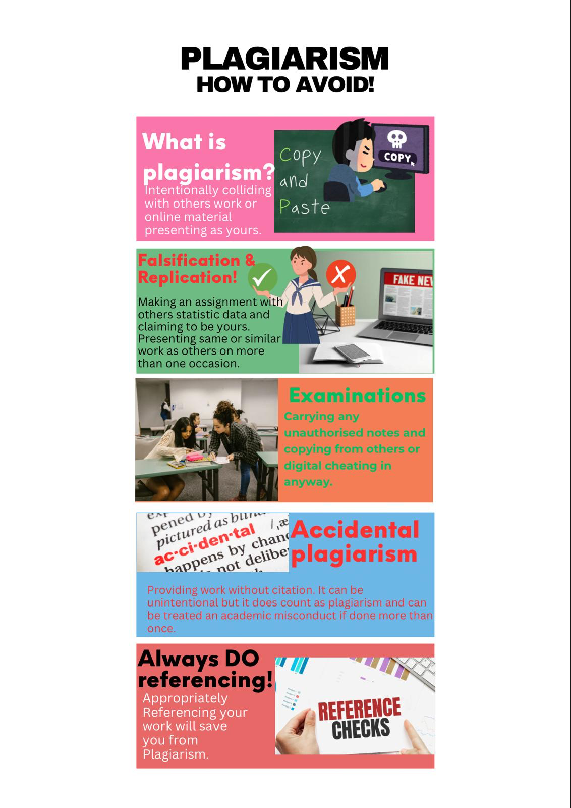
Neville, C. (2010)
Essay outline:
Introduction:
An introduction is the outline of the essay. It usually has 5-10% of word count. In this instance the topic used is ‘Describe and discuss psychological, social and physical benefits of engaging in a sporting activity?’ It represents the systematic approaches to both psychological and social benefits of sports.
Main body:
Several studies have been conducted that show positive effects of sporting activity on emotional wellbeing and social benefits. For instant there was a studies made in Germany where they analysed long term effect of sports on health and subjective wellbeing. The studies was done on 6751 adults. It was found that there was significant amount of positive effect on mental heath high vitality they were more social and better health benefits. The psychological outcomes scores about 87%. (Eime et al., 2013, p. 5)
A study in Belgium conducted between 1919 adults. This time the studies was done on five different types of physical activity like household work, liesure active transport biking as well as walking for work and sports participation and mental health. The outcome of this studies show how sport participation helps in lowering stress and disstress levels. (Eime et al., 2013, p. 7)
The studies display that increasing on physical activity have capability to decrease the risk of depression and mental health problems and also positive behaviour has been noted in psychological and social health benefits of participations. I have chosen this article as it has briefly about psychology, social and physical benefits of sports.

Conclusion:
There are various type of health, social and psychological benefits has been noted. It helps in reducing stess levels, sporting activity make people more social which have impact on there psychological being and they feel more positive. Overall there are significant amount of physical benefits of sport participation we have seen in above experiments simple household activities liesure walking/Biking has shown positive effect on there wellbeing. I chose this because it refects and explains very well about psychological social and emotional wellbeing by sport partipation with experiments done in different countries and on considerable amount of adults. This article is peered reviewed and shows systematic reviews.

Screenshot:
The screenshots I have used below has the content used in my main body.
Before submitting I would make a draft and then proofread it
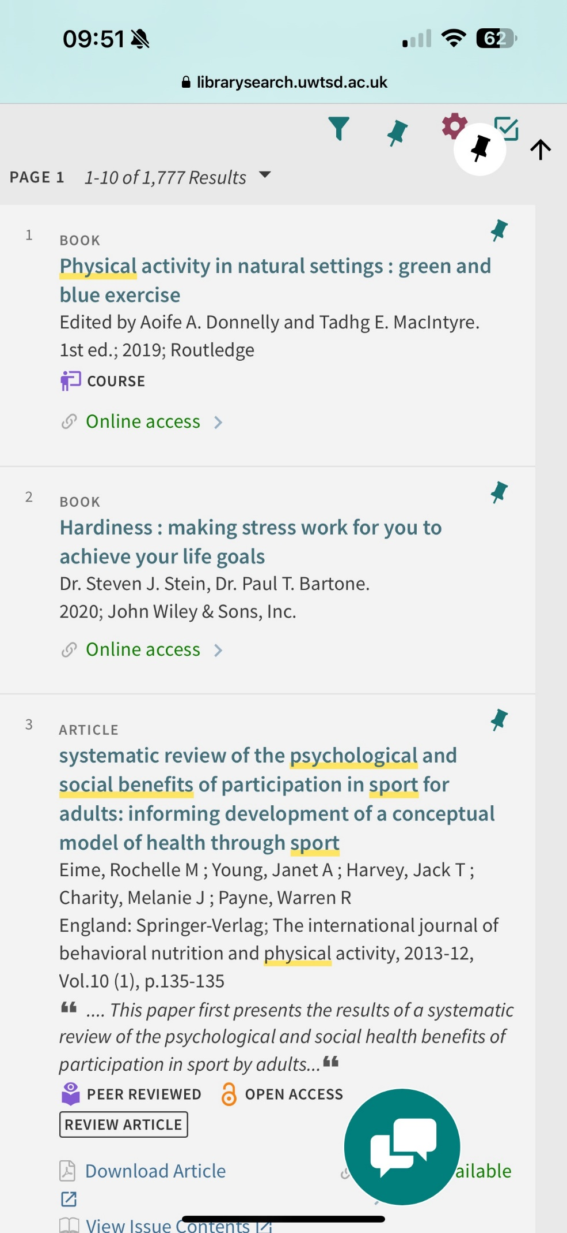
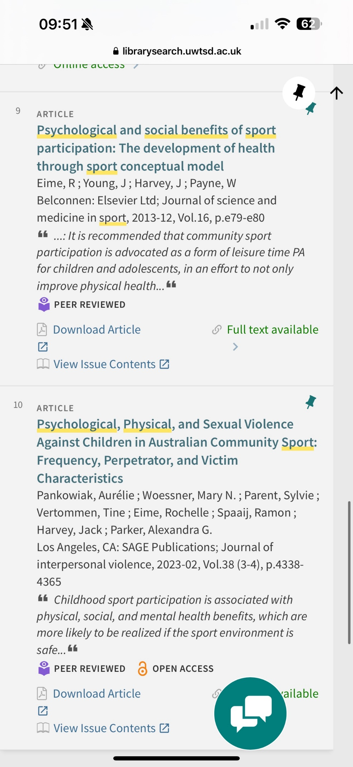
References:
Eime, R. M., Young, J. A., Harvey, J. T., Charity, M. J., & Payne, W. R. (2013). A systematic review of the psychological and social benefits of participation in sport for adults: informing development of a conceptual model of health through sport. International Journal of Behavioral Nutrition and Physical Activity, 10(1), 135. https://doi.org/10.1186/1479-5868-10-135

How does music make you feel? (2024, January 22). BPS. https://www.bps.org.uk/psychologist/how-does-music-make-you-feel

Neville, C. (2010). The complete guide to referencing and avoiding plagiarism (2nd ed.). Open Univ. P.

AI acknowlegdement:
I confirm that I have not used AI for this assignment. I have not used AI for research purposes and planning this assignment. I have not provided any AI generated work as my wrok. I confirm that I have appropiate notes, drafts and resources.

