Marketing and Sustainability



22th November 2019

MODULE NAME: Contemporary Issues In Marketing Management (M6X00874)
student Name: HAROON TERIA
Student Number 1704624
lecturer: Sarah Campodonic

Introduction
This essay is intended to explore the importance of sustainability to organisations and its implementation to their marketing strategies to gain competitive advantage. Critical analysis of the literature to provide understanding of the concept is also included in this essay. With changing trends such as climate change, globalisation, demographic change and social inequality, businesses preferences are also shifting towards green marketing or sustainability marketing to achieve a competitive advantage. Application of sustainability in business is now becoming obligatory for organisations. Marketing practices of business are evolving from the 4Ps (Product, Price, Place and Promotion) into the 4c’s (Customer solution, Customer cost, Convenience and Communication). Theoretically, it is easy to implement such concepts, but few challenges are encountered by marketers to formulate such strategies that cater both sustainability and profitability. Unilever being the leader in sustainable businesses for the last 8 years also faces issues such as the consumer inability to absorb the concept of sustainability. Furthermore, the organisation’s performance must be measured by aligning its social, environmental and financial objectives with the ‘triple bottom sustainability’ approach. Educating consumers and business graduates about the idea of sustainability can result in the minimisation of challenges faced by organisations today.

Introduction to Sustainability
This time of extreme modernisation has affected the organisational culture and business environments leading the organisational practices to gain competitive advantage. As a whole, organisational existence has changed a lot. Many different trends (climate change, globalisation, demographic change and social inequality) have changed the interpretation, creating challenges to the traditional setup of organisational operations. Many trust issues arose due to corporate scandals and the “credit crunch”. The credit crunch is defined as “a significant leftward shift in the supply curve for bank loans” (Bernanke & Friedman, 1991). Businesses now face increased pressure from financial bodies, investors, governments, consumers, and employees regarding adoption of ethical and sustainable business practices (Wales, 2013). Referring to (Porter & Kramer, 2011), “In recent years, business has increasingly been viewed as a major cause of social, environmental and economic problems. Companies are widely perceived to be prospering at the expense of the broader community”. With changing needs and expectations of customers, different issues arose regarding sustainability within organisations and their marketing strategies to achieve a competitive advantage. Sustainability is viewed as a fundamental requirement for an organisational growth and development. It can be seen that organisations need to adopt business practices aligned with sustainability through economic, environmental and social dimensions. According to (Charter et al., 2006)Sustainability works on a ‘Triple Bottom Line’ approach i.e. people, planet and profit. Many organisations want to prioritise the social and environmental sustainability along with the economic needs. However, according to (Musante, 2018), only 12% of these organisations achieved the objective. Furthermore, the reason behind this inability of organisations is obtained from Bain & Company consultants (Musante, 2018) who stated that when employees were asked by the organisation to choose between the business goals and sustainability, they always prefer the business goals. The idea of communicating the importance of sustainability by the company’s management is essential to change the traditional mindset of employees (Jenny, Stone, & Tovey, 2017). This report aims to explain the concept of sustainability for organisations and critically analyse the challenges faced by professionals in aligning their marketing strategies to sustainability to achieve a competitive advantage.

Literature Review on Sustainability
There is a long history of addressing the issues concerning the sustainable development introduced by (Brundtland, 1987) as the “development that meets the needs of current generations without compromising the ability of future generations to meet their own needs”. In another context, Nolberto defines sustainability as “a vision of the future that provides us with a road map and helps us to focus our attention on a set of values and ethical and moral principles by which to guide our actions” (Nolberto, 2005). Also, the definition continues to provide sustainability as “a process involving people, institutions, natural resources, and the environment. It is implemented collectively and really points to the future” (Nolberto, 2005). Other resources such as (Colbert & Kurucz, 2007) relate sustainability to “keep the business going” and (Boudreau & Ramstad, 2005) refers to sustainability as “achieving success today without compromising the needs of the future”. It can be deduced from these definitions that for saving the future, business practices must be aligned with the economic, social and environmental factors to achieve sustainability in the business world. In other words, organisations which aim to be sustainable must contribute towards three dimensions of sustainability that are, namely: the economic performance, social equity and the environmental or ecological preservation (Gladwin et al., 1995) while achieving the triple bottom line (Dyllick & Hockerts, 2002). The triple bottom line was initially suggested by Elkington in 1997 and referred to as “a brilliant and far-reaching metaphor” (Henriques, 2004). The triple bottom line principle assists in evaluating the organisational performance and its successes using the economic, social and environmental indicators (Goel, 2010) and referred to as the “Expansion of the environmental agenda with the integration of the economic and social lines” (Elkington, 1997). The literature studies discuss sustainability in different perspectives. Several studies combined the three dimensions of the economic, social and environmental aspects (Collins, Koning, & Steg, 2007); (Kirchgeorg & Winn, 2006). A summary of the literature studies is shown in Table 1 (Alhaddi, 2015).

Table 1: The various literature studies on sustainability (Alhaddi, 2015).
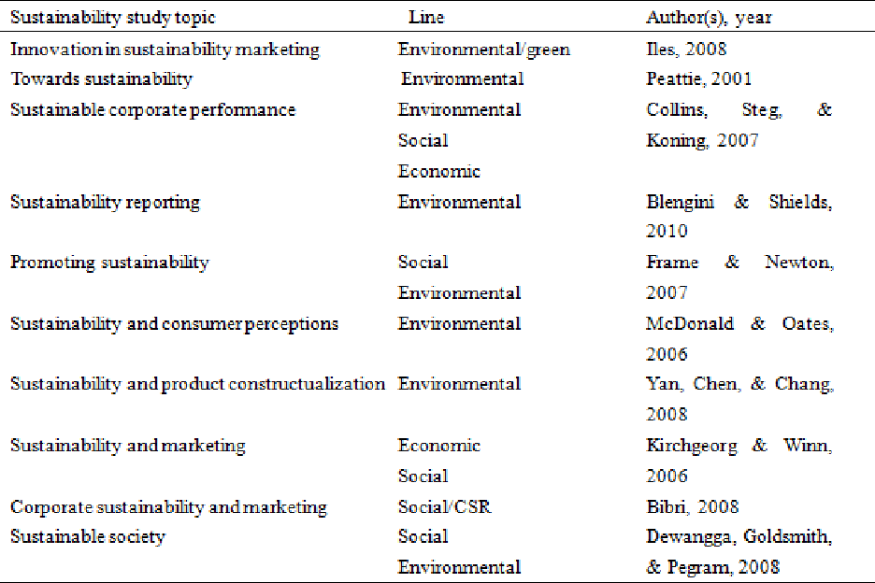

Marketing
Marketing is defined as a “the effective allocation and coordination of marketing resources to accomplish the organisation’s objectives within a specific product market. As such, marketing strategy decisions involve specifying the target market segment(s) to be pursued and the product line to be offered. Further, firms seek competitive advantage and synergy, planning a well-integrated program of marketing elements (the 4P’s) tailored to the needs and wants of customers in the target segments” (M.Zinkhan & Pereira, 1994). It is also defined as the strategy that “deals with decisions related to market segmentation and targeting, and the designing of positioning strategy based on marketing mix” (Slater & Olson, 2001). With time, the definition of marketing has changed in terms of the needs of consumers, however, all definitions of marketing are linked with segmentation, targeting, and positioning, branding and marketing mix of the company while achieving a competitive advantage (Vinod et al., 2012).

Sustainability and Marketing
Sustainability has been emerged as an essential concern in marketing strategies over the time. Nowadays, sustainability has been observed as becoming an essential concern in marketing over time. In this context, different perceptions exist regarding sustainability in the marketing field. Some researchers only focused on the environmental issues (Polonsky, 1995); (Aragón-Correa, 1998); (Buysse & Verbeke, 2003); (Rivera‐Camino, 2007)), while others linked marketing with the social issues (Soriano et al., 2010). However, marketing relative to sustainability is considered a less explored domain. It is essential to relate sustainability to marketing as sustainability is not an option but a requirement (Charter et al., 2006). For organisations, achieving sustainability has become a need to remain competitive. Companies have to formulate their marketing strategies in a way that they can fulfill their customers’ requirements after maintaining profitability, public interest and ecology (Vágási, 2004). Combining the two concepts, (Belz & Peattie, Sustainability Marketing: A Global Perspective, 2014) stated that “sustainability marketing is more explicitly relates to the sustainable development agenda” and it has been defined as “building and maintaining sustainable relationships with customers, the social environment and the natural environment”. In short, companies need to address sustainability as a main concern in practicing their strategic marketing strategies and marketing mix. Although this is somehow difficult to achieve, however, it is necessary to integrate sustainability in the organisation and once this is done, it will result in not only a value delivery to customers but a long-lasting relationship with them. This will not only benefit the organisation but also the society and ecological system. The integration of sustainability into the marketing strategy results in that the 4Ps (Product, Price, Place and Promotion) of marketing are moulded into the 4c’s (Customer solution, Customer cost, Convenience and Communication), Figure 1, (Belz & Peattie, 2009).

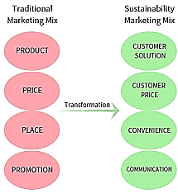

Figure. 1. The McCarthy’s 4P Approach vs. the Sustainability Marketing Mix (Thulin, 2018)

Challenges in Applying Sustainability in the Marketing Strategy

The main concern of any business is to attain a competitive advantage through a desirable, different and defensible position (Obermiller et al., 2008). In theory, applying sustainability to marketing strategies is easy, but in fact, it is not simple to design such marketing strategies to cater both profitability and sustainability. For instance, the sustainability principle stresses upon the preservation of resources which means less consumption. On the other hand, the marketing principle is interested in achieving higher sales and therefore requires a higher production rate and thus, more consumption of resources (Jones et al., 2008). For this reason, achieving the balance between these two phenomena is a difficult task. Therefore, a strategy must be formulated in a way such that profits can be obtained while maintaining the positive impact on the environment and the society. Organisations will encounter issues while formulating their marketing strategies in accordance to the sustainability agenda. Marketers must focus on delivering the message which offers the benefits and not only showing off the ability to deliver a reduction in water consumption, carbon emissions, waste, hazardous materials and energy. The second challenge for marketers is to find a sustainability mindful target market with clear goals of sustainability. They must be reached with clear marketing or sales message to assist them in achieving their goals by offering specific benefits. Thirdly, achieving sustainability can be a costly process at first and it might be difficult to value the principle of sustainability from monetary point of view. This makes sustainability very challenging for organisations in order to correctly comprehend its importance. A data driven matrix can assist the financial and sustainability departments to work collectively to formulate cost effective plans. The fourth challenge that organisations might encounter is the difficulty in engaging the management and colleagues. In a recent survey, 65% of the employees voted that convincing the management about the application of sustainable practices was the greatest challenge. Whereas 47% of the top management personnel declared that it is challenging to engage colleagues and employees in sustaining practices. This issue can be resolved by employing sustainability teams to educate the employees, lead the cross-disciplinary committees, offer incentives for participation and create effective internal marketing materials to drive the company’s objectives (SPP, 2015).

The Impact of Challenges on Sustainability Marketing (Industry Examples)

Companies strive to link their operational strategies with the sustainability agenda to achieve a competitive advantage despite facing challenges. An example of one of the companies which claim sustainability in its practice is ‘Unilever’. This company produces many worldwide known cleaning products such as Persil, Dove, Magnum and Lynx (Unilever_Ltd., 2019). According to (Sustain_Ability, 2018), Unilever holds a dominant leadership position over the last eight years although its ranking dropped by 10% from the year 2018, Figure 2. It believes that the main marketing challenge is to convince the consumers to shift their preferences towards a sustainable behaviour. The sustainable 10 years living plan was introduced by Unilever in 2010, to implant sustainability into all areas of the organisation (Unilever, 2019).While explaining the challenges to persuade the consumers over the sustainability issue, it established an advertising campaign for its ‘Persil’s Small & Mighty’ product that did not get a significant purchase preference needed to achieve the target profits. This product focused on the environmental benefits in terms of the less packaging needs and lower level of transport. Speaking to the media: “The big challenge is getting people to engage more on sustainability and environment. The tricky thing is that only a small number of consumers are motivated to make purchase decisions on that alone” (Baker, 2012). Another example on the same aspect is the marketing of the ‘Lifebuoy’ soap used worldwide which aims at changing the hygiene behaviour of 1 billion people by showcasing the health benefits of hand washing at key times of the day. This message was not favored initially by the consumers, however, it has achieved the expected results of reducing some diseases such as diarrheal and the acute respiratory infection by 25% and increasing the school attendance by up to 40% (Guardian, 2011). The aim of sustainability is to enhance the livelihood of people by helping them to improve their health and well-being conditions (Unilever, Sustainable Living, 2019).

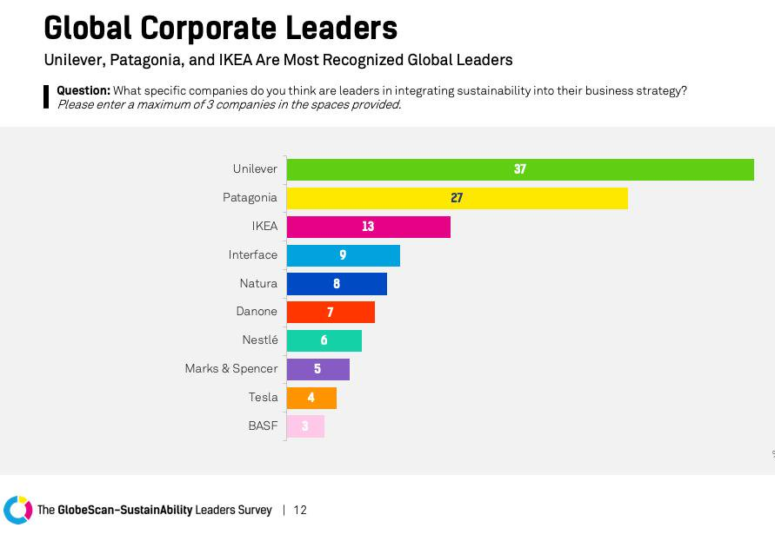
Figure 2: The Globe Scan-Sustain Ability Survey - Corporate leaders 2019 (Sustain_Ability, 2018).

Conclusions

The concept of sustainable marketing strategies has evolved over time. Initially, it was concerned with the ecological issues but has now reached to sustainability issues. It was concluded that sustainability in marketing practices is possible only when organisations show a high implementation throughout their business practices and management where employees need to give attention to this issue. It is recommended that an overall performance must be measured by aligning the organisation’s social, environmental and financial objectives to the triple bottom line sustainability approach. Organisations need to educate their consumers about prioritising the sustainable behaviour. This would help such businesses to examine their sustainable strategies and enable them to justify their highly priced products due to investing in an environmental protection beyond their regulatory requirements. Another essential issue that needs to be addressed is the ability of educate the fresh graduates in terms of the importance of sustainability and to eliminate the challenge encountered today by the management and employees. Therefore, companies have to resolve the issues and challenges to adopt sustainability criteria in marketing as it will become a moral obligation in future to dominate businesses rather than making immoral profits and ignoring the environment and the future generations.

References
Alhaddi, H. (2015, September). Triple Bottom Line and Sustainability: A Literature Review. Business and Management Studies, 1(2). Retrieved November 16, 2019, from http://bms.redfame.com
Aragón-Correa, J. A. (1998). Strategic proactivity and firm approach to the natural environment. Academy of management Journal, 41(5), 556-567. doi:https://doi.org/10.5465/256942
Baker, R. (2012, April 24). Unilever: ‘Sustainability marketing is biggest challenge’. Retrieved November 18, 2019, from https://www.marketingweek.com/unilever-sustainability-marketing-is-biggest-challenge/
Belz, F.-M., & Peattie, K. (2009). Sustainability Marketing: A Global Perspective (illustrated, reprint ed.). Wiley 2009. Retrieved from https://books.google.com.pk/books?id=B5orAQAAMAAJ&dq=Belz%20and%20Peattie&source=gbs_book_other_versions
Belz, F.-M., & Peattie, K. (2014). Sustainability Marketing: A Global Perspective (2 ed.). Wiley, 2014.
Bernanke, B., & Friedman, B. (1991). The credit crunch. Brookings papers on economic activity, 2, 205-247. Retrieved from https://www.brookings.edu/wp-content/uploads/1991/06/1991b_bpea_bernanke_lown_friedman.pdf
Boudreau, J., & Ramstad, P. (2005). Talentship, talent segmentation, and sustainability: A new HR decision science paradigm for a new strategy definition. . Human Resource Management, 44(2). Retrieved November 17, 2019, from https://onlinelibrary.wiley.com/doi/pdf/10.1002/hrm.20054
Brundtland. (1987). Report of the World Commission on Environment and Development. Oxford University Press. Retrieved November 16, 2019, from http://www.un-documents.net/wced-ocf.htm
Buysse, K., & Verbeke, A. (2003). ENVIRONMENTAL STRATEGY CHOICE AND FINANCIAL PROFITABILITY: DIFFERENCES BETWEEN MULTINATIONALS AND DOMESTIC FIRMS IN BELGIUM. Multinationals, Environment and Global Competition, 43-63. doi:https://doi.org/10.1016/S1064-4857(03)09003-X
Charter et al. (2006). Marketing and sustainability. Centre for Business. Retrieved from https://cfsd.org.uk/smart-know-net/links/smart-know-net.pdf
Colbert, B., & Kurucz, E. (2007). Three conceptions of triple bottom line business sustainability and the role for HRM. Human Resource Planning, 21. Retrieved November 17, 2019, from https://www.researchgate.net/publication/235771844_Three_Conceptions_of_Triple_Bottom_Line_Business_Sustainability_and_the_Role_for_HRM
Collins, C. M., Koning, M. A., & Steg, L. (2007). Customers' values, beliefs on sustainable corporate performance, and buying behavior. Psychology & Marketing, 24(6), 555-577. doi:https://doi.org/10.1002/mar.20173
Dyllick, T., & Hockerts, K. (2002). BEYOND THE BUSINESS CASE. Business Strategy and the Environment, 130-141. Retrieved November 16, 2019, from https://www.researchgate.net/publication/36386947_Beyond_the_Business_Case_for_Corporate_Sustainability
Elkington, J. (1997). Cannibals with Forks: The Triple Bottom Line of 21st Century Business. Capstone.
Gladwin et al. (1995, october 1). Shifting Paradigms for Sustainable Development: Implications for Management Theory and Research. Academy of Management Review, 20(4). Retrieved November 16, 2019
Goel, P. (2010). Triple bottom line reporting: An analytical approach for corporate sustainability. Journal of Finance,Accounting, and Management,, 1(1), 27-42. Retrieved November 17, 2019
Guardian, T. (2011). Unilver Sustainable Living Plan. Retrieved November 18, 2019, from https://www.theguardian.com/sustainable-business/unilever-sustainable-living-plan
Henriques, A. (2004). The triple bottom line (1st ed.). London: Taylor & Francis. doi:https://doi.org/10.4324/9781849773348
J. D., Stone, P., & Tovey, C. (2017, May 18). Fighting Sustainability Inertia. SSIR. Retrieved November 17, 2019, from https://ssir.org/articles/entry/fighting_sustainability_inertia
Jones et al. (2008). Marketing and sustainability. Marketing Intelligence & Planning,, 26(2), 123-130. doi:https://doi.org/10.1108/02634500810860584
Kirchgeorg, M., & Winn, M. (2006). Sustainability marketing for the poorest of the poor. Business Strategy and the Environment, 15(3), 171-184. doi:https://doi.org/10.1002/bse.523
M.Zinkhan, G., & Pereira, A. (1994). An overview of marketing strategy and planning. International Journal of Research in Marketing, 11(3), 185-218. doi:https://doi.org/10.1016/0167-8116(94)90001-9
Musante, M. (2018, March 28). 6 SSIR Articles on Business Sustainability. Stanford Social Innovation Review. Retrieved November 17, 2019, from https://ssir.org/articles/entry/6_ssir_articles_on_business_sustainability#
Nolberto, M. (2005). Introduction to Sustainability: Road to a Better Future. Springer. Retrieved November 17, 2019
Obermiller et al. (2008). Sustainable business as marketing strategy. Innovative Marketing, 4(3). Retrieved from https://businessperspectives.org/images/pdf/applications/publishing/templates/article/assets/2261/im_en_2008_3_Obermiller.pdf
Polonsky, M. J. (1995). INCORPORATING THE NATURAL ENVIRONMENTIN CORPORATE STRATEGY: A STAKEHOLDER APPROACH. doi:http://library.shsu.edu/~coba/jbs/vol12/no2/12-2-3.html
Porter, M. E., & Kramer, M. (2011, January 1). Creating Shared Value. Harvard Business Review. Retrieved November 18, 2019
Rivera‐Camino, J. (2007). Re‐evaluating green marketing strategy: a stakeholder perspective. European Journal of Marketing, 41(11), 1328-1358. doi:https://doi.org/10.1108/03090560710821206
Slater, S. F., & Olson, E. (2001). Marketing's contribution to the implementation of business strategy: an empirical analysis. Strategic Management Journal. doi:https://doi.org/10.1002/smj.198
Soriano et al. (2010). Methodology for sustainability strategic planning and management. Industrial Management & Data Systems, 110(2), 249-268. doi:https://doi.org/10.1108/02635571011020331
SPP. (2015, December). Top 3 Sustainability Challenges in Business. Retrieved November 18, 2019, from University of Colorado Boulder: https://www.colorado.edu/sustainablepractices/2015/12/17/top-3-sustainability-challenges-business
Sustain_Ability. (2018). The GlobeScan-SustainAbility Survey. https://globescan.com/wp-content/uploads/2019/07/GlobeScan-SustainAbility-Leaders-Survey-2019-Report.pdf. Retrieved November 18, 2019, from https://globescan.com/wp-content/uploads/2019/07/GlobeScan-SustainAbility-Leaders-Survey-2019-Report.pdf
Thulin, S. (2018). CHINESE STUDENTS’ KNOWLEDGE AND ATTITUDE TOWARDS SUSTAINABILITY. University of Boras.
Unilever. (2019). Sustainable Living. Retrieved November 18, 2019, from Unilever: https://www.unilever.com/sustainable-living/
Unilever. (2019). Sustainable Living. Retrieved November 18, 2019, from Unilever: https://www.unilever.com/sustainable-living/
Unilever_Ltd. (2019, 11 19). Unilever in the UK. Retrieved from https://www.unilever.co.uk/about/who-we-are/introduction-to-unilever/unilever-in-the-uk/
Vágási, M. (2004). Integration of the sustainability concept into strategy and marketing. Periodica Polytechnica Social and Management Sciences, 12(2), 245-260. doi:https://doi.org/N/A.
Vinod et al. (2012). Evolution of sustainability as marketing strategy: Beginning of new era. Social and Behavioral Sciences, 37, 482-489. Retrieved from https://www.academia.edu/8147476/Evolution_of_sustainability_as_marketing_strategy_Beginning_of_new_era
Wales, T. (2013, November). ORGANIZATIONAL SUSTAINABILITY: WHAT IS IT, AND WHY DOES IT MATTER? Review of Enterprise and Management Studies, 1(1). Retrieved November 16, 2019, from https://www.uos.ac.uk/sites/default/files/basic_file/REAMS_1-(1)_Wales-v2.pdf

