


Master of Business Administration
Marketing Environment Analysis
Marketing Management
LCMB7024

Submission date: 24/07/2026 by 14:00

Student name: Andre Pinto 2242421
Lecturer name: Haoran Liu

Table of Contents
1. Report Introduction 3
2. Task 1: Marketing Environment Analysis 3
2.1. Introduction 3
2.2. Company name 3
2.3. Company Overview 3
2.4. Marketing Environment Analysis 4
2.4.1 Natural Environment 4
2.4.2 Technological Environment 5
2.5. Conclusion 6
3 Task 2: Strategic Growth and Competitive Positioning 6
3.1. Introduction 6
3.2. Justification for Applying the Ansoff Matrix 7
3.3. Product Development as the Recommended Growth Strategy 8
3.3.1. Achieving Competitive Advantage 9
3.3.2. Risks and Limitations of the Recommended Strategy 11
3.4. Conclusion 11
4. Task 3: Critical Reflection on AI Usage 12
4.1. Tool Disclosure 12
4.2. Critical Evaluation of AI Output 12
4.3. Contribution Analysis 13
4.4. Ethical and Professional Reflection 13
5. Report Conclusion 13
References 15

Report Introduction
This report critically analyses the external marketing environment influencing BHP Group Limited (BHP) as it transitions towards a lower-carbon business model. Using the PESTLE framework, the report examines the Natural Environment and Technological Environment as the two external factors with the greatest influence on the organisation's strategic direction. Building on this analysis, the report applies the Ansoff Matrix to recommend an appropriate growth strategy and evaluates how BHP can achieve sustainable competitive advantage within the global mining industry. The report concludes with a critical reflection on the use of Artificial Intelligence (AI), considering its contribution, limitations and ethical implications during the preparation of the assignment.

Task 1: Marketing Environment Analysis

Introduction
Marketing environment analysis enables organisations to evaluate external forces that influence strategic decision-making, competitive positioning and long-term performance (Kotler et al., 2024). For organisations operating within the mining industry, environmental and technological changes are reshaping customer expectations, investment priorities and regulatory requirements.

Company name
BHP Group Limited

Company Overview
BHP Group Limited (BHP) is one of the world's largest diversified mining companies, producing commodities including iron ore, copper, metallurgical coal and potash for global markets (BHP, 2025). Operating primarily in Australia and the Americas, the company plays a significant role in supplying critical minerals required for infrastructure, manufacturing and the low-carbon energy transition. In response to increasing environmental expectations, BHP has prioritised lower-carbon production, technological innovation and responsible resource management within its long-term strategy (BHP, 2025).

Marketing Environment Analysis

Natural Environment
The Natural Environment is one of the most influential external factors affecting BHP's marketing environment. Growing demand for critical minerals, increasing stakeholder expectations and stricter environmental regulations have transformed sustainability from a compliance requirement into a source of competitive differentiation (Kotler et al., 2024). According to the International Energy Agency (2024), demand for minerals such as copper and nickel is expected to increase significantly as renewable energy systems, electric vehicles and electricity networks expand. As illustrated in Figure 1, this creates substantial commercial opportunities for mining companies capable of supplying transition minerals responsibly.
Figure 1. Projected Global Copper Demand under the Energy Transition
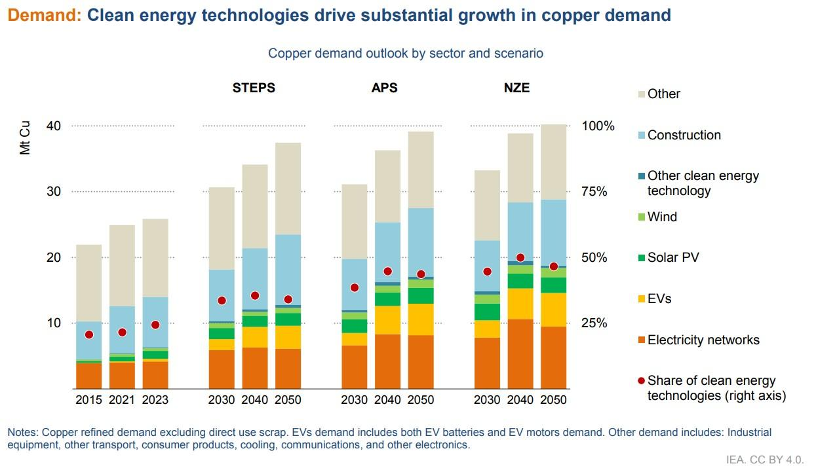
Source: Adapted from International Energy Agency (2024), Global Critical Minerals Outlook 2024.
Recognising these market changes, BHP has prioritised copper and potash within its long-term strategy while investing in lower-carbon production methods (BHP, 2025). This strategic direction reflects changing customer expectations, as industrial buyers increasingly evaluate suppliers according to environmental performance and responsible sourcing practices rather than price alone (Papadas et al., 2023). Consequently, sustainability has become an important marketing consideration because it influences corporate reputation, customer relationships and investor confidence.
Despite these opportunities, environmental change also presents significant challenges. BHP continues to face increasing pressure from governments, investors and local communities to demonstrate measurable progress towards emissions reduction and responsible resource management. Key stakeholder expectations include:
- Compliance with evolving climate regulations.
- Transparent Environmental, Social and Governance (ESG) reporting.
- Responsibly sourced lower-carbon minerals.
- Effective biodiversity protection and land rehabilitation (Freeman et al., 2020; BHP, 2025).
Meeting these expectations is particularly challenging because a large proportion of BHP's emissions originate from Scope 3 activities beyond its direct operational control (BHP, 2025). Consequently, maintaining stakeholder trust requires collaboration across the supply chain together with transparent sustainability reporting. Organisations that fail to provide credible evidence of environmental performance risk reputational damage and accusations of greenwashing (Delmas and Burbano, 2011). Therefore, environmental sustainability represents both a market opportunity and an ongoing strategic challenge that influences BHP's long-term competitive position.

Technological Environment
Technological innovation is a key external factor shaping BHP's transition towards a lower-carbon business model. Within the PESTLE framework, advances in automation, artificial intelligence (AI), renewable energy and digital monitoring technologies are transforming mining operations by improving efficiency while supporting environmental objectives (Kotler et al., 2024; Chaffey and Ellis-Chadwick, 2022). As a result, technology has become an important driver of organisational performance and customer value rather than simply an operational resource.
BHP has invested in autonomous haulage systems, remote-operated drilling technologies and real-time operational centres to improve productivity, reduce fuel consumption and lower operational emissions (BHP, 2025). These investments demonstrate how technological innovation supports environmental performance while enabling the organisation to respond to increasing customer and investor expectations for more sustainable mining practices. Digital technologies also improve supply chain transparency by providing reliable environmental data, allowing BHP to demonstrate responsible sourcing and strengthen stakeholder confidence.
Despite these opportunities, rapid technological change presents several challenges. Continuous investment is required to maintain operational efficiency, while increasing digitalisation exposes organisations to cybersecurity risks and skills shortages. Furthermore, competitors are investing in similar technologies, reducing the likelihood that innovation alone will provide a lasting competitive advantage. Consequently, BHP must combine technological investment with continuous organisational learning and transparent sustainability reporting to maximise the long-term value created through digital transformation (Teece, 2018; BHP, 2025).

Conclusion
The analysis demonstrates that the Natural Environment and Technological Environment are the two most significant external factors influencing BHP's marketing environment. Environmental pressures have increased demand for responsibly sourced minerals and strengthened stakeholder expectations regarding sustainability, while technological developments have enabled more efficient and environmentally responsible mining practices. Together, these factors create opportunities for growth but also require BHP to balance innovation, environmental responsibility and stakeholder expectations. These findings provide the strategic foundation for selecting an appropriate growth strategy in the following section of the report.

Task 2: Strategic Growth and Competitive Positioning

Introduction
The marketing environment analysis identified that environmental sustainability and technological innovation are reshaping competitive conditions within the global mining industry. To remain competitive, BHP must adopt a growth strategy that responds to changing customer expectations while supporting its transition towards a lower-carbon business model. The Ansoff Matrix provides a suitable framework for evaluating strategic growth options by examining opportunities across products and markets (Ansoff, 1957). Building on the findings of Task 1, this section recommends Product Development as the most appropriate strategy for BHP and critically evaluates how it can generate sustainable competitive advantage while managing the associated risks.

Justification for Applying the Ansoff Matrix
The Ansoff Matrix provides a strategic framework for evaluating organisational growth by examining opportunities through existing and new products within existing and new markets (Ansoff, 1957). Despite its longevity, the framework remains relevant because it supports strategic decision-making in response to changing market conditions and external environmental pressures (Kotler et al., 2024). Following the findings of Task 1, BHP requires a strategy that responds to increasing demand for lower-carbon products while strengthening relationships with its existing industrial customers. Consequently, the Ansoff Matrix provides an appropriate basis for identifying a growth strategy that aligns environmental sustainability with long-term commercial objectives.
Although all four strategic options present opportunities for growth, Product Development offers the strongest strategic fit. Market Penetration focuses on increasing sales of existing products and would not sufficiently address evolving sustainability expectations. Similarly, Market Development prioritises geographical expansion rather than responding to changing customer requirements, while Diversification involves substantially higher financial and operational risks (Ansoff, 1957). Product Development, by contrast, enables BHP to enhance existing products through lower-carbon production methods and technological innovation, allowing the organisation to meet emerging customer demands while maintaining its established market position (BHP, 2025). This strategic alignment makes Product Development the most appropriate approach for supporting BHP's transition towards a lower-carbon business model.
Figure 2. Ansoff Matrix highlighting the recommended growth strategy
 | Existing Markets | New Markets
Existing Products | Market Penetration | Market Development
New Products | Product Development (Recommended) | Diversification
Figure 2. Adapted from Ansoff (1957).

Product Development as the Recommended Growth Strategy
Product Development represents the most appropriate growth strategy for BHP because it enables the organisation to enhance its existing portfolio while responding to increasing demand for lower-carbon products. Rather than entering unfamiliar markets or pursuing unrelated diversification, BHP can leverage its established customer relationships and operational expertise to develop minerals with improved environmental performance, supporting customers' decarbonisation objectives (Ansoff, 1957). This approach aligns commercial growth with the sustainability trends identified in Task 1, allowing the organisation to strengthen its market position without significantly increasing strategic risk.
A key aspect of this strategy involves improving the environmental value proposition of BHP's existing commodities. As industries such as automotive, construction and renewable energy accelerate their transition towards net-zero emissions, industrial customers increasingly seek suppliers capable of providing responsibly sourced materials with lower embedded carbon emissions (Kotler et al., 2024). BHP can respond by expanding the use of renewable energy within mining operations, investing in battery-electric equipment and collaborating with downstream partners to reduce emissions throughout the value chain (BHP, 2025). These initiatives enhance product value while supporting customers' own sustainability commitments, creating stronger long-term commercial relationships.
Product Development also enables BHP to differentiate itself through innovation rather than competing primarily on production volumes or price. Papadas et al. (2023) argue that sustainable product innovation creates competitive value when environmental improvements are integrated into organisational strategy and supported by credible stakeholder engagement. By combining technological innovation with transparent environmental reporting, BHP can strengthen its reputation as a responsible supplier of transition minerals while responding to increasing Environmental, Social and Governance (ESG) expectations from investors and industrial buyers. This reflects a shift from selling commodities solely on their functional characteristics to creating additional value through sustainability and responsible production.
Despite these advantages, Product Development requires continuous investment in technology, operational improvements and research partnerships. Success therefore depends on BHP's ability to translate environmental innovation into measurable customer value rather than treating sustainability as a standalone corporate initiative. Consequently, Product Development provides the strongest strategic fit because it integrates commercial growth, technological innovation and environmental responsibility into a coherent long-term growth strategy.

Achieving Competitive Advantage
Implementing a Product Development strategy enables BHP to strengthen its competitive position by creating greater value for existing customers through lower-carbon products and technological innovation. Porter (1985) argues that organisations achieve competitive advantage through differentiation when they offer products or services that are perceived as unique and valuable. Within the mining industry, differentiation is increasingly influenced by environmental performance rather than price alone, as industrial customers seek responsibly sourced minerals that support their own decarbonisation objectives (Kotler et al., 2024). Consequently, BHP can strengthen its market position by integrating lower-carbon production methods, digital technologies and transparent sustainability reporting into its product offering.
Figure 3. Operational net-zero target years of major global mining companies
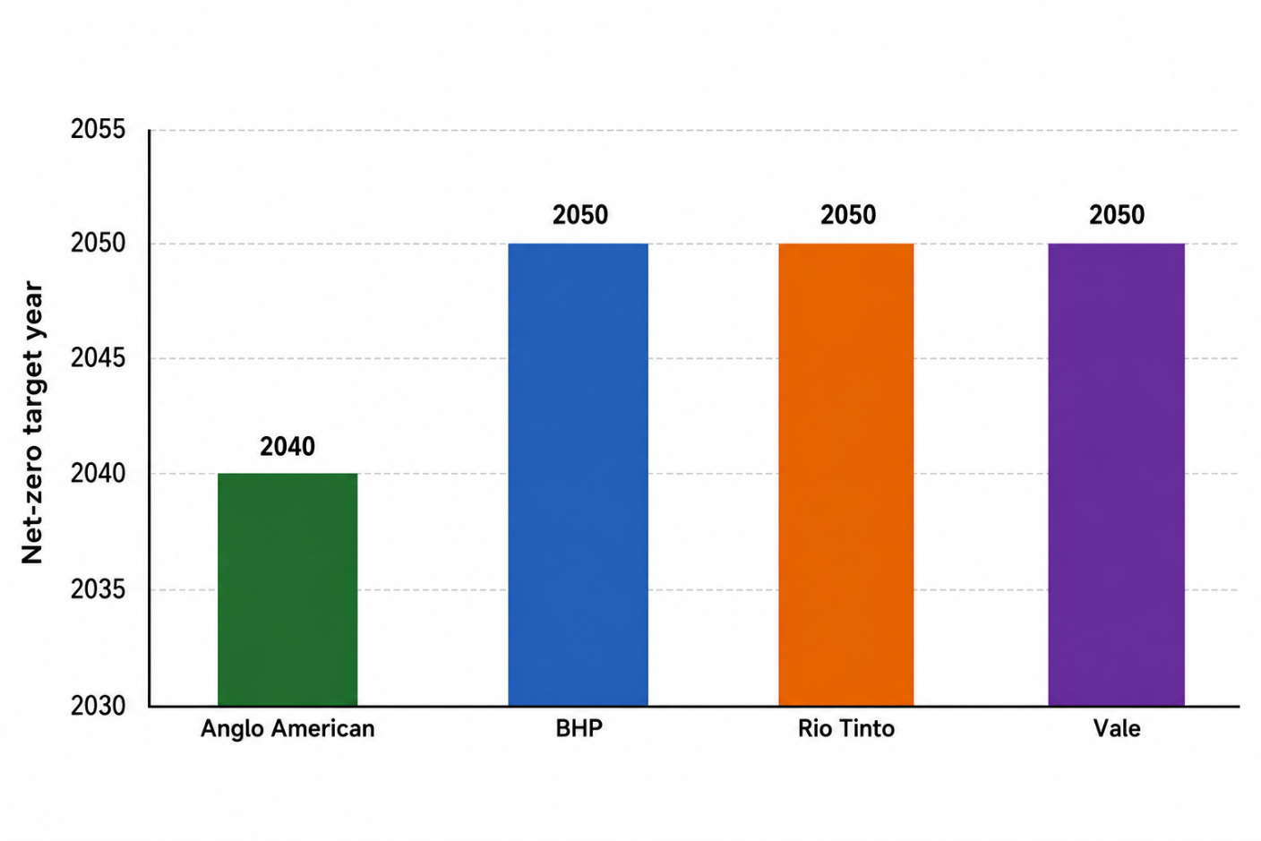
Source: Adapted from BHP (2025), Rio Tinto (2025), Anglo American (2025) and Vale (2025).
Figure 3 demonstrates that operational decarbonisation has become an industry-wide strategic priority rather than a unique source of competitive advantage. While BHP's operational net-zero target aligns with Rio Tinto and Vale, Anglo American has adopted a more ambitious target of 2040. This comparison suggests that sustainability commitments alone are no longer sufficient to differentiate organisations within the global mining industry. Instead, competitive advantage increasingly depends on how effectively organisations implement these commitments through technological innovation, lower-carbon production processes and transparent environmental reporting. Therefore, BHP's opportunity lies in converting its sustainability investments into measurable customer value rather than relying solely on long-term emissions targets (Papadas et al., 2023).
Competitive advantage also depends on effective implementation rather than technological capability alone. Teece (2018) argues that organisations capable of continuously adapting their capabilities are more likely to sustain competitive advantage within dynamic markets. For BHP, this requires ongoing investment in automation, renewable energy and digital technologies while maintaining transparent governance and credible sustainability reporting. Environmental initiatives only create long-term competitive value when they are integrated into organisational strategy and consistently delivered (Papadas et al., 2023). By combining innovation, responsible sourcing and measurable environmental performance, BHP can strengthen stakeholder trust, reinforce customer loyalty and sustain a competitive position within an increasingly sustainability-focused mining industry.

Risks and Limitations of the Recommended Strategy
Although Product Development provides the strongest strategic fit for BHP, its implementation is associated with several financial, operational and market risks. Developing lower-carbon products requires significant investment in renewable energy infrastructure, digital technologies and research partnerships, which may increase costs before commercial benefits are realised (Ansoff, 1957). Furthermore, technological advancements within the mining industry continue to evolve rapidly, creating uncertainty regarding future investment returns and the risk of technological obsolescence (Teece, 2018).
Market-related challenges should also be considered. The success of lower-carbon products depends on continued customer demand and a willingness to recognise environmental value within procurement decisions. Economic uncertainty or fluctuations in commodity prices may reduce customers' willingness to pay premiums for sustainably produced minerals (IEA, 2024). Additionally, increasing stakeholder scrutiny means BHP must ensure that sustainability claims remain transparent, measurable and independently verifiable to minimise reputational risks associated with greenwashing (Delmas and Burbano, 2011). Therefore, successful implementation of Product Development requires continuous innovation, effective stakeholder engagement and robust governance to ensure environmental commitments translate into long-term commercial value.

Conclusion
The Ansoff Matrix identified Product Development as the most appropriate growth strategy for BHP because it enables the organisation to respond to changing environmental and technological conditions while strengthening its position within existing markets. By integrating lower-carbon production methods, technological innovation and responsible sourcing, BHP can enhance customer value and differentiate itself within an increasingly sustainability-focused mining industry. Although implementation presents financial, technological and reputational challenges, these risks can be mitigated through continuous innovation, transparent governance and stakeholder engagement. Consequently, Product Development provides a strategically balanced approach to achieving long-term growth and sustainable competitive advantage.

Task 3: Critical Reflection on AI Usage

Tool Disclosure
Artificial Intelligence (AI) was used as a supplementary tool throughout the development of this report to support research, organisation and academic writing. ChatGPT was primarily used to generate initial ideas, improve the report structure and refine the clarity of written content. It also assisted in identifying appropriate marketing frameworks, including PESTLE and the Ansoff Matrix, and suggested relevant academic sources to support the analysis. However, AI-generated responses were treated as preliminary drafts rather than final content. Company information, theoretical concepts and statistical data were independently reviewed against academic literature and BHP's published reports before being incorporated into the report. Consequently, AI supported the writing process without replacing independent research or critical decision-making.

Critical Evaluation of AI Output
Although AI can assist with information retrieval and idea generation, its outputs required careful evaluation to ensure academic accuracy and reliability. For example, when AI suggested information relating to the mining industry's transition towards lower-carbon products, the data was verified against BHP's Annual Report (2025) and other published company reports before being included in the report. Similarly, where AI identified academic sources, each reference was checked to confirm that it existed, was relevant to the topic and supported the argument being made. This process also involved comparing information across multiple sources to ensure consistency and avoid relying on unsupported or inaccurate claims. These examples demonstrate that AI outputs were not accepted without verification. Instead, they were critically assessed against credible academic literature and organisational reports, ensuring that the final analysis was evidence-based and academically reliable.

Contribution Analysis
AI contributed primarily to the organisation and presentation of information rather than the intellectual content of the report. It assisted with developing section structures, refining academic language and improving the logical flow between topics. However, the selection of BHP as the case organisation, the evaluation of the Natural and Technological Environment, the recommendation of Product Development using the Ansoff Matrix and the critical discussion of competitive advantage reflected independent analysis informed by academic research. Considerable revisions were also undertaken to reduce repetition, strengthen critical evaluation and integrate recent literature throughout the report. Consequently, responsibility for the final arguments, conclusions and recommendations remained with the me the author rather than the AI system.

Ethical and Professional Reflection
The use of AI within higher education offers significant opportunities to improve productivity and support learning; however, it also raises important ethical considerations relating to academic integrity, transparency and critical thinking. UNESCO (2023) emphasises that AI should support, rather than replace, independent learning and professional judgement. Throughout this report, AI was used responsibly by acknowledging its contribution, critically evaluating its outputs and verifying all important information using credible academic and organisational sources. This approach ensured that the final report reflected independent judgement while benefiting from the efficiency and organisational support provided by AI. Developing the ability to evaluate AI critically will become an increasingly important professional skill as AI technologies continue to influence marketing practice and strategic decision-making.

Report Conclusion
This report evaluated how external marketing environment factors influence BHP's strategic decision-making during its transition towards a lower-carbon business model. The PESTLE analysis identified the Natural Environment and Technological Environment as the most significant external influences, demonstrating that increasing stakeholder expectations, sustainability pressures and technological innovation are reshaping competition within the global mining industry. Building on these findings, the Ansoff Matrix identified Product Development as the most appropriate growth strategy, enabling BHP to strengthen its competitive position through lower-carbon products, innovation and responsible sourcing while meeting evolving customer expectations. The critical reflection demonstrated that Artificial Intelligence can enhance research efficiency and organisation when used responsibly alongside independent verification and critical judgement. Overall, BHP's long-term success will depend on its ability to integrate sustainability, innovation and effective strategic implementation to create lasting value for both customers and stakeholders.

References
Anglo American (2025). Annual Report 2025. London: Anglo American plc. Available at: https://www.angloamerican.com/investors/annual-reporting (Accessed on 17/07/2026).
Ansoff, H.I. (1957). ‘Strategies for diversification’, Harvard Business Review, 35(5), pp. 113–124.
Belz, F.M. and Peattie, K. (2021). Sustainability marketing: A global perspective. 4th edn. Chichester: John Wiley & Sons.
BHP (2024). Climate Transition Action Plan 2024. Melbourne: BHP Group. Available at: https://www.bhp.com/sustainability/climate-change/climate-transition-action-plan (Accessed on 14/07/2026).
BHP (2025). Annual Report 2025. Melbourne: BHP Group. Available at: https://www.bhp.com/investors/annual-reporting (Accessed on 16/07/2026).
Chaffey, D. and Ellis-Chadwick, F. (2022). Digital marketing: Strategy, implementation and practice. 9th edn. Harlow: Pearson.
Delmas, M.A. and Burbano, V.C. (2011). ‘The drivers of greenwashing’, California Management Review, 54(1), pp. 64–87.
Freeman, R.E., Phillips, R. and Sisodia, R. (2020). ‘Tensions in stakeholder theory’, Business & Society, 59(2), pp. 213–231.
Hooley, G., Nicoulaud, B., Rudd, J. and Lee, N. (2020). Marketing strategy and competitive positioning. 7th edn. Harlow: Pearson.
International Energy Agency (2024). Global Critical Minerals Outlook 2024. Paris: IEA. Available at: https://www.iea.org/reports/global-critical-minerals-outlook-2024 (Accessed on 17/07/2026).
Kotler, P., Armstrong, G., Harris, L.C. and He, H. (2024). Principles of marketing. 19th edn. Harlow: Pearson.
Porter, M.E. (1985). Competitive advantage: Creating and sustaining superior performance. New York: Free Press.
Rio Tinto (2025). Annual Report 2025. London: Rio Tinto plc. Available at: https://www.riotinto.com/invest/reports (Accessed on 17/07/2026).
Teece, D.J. (2018). ‘Business models and dynamic capabilities’, Long Range Planning, 51(1), pp. 40–49.
United Nations Environment Programme (2023). Emissions Gap Report 2023. Nairobi: UNEP. Available at: https://www.unep.org/resources/emissions-gap-report-2023 (Accessed on 16/07/2026).
UNESCO (2023). Guidance for generative AI in education and research. Paris: UNESCO. Available at: https://unesdoc.unesco.org/ark:/48223/pf0000386693 (Accessed on 20/07/2026).
Vale S.A. (2025). Annual Report 2025. Rio de Janeiro: Vale S.A. Available at: https://www.vale.com/investors (Accessed on 17/07/2026).
World Economic Forum (2023). The Future of Jobs Report 2023. Geneva: World Economic Forum. Available at: https://www.weforum.org/reports/the-future-of-jobs-report-2023 (Accessed on16/07/2026).

