

Topic:VirtuNurse XR: Smart Training for Newly Qualified Nurses
Module Code: BMHP5014
Lecturer: Caroline Salami
Student Number:2334371
Student Name:Tosin Yusuf
Assignment Tittle:Component 2:Assignment(Report)Poster and Pitch

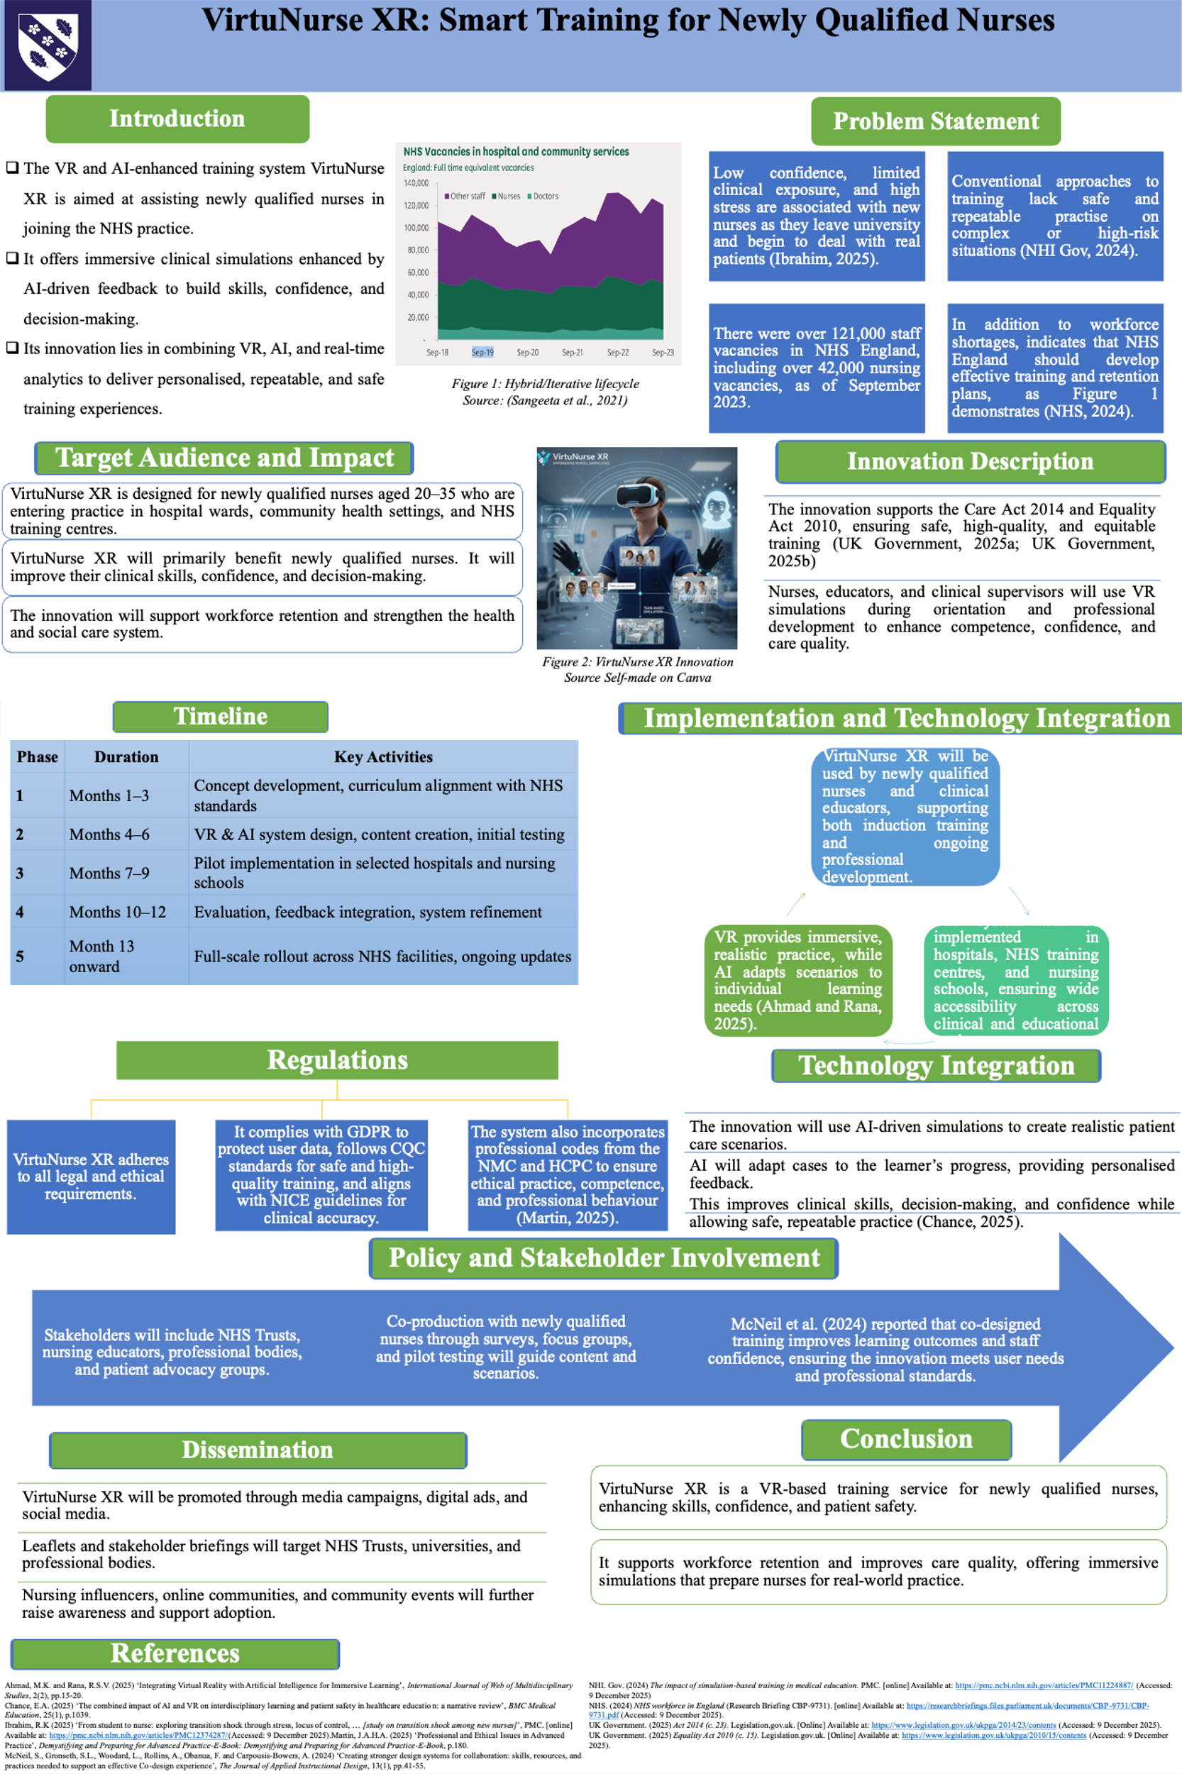

Introduction
VirtuNurse XR is a virtual reality (VR) and AI-enhanced training app that aims to assist newly graduated nurses to enter an NHS practice. It offers immersive clinical simulations enhanced by AI-driven feedback to build skills, confidence, and decision-making. Its innovation lies in combining VR, AI, and real-time analytics to deliver personalized, repeatable, and safe training experiences.

Problem Statement
The time of the transition between university and professional nursing can be challenging, and the lack of confidence, clinical exposure, and stress levels are often reported to be high in new nurses (Ibrahim, 2025). Traditional training includes lectures or clinical placements, which are not usually safe and repeatable experiences with complex or high-risk situations (NHI Gov, 2024). Furthermore, the NHS (2024) reported that workforce strains contribute to these issues, with NHS England indicating over 121,000 vacancies and a total of over 42,000 nursing jobs as of September 2023, showing a great need to find innovative methods of training and retaining personnel. Concerning these issues, VirtuNurse XR will address these gaps using immersive simulations, which improve clinical skills, decision-making, and communication.

Target Audience and Impact
The primary beneficiaries of VirtuNurse XR are newly qualified nurses. The system improves patient care and safety by increasing clinical competence, decision-making, and confidence. VirtuNurse XR is designed for newly qualified nurses aged 20–35 who are entering practice in hospital wards, community health settings, and NHS training centres. The secondary beneficiaries are NHS teams and Trusts who will also have a better prepared, more confident workforce. The patients receive better quality care provided by the personnel with training in the high-risk and realistic conditions. In addition, ensuring staff retention and emotional well-being, VirtuNurse XR can benefit the whole health and social care system, which ultimately leads to the common good.

Innovation Description
VirtuNurse XR is a combination of VR training and AI-driven patient simulations to formulate hospital settings and patient care. The system aligns with the progress made by individual learners, giving them individualized feedback on the clinical decisions, communication, and empathy. The main characteristics are team-based simulations, the ability to collaborate with virtual colleagues or real mentors remotely, and predictive scenarios based on the information about the incidents at the NHS to prepare nurses for the probable cases. Stakeholders include the NHS Trusts, nursing educators, professional bodies and patient advocacy groups. Pilot testing, surveys, and focus groups are the methods of co-production with new qualified nurses to confirm that the content of the simulation is relevant to users and professional requirements (McNeil et al., 2024).
The innovation aligns with the Care Act 2014, which provides a legal context to advocate for the well-being of individuals, protect the vulnerable population, and guarantee high-quality health and social care (UK Government, 2025a). It also facilitates the Equality Act 2010, which safeguards individuals against discrimination due to their age, gender, disability, or race, to provide equal opportunities and access to services (UK Government, 2025b). VirtuNurse XR is an addition to the current NHS services, such as induction programmes, continuous professional development, and community health programmes. The integration and continuous improvement of the system put nurses, educators, and clinical supervisors at the core to ensure that training and patient care are of high quality.

Implementation of VirtuNurse XR
Clinical educators and newly qualified nurses will use the system during induction and continuous professional development. VirtuNurse XR will be used in hospitals and training centres, and nursing schools of the NHS. VR component offers realistic practice that is immersive, whereas AI can adapt any situation to the needs of the individual learner, which means that training is individualized and effective (Ahmad and Rana, 2025).

Timeline
The process of implementation will be organized in stages, and the initial three months will be devoted to the creation of the concept and its compatibility with the standards of the NHS. The fourth to sixth months are devoted to the design of the VR and AI systems, the development of content, and the preliminary testing. The seventh, eighth, and ninth months will be devoted to pilot implementation in chosen hospitals and schools of nursing. Evaluation, feedback integration, and system refinement occur during months ten to twelve, followed by a full-scale alignment across NHS facilities and continuous updates from month thirteen onward.

Regulations
VirtuNurse XR complies with all the legal and ethical standards. It is complying to GDPR to secure the user data, CQC requirements to train safely and of high quality and NICE requirements to train clinical accurately. The codes of professionalism in the NMC and HCPC have also been integrated into the system to provide a professional practice, competence, and professional behavior (Martin, 2025). This provides efficient, safe, and appropriate training to the newly qualified nurses.

Technology Integration
VirtuNurse XR has a strong base of virtual reality (VR), which offers simulated real-life experiences that recreate a hospital ward, interaction with a patient, and emergency high-stress scenarios. These experiences are further enhanced by the AI of the system, which dynamically adapts to the circumstances of every learner and provides personalized feedback and simulates complex patient responses. The performance analytics identify clinical decision-making, communication, and skill development and provide insights on their areas of weakness and shape specific learning. Full adherence to GDPR and NHS data standards, and the protection of sensitive information, is done through secure data management (Ahmad and Rana, 2025). Integrating VR and AI, VirtuNurse XR allows practicing the high-risk clinical situations in a secure and repeatable way, enhancing clinical competence in the learners, and making them prepared and confident nurses.
Dissemination
The awareness about VirtuNurse XR will be provided by targeting media campaigns, advertising online, and social media promotion. NHS Trusts, universities and professional bodies will be given leaflets, newsletters and briefings. Interaction with nursing influencers, web-based healthcare forums, and student networks will expand reach. Community activities, conferences and stakeholder workshops will also facilitate the innovation and promote its implementation in training and clinical environments.
Conclusion
VirtuNurse XR is a VR+AI-powered training programme aimed at helping newly qualified nurses to adapt to NHS practice. This innovation offers immersive, adaptive, and repeated practice, clinical skills, decision-making, and confidence. VirtuNurse XR, produced in collaboration with stakeholders and aligned with the legislation, adheres to professional requirements and helps maintain the workforce and provide better patient care. Implementation of VirtuNurse XR has measurable advantages to nurses, patients, and NHS Trusts, with the ability to address existing training gaps and impact the health and social care system positively in the UK.

References
Ahmad, M.K. and Rana, R.S.V. (2025) ‘Integrating Virtual Reality with Artificial Intelligence for Immersive Learning’, International Journal of Web of Multidisciplinary Studies, 2(2), pp.15-20.
Chance, E.A. (2025) ‘The combined impact of AI and VR on interdisciplinary learning and patient safety in healthcare education: a narrative review’, BMC Medical Education, 25(1), p.1039.
Ibrahim, R.K (2025) ‘From student to nurse: exploring transition shock through stress, locus of control, … [study on transition shock among new nurses]’, PMC. [online] Available at: https://pmc.ncbi.nlm.nih.gov/articles/PMC12374287/(Accessed: 9 December 2025).
Martin, J.A.H.A. (2025) ‘Professional and Ethical Issues in Advanced Practice’, Demystifying and Preparing for Advanced Practice-E-Book: Demystifying and Preparing for Advanced Practice-E-Book, p.180.
McNeil, S., Gronseth, S.L., Woodard, L., Rollins, A., Obanua, F. and Carpousis-Bowers, A. (2024) ‘Creating stronger design systems for collaboration: skills, resources, and practices needed to support an effective Co-design experience’, The Journal of Applied Instructional Design, 13(1), pp.41-55.
NHI. Gov. (2024) The impact of simulation‑based training in medical education. PMC. [online] Available at: https://pmc.ncbi.nlm.nih.gov/articles/PMC11224887/ (Accessed: 9 December 2025)
NHS. (2024) NHS workforce in England (Research Briefing CBP‑9731). [online] Available at: https://researchbriefings.files.parliament.uk/documents/CBP-9731/CBP-9731.pdf (Accessed: 9 December 2025).
UK Government. (2025) Act 2014 (c. 23). Legislation.gov.uk. [Online] Available at: https://www.legislation.gov.uk/ukpga/2014/23/contents (Accessed: 9 December 2025).
UK Government. (2025) Equality Act 2010 (c. 15). Legislation.gov.uk. [Online] Available at: https://www.legislation.gov.uk/ukpga/2010/15/contents (Accessed: 9 December 2025).

