Global Business Challenges:

Module Code – BMSP4001

Lecturer – Dr Louise Emanuel and Anthony Burns

Assignment title – Article on how Waste Disposal through landfill waste can be reduced by promoting recyclable methods:

By – Samuel James Rossiter

Student ID – 1910129

Should We Be Sending Our Waste to Landfills?
Consumers and businesses alike are sending their non recyclables waste to landfills for many years, but is this affecting the environment?
Landfills are made by creating a large hole in the ground so we can put our waste there and bury it for it to deteriorate back into the earth overtime. This doesn’t seem harmful to the environment; however, the issue is that a lot of the waste that goes to the landfill is non-biodegradable which means that these types of waste such as plastic will not disintegrate meaning plastic will stay as its substance underground forever.
The second issue is surrounding decomposition, as already mentioned the idea of landfills is to decompose the waste so it is absorbed back into the ground. However, the decaying process causes air pollution as methane gas is released into the atmosphere and is believed to be causing climate change.
Whilst assessing the damage Landfills have it is important to have a balanced view, below is an assessment of what the expert says:
(Environmental, 2018)

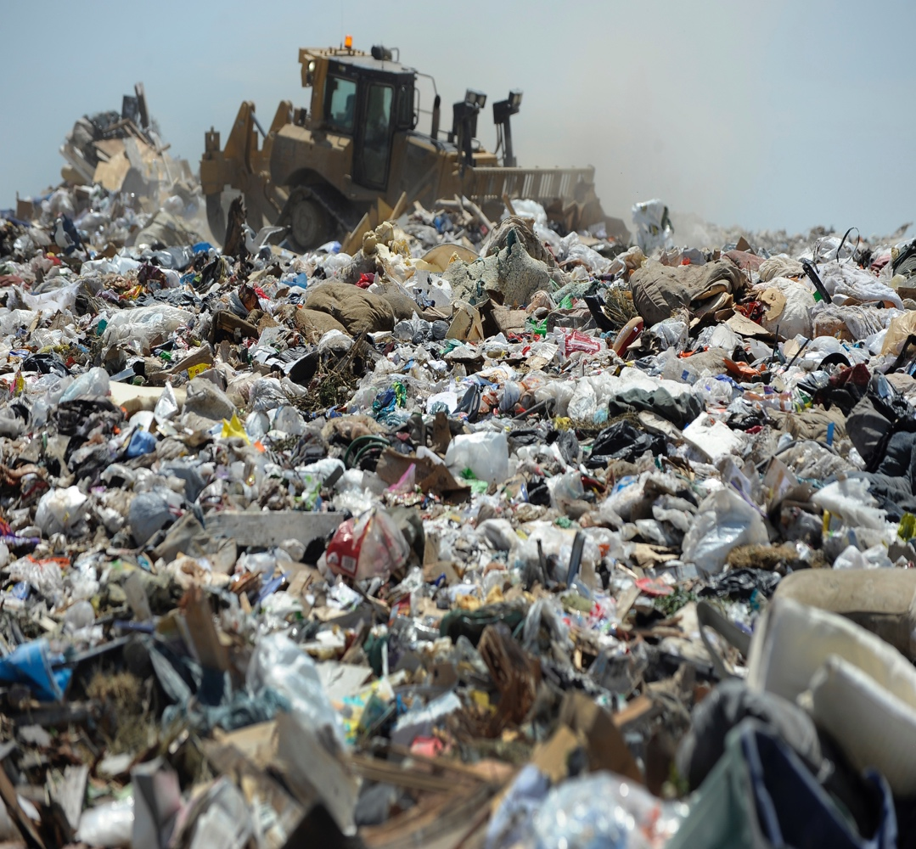
Creator: Kathryn Scott
Copyright: Copyright - 2018 Kathryn Scott

What do the experts say about Landfills?
According to Williams (2005) book Waste Treatment and Disposal (Williams, 2005) it highlights “The major advantage associated with landfilling of waste is the low cost of landfill compared with other disposal options and the fact that a wide variety of wastes are suitable for landfill” (Williams, 2005, p. 172). This could explain why businesses in general find it convenient to send all of their waste to landfills as they do not need to sort their waste into categories of recyclables and non-recyclable and also it could save lots of money rather than spend money on sorting large quantity of waste out.

Williams (2005) also talks about the disadvantages of landfills also as older landfill sites have now been found to have large emission of leachate and other landfill related gases such as methane which are polluting the air and have explosive risks. Methane is particular is 30 times the danger of carbon dioxide with evidence that these greenhouse gases are contributing to global warming. However there is a counter argument to this point as modern day landfills are now required to be suitably monitored for the levels of emissions and also has venting to mitigate against the damage of dangerous gases being released into earth’s atmosphere (Williams, 2005, p. 172 173).

Some experts such as environmental scientist Ian Boyd argue landfills can be useful as while plastic is non-biodegradable it can be placed underground until scientist come up with a plan in the future to find ways to turn the plastic to something that can be reused (Webster, 2018). A counter argument to that however could be the high level of costs it would be to mine all the plastic back to the surface when or if even scientist come up with a solution.

Is the problem only nationwide in the UK?
It has been found that not only the UK faces the problem of sending large quantities of its waste to landfills. According to the guardian article in 2019, it has been found that the United States have also been having a large percent of its recycling now being sent to landfills since 2017 when its biggest buyer of plastic waste China no longer wanted to purchase plastic waste apart from “highest quality plastics”.
This means much of the waste Americans are putting into their recycling bins are not being recycled but are ending up going to landfills. As Americans are not being able to export as much plastic waste as they used to sell, they are being forced to deal with their waste themselves and it was found that as recycling plastic waste became so expensive, the cheaper option is to send their waste to landfills.
As found above sending nonbiodegradable waste to landfills is only a short-term solution and the waste will have to be extracted from the ground in the future. (McCormick, 2019)
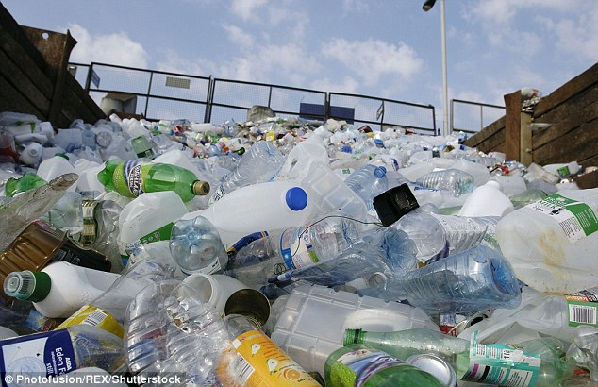
(Fernandz, 2018)

Who is to blame for rising levels of landfill waste?
Rising levels of landfill usage is down to many different contributions including the following:
- Rise in population - Rise in population means that there is a continuing rise of demand in the way countries, businesses and consumers have the need to erase the waste they produce. There are however advantages to rising in population as it means there is more demand for jobs leading to a country increasing its productivity and boosting its economy due to less unemployment.

- Increase output of waste – the demand for waste being collected is on the rise, however it is important to understand that the output for non-recyclable waste is rising. This is down to many different contributions including economies around the globe are increasing their productivity so there is more on the market for consumers to purchase, not all of these goods are made from ethical companies so therefore may not be recyclable.

- Relaxed laws on landfill use – The government rules and regulations both on businesses and consumers alike are fairly relaxed. Landfill tax is affordable to businesses currently costing £91.75 per tonne. If the government took action on encouraging companies to use recyclable materials as it is landfill capacity is running out and has many disadvantages as proven above then companies would then make an effort to transition to ensure materials they use are 100% recyclable (Lets Recycle, 2019).

- Not enough education available to people across the world about the disadvantages of landfills – As discussed above there are many disadvantages to landfills. Non-recyclable waste can lead to plastic pollution across the ocean and could also increase fly tipping if councils do not take waste from people’s houses. This is why it is important to increase the amount of education schools provide to children about the impact of landfills, non-recyclable waste and pollution. Therefore, the lack of education on this subject could be the blame to the use of landfill increasing.

The figures: How much waste is going to landfills?

United Kingdom: VS United States:

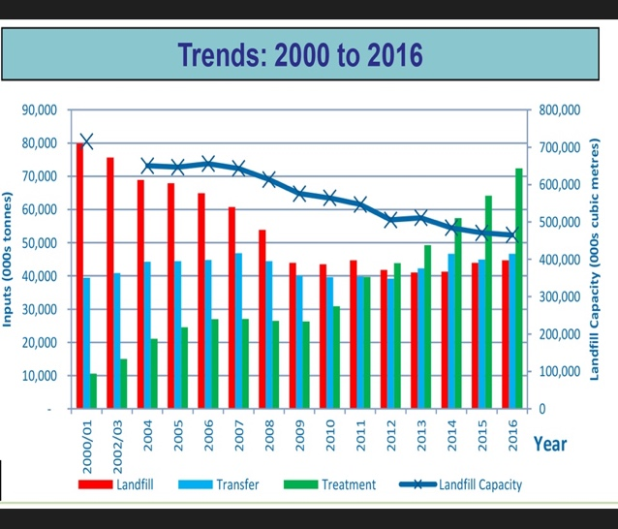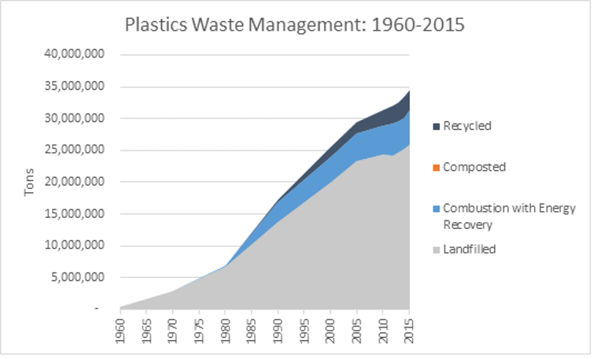
(DC Waste Management Ltd, 2017) (United States Environmental Protection Agency, 2019)
As seen above Landfill capacity is running out and the UK may have little as seven years before it will no longer be able to send any waste to landfills. Therefore, it is essential for the UK to get plans in place to ensure all of its waste become recyclable.
The graph above shows that Landfill wastage hasn’t been decreasing since between 2012 – 2016. This means the UK has still got a lot of work to do to encourage recycling all products so the need for landfills becomes nonexistence.
The trends in the United States show that since 1960 land fill usage has sharply risen up until 2015, however it also indicated the US recycled none of its waste until around 1990. This could be damaging to the environment because large landfill quantities mean large emissions are being released into the US atmosphere.
The US could now start to decrease the amount of waste it sends to landfills by recycling much more of its waste and to do they businesses could promote environmentally friendly recyclable products/services.

Worldwide trends:
Worldwide according to The Worlds Counts, globally humans produce a large 2.12 billion tons of waste every year. This means landfills that are not biodegradable will run out of space and therefore countries will be stuck with nowhere to place their rubbish.
This is why it is important for businesses and consumers to tackle this problem through the promotion of recycling. Below it will be discussed how businesses, councils and consumers are doing to tackle decreasing the demand for landfill waste as more environmentally friendly solutions such as recycling are becoming viable option to more people across the world.
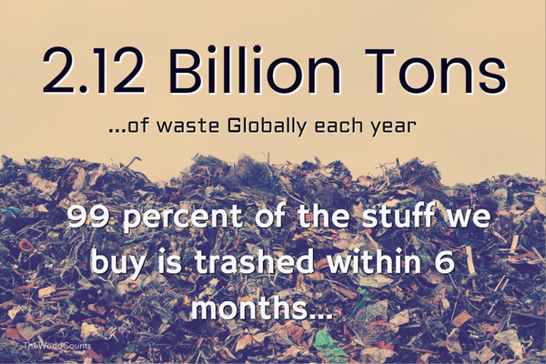
(The World Counts, 2019)
What can be done:
It is important to note that the damages caused as a result of dumping waste in landfills can be reversed. However, the process to doing this is not only expensive but will take a lot of time to transition all countries across the world to stop dumping their waste in landfills but follow other initiatives such as the circular economy.

The circular economy is simply defined as products and services entering a continuous flow starting at production, usage. , maintain, repair, refurbish, reuse, recycle and then the process comes full circle back to production. This ensures that goods that enter the economy they do not end up being wasted and as a result ending up in landfills which as explained about is bad for people’s health and for the climate since landfills release methane gas and also products placed in landfills such as plastic waste is not biodegradable.

Organisations which are contributing to stopping sending waste to landfills:

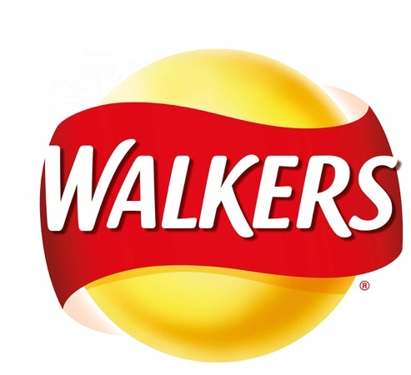

Walkers are a crisp company who’s plastic packaging is currently unrecyclable in the UK. This means that walkers crisp packaging is sent with household black bag rubbish which once processed by councils throughout the UK will be sent to landfills. Once Walkers crisps are sent to landfill, the packaging is nonbiodegradable which means it will stay in its current form and not turn into compost which would be a natural cycle.
Walkers however that there is a problem with its packaging and is working with companies to change its packaging to make it 100% recyclable through means of making it biodegradable or recyclable by 2025.
The advantages of this will be that walkers’ crisps will no longer be contributing to landfill waste meaning the company will be seen as ethical which could increase demand for their products. Increase of demand will mean that the company will turn over more sales thus making more profit. Having recyclable packaging will also help the company contribute to both a circular economy meaning its packaging will have a natural lifespan and will return to compost back in the ground.
However, the company has been a big contributor to landfill waste for a long time so some customers may consider it to be too late for the company as the damage its packaging on the environment going to landfills is irreversible. The company how ever has already attempted to start recycling its non-recyclable products by setting up collection points but this will not be as efficient as having recyclable packaging altogether (Walkers, 2019).



Subaru are another organisation which are making contribution to stopping landfill waste use. This is because Subaru have the following target “Promote new model designs that consider recycling and aim for actual recycling rate of 95% by 2021” (Subaru, 2018). This means that Subaru the car manufacture will ensure that all the parts that make up their new future vehicle models will amount to being a total of 95% recyclable. This will mean customers this company will be perceived as being ethical as only a small 5% of its goods could end up in landfills.
In contrast, Walkers aim to make 100% of its product recyclable so it could be a target for Subaru to consider targets after 2021 to become 100% recyclable which would be in line with walker’s target of being 100% recyclable by 2025.
If all companies followed in the same footsteps as walkers being totally reliant on recyclable waste by 2025, the globe could successfully transition into a circular economy bringing advantages by stopping pollution caused by landfills.



Lidl have taken the idea of recycling one step further as they have recycling stations in place in their stores so customers can take back their carboard, paper and plastic packaging waste which were brought from a Lidl store. This may be considered as a good initiative as Lidl are showing its customers that its taking responsibility for the waste their products make so therefore the company are saying that they will have taken the responsibility to recycle not the consumer (Lidl, 2020).
This initiative could promote consumers and businesses alike to contribute to a circular economy which will stop councils from allowing black big recycling going to landfills which does not promote to companies or consumers that recycling must be the future to stop landfill from running out of capacity and also stop waste pollution in its entirety including in oceans.
Lidl setting up this initiative gives the company a competitive advantage to the other supermarkets chain as these recycling bins could become a unique selling point for consumers to choose Lidl to be the store they shop in. This would lead to higher sales in Lidl so the company can open more chains of stores in the UK leading to more jobs within the company.

How are councils promoting recycling?
Pembrokeshire County Council has a new recycling scheme which is as follows:
Carboard – recycled via blue bag.
Cans and plastic – recycled via red bag.
Glass – recycled via green box.
Paper – recycled via blue box.
Food – recycled via green caddy.
Rubbish including plastic films such as Lidl fruit and vegetable packaging are non-recyclable so it is debatable whether PCC are recycling to their full potential since Lidl could arguably be recycling more than councils.
With this scheme households are allowed 1 grey non-recyclable bag per week which still goes to landfills thus this scheme is not really cutting landfill waste but making household sort their recycling into categories. Some argue this this scheme is not accessible for disabled people as they have to take up to 5 rubbish bins out weekly.
Pembrokeshire County Council argues:
“When we recycle, recyclable materials are reprocessed into new products, and as a result the amount of rubbish sent to landfill sites reduces” (Pembrokeshire County Council, 2019).
It could be considered that if grey bags are sent to landfills then this council is not doing as much as it could be doing to reduce landfill waste to zero over a set target of say five years like walker crisps have with packaging.
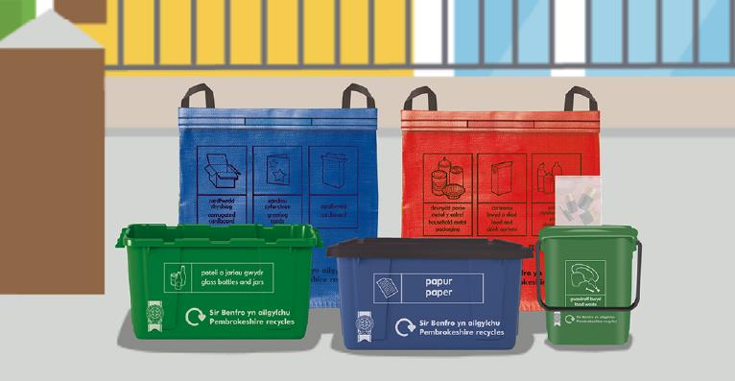

Conclusion:
To conclude this article, it has been found that landfill waste poses a danger to both the environment and health due to the release of toxic gases such as methane. This results in expert believing that landfill waste disposal needs to be replaced by alterative mechanisms such as recycling. It has been considered that there are many different types of ways consumers and businesses can recycle their waste including through means of contributing to the circular economy.
It has been found that landfill capacity in the UK is running out so this could prompt the UK to find alternative arrangements to how they dispose of their waste. Consideration have been given to how three companies including walkers, Subaru and Lidl are contributing to recycling and targets have been set to become waste free in particular to walkers by 2025.
Pembrokeshire County Council are also involved with recycling from the kerbside but it was considered that this scheme may not be reaching its full potential because the scheme allows one grey non-recyclable bags weekly which will go to landfills and there is also no target in place to increase the amount people are allowed to recycle.
To conclude, it could be found that replacing landfill waste disposal into something such as recycling or contributing to a circular economies could benefit everybody around the globe as it stops pollution, improves the environment, improves health and also open up new opportunities for new initiatives which could bring more jobs into the economy such as what Lidl has done with its new recycling stations placed inside its stores.

Bibliography

DC Waste Management Ltd. (2017, September 07). Landfill capacity will run out in 7 years – latest data from Environment Agency. Retrieved from DC Waste Management Ltd: http://www.dcwastemanagement.co.uk/landfill-capacity-will-run-7-years-latest-data-environment-agency/
Environmental, G. (2018, March 15). How Does Waste Disposal Affect the Earth? Retrieved from GD Environmental: http://gd-environmental.co.uk/waste-disposal-affect-earth/
Fernandz, C. (2018, July 19). Up to One fifth of plasic supermarket pacaging cant be recycled with Lidl being the worst offender, study finds. Retrieved from Daily Mail: https://i.dailymail.co.uk/i/newpix/2018/07/19/00/4E63659F00000578-5968541-image-a-7_1531955776914.jpg
Lets Recycle. (2019, April 1). Landfill Tax rate rises to £91.35 per tonne. Retrieved from LetsRecycle.com: https://www.letsrecycle.com/news/latest-news/landfill-tax-rate-rises-to-91-35-per-tonne/
Lidl. (2020). More information about recycling. Retrieved from Lidl: https://www.abettertomorrow-lidl-ni.co.uk/more-information-about-recycling/
McCormick, E. S. (2019, June 21). Americans' plasic recycling is dumped in landfills, investigation shows. Retrieved from The Guardian: https://www.theguardian.com/us-news/2019/jun/21/us-plastic-recycling-landfills
Pembrokeshire County Council. (2019). Pembrokeshire County Council New Kerbside Sort Recycling Guidelines. Retrieved from Pembrokeshire County Council: https://www.pembrokeshire.gov.uk/kerbside-collection
Subaru. (2018). Subaru. Retrieved from The 6th Voluntary Plan for the Environment (FYE2018 to FYE2021): https://www.subaru.co.jp/en/csr/environment/pdf/vision_06.pdf
The World Counts. (2019, November 28th). World Waste Facts. Retrieved from The World Counts: https://www.theworldcounts.com/counters/shocking_environmental_facts_and_statistics/world_waste_facts#image
United States Environmental Protection Agency. (2019). Facts and Figures about Maerials, Waste and Recycling. Retrieved from EPA United States Environmental Protection Agency : https://www.epa.gov/facts-and-figures-about-materials-waste-and-recycling/plastics-material-specific-data
Walkers. (2019). A free and simple way to recycle Walkers crisp packets . Retrieved from Walkers.co.uk: https://walkers.co.uk/recycle
Webster, B. (2018, Febuary 2). ;Bury plastic in landfill until science progresses' . Retrieved from The Times: https://www.thetimes.co.uk/article/bury-plastic-in-landfill-until-science-progresses-and-it-can-be-mined-says-ian-boyd-65slvsl2v
Williams, P. T. (2005). Waste Treatment and Disposal. Chichester, West Sussex: John Wildey & Sons. Ltd.

