
Master of Business Administration

International Business pathway

Report of the international market entry strategy For Toyota in Japan & India
Assessment 1: Individual report. Weight: 100%
Module Name: International Marketing: Principles and Practices
Module code: LCMB7026
Lecturer Name: Amir Homayounfard

Student Name: Shubham Sanjaybhai Dudhat
Student ID: 2526722

Word count: 5031
Submission Date: Thursday 13th August 2026

AI use acknowledgement
Note: One acknowledgement is needed for each used AI tool.
There was no use of any Ai tools to complete the work or conduct research, analyze reports, write content or any part of the project. The complete work has been solely done by me while using academic sources, reports and other information available on google. I take complete responsibility for the content as my own and no use of any Ai tools.

Table of Contents
Introduction 4
Comparative PESTEL Analysis 5
Political Environment 5
Economic Environment 5
Social Environment 6
Technological Environment 6
Environmental Environment 7
Legal Environment 7
Hofstede Cultural Analysis 8
Power Distance 8
Individualism 9
Motivation towards Achievement and Success 9
Uncertainty Avoidance 9
Long-Term Orientation and Indulgence 9
Segmentation 11
Demographic Segmentation 11
Geographic Segmentation 11
Psychographic Segmentation 11
Behavioural Segmentation 11
Targeting 12
Positioning 12
Comparative Marketing Mix (7Ps) 14
Product 14
Price 14
Place 15
Promotion 16
People 17
Process 17
Physical Evidence 17
Strategy for Market Entry: India 19
Entry Mode 19
Strategic Rationale 19
Evaluation 19
Ethical Issues 21
Environmental Responsibility 21
Supply Chain and Responsible Marketing 21
Recommendation 22
1. Expand Localised Hybrid Vehicles 22
2: Strengthen Digital Customer Experience 22
3: Expand Local Manufacturing and Dealership Networks 22
Conclusion 24
Reflection Using Gibbs' Reflective Cycle 25
1. Description 25
2. Feelings 25
3. Evaluation 26
4. Analysis 26
5. Conclusion 27
6. Action Plan 27
References 29

Introduction
Toyota Motor Corporation is a Japanese multinational corporation, a global manufacturer of motor vehicles, motor components and other industrial products (Forbes, 2026). The company is known for its global manufacturing network, wide range of products and its reputation for quality, reliability and technological innovation. It was founded in 1937 and currently sells passenger cars, sport utility vehicles (SUVs), commercial vehicles and electrified mobility solutions under the Toyota and Lexus brands in over 170 countries and regions (Toyota Motor Corporation, 2026). Toyota Motor Corporation has a strong competitive position in the global automotive industry with sales revenue of ¥ 48.04 trillion in the financial year 2025, operating income of ¥4.80 trillion and global vehicle sales of approximately 9.36 million units (Toyota, 2025). This report critically evaluates Toyota's international marketing strategy in its home country Japan and host country as India. It analyses the macro-environment with the PESTEL framework, cultural differences with Hofstede's dimensions, the company's STP strategy, international marketing mix (7Ps), the company's market entry strategy, ethical considerations and gives evidence-based strategic recommendations.

Figure 1: Company Car Logo
(Toyota, 2026)

Comparative PESTEL Analysis

Political Environment
Politically stable Japan and India are good locations for automotive investment but their industrial priorities are different. The Japanese government promotes advanced manufacturing, technological innovation and carbon neutrality through implementing industrial policies to increase research and development (R&D) and industrial competitiveness (ITA, 2025). The programs highlight Toyota's innovation prowess at home and its manufacturing leadership around the world. Meanwhile, India's government is pushing industrialisation with the Make in India initiative, the Production Linked Incentive (PLI) scheme and the foreign direct investment (FDI) policies (PIB, 2025). These are aimed at attracting multinational manufacturers to bring their manufacturing activities closer to home and strengthen domestic supply chains. Moreover, the mutual economic cooperation between Japan and India is improving manufacturing and investment opportunities. As a result, Toyota continues to have strategic management and innovation functions in Japan while expanding manufacturing, localisation and market penetration in India to enhance operational efficiency and meet the growing demand of the market.

Economic Environment
Japan claims high purchasing power and stable demand for technologically advanced vehicles as lower economic growth and demographic changes have affected domestic market growth (Asian Productivity Organization, 2023). While India is one of the fastest-growing major economies in the world, with the growth of urbanisation, rising disposable income and growing private consumption. The automotive sector is an important contributor to India's economy, accounting for around 7.1% of the country's GDP and providing employment to over 37 million people with 18% increased FDI in FY 2024 - 25 (PIB, 2025). The different economic situations affect Toyota's marketing strategy. While premium products with high tech are appropriate for the Japanese market, competitive pricing, local manufacturing and value-oriented products are suitable for the Indian market which is price-sensitive but has a growing number of customers.
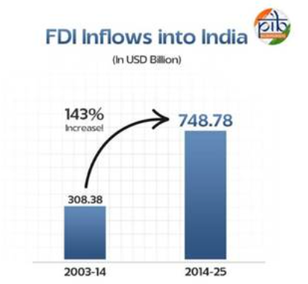
Figure 2: FDI inflows into India
(Source: PIB, 2025)

Social Environment
Consumer behaviour is influenced by social characteristics in different ways in both countries. Japan is an ageing society, has a small family size and has one of the most developed automotive markets, where consumers value quality, safety, reliability and technological innovation. India has a population of over 1.4 billion, a younger population profile, rapid urbanisation and a growing middle class (Bhatia, 2025). While affordability is a key consideration when buying a car, income continues to rise which drives demand for passenger cars. These differences make an advantage for Toyota to sell high-quality, innovative and advanced safety features in Japan and durable, fuel-efficient, low-cost and after-sales service in India to meet local expectations.

Technological Environment
Japan continues to be a leader in the world of automotive innovation in the fields of manufacturing, robotics and digital technologies. In FY2025, Toyota spent around ¥1.37 trillion on R&D, driving ongoing enhancements in vehicle engineering, manufacturing efficiency and future mobility solutions (MReport, 2025). While India's technological expertise focuses on digital manufacturing and modernisation of industries that made the automotive ecosystem stronger in the country. Toyota focuses on high-value research and product development in Japan and introduces manufacturing capacity and technology transfer through Toyota Kirloskar Motor in India (Toyota Motor Corporation, 2026). The company can stay technologically dominant worldwide and increase production efficiency and responsiveness in emerging markets.

Environmental Environment
Toyota's operations in both countries are being impacted by environmental sustainability. Japan's carbon neutrality policy and stringent environmental laws promote manufacturers to lower carbon emissions and enhance sustainable manufacturing (Jarnias, 2025). India has taken measures to enhance environmental governance by implementing Bharat Stage VI (BS-VI) emission standards and policy measures to promote cleaner transportation (Ministry of Road Transport & Highways, 2026). As a result, Toyota takes sustainability goals into production and marketing processes and adjusts to country-specific environmental laws and regulations.

Legal Environment
Japan has a legal system for vehicle safety, product quality, consumer protection and corporate governance which offers automotive manufacturers a stable operating environment (Yamada and Sugihara, 2026). India has made its regulatory framework attractive for foreign manufacturers by introducing new vehicle safety regulations, the implementation of Goods and Services Tax (GST), investment reforms and stricter environmental compliance regulations (Govindan, 2026). While the regulations differ in countries, Toyota's quality standards are consistent throughout the world as manufacturing, distribution and marketing activities are adjusted to meet local regulations. This flexibility allows the company to reduce regulatory risk and keep its competitiveness in both the established and new automotive markets.

Hofstede Cultural Analysis
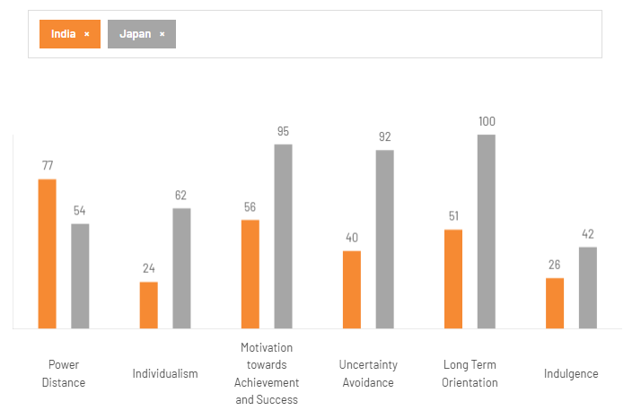
Figure 3: Country Comparison
(Source: The Culture Factor Group, 2026)

Power Distance
India has a Power Distance score of 77 while Japan has a score of 54. This means that in India hierarchy is accepted more than in Japan. The well-established brands are often preferred by Indian consumers as they believe that these brands have a reputation, trust and social status. Japanese consumers are concerned with product quality, fair treatment and reliable customer service. Toyota is working to earn the trust of Indian customers through enhancing its brand image and network of dealerships in the country while in Japan is appreciated for the quality of its products, service standards and customer satisfaction.

Individualism
The Japanese score 62 for Individualism while the Indian score is 24, indicating that Japanese consumers are independent when making purchasing decisions. Before purchasing a vehicle, they typically think about the quality of the product, technology and long-term value. In comparison, Indian consumers are more influenced through family members and decisions regarding purchase are often made for the entire family. This means that Toyota encourages innovation and driving performance in Japan while it provides family safety, comfort, spaciousness and usability in India.

Motivation towards Achievement and Success
Japan's score for motivation towards achievement and success is 95 and India's score is 56. This indicates that Japanese consumers value product excellence, innovation and performance highly. Quality is valued by consumers in India because of the heavy pricing and value for money in investments. Toyota markets its cars as technologically advanced and of high quality in Japan and as durable, fuel-efficient and reliable in India at a competitive price.

Uncertainty Avoidance
Japan has a score of 92 for uncertainty avoidance while India has a score of 40, meaning that the Japanese consumer prefers to take less risk when purchasing a product and requires information about the product before making a purchase. As a result, Toyota focuses on vehicle safety, quality assurance and reliable after-sales support in Japan. Indian customers are flexible and tend to compare cars by their price, financing and maintenance. Hence, Toyota provides flexible financing options and a vast network of dealerships to assist in making the purchase decision in India (Toyota Financial Services, 2025).

Long-Term Orientation and Indulgence
Japan has a higher score for long-term orientation 100 than India does 51, indicating that they are more concerned with future planning and continuous improvement. This is in line with Toyota's Kaizen philosophy which supports continuous improvement and long-term customer relationships. Japan is rated 42 on Indulgence and India 26, indicating that consumers in both countries tend to be careful with their spending. Toyota's marketing communications are pitched towards reliability, quality and longevity as not luxury purchases.

Comparative STP

Segmentation

Demographic Segmentation
Toyota's demographic segmentation differs between Japan and India due to differences in population structure, income and household characteristics. The company aims to sell advanced and safe cars to professionals for older people and small families in Japan (Toyota Motor Corporation, 2025). The younger population and growing middle class in India demand affordable and family-friendly vehicles such as the Innova HyCross and Urban Cruiser Hyryder.

Geographic Segmentation
Toyota customises its products to fit the local geographical environment. Compact and hybrid cars are popular in Japan due to the scarcity of parking spaces and environmental concerns (Kosai, et al., 2022). India's varied road infrastructure and growing urbanisation initiative the demand for SUVs and multi-purpose vehicles which offer enhanced functionality and luxury.

Psychographic Segmentation
Toyota's customers in Japan are innovative, eco-conscious and quality-focused which positions the company as a leader in technology and engineering. In contrast, Indian consumers are more concerned with reliability, fuel efficiency and value due to ethanol- blended (E20) fuel which is why Toyota has focused on durability and economical ownership (Toyota India, 2026).

Behavioural Segmentation
There are differences in consumer buying behaviour between the two markets. While Japanese customers are concerned about quality, safety and technological performance, whereas Indian customers are concerned about affordability, maintenance costs, resale value and after-sales service. Therefore, Toyota modifies its segmentation strategy to local customer needs while retaining its international brand image of quality and reliability.

Targeting
The targeting strategies that Toyota employs are different in Japan and India, due to the differences in customer expectations. The company aims to appeal to customers who are looking for technologically advanced, safe and environmentally friendly vehicles in Japan (Toyota, 2026). These include professionals, ageing consumers, business users and environmentally conscious buyers who are interested in hybrid technology. To supply to the higher purchasing power and preference for product quality of the Japanese as Toyota has the Lexus brand for premium customers.
Toyota primarily focuses on the middle and upper-middle class of people, business owners and growing urban families in India. The company has commercial customers such as utility vehicles and pickup trucks. Toyota aims to appeal to people who want to buy a reliable car that has low running expenses and good resale value as these are important factors in purchasing. The company is going ahead with its expansion in India by manufacturing locally, expanding the dealership network and offering financial services as making it accessible to customers in both metro and emerging states such as Maharashtra (Toyota Motor Corporation, 2026).
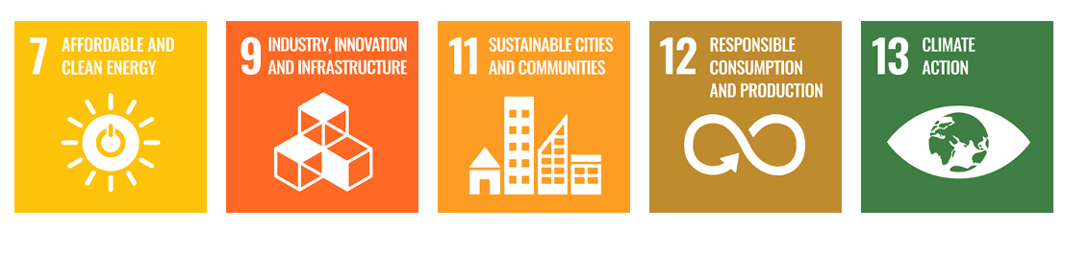
Figure 4: Sustainability Goals of the company for new vehicle manufacturing plant in India
(Source: Toyota Motor Corporation, 2026)

Positioning
Toyota uses a differentiated positioning strategy, having a uniform global brand image with a localised value proposition. The company is known for its high quality, reliability and durability of vehicles across both Japan and India. Consumer expectations, buying habits and the economy differ in each market and may require the company to use a different method (Theocharis and Tsekouropoulos, 2025). Toyota markets itself as an innovative car company that provides technology, engineering excellence, safety and battery EVs for environmental protection in Japan (Toyota, 2023). Product quality, technological advancement and long-term reliability are important factors for Japanese consumers.
Toyota encourages the use of hybrid technology and intelligent safety systems through the Toyota Production System (TPS) which has two pillars such as Jidoka known as automation with a human touch and Just-in-Time for synchronising production processes while using the Kaizen philosophy (Toyota, 2025). This supports its reputation as a trusted domestic brand that is known for innovation and engineering excellence. The company supports durability, low maintenance costs, high resale value and after-sales service which are the major features that affect Indian consumers. This positioning is in keeping with the needs of the emerging middle-income segment and family-oriented buyers in India.

Comparative Marketing Mix (7Ps)

Product
Toyota follows a product adaptation strategy through keeping a globally recognised brand and adapting its product line to the needs of Japanese and Indian consumers. Toyota's technological advancements and commitment to sustainability are evident in its diverse lineup of hybrid vehicles, compact models, luxury Lexus lineup and performance Gazoo Racing (GR) sports cars which are all available in Japan (Priestner, 2017). Toyota is developing new vehicle technologies and intelligent safety systems to maintain its competitive edge and meet consumers’ demand. The TPS and Kaizen philosophy of continuous improvement encourages regular product development and innovation. Toyota manufactures vehicles such as Innova HyCross, Fortuner, Urban Cruiser Hyryder, Hilux and Glanza which are in line with customer demand for spacious, fuel-efficient and durable vehicles (Toyota, 2024). Toyota works with local partners and works to use local supplies to make products affordable but not at the expense of quality. As a result, Japan has a product strategy of technological leadership while India has a practical, affordable and family-friendly mobility strategy.

Price
Toyota does not have an approach to pricing as it takes a market-based approach, taking into account purchasing power, competition and customer value in each market. Toyota can use value-based pricing in the case of hybrid, Lexus and GR models in Japan because of the high-income levels and demand for technologically advanced vehicles. Consumers are willing to pay premium prices because they believe that Toyota is innovative, safe and reliable (Niwa, et al., 2025). Toyota's pricing strategy in India is competitive as affordability and ownership costs play a crucial role in decision-making. Production of vehicles through Toyota Kirloskar Motor helps in keeping the production costs low and provides competitive pricing of the vehicles. The company helps to make vehicles affordable with Toyota’s financial services which offer financing options to make car ownership accessible (Toyota Financial Services, 2025). Toyota's pricing policy includes the promotion of low maintenance costs, fuel efficiency and high resale value. Toyota adjusts its pricing to local economic conditions but continues to attempt for customer value. The flexibility will help the company gain a competitive edge in both the established automotive market in Japan and the fast-growing market in India.
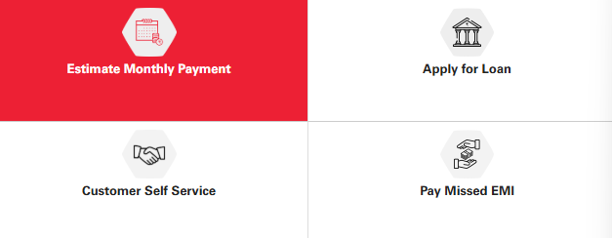
Figure 5: Financial Services by the company
(Source: Toyota Financial Services, 2025)

Place
Toyota adopts a selective and integrated distribution approach, including local production, authorised dealers and online sales channels to enhance product reach in Japan and India. Its distribution strategy is different depending on the maturity of the market and the needs of the customers. Toyota is well-positioned to launch in Japan with a well-developed distribution system, including authorised dealers, organised logistics and digital platforms. The production of vehicles is carried out for the domestic market which allows for efficient inventory management and timely delivery. Integrated digital systems enable customers to configure vehicles online, book test drives and make use of after-sales services, providing a convenient purchasing experience (Bacher and Manowicz, 2020). This distribution method is suitable for the Japanese automotive industry where customers value efficiency, convenience and high service levels.
Toyota's distribution model in India is to increase market coverage with localisation and dealership expansion. Toyota Kirloskar Motor is a manufacturer of cars at its Bidadi Industries Association in Karnataka, both for domestic and export markets (Toyota, 2023). The company reported sales of more than 40,60,81 vehicles with 19% growth in FY2025-26, indicating a rise in demand (Toyota, 2026). Toyota is continuing its dealer and service network in metropolitan areas and Tier 2 - Tier 3 cities enhancing digital platforms which enable customers to compare cars, book test drives and schedule services online. Hence, Toyota is providing its local manufacturing capabilities and distribution network of both physical and digital channels to make its products more accessible to customers and enhance market presence in India.
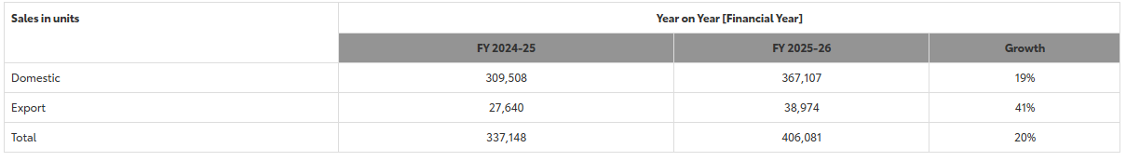
Figure 6: Sales Performance in FY 25 – 26
(Source: Toyota, 2026)

Promotion
Toyota uses an integrated promotional strategy that integrates advertising, digital marketing, public relations and customer engagement. The company's worldwide communication provides quality, safety and reliability as promotional messages are customised to suit local customer preferences. In Japan, promotional campaigns are based on technological innovation, engineering excellence and environmental sustainability. Toyota supports hybrid, intelligent safety features and mobility that continues to validate its reputation for quality and reliability. The company increases brand visibility through Toyota GR sports cars, corporate sustainability initiatives and digital campaigns that support the brand's reputation as an innovative automotive company.
The promotional activities in India focus on the practical ownership benefits and value to the customers. Fuel economy, durability, family comfort and low maintenance are key aspects of marketing campaigns that can affect the decision to buy (Barakati, et al., 2024). Toyota promotes hybrid technology, resale value and reliable after-sales service through TV, social media and digital marketing. The festive season campaigns, dealership events and attractive financing support customer engagement and increase sales of vehicles. Toyota is able to offer the same brand image around the world while at the same time meeting local expectations and enhancing awareness and loyalty in both markets.

People
People are key to Toyota's marketing because their knowledge and service to the customers affect customer satisfaction and customer loyalty. Toyota Way is the company's guiding principle which encourages continuous improvement through Kaizen and respect for people in all aspects of operations (Toyota, 2019). In Japan, Toyota is committed to employee training and development by providing ongoing technical and customer service education which ensures that its employees have knowledge about its products and provide professional service (Toyota, 2026). This helps to build the company's credibility for quality and reliability. Toyota has enhanced the customer relationship with trained dealership personnel, technical and after-sales service teams in India. The company funds dealer capability and employee development programs to ensure that there is a consistent level of service throughout its growing network.

Process
Toyota uses a standardised service process and adapts the service to the requirements of the local market in Japan and India. They will be able to browse online, compare car models, arrange finance, book test drives and schedule servicing appointments on digital platforms in both markets, making the purchasing process convenient and efficient while service delivery varies from market to market. To satisfy high service standards, Japan is focused on digital efficiency, rapid response and smooth customer interactions. India has a personalised approach to dealership support and digital platforms to help customers with guidance throughout the buying and ownership experience (Gangakhedkar, 2021). The extensive warranty programs, proactive maintenance and timely after-sales support enhance customer satisfaction and drive repeat sales.

Physical Evidence
Toyota's brand image is strengthened by physical evidence which reflects the quality and professionalism of the dealerships and service stations. Today's showrooms and organised service centres in Japan are symbols of innovation, operational excellence and high-quality customer service. Toyota is building customers' trust in India through increasing the number of dealerships, customer-friendly showrooms, Toyota-branded lounges and well-equipped service centres. A combined brand approach in both the physical and digital world helps to strengthen Toyota's brand identity in both countries (Toyota, 2020). The efficient service processes and the physical evidence help to build trust, build brand loyalty and support Toyota's competitive position in Japan and India.
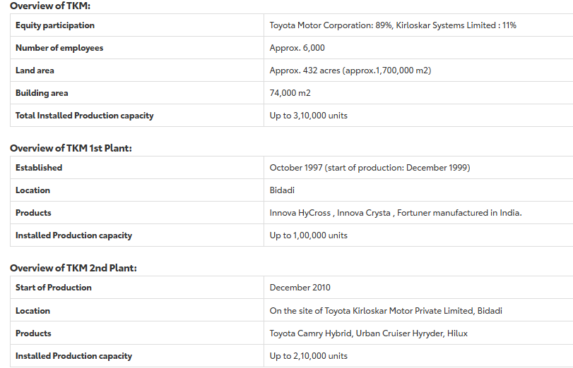
Figure 7: Bidadi Industrial Area Statistics
(Source: Toyota, 2023)

Strategy for Market Entry: India

Entry Mode
Toyota's first venture into the Indian car market was in 1997 with the formation of Toyota Kirloskar Motor in a joint venture with the Kirloskar Group (Toyota, 2012). This approach helped Toyota influence the local market knowledge, supplier connections and understanding of the Indian business environment of the Kirloskar Group while involving its global manufacturing expertise. Toyota Motor Corporation began production in 1999 with the introduction of the Toyota Qualis, making its mark in the Indian passenger vehicle market with an initial investment of 16.4 yen (Toyota, 2000).

Strategic Rationale
The most suitable market entry strategy was a joint venture which minimised the financial and operational risks and enabled access to local resources and distribution networks. The collaboration helped Toyota set up manufacturing plants in India and build a strong supply chain for the Indian market. This localisation approach helped to cut down production expenses, optimise supply chain processes and enable Toyota to modify its offerings to the preferences of Indian consumers. The government has taken several steps to promote manufacturing investments and increase India's manufacturing capabilities as a regional manufacturing hub, including the Make in India and PLI scheme (PIB, 2025). These positive conditions have allowed Toyota to grow its business and become more competitive by producing locally.

Evaluation
The joint venture has played an important role in the long-term growth of Toyota in India. Local production has enhanced cost efficiency, increased the availability of products and improved exports to overseas markets (Dhairiyasamy and Gabiriel, 2025). Toyota has increased the number of its dealers and service stations, making its vehicles more accessible to customers and providing better after-sales service. While the company is affected by heavy competition, price-sensitive customers and shifting government policies. In spite of these difficulties, the joint venture is a good market entry strategy as it provides a combination of global knowledge and local responsiveness (Brouthers, et al., 2022). Ongoing investment in manufacturing, localisation and digital transformation will organise Toyota's competitive position in the growing automotive market in India.

Ethical Issues

Environmental Responsibility
Environmental sustainability is one of the key ethical duties of Toyota in India. The company has set itself the goal of reducing carbon emissions under its Environmental Challenge 2050, as the production of vehicles is causing environmental effects during the manufacturing process and while the vehicles are in use (Toyota, 2023). Toyota has increased hybrid vehicle technologies, enhanced production efficiency and eliminated waste at its manufacturing plants. The company's adherence to the BS-VI emission regulations reflects its dedication to contributing to India's environmental goals. However, ongoing investments in cleaner technologies and sustainable manufacturing practices are necessary to minimise the long-term environmental effects.

Supply Chain and Responsible Marketing
Toyota has ethical obligations to its supply chain and to the transparency of its marketing. The company has a wide supplier network which makes it crucial for them to have responsible sourcing, labour standards and supplier monitoring for ethical business operations (Toyota, 2024). Toyota has adopted codes of conduct and quality management systems from suppliers to increase accountability in its supply chain. The marketing communications can be accurate and contain information about the performance, fuel efficiency, financing options and after-sales services, to assist customers in making informed decisions. Clear communication enhances consumer trust and safeguards Toyota's corporate image. Toyota's commitment to responsible environmental management, ethical supply chain management and honest marketing communications will help build stakeholder confidence and enable sustainable growth of its business in India.
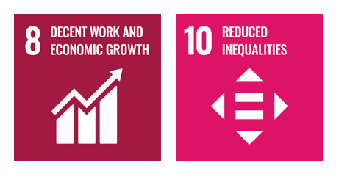
Figure 8: SDGs Contributions in Supply Chain
(Source: Toyota, 2024)

Recommendation

1. Expand Localised Hybrid Vehicles
Toyota can launch locally produced hybrid cars in the lower price brackets to supply the growing demand from consumers and help India achieve sustainability. This would make production cost-effective and competitive in the market through increasing localisation.

2: Strengthen Digital Customer Experience
Toyota's digital platforms need to be enhanced to include vehicle configuration, financing, virtual consultations and after-sales services in a seamless customer journey (Braidy, et al., 2025). This would make it easier for customers, increase digital engagement and build stronger relationships with younger customers.

3: Expand Local Manufacturing and Dealership Networks
Toyota can maintain its investment in manufacturing capacity, partnerships with local suppliers and dealerships in Tier-2 and Tier-3 cities (Toyota, 2025). This would enhance product availability, mitigate supply chain risk and increase long-term market growth in India through increasing the accessibility of the product.
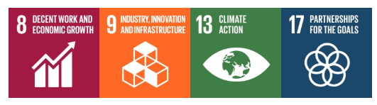
Figure 9: SDGs used in dealership
(Source: Toyota, 2025)

Conclusion
This report has analysed Toyota's international marketing strategy by comparing the operations of Toyota in Japan and India. The results show that Toyota can adjust its marketing strategy to various political, economic, cultural and consumer contexts without compromising its global brand image for quality, reliability and innovation. The company's partnership with Toyota Kirloskar Motor has helped it make a successful entry into the market with localisation, manufacturing growth and better customer reach. Sustainable mobility, digital transformation and local manufacturing will continue to be key for Toyota's competitive edge. Toyota's global standardisation and local adaptation are a good strategy for future success in both markets.

Reflection Using Gibbs' Reflective Cycle
The Gibbs' Reflective Cycle is a structured approach that enables critical reflection on experiences, deepens learning, increases self-awareness and facilitates better practice in the future (Ramasamy, 2026).

1. Description
This report involved myself in critically analysing the international marketing strategy of Toyota Motor Corporation in terms of the comparison of its operations in Japan and India. I used the PESTEL framework to analyse the political, economic, social, technological, environmental and legal factors that affect Toyota's marketing decisions. I analysed the cultural differences using Hofstede's Cultural Dimensions and assessed the segmentation, targeting and positioning strategy of Toyota along with the international marketing mix 7Ps. In addition, I analysed the company's marketing entry strategy into India, ethical problems encountered by the company and suggested some recommendations for future marketing performance. I used academic journals, Toyota's official reports, government publications and industry reports to ensure that my analysis was based on reliable and updated evidence throughout the report.

2. Feelings
I was confident at the start of this assignment to use marketing frameworks as I had studied them in the module. While I was not sure how to apply these theories to assess a multinational company in two markets, I soon discovered that the search for recent and credible evidence was more time-consuming than I had anticipated due to the need to use current company reports and academic research to back up Toyota's international strategy rather than general information. My confidence grew as I gained more knowledge about analysing official reports, government policies and academic literature as the report continued. It was a great experience to learn about how international organisations market their brands in different market environments yet keep a global brand.

3. Evaluation
The use of credible and recent sources such as Toyota's official publications, government reports and academic journals was important for the report. These sources made my arguments more reliable and helped me to provide the discussion with numerical data such as Toyota's financial performance, research and development spending and the number of vehicles sold. I think that the continuous comparison of Japan and India in the report helped to make the report more structured and helped to discuss that marketing strategies need to be adapted to different national contexts.
There was ample information available and it was challenging to determine what was most applicable to each framework. Some studies were conducted on electric vehicles or sustainability, however not in the case of Toyota's international marketing strategy, which needed further research. It was difficult to describe and analyse, as the company reports primarily describe the company's successes rather than analysing business decisions. Therefore, careful interpretation of the evidence was required and an explanation of the impact of environmental, cultural and market differences on Toyota's strategic decisions was necessary.

4. Analysis
This report has been effectve towards enhancing my knowledge of international marketing. I initially thought of marketing as product promotion and communication only before starting the assignment. I realised, however, that organisations must be global yet local when marketing internationally and adjust to the differences in political, economic, cultural and consumer environments. I used the PESTEL framework to gain a deeper understanding of the effect of government policies, economic factors and legal laws on marketing decisions. For instance, India's manufacturing efforts can encourage Toyota to increase its manufacturing in India, while Japan offers a helpful atmosphere for innovation and technological advancements. Hofstede's Cultural Dimensions showed how the values lead to consumer expectations and purchasing behaviour (Wang, et al., 2026). Concerning this, Toyota encourages technological innovation and engineering excellence in Japan and makes it a point to make its vehicles affordable, durable and family-friendly in India.
The STP and 7Ps frameworks helped me to deepen my understanding of strategic marketing. I understood that segmentation, targeting and positioning are related to product development, pricing, promotion and distribution decisions. Toyota's success in keeping its reputation steady in the eyes of customers around the world while modifying marketing activities to local preferences was a good example of how marketing theory and business practice are related. The assignment helped me develop my research and critical thinking skills. I used a variety of academic journals, government publications, consultancy reports and Toyota's official documents for the analysis in my report. This helped me to critically assess evidence, to locate information that was reliable and to develop balanced academic arguments. I was aware of the implications of proper referencing and the use of contemporary sources to enhance the credibility of academic writing.

5. Conclusion
This task helped me to gain a deeper understanding of international marketing and how it is applied in a multinational company. It helped me to analyse a complex business environment, compare international markets and to apply marketing frameworks in a critical rather than descriptive way. The report enhanced my academic research, critical thinking and analytical writing skills. The selection of suitable evidence and critical analysis were difficult for me, but I was able to overcome them as this made my work better and gave me confidence in doing academic work independently. This experience has enabled me to better understand and evaluate international business situations in future academic and professional environments.

6. Action Plan
For future assignments, I will start my research earlier so that I can have enough time to read a variety of academic and industry sources. I want to improve my critical evaluation skills, using other perspectives to compare and contrast with primary company information. In addition, my academic writing will be enhanced with the ability to build a stronger analytical argument and to ensure that theory is always connected to business practice. I plan to deepen my understanding of international marketing by reading recent journal articles on international marketing strategy, cross-cultural management and consumer behaviour. These will enable me to prepare evidence-based reports and prepare me for the future profession of international marketing and strategic management.

References
Asian Productivity Organization. (2023) Adaptation Of High-Income Economies: A Study Of Policies And Transformation. [Online]. Available at: https://www.apo-tokyo.org/wp-content/uploads/2023/07/Adaption-of-High-Income-Economies.pdf [Accessed on: 4 August 2026].
Bacher, N. and Manowicz, A.A. (2020) Digital Auto Customer Journey-An Analysis of The Impact of Digitalization on The New Car Sales Process and Structure. International Journal of Sales, Retailing & Marketing, 9(2), p.16.
Barakati, P., Bertini, F., Corsi, E., Gabbrielli, M. and Montesi, D. (2024) Luxury car data analysis: a literature review. Data, 9(4), p.48.
Bhatia, R. (2025) India’s consumption boom: How demographics, urbanization and aspirations are shaping consumer markets. [Online]. Available at: https://cafemutual.com/news/industry/34167-indias-consumption-boom-how-demographics-urbanisation-and-aspirations-are-shaping-consumer-markets [Accessed on: 4 August 2026].
Braidy, A., Pokharel, S. and ElMekkawy, T.Y. (2025) Research perspectives on innovation in the automotive sector. Sustainability, 17(7), p.2795.
Brouthers, K.D., Chen, L., Li, S. and Shaheer, N. (2022) Charting new courses to enter foreign markets: Conceptualization, theoretical framework, and research directions on non-traditional entry modes: Keith D. Brouthers et al. Journal of International Business Studies, 53(9), pp.2088-2115.
Dhairiyasamy, R. and Gabiriel, D. (2025) Sustainable mobility in India: advancing domestic production in the electric vehicle sector. Discover Sustainability, 6(1), p.52.
Forbes. (2026) Toyota Motor. [Online]. Available at: https://www.forbes.com/companies/toyota-motor/ [ Accessed on: 4 August 2026].
Gangakhedkar, K. (2021) Digital: The new fuel for growth in the Indian automotive industry. [Online].Available at: https://www.salesforce.com/in/blog/digital-the-new-fuel-for-growth-in-the-indian-automotive-industry/ [Accessed on: 5 August 2026].
Govindan, P. (2026) A Study on the Relationship between Goods and Services Tax (GST) and Foreign Direct Investment (FDI) Inflows in India. SJCC Management Research Review, pp.92-119.
ITA. (2025) Japan Country Commercial Guide. [Online]. Available at: https://www.trade.gov/country-commercial-guides/japan-critical-and-emerging-technologies [Accessed on: 4 August 2026].
Jarnias, C. (2025) Environmental Obligations for Japanese Businesses. [Online]. Available at: https://www.jarniascyril.com/company-formation-abroad/company-formation-japan/corporate-environmental-obligations-japan/ [Accessed on: 4 August 2026].
Kosai, S., Hanqing, L., Zhang, Z., Matsubae, K. and Yamasue, E. (2022) Multi-regional land disturbances induced by mineral use in a product-based approach: A case study of gasoline, hybrid, battery electric and fuel cell vehicle production in Japan. Resources, Conservation and Recycling, 178, p.106093.
Ministry of Road Transport & Highways. (2026) Driving the transition to cleaner mobility: PARIVARTAN scheme for modernizing trucks and buses in Delhi-NCR. [Online]. Available at: https://www.pib.gov.in/PressReleasePage.aspx?PRID=2291176&reg=3&lang=1 [Accessed on: 4 August 2026].
MReport. (2025) Toyota tops R&D spending with ¥1.37 trillion, marking 16 consecutive years of growth, survey finds. [Online]. Available at: https://www.mreport.co.th/en/news/industry-movement/160-toyota-rd-spending-2025 [Accessed on: 4 August 2026].
Niwa, Y., Adachi, R., Suzuki, M. and Awaji, M. (2025) Managing for diverse publics: An innovative approach to urban public space management using AHP in Toyota City, Japan. Journal of Urban Management.
PIB. (2025) India’s manufacturing momentum: Performance and policy. [Online]. Available at: https://www.pib.gov.in/PressReleasePage.aspx?PRID=2168711&reg=48&lang=2 [Accessed on: 4 August 2026].
PIB. (2025) PLI Scheme: Powering India’s Industrial Renaissance. [Online]. Available at: https://www.pib.gov.in/pressnotedetails.aspx?noteid=155082&moduleid=3&reg=48&lang=2 [Accessed on: 4 August 2026].
Priestner, M. (2017) Toyota launches new “GR” sports car series in Japanese market. [Online]. Available at: https://www.automotiveworld.com/news/toyota-launches-new-gr-sports-car-series-japanese-market/ [Accessed on: 5 August 2026].
Ramasamy, S. (2026) Self-Awareness and Self-Reflection in IPECP. Springer Nature Singapore. pp. 89-111.
The Culture Factor Group. (2026) Country Comparison tool. [Online]. Available at: https://www.theculturefactor.com/country-comparison-tool?countries=india%2Cjapan [Accessed on: 4 August 2026].
Theocharis, D. and Tsekouropoulos, G. (2025) Sustainable consumption and branding for Gen Z: How brand dimensions influence consumer behavior and adoption of newly launched technological products. Sustainability, 17(9), p.4124.
Toyota (2026) Toyota's safety technology. [Online]. Available at: https://toyota.jp/safety/ [Accessed on: 5 August 2026].
Toyota Financial Services. (2025) Why Toyota Finance? [Online]. Available at: https://www.toyotafinance.co.in/ [Accessed on: 4 August 2026].
Toyota India. (2026) Announcement. [Online]. Available at: https://www.toyotabharat.com/announcements/ [Accessed on: 5 August 2026].
Toyota Motor Corporation. (2025) Your Journey, Our Mission. [Online]. Available at: https://global.toyota/en/mobility/disability-support/welfare/product/ [Accessed on: 4 August 2026].
Toyota Motor Corporation. (2026) Toyota to build a new vehicle manufacturing plant in India. [Online]. Available at: https://global.toyota/en/newsroom/corporate/44318893.html [Accessed on: 4 August 2026].
Toyota Motor Corporation. (2026). The Beginnings. [Online]. Available at: https://global.toyota/en/company/trajectory-of-toyota/history/01/ [Accessed on: 4 August 2026].
Toyota. (2000) Toyota Officially Inaugurates India Production Facility. [Online]. Available at: https://global.toyota/en/detail/7922745 [Accessed on: 5 August 2026].
Toyota. (2012) Item 1. From Stagnation to Growth. [Online]. Available at: https://www.toyota-global.com/company/history_of_toyota/75years/text/leaping_forward_as_a_global_corporation/chapter4/section3/item1_d.html [Accessed on: 5 August 2026].
Toyota. (2019) Corporate Philosophy: Toyota Way 2001. [Online]. Available at: https://www.toyota-global.com/company/history_of_toyota/75years/data/conditions/philosophy/toyotaway2001.html [Accessed on: 5 August 2026].
Toyota. (2020) Toyota Introduces a New Brand Design Across all its Communications. [Online]. Available at: https://media.toyota.co.uk/toyota-introduces-a-new-brand-design-across-all-its-communications/ [Accessed on: 5 August 2026].
Toyota. (2023) Goals & targets. [Online]. Available at: https://www.toyota.com/usa/environmentalsustainability/goals-and-targets [Accessed on: 5 August 2026].
Toyota. (2023) Toyota Kirloskar Motor Enables Scaling-Up of Bidadi Industrial Area. [Online]. Available at: https://www.toyotabharat.com/news/2023/tkm-enables-scaling-up-of-bidadi-industrial-area.html [Accessed on: 5 August 2026].
Toyota. (2023) Toyota Unveils New Technology That Will Change The Future of Cars. [Online]. Available at: https://global.toyota/en/newsroom/corporate/39288520.html [Accessed on: 5 August 2026].
Toyota. (2024) Respect for Human Rights. [Online]. Available at: https://global.toyota/en/sustainability/esg/human-rights/ [Accessed on: 5 August 2026].
Toyota. (2024) Toyota Glanza. [Online]. Available at: https://www.toyotabharat.com/ [Accessed on: 5 August 2026].
Toyota. (2025) FY2025 Financial Results. [Online]. Available at: https://global.toyota/pages/global_toyota/ir/library/annual/2025_001_integrated_en.pdf [Accessed on: 4 August 2026].
Toyota. (2025) Indonesia Exports 3 Million Toyota Cars to Global Markets - Joint Endeavours Towards National Prosperity. [Online]. Available at: https://www.toyota-asia.com/news/n63Qjy4omd [Accessed on: 5 August 2026].
Toyota. (2025) Toyota Production System. [Online]. Available at: https://global.toyota/en/company/vision-and-philosophy/production-system/ [Accessed on: 5 August 2026].
Toyota. (2026) Toyota Kirloskar Motor registers 4,06,081 units sales in FY 25-26. [Online]. Available at: https://www.toyotabharat.com/news/2026/tkm-registers-406081-units-sales-in-fy-25-26.html [Accessed on: 5 August 2026].
Toyota. (2026) Toyota’s Top Training Program. [Online]. Available at: https://global.toyota/en/detail/7627452 [Accessed on: 5 August 2026].
Wang, P., Li, Y., Chapa, S. and Jing, Z. (2026) Consumer and cultural values affecting live streaming impulse buying behavior: A cross-cultural study between China and the United States. Journal of Theoretical and Applied Electronic Commerce Research, 21(4), p.109.
Yamada, T. and Sugihara, T. (2026) Coopetition in a regulated industry: coordinative regulation-making to form competitive actions in the Japanese automotive industry. Asian Journal of Technology Innovation, pp.1-26.

