

Student name: Maria Elisa Jose Dos Santos
Student ID: 2327313
Module name: Changemakers Building your Personal Brand for Sustainable
Module code : BMHP5015
Lecture Name : Brian Mashumba

Assignment Guidance Template
Introduction | This report focusses on Changemakers. Building your brand for sustainable employment, ambition, setting goals, understanding motivation, and autonomy. Purpose of choosing a career, networking and its importance, discuss evaluation, importance of networking and hierarchies in health and social care. On these four units of my changemakers module, I gain the knowledge and understanding, to set goals and build my future career, to provide screenshots from online forum exercises to support my knowledge. It teaches about Resilience, Networking with other professionals that share mutual interest Online, workshops. Importance of Connecting with the right people for opportunities to happen. Opportunities do not arrive all the time, but it is necessary for us to evaluate more often and take the next steps. Talking about self-awareness helps to decision making, communication and resilience skills, enhance interpersonal and professional, self-awareness can assist healthcare professionals in evaluating their capacity to treat patients and determine their needs, prevent situations from spiraling out of control, preserve self-worth and self-efficacy, and exude confidence in trying circumstances. Ambition is also an important assist in this module because ambition is what drives an individual to set always higher goals and strive to have it, to visualize even without seeing what they want to achieve, it can be professionally or academically, this resilience drives this person to be focus to their future.
Reflection on Unit 1: Brand You | Learning about personal brand in unit 1 taught me the real meaning and importance of ambition, for my personal growth. I learned about resilience, competency, and authenticity. I learned to create my own purpose, to challenge myself, to visualize my future goals with confidence, by understanding the importance of my personal career, to reflect on innovation, to reflect on innovative ideas, to equip myself to choose the right path and to help people that have disabilities.  Ambition is a person’s desire to be acknowledge and valued is realized in many areas of human endeavour, it can be seen in specific behavioural traits and personality traits, as well as in other personal motivations and goals that are connected to other psychological traits. Barsuova (2016) A ambitious person seeks to learn from both successes and failures, failures bolster his ambition. When a person is ambitious, they get her higher than any other person. Ashby and Schoon (2010)  For example,  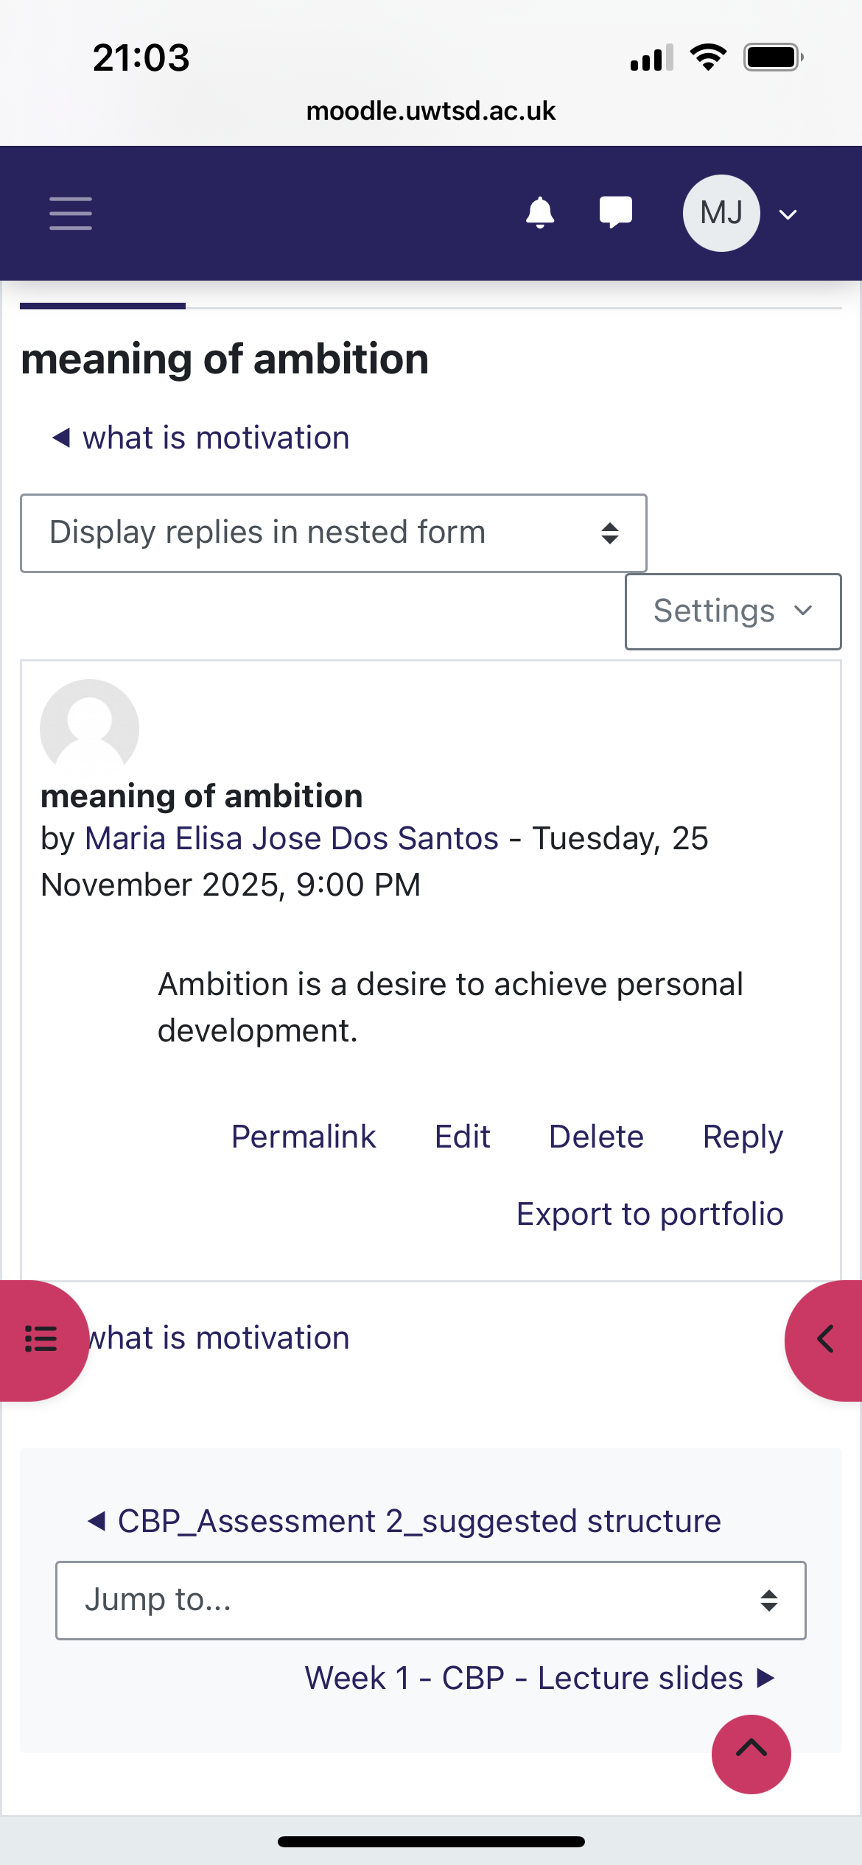  The Johari Window is a communication model that uses self-disclosure and feedback to enhance self-awareness and comprehension. The four questions open, hidden, blind, and unknown, reveal various facets, of interpersonal relationships and self-perception, Luft and Ingham (1955) By fostering open communication and trust this model promotes personal development and strengthens bonds with others. This model taught important tools to understand my weaknesses and strengths, my relationships with others, it builds mine self-awareness/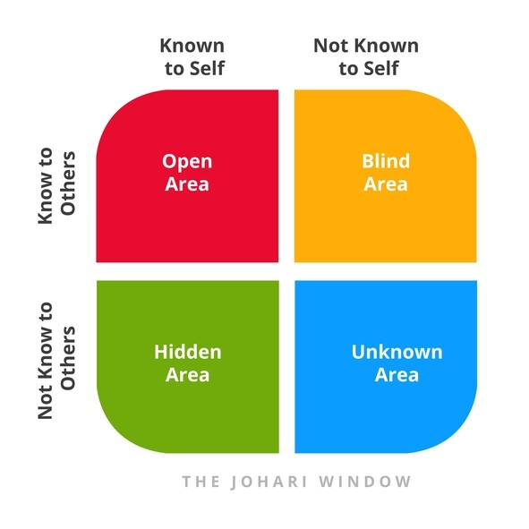
Reflection on Unit 2: | It’s a Small World  By studying about global, connections and diversity in unit 2 I could understand the meaning of globalisation Gig economy  It provided me a broad understanding of how societal values affect behaviours, communication styles, and organisational dynamics across various nations; Hofstede’s cultural dimensions offer an organized framework for improving cultural awareness. People can recognize their own cultural prejudices and change their interactions with individuals from diverse backgrounds by thinking about these aspects. This framework shapes behaviour in others organization and societies.by using this gives opportunity to name six key dimensions are used to improve communication and cultural diversity around other cultures.  Example these dimensions are  Power distance, individualism collectivism, masculinity, femininity, uncertain avoidance, long term orientation and indulge restraint.  For example, we learn about gig economy and boundary less skills, with gig economy states that this model provides flexibility, where they can balance other commitments or any personal circumstances, example can be health issue. This allow professional to be in control etc. The boundaryless skills is transferable and adaptable competencies professionals can move across different jobs roles instead of staying at a single career path they often work through an agency.  Example the British Journal of Social work conducted a survey for students to be prepared to serve in a culturally227 diverse world.  227 students (18 per cent responded to the survey)  I learn to have an open mindset, understanding that exist a difference between each culture, that we are not the same. When we worked with different people, we learn to respect other cultures.  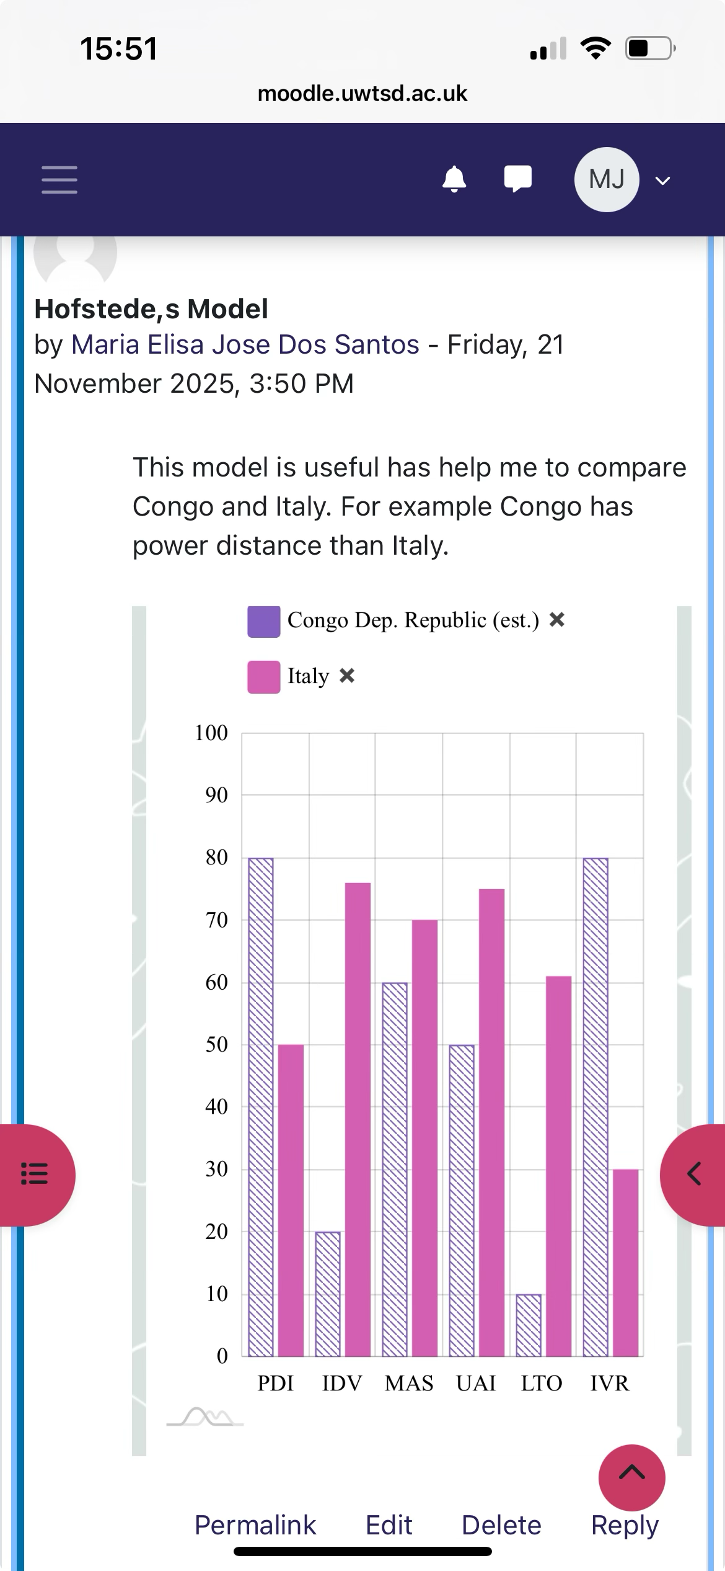  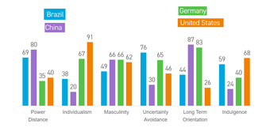  This Photo by Unknown Author is licensed under CC BY-SA  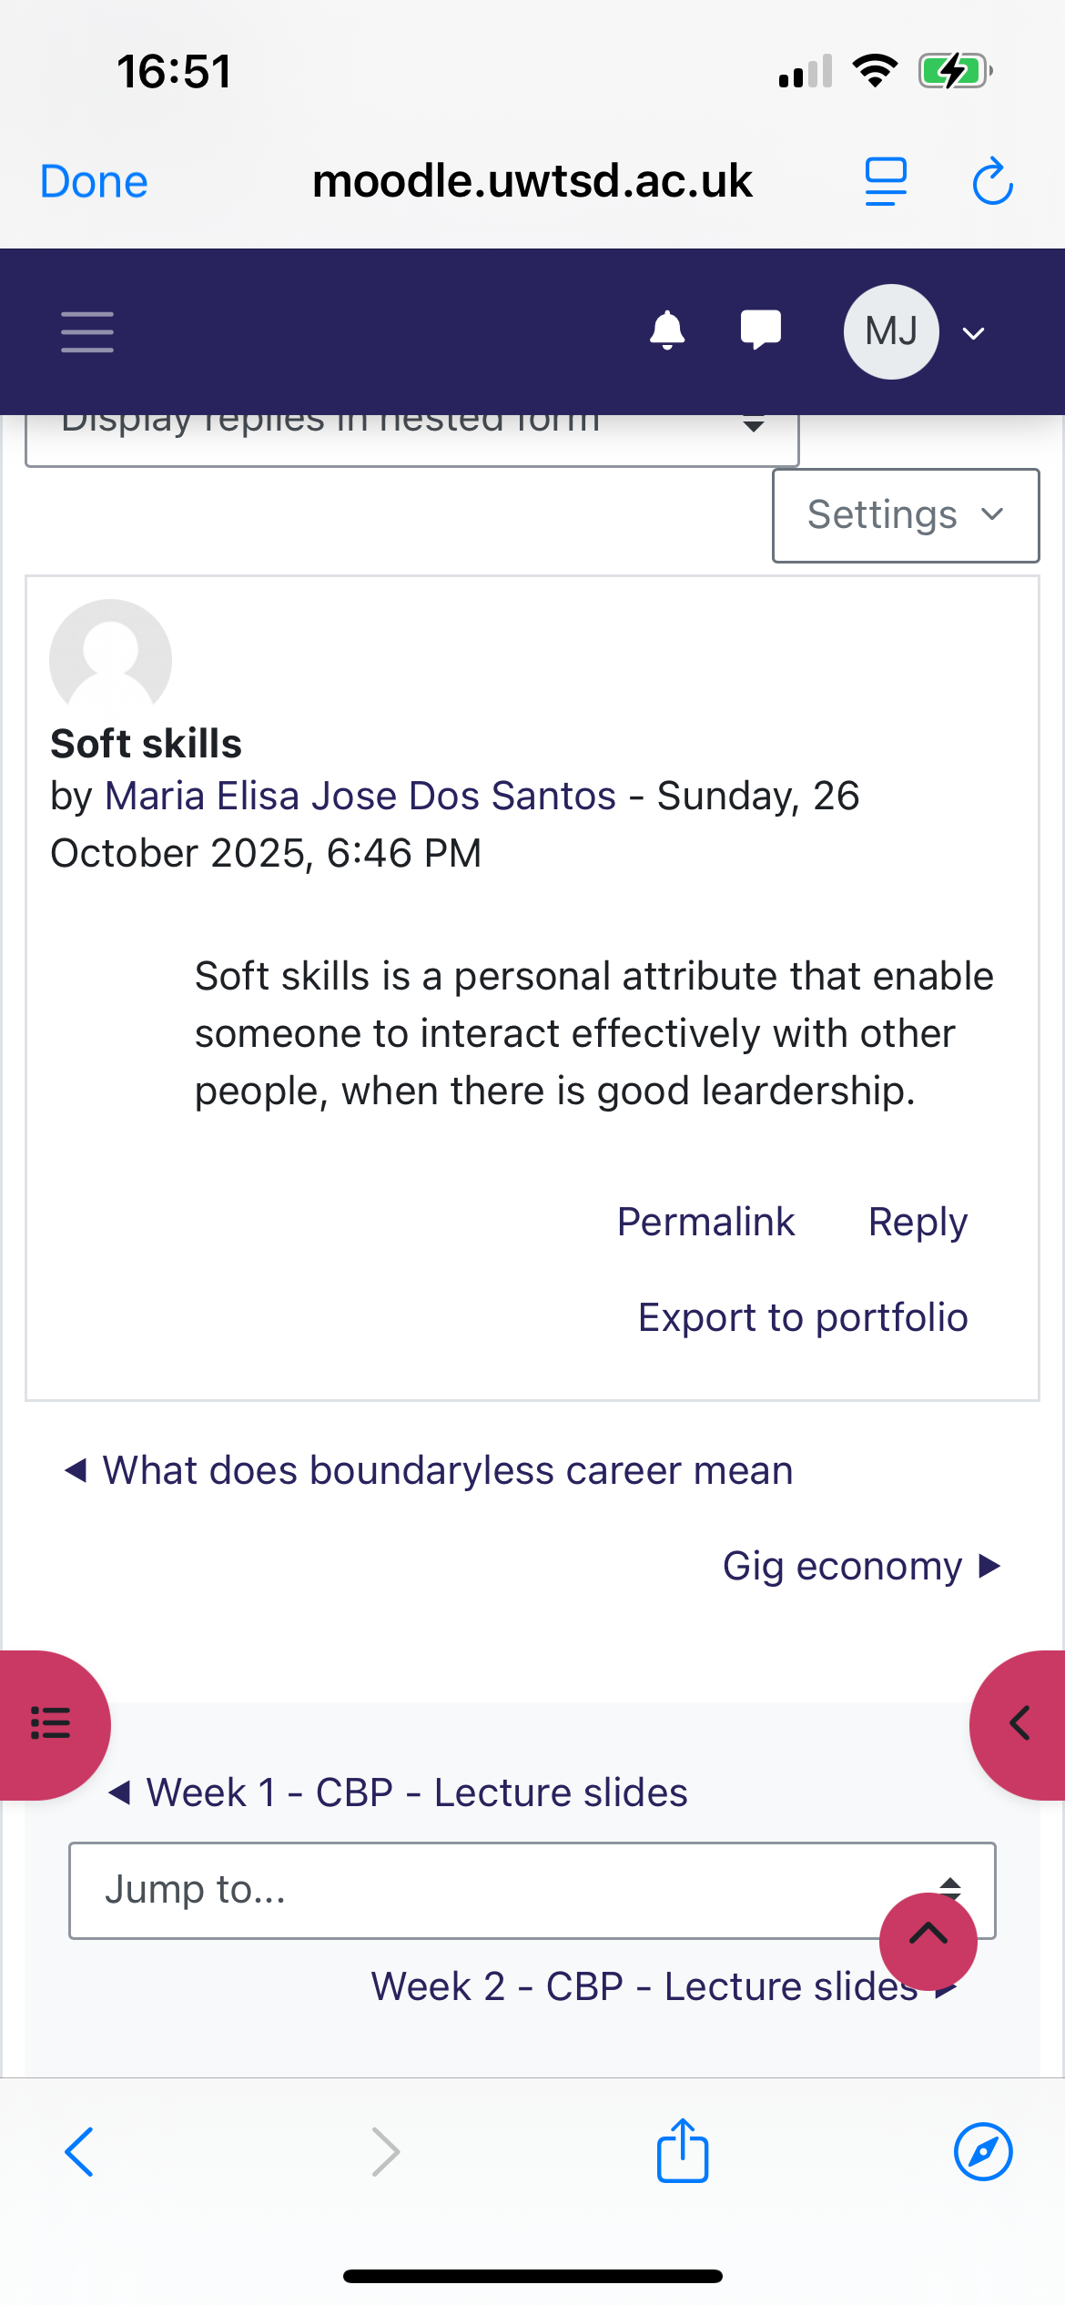  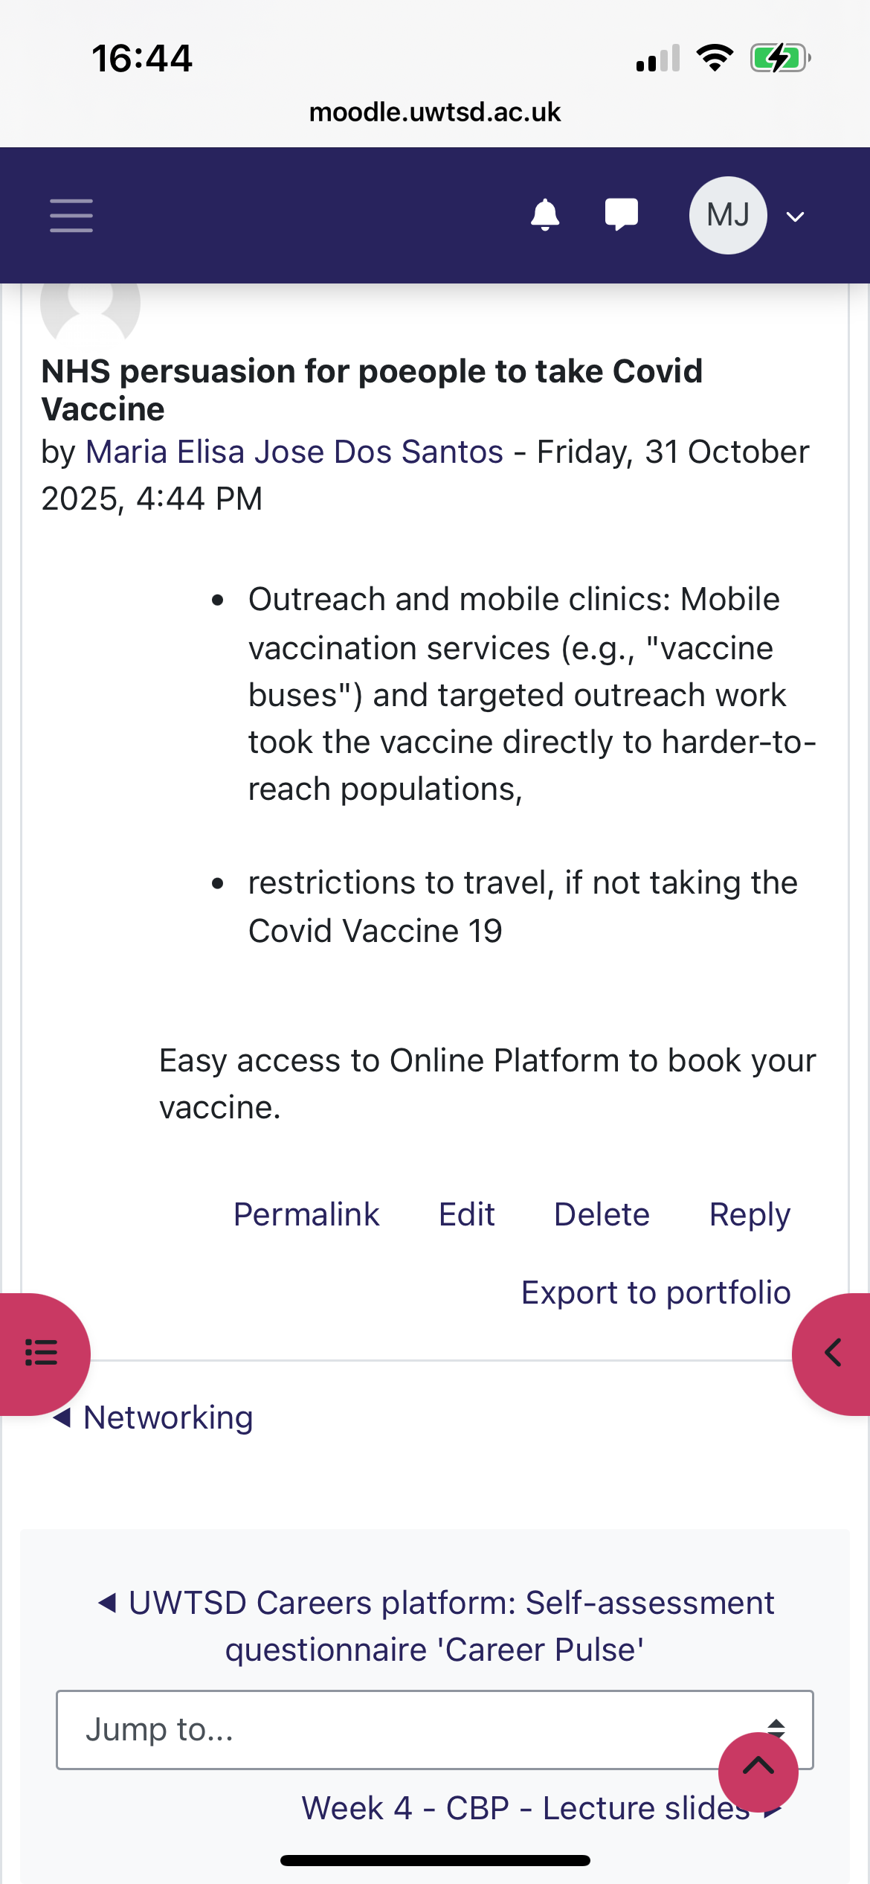  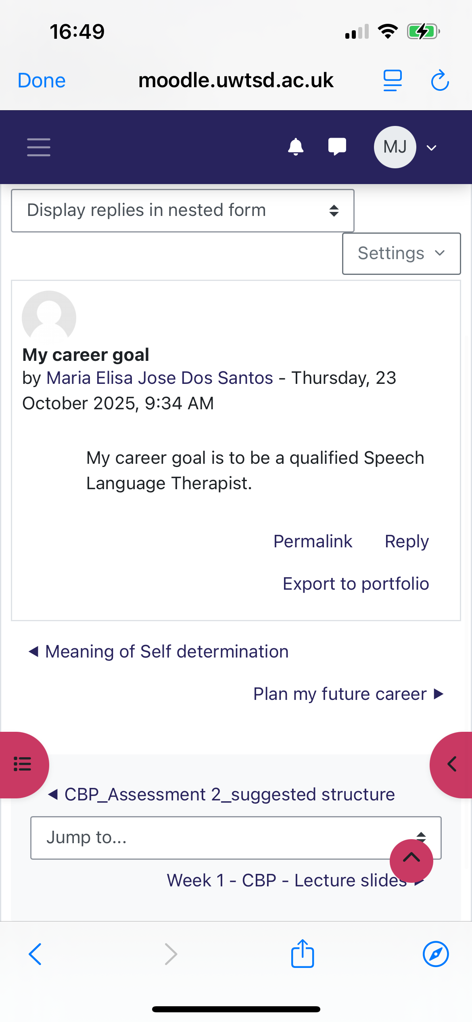
Reflection on Unit 3: | Opportunity Knocks  In unit 3 learned to recognize opportunities. To grow professionally and to build networks, by having connections with colleagues, to always seek development in my skills and career. Is important to build networks. Network is important because that is where you meet people, share information that have the same professional interesses. There are several ways of networking such as LinkedIn, conferences, workshops, twitter etc. Is extremely important to seek positive links enhance growth also increases professional changes.  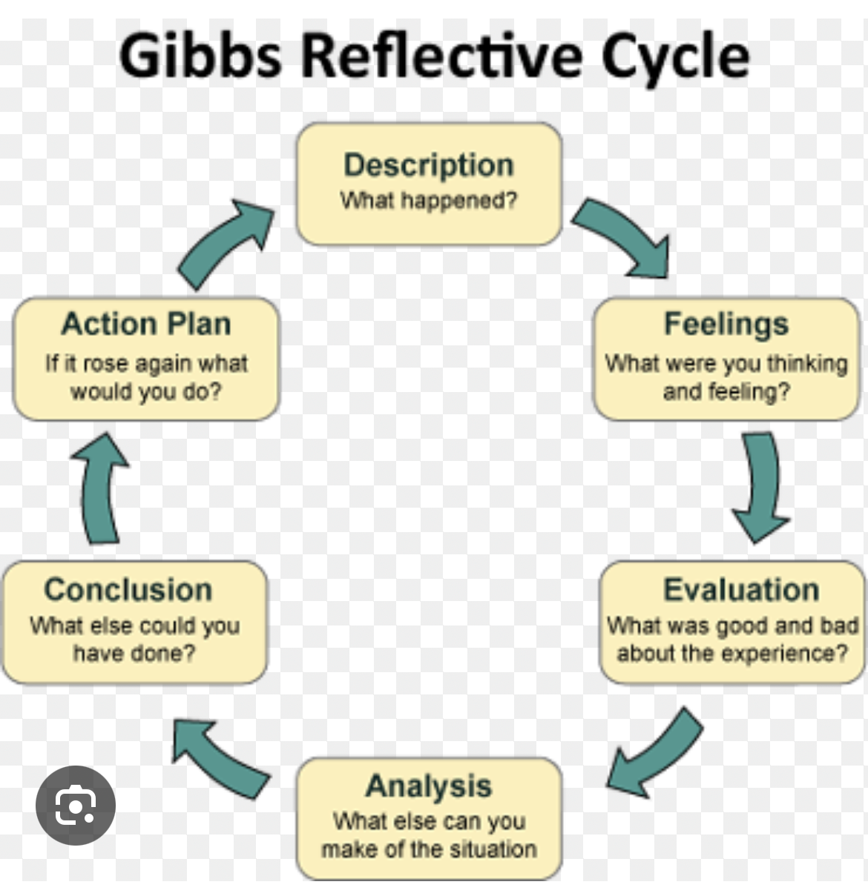  Using evaluation is an important key, to plan, set our goals and learn what we need for my own personal development, these things can be to improve our confidence, taking the right steps or even more responsibility at work, open opportunities, and connections. For example, a goal -based helps to individuals to see my own progress, or goals set by myself. While process-based evaluation helps to analyse the weakness and strengths of our own networking and help us to formulate our own goal-based evaluation. I learned that in order for my professional development I need to be competent and effective in what I do, Today the world is changing, new rules and technologies are always being developed, therefore being stagnant is never an option, continuous development is a way of investing in myself, is necessary to adjust to changes, this will improve my skills and competencies to support my career goals and will boost my employability prospects, credibility and confidence. With this knowledge has the understand and the confidence to evaluate my own learning, more often, Using the Gibbs reflective Cycle.  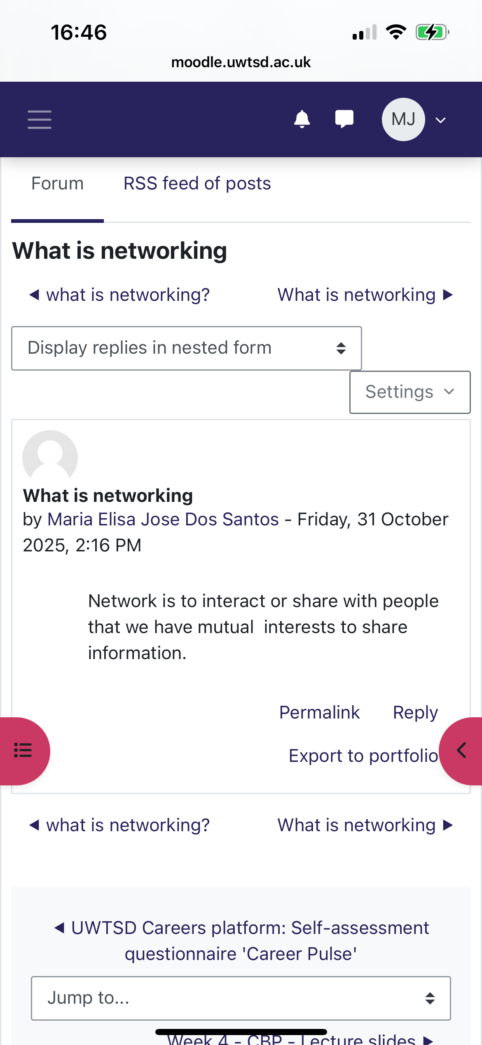
Reflection | In unit 4 we talked about the importance of Social Prescribing, making connections and Well-being, Work-life balance, resilience, and well-being are all related ideas that support both general happiness and career success. To manage workload and avoid burnout, a healthy work-life balance requires prioritizing tasks, setting clear boundaries, and taking regular breaks. Strong relationships, a positive outlook, emotional  capacity to manage stress and adversity. When combined, these components serve as the cornerstone for better physical and mental well-being, increased output, and increased job satisfaction.  Social prescription  In social prescribing, individuals are referred to social prescribing link workers by local organizations like health services, social care, and charities.  Social prescribing link workers help people take charge of their health and well-being by giving them time and concentrating on "What matters to me?" to co-create a straightforward, individualized care and support plan.  Collaborating cooperatively with all local partners, and prescribing link workers also help individuals in starting new groups and making already sustainable Social prescribing is an all age, whole population that works particularly well for people who possess one or more chronic illnesses require assistance with mild mental health problems, are lonely or isolated or have complicated social needs that impacts their wellbeing.  Making connections and growing your network. Building relationships with patients, service users, coworkers in your organization or institution, other services, or the local Government. It is crucial for health and social care professionals.  Connecting people is an evidence-based service user, coworkers in your organization or institution, other services, the local government, is crucial for health and social care professionals.  Connecting People is an evidence-based strategy for encouraging interpersonal connections. obstacles they may meet.  Enhancing service users' social connections is more successful for teams that are more integrated into the communities in which they.  Self-Awareness It is your ability to notice your feelings, physical sensations, responses, routines, actions, and thoughts. It is your ability to show your feelings. The core of self-awareness is concentrating on the reality of your behavior rather than the story you tell yourself about it.  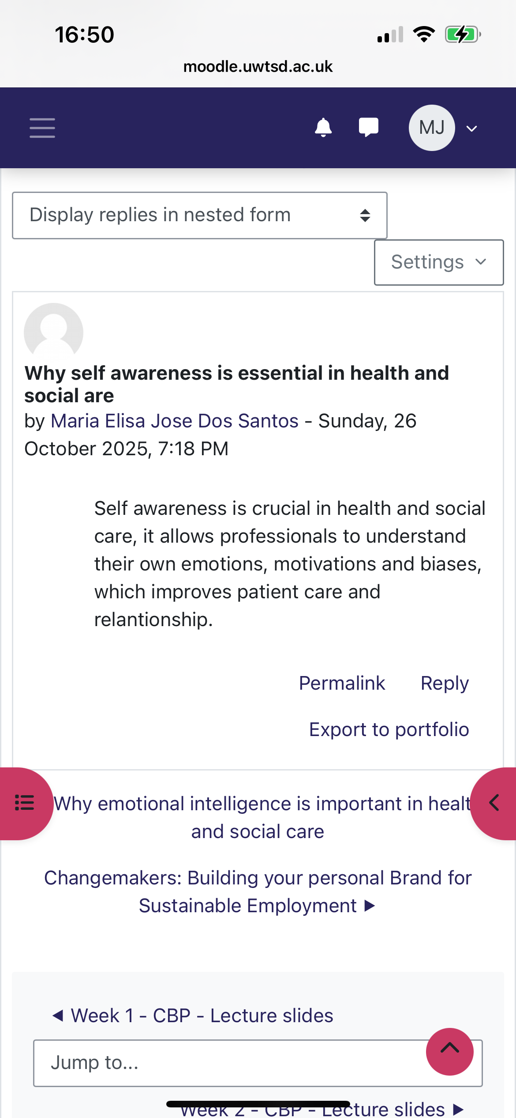  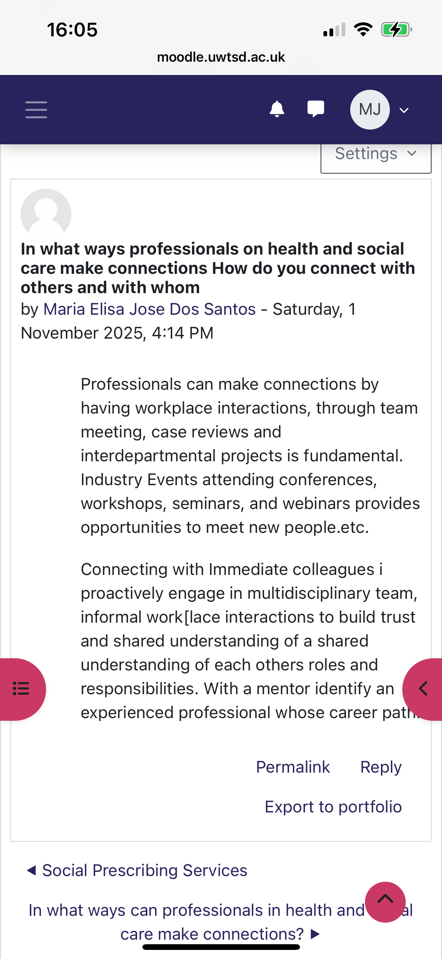
Conclusion | By doing this assignment I understand my personal brand is more valuable than what I think about myself, I acquire new skills to be Resilient, confident and the importance to reflect in my weaknesses and strengths and be prepared to work in Sectors related to Health and Social Care sectors with more confidence. Unit one I learned about personal brand, unit 2 I learned about Culture competence, boundary less and gig economy that allows me to work and to adapt in different jobs and know diverse cultures and gain new skills to adapt and have a better performance at work. Unit 3 is about opportunity knocks, knowing when to get it. it makes ones to grow professionally and to build networks, by having connections with colleagues, to always seek development in my skills and career. Is important to build networks. A good network connection can open new opportunities. Gibbs cycle is an important key to help us to reflect, plan and set my own progress and allow others to see my progress too. Unit 4 Social Prescribing, making connections and Well-being, Work-life balance, resilience, and well-being are all related ideas that support both general happiness for successful career.  By reflecting in these 4 units, I realized that often we tend not to come out of our comfort zone, because of our own fears or people said something about us, we tend to be stagnant by procrastinate things as well. Sometimes we don’t believe in ourselves and end up not taking risks and loose good opportunities in life.  I feel more confident to pursue my personal career as a Speech Language Therapist. I have the assurance that I gained the right tools to succeed and contribute to my career, I gain the understanding that even if things do not go according to what I plan, I must remained focus, talk with people with the same professional interesses. If necessary, do a new course to gain knowledge in a new career path in case if there is a change. Having a clear mindset that life has setbacks , unexpected things such as family commitments, sickness, loose a job, but if I don’t give up, I can do all things. I enjoy learning about Brand in this assignment; it really helps to be focus on my goal.
Maddox. E. J. kleiman.M. (2016) Self efficacy the power of believing you can be Available at https: //www.scribd. com/ document (Accessed: 17 November 2025)

Gardiner, K. (2023) How to use the Johari Window exercise for leadership
Available at: https:// positive psychology.com/Johari- window (Accessed: 21st November 2025)

Luft, J, Ingham, H. (1955) The Johari Window, a graphic model of interpersonal awareness. Proceeding of the western training laboratory in group development Available at: http://alcura.com (Accessed: 24 November 2025)

Barsukova. O. Psychological characteristics of ambitious person (2016) Available at https: // www.researchgate. net/ publication (Accessed:17 November 2025)

The University of Edinburgh (2024) Gibbs Reflective Cycle Available at https:// www. reflection.ed.ac.uk
(Accessed:17 November 2025)

Nickerson, C, (2025) Hofstede’s cultural dimension theory Available at https://www. simply psychology.org (Accessed:17 November 2025)

The society for education and training Supporting your growth at every stage (2015) Available at: https: // www.set.el foundation.co.uk (Accessed :18 November 2025)

Mcleod, S. (2025) Gibbs reflective cycle Available at: https: // www.simplypsychology.org (Accessed: 20th November 2025)

NHS Hertfordshire Partnership University (2014) The care act wellbeing Available at: https://www.hpft.nhs.uk (Accessed: 26th November 2025)

Warley, S,( 2016) What is self awareness Available https:// www.lifeskillsthatmattee.com ( Accessed: 2nd December 2025)

