 | Targets | Evidence
Target 1 | Ensure all points and arguments you make are supported by references to literature. This will help you to further strengthen your critical writing. | I have supported all my arguments with relevant literature.
Target 2 | Look for greater criticality in your literature review, where are the debates and why might opposing ideas exist. | I have greater criticality.

Demonstrate how cross-curricular teaching and learning can influence in-depth skills and understanding.
The Curriculum for Wales contains three mandatory cross-curricular skills, literacy, numeracy and digital competency. To support schools and practitioners in delivering these skills effectively the Literacy and Numeracy Framework (LNF) (Welsh Government, 2024) and the Digital Competence Framework (DCF) (Welsh Government, 2024) have been produced by the Welsh Government to provide clear guidance. The frameworks are broken down into strands which are further separated into elements, to support teachers in planning the correct material to be delivered. Similar to the Areas of Learning and Experiences (AoLEs) the frameworks contain ‘progression steps’ which support the practitioners, giving clear guidance on what skills learners will be developing. It is essential that children learn these skills which will be transferrable into their adult life and future employment. Practitioners have the responsibility to embed these skills into the curriculum to ensure they can be used effectively across the AoLEs and cross-curricular.
Digital competency can offer many opportunities to learners, such as making learning more fun and engaging, developing a wide range of skills and providing assistance to children with Additional Learning Needs (ALN )(Digital Poverty Alliance, 2024). However, to teach digital competence successfully, teachers will need to be digitally competent themselves. Studies show that 24% of teachers lack confidence in their digital skills and deem this to be a barrier to using technology (Digital Poverty Alliance, 2024). Additionally, there may not be access to funding and resources to fully support teaching digital competency. In order to resolve this, teachers should be offered training regarding digital skills to increase their confidence. From a young age, children will attempt to communicate their needs in various ways. Growing up in the 21st century surrounded by social media children may have developed ‘modern’ English which is not always correct. Allowing children to have access to social media platforms can affect how they engage in conversation and their socialisation skills (Reading Kids Active, 2022). It is at the parent’s, carers’ and practitioners’ discretion to teach children the correct literature so that they can develop essential skills such as social, emotional and cognitive. With the growing population in Wales, there are more learners with diverse backgrounds in our schools (Diversity UK, 2023). Therefore, children with English as an Additional Language (EAL) require educators to create strategies to develop their literacy skills. Studies show (ESTYN, 2018) that 20% of pupils in Wales are from ethnic backgrounds and 25% of these pupils receive support in learning EAL. In relation to numeracy skills, it is often based on patterns and previous learning. Therefore, if a child doesn’t have a full understanding of a concept, for example, times tables and addition, it may affect their later learning (Brookes, 2023). For this reason, it is essential that assessment for learning takes place during lessons so that any misconceptions can be corrected, and the child can receive ongoing feedback.
I have created my own lesson plan and resource, based on the topic of ‘Healthy Eating’. The main AoLE focus is ‘health and well-being’ (Welsh Government, 2024) and links to the pedagogical principle of teaching within and across AoLEs (Welsh Government, 2024). Throughout this part of the assignment, I will be using my lesson plan and resource to highlight how it aligns with the cross-curricular frameworks.
My resource and lesson plan follows the DCF framework (Welsh Government, 2024), with the use of the class iPads for pupils to create their own pictogram. Pupils will create their pictogram to represent their group’s favourite fruit using ‘Jit’ via the Hwb website (Welsh Government, 2024). This session will take place in the classroom with children wil split into their ability groups and they will be completing the task either with a practitioner or independently. However, Mrs P (2016) believes that ability grouping can put a limit on children's learning whereas allowing mixed ability groups would encourage children to collaborate in their learning and develop a broad range of skills. Within my lesson plan, I have used Vygotsky’s (1934, quoted in Collins et al, 2011) More Knowledgeable Other (MKO) whereby pupils can provide support to their peers. In future, I would consider using mixed-ability groups in the classroom utilising the MKO concept where the children can learn from each other and not just the teacher. During this session, pupils will be using their Mathematics and Numeracy skills by collecting data and representing their findings on a pictogram. Additionally, the resource I have provided follows the LNF framework (Welsh Government, 2024) as pupils will share their opinions through discussion and express their ideas. Throughout this session, pupils will have access to technology and can progress their skills using iPads, further developing their understanding of healthy eating.
Professor Graham Donaldson’s (2015) ‘Successful Futures’ report produced four purposes: Healthy, confident individuals, ethical, informed citizens, enterprising, creative contributors and ambitious, capable learners (Welsh Government, 2024). The curriculum for Wales underpins these within teaching and learning. The cross-curricular framework encourages the use of the four purposes for child progression across the primary school age. The DCF and LNF frameworks (Welsh Government, 2024) are presented as ‘progression steps’ that range from step one to step five and apply to all children’s levels at which they are learning. All children are viewed as individuals and require varying amounts of challenge and support. For example, a child may be in year three but work at a progression step one, therefore, teachers need to adapt the learning to suit that individual's needs. The resource that I have provided follows this as I have differentiated the learning to suit the range of abilities, whilst being able to adapt should any misconceptions arise.
Cross-curricular teaching and learning provides a wealth of opportunities for learners, such as learning through authentic contexts. Allowing children to apply their learning to real-life contexts encourages them to be Ethical Informed Citizens (Welsh Government, 2024) and develop holistically. A case study (ESTYN, 2018) found that authentic contexts allow learners to develop their language skills, imagination and expand their understanding. In future I would adapt my resource to introduce an authentic context, for example, a lesson on shopping for fruit and veg at the local grocery shop. This would enhance their socialisation skills and well-being as well developing their communication, language and numeracy skills, retaining what they have learnt. This links to the pedagogical principle of ‘creates authentic contexts for learning’ (Welsh Government, 2024) and encourages them to be ‘healthy, confident individuals’. However, with these opportunities come challenges. Consideration must be given to the arrangements of staff, taking pupils off-site, resources to provide support to learning, as well as the financial costs of trips. Research shows (National Education Union, 2023) that 88% of staff in Wales are concerned over the funding provided for resources and feel it is inadequate to provide appropriate learning. Consequently, teachers are encouraged to provide an enriched learning experience within the school environment as opposed to off-site activities.
As mentioned previously, mathematics and numeracy skills are built on previous knowledge and this links to the pedagogical principle of ‘sets tasks and selects resources that build on previous knowledge and experience and engage interest’ (Welsh Government, 2024). This principle expresses the importance of assessment for learning, not only does it avoid misconceptions, but offers instant feedback to learners in the moment of learning. Dylan Wiliam (2006) agrees that assessment for learning moves learners forward in their learning and raises the level of achievement for all pupils. Within my lesson plan, I have included the assessment for learning strategies and as all children will initially be working independently, they will have the support and guidance from the teacher or MKO. During the session, I have taken into consideration the support that pupils will need when using the iPads, supplying each child with their log-in cards and the support of MKOs within the classroom to guide other pupils where necessary.
Cross-curricular learning takes place on a daily basis within the classroom, either by discussion, communicating, writing, counting, following routines and using ICT equipment. As part of the curriculum for Wales, Literacy, Numeracy and Digital competency are mandatory cross-curricular skills that each child should be developing. I have observed all of the above during my participation in research days and my professional development. Recently a class held activities for Red Nose Day, children were requested to bring their own joke in from home and tell it to the class. The children drew a picture of themselves and took a photo using the Funny Movie Maker app. The app also allows the children to animate their drawings so they can talk, and the children told their jokes. This was an example of literacy, digital competence and expressive arts (Welsh Government, 2024). By teaching cross-curricular, children can make connections between their previous knowledge and new concepts, creating schemas (Collins et al, 2011). Cross-curricular teaching and learning offers a creative way to develop skills through different strategies and encourages children to increase their confidence and improve their learning. Earp (2016) proposed that some teachers struggle to teach cross-curricular as they believe it consists of considerable amounts of planning. However, others find this format appealing and connects across the AoLEs when planning a lesson.
My resource and lesson plan encompasses all cross-curricular skills, when creating a pictogram the children would have used literacy, numeracy and digital competency skills. I have made adaptations to all abilities and children with ALN to ensure that they are provided with equal opportunities to their peers. This ensures that children feel included, respected and treated fairly in their learning environment (Learning Journals, 2024).
From thorough research and observation, I have seen the vast benefits cross-curricular teaching can have on children's learning. Having the DCF and LNF in place prepares learners towards their adult lives and their future learning. The skills that children learn from these frameworks will be carried with them throughout their life, such as digital, literacy and number skills. Providing children with the opportunities to learn these skills encourages them to develop four purposes (Welsh Government, 2024). A survey (Welsh Government, 2013) sent out to practitioners regarding the LNF framework implied that teachers found it accessible and flexible to follow. All schools apply these frameworks within their curriculum and establish clear outcomes for learners. Practitioners must also integrate literacy, numeracy and digital competency into their pedagogy and monitor pupils learning through formative assessments.
Within the classroom setting, I have observed cross-curricular learning in various forms and in order to further my professional development I will be applying these strategies within my lessons. As referenced above, some teachers feel they lack technical skills when it comes to teaching digital competency, therefore, to progress my pedagogy I would undertake opportunities within the digital field to enhance my digital skills. I would collaborate with members of staff, parents and outside professionals to build a network of support and provide authentic and rich learning experiences for all children. Torgerson (2022) believes that collaboration builds relationships, improves learning outcomes and allows teachers to learn from others. This includes encouraging pupil voice for topic ideas and enhanced provision, allowing children to build their learning through their interests and develop real-life experiences (ESTYN, 2022). I believe that reflection is an important aspect of the teaching and learning process, both for the practitioner and the learner. Leon Henri (2023) defines reflective teaching as the art of improving your practice and future teaching. To support teaching and learning, the Welsh Government (2024) encourages school staff to reflect on their work in order to identify professional learning. I believe cross-curricular learning across all the AoLEs (Welsh Government, 2024) is an important part of children's learning and covers many aspects of a Child’s school life. It provides equal opportunities for all backgrounds and learning abilities and enables lessons to be carried out in different environments. Cross-curricular learning is a vital tool for our future generation and provides challenge and greater understanding to the learners, enabling them to build on their previous knowledge.

References
Digital Poverty Alliance (2024) Tech4Teacher White Paper. Available at: https://digitalpovertyalliance.org/wp-content/uploads/2024/01/Tech4Teachers-Report-2023.pdf (Accessed: 7th April 2024)
Getting Kids Active (202) How does social media impact children’s literacy skills? Available at: https://riiroo.com/blogs/health-and-wellbeing/how-does-social-media-impact-childrens-literacy-skills#:~:text=Children%20who%20use%20social%20media,that%20can%20limit%20screen%20time. (Accessed: 7th April 2024)
ESTYN (2018) Supporting pupils with English as an additional language. Available at:https://www.estyn.gov.wales/effective-practice/supporting-pupils-english-additional-language-help-them-integrate (Accessed: 8th April 2024)
BROOKES (2023) 9 Big Barriers to Your Students’ Math Success. Available at: https://blog.brookespublishing.com/9-big-barriers-to-your-students-math-success/#:~:text=For%20students%20who%20are%20not,math%20anxiety—as%20possible%20barriers. (Accessed: 7th April 2024)
Mrs p (2016) Mixing it up – mixed ability grouping in my primary classroom. Available at: http://www.mrspteach.com/2016/07/mixing-it-up-mixed-ability-grouping-in.html (Accessed: 8th April 2024)
Professor Graham Donaldson (2015) Successful Futures. Available at: https://www.gov.wales/sites/default/files/publications/2018-03/successful-futures.pdf (Accessed: 8th April 2024)
National Education Union (2023) The crisis in funding for schools and colleges in Wales. Motion 22. Available at: https://neu.org.uk/latest/press-releases/crisis-funding-schools-and-colleges-wales-motion-22 (Accessed: 8th April 2024)
Dylan Wiliam (2006) Assessment for Learning: why, what and how*. Available at: https://dylanwiliam.org/Dylan_Wiliams_website/Papers_files/Cambridge%20AfL%20keynote.doc (Accessed: 8th April 2024)
ESTYN (2018) Learning through play in a real-life context. Available at: https://www.estyn.gov.wales/effective-practice/learning-through-play-real-life-context (Accessed: 8th April 2024)
Torgerson (2022) 5 Benefits of Teacher Collaboration in Education W/Examples on how to promote it. Available at: https://blog.alludolearning.com/benefits-of-teacher-collaboration (Accessed: 8th April 2024)
ESTYN (2022) Placing children at the centre of learning. Available at: https://www.estyn.gov.wales/effective-practice/placing-children-centre-learning (Accessed: 8th April 2024)
Leon Henri (2023) What is reflective teaching? Available at: https://reflectiveteachingjournal.com/what-is-reflective-teaching/ (Accessed: 8th April 2024)
Learning Journals (2024) What is inclusive practice and why does it matter? Available at: https://learningjournals.co.uk/what-is-inclusive-practice-and-why-does-it-matter/#:~:text=Inclusive%20practice%20ensures%20each%20child,and%20resources%20for%20later%20life (Accessed: 8th April 2024)
Welsh Government (2024) Digital Competence Framework. Available at: https://hwb.gov.wales/curriculum-for-wales/cross-curricular-skills-frameworks/digital-competence-framework (Accessed: 8th April 2024)
Welsh Government (2024) Literacy and Numeracy Framework. Available at: https://hwb.gov.wales/curriculum-for-wales/cross-curricular-skills-frameworks/literacy-and-numeracy-framework (Accessed: 8th April 2024)
Diversity UK (2023) Census 2021 data reveals the ethnic make up of UK population. Available at: https://diversityuk.org/census-2021-data-reveals-ethnic-make-up-of-uk-population/#:~:text=According%20to%20the%202021%20Census,increase%20from%2013.8%25%20in%202011. (Accessed: 8th April 2024)
Welsh Government (2024) Health and Well-being. Available at: https://hwb.gov.wales/curriculum-for-wales/health-and-well-being (Accessed: 8th April 2024)
Welsh Government (2024) Pedagogical Principles. Available at: https://hwb.gov.wales/curriculum-for-wales/designing-your-curriculum/pedagogy (Accessed: 8th April 2024)
Welsh Government (2024) HWB. Available at: https://hwb.gov.wales (Accessed: 8th April 2024)
Collins et al (2011) The Psychology Book. London: Dorling Kindersley Limited.
Earp (2016) Navigating the challenges of cross-curricular. Available at: https://www.teachermagazine.com/au_en/articles/navigating-the-challenges-of-cross-curricular (Accessed: 8th April 2024)
Welsh Government (2024) Developing a vision for curriculum design. Available at: https://hwb.gov.wales/curriculum-for-wales/designing-your-curriculum/developing-a-vision-for-curriculum-design (Accessed: 8th April 2024)
Welsh Government (2013) Consultation – summary of responses. Available at: https://www.gov.wales/sites/default/files/consultations/2018-01/130124summaryofresponsesen.pdf (Accessed: 8th April 2024)
Welsh Government (2024) Professional standards for teaching and leadership. Available at: https://hwb.gov.wales/api/storage/19bc948b-8a3f-41e0-944a-7bf2cadf7d18/professional-standards-for-teaching-and-leadership-interactive-pdf-for-pc.pdf (Accessed: 8th April 2024)
Welsh Government (2024) Curriculum for Wales. Available at: https://hwb.gov.wales/curriculum-for-wales (Accessed: 8th April 2024)

Appendix
Student-teacher: | Miss Morgan | Class / Group: | Year 1
AoLE or Subject: | Health and Wellbeing.  Topic – Healthy Eating | Date (please note that this may be a continuous session): | Monday 15th April 2024
Meaningful links to Curriculum (What Matters Statements, Descriptions of learning, ‘previous’ curriculum...) | SOWM: Developing Physical health and wellbeing has life-long benefits.  Progression step 1: I am beginning to make connections between my diet and my physical health and well-being.  SOWM: Our decision-making impacts the quality of our lives and the lives of others.  Progression step 1: I can make decisions based on what I like and dislike.
Meaningful links across the curriculum  Links to other AoLEs or the Cross-curricular skills frameworks) | Mathematics and numeracy: SOWM4: Statistics represent data, probability models chance, and both support informed inferences and decisions (PS1) I am beginning to represent and interpret data, using a range of methods.  Language, literacy and communication: SOWM3: Expressing ourselves through languages is key to communication. (PS1) I am beginning to take turns in conversations, following the topic.  DCF: Data and information literacy (PS1) I can present and evaluate my data by creating simple charts, e.g. pictogram.  Producing (PS1) I can explore and use appropriate software to add text and images, exploring size and colour.  LNF: Purpose (PS1) I can share ideas and feelings and express what I like and dislike.  Collecting (PS1) I can collect data found in my environment.
Personal Targets (targets and consequent impact on learning - refer to any targets that have been identified in learning journal or weekly reflection meeting and describe the desired impact on learning)

Learning Intention
‘This should focus on the pupils’ learning during the lesson, rather than what they will be doing, and should be short, achievable and measurable.’ (Crichton, H., and Mcdaid, A. 2016 p. 196)
By the end of the lesson, pupils should identify what foods are considered as healthy and can differentiate between healthy and unhealthy foods.

Success Criteria
What the pupils need to demonstrate to successfully meet the Learning Intention.
Take part in a discussion on healthy and unhealthy foods.
Complete a pictogram showing pupils’ favourite fruit.
Analyse the pictogram to show which fruit is the most and least popular.
Planning for misconceptions:
Use this section to anticipate pupil errors and misunderstandings and your planned responses to them.
Pupils may have difficulty logging into their Hwb accounts to complete their tasks – require assistance, and clear instructions to encourage independence.
Pupils may be confused between healthy and unhealthy foods – describe the importance of healthy foods (energy).
Pupils may think all sweet foods e.g strawberries are classed as unhealthy foods –explain clearly what makes foods healthy and unhealthy.
Some pupils may not have tried a variety of fruit – where possible provide a variety of fruits for pupils to try throughout the week.
Be aware of pupil’s allergies

SEQUENCE OF TEACHING & LEARNING
(Add or remove rows below as appropriate)

Timing:  Break down timings into groups if appropriate. ensure pupils are ‘doing’ quickly and that transitions are taken into account | Role of the teacher & support staff:  e.g., key questions, retrieval of prior learning, modelling and explanations, checking understanding, planned use of additional adults.  Choice of pedagogical model or of the 12 pedagogical principles | Pupils’ learning and activities:  What will the pupils be learning to do and what activities / resources will facilitate this?  Please refer to Foundation Learning planning document for details of continuous provision. | Inclusive Strategies (including differentiation):  Reasons for and details of scaffolding.  Types of representation in tasks. | Check what pupils know, understand, and can do:  Key questions, types of retrieval practices, self and peer assessment opportunities, purposeful AfL strategies, live marking opportunities, planned feedback.
10 Minutes  Whole class | To begin the lesson, we will be focussing on the retrieval of pupil’s prior knowledge from previously reading the book ‘I Can Eat a Rainbow’. The class teacher will ask questions ‘what do we already know about healthy eating?’, ‘how many fruit and veg should we eat a day?’ etc. The class teacher and TA will introduce a warmup activity to aid this discussion. During this time, the TA will be setting up the classroom and offering support to children. | Pupils will be asked to sit in a ‘cylch mawr’ and will pass round ‘dewi draig’. Each child will have the opportunity to say one thing or more that they know about healthy eating, discussions will be encouraged. | Pupils are able to listen to their peers’ ideas and opinions on healthy eating. To support pupils with ALN staff will use physical and verbal prompts to encourage them in the discussion. | From observing the active discussion. I should be able to interpretate how much the child knows. If there were any misconceptions e.g. a child was to say, ‘chocolate is healthy’, I would take this as an opportunity to explain using the children's knowledge why it isn’t.
5 minutes  Whole class | I will then explain that the pupils will be using iPads to create a pictogram on HWB of their group’s favourite fruits. | Pupils will be sat on the carpet, with listening ears and good sitting. Pupils will have the opportunity to ask questions. | The visual timetable within the class with help pupils understand what we are doing and how long for. | I would ask pupils to either put their thumbs up, to the middle or down based on whether they understand.

30 minutes  Class teacher – Middle ability (MA)  TA – lower ability (LA)  Independent/ class teacher – higher ability (HA) | Children will be put into their ability groups for this part of the session. Each group will be doing similar activities but adapted to suit their abilities. The class teacher and Teaching assistant will work with a group each whilst the higher ability group work independently with little support from the class teacher. The staff will model how to access Hwb and login to their accounts, they will then demonstrate how to make a pictogram. | Each child will have access to an iPad, have laminated login cards for their HWB account, staff will offer support if needed but encouraged to log in independently. MA and LA Pupils will need to copy the title for their pictogram off the board, whilst HA will be encouraged to write this independently. Pupils will then need to discuss with their group what their favourite fruits are and begin to make their pictogram. Once they have created their pictogram, they will be asked to save it. | Pupils with ALN or need extra support will be supported by the MKO within their group. Their work would be modelled, and they would use a scaffolding approach. | Some pupils may be able to log on faster than others. Therefore, they can offer support to their peers. During this time, the members of staff would observe pupils work and correct any misconceptions. This is also an opportunity to offer praise and encouragement.
15 minutes  Continuing in groups. | Once pupils have finished their pictograms the class teacher will either ask them a range of question to describe it as a discussion or they will write the answer to questions from the resource. For the MA the class teacher will need to convert this into a QR code to stick into their books. Staff may need to model how to use the microphone feature on the pictogram. | Once pupils have saved their work, each group will have to answer questions on their pictogram. Following the resource, HA will print off their pictogram and questions will be stuck in their book to answer. MA will use the microphone setting on their work and record themselves answering questions that the class teacher asks them. The LA will print off their pictograms and describe it with their group and TA. | If pupils are having difficulty printing and saving their work, I would use a MKO to support them. I would use visual prompts for children with ALN to discuss their pictogram. | From answering the questions, staff will be able to interpretate what the children have learnt about their pictograms. I will be able to provide verbal feedback.

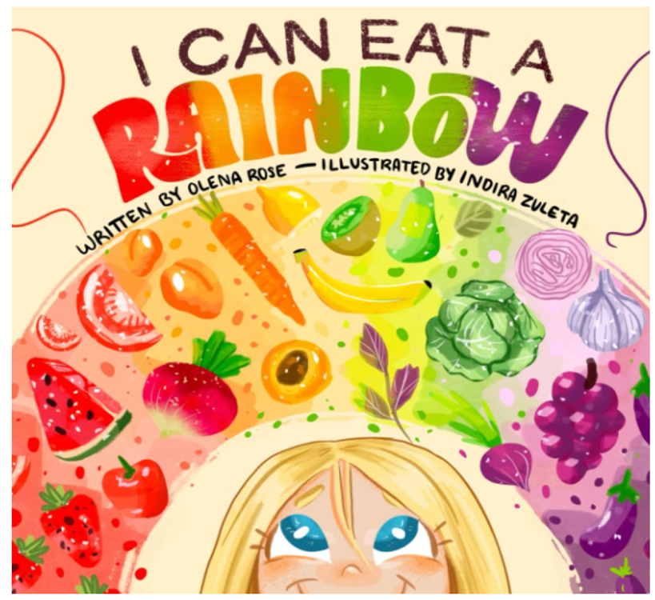
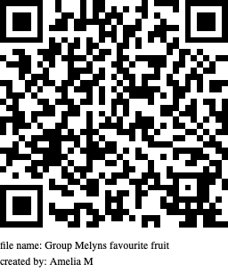
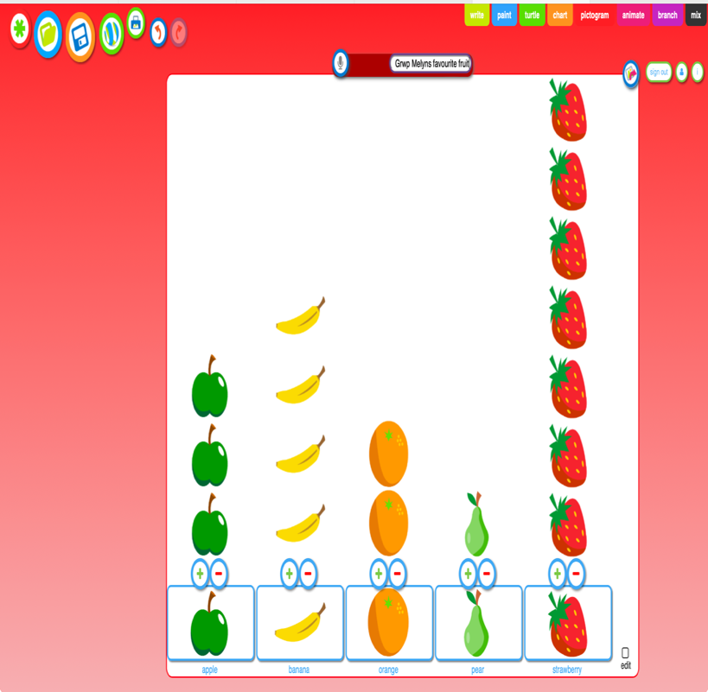
My Resource – Healthy Eating
After reading through the book ‘I Can Eat a rainbow’ as a whole class. In focus groups, pupils will create their pictogram representing the favourite fruits of their group.
Higher ability – Create a pictogram, print it off and answer the series of questions.
Middle ability – Create a pictogram and use the voice recording button to describe it e.g. the most/least popular. (The teacher then to convert it into a QR code and stick it in books).
Lower ability – create a pictogram (print out) and as a group discuss which was the most and least popular.
Higher ability Questions: to be answered in topic books.
- What fruit was the most popular?
- What fruit was the least popular?
- How many people chose strawberries?
- How many people chose bananas?
- What is your favourite fruit?

