BMIH6004
Hotel Placement – Managing Hotel Administration

Student Name: Georgiana Mirela Olaru
Student ID: 2021034

Table of Contents
Introduction 3
Effective Hotel Back Office Supervision Shadowing: A Critical Appreciation of Practical Key Skills 3
Analyses of Systematised Management and Discussions of Knowledgeable Hotel Administration 4
A Thorough Investigation of Hotel Operations and Changing Customer Demands 6
Theory-Driven Solutions in Hotel Administration 7
Conclusion 7
References 8

Introduction
Through my internship with the Novotel Southampton, I have started a transforming journey and explored the nuances of hotel administration. This reflective journey integrates three significant learning objectives, covering the importance of work-based essential skills, the assessment of management performance, and a thorough comprehension of significant concerns in the hospitality sector. To convey my personal life experiences in the specified professional role, I have used Gibb's reflective approach in my essay.

Effective Hotel Back Office Supervision Shadowing: A Critical Appreciation of Practical Key Skills
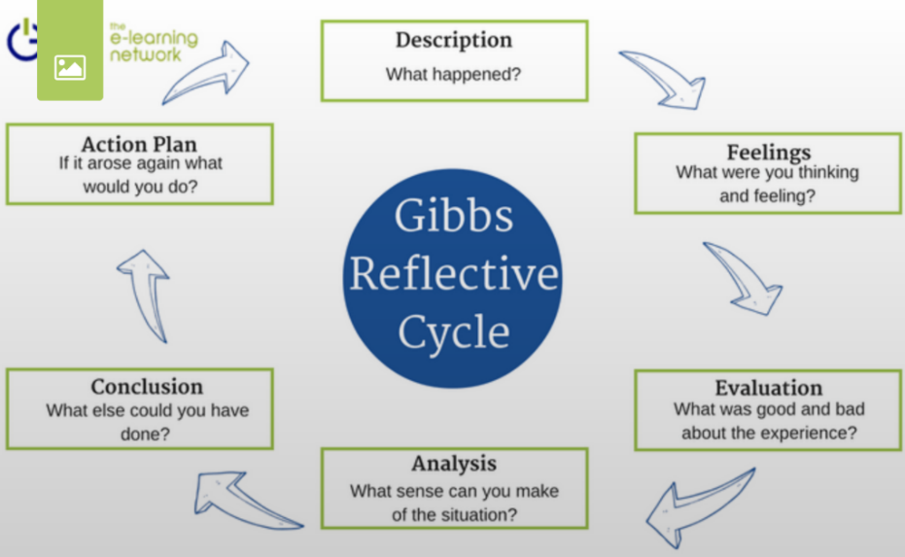
Figure: The Gibbs reflective model
(Source: E-portfolio, 2020)
Description: I took on a supervisory shadow job within the Hotel Back Office and Administration Operations during my employment at the Novotel Southampton. I was able to obtain practical experience managing numerous administrative duties and leading a team in this position (Tawanwongsri and Phenwan, 2019). I oversaw duties including managing payroll, scheduling employee schedules, and making sure the back office ran well.
Feelings: I began this adventure feeling both excited and nervous. The chance to learn and develop in a practical environment excited me, but I was also worried about my capacity to function well in a supervisory role. I was aware that to fulfil the demands of my role, I would need to adjust fast and successfully.
Evaluation: As I advanced in my shadow supervisory position, I came to understand the value of key work-based abilities. The team's ability to coordinate tasks and schedules required effective communication (Golumbic et al., 2022). I had to make sure that everyone agreed and that communication between the front and back offices ran properly (Kraus et al., 2022). This experience made me see how important excellent communication skills are for leadership.
Analysis: Along with communication, I improved my time management abilities. A methodical methodology was needed to balance numerous administrative chores, such as payroll, resource allocation, and health and safety regulations. I discovered how to organise my time well and prioritise my tasks to keep things running smoothly. The significance of work-based essential abilities and their direct connection to organisational effectiveness was confirmed by this experience.
Conclusion: Overall, my time in the Hotel Back Office and Administration Operations shadow supervisory position has been enlightening. I now have a clearer awareness of how important crucial talents are in the workplace. This insight has helped me to better understand the significance of acquiring these talents on the job.
Action Plan: I intend to keep looking for chances to take on leadership duties and roles to further develop my abilities in this area. For both personal and professional development, I think that practice and exposure to real-world situations are essential. To pinpoint areas that need growth and refinement.

Analyses of Systematised Management and Discussions of Knowledgeable Hotel Administration
Description: I had the chance to monitor and evaluate management performance within the hotel's working environment during my placement with the Novotel Southampton. My job also required me to actively participate in meetings and debates concerning hotel administration, which gave me an awareness of the nuances of this industry.
Feelings: It was insightful to watch and evaluate management performance. I initially had some sense of being overwhelmed due to how intricate the hotel's decision-making and administrative procedures were. But I was also eager to pick up knowledge from experts in the sector.
Evaluation: I became more aware of the value of methodically assessing management performance as I carried on observing and reviewing their performance (González-González and García-Almeida, 2021). This includes evaluating their leadership styles, resource management plans, and methods for preserving a strong workplace culture. I gained the ability to assess objectively the benefits and drawbacks of various management philosophies as well as how they affect the operation of the hotel.
Analysis: I noticed that resource allocation was a principal factor. The hotel's management team had to decide how to divide the funds, hire people, and spend money on facilities and technology. I observed how these choices had a direct impact on the hotel's capacity to deliver top-notch service and preserve a competitive edge (Alinasab et al., 2022). My comprehension of the challenges of resource management in the hotel sector has grown because of this experience.
Conclusion: I have gained valuable insight into the nuances of hotel administration thanks to my expertise in methodically analysing management performance inside the hotel's workplace environment (Holder et al., 2019). It has supported the notion that managerial choices have a significant bearing on the hotel's success.
Action Plan: I intend to continue studying and learning about management techniques, leadership philosophies, and the most recent developments in hotel management to expand my expertise in this field. I want to contribute significantly to future conversations on hotel administration by consistently using what I have learned and keeping up with changes in the industry.

A Thorough Investigation of Hotel Operations and Changing Customer Demands
Description: I thoroughly examined and comprehended a variety of important topics about the hotel sector throughout my time spent interning at the Novotel Southampton (Hu et al., 2019). Resource allocation, marketing tactics, management styles, workplace culture, health and safety regulations, software systems, training curricula, and the dynamic nature of consumer needs were among these concerns.
Feelings: It was intellectually interesting and thought-provoking to go through the process of methodically analysing and comprehending these complex subjects. I was first intrigued by how these components interacted with one another and affected the hotel's overall operations. I was, however, a little intimidated by these topics' complexity and dynamic character.
Evaluation: I came to understand the interconnectedness of each component as I dug deeper into these problems (Jewkes et al., 2021). For instance, decisions about how to allocate resources were influenced by marketing plans, which were in turn shaped by knowledge of shifting consumer wants. These difficulties were connected, and I discovered a methodical way to assess how they interacted.
Analysis: The significance of responding to shifting consumer wants was one of the most important lessons I learned. Understanding the changing preferences and expectations of visitors in the highly competitive and dynamic hotel sector is essential for success (Rogerson and Rogerson, 2021). To fulfil these evolving needs, the usage of software systems for data analysis and service customisation has become a crucial instrument. This insight emphasises how crucial it is to keep up with technological changes.
Conclusion: I now have a thorough awareness of the potential and challenges facing the hotel business because of my rigorous analysis and comprehension of numerous problems within this sector. I have been able to have a well-rounded understanding of the complexities of managing a successful hotel business because of this knowledge.
Action Plan: I will read frequently, go to workshops, and take online courses to keep up with changing consumer demands, market trends, and new software systems. I will look out for chances to use what I know and have learned in these fields. Making a solid professional network in the hotel sector will provide me access to a wealth of knowledge and experience.

Theory-Driven Solutions in Hotel Administration
My individual experiences have brought home how crucial theory is to overcoming practical difficulties. The Theory of Constraints emphasizes locating bottlenecks and using the Theory of Constraints Thinking Process to resolve them to optimise resource allocation (Mabin, 2015). The Kano Model, which divides characteristics into basic, performance, and exciting attributes, is necessary for adapting to changing consumer needs. Effective management approaches, built on the Contingency Theory, are flexible because they adapt to changing conditions. The Health Belief Model guides safety in ways to guarantee staff commitment to health and safety regulations (Limbu et al., 2022). Using technology adoption theory as a guide, hotel operations are made more efficient by implementing hotel property management systems. Kirkpatrick's Model is essential for evaluating and improving training initiatives and promoting ongoing development in hotel management.

Conclusion
I now have a profound awareness of the complex world of hotel administration thanks to this experience, which has given me priceless insights. Given my comprehensive awareness of work-based skills, management evaluation, and the dynamic nature of hotel administration, I am dedicated to lifelong learning, action, and participation within this fast-paced business.

References
Alinasab, J., Mirahmadi, S.M.R., Ghorbani, H. and Caputo, F., 2022. Discovering knowledge and cognitive based drivers for SMEs internationalization. Journal of the Knowledge Economy, pp.1-29.
E-portfolio, A.K.S., 2020. How does the Gibbs Reflective model integrate with Evidence-Based Practice in veterinary medicine?
Golumbic, Y.N., Motion, A., Chau, A., Choi, L., D'Silva, D., Ho, J., Nielsen, M., Shi, K., Son, C.D., Wu, O. and Zhang, S., 2022. Self-reflection promotes learning in citizen science and serves as an effective assessment tool. Computers and Education Open, 3, p.100104.
González-González, T., and García-Almeida, D.J., 2021. Frontline employee-driven innovation through suggestions in hospitality firms: The role of the employee’s creativity, knowledge, and motivation. International Journal of Hospitality Management, 94, p.102877.
Holder, N.A.K.A., Sim, Z.L., Foong, C.C. and Pallath, V., 2019. Developing a Reflection Guiding Tool for underperforming medical students: An action research project. Tuning Journal for Higher Education, 7(1), pp.115-163.
Hu, F., Teichert, T., Liu, Y., Li, H. and Gundyreva, E., 2019. Evolving customer expectations of hospitality services: Differences in attribute effects on satisfaction and Re-Patronage. Tourism Management, 74, pp.345-357.
Jewkes, R., Willan, S., Heise, L., Washington, L., Shai, N., Kerr-Wilson, A., Gibbs, A., Stern, E. and Christofides, N., 2021. Elements of the design and implementation of interventions to prevent violence against women and girls associated with success: reflections from what works to prevent violence against women and girls? Global programme. International journal of environmental research and public health, 18(22), p.12129.
Kraus, S., Breier, M., Lim, W.M., Dabić, M., Kumar, S., Kanbach, D., Mukherjee, D., Corvello, V., Piñeiro-Chousa, J., Liguori, E. and Palacios-Marqués, D., 2022. Literature reviews as independent studies: guidelines for academic practice. Review of Managerial Science, 16(8), pp.2577-2595.
Limbu, Y.B., Gautam, R.K. and Pham, L., 2022. The health belief model applied to COVID-19 vaccine hesitancy: A systematic review. Vaccines, 10(6), p.973.
Mabin, V., 2015. Goldratt's" Theory of Constraints" thinking processes: A systems methodology linking soft with hard.
Rogerson, C.M. and Rogerson, J.M., 2021. COVID-19 and changing tourism demand: Research review and policy implications for South Africa.
Tawanwongsri, W. and Phenwan, T., 2019. Reflective and feedback performances on Thai medical students’ patient history-taking skills. BMC medical education, 19, pp.1-8.

