UNIVERSITY OF WALES TRINITY ST DAVID
750 Formula Aerodynamics Report
Group Project – Final Design Report
BEng Motorsport Engineering
Harvey J. Britland, Nathanael Potts, Ashley Lane, Dora Boszormenyi, John Forster, Adrian Galka

March 2022


Document detailing the progression of the 750 Formula aerodynamic body through the use of computer-aided design (CAD) and computational fluid dynamics (CFD). The manufacturing process and braking systems were also reviewed and designed.

Table of Contents
1 Introduction (Harvey) i
1.1 Aims i
1.2 Objectives i
2 Project Organisation (Harvey) ii
2.1 Roles ii
2.2 Timing ii
3 Initial Understanding (Harvey) iii
3.1 Regulation Review iii
3.2 Aerodynamic Targets iv
4 MIRA Methodology v
4.1 Mesh Study (Harvey) v
4.2 Prism Layer Study (Dora) vii
4.3 Domain Size Study (Harvey) ix
4.4 Turbulence Model Study (John) x
5 Initial Design Concepts (Nathanael) xi
6 Baseline Model – Car 4 (Nathanael) xiii
7 Areas of Interest xiv
7.1 Front Wing/Splitter (Harvey) xiv
7.1.1 Introduction xiv
7.1.2 Methodology xiv
7.1.3 Design Iterations xvi
7.1.4 Areas of Issues xix
7.1.5 Conclusion xix
7.2 Sidepods/Venturi Tunnels (John) xxi
7.3 Rear Wing (Dora) xxiv
7.3.1 Research xxiv
7.3.2 Methodology xxv
7.3.3 Angle of Attack Investigation xxviii
7.3.4 Wing Position xxxii
7.3.5 Further Work xxxv
7.4 Diffuser (Nathanael) xxxvii
7.4.1 Diffuser Research xxxvii
7.4.2 Methodology xxxvii
7.4.3 Diffuser Designs xxxviii
7.4.4 CFD Testing and Analysis xl
7.4.5 Final Diffuser Design xlv
7.4.6 Conclusion xlvi
7.5 CFD (Ashley) xlvii
7.5.1 Introduction xlvii
7.5.2 Methodology and initial results xlvii
7.5.3 Measuring techniques xlix
7.5.4 Car 5 lii
7.5.5 Car 6 liv
7.5.6 Further investigations lviii
7.5.7 Centre of pressure lix
7.5.8 Speed variations and final results lx
7.5.9 Communication lxii
7.5.10 Areas for improvement lxii
7.5.11 Conclusion lxii
7.6 Manufacturing (Adrian) lxiii
7.6.1 Introduction lxiii
7.6.2 Research lxiii
7.6.3 Manufacturing processes lxiii
7.6.4 Materials lxvi
7.6.5 Brake Cooling/Windshield lxix
7.6.6 Conclusion lxx
8 Conclusions (Harvey) lxxi
9 Bibliography lxxii
10 Appendices lxxv
10.1 Minutes lxxv
10.1.1 26/10/2021 lxxv
10.1.2 04/11/2021 lxxv
10.1.3 30/11/2021 lxxvii
10.1.4 17/01/2022 lxxviii
10.1.5 24/01/2022 lxxviii

Table of Figures
Figure 1: Team Gantt Chart ii
Figure 2: Regulation boxes for 750 Formula chassis aerodynamic constraints (designed by Nathanael) iii
Figure 3: MIRA Mesh Study vi
4 x
Figure 5 - Car 1 CAD model xi
Figure 6 - Car 2 CAD model xi
Figure 7 - Car 3 CAD model xii
Figure 8 - Baseline model being drawn from 2D picture xiii
Figure 9 - Final Baseline model used to develop each area (car 4) xiii
Figure 10: Angle of Attack of Front Splitter xv
Figure 11: Efficiency of Angle of Attack xv
Figure 12: Car 4 Front End xvi
Figure 13: Optimised underside of front end of Car 4 xvii
Figure 14: Single vs Multi Element xvii
Figure 15: Multi vs Single Element xviii
Figure 16: Efficiency of Multi vs Single Element xviii
Figure 17: Strake Comparison xix
Figure 18: Pressure Comparison xx
Figure 19 - Floor and sidepods of a Lotus 79b Formula 1 car (Formula 1 Dictionary, 2021) xxi
Figure 20 - Topside of left sidepod xxii
Figure 21 - Sidepod Inlet xxii
Figure 22 - Sidepod Outlet xxii
Figure 23 - Coefficient of lift and coefficient of drag against outlet height (mm) xxiii
Figure 24 - Coefficient of lift and coefficient of drag against inlet height (mm) xxiv
Figure 25- Airfoil Geometry xxv
Figure 26- Wing Design xxvi
Figure 27- Wing Profile xxvi
Figure 28- Wing Position xxvii
Figure 29- Pressure Contour of Wing at 5 degrees xxx
Figure 30-Pressure Contour of Wing at 11 degrees xxxi
Figure 31-Velocity Contour of Wing at 5 degrees xxxi
Figure 32-Velocity Contour of Wing at 11 degrees xxxii
Figure 33- Middle Top Position Pressure Contour xxxiv
Figure 34- Middle Top Position Streamlines xxxiv
Figure 35- Middle Top Velocity Vectors xxxiv
Figure 36- Middle Top Velocity Contour xxxv
Figure 37- S1223 Airfoil xxxv
Figure 38- Angle of Attack on S1223 (Doosttalab, Mohammadi, Ashrafizadeh, & Doosttalab, 2012) xxxv
Figure 39- Wing Mounts xxxvi
Figure 40- Swan Neck Wing Mounts xxxvii
Figure 41 - Straight angled diffuser CAD model xxxix
Figure 42 - Radius diffuser CAD model xxxix
Figure 43 - Diffuser with three added strakes CAD model xl
Figure 44 - Graph demonstrating the Coefficient of downforce and Coefficient of Drag change depending on the Angle of Attack xl
Figure 45 - Graph demonstrating the efficiency of each angle of attack xl
Figure 46 - Flow vectors on the 10 degree angled diffuser xli
Figure 47 - Graph demonstrating the Coefficient of downforce and Coefficient of drag against the diffuser radius xli
Figure 48 - Graph demonstrating the efficiency of the diffuser radius xlii
Figure 49 - Flow vectors of the 2400mm radius diffuser xlii
Figure 50 - Graph demonstrating the coefficient of downforce and coefficient of drag against the diffuser length xliii
Figure 51 - Graph demonstrating the efficiency of the diffuser length xliii
Figure 52 - Graph demonstrating the coefficient of downforce and coefficient of drag against the number of strakes xliii
Figure 53 - Graph demonstrating the efficiency of the number of strakes xliv
Figure 54 - Flow vectors of the diffuser with a skirt. Vorticity forming circled in red xliv
Figure 55 - Screenshot of the flow vectors underneath the diffuser with skirt xlv
Figure 56 - Screenshot from the rear of the car of flow vectors around the diffuser without skirt xlv
Figure 57 - Final diffuser design xlvi
Figure 58 - Final diffuser design from the rear xlvi
Figure 59 - Final Diffuser design with flow vectors around the diffuser xlvi
Figure 60 Car 6 velocities xlvii
Figure 61 Car 1 model xlviii
Figure 62 Race helmet xlix
Figure 63 Measuring device l
Figure 64 Point cloud l
Figure 65 FMEA table li
Figure 66 Rear body section lii
Figure 67 Car 5 lii
Figure 68 Car 6 liv
Figure 69 Car 6 Radiator liv
Figure 70 Car 6 Safety switch lv
Figure 71 Car 6 Focus on splitter pressure lvi
Figure 72 Car 6 velocities on a cut plane lvii
Figure 73 Car 5 individual areas graph lviii
Figure 74 Car 6 individual graphs lix
Figure 75 Car 4 Center of pressure lix
Figure 76 Car 5 Center of pressure lx
Figure 77 Car 6 center of pressure lx
Figure 78 Car 5 speed investigations lx
Figure 79 Car 6 speed investigations lxi
Figure 80 Car 5 vs Car 6 lap times lxi
Figure 81: Resin Infusion lxiv
Figure 82: Resin Infusion Process lxiv
Figure 83: Prepreg lxv
Figure 84: Wet Layup lxvi
Figure 85: Flax Fibre lxvi
Figure 86: Stainless Steel lxvii
Figure 87: Kevlar lxviii
Figure 88: Glass fibre lxviii
Figure 89: Car 2 (no windshield) lxix
Figure 90: Car 2 (with windshield) lxix

Table 1: Roles of Aerodynamics Team ii
Table 2: Mesh Study vi
Table 3- Prism Layer Study vii
Table 3: Front End Overall Results xix
Table 5- Angle of Attack Results Table xxx
Table 4 Initial results xlviii
Table 5 Car 5 results liii
Table 6 Car 6 Splitter modifications lvi
Table 7 Car 6 lowered wing lvi
Table 8 Car 6 diffuser modifications lvii
Table 9 Car 5 against Car 6 lvii
Table 10 Car 5 individual areas lviii
Table 11 Car 6 individual areas lviii
Table 12 Car 5 vs Car 6 percentage change lix
Table 13 Table of communication lxii
Table 14: Car 2 Results (Ashleys) lxix
Table 15: Car 2 (with windshield) lxx

Acknowledgments
The team would like to express their deepest gratitude to Tim Tudor (UWTSD) for his invaluable input towards understanding the use of multiple software as well as input into key areas of interest for the bodywork.
The team would also like to thank Ben Gilbert, 3rd year student of UWTSD, for several measured components of the Falcon Racekit as it allowed us to speed up the process of getting an accurate model saving the team valuable hours.

Introduction (Harvey)

Aims
To develop a complete theoretically working bodywork package for the 750 Formula racing series.

Objectives
In order to achieve this aim, the group had several key objectives to complete. The first was to develop a method for understanding and completing an accurate and repeatable methodology. This is to be done on the MIRA Notch car inside Ansys Workbench 16.2. By running the MIRA car through this validation study, it will allow us to know that the subsequent designs run through will be reliable. Once this validation study is complete, the individual areas of the car will then have several studies performed upon them, with design iterations and improvements then tested and the results recorded. From here, post processing will allow the team to understand where poor areas of lift and drag are and can be tweaked to further improve the overall design. Simultaneously, several methods of measurement including photogrammetry will take place to measure a current kit being used in the 2021 championship.

Project Organisation (Harvey)

Roles
Table 1: Roles of Aerodynamics Team
Name | Primary Role | Secondary Role
Harvey Britland | Team Lead | Front Splitter Design
Nathanael Potts | CAD Lead | Diffuser Design
Ashley Lane | CFD Lead | Bodywork Measurement
Dora Boszormenyi | Rear Wing Design
Adrian Galka | Manufacturing Lead | Brake Cooling
John Forster | Sidepod Design

Above, in Table 1, are the current roles in which the team have taken. These were decided upon within the first week of the groups formation and were chosen with consideration to the various team members strengths. Those that had a further knowledge and understanding of CFD processes were chosen to pursue that area of study.

Timing
To keep the project on track, time management is a key element in ensuring the progression of development is kept at a steady pace. Having a Gantt chart that all team members can use and have a copy of allows members to have a greater understanding of where the team should be and what they should be doing at any given moment.
Figure 1: Team Gantt Chart

Initial Understanding (Harvey)

Regulation Review
To understand the technical boundaries that the team faced when designing the bodywork for the 750 Formula chassis, the regulations were examined. From here, sections of the car were then broken up to form key areas of interest. In order to visualize the constraints each area of the car is under, a rough shape of the vehicle was created using regulation boxes. This is to make sure that elements that are being designed on the vehicle do not fall outside of the given technical parameters.
As can be seen in Figure 1, the vehicle has several areas that are constrained. Highlighted in red, the constraint showed is the minimum floor height from the ground. This is 40mm, as per regulation 5.6.1.6 of the 750 Formula Championship 2021 (The Seven Fifty Motor Club Limited, 2021). This in turn is a regulation as presented by Motorsport UK as regulation J5.20.11 (Motorsport UK, 2019). This is measured standing with occupants on board, meaning that with certain aerodynamic features, such as Venturi tunnels, the car may run closer to the ground while running due to a vacuum forming on the underside of the car. This could be a particular area to explore.
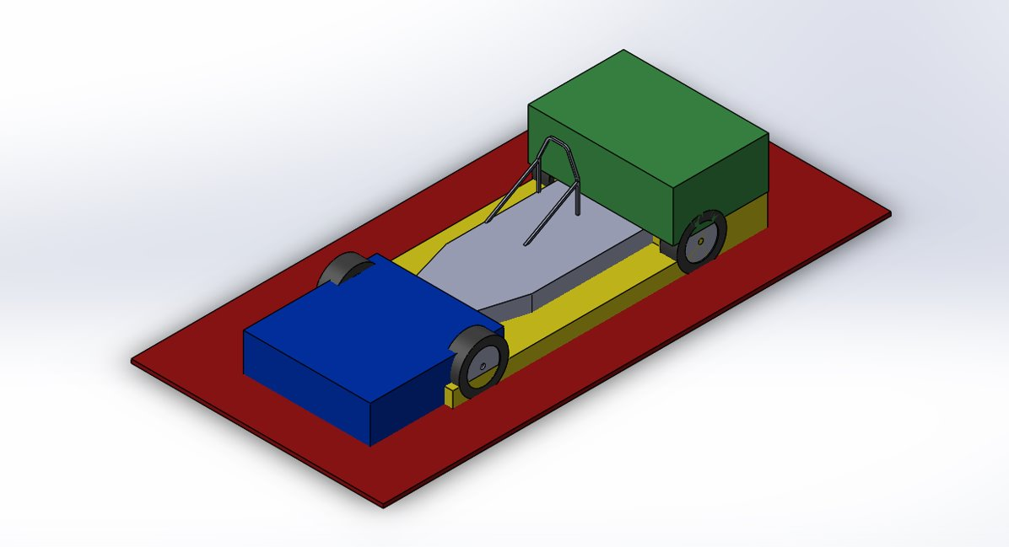
Figure 2: Regulation boxes for 750 Formula chassis aerodynamic constraints (designed by Nathanael)
A second area of interest is highlighted in blue in Figure 1. This is the frontal area of the car, detailing how large the area in which the frontal aerodynamic elements are constrained. Regulation 5.6.1.4.i of the 750 Formula Championship 2021 details that
“Aerofoil devices ahead of the front wheels are permitted, but must be below the top of the front wheel rims and not exceed in width the centre line of the front tyres. They must form a continuous part of the bodywork.” (The Seven Fifty Motor Club Limited, 2021).
This means that the splitter or front wing, whichever the competitor decides to employ on their car, must not sit above the top of the front wheel rims. It does not say however, that the joining bodywork (as it has to be continuous) has to be below the front wheel rims so this could be an area to exploit in the regulations.
Regulation 5.6.1.4.iv “Any forward facing horizontal splitter attached to the lowest edge of the front bodywork may not exceed the maximum overall width of the wheels or bodywork whichever is the greater.”
The third area with constraints is at the rear of the car, highlighted in green in Figure 1. This outlines the limits in which the rear wing can be placed, as well as width and height restrictions. The rear wing has several regulations surrounding its build and size. Regulation 5.6.1.4.ii states the “chord must not exceed 30cm (11.8in). Maximum width to be full body width or outermost track whichever is the greater” (The Seven Fifty Motor Club Limited, 2021). It also states that
“Any rear aerofoil or bodywork must not overhang the rear of the vehicle by more than 70cm (27.5in) measured from the centre line of the rear wheels. The height of any bodywork or aerofoil must not exceed 90cm (35.4in) with the driver aboard, measured from the ground, excluding safety roll over bars, or bodywork of closed cars between the centre line of the front and rear wheels.”

Aerodynamic Targets
The aerodynamic targets for the vehicle are based upon 2 areas: improvement over the current Falcon race kit that is on the chassis and a coefficient of lift and drag close to that of the MCR race car that the University of Wales Trinity St David is running in the 2022 Sports 2000 Duratec championship. These values have been provided by the university with the current car having a lift coefficient of -2.67 and a drag coefficient of 0.72, therefore with an efficiency of -3.68. This is a car that does not run with venturi tunnels nor a diffuser due to the regulations for that series. Therefore the aim is to get as close to the values of the MCR as possible with the original aim of the car to have a lift coefficient of -2 and a drag coefficient of 0.7.

MIRA Methodology
In order to create a reliable methodology for improving the bodywork, it is important to create an accurate and repeatable methodology to then compare against known values. To do this, the MIRA reference car was used and analysed in Ansys Workbench, a software using the Navier Stokes equations to solve and understand air flow over a body (Ansys, Inc, 2022). Known values were obtained by a previous study on this vehicle (Hu, Yang, Yang, Li, & Lei, 2015). Several studies had to take place in order to validate the methodology; these are the mesh, prism layers, domain size and turbulence model.
In order to carry out the appropriate testing, the MIRA notchback car was downloaded as a file and then kept unchanged in order to keep results as consistent as possible. The method in which these tests took place were carried out with all variables under test conditions, with the only variable changed being the one investigated for a particular study.

Mesh Study (Harvey)
A key area of interest was the mesh study. This was to best understand the compromise between the size of the meshing of the model and the speed at which the meshing can take place. A range of mesh sizes were considered and so to carry out this study, the mesh size needed to be changed globally.
This was done using the “Global Mesh Setup” tab in ICEM CFD, inside Ansys Workbench 16.2. Here, the scale could be changed. The scale factors chosen for this study ranged between 0.7 and 1.2. The values chosen were to show the computational effects would have with different mesh sizing. Once the model had been placed inside the geometry feature inside Ansys and the tunnel drawn and created around it, the meshing could take place inside ICEM CFD. A prism layer of 5 was used throughout this process, inputted under the “Part Mesh Setup” tab. The car was also set to have a maximum size under this tab of a scale of 0.05. performed using the “All Tri, Patch Independent” parameter. One of the determined values were chosen to be run as the global element scale factor from that particular run and the mesh was computed from this.

Table 2: Mesh Study
Mesh Number | Scale Factor | Coefficient Lift | Coefficient Drag | Iterations
Mesh 1 | 1.3 | -0.22907179 | 0.32529896 | 388
Mesh 2 | 1.2 | -2.7009705 | 0.45482257 | 301
Mesh 3 | 1.1 | -0.11888322 | 0.30464199 | 453
Mesh 4 | 1 | 0.30891929 | 0.097129213 | 571
Mesh 5 | 0.9 | 0.3008674 | 0.47656994 | 1136
Mesh 6 | 0.8 | -0.10150782 | 0.29241044 | 545
Mesh 7 | 0.7 | 0.25728311 | 0.50781511 | 1967
Mesh 8 (rerun) | 1.2 | -2.7010116 | 0.45482949 | 301

Figure 3: MIRA Mesh Study
Key consistent variables were kept the same throughout the study to ensure accurate and repeatable results. The results from this study are shown in Table 2. The best result to be had from the study would be a compromise between the number of iterations and the size of the mesh. Therefore, the results shown in Figure 2 suggest that the scale factor of 0.8 would be the best option for completing the mesh due to its small mesh size as well the relatively low number of iterations (545). A rerun was done for the scale factor of 1.2 but found the results almost directly comparable, with both runs giving almost the exact same negative lift. This is a clear outlier and so will be ignored for the duration of the MIRA validation.
However, when running Car 4 it was found that this mesh was not fine enough as it could not mesh the slimmer elements properly. A test on Car 4 found that in order to get a proper mesh on all of the car, the mesh sizing had to be reduced to 0.5. Subsequent cars were therefore run at a global mesh size of 0.5 to ensure a proper mesh.

Prism Layer Study (Dora)
An important study for the methodology was finding the optimum amount of prism layers to run on the MIRA car. The prism layers capture or resolve the strong transverse gradients of the solution (i.e.velocity) within the boundary layer. In order to ensure that the correct number of layers are applied, the study started from 0 prism layers and worked its way up to a point in which the coefficient of drag and lift became constant. That ensured that the results that were being seen were not being affected by the number of prism layers.
Table 3- Prism Layer Study
No. of prism layers | Coefficient of Drag | Coefficient of Lift | Efficiency
0 | 0.28 | -0.17 | -0.60
1 | 0.32 | -0.12 | -0.37
2 | 0.31 | -0.15 | -0.48
3 | 0.32 | -0.14 | -0.44
4 | 0.31 | -0.13 | -0.42
5 | 0.31 | -0.10 | -0.33
6 | 0.31 | -0.09 | -0.29
7 | 0.31 | -0.09 | -0.28
8 | 0.31 | -0.08 | -0.24
9 | 0.31 | -0.08 | -0.24
10 | 0.31 | -0.08 | -0.24

Table 3 shows the results obtained from Ansys. As seen in the table, the coefficient of drag starts to become constant after 4 prism layers however the coefficient of lift was still changing. Thus, meaning that the overall results were still being affected by the number of layers meaning the boundary layers were not being captured entirely. Both coefficients of drag and lift started to stabilise around 8 layers. Both coefficients of drag and lift reach the actual values of the MIRA car (Hu, Yang, Yang, Li, & Lei, 2015) which proves that anything above 8 layers is sufficient. The reason why it was decided to use 8 prism layers in the final studies is because the efficiency stays the same for all layers above 8 as well as computing time. The computing time increased with each layer therefore it was decided that there was no use of having extra layers.

Graphs 1 and 2 show the coefficients of drag and lift plotted against the number of layers and Graph 3 shows the efficiency.

Graph 1- Prism Layer Study Drag

Graph 2- Prism Layer Study Lift Coefficient

Graph 3- Efficiency of No. of Prism Layers

Domain Size Study (Harvey)
The domain study was to be carried out by a member of the team who unfortunately dropped out late on into the project, meaning by the time the other deadlines for the group were due, it was too late to complete this study as it had not been started. Therefore, a standard domain size (the same size as the MIRA wind tunnel) was chosen. The resulting size of the domain was 10m forward from the origin, 25m to the rear of the origin and 4m tall, with a slight cut off on the wheels to simulate the wheels under weight when air moves around the car.

Turbulence Model Study (John)
Another key area of interest was to study the different turbulence models in Ansys Workbench 16.2. This was to determine the best turbulence model to use on our concept ideas for the aerodynamic package for the 750 Formula car. This was necessary as each different model in Ansys workbench give different values depending on the model. Therefore, the model that gave the closest values for the coefficient of lift and the coefficient of drag to the known values of the MIRA car shown in Figure 2 was the turbulence model to use. Following the study, the turbulence model that was selected to be used going forward was the k-epsilon realizable turbulence model as this model gave the closest value for the coefficient of drag and coefficient of lift to the actual measured values from the Mira reference car shown in table 1. (The results for all the turbulence models analysed in this study is shown in table 2). This result is also supported by (Zhou Hua, 2016) as in their report it states that “The most suitable two-equation turbulence model was validated as realizable k-epsilon approach”. However, the study referenced was tested to the conditions in the Aerodynamic and Aero-acoustic Wind Tunnel of Shanghai Automotive Wind Tunnel Center (SAWTC) rather than the conditions of the MIRA wind tunnel.
Table 1: Known values of coefficient of lift (cl) and coefficient of drag (cd) for MIRA reference car
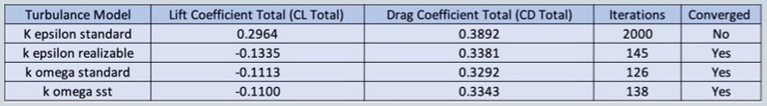
Table 2: Values for the coefficient of lift, coefficient of drag, the number of iterations and if the CFD run converged
As the K epsilon standard model did not converge it was deemed necessary to run that model to 2000 iterations to acquire an accurate coefficient of lift and coefficient of drag for that turbulence model. This turbulence model was then not chosen as it gives a positive coefficient of lift.
4

Initial Design Concepts (Nathanael)
To decide on an aerodynamic philosophy for the car, three initial concepts were modelled based on the existing formula 750 cars. Using research three main concepts were identified within the championship. These concepts were modelled so that Ashley could run them in ansys to give us a better understanding of how they perform aerodynamically. Although the models aren't a true representation of the cars in real life, due to the fact they were modelled using pictures sourced instead of accurate measurements, they still gave us results that we could anaylse moving forward.
The first concept car 1, drawn by Ashley, was based off a prototype style bodywork with fairings over the wheels. In the following figure is a screenshot of car 1. You can see that the wheels have wheel fairings, there is a rear wing as well as the Formula 750 roll hoop.
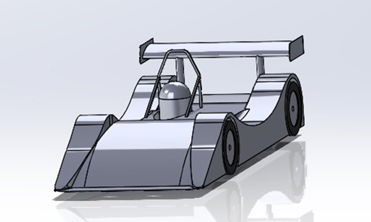
Figure 5 - Car 1 CAD model
The second concept car 2, drawn by Nathanael, was based off a formula 1 style bodywork as an open wheeler and a front wing instead of a splitter. In the following figure is a screenshot of car 2. From this you can see that the wheels have no fairings, there’s a rear wing and a formula 1 style multi-element front wing.
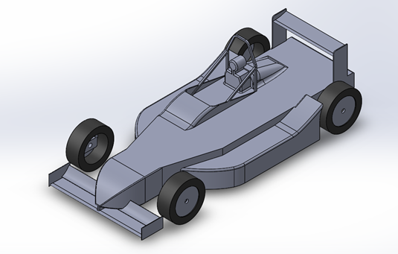
Figure 6 - Car 2 CAD model
The third concept car 3, drawn by Nathanael, was a fully enclosed style car with the wheels fully covered over seen in the following figure. You can see the difference from car 1 and 2 as the wheels are fully enclosed. This would in theory, reduce the aerodynamic drag from the car. As well as the wheels being fully enclosed, the car has a rear wing and a diffuser to produce negative lift.
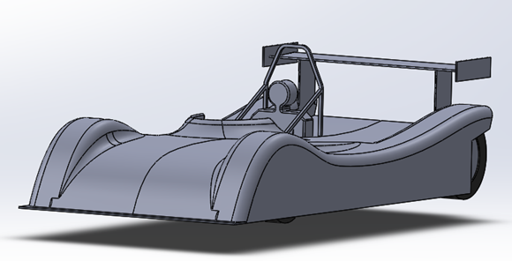
Figure 7 - Car 3 CAD model
Each design concept was run in CFD by Ashley so we could then anaylse the aerodynamic results from each of the concept so then we could discuss and decide what aerodynamic route we wanted to explore further.

Baseline Model – Car 4 (Nathanael)
The baseline model was designed from pictures of the Falcon race kit imported into CAD to generate a baseline model that would could be run to give us initial results from the falcon kit. This model could also then be used as the baseline to develop each individual area of study to optimise the performance from that area. Although the baseline model was drawn from pictures of the falcon race kit seen in figure() below, the CFD results weren’t a true representation of the what the falcon kit could produce aerodynamically. This is due to the fact that there was limitations when using 2D pictures imported into CAD to create a 3D model. It did however make for an ideal baseline model that could be editing and transformed according to each individuals study. The below figure is a screenshot of the baseline model being designed in SolidWorks using a 2D image.
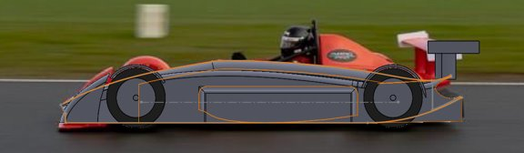
Figure 8 - Baseline model being drawn from 2D picture
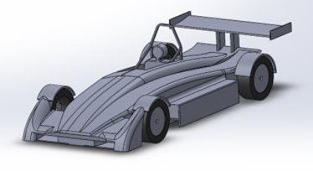
Figure 9 - Final Baseline model used to develop each area (car 4)
The above figure is the final baseline model that was generated in CAD which went on to be the overall baseline model used for each study.

Areas of Interest

Front Wing/Splitter (Harvey)

Introduction
The front of the car is where the highest area of pressure will be found as it is the first point of contact to the airflow. It shapes how the rest of the air will move over the rest of the cars aerodynamic devices function. Therefore it is vital that the design is optimised to create the best efficiency between lift and drag on not only the front of the car, but the rest of it as it will affect the performance of the diffuser (Tech, Reddy, & Gupta, 2006). There are several areas of interest; splitter vs wing, the angle of attack, length of protrusion, multi vs single element and strakes.
Commonly seen on touring cars, a front splitter is a key aerodynamic device that helps to direct air flow. A splitter works by forcing high pressure up and over it, creating low pressure beneath the splitter. This consequently helps to push the splitter towards the ground, resulting in an increase in traction (Time Attack Ltd, 2014). Optimising this is important as a too aggressive front splitter will result in reduced air flow under the car, creating increased drag.

Methodology
The first area of research was the comparison of having a front splitter vs a front wing. The initial study was the comparison of Car 2 vs Car 4. Car 2 was the Formula style car with a front wing. This was then ran through Ansys and compared against the results of Car 4. Results pointed towards a Formula style car as it has a better efficiency ratio than the Falcon race kit. However, after consideration and comparing the top runners on the grid, it suggested a front splitter style design as it had a better efficiency ratio once the simulation was run with moving wheels and floor. Therefore, the baseline car was designed to have a front splitter, which is where the rest of the front area studies occurred.
The next area of interest was the angle of attack. The front splitter angle will have a drastic effect on the amount of negative lift it can generate. Therefore, it is important to understand how changing the splitter angle will affect the car. A range of values were chosen to be investigated through this study. The angle of attack values chosen were 3, 5, 7 and 10 (all in degrees). Several other angles were chosen but due to the length of time that Ansys takes to solve a model running through the wind tunnel, these were the values ran. As can be seen in Figure 6, the best performing angle of attack was 5 degrees with a coefficient of lift and drag of -0.27982 and 0.60854 respectively. However, running the front wing at 7 degrees gave a very similar coefficient of lift of -0.28269 but with a slightly high coefficient of drag of 0.701892. In order to present the results more clearly, an efficiency graph was produced which can be seen in Figure 7. The graph shows that the most efficient angle for producing negative lift compared to drag was the 5 degree angle. Through research, this result was corroborated by other studies where it was found that 5 degrees was the optimum angle for the front aerodynamic device (Fareeq, 2015). Once this result had been produced, the splitter length was researched.
Figure 10: Angle of Attack of Front Splitter

Figure 11: Efficiency of Angle of Attack
A preliminary investigation was conducted on splitter protrusion length. Though no substantial results were produced, research shows that by increasing the protrusion of the splitter, the increase of surface area that the air will flow over helps to improve the amount of downforce that can be created (Roberts, 2013). There is a limit to the protrusion in that as the area is increased, its effectiveness will reach a cliff and drop off rapidly. This is due to a decrease in the difference of air speed the further the air is split from the bodywork of the car. This would be an area of interest if the car was to be researched further.

Design Iterations
After initial research into the way the front splitter could be optimised, the overall design of the front end of the car was changed to help increase airflow to the rear while increase the amount of downforce that the front end could create. To do this, a large section originally created when Car 4 was built was cut away, and the subsequent floor was tapered off at a slight angle to help better direct the flow of air towards the rear.
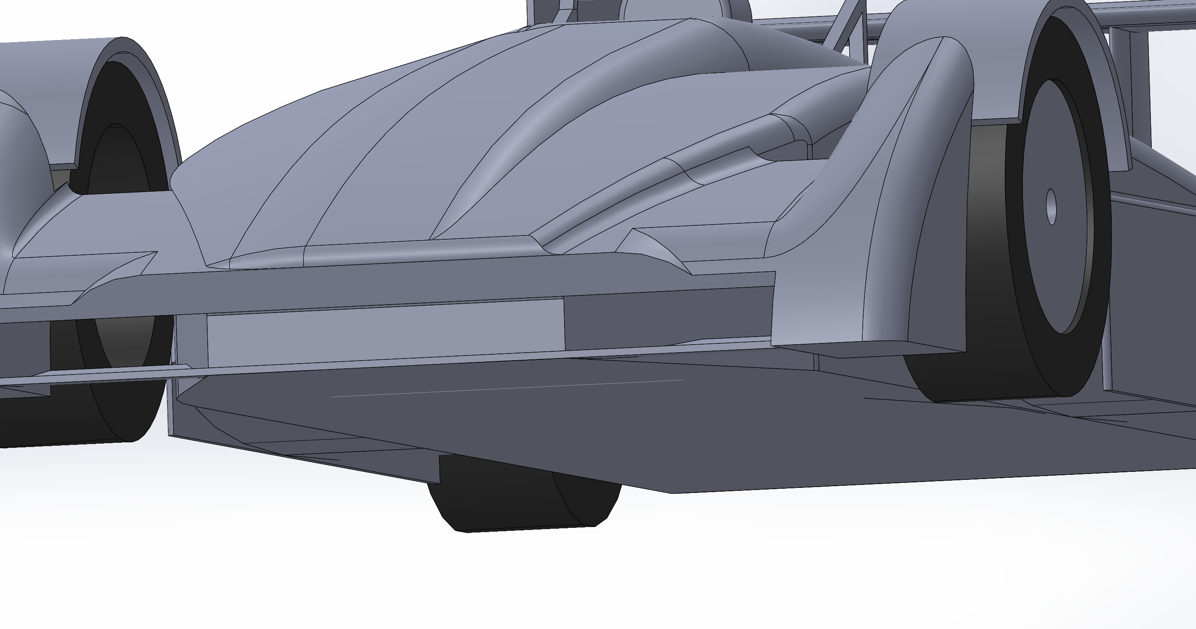
Figure 12: Car 4 Front End
As can be seen in Figure 8, the front of the car has a huge section where a high area of pressure builds up. This is not ideal as it creates a very large amount of drag. Air is directed to the sides to help funnel air towards the venturi tunnels but it is still a very crude design. However, as can be seen in Figure 9, the sloped edge, combined with strakes and better designed side splitters helped to channel the air flow in a more streamlined fashion without having the huge block creating drag. There is still a build up of pressure which can be found around the edge of the opening of the front end of the car. From here, the front end was optimised further. 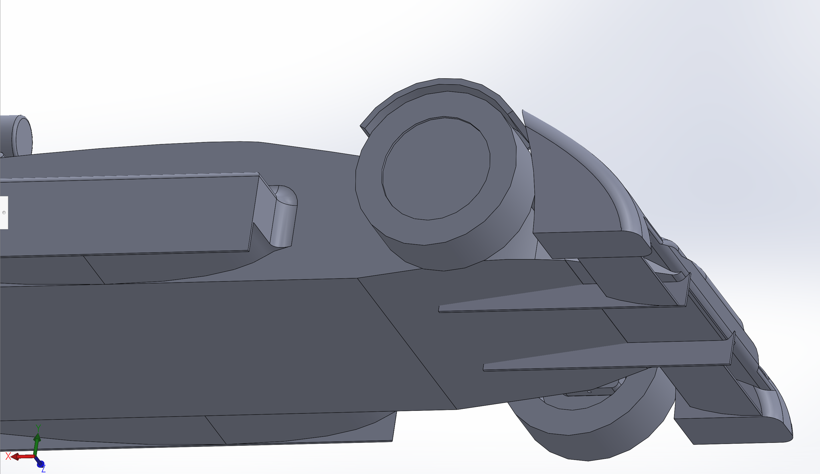
Figure 13: Optimised underside of front end of Car 4
The next area of interest for the car was to optimise the design of the splitters themselves. As already highlighted in Figure 9, the baseline model was improved upon with a better and more streamlined front end. Part of this streamlining was considering the use of a middle plane to increase downforce, though it would slightly hinder air flow to the rear of the car. As shown in Figure 10, the car was ran through Ansys with the same wing angles on the outers (7 degrees) but with one with a 0 degree middle plate. The idea behind this concept was that if the middle element was also angled, it would force too much air onto the underside of the floor, pushing upwards.
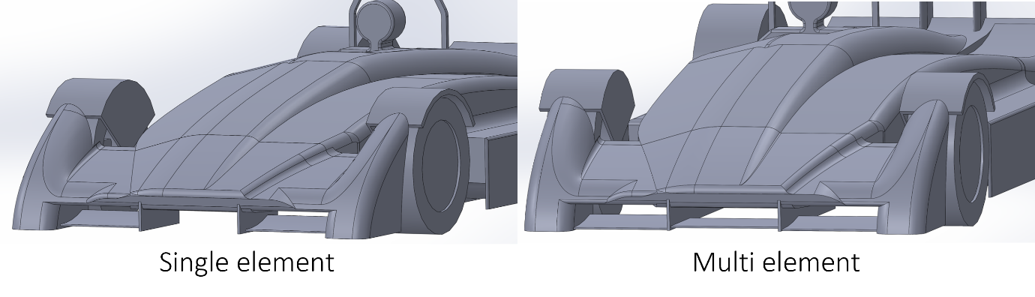
Figure 14: Single vs Multi Element
The results produced, as seen in Figure 11, showed that by leaving the gap open for air to pass straight to the diffuser, the coefficient of lift was far lower than the two runs using the middle element. The rerun was done to see whether the solving in Ansys was done correctly as the front end should not have been producing positive lift. This was a problem faced a number of times throughout this project.

Figure 15: Multi vs Single Element
In order to make the results as clear as possible, an efficiency ratio graph was produced to clearly show the effect that the middle plate elements had.

Figure 16: Efficiency of Multi vs Single Element
Another design decision was to add strakes to front end. This was a design that was iterated upon to run further along the car which yielded a better result than the shorter strakes. These can be seen in Figure 13. Version 3 was improved upon slightly with the smoothing out of surfaces, hence has a better result on the final result table, as seen in Table 3.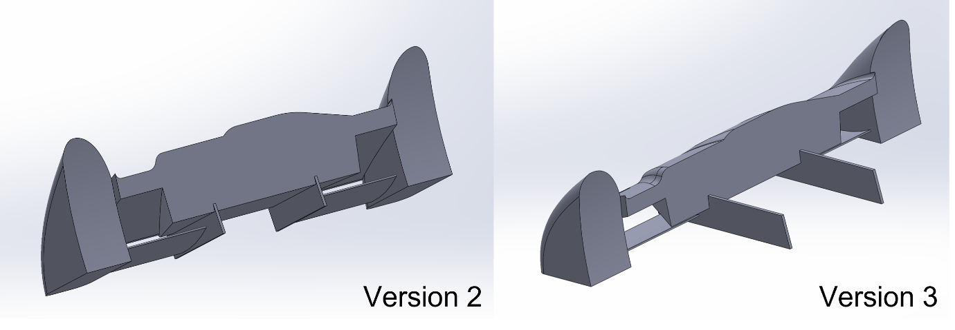
Figure 17: Strake Comparison

Areas of Issues
When attempting to complete this areas of the car, there were several areas that caused issues. First, due to the fact that air flow manipulated by the front elements of the car affected the flow over the rest of the car, the entire car had to be run in Ansys Workbench which slowed the rate of progression when optimizing the various elements of the front end. Therefore, to try and mitigate this, smaller studies were performed but researching multiple areas of the front end. A major issue faced was Ansys not performing as it should, with results being incredibly wrong compared to where they should be. To show this, a result has been left in Table 3 that shows that even though that particular model was run under the same conditions as all the other models, it can come back with wrong results. This in turn meant hours lost trying to fix a model or restarting the process entirely inside Workbench 16.2. The process was very labour intensive and a solution for further studies would be to gain a better understanding of the software before performing such studies to mitigate as many errors occurring.

Conclusion
Table 3: Front End Overall Results
 | AoA | Cl | Cd | Efficiency | Converged? | Iterations
FW AoA 3 Deg | 3 | -251.823 | 9.545889 | -26.3803 | No
FW AoA (updated FEnd) 3 Deg | 3 | 0.177675 | 0.692738 | 0.256482 | No | 416
FW AoA 5 Deg | 5 | -0.27982 | 0.608543 | -0.45982 | No | 2050
FW AoA (updated FEnd) 5 Deg | 5 | -0.28323 | 0.617643 | -0.45856 | Yes
FW AoA 7 Deg | 7 | -0.28269 | 0.701892 | -0.40276 | No
FW AoA 10 Deg | 10 | 1.34149 | 0.870976 | 1.540214 | No | 3102
Updated FEnd V1 | 12 | -0.09725 | 0.719894 | -0.13509 | No
Updated FEnd V2 | 12 | 0.199571 | 0.745247 | 0.267792 | No | 3055
Updated FEnd V2 (rerun) | 12 | 0.214413 | 0.729291 | 0.294002 | Yes | 590
Updated FEnd V3 | 7 | -0.21793 | 0.692372 | -0.31476 | Yes | 921
Updated FEnd V4 (7 Deg) | 7 | -0.28778 | 0.66617 | -0.43199 | Yes | 878

Overall, the design has been optimised as a new baseline. Overall, the design was an improvement upon the original car 4 front end. There are certainly areas of improvements for the design. For instance, canards could have been added to the sides of the front end to help gain extra downforce without creating too much extra drag (Szudarek & Piechna, 2021). There has also been an improvement in my knowledge of both the material subject and the software which will be important for the future. The design shows an overall improvement which can be seen in Figure 14 below. This can be seen visually by the increase of blue under the front on the splitter, showing an improvement and a darker blue compared to the original design. The overall improvement, using the individual study results Ashley performed, shows an increase of lift from -0.1592 to -0.3165 which is almost a 100% increase.
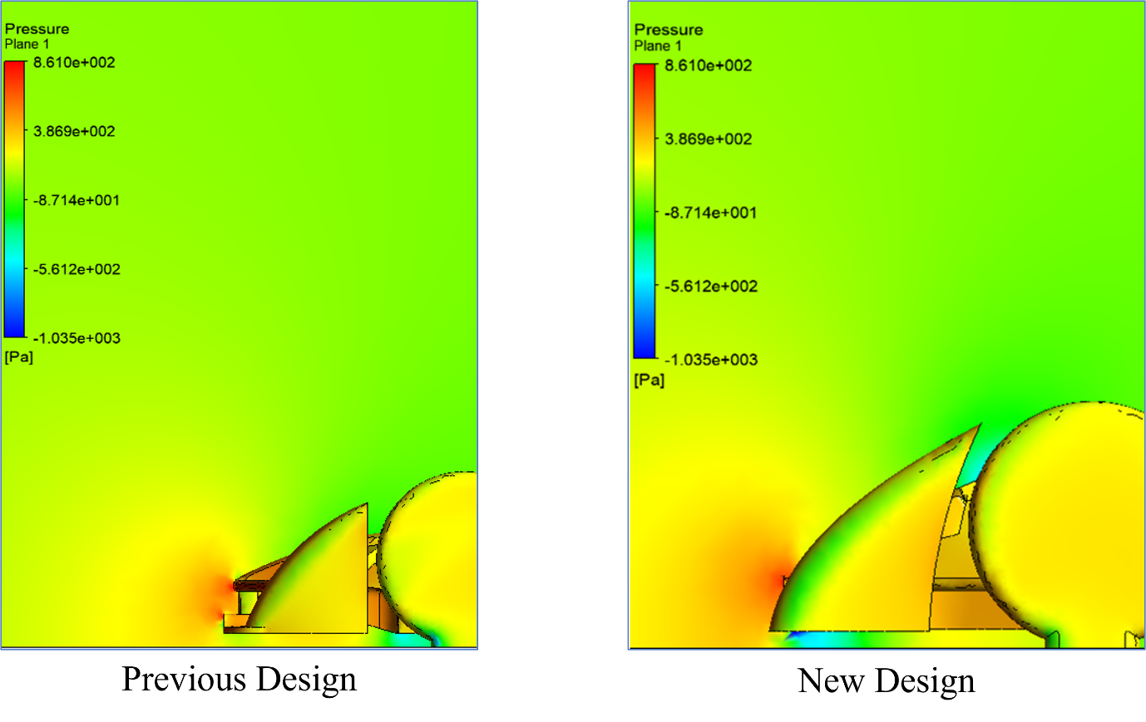
Figure 18: Pressure Comparison

Sidepods/Venturi Tunnels (John)
7.2.1 Regulations & Research
Ground effect is a very powerful way for a car to generate downforce which is why the 750 Formula car incorporates ground effect into the cars design. This is allowed in the 750 Formula regulations as ground effect devices such as venturi tunnels are not specified in the regulations (750 Motor Club, 2021). Therefore, the 750 Formula car incorporates venturi tunnels into the sidepods as a part of the aerodynamics so that it can generate more downforce (negative lift). Figure 1 shows the air flow under a ground effect racing car.
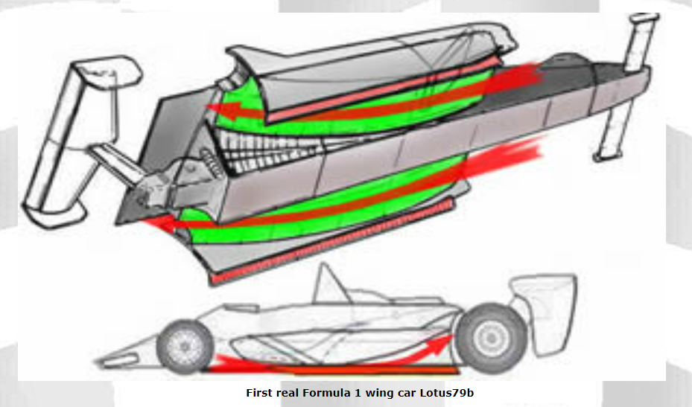
Figure 19 - Floor and sidepods of a Lotus 79b Formula 1 car (Formula 1 Dictionary, 2021)
7.2.2 Methodology
Firstly, the existing venturi tunnels from the Falcon Racekit were measured in the workshop so that a model of the venturi tunnels could be produced in Solidworks (computer aided design (CAD) program). Following that the existing sidepods from the Falcon Racekit were then measured in the workshop and subsequently modelled in Solidworks. These two models were then assembled in Solidworks to create the baseline sidepods to test in Ansys workbench 16.2 (computational fluid dynamics (CFD) program). This process was conducted in collaboration with a third-year university student at University of Wales Trinity Saint David in order to allow for more time to run the models in Ansys workbench 16.2. The sidepods were run on the modelled 750 Formula car baseline with rotating wheels and moving floor. The speed of the moving floor was 35 m/s as this was deemed the average speed around one of the tracks from the 750 Formula calendar. Rotating wheels and moving floor will make the results more accurate as it makes it more representative to real world wind tunnel or track data. The Solidworks model of the sidepods is shown in the figures 2,3 and 4 below.
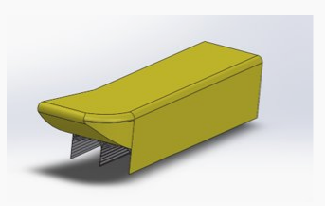
Figure 20 - Topside of left sidepod
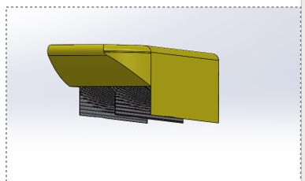
Figure 21 - Sidepod Inlet
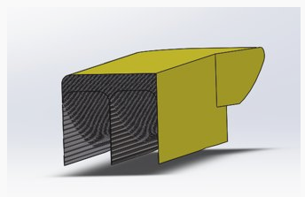
Figure 22 - Sidepod Outlet

7.2.3 Results & Analysis
Once the baseline had been modelled the height of the venturi outlet was then set at different heights from 235mm to 275mm in 10mm increments. This was done in order to analyse the coefficient of lift as well as the coefficient of drag produced by the sidepods so that the optimal sidepod outlet could be found. The new sidepods were also ran on the car model with rotating wheels and a moving floor. This was to make the values comparable to each other and to keep the CFD runs to the same level of accuracy. The turbulence model used was the k epsilon realizable as this was found to be the best turbulence model to use from the turbulence model study. The best sidepod outlet was the 255mm outlet as this produced the greatest coefficient of lift with the smallest coefficient of drag. This is shown in the table 3 and figure 5 below.
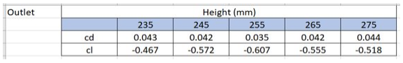
Table 3: Coefficient of lift and coefficient of drag at different venturi outlet heights (mm)
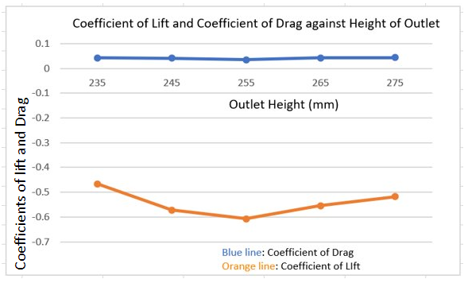
Figure 23 - Coefficient of lift and coefficient of drag against outlet height (mm)
After the sidepod outlet was analysed, the inlet was then analysed to see how the sidepod entrance height effects the coefficient of lift and coefficient of drag. Five different inlet heights were modelled in order to determine what the optimum inlet height was. The inlet heights start at 110mm and increase in increments of 10mm to 150mm in order to acquire 5 different heights. These different models were all run on the car with moving floor and wheels as this would generate more accurate readings in Ansys workbench. The optimal inlet height found was the 130mm inlet as the lowest coefficient of lift and coefficient of drag was found when run in CFD using this model. The result for this analysis is shown in table 4 and figure 6.
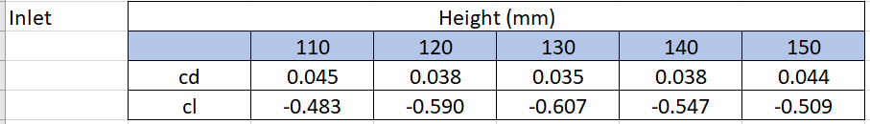
Table 4: Coefficient of lift and coefficient of drag at different inlet heights
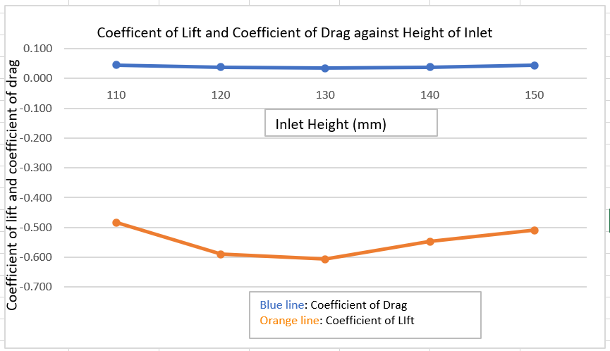
Figure 24 - Coefficient of lift and coefficient of drag against inlet height (mm)

7.2.4 Conclusion
After completing the sidepod investigation I am somewhat pleased with how my results have ended up as I have completed data that shows what the best inlet and outlet for the venturi tunnels. Despite this I feel like there is more that could be done to the study of the sidepods. For example, the study of the length of the sidepods as well the throat angle in the venturi. However, overall, I feel I have learnt how to use Ansys correctly after hours using the software.

Rear Wing (Dora)
The target for this project was to create a wing which would perform better than the current Formula 750. There were multiple investigations run in order to find the optimum angle of attack of the wing as well as the position in correlation with the car.

Research
In order to achieve our target goal and be able to design a wing that work well with the car some initial research had to be conducted in order to better understand the geometry of an airfoil. A better understanding of the geometry of an air foil means a better understanding on how it affects lift and drag.
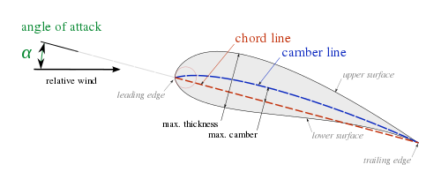
Figure 25- Airfoil Geometry
The effect of increasing airfoil camber is a greater differential change in momentum of the flow around the airfoil, which generates pressure differences and thus increases lift. There is a trade-off however, increasing the camber of the airfoil also increases drag. When a high camber is used, it creates a large separation region on trailing edge of the airfoil. This separation region effectively increases the size of the wake behind the airfoil and thereby increasing the momentum deficit and, as a result, drag (Winslow, Otsuka, Govindarajan, & Chopra, 2017).
The direction of the airflow is shown in Figure 15 above to show the concept of an airfoil's angle of attack. As the air flows over the airfoil streamlines will form across the upper and lower surfaces. The amount of lift acting on the airfoil is determined by the shape (i.e camber, chord length) and velocity of the laminar flow. The velocity and shape of the airfoil’s surface will determine the drag acting on the aircraft (Cadence CFD, 2022).

Methodology
In order to achieve optimum performance from the rear wing, different areas were investigated, and tests were carried out on the baseline model (Car 4) in order to keep a constant so the results could be comparable to one another.
The two areas of development for the rear wing were: angle of attack and the position of the wing relative to the car.
The profile used to carry out the investigations was the one that is already on the Formula 750 Falcon Kit. The profile was sketched on an A4 sheet of paper and then scanned and imported onto SolidWorks and scaled to size using the scaling tool in order to achieve a model as accurate as possible. The profile of the Falcon Kit Wing can be seen in Figure 16 and 17. A simple design of endplates and conventional bottom rear wing mounts were added to the profile as seen in Figure 17.
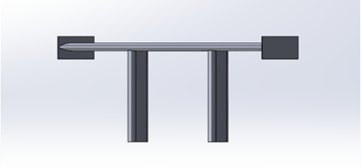
Figure 26- Wing Design
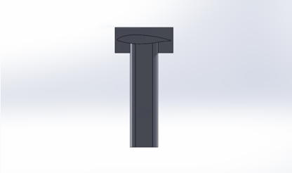
Figure 27- Wing Profile
After the design of the rear wing was completed, the wing was run in isolation on Ansys Workbench using the optimal methodology which was determined earlier on in the project using the MIRA reference car.
The aim for this investigation was to analyse and understand the effect the different angles of attack have on the rear wing and determine which would be best to be put on the Formula 750. Part of this investigation was to post-process the different angles of attack on Ansys and understand where the wing generated high and low pressures as well as look out for any boundary layer separation.
The angles of attack which were investigated ranged from 0 degrees up to 20, which was found to be the point at which the wing stalls. The efficiency of the wing was then calculated, and a decision was made as to which angle of attack to run on the car.
After the angle of attack investigation was carried out and the optimum angle was found, the wing was then run on the car in order to find its optimum position. Unlike for the angle of attack investigation, the wing could not be run in isolation due to the fact that it was important to understand how the wing interacts with the other elements on the car.
In order to determine the optimum position, the wing was placed in a neutral position that was relatively similar to how it’s placed on the Formula 750 Falcon Car and from that position, a grid of 8 other position were determined based on the regulations set by the Formula 750 Championship. Figure 18 shows the wing in the neutral position with the rest of the positions displayed by the coloured circles. The circles represent the midpoint of the endplate.
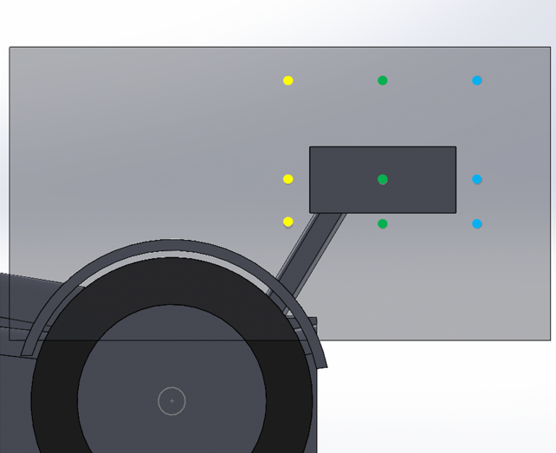
Figure 28- Wing Position

Angle of Attack Investigation

Whilst analysing the results obtained from Ansys and plotting them onto a graph it was clear to see that the coefficient of drag stayed constant at small angles of attack (between 0 and 5 degrees), this was supported by (NASA, 2000). However, as the angle increased above 10 degrees, the drag had a gradual increase due to the increased frontal area and increased boundary layer thickness. The friction between the airflow and the surface of the airfoil will produce more and more drag as the angle increases.
Flow separation can occur at high angles of attack which in turn could make the flow turbulent which increases drag, that is seen when the wing stalls.
Graph 4 shows the lift and drag coefficients as the angle of attack increases. It’s clear to see that at 20 degrees, the wing stalls as there is a significant change in the lift coefficient.

Graph 4- Angle of Attack Investigation

Graph 5- Efficiency

Table 5- Angle of Attack Results Table
Angle | Drag | Lift | Efficiency
0 | 0.06 | -0.30 | -4.94
1 | 0.07 | -0.35 | -5.19
5 | 0.08 | -0.53 | -7.08
10 | 0.13 | -0.77 | -6.13
11 | 0.14 | -0.84 | -6.18
12 | 0.15 | -0.86 | -5.63
13 | 0.16 | -0.91 | -5.71
14 | 0.17 | -0.95 | -5.74
15 | 0.18 | -0.96 | -5.36
17 | 0.21 | -1.00 | -4.76
19 | 0.26 | -1.06 | -4.11
20 | 0.27 | -0.88 | -3.30

Table 5 shows the results from the different angles of attack ran on Ansys. The efficiency peaks at 5 degrees however that is due to a small value for drag. The reason why running the wing at peak efficiency was not an option was due to the fact that, whilst it had a low value for drag it also had a significantly lower value for lift compared to other angles.
The next best efficiency was at 11 degrees and after that the efficiency decreased more and more due to the drag generated by higher angles of attack but also due to the separation of boundary layers. The separation of airflow from the upper surface of the wing increases with the higher angles of attack which leads to a reduction in the rate of change of the increase of downforce.
The choice was made to run the wing at 19 degrees because it generated the highest amount of lift with not much increase in drag, only 0.12 increase in drag with a 0.22 increase in lift.

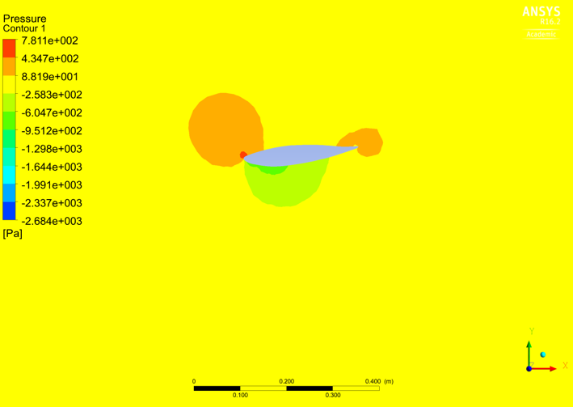
Figure 29- Pressure Contour of Wing at 5 degrees
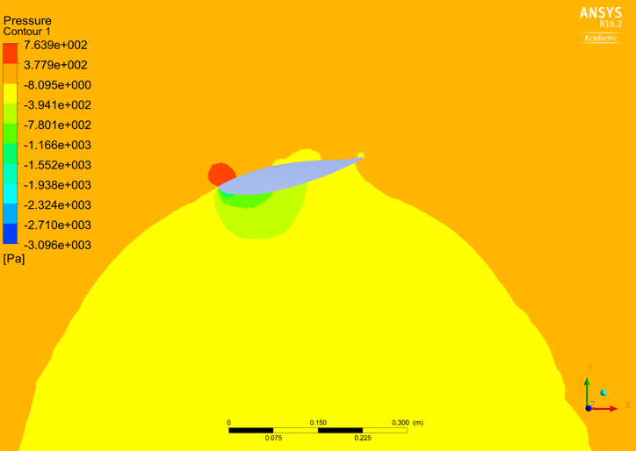
Figure 30-Pressure Contour of Wing at 11 degrees
Figure 19 shows the pressure contour of the airfoil at 5 degrees angle of attack. It’s clear from the figure that there are some areas under the wing that have generated low pressure as indicated by the green bubble. There are some high-pressure areas on the leading edge of the wing as well as the trailing edge which are indicated by the orange bubble.
Figure 20 shows the pressure contour of the wing at 11 degrees. There is a much larger area of high pressure on top of the wing as shown by the orange as well as a higher pressure on the leading edge. The low pressure under the wing has increased as well as shown by the darker shade of green.
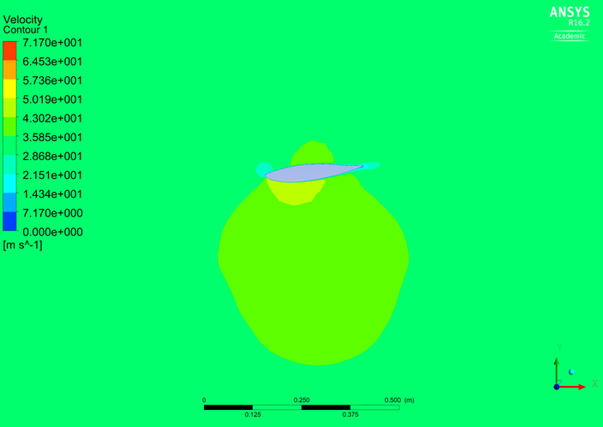
Figure 31-Velocity Contour of Wing at 5 degrees
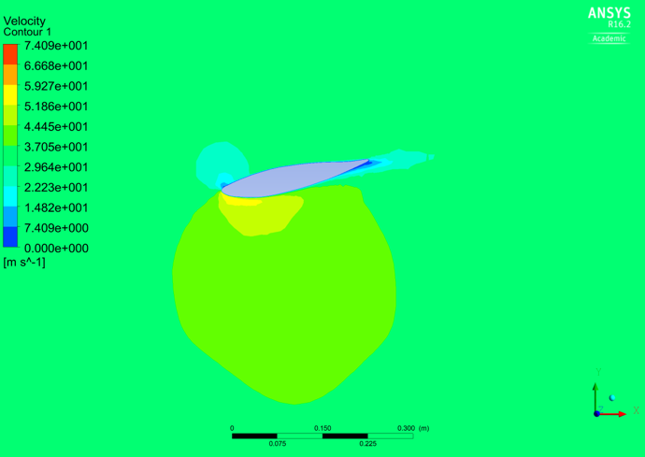
Figure 32-Velocity Contour of Wing at 11 degrees
Figures 21 and 22show the velocity contours of the wing at 5 and 11 degrees. It’s clear to see that there is a much larger area of high velocity under the wing that is being run at 11 degrees. Not only has the green area increased under the wing, but there is also a much larger yellow bubble and more blue areas on the upper surface. The blue indicates low velocity which proves that increasing the angle of attack does increase lift.
There are some areas that show very low velocities on the lower surface, however that is due to the wing mount which creates flow separation.

Wing Position
Whilst the wing on its own generated up to -1.06 of lift on its own, it was important to run a study in which the wing interacts with the rest of the car. It was found that running the wing at its highest position worked the best, which was backed by Simon McBeath and that is believed to be due to the cleaner airflow (McBeath, Advice, 2014).

Graphs 6 and 7 shows the values achieved in each position and the repeating trend seem to be that the wing performs best in the top position in each study, followed by the bottom position and then middle.
It is believed that the bottom position generated the next best set of results due to the fact that it was interacting the best with the provided diffuser, and it was continuing its flow.

Graph 6- Lift

Graph 7- Drag

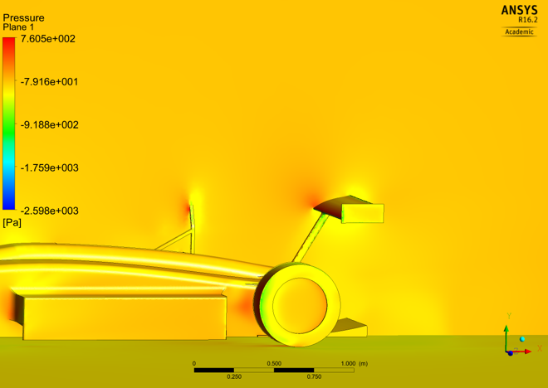
Figure 33- Middle Top Position Pressure Contour
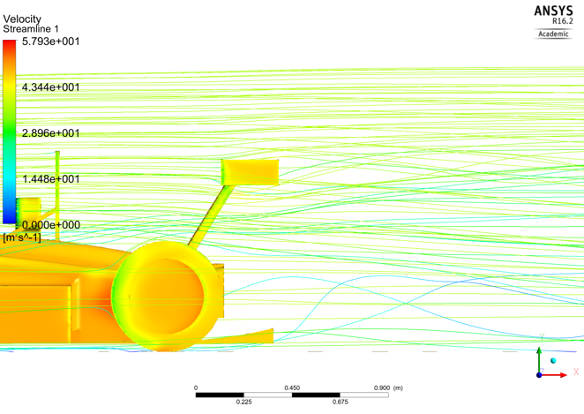
Figure 34- Middle Top Position Streamlines
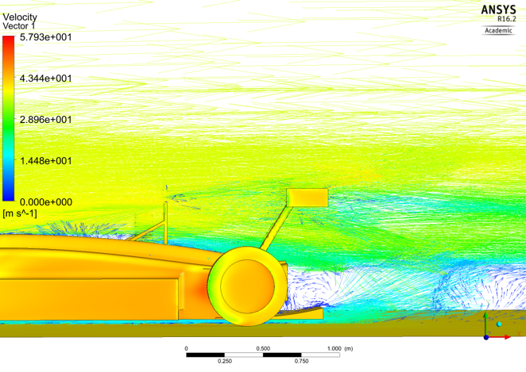
Figure 35- Middle Top Velocity Vectors
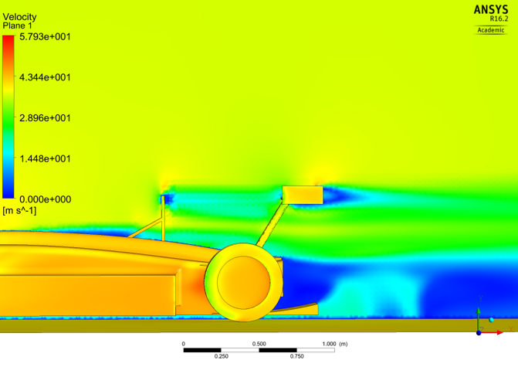
Figure 36- Middle Top Velocity Contour

Further Work
Further developments in this project would be to investigate different wing profiles such as the S1223 that has a high lift and low Reynold’s number (Doosttalab, Mohammadi, Ashrafizadeh, & Doosttalab, 2012). Research shows that the S1223, Figure 27, profile generates a higher lift that the wing profile found on the Falcon Car. However due to challenges found along the way with running CFD simulations and creating models which were suitable for running in Ansys, there was not enough time to pursue this investigation
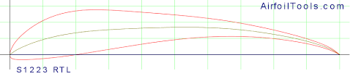
Figure 37- S1223 Airfoil
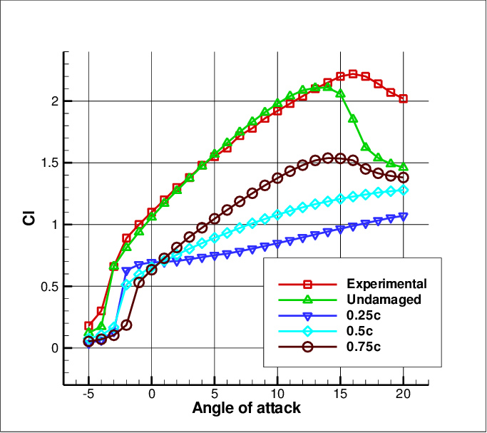
Figure 38- Angle of Attack on S1223 (Doosttalab, Mohammadi, Ashrafizadeh, & Doosttalab, 2012)

The wing mounting systems is another area that would have been beneficial to investigate. A swan neck design was created by Ashley but there was not enough time to refine it and run it on Ansys. Because the air on the lower surface of the wing must move faster in order to effectively generate downforce placing the mounting points on the upper surface, like the swan necks, would not disturb the airflow as much. It would also cause less flow separation which would further improve the lift and drag coefficient (Fuller, 2012).

Figures 29 and 30 show the swan neck designed by Ashley, however as mentioned before, it has not been refined as there was not enough time to complete it.
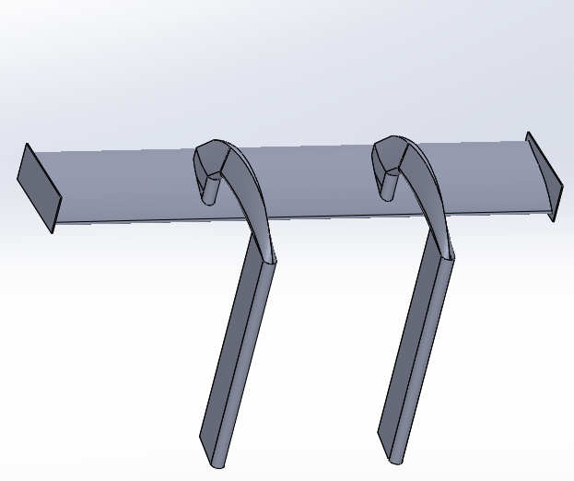
Figure 39- Wing Mounts
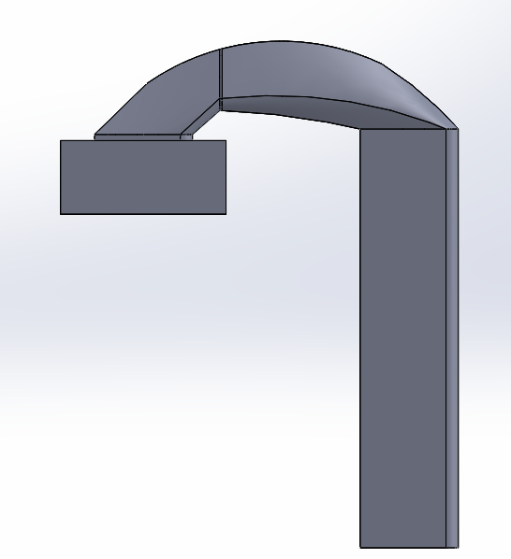
Figure 40- Swan Neck Wing Mounts

Diffuser (Nathanael)

Diffuser Research
A car diffuser has the function of generating additional downforce by speeding up the air underneath the car to create more low pressure. The low pressure underneath the car then sucks the car down, generating more grip for the driver to utilise (Mai, 2019). This due to the ground effect. Ground effect is an aerodynamic phenomenon that creates a low pressure region on the underside of the car (Joep, 2021). Ground effect on cars is very powerful as this can create massive amounts of downforce for little drag penalty. Diffusers are often found at the rear most section of the car as well as on the rear section of a front splitter (Hazen & Lucas, 2018).
As well as looking into how diffusers work and the effect that ground effect has, I looked at different cars diffusers from different race series to get some inspiration. Different series have different regulations surrounding the diffuser and what is allowed. The regulations in the formula 750 series are very open and allow for different design interpretations.

Methodology
To find the optimum performance from the rear diffuser, a few different investigations were conducted. These investigations were; looking at the difference between a straight edge and curved diffuser, looking at the angle of attack to find the best angle as well as looking at the end plates and how they impact the air flow. To run each of the studies, the CFD sofware Ansys 16.2 will be used to accurately determine each of the diffusers results. All the tests will be conducted using a baseline model to accurately determine the results of each study to one another. The baseline model will run at 35m/s windspeed for each run for consistency between each result. This will ensure that the results taken will be precise and consistent.
The first investigation was to analyse the effect of change in the angle of attack using the straight edge diffuser and how the lift and drag coefficients relate as well as looking out for any flow separation that could affect the diffusers performance. To conduct the investigation, each angle design will be tested on the baseline model. The results will be extracted to find the optimum downforce to drag efficiency.
After studying the straight edge angled diffusers, designs for the curved diffuser will be created, influenced by the previous test. Similar to the previous test, the curved designs will again be CFD tested on the baseline. These results will be analysed and compared to the previous results to see the difference between the results.
Once the optimum curved edge diffuser has been determined, a study will take place on the length of the diffuser. This will mean reducing or increasing the length of the diffuser by extending/shortening the curve. Each test will be conducted in 50mm increments to find the effect the diffuser has on lift and drag relative to the length.
The final diffuser study will be on the effect of the strakes and endplates of the diffuser and how they have an impact on the airflow. Endplates and strakes help reduce the spill from high pressure regions into low pressure regions which has an effect on the overall performance of the diffuser. Endplates and strakes will be added and in post-processing, the effect of the added strakes will looked at and analysed.
From this, the final diffuser design will be determined and taken forward to the final aerodynamic package for the Formula 750 car.

Diffuser Designs
The first area of study designs I investigated were the angles of the diffuser. This was done by designing a diffuser the same size length and width ways and only changing the angle of attack. The angles go from 0 degrees up to 10 degrees in 1 degree increments. Each diffuser design was then mated onto the baseline model which was then saved as a part file before it was then saved as an x.t file to be imported into Ansys 16.2.
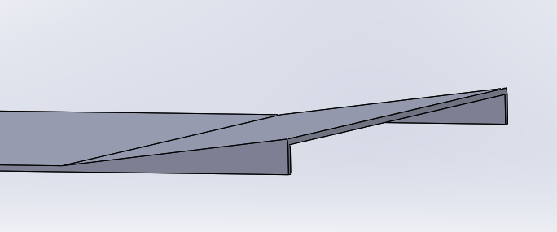
Figure 41 - Straight angled diffuser CAD model
The second diffuser study design is the curved edge diffuser. Following the first study, the diffusers curve is based on the findings of the previous study. The curve will be modeled at different radiuses to find the optimum diffuser radius. This will be done with the aid of the previous study in mind.
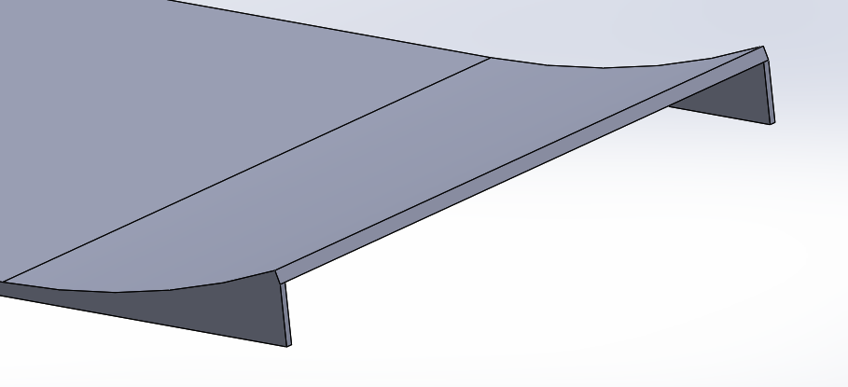
Figure 42 - Radius diffuser CAD model
The third diffuser study is the length study where the curved edge diffusers length will be decreased/increased in 50mm increments to find the optimal diffuser length starting at 400mm. The wing position will also have an effect on the performance of the diffuser as the rear wings airflow should interact with the diffusers airflow generating more downforce.
The final diffuser study was to investigate the endplates and strakes and how they interacted with the airflow to improve performance. These diffuser designs will be developed predominately using post processing from previous studies. This is to look at how the flow interacts in and around the diffuser. To stop the high pressure air outside of the diffuser spilling into the diffuser, endplates are placed either side. This is to minimise the amount of spillage getting into the diffuser area reducing the overall performance of the diffuser. Strakes also help to keep the flow as laminar as possible.
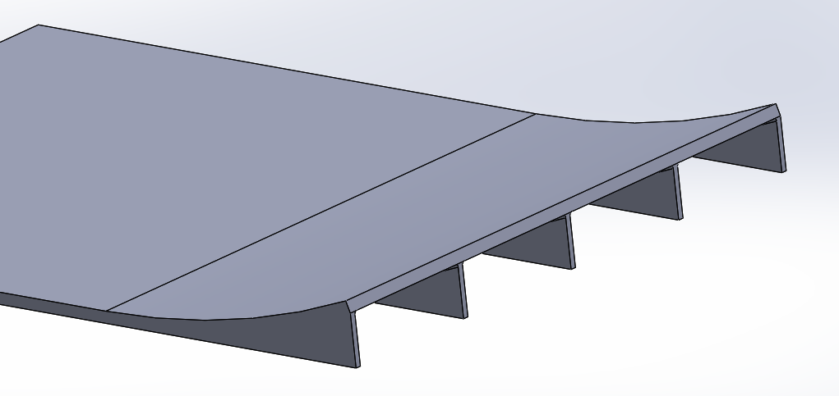
Figure 43 - Diffuser with three added strakes CAD model

CFD Testing and Analysis

Angled Diffuser Study
The results from the first study of the angled diffusers showed that the diffuser producing the most amount of downforce was 7 degrees. However, the most efficient angle shown in figure 44 was actually 5 degrees as the drag coefficient was smaller compared to the 7 degree diffuser which produced more drag. After 7 degrees, the airflow would stall meaning a huge drop in negative lift (downforce). Research backed this up by stating that the airflow under a diffuser will stall at around 7 to degrees (Toet, 2017).
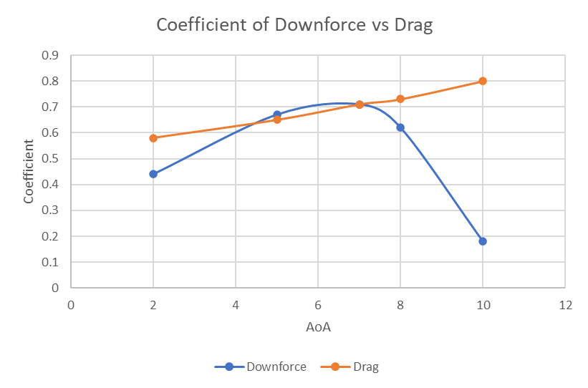
Figure 44 - Graph demonstrating the Coefficient of downforce and Coefficient of Drag change depending on the Angle of Attack
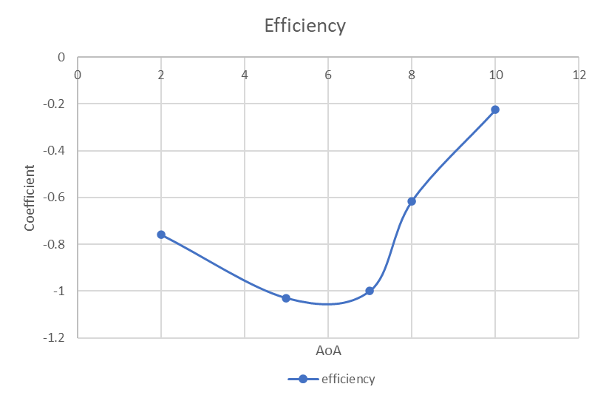
Figure 45 - Graph demonstrating the efficiency of each angle of attack
In figure 43 the graph shows coefficient of downforce is compared to the coefficient of drag. As demonstrated in the graph, the drag is always gradually increasing as the diffuser angle increases whereas the downforce coefficient rises gradually and peaks at around 7 degrees before falling rapidly due to the airflow stalling at 8 degrees.
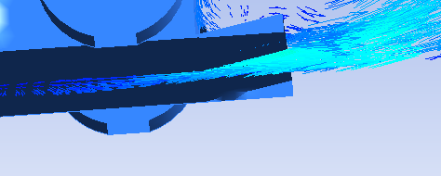
Figure 46 - Flow vectors on the 10 degree angled diffuser
The above figure is a screenshot of the flow vectors of the 10 degree diffuser on a cut plane. We can see from the flow vectors that the flow separates just after the cut plane. This is the reason that the diffuser stalls and there is a loss in downforce.

Curved Diffuser Study
From the second studies results the curved diffuser with a radius of 2000mm proved to produce the most amount of downforce before the airflow stalled. The efficiency of the 2000mm radius diffuser was also most efficient. The drag coefficient throughout each of the tests were very similar throughout apart from the 1400mm radius where the drag dropped to around 0.4. The downforce coefficient peaked at 0.77, that was at 2000mm radius. The 2000mm radius diffuser will be taken forward further to look at the optimum length.
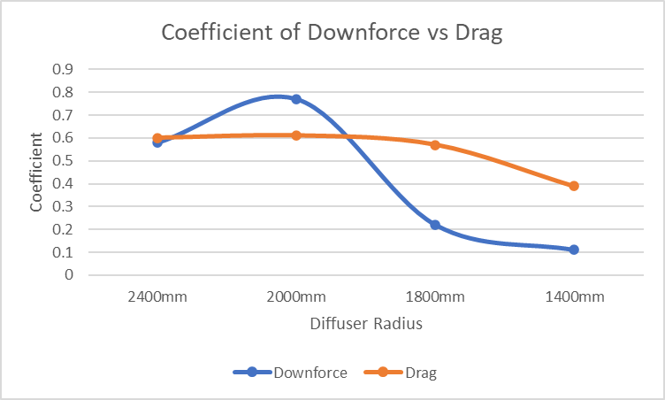
Figure 47 - Graph demonstrating the Coefficient of downforce and Coefficient of drag against the diffuser radius
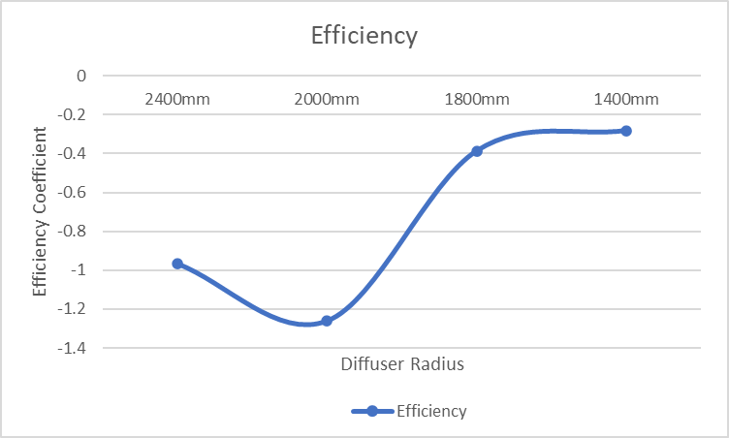
Figure 48 - Graph demonstrating the efficiency of the diffuser radius
From figure 46 you can see that the downforce increases from 2400mm radius and peaks at 2000mm radius before stalling at around 1800mm radius with a huge drop in downforce. While the airflow stalls the drag also drops off. This is due to the fact that the radius gets smaller and the flow separation increases due to the air flow struggling to stay attached to the tighter radius.
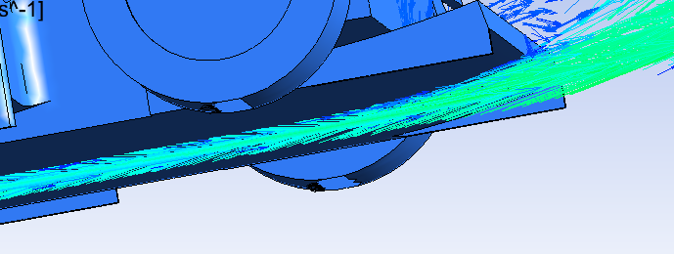
Figure 49 - Flow vectors of the 2400mm radius diffuser
The above figure is a screenshot of the 2400mm diffuser flow vectors along a cut plane. From this screenshot, we can see that the flow along the bottom edge of the diffuser is attached. We can also see there is some up-wash coming off the diffuser. This diffuser was then designed steeper to push the limits of the radius.

Diffuser Length Study
The third study of the diffuser length showed that the optimum length of the diffuser is 500mm. I started by running the diffuser at 400mm and gradually increased the diffuser length by 50mm. The results from the study showed that as the diffuser increased from 400mm to 500mm, the downforce coefficient increased. After 500mm the results showed that the downforce coefficient started to reduce. This could be for a couple of reasons; firstly, as the diffuser length increased, the airflow interaction with the rear wing reduced meaning that the downforce reduced and secondly, as the diffuser length increased the flow started to separate with the curve getting steeper. The drag of the diffuser during this study stayed relatively stable at a coefficient of around 0.6.
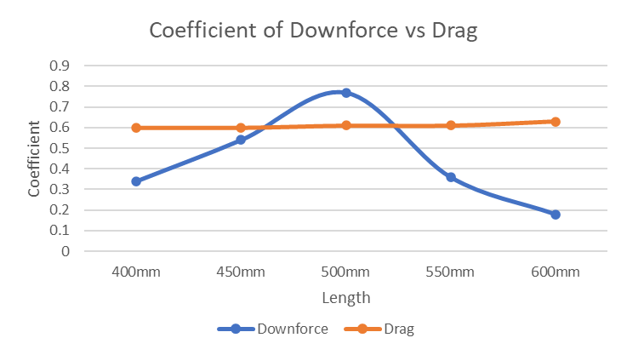
Figure 50 - Graph demonstrating the coefficient of downforce and coefficient of drag against the diffuser length
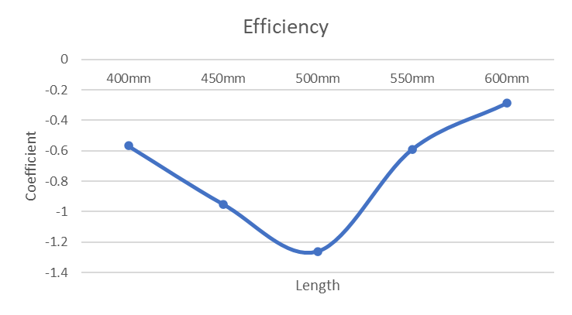
Figure 51 - Graph demonstrating the efficiency of the diffuser length
In figure 50 above you can see that the peak efficiency is at the diffuser length of 500mm. The efficiency of the 500mm length diffuser peaks at a coefficient of -1.25.

Endplates and Strakes Study
The final study of the endplates showed that there was a small improvement in performance resulting in a final design for the diffuser. Using post processing to look at the flow structures in and around the diffuser, the endplates and strakes were determined by how the flow interacts with the diffuser.
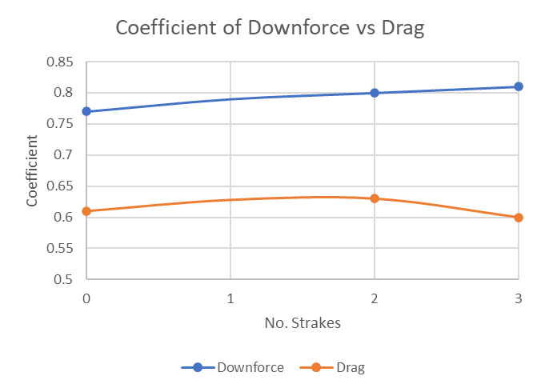
Figure 52 - Graph demonstrating the coefficient of downforce and coefficient of drag against the number of strakes
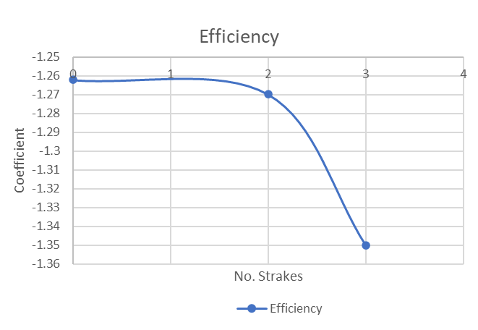
Figure 53 - Graph demonstrating the efficiency of the number of strakes
Using the flow vectors, I was able to see the amount of high pressure air spilling into the diffuser area. To counteract/reduce the spillage, a little lip extruded onto the outside bottom of the diffuser endplates, designed to act as slight skirt (see figure 53). The skirt creates a vortex to help seal the end plate reducing the amount of high pressure air spilling into the low pressure region of the diffuser. In figure 53 below, you can see the rotational vortex forming (circled in red) on the end of the endplate sealing the diffuser. This lip that forms the vortex results in more laminar flow in the diffuser because the flow underneath the car and in the diffuser itself isn’t as disturbed.
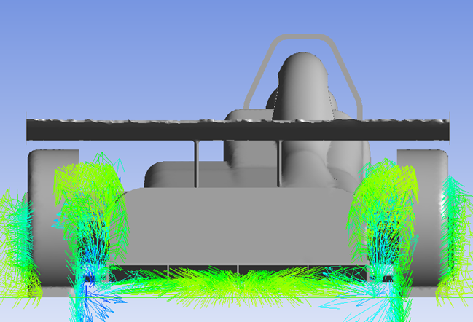
Figure 54 - Flow vectors of the diffuser with a skirt. Vorticity forming circled in red
This can also be seen in the figure 54 below. We can see that at the leading edge there is small bit of spillage but as the diffuser rises towards the trailing edge there is little to no spillage into the diffuser. It also shows more clearly the laminar flow throughout the diffuser, in particular the middle.
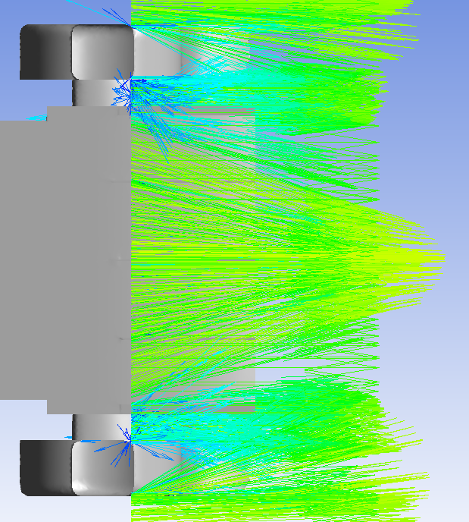
Figure 55 - Screenshot of the flow vectors underneath the diffuser with skirt
To compare the difference between the lip and no lip, figure 55 below shows the airflow spilling into the diffuser (circled in red). This results in less laminar flow in the diffuser due to the flow being disturbed resulting in a slight decrease in downforce.
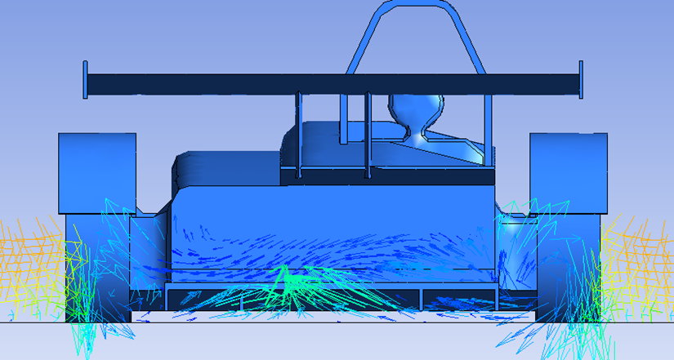
Figure 56 - Screenshot from the rear of the car of flow vectors around the diffuser without skirt

Final Diffuser Design
The following figures 56 and 57 shows the final design diffuser design produced following the diffuser studies. The final results for the diffuser were: a coefficient of lift of -0.81 and a drag coefficient of 0.6 producing an overall efficiency of -1.35 (numbers using the baseline model). Although these are the best results of the diffuser study, they might not be fully represented when it comes to the final aerodynamic package. This due to the fact that the rest of the cars development area would’ve changed meaning the airflow in and around the diffuser won’t be exactly the same as the baseline. For example, the front splitter may have been developed to produce more downforce which may mean that there could be less air flow traveling towards the diffuser resulting in a potential loss of downforce.
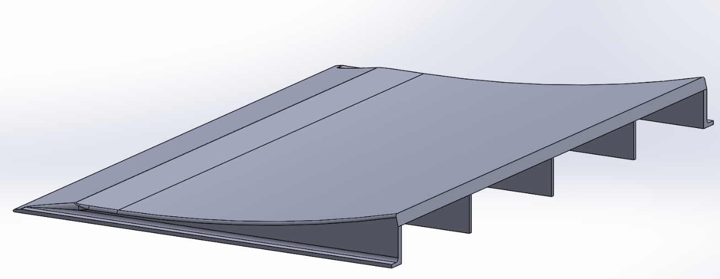
Figure 57 - Final diffuser design
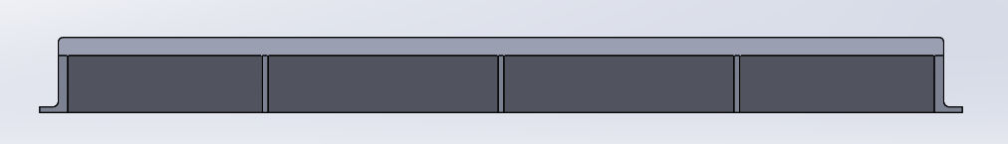
Figure 58 - Final diffuser design from the rear
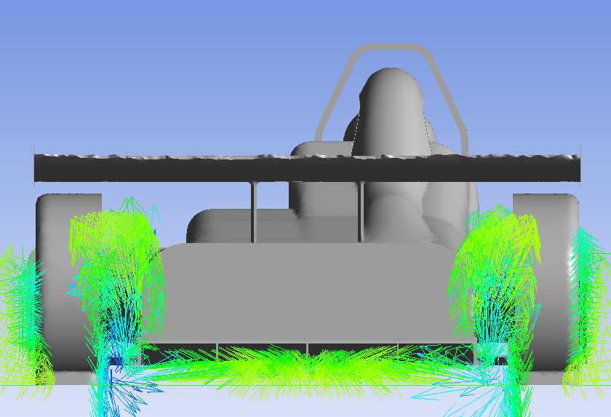
Figure 59 - Final Diffuser design with flow vectors around the diffuser
Figure 58 shows the final design with flow vectors coming off the rear of the car demonstrating the flow structures that have been formed. This screenshot is taken from post-processing within the ansys software.

Conclusion
After many successful and plenty of failed runs using Ansys to CFD test each diffuser as part of each study, I am happy with the final diffuser design. Not only have I learnt a lot when it comes to CFD simulations, but I also have developed my knowledge and understanding around aerodynamic principles. The group project has been a steep learning curve that has brought many challenges along the way that will help me moving forward.

CFD (Ashley)

Introduction
My area of focus within the group was to lead the CFD developments with the Formula 750 car. Initially my first task was to learn the CFD software Ansys. It is a software that was completely new to me personally however my strong background within CAD made me suitable for this role. A high level of patience has certainly been required. Alongside the CFD development, I also designed Car 1 and developed techniques to measure the existing bodywork to soon create a Car 5, Car 6 Ice and Car 6 Electric vehicle.
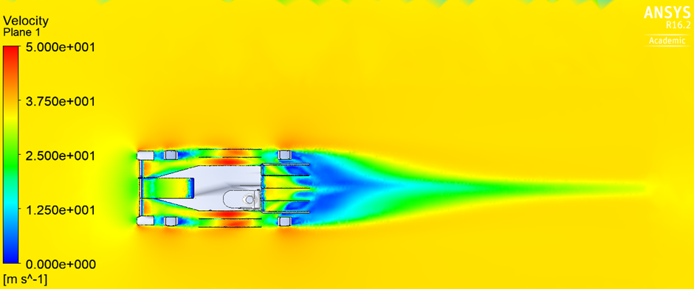
Figure 60 Car 6 velocities

Methodology and initial results
As mentioned, I designed the first car (Car 1) this was loosely based on the existing MCR car that the university owns. The other initial 3 cars were designed by Nathanael. Car 2 was a traditional Formula style car, Car 3 was aimed to be the most streamlined and finally Car 4 was based on the Falcon car.
Each one of these cars I ran in the CFD software Ansys once studies on the domain, mesh and density boxes were completed by the other members. To begin with the cars were simulated with stationary floor and stationary wheels. Then they were run with a moving floor at the same speed as the air flow of 35M/S. This figure was chosen as it was the average speed that these vehicles reached (Championship, 2022). Car 1 and Car 3 performed the poorest out of the four, so these investigations were halted. Car 2 and car 4 were further investigated with moving wheels then moving floor and moving wheels together. This was to see how they were set apart with these parameters.
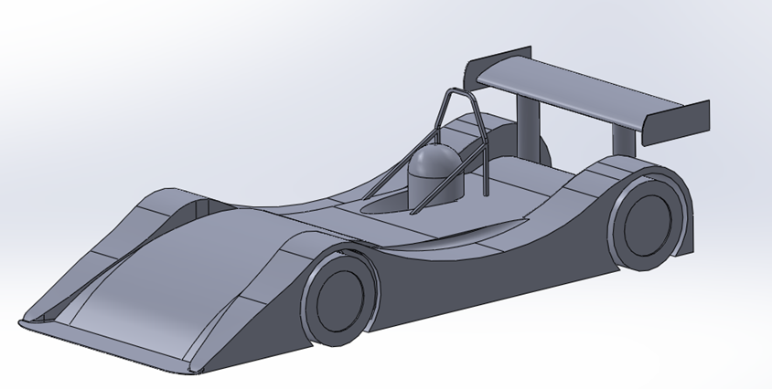
Table 4 Initial results
Figure 61 Car 1 model
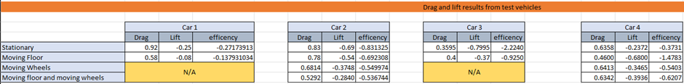
Car 4 performed the best above car 2 as shown, with a higher negative lift produced of -0.39 compared with the negative lift of -0.28. it’s not just the lift that is important, the drag is also considered. To see both the effect of the lift and the drag the efficiency can be calculated with an equation as simple as lift over drag. With the efficiency, Car 4 still stands out as the best car to aim for, for our base model. The other members could now begin to really investigate their own areas.
You’ll notice with the majority of the cars the efficiency is reduced once the floor was simulated, however, with Car 4 the effect is opposite and by a significant amount. The efficiency jumps from -0.3731 to -1.4783. This can be put down to this car being more efficient with ground effect, this is most prominent at the front splitter as shown in the picture below.
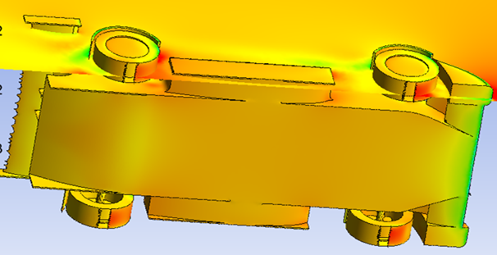

Measuring techniques
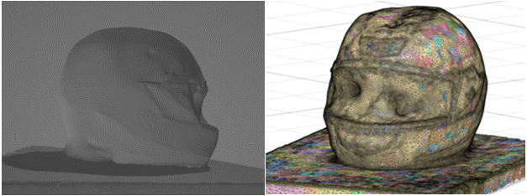
While the other members were investigating their own areas, I was tasked with modelling the original falcon bodywork which was delivered to the university. I investigated the various methods which makes this possible. Firstly, I practised a technique called photogrammetry. This involves taking around 150 images of an object then uploading the model into a software which converts the pictures into a mesh. I practiced this technique on a race helmet, the results are below in Figure 61.
Figure 62 Race helmet
As can be seen the outcome isn’t as accurate as first hoped. There are areas on the helmet that have been ignored. Even though the visor on the helmet was down the software tried to create a hole around this area. This technique was dropped for this reason.
The second area I investigated was the main method which is used by the university for the previous years. It involves dropping a plum attached to a fishing line onto the bodywork at different intervals. This technique was very time consuming and not very accurate. To overcome the problems faced with this method I created my own.
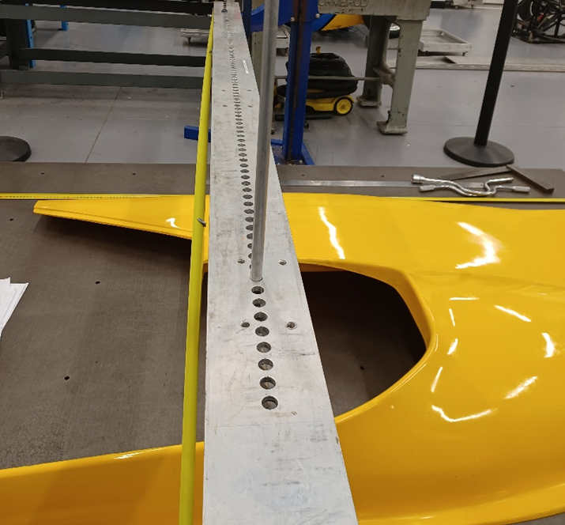
Figure 63 Measuring device
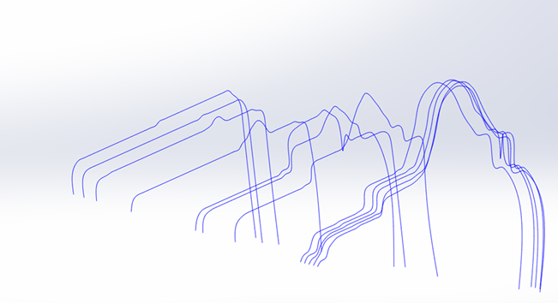
With just the use of scrap materials I took a long piece of aluminium bar and drilled over 150 holes into the top and bottom face with a mill from the engineering department. Each hole was then deburred by hand. After this the next process was to take a long rod and create a chamfer of 45degress on the one end using a lathe. The idea of manufacturing this device is that the rod can be dropped down each hole which are at 20mm intervals, and then a measurement taken of how much of the rod is sticking out the top of the drilled bar. I approached Dora to help record the numbers into an excel sheet as I took the measurements using a steel rule. This design proved to be very effective with the results shown below of which is the point cloud that was created from the data as shown below in Figure 63. However, the manufacturing time of 15 hours was very time consuming under the constraints. It has now been adopted by the university for use by future years. I have created an FEMA table as shown in the figure on the next page. To make sure all health and safety practices were followed.
Figure 64 Point cloud
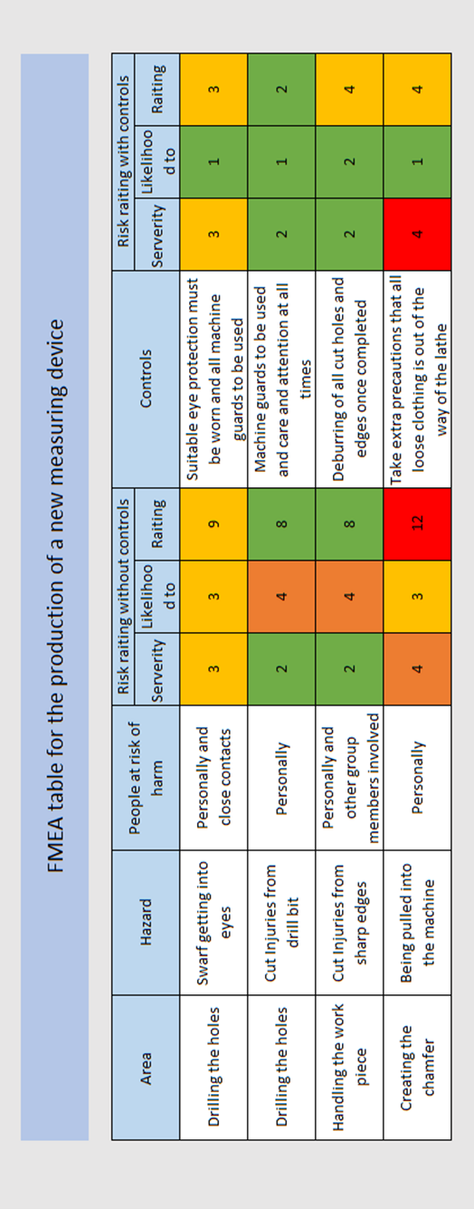
Figure 65 FMEA table

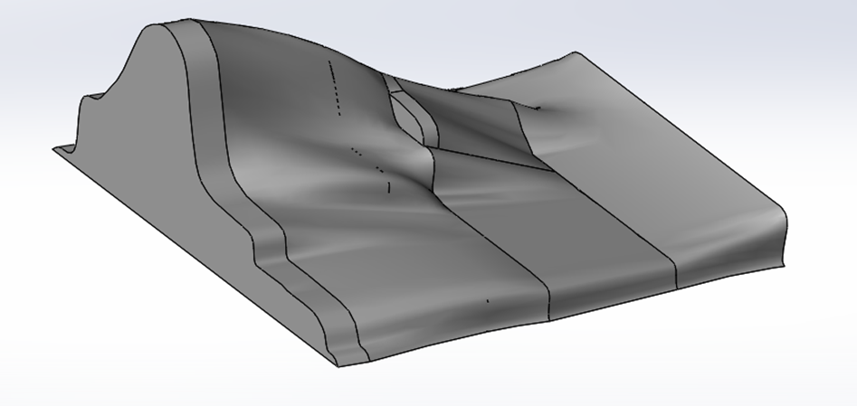
The result from the modelled rear section is above in Figure 66, compared to the actual bodywork section it does look fairly accurate. To create lofts of all the coordinates did take a lot of time. I consulted Ben Gilbert, whom is a third year completing a similar project in his third year of university. We traded the use of this rear section for his measured front splitter, venturis, and diffuser. I then constructed these parts together onto a modelled chassis, constructed from the chassis group of university.
Figure 66 Rear body section

Car 5
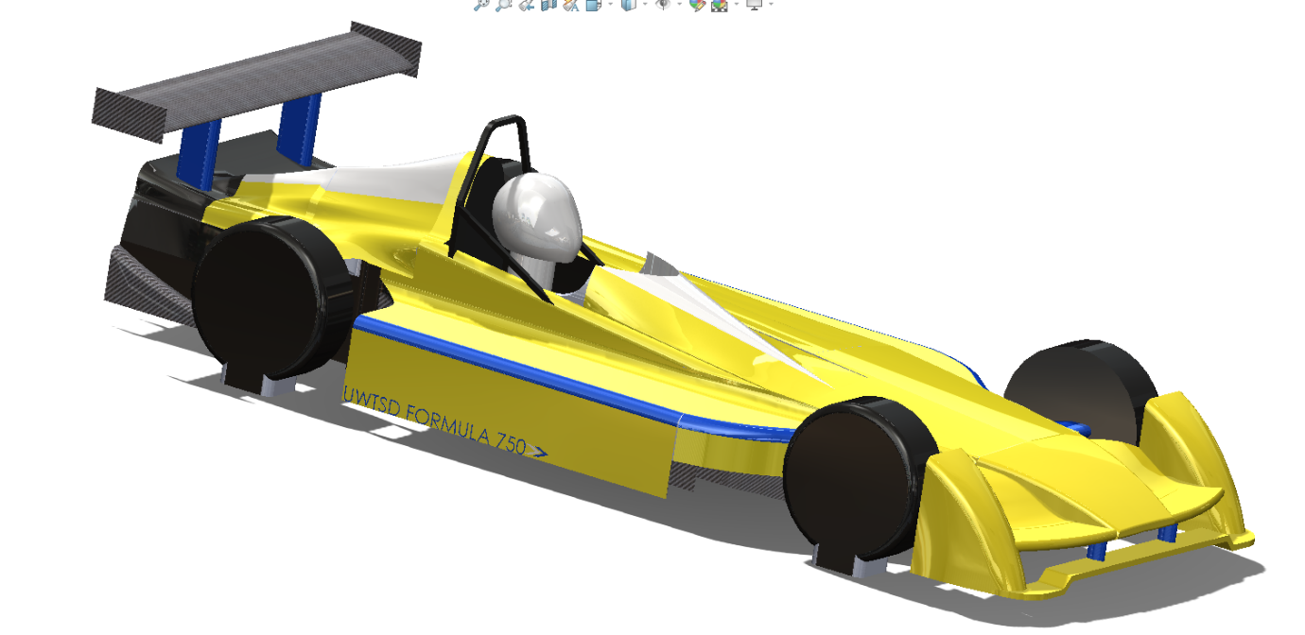
My finished result is shown below in Figure 67 for Car 5, I sent this finished car to Ben for him to use as his base model, without the rendering. The rendering was chosen as a small nod to the universities race team for their help with the borrowing of equipment. The basic results that this car produces are shown below in Figure 67.
Figure 67 Car 5
Table 5 Car 5 results
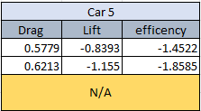
Comparing these results with those of Car 4 it can be seen that Car 5 is more efficient with the floor firstly stationary then moving. These are the true figures we are now to aim for. The moving wheel study wasn’t completed for this vehicle due to the fact all the other future studies will be completed with the wheel’s stationary.

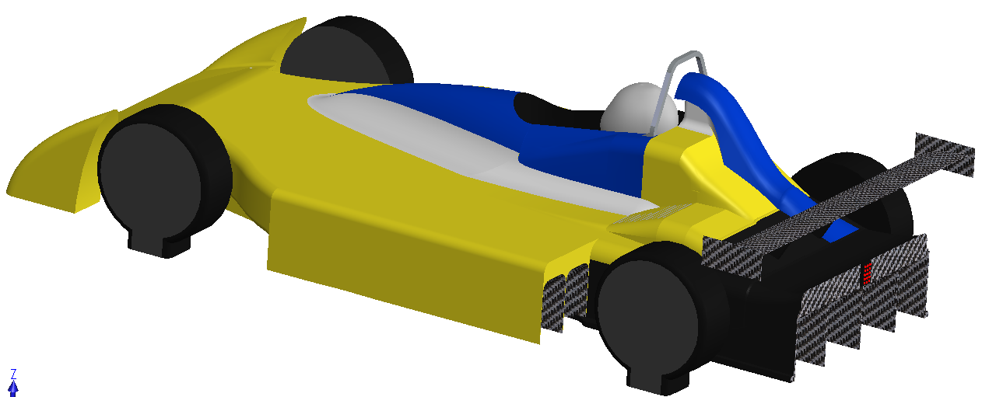
Car 6
Figure 68 Car 6
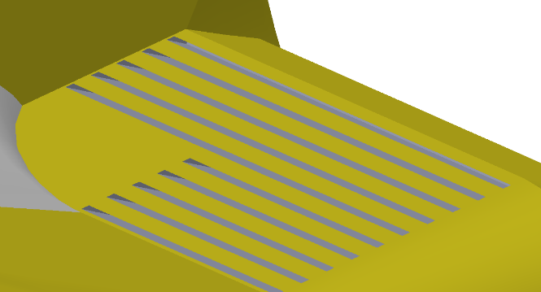
I constructed Car 6 as shown above in Figure 68 in a similar method as car 5. However, with the improved areas created by the other members of the aerodynamic group. This vehicle has been influenced by the internal combustion engine group of the university. You’ll notice I’ve created a large airbox on this model, the raised area alongside the airbox contains the gearbox to the rear, and the radiator to the front from specification of the Ice group. The cad model of the engine itself had been supplied from Sam Benbow.
Figure 69 Car 6 Radiator

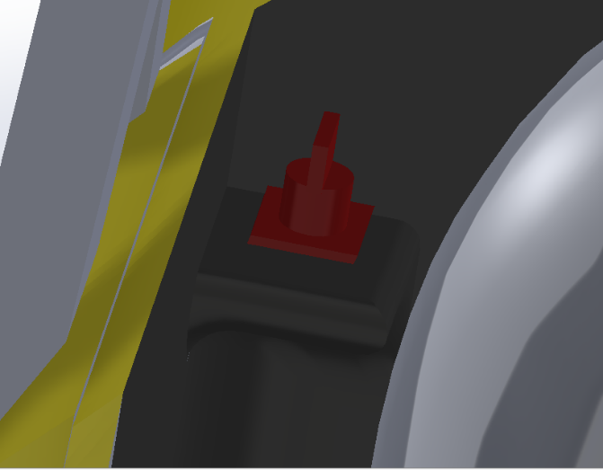
Safety devices are also incorporated into this model. These include the rear light and the engine shut off switch as shown in Figure 70. Both the light and the shut off switch was supplied by Michael Reeves from the ICE group. I’ve placed them both in locations that comply with the motorsport regulations.
Figure 70 Car 6 Safety switch
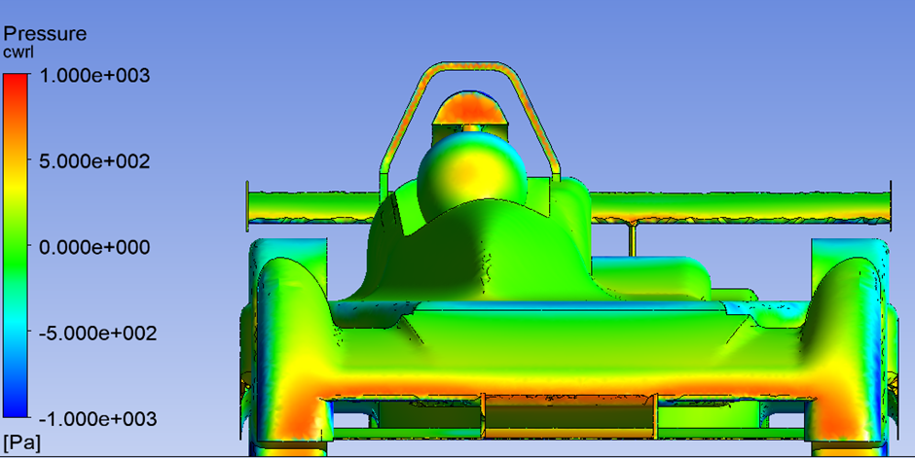
Figure 71 Car 6 Focus on splitter pressure
Although Harvey supplied the best performing front splitter which can be seen above in Figure 71 for our base model the interaction with the other areas of car 6 wasn’t the same as before, I lightly modified the splitter to have an extended middle section. The angle investigated by Harvey was kept the same as the one he supplied to me.
Table 6 Car 6 Splitter modifications
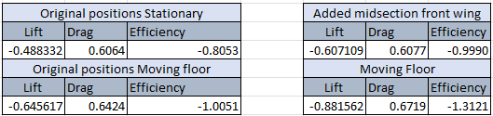
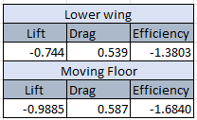
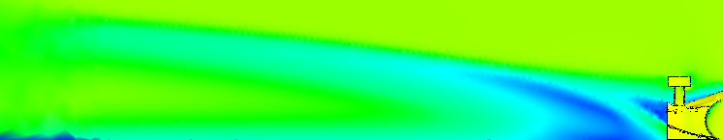
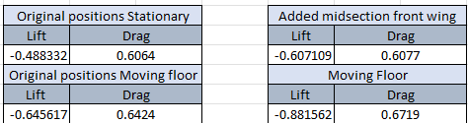
The improvements that this gave is shown in the table above in Table 6. The downforce increasing from -0.6456 to -0.8815. with an efficiency increase from 1 to 1.3 is a fair improvement.
Table 7 Car 6 lowered wing
The interaction with the wing and diffuser for the vehicle wasn’t acting as well as it did with car 5. This can be shown in the picture below in figure. I lowered the wing while keeping the same angle that Dora supplied me with so see if I could get the wing and diffuser to interact well together. The figures of these improvements are shown in the table below in Table 7.
Not only did this improve the lift produced the drag was also reduced significantly to give a better efficiency up to 1.6. 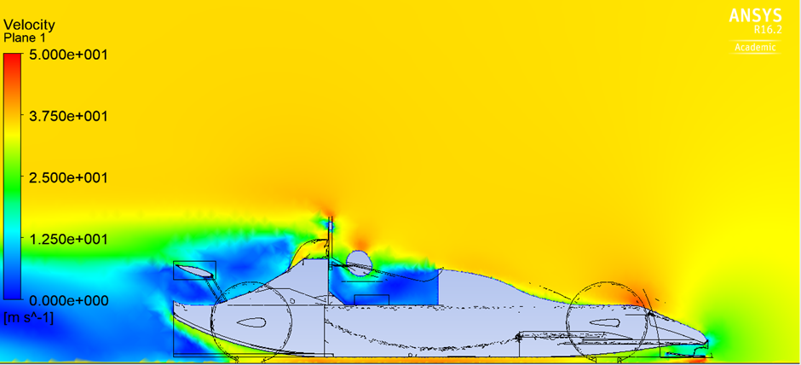
Figure 72 Car 6 velocities on a cut plane
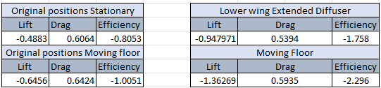
With the wing lower I wanted to see how a longer diffuser would perform. I kept the supplied angle of the diffuser and number of vanes the same as supplied by Nat. The results are recorded below in Table 8alongside the original value car 6 produced before I made these small adjustments. The visualisation is shown in Figure 72 above.
Table 8 Car 6 diffuser modifications

Overall, not only has the negative lift doubled the drag has also been reduced. This is a great improvement on the original model. And to compare this to the car 5 base model which is used by W3 the Formular 750 series it is also a great improvement considering our Car 6 has a larger airbox compared to the original to accommodate the new engine. The target has been reached. An efficiency increases from 1.86 raised to 2.3 as shown below in Table 9 it is a great achievement.
Table 9 Car 5 against Car 6
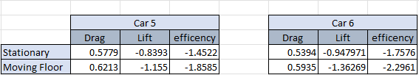

Further investigations
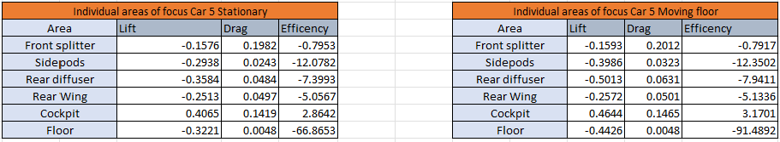
The effectiveness of certain areas is very important to determine where improvements can and have been made. Below, Figure 75 shows the effectiveness of the areas of focus on car 5. Firstly, when the road is stationary then moving at the speed of 35m/s.
Table 10 Car 5 individual areas
The area of the cockpit really stands out for Car 5 as it produces a positive lift between 0.4065N and 0.4644N this is a large area that poorly effects the car. On the other end of the scale the diffuser is the most effective area on this car with a negative lift of -0.3584 which raises to -0.5013 once the road is simulated. This highlights the effectiveness of ground effect. 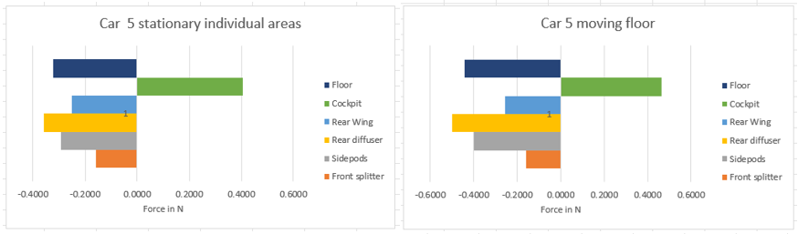
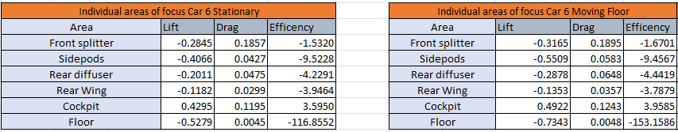
Figure 73 Car 5 individual areas graph
Table 11 Car 6 individual areas

Car 6 results are shown above in Figure 74, the most effective area of the vehicle is the floor itself, the interaction that the front splitter has on the floor and the exit that the diffuser provides gives the floor a great advantage on the performance. So, although the actual lift produced from the new diffuser is reduced from the one on Car 5 it does have a greater interaction on the car overall giving us a great benefit. 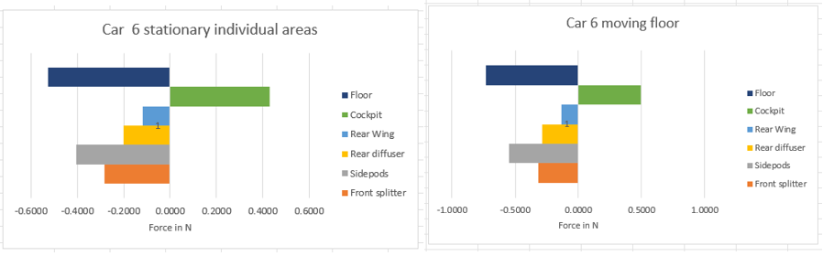
Figure 74 Car 6 individual graphs
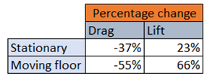
Figure 74 clearly shows the percentages. A drag decrease of up to 55% is a great achievement to make the vehicle run cleaner through the air. With a lift increase up by 66% this is a massive benefit that will really benefit the car for producing increased lap times.
Table 12 Car 5 vs Car 6 percentage change

Centre of pressure
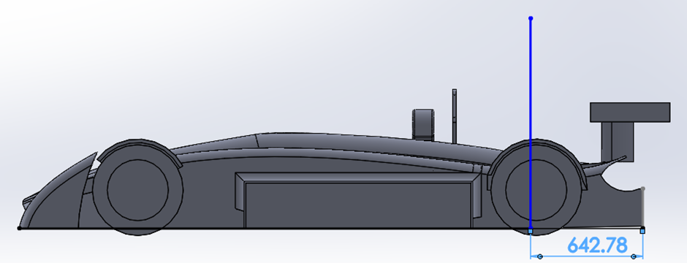
The centre of pressure of the vehicle is very important can be the difference between a well handling track car to a very dangerous way to complete a circuit. Deaths and serious injuries have been caused by poor calculations of CofP (Radu, 2021). For Car 5 and Car 6 the centre of pressure has been calculated in Ansys by selecting the moments. Within real world test the centre of pressure is measured from the centre point of an axel. In this instance the centre of pressure is measured from the rear of the vehicle. This is down to how the centre of pressure is calculated in Ansys. The origin of the car is positioned at the rear of the vehicle. So although this isn’t the method used in industry it is till reliable to see where the position is.
Figure 75 Car 4 Center of pressure
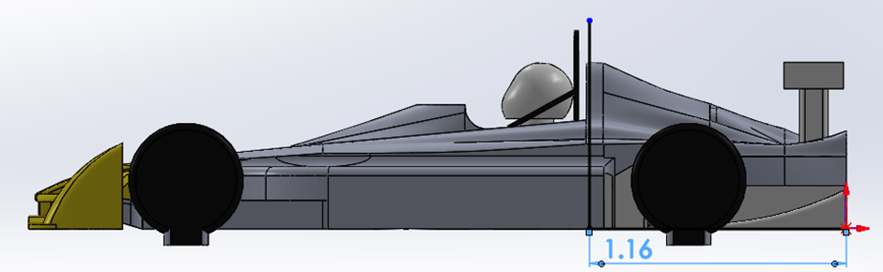
Figure 76 Car 5 Center of pressure
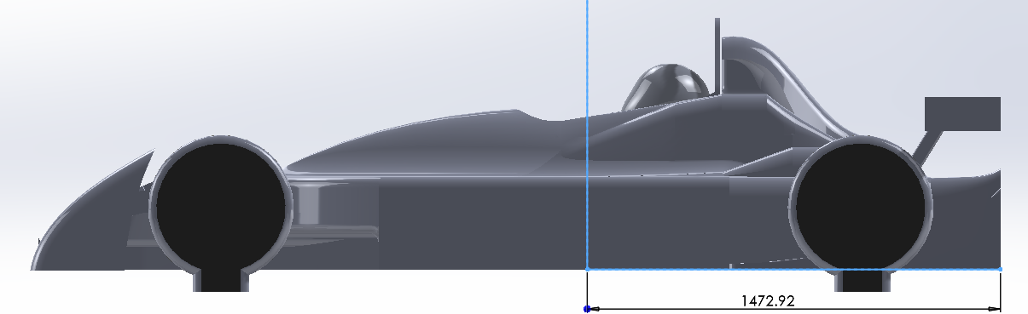
The centre of pressure for car 6 is shown below in Figure 75 you’ll notice this has moved forward from car 5 by a considerable amount. The reason for this is the advancements that have been made to the car as a whole. The floor producing the majority of lift makes the car more balanced overall. The advancements that Harvey has made with the splitter has brought the CofP to a more forward point whereas Nat and Dora have created a better design for the flow of the air to the rear of the vehicle giving an overall better performance. Car 6 has a balance of 42.59/57.41 comparing this to the balance of Car 5 31.26/68.74 and Car 4 of 17.99/82.01. it is clear to see how much more balanced this car 6 would be. Having a better-balanced vehicle by itself will create better lap times.
Figure 77 Car 6 center of pressure

Speed variations and final results
Of course, with any vehicle the speed doesn’t remain constant throughout the race, as mentioned our tests were all completed at 35m/s. As a further investigation I wanted to see the effect on the aerodynamics if both the air speed and road speed was changed. 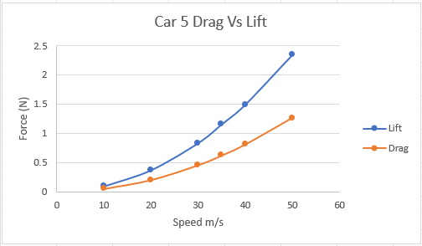
Figure 78 Car 5 speed investigations
For Car 5 the correlation of lift and drag increase with a smooth curve. Lift does increase with a steeper slope then that of the drag. From this graph it would give the impression that the speeds this car is raced at is too slow for the bodywork package lift and drag effect on a car. (Aerodynamics, 2019). More lift would be able to be produced for a less amount of drag.
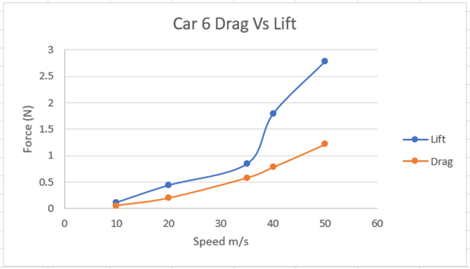
It is a similar case for Car 6 however you’ll notice that the graphs lift curve is steeper than that of car 5’s. The slope isn’t as smooth as that of car 5. There is a point where the lift jumps in its efficiency over drag, this is at 40m/s. From this the car would do better at its top end speed in terms of aerodynamic performance then with lower speeds.
Figure 79 Car 6 speed investigations
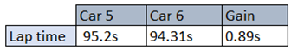
For the actual speeds reached round a circuit in particular Donnington Park, Car 6 was simulated to reach 110mph car 5 reached 108MPH (Atif, 2022). This is a small improvement but when you consider this is an improvement on the aerodynamics alone then it is a considerable amount. This equates to a lap on lap increase of 0.890 seconds. This can really make the difference between competitors.
Figure 80 Car 5 vs Car 6 lap times

Communication
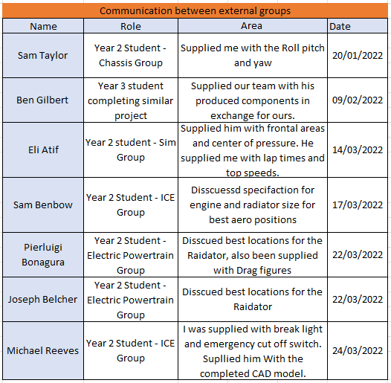
Within a large overall group project such as this one, it is crucial communication can be made between all members. Not only are the interactions between the 5 other immediate members important but communication was also had by the other groups and members of the university. These communications were recorded in Table 13below in figure to make sure any follow up questions can be directed to the appropriate student if needed.
Table 13 Table of communication

Areas for improvement
Ansys is a very compatible software for the applications we needed it for. The improvements that we could have implemented is better time planning. The time is very hard to predict with Ansys however spending roughly 440 hours myself over the course of this project. Has been more then expected. Behind the scenes there has been a lot of experimenting with trial and error sometimes being the way forward. For Car 5 and Car 6 alone there are over 200 CAD files that have been produced to get the final results. A small hole in the geometry can cause many hours’ worth of rework.

Conclusion
In conclusion this project has been a real learning experience to really understand the behaviour of the air around a vehicle. To have a target of -1.15 lift to beat and achieving that target by reaching -1.36 lift is a success. It has taken some modification with the initial result of -0.64 lift for car 6 it didn’t feel as though the project was heading in the right direction however with investigations on the postprocessing of the airflow an achievement was soon met.

Manufacturing (Adrian)

Introduction
In my section of the report my main goal was to investigate and research many varied materials that can be applied onto the car that will allow the best performance for the car during races. This would follow up with finding the most optimum manufacture process for the material chosen. Another task that I have undertaken during the group project was to evaluate if the formula 750 car would need any brake cooling and if so, how much cooling is required to keep the brake temperature at an optimal level for best performance. The last area that I have investigated was the difference in drag coefficient between the car having a windshield and drag without the windshield, to see if it would be beneficial for the performance of the car and if the windshield would affect the aerodynamics around the car.

Research
The research was conducted to see the difference between many possible materials that the formula 750 car could be manufactured from, the key factors for the materials was the cost, availability, useability and the strength of each material under formula 750 racing loads. The researched materials that I have chosen to closely look at were Glassfiber, flax, bcomp, stainless steel and aramid (Kevlar) as well as for the manufacturing processes being wet layup, resin infusion and prepreg with a choice between two resins that would be mixed with the material during the manufacturing process being polyester resin and epoxy resin. For the majority of materials, I have used a book written by Simon McBeath called “competition car composites” that helped me find out the key information about the materials that were based around racing cars as well as useful information about the three manufacturing processes. The main properties of any material that I was mainly interested in was the cost of the material, the strength of the material in various categories for example tensile strength and/or compressive strength with many other variables investigated as well. Lastly, I looked at how the material will work with the manufacturing process that I would have chosen as it is important for the material to be suitable for the machine and the resin used during the process.

Manufacturing processes
In this section of the report, I talked about the three different manufacturing processes that I have researched. The positives and negatives for each of them with a conclusion for each to decide the best manufacturing process for the material as well as for the manufacturing process to be easily done by any member of the group when trying to manufacture any part of the bodywork for the formula 750 car.

Resin infusion
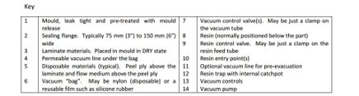
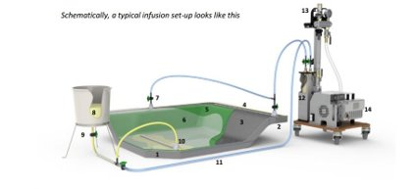
The first manufacturing process that I investigated was resin infusion manufacturing. Resin infusion is a process the material is filled with liquid resin by the voids in an evacuated stack. This is show in Figure 55.
Figure 81: Resin Infusion
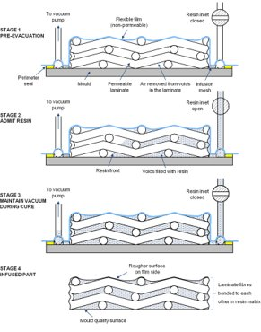
Figure 55 show all the various parts of the machines used for the resin infusion manufacturing process. After the material is injected with resin and then the material solidifies, the solid resin matrix bunds the assembly of the materials into a unified rigid composite. A key part of the resin infusion process is the removal of the air from the porous material prior to injecting it with resin. Air has the be removed with a proper tool like an aluminium roller that is suitable for removing air without damaging the material. This is done to prevent any air blocking the resin from attaching itself to the material and the mould. The are many materials that can be used with resin infusion manufacturing process but the class of materials that work best are organic fibres such as flax or bcomp.
Figure 82: Resin Infusion Process
Figure 82 clearly shows how the resin infusion process is done. From step one we can see how the material and the mould is prepared before the resin is injected into the material. Between stages two and three you can see how the resin is filling all the gaps between the material and the laminate as well as stage four showing how the inside of a completed mould looks.

Prepreg
Prepreg is a manufacturing process that requires pre-impregnated fibres such as fiberglass or polyaramid (Kevlar) and a specially cured resin such as epoxy. The fibres are usually in a form of a weave and the matrix is used to bond them together with the other components during manufacture. The matrix is only partially cured to allow easier handling of the material while moving it to smooth edges et cetera. The material then requires to be stored in a cold room or storage to prevent the material from completely curing as heat accelerates the polymerization of the material. When the material is ready it is placed inside an oven or an autoclave to cure it and finishing the mould.
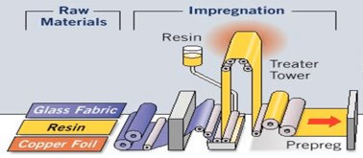
Figure 83: Prepreg
In Figure 83 we can clearly see how the impregnation process starts with firstly the material fabrics being squeezed by a machine and then the material fabric being moved into a bucket where the resin is being pumped into, the material is the mixed and rolled through various rolling rods and the outcome product is a ready prepreg material.

Wet Layup
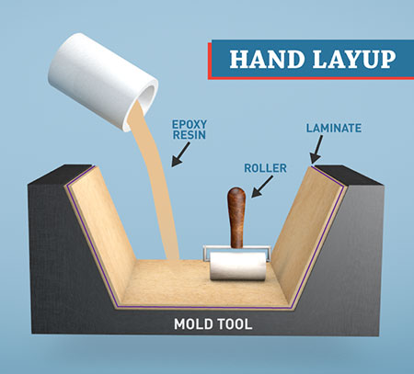
Wet layup was the last manufacturing process that I have investigated. Wet layup manufacturing process is a simple open mould fabrication process which positions layers of laminates into a previously designed mould until a desired shape or thickness is achieved. Similarly, to the resin infusion manufacturing process you will be required to use a roller to remove any excess epoxy resin as well as removing any trapped air in between the material and the mould. The materials that can be used with wet layup are diverse types of fiberglass like E glass or S glass with S glass offering much higher tensile strength and elastic modulus with around 10% more stiffness of the material. This comes with the biggest disadvantage in this project of a higher material cost. The rest of the materials being aramid (Kevlar) bcomp and flax.
Figure 84: Wet Layup
Figure 84 stands for how the wet layup is being done as an animation, from research I was able to acquire a simple step by step guide on how to work with wet layup manufacturing process.
- Cut the laminates
- Mix the resin
- Coat the working surface with resin
- Place dry laminate onto the working surface
- Pour the resin onto the laminate
- Transfer the laminate to the mol or application surface
- Remove trapped air bubbles using a roller or a brush
- Remove excess resin
This straightforward guide shows how easy the wet layup manufacturing process can be and that it does not require high engineering skills to be able to use it by yourself.

Materials

Flax

The first material that I have investigated as a possibility for the car was flax fibre. The way flax fibre is acquired is from the bast of a flax stem plant. Flax fibre is flexible, soft and much stronger than cotton that is another material in the same category as flax but on the other hand cotton fibre is much more elastic.
The first goal that I investigated about flax fibre was the cost per square meter which was £0.92 per square meter which compared to other fibres that I have investigated is a considerably cheap cost for the material. For the material strength category, I have narrowed down the number of strengths to four as I was not able to research the same strengths categories for each individual material. The four material strengths gave me a good overview of the material to later make a comparison between all the materials.
Figure 85: Flax Fibre
Flax fibre strength:
- Tensile strength – 1500 to 1800 MPa (megapascals)
- Compressive strength – 1200 MPa
- Shear Modulus – 2500 MPa
The difference range found in the flax fibre for its tensile strength varies because of the quality of the material as well as the quality of the person manufacturing the material.

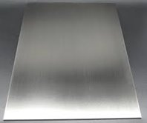
Stainless steel
Figure 86: Stainless Steel
Another material that I had investigated was stainless steel. I instantly focussed on this material for the floor of the car as I have gotten some insight on why the stainless steel would be a good fit for the group formula 750 car from a person named Martin from the falcon racekits that are currently competing in the formula 750 season. Falcon racekits company has been in formula 750 for many years and with further research into why stainless-steel floor would be good for the car I have decided to pick the material. The stainless-steel material comes with many advantages for example high heat toleration, good resistance to corrosion with two most important advantages for this project being low cost of just £1 per kilogram of the material and the superior durability of the stainless steel. Every material has their advantages and disadvantages and for stainless steel a big disadvantage is that when you make the floor it is then difficult to weld it properly, that means that if the floor is not welded properly, it can disturb the airflow underneath the car as well as cause damage to the car or completely dismount from the car while racing causing damage and danger on the track to all the drivers involved.
The strengths of the material are shown below compared to the other alternatives:
- Tensile strength – 621 MPa (megapascal)
- Compressive strength – 170 MPa
- Elastic limit – 170 MPa
- Shear modulus – 77 MPa
Following the question for the viva about the mass of the floor, the approximate weight of the stainless-steel floor would be 40kg. This is an excellent choice because of the high durability of the material as well as other variants of materials have a similar weight of the floor as stainless steel.

Aramid (Kevlar)
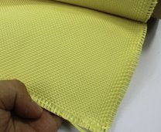
Aramid is a high-performance manufactured fibre that holds molecules that are characterized by their rigid polymer chains, these molecules are strongly linked together allowing manufactures to use chains of relatively low molecular weight.
Figure 87: Kevlar
- Tensile strength – 3000 MPa (megapascal)
- Elastic limit – 60 to 140 MPa
- Shear modulus – 17 MPa
From that data above we can see that the aramid material has a much better tensile strength compared to the other materials presented but it lacks on the other strengths which is not a desirable choice when looking at overall strength and performance. The material is also expensive, the current value on the market for aramid fibres is approximately £20 per kilogram. This is not a practical choice due to the limited budget that we have for this formula 750 project.

Glass fibre
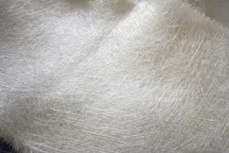
The next material that I have investigated was Glass fibre. Glass fibre is a fibre reinforced plastic which then allows it to be moulded into various complex shapes up to your desire. This also makes the material remarkably high impact strength which is especially important in case of an accident the car can absorb most of the gravitational forces and reduce the impact power on the driver. On the other hand, a disadvantage in this area with glass fibre is that glass fibre easily shatters. This makes it difficult for the driver as when he makes a mistake, the front wing or diffuser hits a kerb it would cause damage to the car and may even puncture the tire is a sharp piece of the material goes into the tire. Another key advantage with glass fibre is that the material is moisture and fire resistant, this is a benefit because if the car must be run is wet conditions the material would not change its form or shape to keep its maximum properties.
Figure 88: Glass fibre
The strengths of the material are shown below compared to the other alternatives:
- Tensile strength – 1950 to 2050 MPa (megapascal)
- Compressive strength – 4000 to 5000 MPa
- Elastic limit – 2750 to 2875 MPa
- Shear modulus – 30 to 36 MPa
From this data we can conclude that the glass fiber has a superior advantage in the areas of tensile strength, compressive strength and elastic limit over other materials previously presented. We can see that the glass fiber material has a greater strength in nearly all categories making it an excellent choice for running it on the car. Another advantage going in favour of the glass fiber material is that the cost being £0.70 per meter squared is much lower than any other materials presented. This is important because the overall aim of the formula 750 car is to be as good as possible with the parts being cheap to reduce cost of overall running.

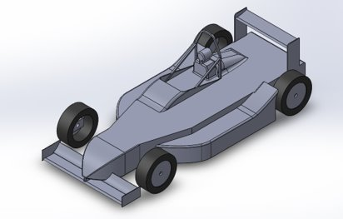
Brake Cooling/Windshield
Figure 89: Car 2 (no windshield)
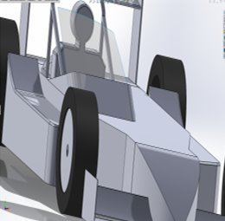
Another area that I have investigated during the formula 750 project was brake cooling. For the first half of the project, I investigated if the formula 750 car would need brake cooling or would the air moving out of the front wing/splitter be enough to cool of the brakes keeping their performance at its highest. I have also investigated installing air ducts onto the car if the brakes were not receiving enough cooling but data from the earlier races have shown that the car does not go at a fast enough at 80 kilometre per hour average speed for the brakes to be overheating with the highest gravitational forces reaching 4.4 and 1.8 on corners while braking. This means that the brakes were able to be cooled enough by the air from the front wing/splitter before the next braking zone. This has led me to investigate another area of the car which was the difference in drag with the car having a windshield installed compared to the car without the windshield.
Figure 90: Car 2 (with windshield)

Table 14: Car 2 Results (Ashleys)
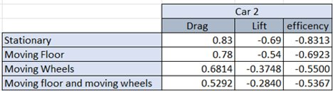

Figure 63 and Figure 64 is just a CAD comparison of the car number 2 with and without the windshield with Table 14 and Table 15 presenting the different results from the CFD testing. From this data we can conclude that the car number 2 with windshield creates more drag and produces less lift which is not optimal for formula 750 racing. We can see that there is lower drag with moving floor which shows that this could be an anomaly and requires more testing with different cars.
Table 15: Car 2 (with windshield)
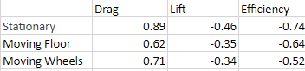

Conclusion
In conclusion for my overall area in this project I can conclude that the material that I have chosen for the body work of the formula 750 car is Glass fibre with couple particularly important advantages being the overall strength of the material and the low cost of the product. For manufacturing process, I chose the wet layup process as it works best with the glass fibre material as well as being easy to work with compared to the other manufacturing processes. The most suitable resin for the wet layup process was the epoxy resin that gave the material the extra boost of strength. Brake cooling was not needed for the car as the car was not braking hard enough for the brakes to increase highly in temperature as well as from that data shown I concluded that the windshield I have created did not reduce the drag created in the upper areas of the car and requires more various tests to be carried out.

Conclusions (Harvey)
In conclusion, the group project was a partial success. As outlined by Ashley, there was an improvement in all areas apart from the cockpit area, which was not developed. Therefore, the group has produced a car that performs better than the Falcon race kit and is something that the team can be proud of for doing. However, we did not achieve the original aim of creating a car with a better lift/drag coefficient compared to the MCR Sport 2000 race car.
The length of time it took to complete a run to convergence was lengthy and substantial. Subsequently, comparing the original timing of the team as a whole, the amount of time taken for most team members was 2 to 3 times more than the 200 hours originally outlined over the course of the projects lifespan, detailed in Figure 1. The team had to take a considerable time learning the software which further increased the amount of time taken to solve simulation runs. This was because if the car were to fail a run or the wrong result was produced (ie a car producing far too much lift or drag – coefficients in the tens) then time had to be taken to understand why the model did not solve as expected. Subsequent areas of improvement would have been to perform a domain study as well as concentrating on the cockpit section of the vehicle as this had no development.

Bibliography
Aerodynamics, T. (2019). Sciencedirect. Retrieved from https://www.sciencedirect.com/topics/engineering/aerodynamic-lift
Ansys, Inc. (2022). Governing Equations of Fluid Dynamics. Retrieved March 23, 2022, from Ansys Innovation Courses: https://courses.ansys.com/index.php/courses/governing-equations-of-fluid-dynamics/
Atif, E. (2022).
Cadence CFD. (2022, 03 01). How an Airfoil's Angle of Attack Creates Lift and Drag. Retrieved March 08, 2022, from Cadence System Analysis: https://resources.system-analysis.cadence.com/blog/msa2022-how-an-airfoils-angle-of-attack-creates-lift-and-drag
Championship, 7. F. (2022). 750 Formula Championship. Retrieved from https://www.750mc.co.uk/formulae/750-formula.htm
Doosttalab, A., Mohammadi, M., Ashrafizadeh, A., & Doosttalab, M. (2012). Numerical Investigation of Aerodynamical Performance of Damaged Low-Reynolds Airfoils for UAV Application. NASA TFAWS 2012. Caltech, Pasadena, CA. Retrieved March 19, 2022, from https://www.researchgate.net/publication/282650216_Numerical_Investigation_of_Aerodynamical_Performance_of_Damaged_Low-Reynolds_Airfoils_for_UAV_Application
Fareeq, S. (2015). AERODYNAMIC EVALUATION OF RACING WINGS OF A FORMULA CAR. University of Hertfordshire. Retrieved March 07, 2022, from https://www.researchgate.net/figure/Forces-coefficient-vs-angle-of-attack-for-rear-wing-in-wind-tunnel_fig33_290964900
Fuller, M. (2012, January). The Rise of The Swan Neck. Retrieved March 22, 2022, from Mulsanne Corner: http://www.mulsannescorner.com/rearwingLMPCFD2009.html
Hazen, E., & Lucas, P. (2018). Diffusers - How they work. Versus Engineering.
Hu, X.-J., Yang, H.-B., Yang, B., Li, X.-C., & Lei, Y.-L. (2015, July 13). Effect of Car Rear Shape on Pollution Dispersion in Near Wake Region. (F. Braghin, Ed.) Mathematical Problems in Engineering, 2015. doi:10.1155/2015/879735
Joep. (2021). Ground Effect in Formula 1: A Brief History. F1 2022 News.
Mai, M. (2019). What Is The Function of A Car Rear Diffuser? Winn Autosports.
McBeath, S. (2000). Competition Car Composites. Veloce Publishing Ltd. Retrieved from 25
McBeath, S. (2014, September 17). Advice. Retrieved March 12, 2022, from SM Designs: http://www.sm-designs.co.uk/advice.html
Motorsport UK. (2019, December 14). J Competitors: Vehicles. Retrieved October 20, 2021, from Motorsport UK: https://www.motorsportuk.org/wp-content/uploads/2019/12/145-154-Vehicles-J.pdf
NASA. (2000, April 10). Inclination Effecrs on Drag. Retrieved March 10, 2022, from NASA: https://www.grc.nasa.gov/www/k-12/airplane/inclind.html
Radu, V. (2021, June 30). Autoevolution. Retrieved from https://www.autoevolution.com/news/the-story-of-the-mercedes-benz-clr-the-silver-arrow-that-took-flight-at-le-mans-164294.html
Roberts, N. (2013, May 01). Air Dams, Splitters, Spoilers and Wings. Retrieved March 07, 2022, from Nasa Speed: https://nasaspeed.news/tech/aero/air-dams-splitters-spoilers-and-wings-downforce-increases-grip-grip-decreases-lap-times-and-isnt-that-the-whole-point/
Strong, A. B. (2007). Fundamentals of Composites Manufacturing: Materials, Methods and Applications. Society Manufacturing Engineers. Retrieved March 27, 2022
Szudarek, M., & Piechna, J. (2021). CFD Analysis of the Influence of the Front Wing Setup on a Time Attack Sports Car’s Aerodynamics. (C. Liu, Ed.) energies, 14(7907), 4. doi:. https://doi.org/10.3390/en14237907
Tech, B., Reddy, J., & Gupta, M. (2006). FINDING THE OPTIMUM ANGLE OF ATTACK FOR THE FRONT WING OF AN F1 CAR USING CFD. Engineering. Retrieved March 08, 2022, from https://www.semanticscholar.org/paper/FINDING-THE-OPTIMUM-ANGLE-OF-ATTACK-FOR-THE-FRONT-Reddy-Tech/554c81be534fc940f1ed86314e72cd2ed933fd52#related-papers
The Seven Fifty Motor Club Limited. (2021, January 19). 750 Formula Championship Sporting and Technical Regulations 2021. Retrieved October 15, 2021, from 750 Formula Championship: https://www.750mc.co.uk/ugc-1/1/1/0/2021_750_formula_-_final_regs.pdf
Time Attack Ltd. (2014, May 15). All About Aero : The Basics. Retrieved March 03, 2022, from Time Attack: https://www.timeattack.co.uk/all-about-aero-the-basics/
Toet, W. (2017). Willem Toet explains….motorsport diffusers. Race Tech Motorsport Engineering.
Winslow, J., Otsuka, H., Govindarajan, B., & Chopra, I. (2017, December 15). Basic Understanding of Airfoil Characteristics at Low Reynolds Numbers (104–105). Aerospace Research Central, 55(3). Retrieved March 08, 2022, from https://arc.aiaa.org/doi/10.2514/1.C034415

Appendices

Minutes

26/10/2021
- CFD validation
- Graphs w/ Mira, best results, wind tunnel, domain, mesh, turbulence, prism
- Therefore – validation study
- Composite lay up options, pos neg of each material and process
- 3 concepts be evaluated by Christmas, proper CFD methods, materials and manufacturing
- Falcon kit due early Nov, therefore scan and model it and compare
- Each individual area, parameters – height chord size, wing width etc.
- General concept -> specific geometries
- Concepts should package both
- 4th concept? Best of 3 but with flat rear for electro, plus performance advantage
- Target lift and drag coefficient – look at race car with 40mm ride height best coefficient of downforce and drag?
- Therefore, target of x, should be able to achieve x - y
- Downforce coefficient of -2.8, MCR -0.7, Group C LE Mans -4.8
- Lift -0.65, target of -2
- F1 drag 1.1, group c 0.8,
- SIMULATION TO GIVE US A LIFT TO DRAG THEREOFRE WHAT WOULD BE BETTER
- MCR Aims
- ORIGINAL MCR -0.51 LIFT, 0.6 DRAG – EFFICIENCY = 0.84
- MCR -2.67 LIFT, 0.72 DRAG – EFFICIENCY (LIFT/DRAG) = 3.68

04/11/2021
- CoD, CoL on PowerPoint in table, same with references for Mira
- Mira Reference complete
- Individual areas looked at with parameters, potentially in SolidWorks
- Think about each parameters – 3 own concepts (3 angle of attacks, different angle)
- John – turbulence, cockpit
- Shay – profiles, end plates, (profiles in books), naca (specific profiles) – run CFD profiles of wing
- Bot look at wing files
- Wing profile in wing tunnel, get data and model in cfd therefore will be able to validate wing profiles vs CFD
- Different profiles
- Do some resins work better with some fibres?
- In viva will ask questions (ie what fibres have been researched – carbon fibre, b comp, flax, glass) -manufacturing methods – Andrew Tibbett to show molding etc. (gets us to lay up carbon fibre car shapes in moulds – pre impregnated vs wet)
- Huge priority for environmental – alt for bodywork i.e. resin etc
- Manufacturing processes for making a part – something to stiffen in bodywork (not just fiberglass) – therefore use foam (what foam?)
- Dora – copy shape of lotus 78 ad bolt onto concept car – does it improve performance?
- SolidWorks chassis from chassis group and superimpose, then check which will be best
- Assembly -> part -> Parasolid -> Parasolid repair
- Run off desktop, close and then move both file and folder to right place
- Plans for each individual area tests
- Reference (compute from inlet (results correct but coefficients wrong), can also be wrong due to being run backwards not forwards)
- Suggestion: go to library, book room out, do plan etc. and work together, to make
- For first viva – citations, books, papers for each individual reference area, proper reading from proper spec and limitations - limitation boxes and then mention references on both slides and discuss them
- While we ran concepts, we did a baseline case and these were the results we got. This is our CFD methodology, applied to 3 concepts to bench mark – waiting for bodywork and photogrammetry techniques applied to get another reference
- Then, where are we going next - individual parameters
- Theta, angle for wing
- Buy some b comp and test for future after viva
- Wing profile, height, position, parameters, these are what we will look at after Christmas – realized important through initial research
- Where should our cop be, we need to work out where cog will be first. Weight split, want cop behind cog (static margin) – research where cop should be on race car
- ALLOCATE TASKS
- Cooling to be done, does cooling need to be in sidepods, energy dissipation in brakes
- Brake cooling design aspects
- Formalizing instead of general ideas and how we will measure performance
- Organize time for wind tunnel`

30/11/2021
- First Slide
- MCR instead
- Roles
- Picture of car, name next to area related to
- Timing
- Cant read Gantt chart, make bigger, full size, make clearer
- Regulation
- Make regulation boxes larger
- Domain study
- Validation study altogether
- Before we ran any CFD, used MIRA reference car as a validation study to ensure we head in right direction. Tasks were split into individual tasks and each person did _____. We ran this study and found that _______ needed to be _____
- Concepts
- Here are 3 concepts we looked into, these were looked into from current grid and winners
- Benchmark current car, model falcon race kit
- Diffuser research and investigation
- CFD
- Move to concepts
- 4th column for efficiency, lift/drag
- 4 images of cross plane cuts
- More post processing on how each are producing downforce
- Pressure contours of all 4 cars!
- Photogrammetry
- Didn’t work, as you can see, but…………….
- Results
- move to end of methodology
- Conclusions and questions?
- Research and reference for cfd - ie turbulence model is best for this because _____ and _____ reference agrees
- Can pass
- Marco lamphrett 1996 – look at
- I’m not sure, but if you apply engineering knowledge, then …………..
- Other
  - counts of drag/lift will be very good (4 points)

17/01/2022
- 28th March 2022 is the VIVA (probably on Wednesday)
- Report will be due the same week
- Plan needed by Wed 19th Jan – both independently and as a group
- Rough dimensions of the Falcon kit needs to be done
- Use gantry and ruler to measure every 10mm
- Bar down from gantry used too
- Distance from centreline and depth from gantry bar
- Laser measurements also
- Base points put into solidworks via point cloud
- Basic approximation of geometry
- Organise mounting of Falcon kit on existing chassis
- Needs mounting – sort this week
- (Have since spoke to Paul – should be fine to organize soon)
- Hanging panels will give an idea of how it all fits, ideas for mounting points for ourselves too
- Fill in CFD model
- Side note – Dave has use of CBM machines; can do detailed scan but creates millions of points, will need time for correcting
- Useful, but slow and has huge point cloud
- Include in report as option but explain why we didn’t do it (ie not time effective)

24/01/2022
- 6 x car length
Run Results
Car Type | Cl | Cd | Efficiency
Car 1 | -0.08 | 0.58 | -0.14
Car 2 (F1 style) | -0.69 | 0.83 | -0.83
Car 3 (closed wheel) | -0.37 | 0.4 | -0.93
Car 4 (Falcon) | -0.96 | 0.68 | -0.68
Finalised Methodology
- Mesh Scale Study: 0.8
- Prism Layer Study: 8
- Turbulence Model Study: K Epsilon Realizable
- Domain Study: 10m F, 25M R, 4x Car W, 4x Car H
Decided Car
- Car 4 will be Baselines
- Need to test with/without moving floor/wheels
- Look at cooling and manufacture of each car
- Air through front splitter?
- Air through sidepods?

This car is the Falcon kit that N. Potts designed and replicated using photographs to create a model – see page viii.
See page 25 for Car 2 details.

