The Evolution and Influence of Comic Art
Name: Harlow Pearson (2404710)
Word count: 1599
Course title: BA Illustration
Course tutor: Chris Harrendence

Throughout history all types of comic art have shared the common themes of being illustrated narratives that tend to tell stories using a combination of images and words. They’ve been pillars for telling stories documenting the past and predicting possible futures, and conveying emotions. From some of the first stone age cave paintings to comics by Rodolph Töpffer, nicknamed the father of the comic, they have vastly changed from what they were to what they are now. The focus of this essay will be on the history of comics stretching all the way back to the cave paintings to the present and how massively they’ve changed over time and how comics are interpreted today.

“The year 1895 was a decisive one for the modern conception of the early periods of human culture” (Frobanius and Fox, 1937,p13) as at this time we started digging into our history, it was then that the first cave paintings discovered from the ice age in northern Spain were found by French scholar Rivière . The cave paintings consisted of bison, ibex, stag, horse and reindeer. At the time these paintings were controversial as there was a lot of discussion whether or not cavemen were capable of making art. As more archeological discoveries were made these cave paintings became more accepted by the public as authentic art in 1902. Around this time the Anthropological Society described these paintings as “neither primitive nor simple …these pictures were true and great works of art” (Frobanius and Fox, 1937,p13-14).

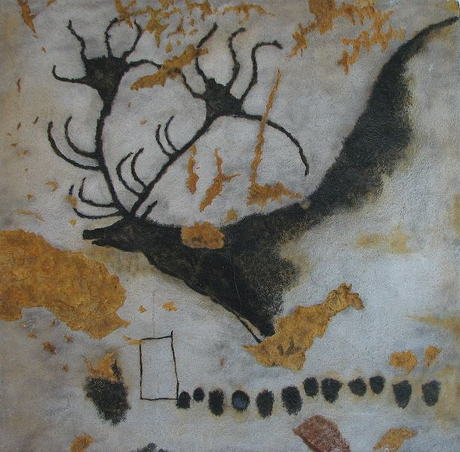
Figure 1 (Giant deer ‘Megaloceros giganteus’, unknown author, unknown date)
This showed that they weren’t meaningless scribbles. Some of the paintings with animals included dots next to them which were actually some form of early writing for man, it was their way of communicating and understanding mating and birth cycles of species. Though we don’t fully know what the paintings were for it could be their way of documenting different species or telling stories from hunting or maybe a religious standpoint. Regardless, art was the first recorded method of communication and connection between people.

Rodolphe Töpffer was a Swiss artist greatly known as ‘father of the comic strip’ and was the backbone to the comic industry, inspiring the comic genre almost two decades after his time. His work is described as satirist and comical and inspired by theatre. His characters went through ridiculous and absurd scenarios making them quite entertaining for their time showing a shift from communicating and documenting factual information.
His art styles were of black and white simple caricatures with exaggerated features of each character. The first comic he made was called ‘Histoire de Mr. Vieux Bois’ published 1827. He created many stories and was aware of his impact on history and art so in 1842 he published ‘Essai d’Atougraphie’ outlining his reasons for his work as well as the techniques for his art, talking about the relevance of facial expressions and combining text and images. This has followed into todays work as the basic layout for comics. In 1846 Rodolphe Töpffer died, and people believed the genre he created for his work wouldn’t continue without him, however his legacy carries on and some say “The impact of Töpffers new invention was immediate and long lasting European wide and even reached the United states”.(Kunzle,2007,p.143)

Comics first started in newspapers as comic strips in the 19th century, with an over flowing amount of work from the UK and America under the title of comical comics. Some popular ones being the Peanuts, Garfield and Popeye.
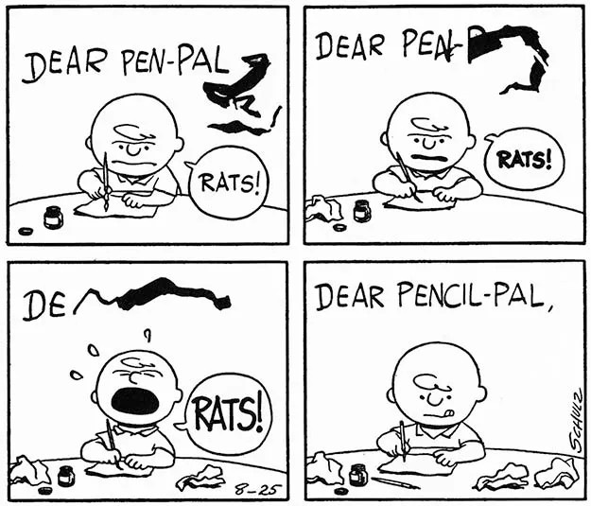
Figure 2 (Peanuts Daily strip August 25 1958, Klein, 2023)
One genre that was quite popular at the start were funny animals for example pogo, followed a cast anthropomorphized characters and their life in Okefenokee swamp combining art, humour and civilised. One that was not popular but still in the genre and influenced by funny animals was Vootie an underground apazine. This had individual artists contribute their work into one piece and publish it as funny animal comic strips and anthropomorphic art.

In 1938 the debut of the Golden age of comics dawned with the release of superman giving way for the superhero genre with his counterpart Batman being released a year later. Following was Captain America made by Timely Comics, which later is renamed to Marvel comics, based around World War 2 with Captain America fighting Hitler and Nazis as a political standpoint for Americans.
In 1954 the Comics Code Authority was created to censor what would be shown in comics, as they were deemed to have been inappropriate for children to read, promoting ‘violence’ as well as Batman and Robin ‘encouraging homosexuality’. At this time comics started to gradually lose popularity as they gained a negative reputation. Luckily Stan Lee's involvement with timely comics created the most iconic characters of marvel reviving the popularity for comics industry.

Figure 3 (Stan Lee, Unknown author, unknown date)
They proceeded to continue with their popularity influencing Europe and Japan and vice versa. Japanese comics (more so known as manga) started to get published in the 60s with series like ASTRO boy but weren’t too successful; manga only started to be popular in the 80s with more series like Ranma.

In the last decade comics have gone through a transformation from them being solely produced as entertainment for children to plenty of other stylized genres like graphic novels and manga with their themes becoming mature with action, horror and of sexual nature. Some popular franchises like marvel originally created by Stan Lee who had a big impact on the super hero scene. In 1961 Stan Lee created the comics Fantastic Four with his collaborative partner Jack Kirby.
After its success they went on to create Spiderman, The incredible Hulk and X-men. There work was quickly climbing the ladder and taking the number 1 spot in the comic industry. People were intrigued by the marvel comics stories but also the characters making them relatable going through issues in their lives giving them tragic backstories or flaws that made them human giving the readers a feeling of connection with the characters making people love them more. A perfect example of a character is Spiderman as he once stated “What I like about the costume is that anybody reading Spider-Man in any part of the world can imagine that they themselves are under the costume. And that’s a good thing” (Stan Lee on What Made Spider-man so Special, Matter, 2018), making it so that he could be anybody under the mask. Many perceive him as a great creator as he keeps his readers in mind when making the stories as he caters to making them feel seen or represented in The marvel world.

Akira Toriyama was a Japanese illustrator creating one of the most influential works, ‘Dragon Ball’. This piece of pop culture is a type of Shonen (Manga series catered towards boys as the target audience) and is based around Goku protecting friends and family from enemies through the universe full of action fantasy and comedy. His art style is very cartoony, with the character designs have rounder soft designs, then shifting to more angular and spiky appearances as he developed his work through the years.
Akira's impact on people with Dragon Ball has created the manga creators and animators we know today, inspiring many with new genres and storytelling dynamics we wouldn’t get from anyone else . Evidence of his art influencing artists of today can be seen through works like One piece and Fairytail with them inspiring others and so on. Almost all manga we know today like Demon slayer and My hero academia can be traced back to Akira Toriyama, he may be gone but his legacy lives on.

Over the decades comics, novels and manga have all changed significantly from the dawn of time with cave men, being a passionate way of communication, to current day with deep incredible stories. Semiotics is “the signifier, which in language is a set of speech sounds or marks on a page, and the signified, which is the concept or idea behind the sign.” These were pretty much all cave paintings, not using a set language but pictures with them representing a variety of subjects, for example the dots as simple as they are were; used to measure passing time and documenting information. From comics closer to today a speech bubble's shape can symbolize a different emotion, regular round ones are normal talking but a bubble being spiky can signify a character is shouting or angry, different variety of shapes for speech can emphasize how a character is feeling. Over exaggerated expressions can be considered semiotics. Not just making a character simply frown that could just be seen as sad or angry making them have arched eyebrows with a frown with spiky teeth and fire radiating off them shows very clearly that character is angry. The comic art-style allows you to create more exaggerated and over the top expressions that can’t normally be shown on a human but can make perfect sense in a comic setting. What all these different comics have in common is they all use a mixture of typography and pictures to convey information to the person observing them whether its informative or a fun narrative. Although, all remain unique! Cave paintings were commonly used as a function to maintain information. Comics back from 17th to 20 century were mostly comical short stories to be enjoyed by children and have now evolved to be more stylized, have more complex stories that involve a lot of emotion and genres to be enjoyed by all ages.

Bibliography
Britannica (2018). Semiotics. In: Encyclopædia Britannica. [online] Available at: https://www.britannica.com/science/semiotics.
Celic, N. (2024). Remembering Akira Toriyama, Creator of Dragon Ball. [online] The New York Public Library. Available at: https://www.nypl.org/blog/2024/04/24/remembering-akira-toriyama-creator-dragon-ball.
en.m.wikipedia.org. (n.d.). Lascaux - Wikipedia. [online] Available at: https://en.m.wikipedia.org/wiki/Lascaux.
https://facebook.com/animeuknews (2024). Memories of Akira Toriyama • Anime UK News. [online] Anime UK News. Available at: https://animeuknews.net/2024/03/memories-of-akira-toriyama/ [Accessed 27 Apr. 2025].
Klein, T. (2023). CHARLES SCHULZ - LETTERER - Todd’s Blog. [online] Todd’s Blog. Available at: https://kleinletters.com/Blog/charles-schulz-letterer/ [Accessed 27 Apr. 2025].
Kunzle, D. (2007). Father of the comic strip : Rodolphe Töpffer. Jackson: University Press Of Mississippi.
Matter, B. (2018). Stan Lee on What Made Spider-Man So Special. [online] Marvel Entertainment. Available at: https://www.marvel.com/articles/comics/stan-lee-on-what-made-spider-man-so-special.
New, A., Frobenius, L. and Fox, D.C. (1937). Prehistoric Rock Pictures in Europe and Africa. Arno Press.
Stan Lee | Biography, Comics, Characters, & Facts. (2018). In: Encyclopædia Britannica. [online] Available at: https://www.britannica.com/biography/Stan-Lee.
Stan Lee. (1922). IMDb. Available at: https://www.imdb.com/name/nm0498278/.

Figures
Figure 1: en.m.wikipedia.org. (n.d.). Lascaux - Wikipedia. [online] Available at: https://en.m.wikipedia.org/wiki/Lascaux.
Figure 2: Klein, T. (2023). CHARLES SCHULZ - LETTERER - Todd’s Blog. [online] Todd’s Blog. Available at: https://kleinletters.com/Blog/charles-schulz-letterer/ [Accessed 27 Apr. 2025].
Figure 3: Stan Lee. (1922). IMDb. Available at: https://www.imdb.com/name/nm0498278/.
Youtu.be. (2025). Available at: https://youtu.be/iv0QaTW3kEY?si=4VO2awhL7t9hZkH7 [Accessed 28 Apr. 2025].

