HTML & CSS WEB DEVELOPMENT

ACCA4023

SELECT THE DATE YOU WILL BE SUBMITTING STUDENT NAME: Silvia Kalokova
Student ID: 2436974

Table of Contents
Introduction 2
Requirements 3
Purpose: 3
Subject matter 3
Intended audience 3
Implementation 4
Screenshots of the Webpages 4
Validation 8
HTML Validation 8
CSS Validation 8
Evaluation 9
References: 12
Appendix 13

Introduction

The site of the Artisan Cake Co. web page was presented in such a way that it describes the services and product of an award-winning bakery located in London that creates a visually stimulating yet informative site to prospective customers. This report explains the planning, construction and testing of the site with emphasis on the steps and choices made to achieve a successful online presence. The site is designed with HTML5 and CSS3, includes the responsive design approach and media queries in order to be productive under different devices with different screen size [1]. It also focuses on the local customers and also on the foreigners who are keen on the baked goods of high quality. The main peculiarities are its multi-page format: Home, Menu, About, and Contact pages, its hero section including a large number of calls-to-action, a display of featured products, testimonials, and a convenient contact form that will promote the user engagement, ease of use, and general experience.

Requirements

Purpose:
The Artisan Cake Co. website was created to serve as an interactive online tool that will display the high quality products offered by the product, promote the brand name of the bakery and appeal to new and current customers. The site is also useful in connecting with the customer by enquiring and placing special orders, enabling communication between the customers via their useful contact form and much-needed details like contact hours, and location [2]. The bakery will further develop its presence in the online market by designing an appealing and informative site which will help to promote the business amidst the competitive market.

Subject matter
The site is laid out with four major pages having different purposes. The Home page has a hero section that contains major calls-to-action that are pointing out featured products and promotions [3]. The bakery products are seen on the Menu page with prices; one can find it easy to explore the products the bakery offers. About page creates brand identity by giving a history of the company, mission and a story of the company. The Contact page has a working form and a location map, which provides accessibility to customers by providing detailed hours of opening, which is important. The site is created to be completely responsive and make it usable on various devices, plus being well structured in terms of navigation, accessible features, such as semantic HTML and alt text, and search engine engine (SEO) optimised to enhance search discoverability [4].

Intended audience
The main audience is the local customers in London in need of the products of the artisanal bakery. The online visitors are the secondary users that can be found researching what the bakery has to offer, visitors that intend to visit the bakery and also event planners who seek to order personalized cakes to celebrate special occasions. Both the content and design are specific to address the needs of the two groups of audience.

Implementation
The Artisan Cake Co. Web site consists of four primary pages: Home, Menu, About and Contact that are meant to bring out the intuitive and attractive user experience of its site. All the pages are provided as screenshots in the appendices to show layout and design features that were applied.
The Home page consists of a hero section with a background of the image of the artisanal baked goods and call-to-action (CTA) to the Menu and Contact pages [5]. At the bottom of the page, a grid of featured products represents popular cakes and pastries of the bakery and draws attention to several main products and has illustrative pictures and price tags. Semantic article elements have been used in the testimonials section to ensure clarity in customer feedback and make them more credible and easily reachable.
The Contact page also has a built-in contact map using Google Maps, as well as unique contact and a working form to make inquiries and place a custom order. Multiple pages have a call-to-action section that encourages user interaction through leading the visitors to ordering or visiting the bakery.
The use of styling was done with a lot of care so that the brand is consistent and appealing to the eye. Gradient backgrounds have been used to enhance the interactivity with hover effects on buttons. The typeface will be Playfair Display, headings, and Roboto, a body typeface, which provides a sense of style and readability[6]. There are always the use of colours, gradients and shadow effects to support its brand and emphasize significant content.
Relative links maintain the implementation of navigation on a page between pages, and the highlighting of active pages offers the user context and orientation. The site is fully responsive, with CSS flex-boxes and grid being the layout management styles. The media queries were implemented to scale back the content to be shown on mobile and tablet gadgets, so that images, text and navigation will be accommodative and harmonied in all screen sizes [7]. All in all, the implemented considerations are outstanding in both usability and accessibility and are blended with aesthetic requirements, which make the overall implementation a site that serves professional and functional purposes and satisfies the needs of the intended audience.

Screenshots of the Webpages

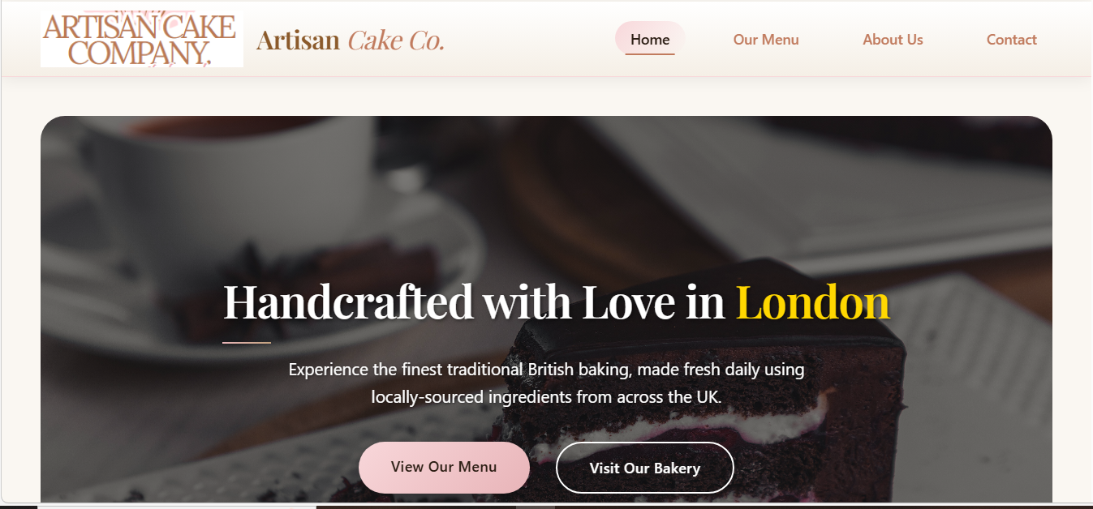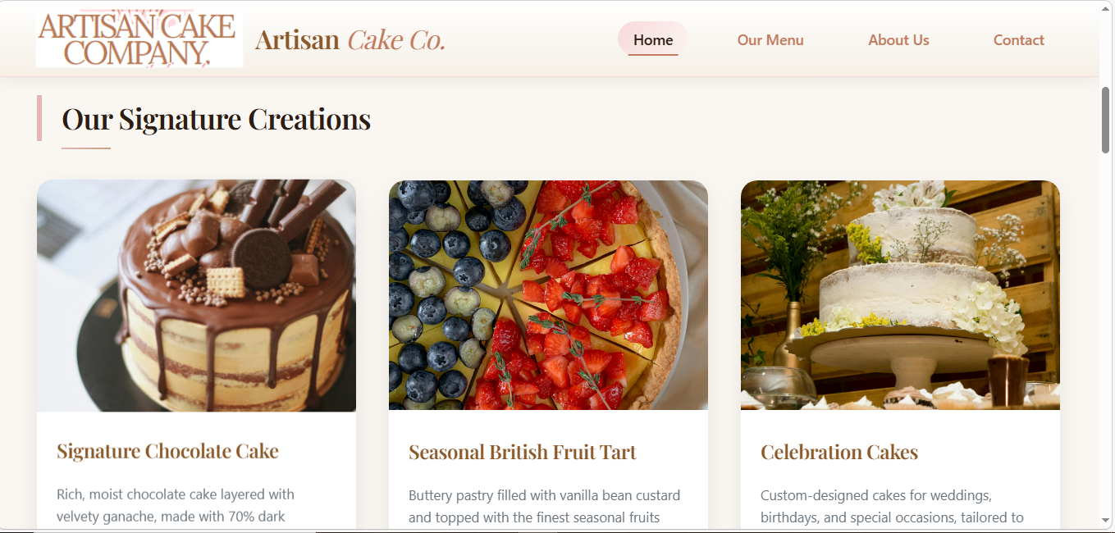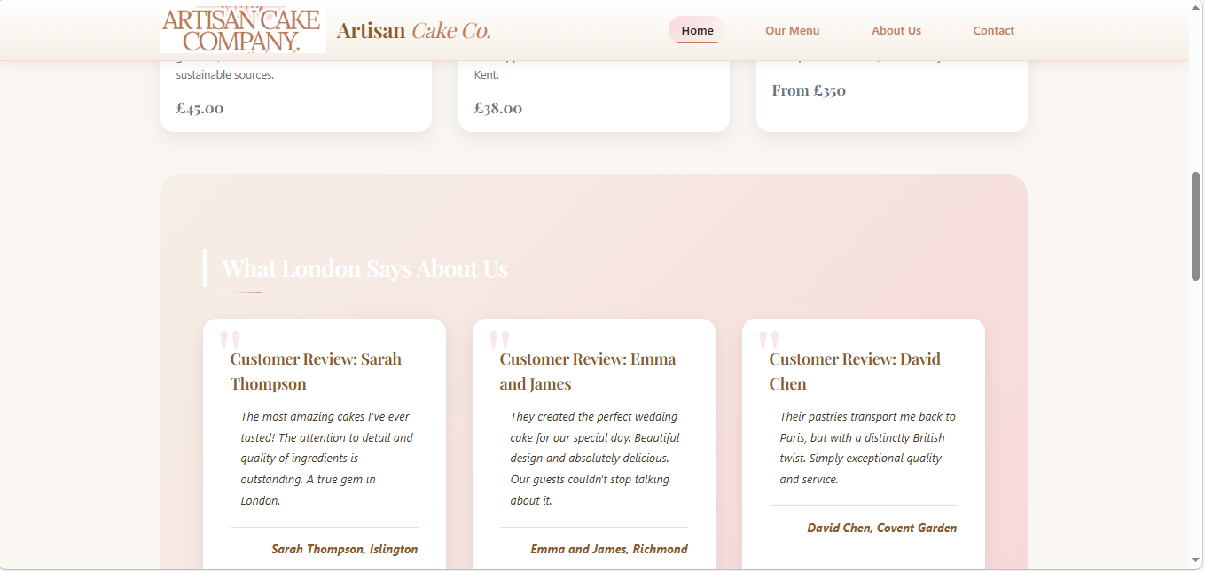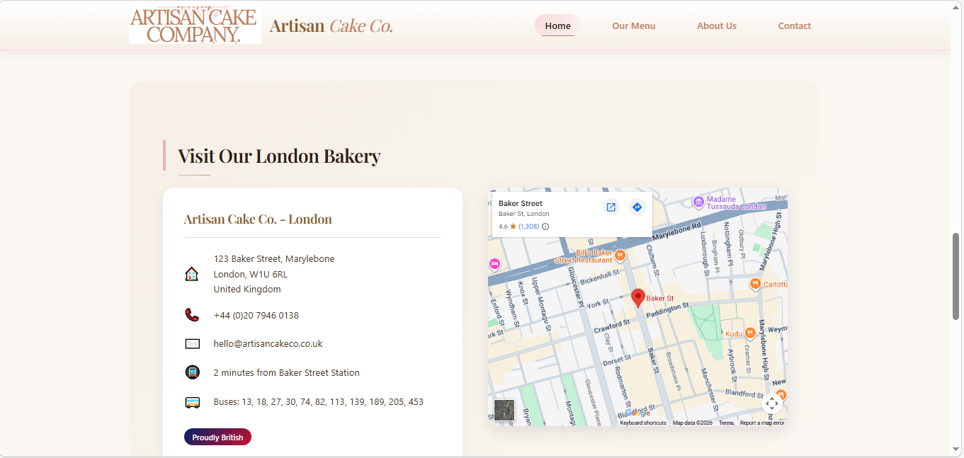
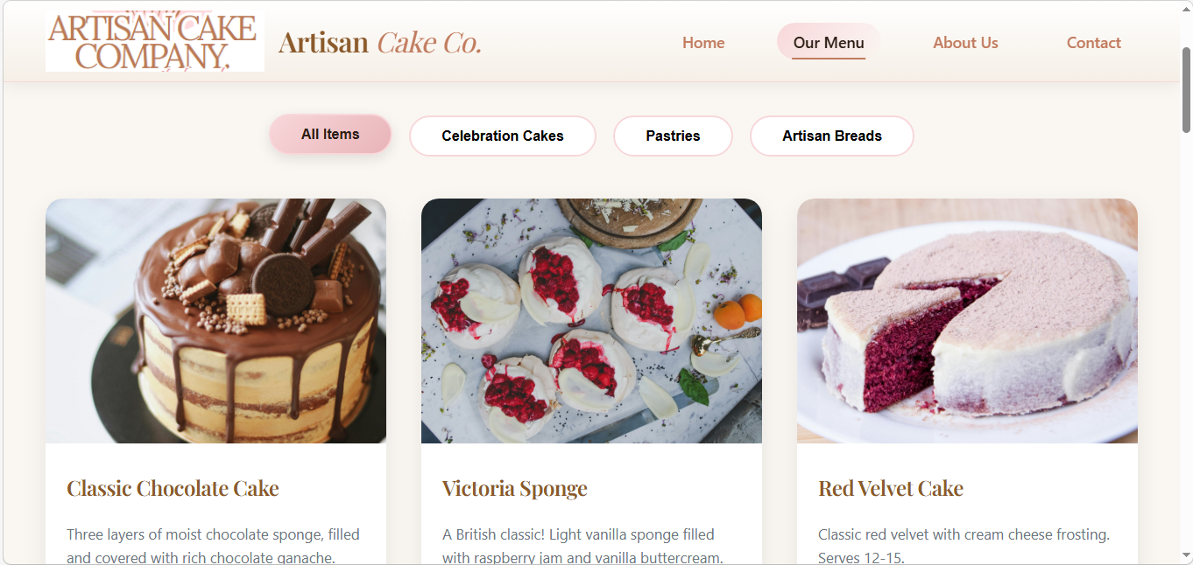
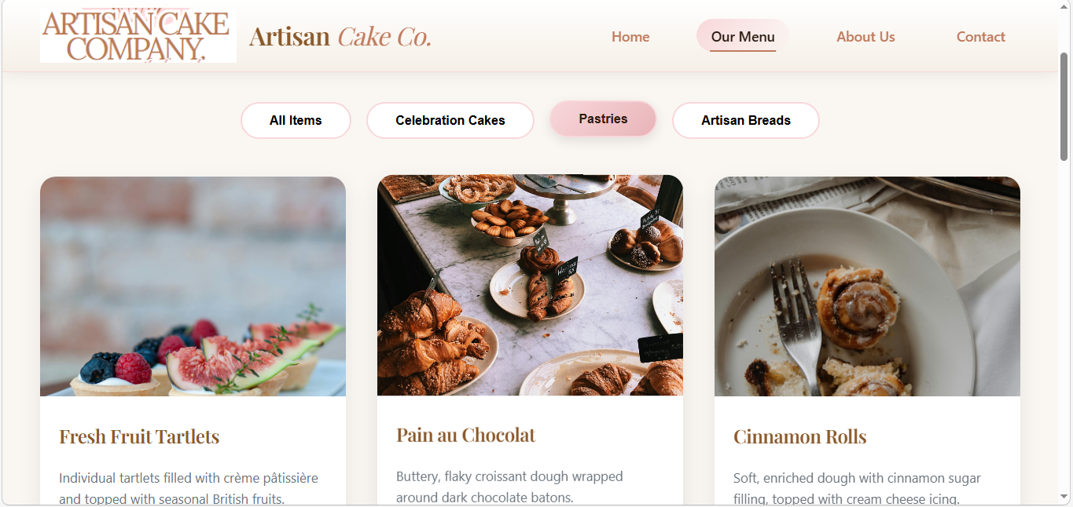
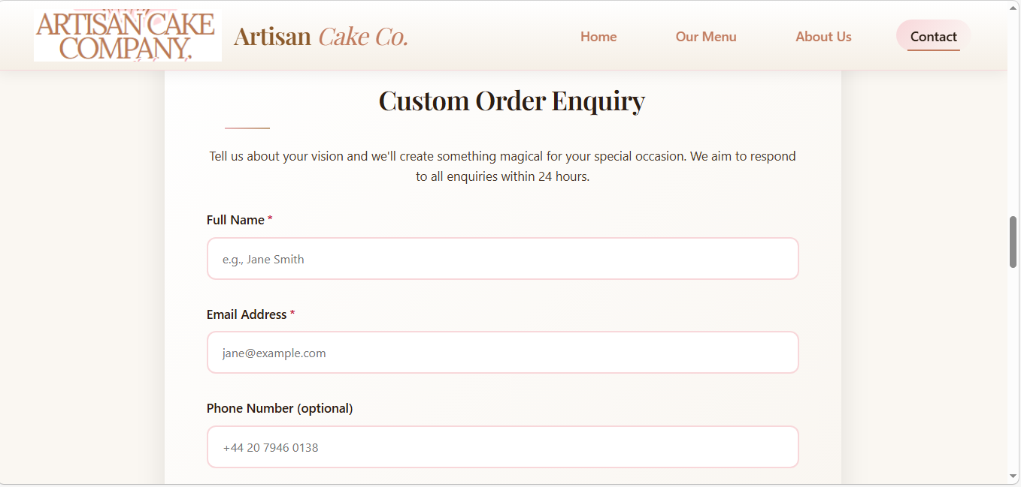
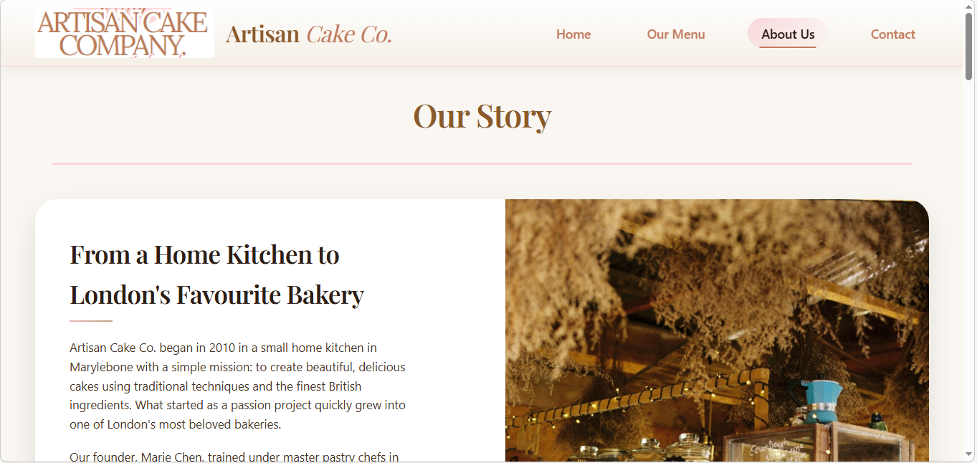
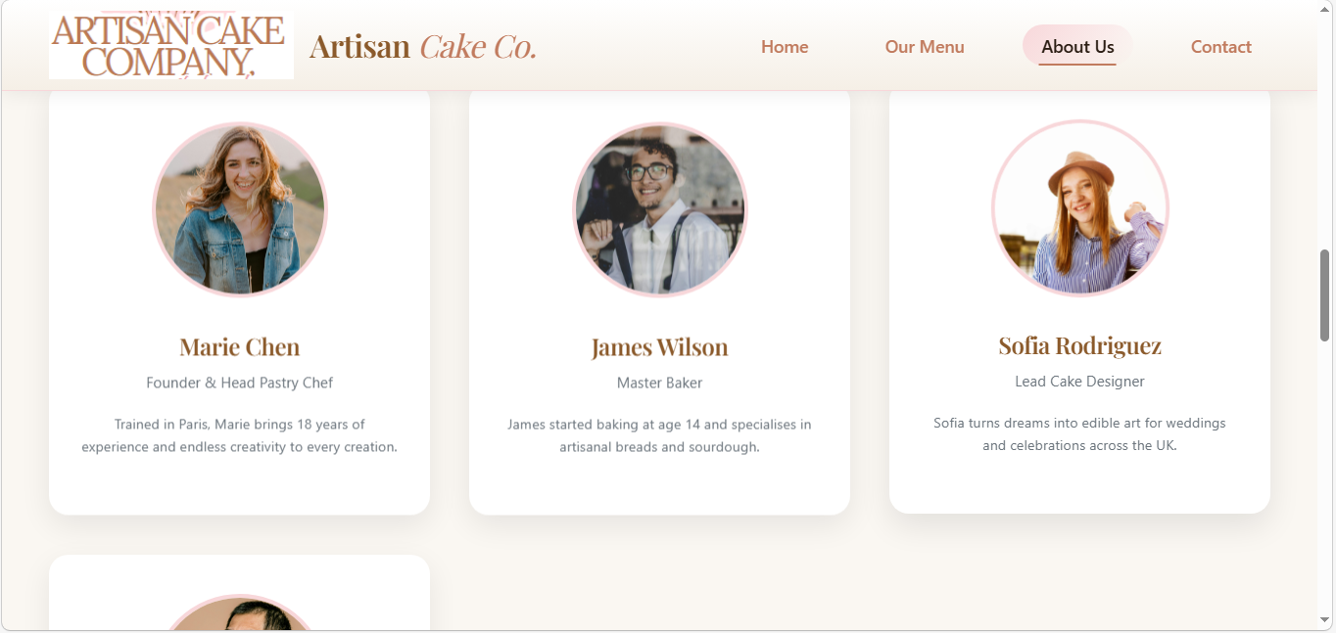

Validation

HTML Validation
The W3C Markup and CSS Validators were used to check the HTML and CSS of the site to check their adherence to the web standards. HTML validation was done on the index.html page where the results are presented in the form of screenshots in the appendices [8]. At first validation, there were detected problems with the structure of headings, namely, with its skipped levels, and the absence of the element of heading as h3 in testimonial <article> sections. To rectify all these problems, proper headings were provided at the top of every testimonial post and proper sequence between <h2>and<h3> was followed on the whole page. After these corrections, the HTML validation did not display any errors or warnings and it was deemed that it met the standards of W3C.

CSS Validation
CSS validation was done on the CSS file main.css. The validation process made minor syntax adaptations such as the correction of replicated properties and closing brackets [9]. The CSS validation was complete after these corrections showing that all the rules were valid. Such validation processes ensure that the site is semantically accurate and the visual representation is also present and cohesive in all current web browsers, which promotes ease of use, accessibility and professionalism.

Evaluation

Part A (In this section explain your research on the following topics)
Website usability is a term used to describe the degree to which a website is effectively interactive with the users and the ability to perform a task. Such points are content layout, clarity, readability, and consistency of design[10]. More recent research has shown that usability has a strong correlation with user satisfaction, engagement and conversion rates because poor usability raises the cognitive load, and decrease return visits. Accessibility in websites guarantees web users with different abilities to perceive, explore and engage with online content easily. WCAG 2.1 guidelines which are founded on the principles of perceivable, operable, understandable and robust recommend the use of alt text and keyboard support [11]. SEO maximises web contents by optimisation of the search results in search engines and accessibility techniques like semantic HTML are also becoming more accessible and visible.

Part B (In this section explain the evaluation of your website)
The Artisan Cake Co. Web site has a high degree of usability. Categories of products and contact details are well-placed and easily identified by the normal labels in navigation menu, which enables a user to find anything easily [12]. The content has logical progression where the site starts with a section of heroes to attract attention, a section of featured products, testimonials, and contact. The main calls-to-action, which are, View Our Menu and request a custom cake, lead users to the most important sections which helps to complete more tasks. CSS media queries and grid layouts result in responsiveness and guaranteed best functionality on the desktop and mobile gadgets.
Accessibility has been taken care of through semantic HTML, a description text alternative of image and skip link to the people who use the screen reader so that they can navigate through assistive technology. Correct scale of headings contributes to accessibility and search engine optimization, whereas the use of keyboards boosts inclusivity. Any further development is the adjustment of colour contrast to WCAG AA levels and addition of the ARIA labels to the complex content.
SEO is facilitated by the valid page titles, meta description, headings programmed and the internal linkages. Mobile-friendly design also enhances the search engine optimization, but structured data would enhance exposure of goods and local business information.
Strengths:

- Distinct and coherent navigation having contextual calls to action.
- Dynamic layout to flexible size screens.
- Alt text and Semantic HTML: accessibility and search engine optimization.
Weaknesses:
- Some of the text required better colour contrast.
- Further accessibility characteristics (e.g. ARIA roles) would make it inclusive.
- Advanced SEO signals are currently not implemented since structured data markup is not practiced.

Part C (Provide the comparison of two Live Websites)

In order to place the usability, accessibility, SEO, and mobile-friendliness of the Artisan Cake Co. site into perspective, two real-time UK coffee websites were reviewed: ZeroToOne Coffee .a specialty coffee shop in London with references to Vietnamese culture of coffee drinking, and Benjamin’s, a luxurious coffee and patisserie in Luton.
Artisan Cake Co. and ZeroToOne Coffee have easy navigation and consistent menus with the logical flow of the content, some of which are more structured and highlighted by the active page in Artisan Cake Co. The site of ZeroToOne Coffee has the opportunity to tell its story and menu items very well, but is less semantically organized and has less accessibility support like skip links or sequentiality of headings that may complicate assistive technology. The location of Benjamins Cafe is showing average clarity with regard to the navigation and is not showing clear features regarding accessibility; that is content sections are not always organized in a similar pattern and in some cases there are no descriptive labels to accompany the interactivity.
Regarding SEO, Artisan Cake Co. has page titles and meta descriptions of major pages tailored to their purpose and promotes relevance to this search engine. The location of ZeroToOne Coffee has the fundamental aspects of SEO but could have better semantic markup as well as structured headings to better search optimization. The search optimisation potential of Benjamin’s Café is usually limited by poor consistency in heading hierarchies and inability to locate positioning in the headings, which tends to make the search not that optimised.
All the three sites are mobile responsive, such that there is usability in all devices. Nonetheless, the location of the Artisan Cake Co. has been quite stable in terms of the page load time and structural clarity which plays a role in usability and the search engine optimization. ZeroToOne Coffee also fits the mobile screens quite well yet can be enhanced with the accessibility and semantic strength. Although Benjamin Café is aesthetically well-developed, it needs improvements in terms of accessibility and structural uniformity to reflect the best practices.
All in all, the site of Artisan Cake Co. has the best overall performance, which provides a good combination of usability, access, SEO, and the mobile-friendliness. Its considered design and technical execution make it an inclusive and search optimised experience than the other UK websites looked at.

Area | ZeroToOne Coffee (Website 1) | Benjamin’s Café (Website 2)
Weblink of the Website | https://zerotoonecoffee.co.uk | https://benjaminscafe.co.uk
Usability | Good: Navigation is clear, menus are logical, content flow is acceptable; some CTA buttons not fully highlighted | Moderate: Navigation is average, menus sometimes unclear, content flow less structured; CTA placement inconsistent
Accessibility | Some alt text and headings present, but limited skip links; semantic structure partially applied | Few accessibility considerations; missing alt text on some images, inconsistent heading hierarchy, limited support for screen readers
SEO | Moderate: Page titles and meta descriptions included; semantic markup could be improved | Moderate: Basic meta descriptions and headings; inconsistent semantic structure reduces search engine visibility
Mobile Friendliness | Responsive: Site adjusts well to different screen sizes | Responsive: Site adapts to mobile, but some elements not fully optimised (e.g., images overlap text)
Conclusion | Performs reasonably well with clear navigation and acceptable SEO; accessibility can be improved | Performs below average in usability and accessibility; requires better structure and optimised elements for mobile and SEO

References:
[1]
B. Frain, Responsive Web Design with HTML5 and CSS. Packt Publishing Ltd, 2022.
[2]
Dr Umapathi Janne, Web Design and CSS Animation. 2024.
[3]
Bora Kurum, Marketing Communication Essentials: From Zero to Hero. Bora Kurum, 2023.
[4]
S. Wallenius, “Recommended SEO-techniques to increase organic traffic for a website : a scoping review.,” Urn.fi, 2024, doi: http://www.theseus.fi/handle/10024/876381.
[5]
N. KC and K. Neupane, “From Oven to Online- Enhancing Social Media Marketing for Lintskun Bakery,” Theseus.fi, 2025, doi: http://www.theseus.fi/handle/10024/908865.
[6]
A. T. Wolf and K. Putnam, Beyond the Static Page. A.T. Wolf & Company, 2023.
[7]
D. Cruse and D. Boudreau, Inclusive Design for Accessibility. Packt Publishing Ltd, 2025.
[8]
J. Dean, Web Programming with HTML, CSS, and JavaScript. Jones & Bartlett Learning, 2025.
[9]
D. Durocher, HTML and CSS QuickStart Guide : the simplified beginners guide to developing a strong coding foundation, building responsive websites, and mastering the fundamentals of modern web design. Albany, New York: Clydebank Technology, 2021.
[10]
Tereza Semerádová and Petr Weinlich, “Looking for the Definition of Website Quality,” SpringerBriefs in business, pp. 5–27, Jan. 2020, doi: https://doi.org/10.1007/978-3-030-44440-2_2.
[11]
J. Wei, Human-Centered Design, Operation and Evaluation of Mobile Communications. Springer Science+Business Media, 2024. doi: https://doi.org/10.1007/978-3-031-60487-4.
[12]
Q. Xu, “User Interface Design,” Multimedia Foundations, pp. 409–451, May 2023, doi: https://doi.org/10.4324/9780429422669-18.
[13]
“ZeroToOne Coffee,” ZeroToOne Coffee, 2025. https://zerotoonecoffee.co.uk/?gad_source=1&gad_campaignid=23558304169&gbraid=0AAAAA-AP64NFRTYWyw-1mWapnMcXByxUh&gclid=EAIaIQobChMI3_O2ja2pkwMVbaNmAh2WggNjEAAYASAAEgIoQvD_BwE (accessed Mar. 18, 2026).
[14]
“Benjamin’s Café – Luxury Café and Patisserie,” Benjaminscafe.co.uk, 2023. https://benjaminscafe.co.uk/

Appendix


