
Madalina Blaglosov (2207678)

People and Organisation



Contents
Introduction 2
Discussion 3
Conclusion 7
References 9

Introduction

‘The role of a creative leader is not to have all the ideas; it’s to create a culture where everyone can have ideas and feel they are valued’ (Ken Robinson,2011)
Employees will contribute more and work more effectively when they feel appreciated. They usually demonstrate more dedication, passion, and extreme loyalty.
According to Scott Mautz anyone can recognize the obvious signs of a toxic workplace: lack of gratitude, poor accountability, or a manager who is a raving crazy. People leaving due to a toxic leader, toxic cultures, and poisonous organisations.
According to the statistics, employees often leave their employer. 50% of employees have quit a job or have thought about doing so because of their line manager. And this isn't because they're unreliable or toxic; rather, it's because they lack managerial knowledge or abilities. When you invest in people, they will take care of you, your team, and your clients.
How significant is organisational structure? How can organisational culture affect productivity?

Organizational structure
When tasks are assigned, organised, and managed to achieve authoritative goals, it is said to be done in a hierarchical manner. Authentic structure, which serves as the basis for standard methods and schedules, has an impact on how hierarchies operate.
Organizational culture
Most often, organizational culture is seen to include all of an organization's beliefs, values, and mentalities as well as how they affect how its representatives act. When a customer purchases an affiliation from a business or service provider who collaborates with it, how people perceive the association is influenced by culture.
Levels of culture- ED Schein
Schein separated the way of life of the association into three distinct levels: curiosities, values, and assumptions. In the association, curiosities are active and distinct components. Such factors as office setup, uniforms, inside comments, and slogans are typically visible to even an outcast.

Main Findings

Discussion
Relationship between organization culture and structure
In one way or another, the authoritative culture characterizes the hierarchical design of the organization, but the construction also somewhat characterizes the organization's way of life. Similarly, design can be said to be a way of life to be carried out, while a way of life directs how an organization is to be organized.
The correspondence flow of hierarchical design is critical to the extent that should change occur; representatives must be carefully positioned toward a better approach to getting things done. This may require investment. If the correct construct is presented, the hierarchical culture will forcefully adapt (Widarko, 2022).
Importance of organization culture in structure formation
Organization Culture is perceived by businesses significantly. Some organizations understand its importance and spend commensurate resources to improve or support a positive culture, while others completely ignore it.
Even though it is difficult to show the effect of a hierarchical culture, it is accepted that workers from companies with thoughtful areas of cultural strength experience a sense of place, commitment, and responsibility towards their organization, which is certainly the basis for progress. Critical mechanism of culture are listed under:
• A hierarchical culture goes a long way in creating an organization's brand image. Work culture gives the organization its character. As such, the organization is known for its way of life (Karikari, 2022).
• Culture shapes the way agents connect with their work environment. A solid culture encourages workers to stay motivated and loyal to leaders. In addition, the work culture promotes healthy relationships between representatives. It also goes quite far in advancing sound competition in the work environment. The lifestyle of the work environment inspires representatives to perform.
• A culture of organization helps create a close connection with the business. The way of life develops a sense of place and responsibility towards the company and promotes a sense of belonging in the work environment (Thelen, 2022).
• Each organization has probably set rules for representatives to function similarly. The organization's way of life deals with certain pre-defined strategies that guide the representatives and give them a sense of leadership at work. Each individual is clear about their work and responsibilities in the organization and expertise to complete tasks before the deadline. Additionally, these strategies help curb positive tendencies in people, making them prolific professionals. It is a way of organization life that brings out the best in each colleague.
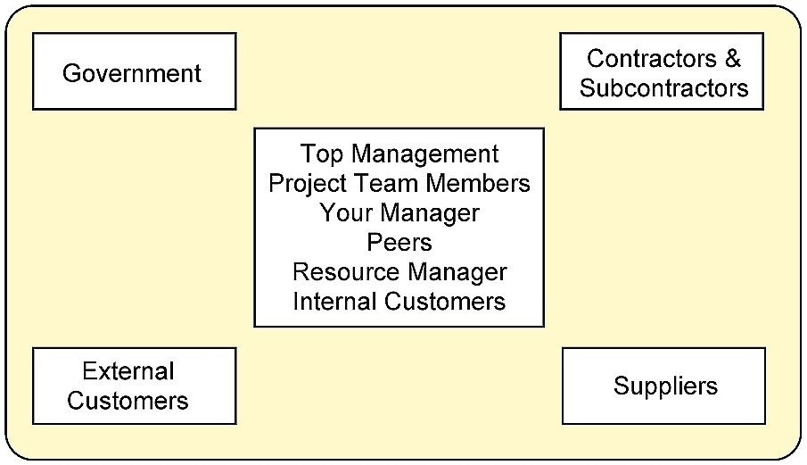
Effect on organizational performance
According to the Rick while doing business in the construction of a Useful Organization can be seriously affected if correspondence progress through different levels of an order takes, making the organization extremely late to adhere to innovation, political circumstances, economics, social changes. Mostly, it has a narrow range of control that could cause limitations in individual articulation and strength, causing work frustration and loss of inspiration. The level of inspiration the reps have will affect their outcome influencing business execution.
The representatives probably do not understand their unique work's larger situation and meaning. Representatives can have a terrible discernment to work with, or because everything is so obviously characterized and correspondence is limited, it can result in significantly more indifference and mentality, affecting representative relationships, affecting inspiration, and bringing low business fulfillment.
Organizations, as a whole, realize that representative maintenance is a vital concern for the organization. Not at all like it is now, time is demanding, expensive and people who leave often take limiting the information that is difficult to replace. As a result, managers understand the importance of pinching their current individuals.
Currently, every business proposal consists of a certain combination of effects, such as compensation and benefits, and intangibles, for example, connection with partners, a balance between fun and serious activities, and trust in the administration. In this way, the chance to join another organization is presented when the current position does not address the worker's requirements.
Responding to the question in this way, if the motivation to change is unmistakable - it does not have to be a big task to maintain the ability. Even though it is a last resort - the administration has the main job because an authoritarian culture cannot be changed immediately. In any case, authoritarian culture influences each of the views mentioned above. Organizations that reward their representatives for outstanding performance give people a sense of fulfillment and accomplishment.
Organizers provide ways to keep up with this balance in a healthy hierarchical culture, including flexible schedules, location conveniences, and telecommuting options. In addition, maintenance is strongly influenced by work societies where expansive goals penetrate representatives of all levels, workers are forced to work in a joint effort, and the door is open to all for preparation, new learning, development, and progress.
Embed strongly believes in the importance of a hierarchical culture for attracting and retaining important executives. It is one of the significant parts that our bosses, CTOs, and various pioneers use to support execution, produce close to a home interface, and maintain supremacy. We consider it a central trading technique. Organizational culture takes on an urgent role in organizations - it is a significant resource and a critical driver for workers (Jamali, 2022).
Role of stakeholder to improve organizational performance
The main role of stakeholders is to help organizations achieve their basic goals by contributing their experiences and perspectives to the business. We can also provide important materials and assets. Their help is essential for an efficient business. Commitment to partners further develops the dynamic cycle of the organization. Executive relationship managers improve the organization's social license. Constant communication with the network avoids costly disputes. Our commitment to our partners helps organizations meet global support challenges.
Partners can be divided into two main categories: (i) internal and (ii) external partners. Requests made by external partners encourage the organization to move forward and achieve its goals and objectives. Internal partners of an organization consist of employees and managers. In contrast, external partners are financiers, customers, providers, lending professionals, government agencies, government departments, labor unions, neighborhoods, pressure groups, and the general public.
Powerful stakeholders influence the organization's management most, especially during trips. These partners can be grouped in different ways. According to this feature, partners can be (i) customers, (ii) providers, (iii) consultants, (iv) regulators, and (v) adversaries.
Characterize targets and circuits and inform company representatives of authoritative targets at each point. This will give them an unmistakable idea of ​​how they should push themselves. Make the entrance an ordinary piece of every working day. Criticism must flow in all directions, and management should assist representatives in changing their style to match the job requirements. Insert resources into the peer connection.
Employee performance. Simply put, a positive work culture increases efficiency and engagement and further develops representative experiences. Interestingly, threatening work culture can affect efficiency levels, increase turnover rates, and make reps feel disconnected from their work and work environment. Employee satisfaction is influenced by organizational culture, co-workers, individual issues, board assumptions, etc. Organizations should empower and fulfill their workforce by understanding their needs and giving them the right tools to enhance representational skills. Assuming organization is trying to develop and work on the effectiveness of representatives and business, focus on cultivating a culture that supports reps, employee well-being, persistence, and helpful initiative. An incredible method to improve the performance and effectiveness of workers is to excite selected representatives and provide them with progressive training (Naveed, 2022).
Representatives who have a definite and energetic outlook on their work are individuals who will stick around. Company turnover will be lower, and organization will have workers who understand what they are doing. If representatives are not motivated to perform their duties competently, then their exhibitions will last, and they will invest more energy in fooling around than in really useful work.

Conclusion
According to the article authoritative culture and representative commitment remain closely linked. The strength of corporate culture determines how productive an organization is. It is the establishment that representatives will represent for the entire time they are working for organization. An organized, straightforward, and moderate work culture will help further develop representative commitment and, therefore, representative execution levels. In this way, to build a high-performing workforce, company should invest resources in further developing the culture of work environment. Changing authoritarian cultures and employee engagement systems is certainly not an easy feat. Be that as it may, it is worth speculating. When employing individuals, be clear about firm work culture in any case. Agents who can adapt to the work culture will stay for a longer time frame. Contribute by investing in exploring firm’s ongoing commitment and employee culture (Alharbi, 2022).
Specialists accept that when management takes a step back and allows representatives to engage, chat and even bump into each other, it can improve and naturalize contact between workers. Create a climate of adaptability. Allow reps to have the opportunity to do individual business or work from home when needed. This further develops the commitment and experience of the workers. Stay in line with the régime association have designed. Nothing discourages a representative like an administration that sincerely distrusts the way of life it proposes. Just put resources into a culture that the initiative fully agrees with the organization (Aisyah, 2022).

References
Aisyah, S., Ilmi, M. U., Rosyid, M. A., Wulandari, E., & Akhmad, F. (2022). Kiai Leadership Concept in The Scope of Pesantren Organizational Culture. Tafkir: Interdisciplinary Journal of Islamic Education, 3(1), 40-59.
Alharbi, I. B., Jamil, R., Mahmood, N. H. N., & Shaharoun, A. M. (2022). Exploring the relationships between organizational culture, management control system and organizational innovation. Global Business Review, 23(3), 662-675.
Jamali, A., Bhutto, A., Khaskhely, M., & Sethar, W. (2022). Impact of leadership styles on faculty performance: Moderating role of organizational culture in higher education. Management Science Letters, 12(1), 1-20.Karikari, E. (2022). Drawing the Contours of Organizational Culture through Neoliberal and Colonial Discourses. Management Communication Quarterly, 36(1), 149-173.
Karikari, E. (2022). Drawing the Contours of Organizational Culture through Neoliberal and Colonial Discourses. Management Communication Quarterly, 36(1), 149-173.
Naveed, R. T., Alhaidan, H., Al Halbusi, H., & Al-Swidi, A. K. (2022). Do organizations really evolve? The critical link between organizational culture and organizational innovation toward organizational effectiveness: Pivotal role of organizational resistance. Journal of Innovation & Knowledge, 7(2), 100178.
Scaliza, J. A. A., Jugend, D., Jabbour, C. J. C., Latan, H., Armellini, F., Twigg, D., & Andrade, D. F. (2022). Relationships among organizational culture, open innovation, innovative ecosystems, and performance of firms: Evidence from an emerging economy context. Journal of Business Research, 140, 264-279.
Sudiantini, D., Sastrodiharjo, I., Narpati, B., & Meutia, K. I. (2022). Testing the Structural Equation of Organizational Culture Modeling as a Moderator of Public Services. Journal of Accounting and Finance Management, 2(6), 218-223.
Thelen, P. D., & Formanchuk, A. (2022). Culture and internal communication in Chile: Linking ethical organizational culture, transparent communication, and employee advocacy. Public Relations Review, 48(1), 102137.
Widarko, A., & Anwarodin, M. K. (2022). Work Motivation and Organizational Culture on Work Performance: Organizational Citizenship Behavior (OCB) as Mediating Variable. Golden Ratio of Human Resource Management, 2(2), 123-138.
Xenikou, A. (2022). Leadership and organizational culture. In Handbook of Research Methods for Organisational Culture (pp. 23-38). Edward Elgar Publishing.

