Intercultural Competence Report

Module: Foreign Languages & Cultural Awareness
Module code: BMIH5003
Lecturer: Heidi Prosser
Student name: Catalina Chirila
Student id: 2233497
Wordcount: 1066
Executive summary
The report will discuss the key differences between the Portugal and England culture. The Assistant General Manager of the inclusivity hotel will learn about the chain operation and other skills of the hotel, the headquarters of the hotel is in Portugal. Portugal's weather is far superior to the UK's. Portugal not only has superior weather but also features some of the world's most stunning beaches, as well as gorgeous mountainous regions, lakes, and other areas of enormous natural beauty. The GLOBE result shows that in Portugal in-group collectivism has the highest country practice score and the team-oriented leadership is mostly followed leadership that the Portuguese follow. Moreover, as hospitality organisations expand globally, workers and management have face challenges in interacting and collaborating with individuals from many cultural backgrounds. Various issues may arise in intercultural communication among managers, staff, and hotel customers from diverse cultural backgrounds. Intercultural interaction has gained prominence in the hotel business. sIn this report, the recommendations will also be presented to the hotel manager for developing intercultural practices in the hotel.

Table of Contents
1 Introduction: 4
2 Key Differences between England and Portugal 4
3 The GLOBE Project’s Culture and Leadership Study 5
3.1 Culture: 5
3.2 Leadership: 6
4 Challenges of Intercultural Leadership in the Hospitality Industry 7
5 Conclusion: 8
6 Recommendations for Overcoming Challenges 8
7 References 10

Introduction:
The Inclusivity Hotel company headquarters are located in Portugal and the assistant General manager of the 5-star Inclusivity hotel & spa is in England. The Assistant General Manager, before starting their new role must visit Portugal to learn the hotel chain operation and also the hotel brand standards. This report discusses the key differences in culture and customs between England and Portugal. In this, it also analyses and compares the culture and the leadership styles of Portugal and England. Moreover, discusses the challenges of intercultural leadership in the hospitality industry and gives recommendations on how these challenges can be overcome by the management of the hotel. In the end, conclude all the parts of the report.

Key Differences between England and Portugal:
Portugal's weather is far superior to the UK's. Portugal not only has superior weather but also features some of the world's most stunning beaches, as well as gorgeous mountainous regions, lakes, and other areas of enormous natural beauty (Schleussner et al, 2020). British cuisine cannot surpass Portuguese cuisine, yet the UK offers a wide range of foreign options. Supermarkets provide a variety of items from globally, including pre-made meals and supplies for cooking. Many towns and cities provide a wide variety of foreign eateries (Burns, 2023). Moreover, many items are more affordable in Portugal while others are more economical in the UK. Portugal is more affordable in several aspects such as dining out, alcoholic beverages, train transportation, and health insurance (Birmingham, 2018). Evenings spent dining out or at a bar are more cost-effective. Portugal has higher costs for automobiles, energy, toiletries, publications, reading glasses, technology, and imported goods. Portugal is becoming digitised; however, advancements have been notably slower compared to the England. Emails often go unanswered, therefore, to accomplish tasks, one usually has to get a ticket, wait in line, and have an in-person conversation.

The GLOBE Project’s Culture and Leadership Study

Culture:
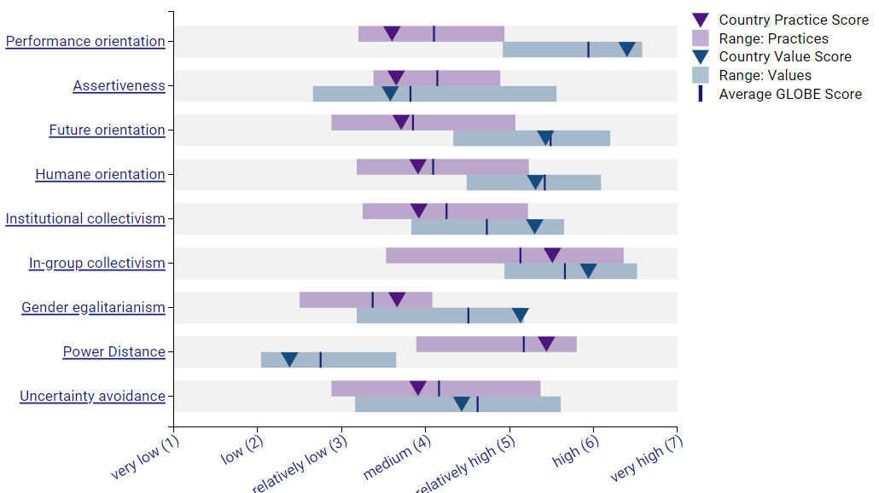
Figure 1: Culture in Portugal
Source: (Globeproject.com, 2020 a)
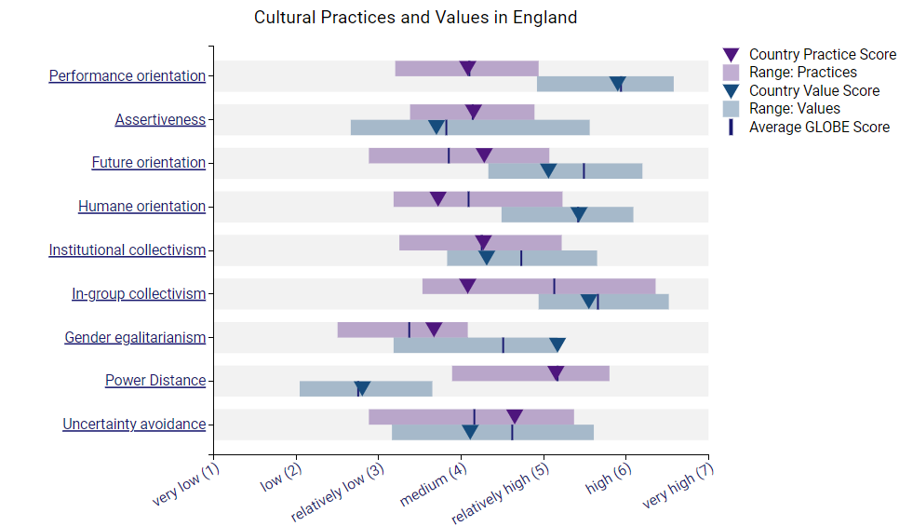
Figure 2: Culture in England
Source: GLOBE Project, 2024
From the cultural visualization GLOBE study of Portugal, it has been identified that the group collectivism has the highest country practice score which is 5.51. On the other hand, practice score of England is 4.08. While performance orientation has the lowest country practice score in Portugal which is 3.6. The performance orientation score of England is 5.9 which is high. Additionally, Portugal’s people express their loyalty, their pride, and their cohesiveness in their families or in the organization where they work because in group collectivism the people's behavior shows their background (Barros, and Albert, 2020). Moreover, Portugal should focus on the Performance orientation of the hotel industry in which market orientation, performance assessment, evaluation of performance, and satisfaction with services in the hotel sector (Santos, and de Waal, 2020).

Leadership:
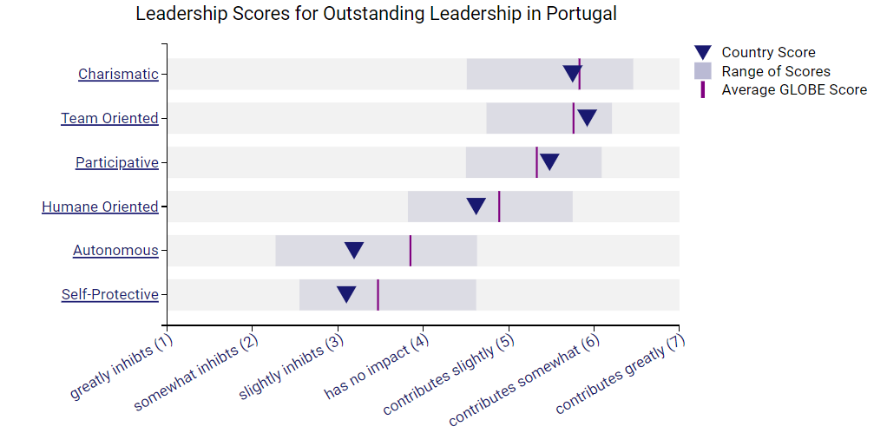
Figure 3: Leadership in Portugal
Source: (Globeproject.com, 2020 b)
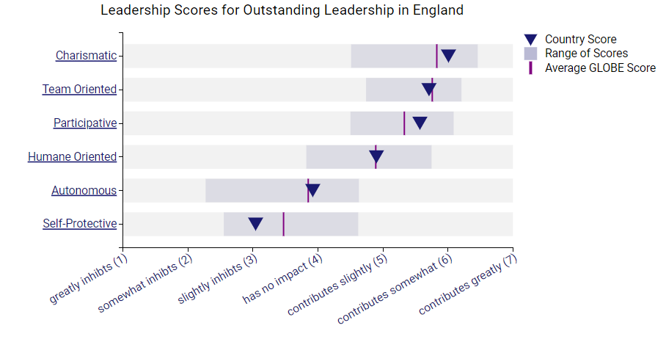
Figure 4: Leadership in England
Source: GLOBE Project, 2024
From the leadership visualisation according to the GLOBE project study it has been identified that the Team-oriented leadership style is the most followed in Portugal while the self-protective leadership style is the least leadership style that has followed in Portugal. On the other hand, charismatic leadership style is followed in England. Team-oriented leadership helps to develop opportunities for the team members, and they work in collaboration. This team collaboration work helps to make strong bonds among the team members and helps to build trust among them (Nelson et al, 2016). But Portugal needs to focus on the self-protective leadership style, this leadership style helps to ensure the individuals are safe and their data are secure (Kroumova, and Mittal, 2023). Further, England need to focus on growth and development as charismatic style limits that.

Challenges of Intercultural Leadership in the Hospitality Industry
As hospitality organisations expand globally, workers and management have hurdles in interacting and collaborating with individuals from many cultural backgrounds. Various issues may arise in intercultural communication among managers, staff, and hotel customers from diverse cultural backgrounds. Intercultural interaction has gained prominence in the hotel business. Recognising and comprehending variances in culture is crucial for achieving success in the organisation. Today's hotel personnel should be knowledgeable of these encounters and the potential for controlling them due to many causes. Effective communication's significance is widely acknowledged in modern times. Communication has a crucial role in the hospitality industry since it is essential for enhancing quality, productivity, and competitiveness. Managing people presents significant problems for managers, with communication being a particularly challenging aspect. Miscommunication may significantly impact corporate effectiveness, resulting in the loss of status, credibility, and financial stability. Research shows that 80% of a hotel manager's working day is dedicated to talking with hotel customers, colleagues, supervisors, and most often with subordinates (Khan, 2019). A transformative leadership style enhances employee commitment, social interactions, job understanding, and contentment. Various leadership styles might impact workers, who may lack knowledge about the most suitable leadership style in the hospitality sector. Issues may arise when individuals from diverse cultural backgrounds misinterpret one another, stemming from both linguistic obstacles and cultural distinctions (Barnett, and Carter, 2018). It is crucial to not only be proficient in a foreign language but also to understand the cultural variations present in other nations.

Conclusion:
The world has diverse cultures, and people notice these cultural distinctions while transitioning from one country to another. The cultures of England and Portugal are vastly distinct from each other. Significant cultural distinctions between English and Portuguese culture lie in language, culinary preferences, purchasing behaviours, and recreational pursuits. The GLOBE research of Portugal's cultural visualisation showed that group collectivism had the highest national practice score. In Portugal, the team-oriented leadership style is the most popular. Globalisation and cross-cultural practices in the hospitality industry need hotel workers to navigate cross-cultural disparities. Most executives in the hotel business struggle with communication as a significant problem.

Recommendations for Overcoming Challenges:
- The hotel manager will effectively convey the business's vision to all workers to inspire them to strive for excellence in their jobs.
- The manager establishes a culture and environment characterised by interdependence, adaptability, and mutuality. These are the primary duties of a transformative leadership position. This organisational culture will motivate people to attain outstanding performance and reach new milestones at work.
- The manager maintains positive relationships with external suppliers to ensure resource supply and technology help, as well as to stay informed about current best practices in the business sector. This attribute enhances the bond with the intended stakeholders or organisational collaborators.
- The manager prioritises creating a cohesive team where each member is supportive. This is going to establish a motivated atmosphere and positive environment in the workplace to encourage collaborative effort.

References:

Barnett, L. and Carter, E., 2018, May. Challenges to leadership in intercultural settings: intercultural interactions and knowledge management: research From Thailand. In ICMLG 2018 6th International Conference on Management Leadership and Governance (pp. 60-67).

Barros, S. and Albert, I., 2020. “I feel more Luxembourgish, but Portuguese too” cultural identities in a multicultural society. Integrative Psychological and Behavioral Science, 54(1), pp.72-103.

Birmingham, D., 2018. A concise history of Portugal. Cambridge University Press.

Burns, A., 2023. History of the British West Indies (Vol. 31). Taylor & Francis.

Globeproject.com. 2020 a. Portugal Results - GLOBE Project. [online] Available at: https://globeproject.com/results/countries/. Accessed on 23/02/2024.

Globeproject.com. 2020 b. Portugal Results - GLOBE Project. [online] Available at: https://globeproject.com/results/countries/. Accessed on 23/02/2024.

GLOBE Project 2024. GLOBE 2020. [online] Available at: https://globeproject.com/results/countries/GBR%3Fmenu=list.html#list Accessed on 23/02/2024.

Khan, M.Y.H., 2019. Cross cultural leadership and the hospitality industry: A leadership style towards success in organizational goals in France. Art. Human Open Acc J, 3(1), pp.25-30.

Kroumova, M. and Mittal, R., 2023. Cross‐cultural experiences and self‐protective leadership: a multi‐country comparison of managerial perception. Global Business and Organizational Excellence, 42(6), pp.89-100.
Nelson, M.W., Proell, C.A. and Randel, A.E., 2016. Team-oriented leadership and auditors' willingness to raise audit issues. The Accounting Review, 91(6), pp.1781-1805.

Santos, P. and de Waal, A., 2020. Factors of high performance in Portugal. International Journal of Organizational Analysis, 28(3), pp.611-625.
Schleussner, C., Menke, I., Theokritoff, E., van Maanen, N. and Lanson, A., 2020. Climate impacts in portugal. Clim Analytics.

