Introduction to Virtual Production
VFX Composting Sequence Reflective Account
This document will be going through the production process for creating a short clip as part of the Introduction to Virtual Production module. The files for the clip produced can be found Here.

Pre-Production
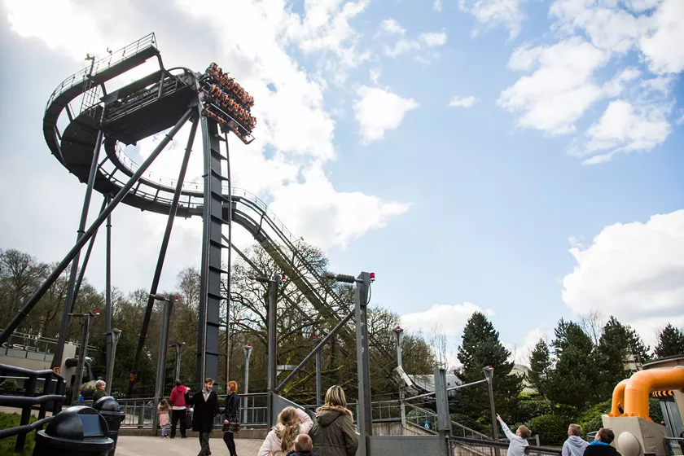
For this project, I wanted to create a video using effects on pre-existing footage of the rollercoaster Oblivion (as pictured on the left).
Many videos of on-ride footage exist, and with the layout of the structure itself, this gives good opportunity to create interesting visuals.

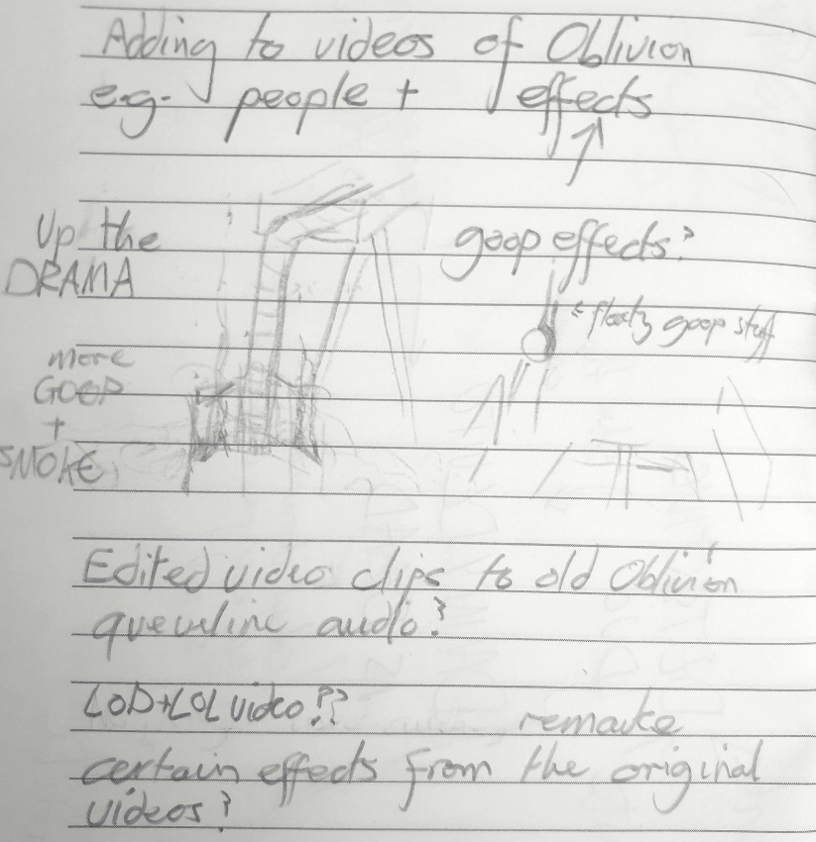
The image here shows the initial conceptualisation of ideas, although most of what was written about wasn’t included, due to it being a larger idea for a full, two-minute-long effects heavy video.
The queueline videos mentioned in the notes can be seen Here (with ‘LOD+LOL video’ being video 3), and the idea presented with it is something I may come back to in future.

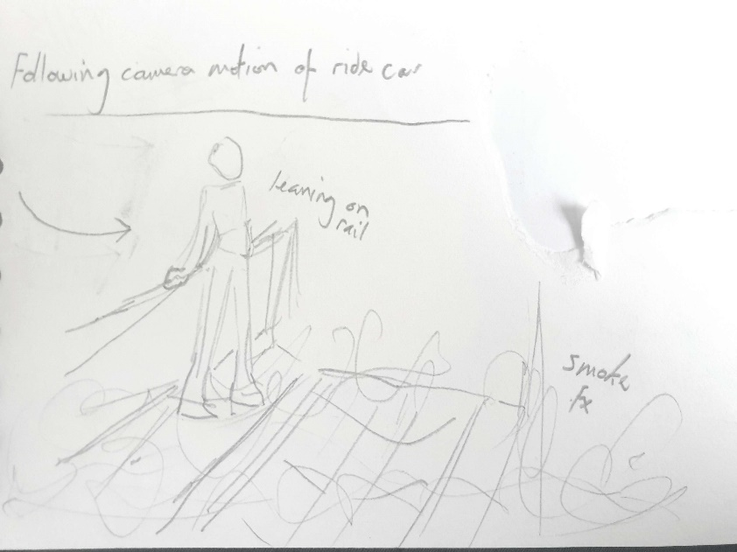

What I did settle on doing in the end, was to have someone standing on the walkway at the top of the ride, using on-ride footage as the source material, as well as adding some additional atmospheric effects.
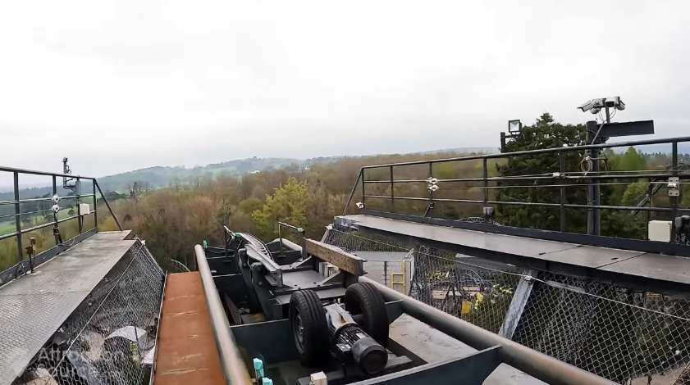
The positioning of the person would include having them leaning on the rail, as a way to make it seem as though they’re more part of the scene as they’re interacting with the environment.

Production
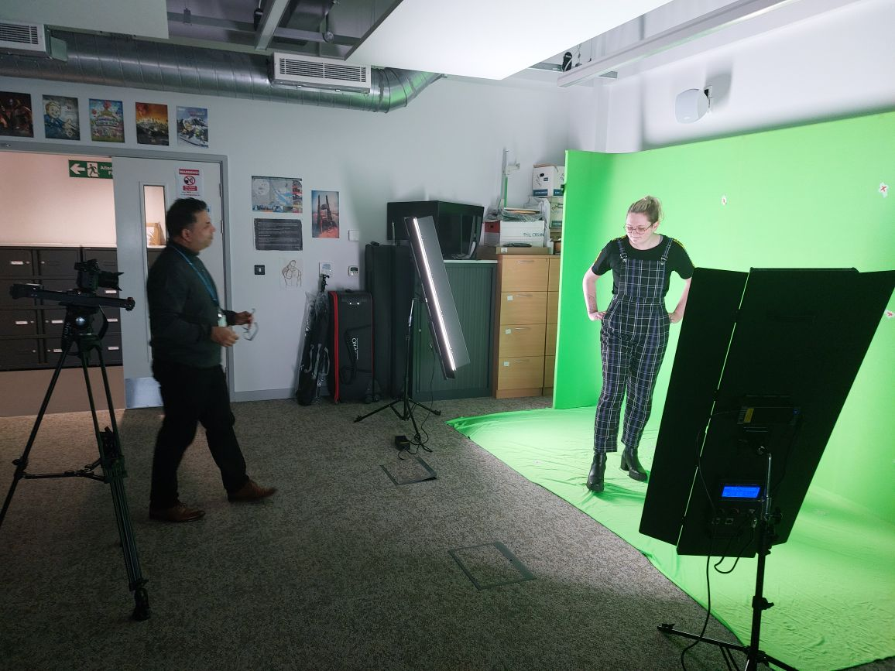
Production was the briefest section of the project, consisting of two filming sessions. The first session was done as a test, to see how well the idea would work with a rough edit being produced after (though I don’t have that available to show). Using the knowledge gained from that, another set of recordings were taken, which were used in the final video.
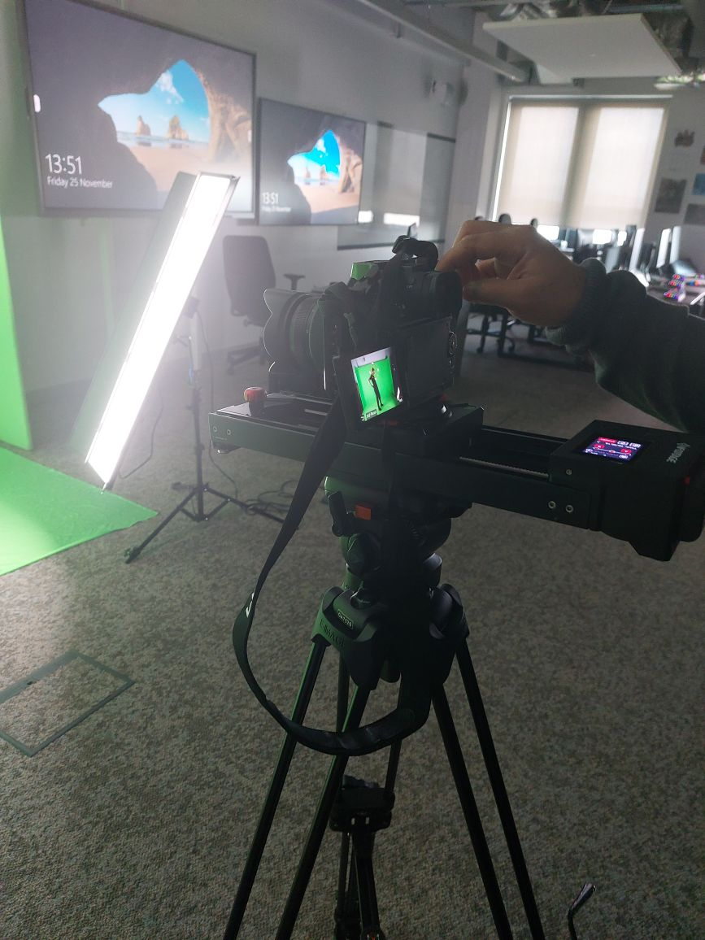
Filming was relatively short and low hassle, as due to the footage the recordings would be placed in, it could be filmed as a static shot.
As seen in the images, all the filming was done with the use of greenscreen in a controlled environment. This differs drastically from on-location filming for example, where factors such as weather and time of day play a crucial role in how the footage will turn out. Since the location in question is the top of a rollercoaster, on-location filming wouldn’t be viable anyway, so it was required to film this way regardless.
One thing to be noted when it comes to the filming though, is that not much thought was put into the lighting. The footage that this would be edited into wasn’t looked at in regards to the lighting of the scene, so it could only be hoped that it would match in the end. While it did work out, taking some time to look into this in future would likely be beneficial, as to not end up needing to redo shots because of out of place lighting.

Post-Production
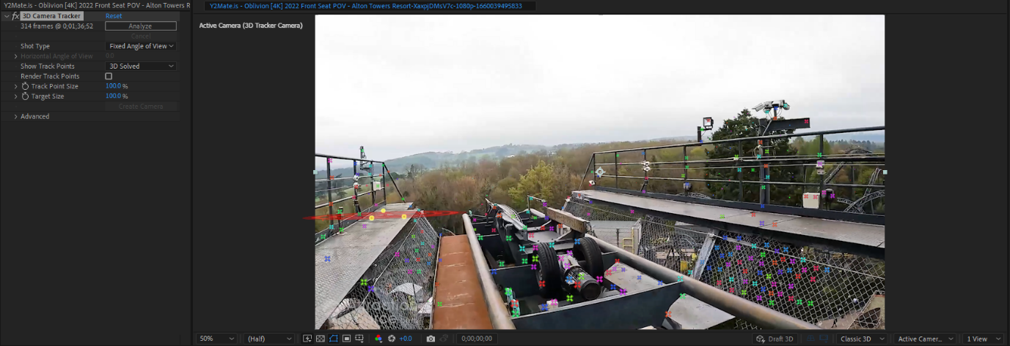
For the post-production I started with clipping my footage to the small section I would be using. Since the full video was 3 minutes long and only a few seconds would be used, cutting the length down saved time in the long run as any changes made to the clip would only need to render for those few seconds. In an original test for this project, I didn’t think to do this until attempting to set up the 3D camera tracker, where it spent a considerable amount of time analysing the entire video, most of which wouldn’t be used.
With the reduced clip length, there were no more issues in setting up the tracker. Initially I was unsure which of the footage to use, and so I brought both clips into After Effects to test them. Here I did the first of the greenscreen effects, using the basic keylight tool to roughly remove the backgrounds. There was a lot of residual shadow from the greenscreen, leaving grey patches across the footage, especially in places where there were creases in the screen’s fabric. This would be addressed later, but for the sake of testing, they were left with only basic greenscreen removal.

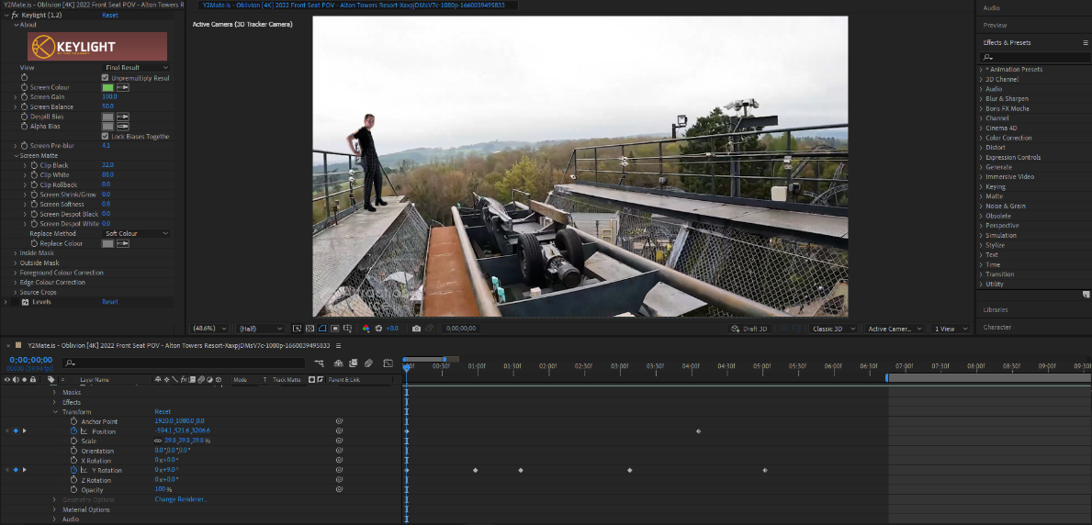
Once the clip had been chosen, I began making slight adjustments on it to make the camera track look more natural. Since the angle of the camera in the background video changes while the added footage is a static shot, it gave the appearance of the person sliding in place in a way that could be quite jarring once spotted and distracted from the scene.
To counteract this, I made very slight adjustments in the position and rotation of the clip. While it didn’t completely fix the problem, it helped make it much less noticeable.
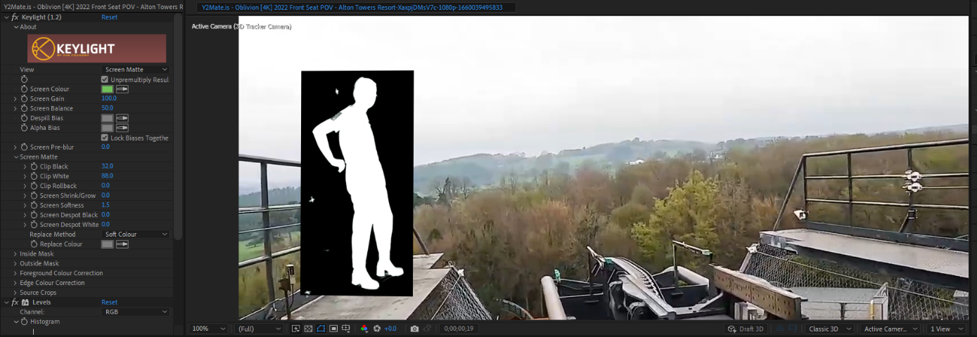

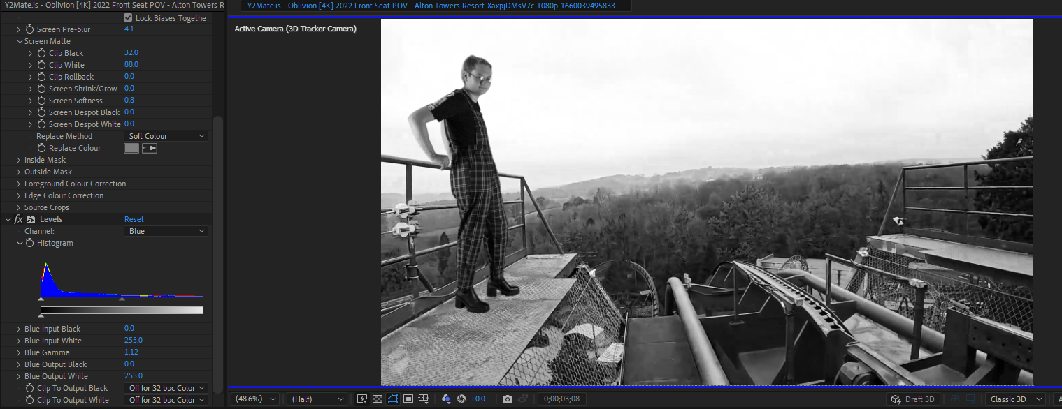
Once satisfied with this, I moved on to polishing the greenscreen more through the use of the screen matte. This allowed me to clean up the effect considerably, and with some slight softening of the edges, I was able to make a much more natural looking effect.

After this, adjustments were made to the levels of the footage to make it match more with the background environment. The levels of each of the colours were adjusted individually so that the end result would match as closely as possible to give a more natural look.
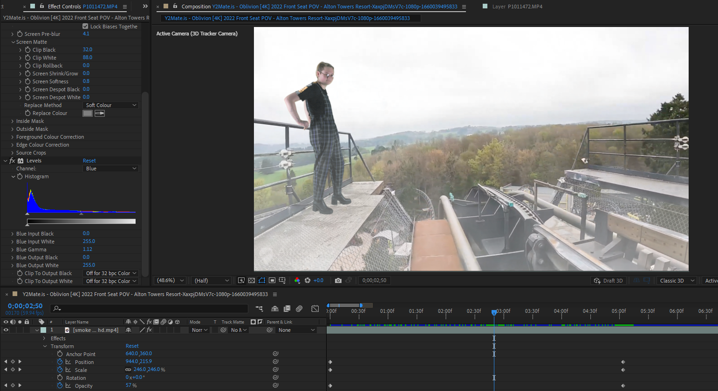
The last addition to the scene is a smoke/fog effect, using a greenscreen clip. Like the main footage added, two different clips were tested, and once decided on some adjustments were made to it. This time, it was to give the effect of the smoke increasing in intensity, as well as having some movement so it doesn’t appear stagnant compared to the moving camera.
Since the background video already had audio, that being the recorded sounds of the rollercoaster itself, I decided not to add any additional sound to the video. The final video was then exported using Media Encoder.

Sources
Assets for video:
Oblivion [4K] 2022 Front Seat POV - Alton Towers Resort. YouTube, 2022. Link: https://www.youtube.com/watch?v=XaxpjDMsV7c
Smoke Green Screen Background HD. YouTube, 2018. Link: https://www.youtube.com/watch?v=b7LDnnEXBJs

Image of Oblivion used in Pre-Production: 02_Oblivion_Drop. Merlin Entertainment, 2023. Link: https://www.altontowers.com/explore/theme-park/rides-attractions/oblivion/

