
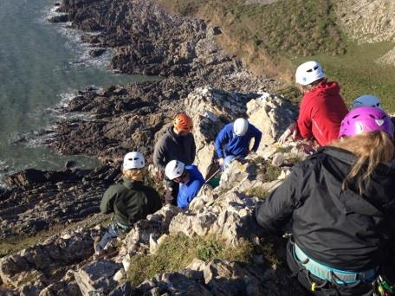
Priest’s Tree Metaphor
Kolb’s Learning cycle
My Personal philosophy on Outdoor Education
Experiential Learning – an underlying theory that underpins OE
Environmental Education
Personal and social development
Outdoor Activities
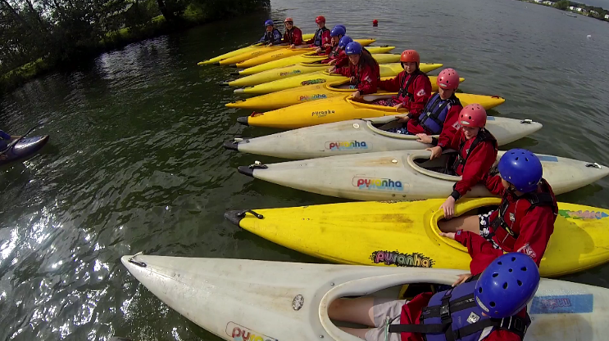

- is an approach to learning through doing in an outdoor setting.

Adventure
Freedom
Reflection
Flow
Risk taking
Challenge
Outdoor Education in the National Curriculum for England



