

FINANCIAL MANAGEMENT

Student Name: Akshay Maheshbhai Tadhani
Student ID: 2334624
Module Code: LCMB7002
Module: Financial Management
Lecturer: MD Kalam
Executive Summary
financial management is considered to be one of the prominent prospectuses that is used by companies in terms of formulating their financial performance. Subsequently, the concerned report is focused towards formulating a financial comparison of Rolls Royce and Bae Systems against the overall performance of their business over the recent five financial years. Following this, three of the prominent investment appraisal tools are being used to compare two of the investments. Following this, the advantages and shortfalls of the investment appraisal techniques have been discussed. Furthermore, in the last some of the prominent non-financial factors has been identified that are required to be considered by an individual while making the choice of investment.

Table of Contents
Part A: Introduction 3
History of the organisation 3
Marketplace and major competitors 3
Recent events 4
Profitability 4
Strategic Change 4
Part B: Financial Performance Review 4
Calculation of the key financial ratios 4
Critical evaluation of the ratios 6
Comparison to major competitors 9
Recommendation for improvement 12
Part C: Investment appraisal 12
Calculation of the investment appraisal techniques and their evaluation 12
Critical discussion over the advantages and shortcomings 15
Reference List 18
Appendices 21
Appendix 1: Financial Statements for the past five years of Rolls Royce 21
Appendix 2: Financial Statements for the past five years of Bae Systems 27

Part A: Introduction

History of the organisation
In 1998, Rolls-Royce Motor Cars Limited, a division of BMW was founded after the brand's licensing from Rolls-Royce Holdings plc and its acquisition of trademarks from Volkswagen AG. After VW bought Bentley and the former Rolls-Royce factories, the business started producing Rolls-Royce automobiles in 2003. The previous CEO of the firm, Torsten Müller-Ötvös, sought to bring back quality standards. China became the world's second-largest market in 2010 after sales there grew by 600%. Müller-Ötvös, who is now the CEO of BMW UK, will retire in 2023. Brownridge has been the CEO of the corporation for the longest (Azevedo and Olschewski, 2020).

Marketplace and major competitors
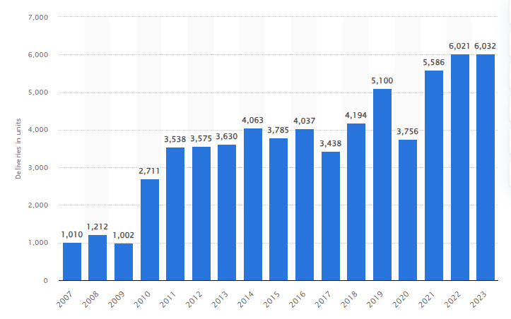
Figure 1: Global deliveries of Rolls-Royce automobiles from FY 2007 to FY 2023
(Source: Statista, 2024)
In the fiscal year 2023, Rolls-Royce Motor Cars delivered over 6,000 automobiles, an increase of 11 vehicles over the prior year. The launch of the Spectre model helped the premium car company, a fully owned subsidiary of BMW, post record sales. International sales of new light vehicles, however, fell sharply in 2020 after being stagnant from 2016 to 2019. Since 90% of completed cars are exported from the UK, manufacturers located there are concerned about the UK's possible exit from the EU. With the UK supplying only 10% of the components for Rolls-Royce cars, the US and China are anticipated to become important trade partners. Rolls Royce's major competitors include models like the Rolls-Royce Ghost and Cullinan, Bentley and Maybach are rival luxury automakers to Rolls-Royce. Other competitors include the Mercedes-Maybach S-Class, Maserati Quattroporte, BMW 7 Series, Bentley Mulsanne, and Bentley Flying Spur (Brutailer, 2018).

Recent events
In the recent financial year of 2023, the organisation released “Rolls-Royce Spectre” one of its electric cars that is fully automated (BMW Group, 2024). Based on the present requirements of the consumers, it is expected that this new product line will provide a broader change within the automobile segment as a whole.

Profitability
The organisation has observed a broader transformation in the profitability of its business. Certainly, it can be noted that between 2019 to 2022 the company was running at a loss. However, by the end of the year 2023, the organisation has formulated a standard profit.

Strategic Change
In terms of considering the recent change, it can be ascertained that the organisation is now formulating a transformation towards electronic automated vehicles that are sustainable in nature. The key reason behind this transformation is just that there is a broader requirement for electronic and conventional vehicles in the recent time period.

Part B: Financial Performance Review

Calculation of the key financial ratios
Profitability Ratios
Profitability Ratios
Ratio | Formulas | 2019 (in £m) | 2020 (in £m) | 2021 (in £m) | 2022 (in £m) | 2023 (in £m)
Gross Profit Margin | (Gross Profit/ Revenue) * 100 | (942 / 16587) * 100 | (187 / 11491) * 100 | (2136 / 11218) * 100 | (2757/ 13520) * 100 | (3620/ 16486) * 100
Gross Profit Margin | (Gross Profit/ Revenue) * 100 | 5.68% | 1.63% | 19.04% | 20.39% | 21.96%
Net Profit Margin | (Net Profit/ Revenue) * 100 | (-1311 / 16587) * 100 | (-3169 / 11491) * 100 | (121 / 11218) * 100 | (-1274 / 13520) * 100 | (2404 / 16486) * 100
Net Profit Margin | (Net Profit/ Revenue) * 100 | -7.90% | -27.58% | 1.08% | -9.42% | 14.58%
Table 1: Profitability Ratios
(Source: Prepared by self)
Liquidity Ratios
Liquidity Ratios
Ratio | Formulas | 2019 (in £m) | 2020 (in £m) | 2021 (in £m) | 2022 (in £m) | 2023 (in £m)
Current Ratio | (Current Assets/ Current Liabilities) | (16054 / 14976) | (14331/ 13700) | (13287 / 11159) | (16011 / 13918) | (18111/ 14926)
Current Ratio | (Current Assets/ Current Liabilities) | 1.07 | 1.05 | 1.19 | 1.15 | 1.21
Quick Ratio | (Current Assets - Inventory)/ Current Liabilities | (16054 - 4320) / 14976 | (14331- 3690)/ 13700 | (13287 -3666)/ 11159 | (16011- 4708) / 13918 | (18111- 4848) / 14926
Quick Ratio | (Current Assets - Inventory)/ Current Liabilities | 0.78 | 0.78 | 0.86 | 0.81 | 0.89
Table 2: Liquidity Ratios
(Source: Prepared by self)
Gearing Ratios
Gearing Ratios
Ratio | Formulas | 2019 (in £m) | 2020 (in £m) | 2021 (in £m) | 2022 (in £m) | 2023 (in £m)
Debt-to-Equity | (Total debt/ Total equity) | (35599/1114) | (34365/4517) | (33286/(4278) | (33286/6016) | (35141/3,629)
Debt-to-Equity | (Total debt/ Total equity) | 31.96 | 7.61 | 7.78 | 5.53 | 9.68
Debt-to-Asset | (Total debt/ Total assets) | (35599/34485) | (34365/29848) | (33286/29008) | (33286/29008) | (35141/31512 )
Debt-to-Asset | (Total debt/ Total assets) | 1.03 | 1.15 | 1.15 | 1.15 | 1.12
Table 3: Gearing Ratios
(Source: Prepared by self)
Efficiency Ratios
Efficiency Ratios
Ratio | Formulas | 2019 (in £m) | 2020 (in £m) | 2021 (in £m) | 2022 (in £m) | 2023 (in £m)
Inventory Turnover Ratio | (Cost of goods sold/ average inventory)
Inventory Turnover Ratio | (Cost of goods sold/ average inventory) | (16587/4320) | (11824/3690) | (9082/3666) | (10763/4708) | (12866)/4848)
Receivable Turnover Ratio | (Cost of goods sold/ accounts payable) | 3.84 | 3.20 | 2.48 | 2.29 | 2.65
Receivable Turnover Ratio | (Cost of goods sold/ accounts payable) | (16587/8460) | (11824/8460) | (9082/6017) | (10763/6983) | (12866)/6896)
 |  | 1.96 | 1.40 | 1.51 | 1.54 | 1.87
Table 4: Efficiency Ratios
(Source: Prepared by self)

Critical evaluation of the ratios
The relevance of the profitability ratio lies in the evaluation of the key income that an organisation is able to generate from its key operational activities (Lowe et al., 2020). An organisation generally has different options to maintain a profit for its business. Certainly, based on this two of the prominent profitability ratios have been computed for Rolls Royce against the past five financial years. The first profitability ratio that has been computed is of gross profit margin. The gross profit margin of the organisation is computed to be 5.68% in 2019, which has decreased to 1.63% while reaching the end of the financial year of 2020. However, in the very next financial year, it has been noted that the value of the ratios has reached 19.04% by the end of the year 2021. Again, in the year 2022, the gross profit margin has reached 20.39% and 21.96% in the very next financial year of the same. In terms of comparing the overall gross profit margin of the company, it can be ascertained that the profitability of the company has increased over time.
The very next profitability ratio that has been computed is the net profit margin. The relevance of net profit margin lies in the evaluation of the overall income that an organisation is able to maintain by means of managing the operational activities (Mulyadi, 2020). Based on this, it can be observed that the organisation has generated a net loss of about -7.90% during the financial year of 2019 which in turn has increased to -27.58% towards the end of the year 2020. Apparently, the organisation has somehow managed to maintain a profitability of 1.08% in 2021 which has again changed into a loss by the end of the year 2022. However, while reaching the end of the year 2023, the company is noted to have a net profit margin of 14.58% as a whole. In terms of comparing the overall profitability of the company, it has been observed that right from the beginning of the year 2019 the company was generating a loss. However, while reaching the end of the year 2023, the company has somehow managed to maintain a standard profit margin to support its business.
The second category of ratios that have been computed is the liquidity ratio. The liquidity ratios are mainly used for the evaluation of the liquidity level of the companies in terms of repaying the obligations that are outstanding (Štangová, 2021). In any business, higher liquidity is considered to be having a positive attribute to their operational activities. Based on this, it can be ascertained that the first liquidity ratio that has been computed is the current ratio. The current ratio of the company is computed to be 1.07 times for the financial year of 2019 which has further decreased to 1.05 times towards the end of the very next financial year. Again, for the year 2021, the current ratio of the company was standing at 1.19 times which has further decreased to 1.15 times by the end of the year 2022. Again, in the year 2023, the organisation is observed to have a current ratio of about 1.21 times which is the highest in all the past five financial years.
The second liquidity ratio that had been computed is the quick ratio which basically relates the relevance of the company in terms of using their quick assets within the business. In this aspect, the quick ratio of the organisation was standing at 0.78 times against both the financial year of 2019 and 2020. After that, the company observed a broader increase within their quick ratio wherein the value of the ratio was standing at 0.86 times during the end of the year 2021. Apparently, in the year 2022, the quick ratio of the company was computed to be 0.81 times which has turned to 0.89 times towards the end of the very next financial year of 2023. Thus, by means of comparing the overall liquidity level of the company, it can be noted that over time the value of ratios of current assets has increased for the company in terms of managing the obligations that are standing during the accounting period.
The debt-equity ratio determines what part of the company’s capital is financed through debt. It determines how much of a corporation is funded by borrowing in relation to shareholders’ investments (Nuryani and Sunarsi, 2020). In an event when a business relies heavily on borrowed funds, it becomes more leveraged. In this case, if such an enterprise has problems with finance, its peril will be higher too.
From 2019 to 2023, Rolls-Royce's debt-equity ratio was not constant and reached its peak at 31.96 in 2019 but fell to 7.61 the next year, that is 2020. In other words, the high proportion recorded for the initial year means that most funds were raised using credit facilities which can be very risky, especially during economic recessions. Although there was some progress made towards reducing this figure over subsequent years when compared against each other they still remained relatively high until another rise occurred in 2023 where it went up again hitting 9.68%. Recent surge might indicate difficulties encountered while trying to manage equity or could simply imply the need for more borrowing either because of investment requirements or any other strategic considerations. This inconsistency shows unstable financial management practices adopted by the firm which raises questions regarding its long-term sustainable growth plan as well as the overall risk exposure level of the organization.
Further, the debt-to-asset ratio demonstrates the extent to which a company’s assets are financed through debt, i.e. it shows how much leverage a company is concerned with. In case, this number is higher than one, it means that the business owes more money than it actually possesses and such a situation can scare away investors or lenders (Shahfira and Hasanah, 2021).
From 2019 to 2023, Rolls-Royce’s debt-to-asset ratio stayed rather unchanged at around 1.03 – 1.15. This consistency implies that most of its assets have been funded by debt thus maintaining a high level of leverage throughout this period. Having an above-one ratio all the time indicates that liquidity might become problematic for the corporation because it may lack enough property to offset obligations. Such an amount of riskiness can be especially dangerous for enterprises operating in volatile industries like aerospace where external events such as economic recessions or shifts in regulations could have significant impacts on financial stability.
The rate of inventory turnover is calculated by the number of times a company buys and sells its inventory over a certain period. Suppose it has a larger ratio, this means that it uses its stocks more efficiently thus incurring low preservation costs while also keeping them updated (Amanda, 2019).
Rolls-Royce’s rate of turnover for inventory has shown negative progress where it declined from 3.84 during 2019 to 2.29 by 2022 then rose slightly to 2.65 during 2023. Such a dip signifies that goods were kept for long and this might have resulted due to; reduced need, ineffective production or problems within the supply chain management. Though some improvement was made in the same year which could be an indication towards solving these challenges generally looking at the trend line indicates difficulties faced with matching output levels against customer demand thereby resulting in higher storage expenses and lower profits.
The ratio of receivables’ turnover is a measure of how efficiently a firm collects its accounts receivable (Eretnaet al., 2021). In case this ratio is high, it means credit and collection policies are good which will in turn improve cash flow.
Rolls-Royce’s receivable turnover ratio fell from 1.96 times in 2019 to 1.40 times in 2020 and then rose gradually until it reached 1.87 times by the end of 2023. This decline at first may suggest problems with collecting money owed by customers or extending credit terms which can stretch on-hand cash flows thin. The later increases imply stricter credit policy enforcement or better collection strategies adopted over time while still keeping up low levels of efficiency throughout this period thus signifying there are more opportunities for enhancements in credit management practices since too much capital might be tied down as accounts receivable at such points within the organization.

Comparison to major competitors
Profitability Ratios
Profitability Ratios | Rolls Royce's |  |  |  |  | Bae Systems Plc
Profitability Ratios | 2019 | 2020 | 2021 | 2022 | 2023 | 2019 | 2020 | 2021 | 2022 | 2023
Gross profit ratio | 5.68% | 1.63% | 19.04% | 20.39% | 21.96% | 8.64% | 8.25% | 9.11% | 9.36% | 9.36%
Net profit ratio | -7.90% | 0.78 | 0.86 | 0.81 | 0.89 | 8.37% | 7.11% | 9.79% | 7.87% | 8.41%
Table 5: Comparison of Profitability Ratios
(Source: Prepared by self)
The above-indicated table (Table 5), is relating the comparison of profitability ratios of Rolls Royce and Bae Systems for a period of five financial years. In the years 2019 and 2020, the gross profit margin of Bae Systems was observed to be higher than that of Rolls Royce. However, from the year 2021, a different scenario can be seen wherein the gross profit margin of Bae Systems has increased at a higher level as compared to that of Rolls Royce. However, in terms of considering the net profit margin, a different scenario can be observed. Rolls Royce was having a loss in their business from 2019 to 2022. On the other hand, Bae Systems was able to maintain a standard level of profit margin within their business. However, by the end of the year 2023, it can be observed that the overall profit margin of Rolls Royce is higher than that of its competitor.
Liquidity Ratios
Liquidity Ratios | Rolls Royce's |  |  |  |  | Bae Systems Plc
Liquidity Ratios | 2019 | 2020 | 2021 | 2022 | 2023 | 2019 | 2020 | 2021 | 2022 | 2023
Current Ratio | 1.07 | 1.05 | 1.19 | 1.15 | 1.21 | 1.01 | 1.00 | 1.01 | 3.20 | 1.08
Quick Ratio | 0.78 | 0.78 | 0.86 | 0.81 | 0.89 | 0.92 | 0.91 | 0.92 | 3.10 | 0.97
Table 6: Comparison of Liquidity Ratios
(Source: Prepared by self)
The table presented above (Table 6), is relating the tabular presentation of the comparison of the two liquidity ratios for the concerned companies against the recent five financial years. Based on the data and the ratios it can be noted that in all the five financial years, the current ratio of Rolls Royce was higher than that of the Bae Systems. This implies that Rolls Royce was using its current assets in a more efficient format for the outstanding business obligations as compared to that of its competitor. However, on the other hand, a different scenario can be observed in the case of the quick ratio of the companies. In the past five financial years, the quick ratio of Bae Systems was higher than that of Rolls Royce. This indicates that Bae Systems was more efficient in terms of using its quick assets over the period for business requirements.
Gearing Ratios
Gearing Ratios | Rolls Royce's |  |  |  |  | Bae Systems Plc
Gearing Ratios | 2019 | 2020 | 2021 | 2022 | 2023 | 2019 | 2020 | 2021 | 2022 | 2023
Debt-to-Equity | 31.96 | 7.61 | 7.78 | 5.53 | 9.68 | 3.65 | 4.59 | 2.54 | 1.76 | 3.01
Debt-to-Asset | 1.03 | 1.15 | 1.15 | 1.15 | 1.12 | 0.78 | 0.82 | 0.72 | 0.64 | 0.75
Table 7: Comparison of Gearing Ratios
(Source: Prepared by self)
In 2019, Rolls-Royce showed a debt-to-equity ratio of 31.96 and then declined to 9.68 in 2023. Such variations expose the mismanagement of the capital structure within an organization. The figure for this indicator was quite high in 2019 thereby signifying overdependence on loans; however, they might have restructured or serviced some before reducing them that much. On the other hand, BAE Systems has always had lower levels with less volatility ranging between 1.76 and 4.59 during the same period showing more conservative approach to financing its activities which is characterized by low-risk perception associated with high indebtedness.
Rolls-Royce consistently reported a debt-to-asset ratio around 1.15, meaning most assets are funded through borrowing money hence they have higher financial leverage and could be more sensitive to economic downturns or interest rate changes than companies with smaller ratios like BAE systems that recorded figures ranging from 0.64 – 0.82 implying stronger equity base as well as lower reliance on debt capitalization which aligns better with stable operational performance over time leading to reduced financial risks at all levels for BAE Systems .
Efficiency Ratios
Efficiency Ratios | Rolls Royce's |  |  |  |  | Bae Systems Plc
Efficiency Ratios | 2019 | 2020 | 2021 | 2022 | 2023 | 2019 | 2020 | 2021 | 2022 | 2023
Inventory Turnover Ratio | 3.84 | 3.20 | 2.48 | 2.29 | 2.65 | 20.03 | 20.61 | 21.88 | 19.74 | 18.09
Receivable Turnover Ratio | 1.96 | 1.40 | 1.51 | 1.54 | 1.87 | 17.53 | 15.19 | 3.83 | 3.86 | 13.12
Table 5: Comparison of Efficiency Ratios
(Source: Prepared by self)
The inventory turnover ratio of Rolls-Royce fell from 3.84 in 2019 to 2.65 in 2023 which denotes that there is a decline in the rate at which inventories are sold over a given period. This could mean that there are difficulties with forecasting demand or managing stock levels which might result in higher holding costs and/or obsolescence risks. Conversely, BAE Systems recorded significantly higher figures for this ratio; ranging between 18.09 - 21.88. Such frequent changes in ownership demonstrate effective control over stocks as well as speedy conversion of them into sales hence indicating good operational efficiency coupled with strong demand from customers.
Between years, receivables’ turnover ranged from 1.40-1.96 for Rolls-Royce showing their relatively slow collection process. The company can better its performance here by looking into issues around cash flows or credit policies since when it takes long to collect such debts, they may find themselves having liquidity problems. On the other side however, BAE systems had much bigger numbers on this ratio where at one point reached the highest ever figure;17.53 (2019) before slightly stabilizing at 13.12 (2023). This shows that the firm managed credits efficiently throughout the year thereby enabling healthy inflow of funds needed either for further investment purposes within their business entities and debt reduction initiatives

Recommendation for improvement
Based on the financial comparison of the companies, the following recommendations can be made for Rolls Royace that can formulate a better approach towards the growth and development of their business:
- The organisation is recommended to maintain a lower expenditure within their business. It has been observed that in the recent four financial years, the business was running at a loss. However, in 2023, the company has somehow managed to maintain a certain margin of profit. Certainly, in this context, the company is recommended to maintain a lower expense in their business that can help to acquire an adequate level of profit margin.
- The efficiency ratios of Rolls Royce are also observed to be at a lower level. Based on this, it is recommended that the company use a higher level of their internal resources which are mainly their assets and inventory for meeting the business requirements.
- Rolls Royce is also noted to have a higher proportionate of debt within their business as a result of which their entire operational activities are affected. In this aspect, it is recommended that the company minimise the debt obligations within their business so as to have a stable operational activity.

Part C: Investment appraisal

Calculation of the investment appraisal techniques and their evaluation
Payback Period
Calculation of the Payback Period
Particulars | Cashflow for A | Cumulative  Cashflow for A | Cashflow for B | Cumulative  Cashflow for B
0 | -£80,000,000.00 | -£80,000,000.00 | -£75,000,000.00 | -£75,000,000.00
1 | £25,000,000.00 | -£55,000,000.00 | £50,000,000.00 | -£25,000,000.00
2 | £25,000,000.00 | -£30,000,000.00 | £20,000,000.00 | -£5,000,000.00
3 | £20,000,000.00 | -£10,000,000.00 | £20,000,000.00 | £15,000,000.00
4 | £55,000,000.00 | £45,000,000.00 | £20,000,000.00 | £35,000,000.00
Payback period | 3.2 |  | 2.3
Table 6: Payback Period
(Source: Prepared by self)
In the field of investment payback period is associated with the determination of the time that a certain investment is taking in terms of covering the cost of investment (Olayinka, 2022). Generally, a lower payback period is relevant for having a standard profit margin. Based on this, the table presented above relates the comparison of the payback period of two of the investment options. Certainly, it can be noted that the investment “A” will take a time of 3 years and 2 months to cover the cost of the investment. On the other hand, investment “B” will take 2 years and 3 months to cover the cost of investment and generate profit from the same. In this aspect, it can be ascertained that from the prospectus of the payback period, investment “B” will be relevant for covering the cost of investment within a short period of time.
Net Present Value
Calculation of the Net Present Value
Years | 9.75% Discounting  Factor | Cash flows  in £ for A | Discounted  cash inflow for A | Cash flows  in £ for B | Discounted  cash inflow for B
1 | 1.11 | £25,000,000.00 | £27,700,831.02 | £50,000,000.00 | £55,401,662.05
2 | 1.23 | £25,000,000.00 | £30,693,441.58 | £20,000,000.00 | £24,554,753.26
3 | 1.36 | £20,000,000.00 | £27,207,482.84 | £20,000,000.00 | £27,207,482.84
4 | 1.51 | £55,000,000.00 | £82,903,687.32 | £20,000,000.00 | £30,146,795.39
Present Value of the cash flows |  | £168,505,442.77 |  | £137,310,693.54
Initial Investment |  | £80,000,000.00 |  | £75,000,000.00
NPV |  | £88,505,442.77 |  | £62,310,693.54
Table 7: Net Present Value
(Source: Prepared by self)
The relevance of net present value (NPV), is related to the evaluation of the future return that a certain investment is generating in the future course of action (Fitzgerald, 2022). On the basis of this, it can be ascertained that from the investment “A”, the NPV will be £88,505,442.77 and from the investment “B” the NPV will be about £62,310,693.54. By means of considering the future prospectus of both investments, it can be ascertained that option A will be the most appropriate one over here as it has a higher NPV after a period of four financial years.
Accounting Rate of Return
Calculation of ARR
Year | Cashflow for A | Cashflow for B
1 | £25,000,000.00 | £50,000,000.00
2 | £25,000,000.00 | £20,000,000.00
3 | £20,000,000.00 | £20,000,000.00
4 | £55,000,000.00 | £20,000,000.00
Average | £31,250,000.00 | £27,500,000.00
Initial Investment | £80,000,000.00 | £75,000,000.00
ARR | 39.06% | 36.67%
Table 8: Accounting Rate of Return
(Source: Prepared by self)
The main function of the accounting rate of return (ARR) is the evaluation of the aggregate return that a certain investment is able to generate against a certain accounting period (Penman,2021). Based on this, the table presented above compares the ARR of both investments. It can be certainly observed that investment “A” will generate an ARR of 39.06% for the future four financial years. At the same time the investment “B” is observed to have an ARR of about 36.67% against the same financial years. Based on the comparison of ARR, option A is observed to have a better percentage in the future course of action.

Critical discussion over the advantages and shortcomings
Investment appraisal techniques | Advantages | Shortcomings
Net Present Value (NPV) | - The NPV focuses on the time value of money (Weber, 2021). As a result of this, the future return of a certain some of money can be easily computed in a systematic manner.  - The NPV of a certain investment is also integrated with the profitability prospectus that can be acquired in the future course of action (Repalli, 2024). | - The NPV is based on the estimated cash flows that may affect the future outcome of investment in case there is any change within the financial prospectus.  - The NPV is also complicated to compute as compared to the other investment appraisal techniques (Magni, 2020).
Payback Period (PBP) | - The major advancement involved within the PBP is just that it helps towards the evaluation of the time after which a certain investment can generate income (Bai, 2021).  - The PBP also formulates a relevant and systematic evaluation of the time that is required to cover the overall cost of the expense involved with the same. | - The payback period does not consider the time value of money as a result of which the future value of the investment is ot possible to be evaluated (Dai, 2021).  - The payback period is also based on the estimated cash flows of the investment and is integrated with having a short-term approach.
Accounting Rate of Return (ARR) | - The ARR measures the growth rate of a certain investment (Anwar, 2022). As a result of this, it becomes easier to measure the aggregate growth and development that a certain investment has observed over the period.  - ARR also considers the time value of money in terms of relating the future prospectus of a certain investment. | - The calculation of ARR is also quiet complicated that consists of different stages.  - Unlike all the other techniques, ARR is also integrated with the use of estimated cash flows of an investment.
Table 9: Advantages and Shortcomings of the different investment appraisal techniques
(Source: Prepared by self)
Non-financial factors
There is a wide range of non-financial factors that must be considered when making a choice for investment. In this respect, a brief explanation of these non-financial factors is discussed below:
- Economic condition- The economic condition of a certain country acts as a prominent non-financial factor in terms of affecting the decisions of investment (Sukharev, 2020). In case the economic condition of a country is not favourable, then there is a higher chance that the investment that is made will not be fruitful in nature. Certainly, it is necessary for an individual to consider the economic condition of the countries before making the choice of investment.
- Need of the consumers- There is a constant change in the preferences of the consumers (Thiele, 2021). In this aspect, it becomes quite difficult for the companies to understand the market requirements in an adequate manner. However, without having an adequate understanding of the market requirements, it is difficult to formulate the decisions of investment. On the basis of this, it can be ascertained that the needs of the consumers are also an active non-financial factor that can affect the decisions of investment.
- Risk factors- The evaluation of the risk is quite necessary for any investment in a very initial stage (Gompers, 2022). The key reason behind this aspect is just that an investment generally comes with a wide range of risks involved with the same that can further affect a project. These risks can also formulate a broader negative impact on the different projects. Thus, on the basis of this, it can be ascertained that the risk factors are one of the most important non-financial prospectuses of an investment that is required to be considered by an individual before making the decision of investment.
- Technological prospectus- The technological involvement of an investment is generally considered to have a broader positive attribute in the future course of action. The key reason behind this aspect is just that the use of technological appliances can diversify the overall productive segment. In this context, the technological prospectus or the technological involvement of a project also acts as a major non-financial factor before making the decision to invest.
- Legal and regulatory compliance- The legal and regulatory compliance involved with a certain investment is necessary to be considered before associating with a certain investment (Laplane, 2023). The main reason behind this aspect is just that legal compliance focuses towards the maintenance of a systematic balance within the different rules and regulations. Certainly, it can be ascertained that the legal and regulatory compliance of an investment is also necessary to be considered before associating with a certain investment.

Reference List
Amanda, R.I., 2019. The impact of cash turnover, receivable turnover, inventory turnover, current ratio and debt to equity ratio on profitability. Journal of research in management, 2(2), pp.14-22.
Anwar, M.B., Stephen, G., Dalvi, S., Frew, B., Ericson, S., Brown, M. and O’Malley, M., 2022. Modeling investment decisions from heterogeneous firms under imperfect information and risk in wholesale electricity markets. Applied Energy, 306, p.117908.
Azevedo, B.A.M. and Olschewski, M.P., 2020. Equity Research in the Automotive Industry: Valuation of BMW (Master's thesis, Universidade NOVA de Lisboa (Portugal)).
Bai, B., Xiong, S., Ma, X. and Tian, Y., 2021. Effectiveness evaluation of photovoltaic poverty alleviation project in China: From a capital perspective. Journal of Cleaner Production, 284, p.124684.
Brutailer 2018 The Ultimate Luxury Car Battle - Rolls Royce vs Bentley vs Maybach. https://www.team-bhp.com/forum/super-cars-imports-india/194215-ultimate-luxury-car-battle-rolls-royce-vs-bentley-vs-maybach.html.
Dai, H., Li, N., Wang, Y. and Zhao, X., 2022, March. The analysis of three main investment criteria: NPV IRR and payback period. In 2022 7th International Conference on Financial Innovation and Economic Development (ICFIED 2022) (pp. 185-189). Atlantis Press.
Eryatna, E.N., Eltivia, N. and Handayawati, K.U., 2021, July. The effect of cash turnover, receivable turnover, and inventory turnover towards profitability of consumer goods companies in Indonesia. In the 2nd Annual Management, Business and Economic Conference (AMBEC 2020) (pp. 191-197). Atlantis Press.
Fitzgerald, K.C., 2022. The application of real options as an enhancement to the net present value technique: a case of the financial services sector (Doctoral dissertation).
Gompers, P.A., 2022. Optimal investment, monitoring, and the staging of venture capital. In Venture Capital (pp. 285-313). Routledge.
Laplane, A. and Mazzucato, M., 2020. Socializing the risks and rewards of public investments: Economic, policy, and legal issues. Research Policy, 49, p.100008.
Lowe, A., Nama, Y., Bryer, A., Chabrak, N., Dambrin, C., Jeacle, I., Lind, J., Lorino, P., Robson, K., Bottausci, C. and Spence, C., 2020. Problematizing profit and profitability: discussions. Accounting, Auditing & Accountability Journal, 1233(4), pp.753-793.
Magni, C.A. and Marchioni, A., 2020. Average rates of return, working capital, and NPV-consistency in project appraisal: A sensitivity analysis approach. International Journal of Production Economics, 229, p.107769.
Mulyadi, D. and Sinaga, O., 2020. Analysis of Current Ratio, Net Profit Margin, and Good Corporate Governance against Company Value. Systematic Reviews in Pharmacy, 11(1).
Nuryani, Y. and Sunarsi, D., 2020. The Effect of Current Ratio and Debt to Equity Ratio on Deviding Growth. JASa (JurnalAkuntansi, Audit dan SistemInformasiAkuntansi), 4(2), pp.304-312.
Olayinka, A.A., 2022. Financial statement analysis as a tool for investment decisions and assessment of companies’ performance. International Journal of Financial, Accounting, and Management, 4(1), pp.49-66.
Penman, S.H. and Zhang, X.J., 2021. Connecting book rate of return to risk and return: The information conveyed by conservative accounting. Review of Accounting Studies, 26(1), pp.391-423.
Repalli, M.V., Hashmi, S.Z., Mubeen, S.A. and Sultana, K., 2024. Basic Concepts Of Financial Management. Academic Guru Publishing House.
Rolls-Royce Motor Cars celebrates UK dealer premiere of Spectre. 2024 BMW Group PressClub. Available at: https://www.press.rolls-roycemotorcars.com/rolls-royce-motor-cars-pressclub/article/detail/T0420140EN/rolls-royce-motor-cars-celebrates-uk-dealer-premiere-of-spectre?language=en (Accessed: 30 July 2024).
Štangová, N. and Víghová, A., 2021. Company liquidity as a reflection of receivables and payables management. Entrepreneurship and sustainability issues, 9(2), p.238.
Statista (2024). Rolls-Royce: global car deliveries 2023 |https://www.statista.com/statistics/267243/worldwide-sales-volume-of-rolls-royce-automobiles/#:~:text=The%20United%20States%20 and%20 China,and%20has%20been%20 growing%20 considerably.
Sukharev, O. and Voronchikhina, E., 2020. Financial and non-financial investments: Comparative econometric analysis of the impact on economic dynamics. Quantitative Finance and Economics, 4(3), pp.382-411.
Syahfira, D. and Hasanuh, N., 2021. The Influence of Company Size and Debt to Asset Ratio on Return On Assets. JurnalKhatulistiwaInformatika, 8(1), pp.9-13.
Thiele, G., Dufour, D., Vernier, P., Mwanga, R.O., Parker, M.L., Schulte Geldermann, E., Teeken, B., Wossen, T., Gotor, E., Kikulwe, E. and Tufan, H., 2021. A review of varietal change in roots, tubers and bananas: consumer preferences and other drivers of adoption and implications for breeding. International Journal of Food Science & Technology, 56(3), pp.1076-1092.
Weber, R., 2021. Embedding futurity in urban governance: Redevelopment schemes and the time value of money. Environment and Planning A: Economy and Space, 53(3), pp.503-524.

Appendices

Appendix 1: Financial Statements for the past five years of Rolls Royce
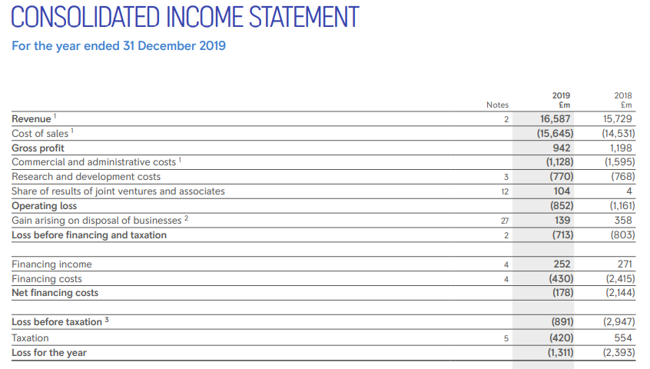
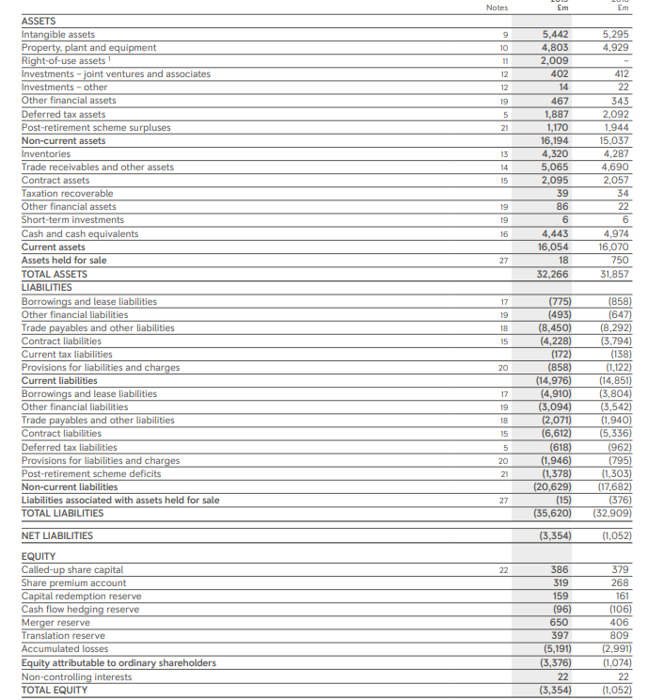
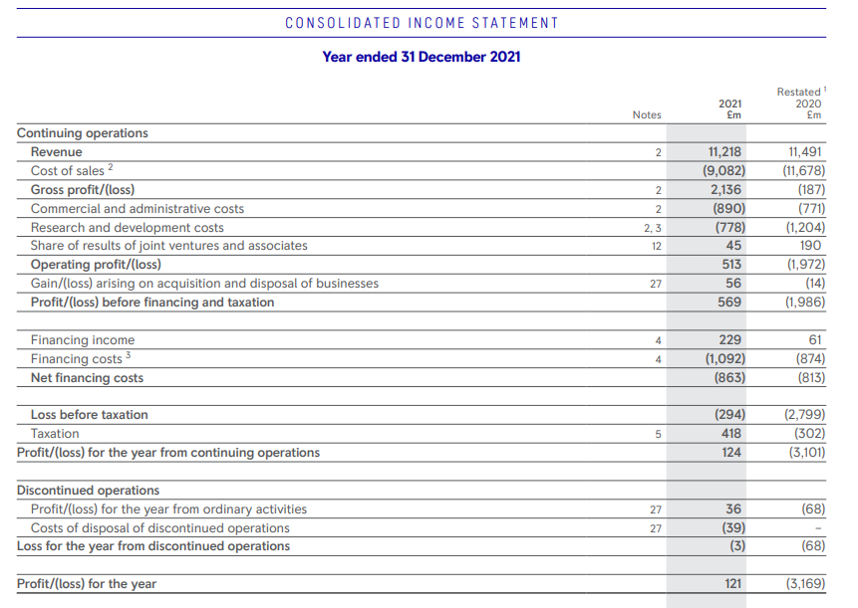
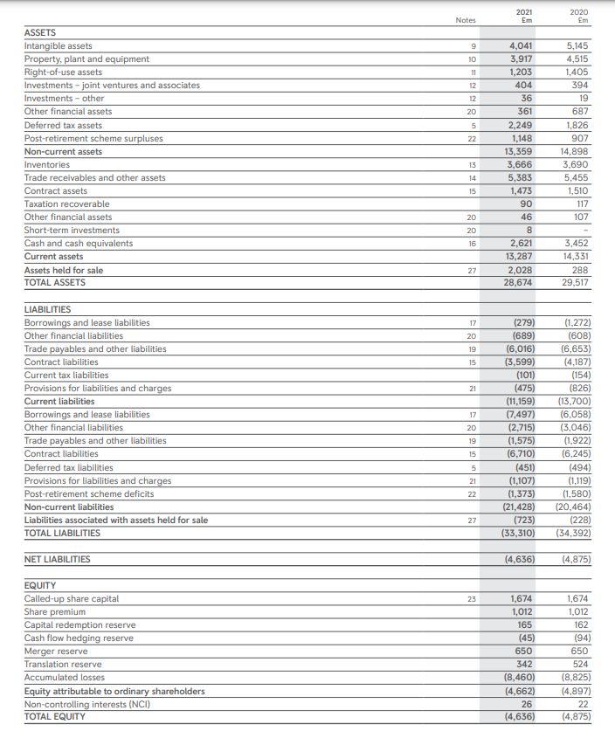
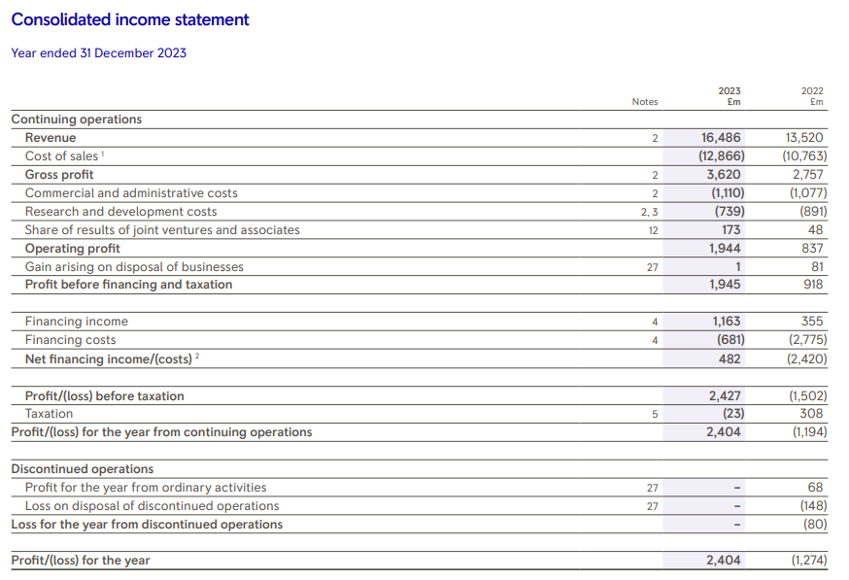
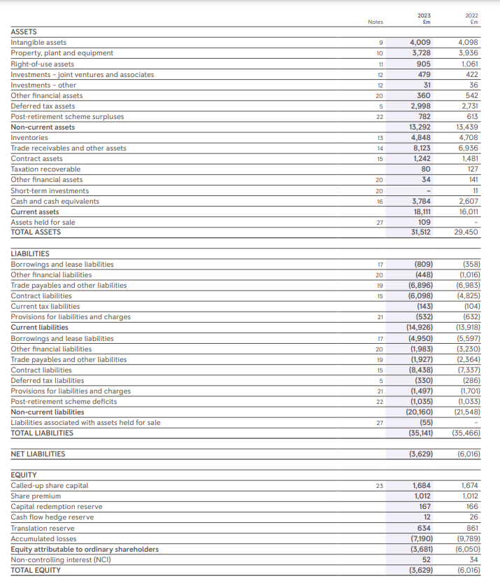

Appendix 2: Financial Statements for the past five years of Bae Systems


