Analysis of The Economist Magazine
Nouf Alotaibi

Table of Contents
1 Introduction 3
2 Decline In Print 3
3 The Economist 4
4 Trends 5
5 Porters 5 Forces 5
5.1 New Market Entrants 5
5.2 Supplier Power 6
5.3 Competitive Rivalry 6
5.4 Buyer Power 6
5.5 Alternative Products 6
6 Pest Analysis 7
6.1 Political 7
6.2 Economic 7
6.3 Social 7
6.4 Technology 7
7 SWOT Analysis 8
8 Conclusion 9
9 References 10
10 Appendix 12

Introduction
The Economist is a weekly newspaper printed in magazine-format that is based in London, England and has editorial offices in major cities in Europe, North America, Asia and Middle East. The Economist is renowned globally for quality and informative global news coverage on business, politics and science and technology (Hobbs 2018). The Economist was established in 1843 by James Wilson to protest against the British Corn Laws. However, the newspaper expanded into the political economy before starting running articles on current events. The editorial stance of The Economist is mainly informed by the economic liberalism and classical framework. The Economist is known for favoring government policies and governments that favor centralist politics, neoliberalism economics and free trade. The economist has subscriptions and newsagents in more than 200 countries across the world. The Economists global print circulation was estimated at 909,476 while the digital readership topped 700,000 across the globe (Hobbs 2018). About 70% of its audience is men while female readers make an estimated 30% of its 1.6 million print and digital subscribers.

Decline In Print
The digital media has brought significant disruption to the UK print titles since the start of the internet era. The number of print newspapers and magazines has declined by 55% since the inception of internet in 2000 (Sweney 2018). The sales of the top 100 most bought print magazines and newspapers in UK fell by 42% between 2010 and 2017 from 23.8 million to 13.9 million (Thorpe 2019). The amount of advertising titles has also declined from £512m in 2010 to £250m in 2017. The disruption by the digital media promoted most of the print magazines to stop publication of the print editions to follow the digital-only path. Some of the magazines that have shifted to the digital- only editions include the NME, Glamour, and Loaded, Maxim, The Face, Arena and Bliss. The decline in sales and advertising was aggravated by Google and Facebook growth in popularity as digital advertising platforms. Google and Facebook control an estimated 65% or close to £4.7bn of the UK’s digital ad display (Sweney 2018). Facebook is relied upon as a major source of news information in the UK, with 73% of the population using it for news (Sweney 2018). An estimated 52% of those who use Facebook as a source of news get the news directly from the publishers in their feeds while 47% find news directly from their friends and family.
News magazines such as The Economist capture the new customer preferences by operating both on print and digital platforms. Advertisers are looking for magazines that are able to reach audience at scale (Thurman 2018). While there is a decline in print advertising and single-copy sales, venturing online is an important step towards ensuring sustainability of the magazines.

The Economist
The Economist Magazine has been affected significantly by the digital disruptions over the years. In the early 2000s, The Economist had more than 1.3 million print circulation and subscribers. However, the number of print circulations has fallen from 1.3 million to 909,000 in 2019 (Sweney 2018). However, investment in the paid digital audiences has helped The Economist to offset the challenges that are coming with declining number of the print circulations. In the period between 2012 and 2015, The Economist recorded a 3% decline in the number of print circulations while the digital readership/subscription grew by 6% in the same period (Guaglione 2018). Between 2016 and 2019, the overall news magazine industry has been experiencing growth both print and online circulations. The growth is mainly attributed to the presence of all all-acess digital access titles that are in intended to promote the number of news magazine subscriptions. In 2017, The Economist experienced a 5% (248,196) increase in the number of online and print subscriptions thus signifying a bright future for news magazines (Mclntosh 2017).

Trends
The digital disruption has made magazine audience increasingly impatient; no one is willing to wait a week to read an article or information print magazine. Social media has become the new way for accessing news for the millennial and most of the younger people below the age of 55 years. The proliferation of digital technologies such as smartphone, personal computers and internet has led to emergence of new digital information sources including vlogs, blogs, and podcasts that offer free content on a wide range of issues with ease of online access (Silber 2018). The print news sources such as The Economist have also turned to the digital news platforms including Facebook, Economist app, Twitter, Economist blog, and Website to reach the digital consumers. An estimated 61% of news consumers use internet as a source of news and are active social media users. The majority of this population falls in the age between 24 and 55 years (Garcia 2018). The majority of news consumers who are above 55 years of age prefer use of newspapers’ apps for information.
Women have also become a catalyst of change in the digital era and majority of the print news media are targeting women to pursue an increase in readership and copy circulation. The new digital technologies have become important tools for decision-making, communication, shaping identity, and innovation for women. Women are more likely to comment, like, and share information than men on social media. More than 92% of women have smartphone and they make use of social media remain up-to-date with favorite brands and news information (Mclntosh 2017).

Porters 5 Forces

New Market Entrants
The Economist faces significant threat from the new entrants such as Buzzfeed, Huffington Post, and Refinery that utilize non-traditional media platforms such as Snapchat Discover and Instagram to inform and engage with their audience (Thurman & Fletcher 2019). The new entrance also faces limited geographical resistance. However, exclusive use of new digital platforms by these new entrants creates the perception that this new media are only for elitists.

Supplier Power
The Economist has a strong brand identity and the strong brand serves as a pivotal journalistic voice. The Economist is able to attract credible authors in different fields who offer controversial opinions that stir curious debate (Sweney 2018). The Economist is able to attract contributors from different fields which in turn promotes brand following rather than weekly subscription.

Competitive Rivalry
The Economist Faces stiff completion in Newspaper and magazine industries. Its main competitors include the Financial Times, Wall Street Journal, The Sun, The Mirror, Business Today and others (Sweney 2018). Pricing is one of the main attributes that competitors use for differentiation. However, the majority of competitors only focus on male audience using male opinionated points of view. This allows The Economist to be more diverse and attract both male and female audience.

Buyer Power
The buyer possesses significant power due to high proliferation of the digital technology. The buyers can easily switch content consumption at any time (Mediatique Limited 2018). Weekly news magazines are perceived as a luxury and not a necessity. Therefore, buyers have the choice to switch to newspapers, newspaper apps, websites, and other digital news source thus giving them significant power over The Economist.

Alternative Products
The rise of the digital platforms has led to proliferation of new news sources including social media and other platforms that enable everyone to be a content creator. The digital media platforms have led to market saturation and limited opportunities in the market if a news outlet has no a proper element for differentiation (Hobbs 2018). News outlets with a clear point of differentiation are able to win consumers more easily.

Pest Analysis

Political
The geopolitical realignments and geopolitical instabilities are turning international markets inwards. The Economist markets itself as liberal journalistic publication. It also preserves anonymity of writers to promote their freedom of expression (Thorpe 2019). The Economist perceives that the story is more important than the writer.

Economic
Most of the economies are experiencing economic boom and increased consumer spending which thus creating a reliable market for news magazines (Thurman 2018). The Economist Weekly Edition costs £5, print and digital £5 and £45 for three months subscription to the print and digital copies.

Social
The social trends are changing as more people across the globe are becoming more information empowered leading women empowerment and increased heterogeneous society. New innovative technologies such as digital media platforms are promoting increased consumption of information over the internet (Saragi & Harahap 2020). Consumers are looking for personalization of experience with what they are consuming.

Technology
There is need for The Economist to make good use of social media platforms to attract new and retain existing customers. The majority of new readers find The Economist when using social media platforms such as Facebook, Twitter, and Instagram (Hobbs 2018). The Economist should increasingly make use of the technology to increase access to its customers.

SWOT Analysis
Strength  - Strong brand-well respected and highly credible (Hobbs 2018).  - Growing readership  - Un-biased opinion  - Anonymity of authors  - Witty and controversial news pieces (Thorpe 2019) | Weaknesses  - Significant decline in print  - Perceived as money or business oriented.  - Subscription based while customers want immediacy.
Opportunities  - New market with aspiring females as elements of change  - Grow content segments –to appeal to more people  - Growing digital content opportunities | Threats  - Rapid decline in print business  - Rise of new digital platforms leading to spirited change in existing communication (Thurman, 2018).  - Societal beliefs affecting media consumption

Conclusion
The Economist Magazine is one of the renowned multinational weekly news magazines that create high quality news insights for the progressive audiences across the globe. The proliferation of the digital news platforms has led to significant decrease in number of print circulation and revenue from advertisement. As a consequence, The Economist has ventured in both the print and online circulation. The digital disruption has contributed significantly to changes in audience dynamics. The millennials spend most of their time on the phone and value free access to information. However, the older generation is looking for credible sources of information thus making magazines such as The Economist that has an authoritative voice on political and business news to continue attracting increased print circulation.

References
Deloittee (2015). Media Consumer 2015: The signal and the noise. https://www2.deloitte.com/uk/en/pages/technology-media-and-telecommunications/articles/media-consumer-survey.html
Garcia, M. 2018. Why single copy magazines sales present a challenge. Garcia Media. Available from https://www.garciamedia.com/blog/why-single-copy-magazine-sales-present-a-challenge/
Guaglione,S. 2018. ‘The Economist’ introduces new app for subscribers. Publishers Daily. Available from https://www.mediapost.com/publications/article/319134/the-economist-introduces-new-app-for-subscribers.html
Hobbs, T. (2018). The Economist and OK! On why print circulations do not paint the full pictures for advertisers. Marketing Week. Avaialable from https://www.marketingweek.com/the-economist-and-ok-on-why-print-circulations-do-not-paint-the-full-picture-for-advertisers/
Mediatique Limited . 2018. Overview of recent dynamics in the UK press market. Asset Publishing Service, UK. Available from https://assets.publishing.service.gov.uk/government/uploads/system/uploads/attachment_data/file/720400/180621_Mediatique_-_Overview_of_recent_dynamics_in_the_UK_press_market_-_Report_for_DCMS.pdf
Mclntosh, S. 2017. Magazines: How print is surviving the digital age. BBC News. Available https://www.bbc.com/news/entertainment-arts-40897967.
Neuts, D. 2016. New study shows news magazine single-copy digital sales up 30 percent. Subscription Insider. Available from https://www.subscriptioninsider.com/reports-research/new-study-shows-news-magazine-single-copy-digital-sales-up-30-percent
Silber, T. 2018. Big ideas for a magazine newsstand industry in distress. Forbes. https://www.forbes.com/sites/tonysilber/2018/05/29/big-ideas-for-a-magazine-newsstand-industry-in-distress/#17ff63495930
Sweney, M. 2018. Out of print: NME’s demise shows pressure on consumer magazines. The Guardian. Available from https://www.theguardian.com/media/2018/mar/12/nme-vogue-death-print-magazines
Saragih, M.Y. and Harahap, A.I., 2020. The Challenges of Print Media Journalism in the Digital Era. Budapest International Research and Critics Institute (BIRCI-Journal): Humanities and Social Sciences, 3(1), pp.540-548.
Thorpe, E.K. 2019. How people in the UK are accessing news: 6 key findings. Whats New In Publishing. Available from https://whatsnewinpublishing.com/how-people-in-the-uk-are-accessing-news-6-key-findings/.
Thurman, N., 2018. Newspaper consumption in the mobile age: Re-assessing multi-platform performance and market share using “time-spent”. Journalism Studies, 19(10), pp.1409-1429.
Thurman, N. and Fletcher, R., 2019. Effects of a Magazine’s Move to Online-only: Post-print Audience Attention and Readership Retention Revisited. Journalism Practice, pp.1-19.

Appendix
The Economist Combined Circulation (Print and Digital) across the world
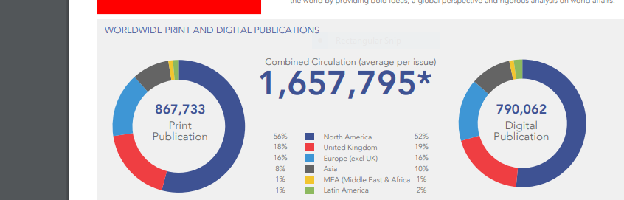
Active Markets And Social Media Followers
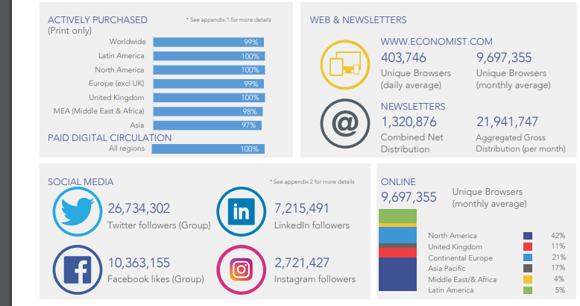
Social Media Platforms


