University of Wales Trinity Saint David

Wales institute of Science and Arts


Electronic ignition and fuel injection systems

Engineering ACHA4010

Joseph Britton

2104278

March/April-2022

Abstract
Two engines were tested in the hopes of finding areas of improvement. These being an LE3 Jetronic Vauxhall system and a Motronic Vauxhall system. These are two very similar engines from different time periods which is where they differ in technology with the Motronic system being the newer of the two. The method of testing will be through studying oscilloscopes produced by the engines and comparing them to see major differences from the newer technologies and drawbacks in certain areas where even newer technologies can be applied. One fault found was a discrepancy in the resistance of the throttle potentiometer for the Motronic engine when opened which was way over the manufacturer’s specification. A similar fault found on the same engine occurred in the air flow sensor with a resistance outside of the manufacturer’s specification. One issue when comparing resistance values for the ntc 2 resistances is the lower operating temperature on the LE3 engine which makes it difficult to determine the trend of the graph past the final plot which harms its ability to be compared to the Motronic data. With concern to the modification that could improve one particular engine, the addition of a lambda sensor to the LE3 engine would mean the ECU would have more parameters to decide the appropriate amount of fuel to send to the engine for the most efficient burn.
Contents
1 Introduction 3
1.1 Comparison of systems 3
1.2 Modifications to the systems 3
2 Methodology 4
2.1 Equipment list 4
2.1.1 Reasoning for choice of equipment 4
2.2 Procedure 5
2.2.1 Health and safety 5
3 Results 6
3.1 LE3 Jetronic Engine Static 6
3.1.1 Resistance testing for sensors 7
3.2 LE3 live testing 7
3.3 Motronic Engine Static 10
3.3.1 Motronic testing for sensors 11
3.4 Motronic Live testing 12
4 Analysis 15
4.1 LE3 Engine 15
4.1.1 Static testing 15
4.1.2 Live testing 15
4.2 Motronic Engine 17
4.2.1 Static testing 17
4.2.2 Live testing 17
5 Discussion 19
5.1 Comparison of ntc 2 oscilloscopes 19
5.2 Modification to a system 20
6 Conclusions 21
7 References 22

Introduction

Testing of two Vauxhall engines from sperate eras will take place with an LE3 Jetronic engine and a Motronic engine. This will cover the characteristics of fuelling and ignition throughout the running of an engine. Testing against the specification will take pace for the pin outputs off the ECU for the Motronic engine to test voltages with ignition on and off and the spark advance unit along with the fuel management unit on the LE3 engine will be tested likewise. The duration of injection On-Time will be measured and interpreted for the following engine conditions for both engines, Cold start, Warm up phase (at various points), snap acceleration and idle at operation temperature. Other static measurements will take place and compared to specifications such as resistances on the throttle potentiometer, idle speed control valve, lambda sensor and more for the Motronic engine.

Comparison of systems
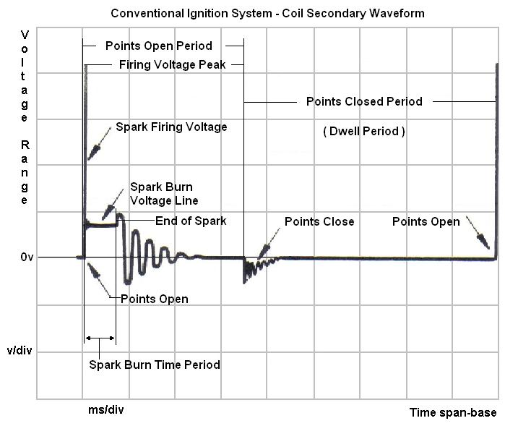
The two systems will be compared not in terms of their performance, yet their injection on times and dwell times will be analysed to highlight the difference between them. More specifically what the newer and more extensive technology on the Motronic system can provide for the LE3 system in terms of improvement to it capabilities. The aim is to show the operational differences between the two, and then to comment on the signal waveforms from the graphical data, analysing and evaluating each.

Modifications to the systems

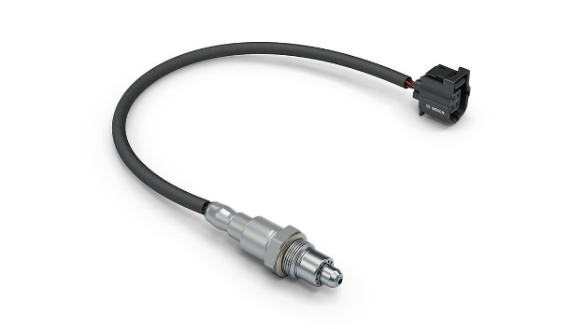
An investigation will take place to decide where one of the engines can be improved, from upgrading parts to newer and better components, to adding additional sensors for the benefit of the system. An example of this could be adding a lambda sensor to the LE3 engine which would give the engine more data to adjust the ignition and fuel management for a better running engine. This would result in a possible increase in efficiency and a reduction in harmful exhaust fumes.

Methodology

Equipment list

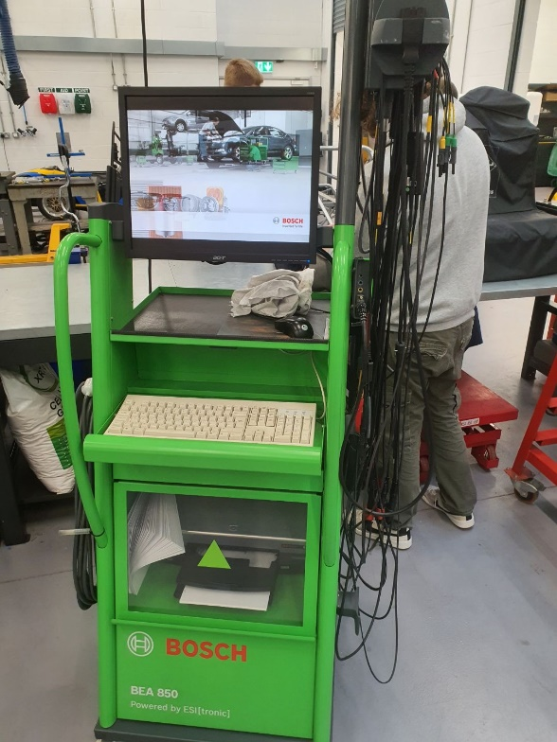
The tester used to analyse the engine characteristics was a Bosch BEA 850 emissions tester. This is typically used by workshops in completing the emissions sections of MOT tests, however the system has many other uses such as the testing which was done on these engines. It has many attachments that can measure many variables on the engine such as an electronic dip stick to measure oil temperature very accurately.

The testing also required the use of a multi meter to measure resistance on a few sensors and voltage outputs for the static testing on ECU pin outputs, fuel management and spark advance unit.
This multi meter was used for all static checks including the resistance tests against the specification so it was important that it was set to the adequate range for all results to be accurate.
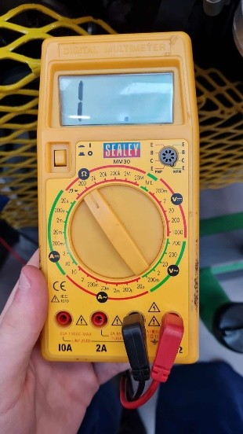
No hand tools such as spanner and rachets were necessary as all the components that needed to be accessed were already visible and didn’t need disconnection other than tabs which could simply be separated by clips.

Reasoning for choice of equipment

The Bosch BEA 850 is a great choice for this testing as its interface is very user friendly and can be used with no previous experience in producing the level of results in this test. The computer is easily accessible and the whole trolley is easy to move around which was great for this instance as two systems were being tested(BEA Emission Analysers for a Clean Environment, n.d.). The multi meter was really the only suitable tool for the job that was required as every measurement that was taken for all the static testing needed this product. One great thing with using the multi meter is the fact that all the testing can be done off the single controller as you only need to spin the dial to change the parameters that the user wants to measure. In this instance, voltage and resistance were both tested, this could all be done by the same multi meter.

Procedure

Then testing started on the LE3 engine which began with static testing on the spark advance unit and the fuel management unit. All this require was testing each pin output with ignition on and off to test which pin are used for what. For example, testing which were live, which were ground, and which were signal pins by looking at the voltage output accounting for losses in the cables.

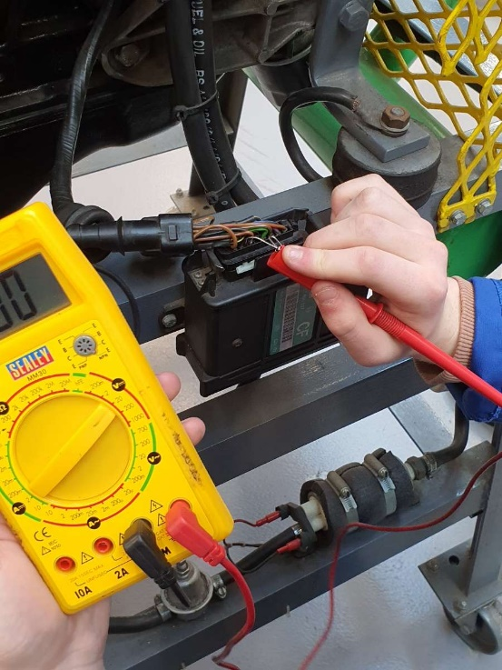
Following this, live testing on the engine began. This where the use of the emissions tester was required to measure injection on time and spark duration amongst other sensors. The process of using this piece of equipment is simple. It requires one person to correctly place the two leads to the correct pins being tested and other accessories fitted to the engine like the electronic dip stick for engine oil temperature. Once these are in place the engine can be run through its warmup stage, during this process oscilloscopes will be created by the person controlling the computer system on the emissions tester at intervals of 10 degrees Celsius.
These processes are then repeated for the other engine (Motronic) with the difference being the lack of spark advance unit and fuel management units which are both integrated into the ECU on this model.

Health and safety


It is of the upmost importance that health and safety is not overlooked in the workshop when performing any activities. When testing an engine there are a few safety rules that apply. As there are exposed rotating components, like the accessory belt for example, it is critical to be aware of them and keep a fair distance from them. Also, wearing gloves around these exposed rotating components is extremely dangerous if the users glove gets caught in the rotation which can lead to the user’s hand being pulled towards the assembly.



Testers must be attentive towards signage posted around the workshop. Notably prohibition, mandatory and warning signs. A prohibition sign will be red in colour in the shape of a circle with a diagonal line cutting through it, whenever you see a prohibition sign its purpose is to tell you not to do something. A mandatory sign will be a blue circle explaining something you must do, for example a mandatory sign may tell you, you must wear safety glasses in a certain area of the workshop. Finally warning signs indicate a danger and these will warn you to that danger. You can identify these as a yellow triangle.

Basic PPE was essential when performing the tests on the engines. This includes overalls and steel toe cap boots. The boots must be worn as the engines were mounted for moveable stands and should these fail, or should a heavy tool fall onto your foot, the safety boot will protect your foot.

It is highly important you apply barrier cream to your hands before any workshop activities to decrease the chance of infection from and liquids and swarf in the area. Also, when you finish you must clean your hands properly with Swarfega. Swarfega is great at removing dirt and grime that is very commonly occurring in an engineering environment such as a workshop(Swarfega - Wikipedia, n.d.).

Results

LE3 Jetronic Engine Static

Resistance testing for sensors

Throttle switch ignition off –

Throttle closed = 0Ω
Throttle open = infinityΩ
Both values are true to the specification.

Auxiliary air valve –

Specification = 40Ω
Recorded value = 45.8Ω

Injector valves –

Specification = 15-17Ω

Cylinder 1 injector = 15.7Ω
Cylinder 2 injector = 15.7Ω
Cylinder 3 injector = 15.8Ω
Cylinder 4 injector = 15.8Ω

LE3 live testing

Cold crank –
The initial injection on time when firing up the engine was measured at 77.1ms. Approximately 500ms of cranking was required to start the engine and then once it had fired injection on tie was measured at 6.4ms. The static engine temperature was noted at 18.2°C.

Warm up sequence –

Note: All engine oil temperatures are an approximation

The maximum temperature the engine reached was 63°C where the injection on time was recorded to be 2.5ms.

Shown below is a scope of pin 1 on the amplifier which shows the primary wave form from a test done prior under separate conditions meaning the direct values will be different however the shape of the scope remains.
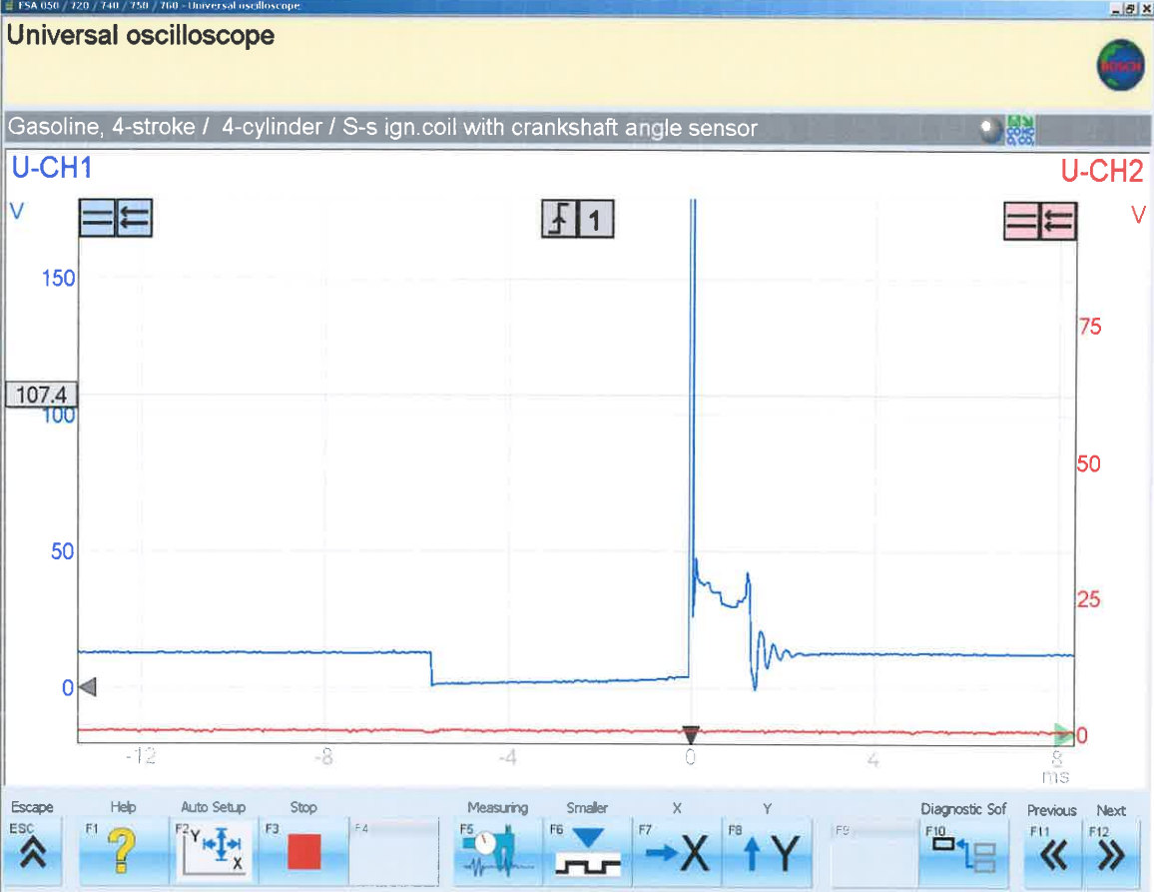
The dwell time recorded in the testing of the LE3 engine came to 5.1ms at operating temperature. This is the time measured between the dip and the spike on the scope shown alongside.

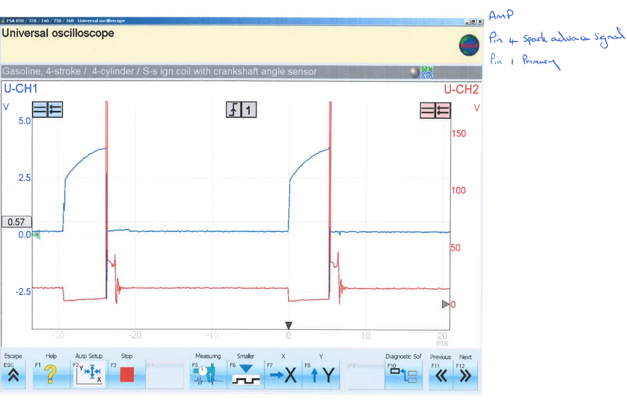
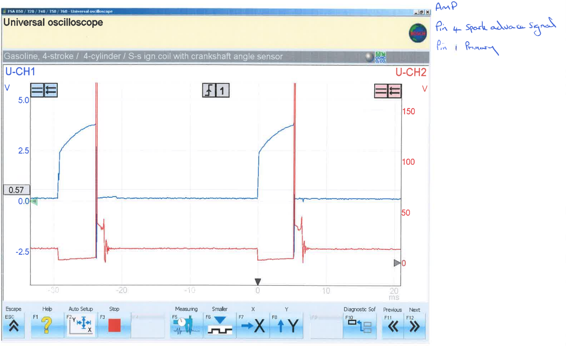
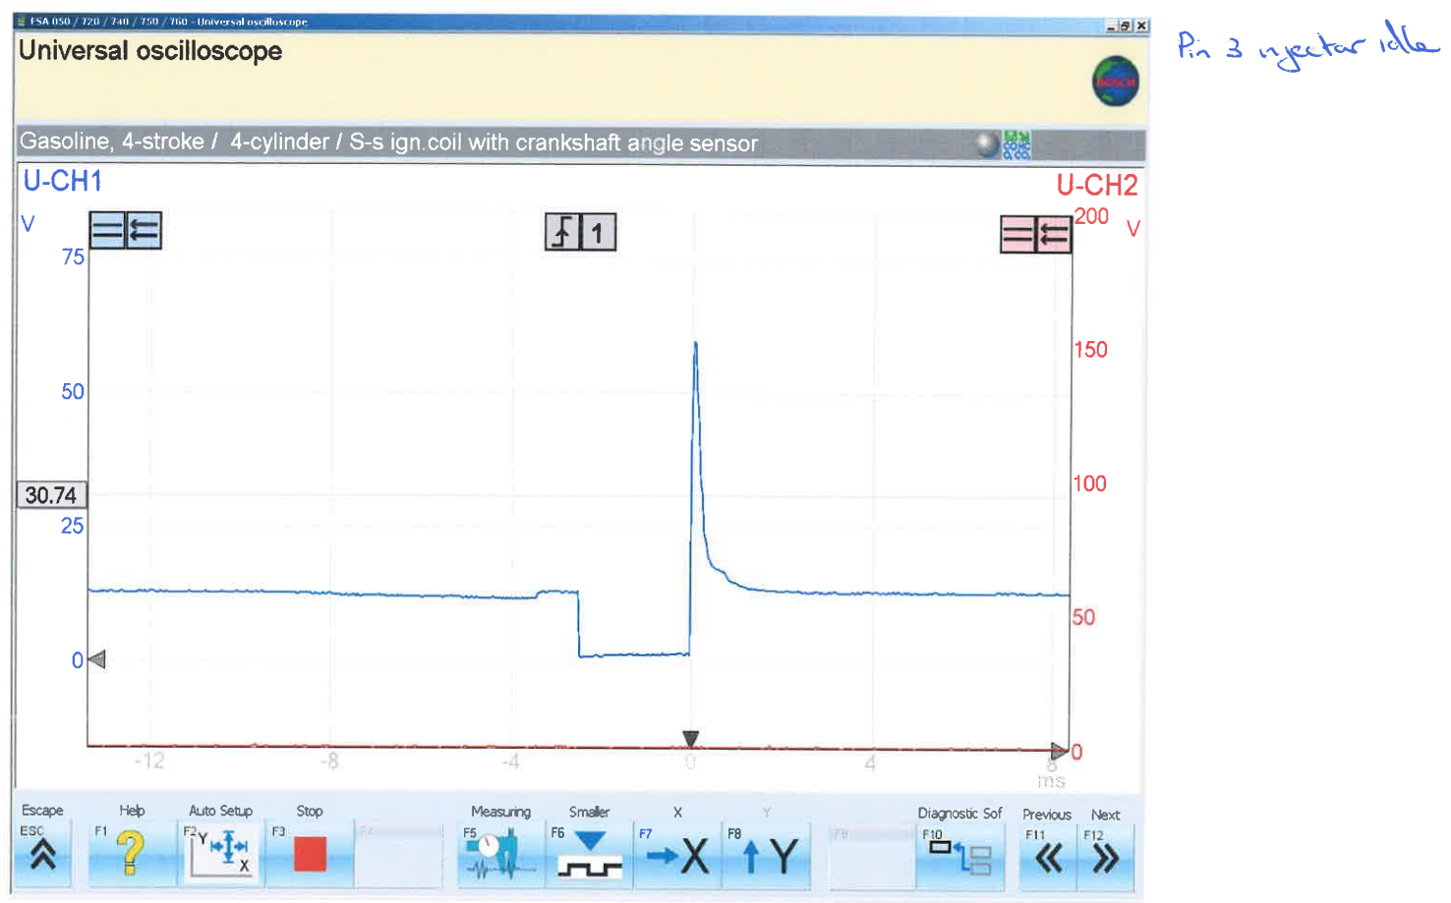

Motronic Engine Static

Battery voltage ignition off - 12.44V

Battery voltage ignition on – 12.37V

Motronic testing for sensors

Throttle potentiometer –

This sensor has three pins:
Pin 1 – Earth
Pin 2 – 5V supply to air flow meter and throttle potentiometer
Pin 3 – Output from throttle potentiometer

With the throttle closed, pins 1 & 2 were measured:

Specification – 1900 - 2000Ω
Measured – 2000Ω

With the throttle opened, pins 1 &3 were measured:

Specification – 1000 - 2000Ω
Measured - 2580Ω

Injector valves –

Specification – 15 - 17Ω

Cylinder 1 injector – 16.5Ω

Cylinder 2 injector – 16.4Ω

Cylinder 3 injector – 16.4Ω

Cylinder 4 injector – 16.4Ω

Idle speed control valve

Specification - 8Ω

Measured – 8.4Ω

Air flow sensor

The air flow meter has 5 pins:
Pin 1 – Output from CO potentiometer (not fitted with catalyser)
Pin 2 – Load signal output from air-low meter
Pin 3 – 5V supply to air-flow meter and throttle potentiometer
Pin 4 – Earth
Pin 5 – Output from ntc 1

For testing this component, pins 2,3, and 4 was necessary.
Specification for pins 2 and 4: 8 - 2500Ω

Measured - 33Ω

Specification for pins 3 and 4: 300 – 550Ω

Measured - 560Ω

Motronic Live testing

The injection time on cold crank at 18°C was 20.3ms. Ntc 1 was measured at 20°C and 80°C where the voltage started at 3.7V and decreased to 3.3V when it reached the higher temperature. Also, to note the fan came on during the live testing at 70°C.

The pins being tested during the warmup phase of the engine are as follows:
Pin 4 – Pulsed side of the rotary idle valve
Pin 5 – Pulsed side of the tank vent valve
Pin 16 – Pulsed side of injectors (bank of two)
Pin 28 – Output from lambda sensor
Pin 44 – Output from ntc 1
Pin 45 – Output from ntc 2

Warm up phase –

The following oscilloscopes were from testing on a separate day meaning conditions don’t align perfectly however the rough values are very similar than those calculated on the day.
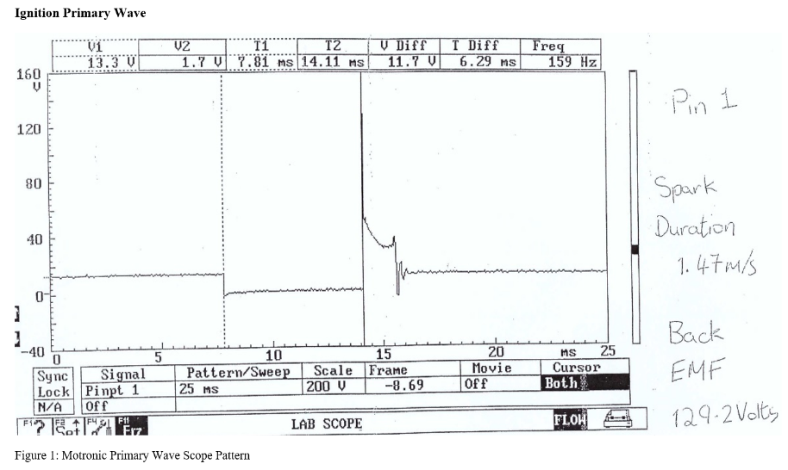
The dwell time recorded for the Motronic engine came out as 7.81ms. with a spark duration of 1.47ms.
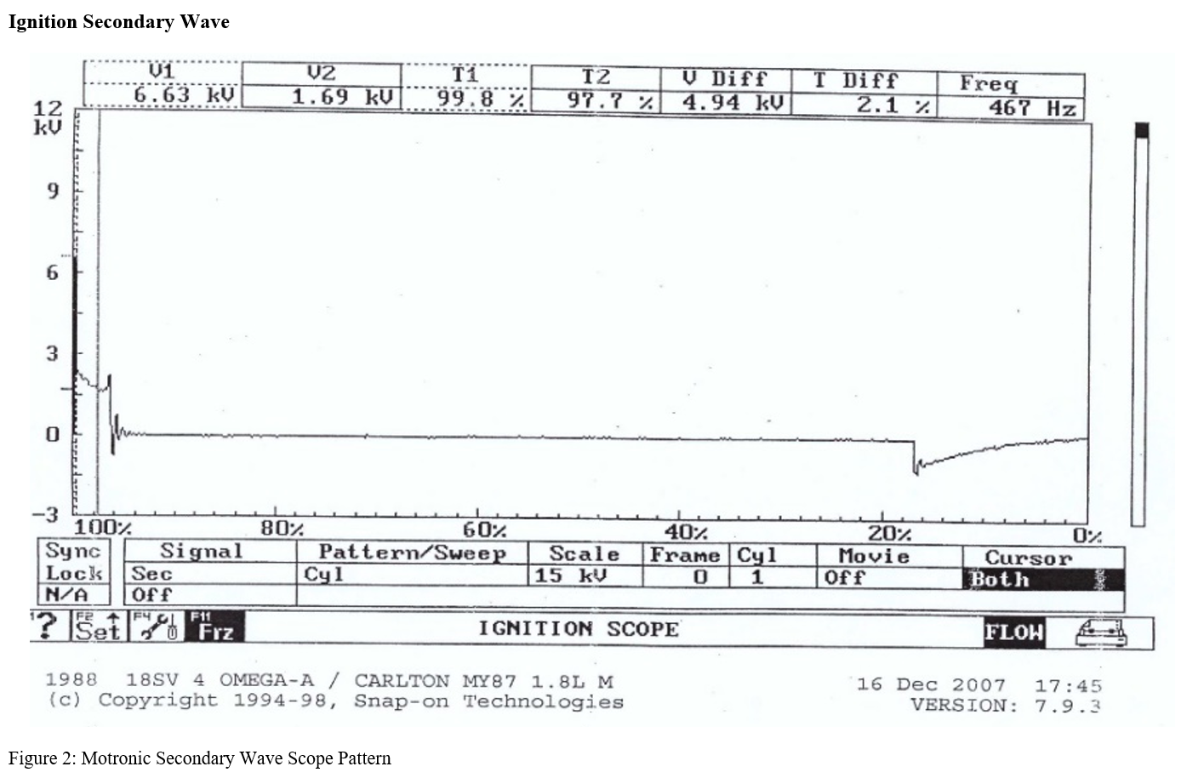

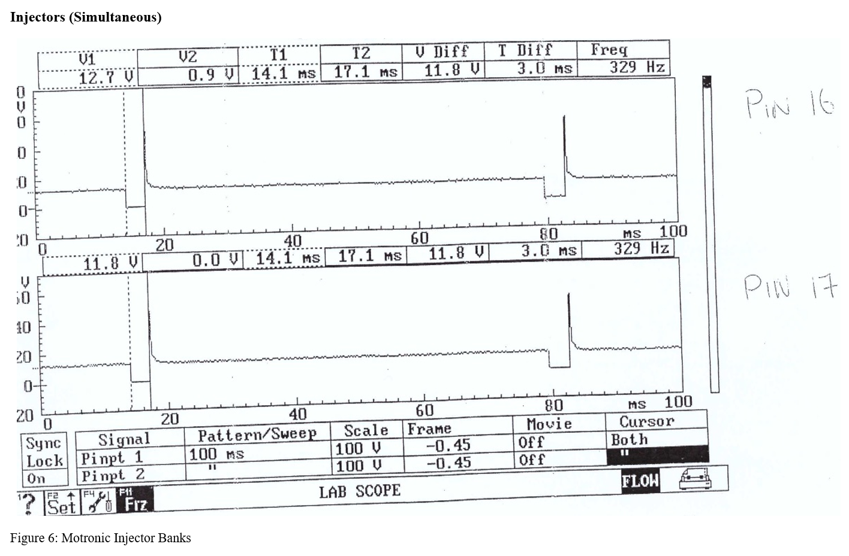
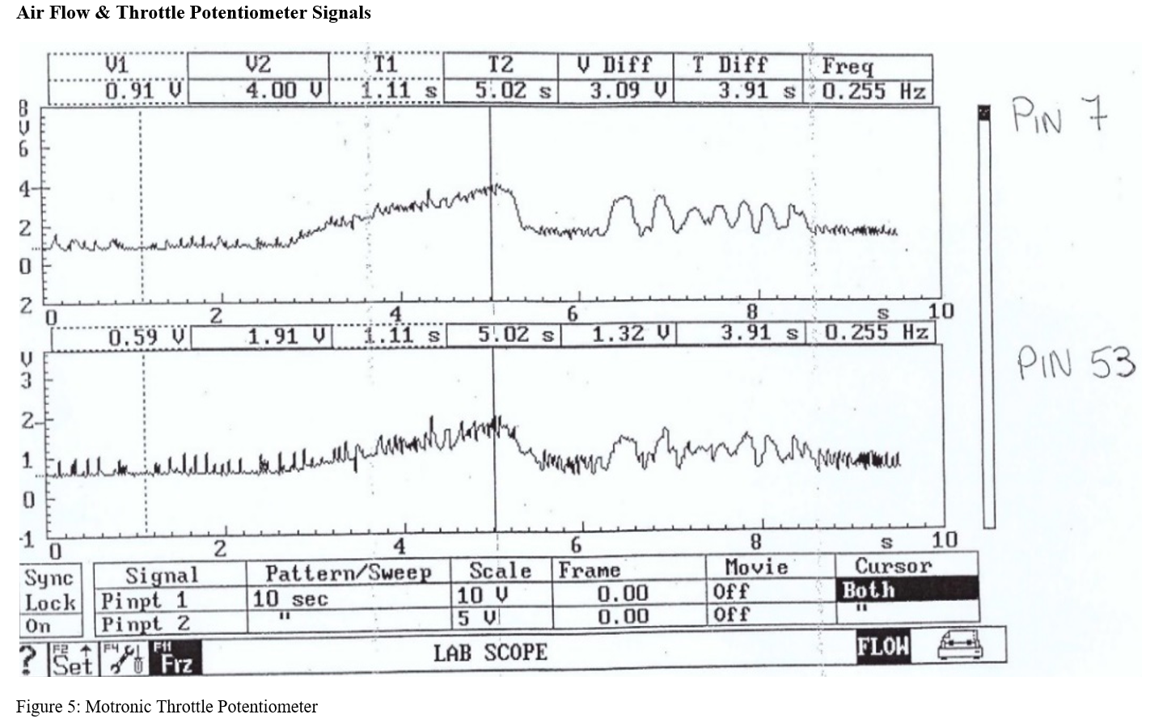

Analysis

This section will go over the results obtained for each test in detail, analysing both static and live results. The sensors will be compared to their specification from the manufacturer to see if they are functioning as they should, and if nit it will be a topic of discussion as to whether that part maybe can be upgraded to newer technology in the hopes of improving the running of the engine.

LE3 Engine

Static testing

Starting with the sensors for the LE3 engine, firstly the throttle switch which was tested with the ignition off. When closed under testing it read a resistance of 0Ω which was true to the specification from the manufacturer and is what you’d expect to see from this reading. If the throttle was reading a resistance when closed it could mean that it may be stuck open ever so slightly which would in turn affect the air to fuel ratio unknowingly. When open it read infinity, this is also expected as the ignition is off.

Next to analyse is the auxiliary air valve which was measured slightly over specification. The manufacturer expects a resistance reading of 40Ω; however, the test results show a reading of 45.8Ω. This issue will cause the valve to not operate correctly. The purpose of the valve is to measure the engine temperature and dependant on that temperature open or close slightly, to adjust the air flow in the engine as it bypasses both the idle screw and the throttle. This is especially important when starting the engine from cold (9. Cold Start Valve & Auxiliary Air Valve, n.d.). Should this valve not operate properly it will affect the engine when starting from cold which may cause the engine to consume more fuel as it thinks it is sending in more air than it already is or vice versa.

All the injector valves fell within the specification boundaries 15-17Ω. Injectors in cylinders 1&2 read 15.7Ω whilst injectors in cylinders 3&4 read 15.8Ω. This deviance between the cylinders is so small that it very unlikely to cause any issues in the health of the engine. Nonetheless it is notable that the higher resistance is recorded in the back two cylinders (the cylinder number ascends from the front of the engine).

Live testing

The testing of the engine started from a completely cold engine which had an oil temperature of 18.2°C. Upon the initial fire up the first injection lasted 77.1ms which Is significantly longer than any other period of injection across all the other testing. An engine will need a lot of fuel straight away when it is cold so that it can combust as much as possible to allow the sustain itself. Without this long injection of fuel, the engine would likely stall. This stalling occurs when the air fuel mixture is off and the engine will stop rotating once the starter motor disengages (Three Primary Causes of Engine Stalls - United Auto Care, n.d.).
Once the engine has started to run whilst still cold a measurement of ignition on time was taken once more with it now reading 6.4ms. This reading will continue to drop as the oil temperature rises to operating temperature.
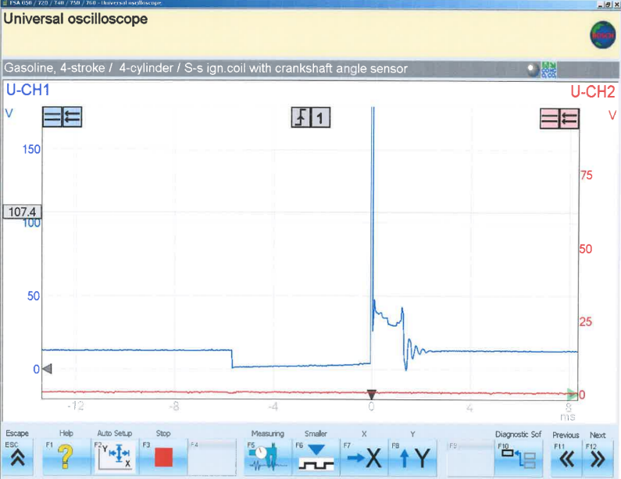
At 20°C injection on time was at 3.5ms until it reached its maximum temperature recorded at 63°C where injection on time sat at 2.5ms. Through this this ntc 2 resistance and voltage both dropped from 1830Ω to 400Ω and 1.5V to 0.5V. One variable that may have affected these values is the approximation of the temperatures as it is extremely difficult to hold the engine at a specified temperature whilst trying to take measurements. Although its tough to see from the oscilloscope, the spark duration seem to be in the region of 1ms.

Motronic Engine

Static testing

Four sensors were tested on the Motronic engine, these being the throttle potentiometer, injector valves, idle speed control valve and the air flow sensor.
Starting with the throttle potentiometer, when it was closed the resistance fell within the specification of 1900Ω - 2000Ω as it read 2000Ω. However once opened the factory spec changes to 1000Ω - 2000Ω, and once measured the results showed 2580Ω which is way outside of what the manufacturer suggests it should be. This shows that there is clearly a fault in the part, and it should be replaced. This issue can lead to a whole host of problems as it is so var out of specification. This can lead to the engine running very poorly which may consume more fuel than it typically should. This may also result in poor response when trying to accelerate which can also make changing gears more difficult due to the revs increasing without intention (What Are the Symptoms of a Bad or Failing Throttle Position Sensor? - McSpadden’s Tire & Automotive, n.d.).
The injector valves all fell within the specification which shows well for the health of the fuel systems of this engine. The threshold specified by the factory for the resistance of the injector valves was 15Ω - 17Ω. The injector on cylinder 1 measured at 16.4Ω whilst cylinders 2, 3 & 4 were all recorded at 16.5Ω. It is important these values are within spec as they are the last resort before fuel enters the cylinders (Motronic - What Is the Motronic Fuel Injection System - AvtoTachki, n.d.).
The idle speed control valve isn’t as important for the engine whilst it’s been running for some time. Although when trying to start the engine under cold conditions its essential to ensure the engine idles steadily and at a suitable RPM. The spec provided by the manufacturer calls for 8Ω whereas the measured value came to be 8.4Ω.
Finally, the air flow sensors results are as follows. Two tests needed to be performed on this part. Pins 2 & 4 first and then 3 & 4 second. The spec for 2 & 4 is 8Ω - 25000Ω, for this test the result came out as 33Ω which sits nicely within spec. For pins 3 & 4 the spec is 300Ω – 550Ω, this was measured at 560Ω, just outside what the manufacturer states. Even though the recorded value for pins 3 & 4 falls outside of the specification it is by a small margin. This may affect the running of the engine but not juristically. A fault with the air flow sensor can have similar effects to an issue with the throttle potentiometer. This sensor determines to volume of air entering the engine and should it read incorrectly the driver of the vehicle may experience stalling of the engine and hesitation under acceleration (How to Detect and Clean a Faulty Mass Airflow Sensor - CarsDirect, n.d.).

Live testing

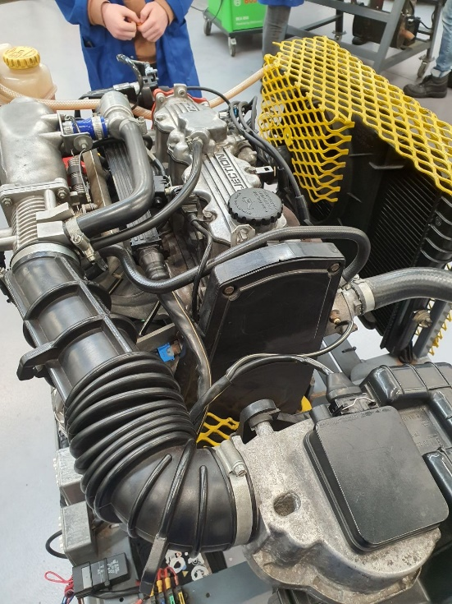
The live testing for the Motronic engine began from a cold engine at 18°C and went through a warmup cycle up until operating temperature at 80°C. Throughout the warmup of the engine, as oil temperature increase, the ntc 2 resistance and voltage dropped at every point measured. With regards to the injector on time, these recordings did not seem to have any fashion to them which may be a result of the issues stated previously with throttle potentiometer and air flow sensor. From 20°C - 30°C the injector on time remained at 3.3ms, but once at 40°C it rose to 3.5ms and then significantly dropped to 2.7ms. After this it began to rise again until reaching operating temperature. The tank vent valve controls the air that escapes from the charcoal canisters which stores fuel vapour that’s released from the engine to control emissions (EVAP Vent Valve (Solenoid): How It Works, Problems, Testing, n.d.). This valve began to switch on between 40°C - 51°C, the exact value is uncertain as tests were ran in increments of 10°C. The last sensor tested under live conditions was the lambda sensor. The role of a lambda sensor is to measures the oxygen content of the exhaust gasses, and thus calculating the air to fuel ratio. This is a great way to determine if the other sensors are performing well as it will tell you if there is extra fuel being exhausted that hasn’t been combusted (Lambda Sensor Testing and Troubleshooting | HELLA, n.d.). The lambda began to switch in the region of 28°C - 37°C.

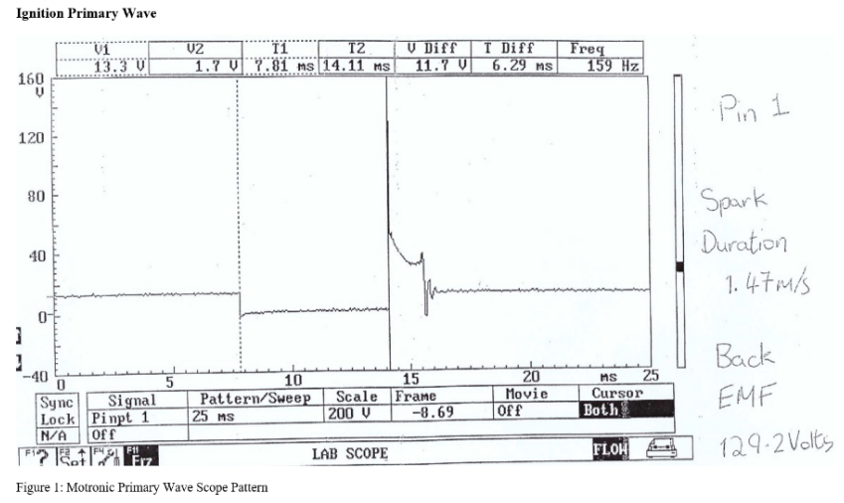
The spark duration as seen in the oscilloscope alongside shows the spark duration to be 1.47ms and a dwell time of 7.81ms. When an engine is idle below 1000 rpm this is an expected dwell time for an engine. At 1000 RPM an expected dwell time is around 4ms (DENSO | Everything You Need to Know about Ignition Coil Charge-Up, n.d.).

Discussion

Comparison of ntc 2 oscilloscopes

As illustrated above, the resistance from the ntc 2 is much lower than on the Motronic system. This voltage can be used as a signal to trip a switch such as turning on the fans to lower the temperature of the coolant in the hopes of lower engine oil temperature (Thermistors and NTC Thermistors, n.d.). These values are hard to compare due to the small amount of data from the LE3 engine, meaning that not many conclusions can be drawn from this data.

Due to the issue of the LE3 engine having a lower operating temperature, a challenge is created when comparing the two data sets. From what is presented however we can see both resistances start at very similar values however their course changes at 30°C where the Motronic ntc 2 resistances decline at a faster rate. The job of a ntc sensor is to lower its resistance with a raise in temperature so both sensors are clearly both performing their role (Thermistors and NTC Thermistors, n.d.). The difference being they perform their role different as they act at different resistance shown through the data. This could be down to many variables such as the different production dates on the engines and the advancements in technology on the Motronic system comparable to the LE3 engine meaning that the same results can be recorded using lower resistances.

Modification to a system

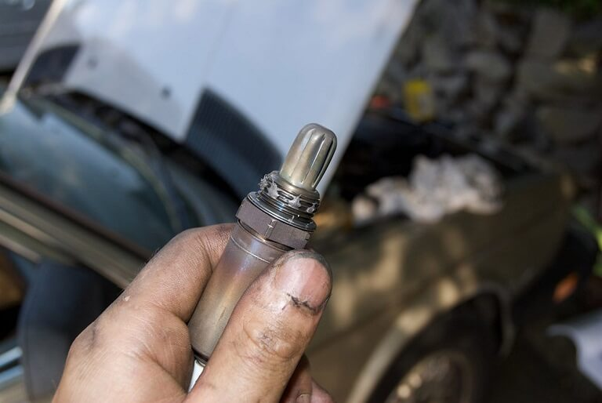
A modification to the LE3 system that could significantly increase the amount of data supplied to the ecu would be the addition of a Lambda sensor. This will supply the ecu with data on the air to fuel ratio of exhaust fumes. Giving the ECU access to this information allows it to make more critical decisions on the amount of fuel to send into the engine at any given moment. With this information the ECU will adjust the injection duration and the timing at which it enters the cylinder to either create a leaner or richer mixture dependant on the oxygen content determined by the lambda sensor (The Lambda Sensor and Its Important Input to the ECU - ACtronics LTD, n.d.).

The inclusion of a lambda sensor can also reduce exhaust fumes as this engine does not have a catalytic converter which modern engines rely on highly to reduce CO entering the atmosphere. Given the current climate, a reduction of exhaust fumes is extremely important due to the harm carbon monoxide entering causes. Continuous exposure on a human can lead to brain damage, breathing issues and many more life-threatening symptoms (Carbon Monoxide Poisoning: Health Effects (AEN-166) - Department of Agricultural and Biosystems Engineering, n.d.).

Conclusions

The aim when testing these engines intended in gaining information on the performance of each to find areas of improvement aided by more modern technology. This began with measure static and live data from both LE3 and Motronic systems to determine where each performs best and areas where they are comparable to each other. The results found that both engines were healthy however some sensors that were recorded were determined to be outside of the manufacturers specification, namely the throttle potentiometer and air flow sensor on the Motronic engine. One issue that represented itself with the LE3 engine was a high resistance on the auxiliary air valve which could cause issues with air to fuel ratios being out of line especially when there isn’t a lambda sensor to tell the ECU what the oxygen content of the exhaust fumes is.

Through comparison of the ntc 2 graphs for resistance and voltage, it was found that both systems perform similarly in many aspects however the newer Motronic engines ntc 2 sensors recorded higher voltages and lower resistances which could be due to it being a newer way of recording the readings its receiving.

The modification that was decided to be suitable for the LE3 engine was the addition of a lambda sensor which would give the ECU extra information to work with in deciding what injection duration and timing will give to engine its highest volumetric efficiency. Due to the lack of catalytic convertor on this engine also, it will help reduce emission indefinitely.

References

9. Cold start valve & Auxiliary air valve. (n.d.). Retrieved April 23, 2022, from https://jetronic.org/en/d-jetronic/aav
BEA Emission Analysers for a clean environment. (n.d.). Retrieved April 22, 2022, from www.boschautoparts.co.uk
Carbon Monoxide Poisoning: Health Effects (AEN-166) - Department of Agricultural and Biosystems Engineering. (n.d.). Retrieved April 24, 2022, from https://www.abe.iastate.edu/extension-and-outreach/carbon-monoxide-poisoning-health-effects-aen-166/
DENSO | Everything you need to know about ignition coil charge-up. (n.d.). Retrieved April 24, 2022, from https://www.denso-am.eu/news/deneur21_08_ignition-coil-charge-up
EVAP Vent valve (solenoid): how it works, problems, testing. (n.d.). Retrieved April 24, 2022, from https://www.samarins.com/glossary/vent-valve.html
How to Detect and Clean a Faulty Mass Airflow Sensor - CarsDirect. (n.d.). Retrieved April 24, 2022, from https://www.carsdirect.com/car-repair/how-to-tell-if-you-have-a-faulty-mass-airflow-sensor
Lambda sensor testing and troubleshooting | HELLA. (n.d.). Retrieved April 24, 2022, from https://www.hella.com/techworld/uk/Technical/Sensors-and-actuators/Test-lambda-sensor-4379/
Motronic - what is the Motronic fuel injection system - AvtoTachki. (n.d.). Retrieved April 23, 2022, from https://avtotachki.com/en/chto-takoe-sistema-motronic/
Swarfega - Wikipedia. (n.d.). Retrieved April 23, 2022, from https://en.wikipedia.org/wiki/Swarfega
The lambda sensor and its important input to the ECU - ACtronics LTD. (n.d.). Retrieved April 24, 2022, from https://www.actronics.co.uk/news/the-lambda-sensor-and-its-important-input-to-the-ecu
Thermistors and NTC Thermistors. (n.d.). Retrieved April 24, 2022, from https://www.electronics-tutorials.ws/io/thermistors.html
Three Primary Causes of Engine Stalls - United Auto Care. (n.d.). Retrieved April 23, 2022, from https://www.unitedautocarega.com/3-primary-causes-engine-stalls/
What are the Symptoms of a Bad or Failing Throttle Position Sensor? - McSpadden’s Tire & Automotive. (n.d.). Retrieved April 23, 2022, from https://mcspaddenautomotive.com/blog/what-are-the-symptoms-of-a-bad-or-failing-throttle-position-sensor

