Management & Organisational Behaviour
Written Report
Lecturer : Ernest Balutie Wavei
Student ID:2216013 Oana Elena Bejinariu

Table of Content
Introduction 3
Organisational Structure of Hilton 3
Organisational Culture and Goals of Hilton 5
Change Initiatives taken by Hilton 7
Strategic Direction of Hilton 8
Conclusion 8
References 10

Introduction
This report is focused on assessing the organisational structure, culture and goals of Hilton Hotel Group. The recent initiatives that are taken by the group and the impact of these initiatives are also assessed in this report. Moreover, the strategic direction of the organisation is also evaluated. All the aspects of the report are addressed by considering the relevant literature pertaining to organisational structure, culture, and strategic management. Organisational structure and culture play a vital role in promoting adherence to norms and rules of organisation, cultivating team spirit, and boosting employee engagement and job satisfaction.

Organisational Structure of Hilton
The group is led by Christopher J Nassetta who is the CEO of Hilton group and got this position in 2007. Under him comes a core teams of executives who lead different functional teams such as human resources and finance. Moreover, the three geographic division’s (Americas, Asia Pacific, Europe, Middle East, and Africa) heads also come under the CEO. (Hilton, 2024) The following image shows the visual representation of the organisational structure of the company:
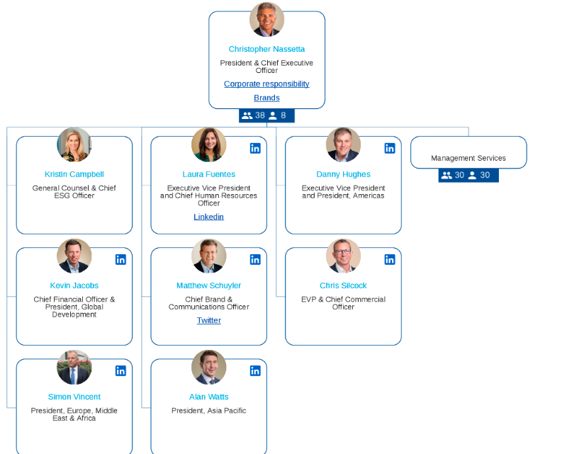
Figure 1: Organisational Structure of Hilton Group
From the assessment of the organisational hierarchy shown above, it can be said that the organisational structure followed by the company is divisional or functional. The reason behind this is the top-most management is responsible for managing different functional and geographic divisions. The organisational structure of Hilton is highly influenced by the scale of its operations. Since it operates on a very large scale level, it is more complex and have more rules. Having this structure provides a number of benefits such as each department is focused on their function (Nene and Pillay, 2019). Moreover, as there is a head who oversees all the operations happening, there is higher accountability of tasks. There is also clarity of roles that are assumed by top level, mid-level, and low level employees. Everyone knows their roles and responsibilities thus they perform well according to it (Holtzhausen, 2002). Along with the various advantages that are offered by a functional organisational structure, it should be noted that there is a major gap between top and bottom. This may result in excessive time required to coordinate with each department (Varzaru and Varzaru, 2013).

Organisational Culture and Goals of Hilton
Organisational culture is defined as the traditions, beliefs, values, attitudes, and policies as a collection that constitute a pervasive context for everything that is done and though in an organisation (McLean, 2013). A more recent definition provided by Woffindin (2023) states that culture is the collection of expectations, practices, and values which guide and inform the team members working in an organisation. It is often considered as the company’s character or personality which makes the organisation what it is. There are a number of theoretical models and concepts of organisational culture which can be referred to understand the culture of Hilton.
One of such models is Schein’s culture model which states that there are three levels of culture within an organisation (Hogan and Coote, 2014). The following table shows the explanation of each level in the context of Hilton:
Artefacts | The organisation’s culture is represented through artefacts. It includes factors such as beliefs, norms, and values with respect to the external stakeholders as well as the employees. Nonetheless, it is not necessary that artefacts reflect the actual culture of the organisation (Akpa et al., 2021).
Espoused Values | The espoused values tend to guide the decision making, employee behaviour and decision making within an organisation. These tend to shape the culture of the organisation and are often communication with the official channels of organisation. Cultural inconsistencies can occur if there is discrepancy between espoused values and the actual practices (Assoratgoon and Kantabutra, 2023).
Assumptions | Assumptions influence employee behaviour, decision-making, and interactions, often outside of conscious awareness. They can be difficult to identify and change, as they are deeply embedded in the organization's culture (Hadavi Nejad et al., 2020). However, understanding and addressing assumptions is crucial for cultural transformation and alignment with strategic goals.
Figure 2: Schein's Culture Model
Based on the above explanation of different levels of culture, the first level of culture i.e. artefacts include the logo and brand identity of Hilton, daily staff meetings, welcome ceremonies extended to guests, and the architecture of hotel properties. The language which is used by the Hotel also comes under this level. Hilton has a guest-centric culture where they prioritise the guests and their needs among their employees (Kim and Jung, 2022). The second level of espoused values include the mission statement which is "To fill the earth with the light and warmth of hospitality". The company values are also a part of this level. Hilton’s value includes: hospitality, leadership, ownership, teamwork, and integrity (Hilton World Wide, 2015). The strategic plans that are undertaken by the hotel such as sustainability initiatives and guest experience enhancement programs. The policies for customers as well as employees also comes under espoused values such as customer service standards and employee conduct guidelines. The last level of culture is assumptions which comprises of cultural norms, tacit knowledge, unwritten rules, and shared beliefs. Hilton has a collaborative and supportive work environment for employees and they have an emphasis of employee’s development (Kitterman, 2023) which shows their cultural norms. Tacit knowledge for Hilton is their expertise in hotel management and operations. The unwritten rules that are followed by Hilton are: innovation, adaptability, empowering team members, and prioritising guest satisfaction. Lastly, the shared beliefs of Hilton Group are that each member of the organisation is key to providing high quality services to the customers.
Another important theoretical model of culture is Handy’s four types of culture. According to this model, there are four types of culture: power culture, role culture, task culture, and person culture (Nastase et al., 2020). The following table explains each type of culture:
Power Culture | Role Culture | Task Culture | Person Culture
Characterized by a centralized decision-making structure, where authority is concentrated among a select group of individuals. | Defined by a formalized hierarchy, where roles and responsibilities are clearly delineated and bureaucratic processes predominate. | Focused on accomplishing specific objectives, where individuals contribute their expertise and skills to achieve shared goals. | Marked by a high degree of autonomy and individual freedom, where employees are empowered to act independently and take ownership of their work.
Figure 3: Handy's Culture Model
Based on the above model, the Hilton Hotels fall under the role culture. This is mainly because it has a formalised hierarchy where the roles and responsibilities of each team member is clearly defined (Reidhead, 2020). It has already been established from the discussion on the organisational structure of Hilton group that the company has a person assigned for each function and division who oversees the operations of their respective function or division. Moreover, the employees working at Hilton Hotels have to follow the hierarchy which is set out by the c-suite of the company.

Change Initiatives taken by Hilton
Hilton is one of the renowned names within the hospitality industry and in order to maintain their stance in the market, they keep on adapting with the changing external environment. Through the various change initiatives, the company has been able to stay in the positive limelight and contribute to their reputation within the hospitality industry. This section will discuss two such initiatives that were taken by Hilton recently. Organisational change refers to a process through which an organisation goes through for internal or external transformation (Hanelt et al., 2021).
Four years ago Hilton launched their 2030 goals as a part of their ESG strategy which is ‘travel with purpose’. This strategy of theirs make them the first hospitality company to introduce science-backed climate targets. However, now, the company has reviewed their strategic goals and updated them. The company updated their benchmarks for the purpose of fulfilling more ambitious environmental and social targets (Stories from Hilton, 2022). Implementation of this renewed strategy will help Hilton to become more sustainable and contribute efficiently to their social impact goals. Through these changed goals, the company is aiming to play their part towards a net-zero future in the world. As the climate science is advancing, it is important for Hilton to reaffirm their commitments.
The need for this change can be characterised by the fact that Hilton has a long history of leading the hospitality industry through setting specific and measurable sustainability goals which not only contribute towards the environment but also increases efficiency. Being one of the largest hotels in the hospitality industry, Hilton realises its responsibility to protect the planet and its communities. Another recent initiative by Hilton was collaborating with United Nations Environment Programme (UNEP), West Asia, Winnow and National Food Loss and Waste Initiative in UAE to launch their programme of Green breakfast. This programme was launched after the success of the Green Ramadan campaign. This initiative was taken to reduce food waste across the different breakfast options given to the guests in the UAE based Hilton hotel properties (Stories from Hilton, 2023). This strategy provided a blue print across the hospitality industry for attempting the reduce food waste. Through such initiatives, Hilton has been able to contribute towards their strategy ‘Travel with Purpose’, hence promoting responsible tourism.

Strategic Direction of Hilton
Hilton Hotels ESG strategic framework is a major part of its strategic direction. The company has a major focus on their strategy called ‘travel with purpose’ (Hospitality, 2023). This not only helps the company to be on the frontline of achieving its sustainability goals, but it also encourages other players within the hospitality industry to use Hilton’s initiatives as the blueprint to follow the same steps to contribute positively and effectively towards the environment and society. Hilton has always been focused on empowering and encouraging its employees. The company has a firm belief that each employee plays an important role in giving the best service to the customers. In 2023, Hilton was named the best place to work in the world by Fortune Magazine and Great Place to work (Kitterman, 2023). Sustainability has always been at the forefront of the overall strategy of Hilton, an example of this can be the hotel providing its guests with electric vehicle charging network in more than 1800 hotels globally (Mody, 2023). Having a clear strategic direction has helped Hilton Group to have greater consistency in terms of their performance and productivity. Moreover, it has also helped them to achieve their short-term and long-term goals more efficiently.

Conclusion
To sum up this report, the findings have suggested that the organisational structure followed by the company is divisional or functional. The reason behind this is the top-most management is responsible for managing different functional and geographic divisions. The organisational culture analysis of Hilton shows that Hilton has a collaborative and supportive work environment for employees and they have an emphasis of employee’s development which shows their cultural norms. Moreover, Hilton is their expertise in hotel management and operations. By applying Handy’s culture types, it can be deduced that Hilton has a role culture because it has a formalised hierarchy where the roles and responsibilities of each team member is clearly defined. One of the initiative discussed in the above report is that the company has reviewed their strategic goals and updated them. The company updated their benchmarks for the purpose of fulfilling more ambitious environmental and social targets. Moreover, Hilton collaborated with United Nations Environment Programme (UNEP), West Asia, Winnow and National Food Loss and Waste Initiative in UAE to launch their programme of Green breakfast. The analysis shows that both these initiatives have a great impact because they contribute towards the society and also provides guidelines and blueprint for other players within the industry. Lastly, it has been determined from the analysis of strategic direction of the company that it has a major focus on their mission of ‘travel with purpose’.

References
Akpa, V.O., Asikhia, O.U. and Nneji, N.E., 2021. Organizational culture and organizational performance: A review of literature. International Journal of Advances in Engineering and Management, 3(1), pp.361-372.
Assoratgoon, W. and Kantabutra, S., 2023. Toward a sustainability organizational culture model. Journal of Cleaner Production, 400, p.136666.
Hadavi Nejad, M., Naghi PourFar, V. and Danaei Fard, H., 2020. Assumptions And Values Of Islamic Organizational Culture. Commercial Strategies, 9(47), pp.93-120.
Hanelt, A., Bohnsack, R., Marz, D. and Antunes Marante, C., 2021. A systematic review of the literature on digital transformation: Insights and implications for strategy and organizational change. Journal of management studies, 58(5), pp.1159-1197.
Hilton Worldwide, 2015. CODE OF CONDUCT [Online] Available at: https://ir.hilton.com/~/media/Files/H/Hilton-Worldwide-IR-V2/committee-composition/HW-Code-Of-Conduct-OCT2015-L26.pdf [Accessed 29th May 2024]
Hilton, 2024. COMMITTEE COMPOSITION [Online] Available at: https://ir.hilton.com/corporate-governance/committee-composition [Accessed 29th May 2024]
Hogan, S.J. and Coote, L.V., 2014. Organizational culture, innovation, and performance: A test of Schein's model. Journal of business research, 67(8), pp.1609-1621.
Holtzhausen, D., 2002. The effects of a divisionalised and decentralised organisational structure on a formal internal communication function in a South African organisation. Journal of communication management, 6(4), pp.323-339.
Hospitality, 2023. Campaign - Hilton Travel with Purpose 2030 Goals [Online] Available At: https://hospitality-on.com/en/worldwide-hospitality-awards/hilton/hilton-travel-purpose-2030-goals [Accessed 29th May 2024]
Kim, J. and Jung, H.S., 2022. The effect of employee competency and organizational culture on employees’ perceived stress for better workplace. International Journal of Environmental Research and Public Health, 19(8), p.4428.
Kitterman, T., 2023. The 2023 World’s Best Workplaces make strong case for building trust with workers [Online] Available at: https://fortune.com/2023/11/16/worlds-best-workplaces-trust-fair-pay-work-life-balance-hilton/ [Accessed 29th May 2024]
McLean, A., 2013. Leadership and cultural webs in organisations: weavers' tales. Emerald Group Publishing.
Mody, S., 2023. Tesla to install charging stations at 2,000 Hiltons in North America [Online] Available at: https://www.cnbc.com/2023/09/07/tesla-to-install-charging-stations-at-2000-hiltons-in-north-america.html [Accessed 29th May 2024]
Năstase, M., Roja, A.L.E.X.A.N.D.R.U., Burlacu, S.O.R.I.N., Coroban, L.A.U.R.E.N.Ț.I.U., Matis, C.O.S.M.I.N., Cristescu, I.O.A.N. and Cristache, N.I.C.O.L.E.T.A., 2020. Perspectives regarding the organizational culture within the Romanian textile industry. Industria Textila, 71(1), pp.73-80.
Nene, S.W. and Pillay, A.S., 2019. An investigation of the impact of organisational structure on organisational performance. Financial Risk and Management Reviews, 5(1), pp.10-24.
Reidhead, C., 2020. Impact of organizational culture on employee satisfaction: A case of Hilton hotel, United Kingdom. Journal of Economics and Business, 3(1).
Stories from Hilton, 2022. Hilton Enhances ESG Targets to Drive Climate Action and Social Impact [Online] Available at: https://stories.hilton.com/travel-with-purpose/hilton-enhances-esg-targets-climate-action-social-impact [Accessed 29th May 2024]
Stories from Hilton, 2023. Hilton Continues to Lead in Food Waste Reduction Efforts with Launch of Green Breakfast Initiative [Online] Available at: https://stories.hilton.com/emea/releases/hilton-continues-to-lead-in-food-waste-reduction-efforts-with-launch-of-green-breakfast-initiative [Accessed 29th May 2024]

