Wider Context Awareness
Within this assignment, it will start off with an introduction to public health campaigns, then going onto the research that is used to start the planning for the campaign and the demographic. Then going on to the approaches that campaigns use and what problems they can face and what they do to resolve the problems. Then ending on explaining the behavioural changes on individuals and what behavioural models are put into place to help.

Introduction to public health campaigns
Springston (2005) explains that a public health campaign is a way for someone to engage the public and to raise awareness to them about different health issues and to explain all the ways an individual can improve the issues.
Encyclopedia (2019) explains that it is important for public health campaigns to be put into place and to be promoted as this is a way to make people aware of the dangerous health risks and to help prevent the integral communication function today. Encyclopedia (2019) explains that campaigns are put into place to make sure they are aimed at the relevant people to help them to adapt their behaviours to help them have a healthier lifestyle and to help with their health issues. [LiveLifeWell (2020)] Here is a list of different health campaigns and what they are used for:
 | Campaign | What is it for?
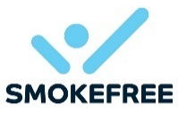Figure 1: SmokeFree NHS | SmokeFree NHS | NHS (2020) explains that this campaign is put into place to help individuals to stop smoking, they explain that the reason why the individual should stop smoking because it will improve their health, their family’s health and saves the individual money.
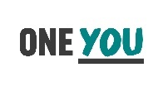  Figure 2: One You – Drink Less | One You – Drink Less | Public Health England (2020) explains that this campaign is put into place to help encourage the individuals who drink alcohol excessively to take control of their own health to help them to have a healthier lifestyle due to stop drinking so much or all together.
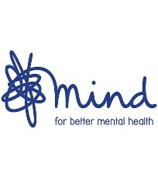  Figure 3: Mind | Mind | Mind (2020) explains that this campaign is put in place to help individuals with mental health issues. Mind campaign has aimed to raise awareness of the importance of mental health and to encourage individuals suffering from mental health to seek help. Mind (2020) aims is to work with other organisations to promote the issue further.
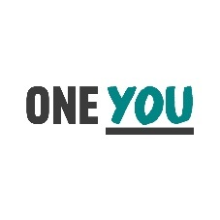  Figure 4: One You – Sexual Health | One You - Sexual Health | Public Health England (2020) explains that this campaign is put into place to raise awareness to people on how important it is to look after their sexual health. This is because if their sexual health is affected then it can then also lead to their mental health worsening. Public Health England (2020) spreads awareness about sexual health, STIs, Contraception, planned/unplanned pregnancy, and where individuals can go to help them with these issues.
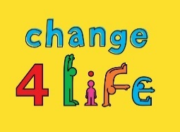  Figure 5: Change4Life | Change4Life | Change4Life (2020) has two campaigns, one aimed at children and then the other is aimed at adults. The campaign shows awareness that in this day and age, people are less active due to TV and Computers, etc, and also eat more of the unhealthy fast foods. The campaigns aim to make people aware of the health issues they can get if they stay the lifestyle they are having. Change4Life (2020) also promotes how the whole family can have a healthier lifestyle with the different ways they can eat healthy and different activities they can do for exercise.

Research used to conduct
WHO (2012) explains that when planning to promote a health campaign that there are different stages that must be taken to make sure the campaign becomes as effective as possible. Without taking these the campaign will not be effective. WHO (2012) explains the steps to follow are;
- Look at who the target audience is and what partners and other organisations that can be worked with.
- Make sure there is a relevant key message about the campaign.
- Mobilize the community
- Plan events that people can get involved with.
- Prepare materials that the target audience will understand.
- Make a way for the campaign to be seen on media and to be easily accessible.
- To make a way to be able to monitor the campaign, what results are being gotten from it, how the events are going, how the media pages are going.
The Health Communication Unit (2007) agrees with this but also adds some more points, that the campaign should use commercial and social marketing for them to increase the effectiveness of the campaign to work. Another point that should be taken into consideration when creating the campaign would be to make sure that the existing knowledge of the topic that the targeted audience would know is still included in the campaign. The Health Communication Unit (2007) explains that goals and objectives should always be set and to be achieved within a reasonable amount of time. And the last step from them would be to also develop the message further, this is to also keeping the audience interested in the campaign because if it stays the same this could lead to the audience being bored of the campaign and for the campaign to just end.
Upp B2B (2017) explains that there is also a seven-step model that campaigns should use;
- Set Objectives: This is a key influence to start the campaign off and to make sure that it is effective and is everything it should be.
- Set a budget: This is where the campaign should consider how long it should be run for and to work out what the audience and marketing price should be and how much it will be to run for the time wanting.
- Market, audience and competition: understand the context of what market, competition, and audience are, to make sure that the campaign is so successful.
- Messaging: what is relevant to the campaign to share the message to the audience.
- Creative Platform: this is the part of the campaign that makes it come realistic and to life. This is where the campaigners have to make sure that the presentation of the campaign is correct if it will attract the correct audience if it is sending the right message across and effectively.
- Campaign plan: this is where all the planning is put together, where the campaign is looked at, marketing, audience and the budget is all looked together to make sure it is all working and is cost-effectively for was planned.
- Review and adjust: this is where the campaigns all sit down together look at the campaign as a whole review of what is happening and to see if anything needs to be changed, taken out or added.
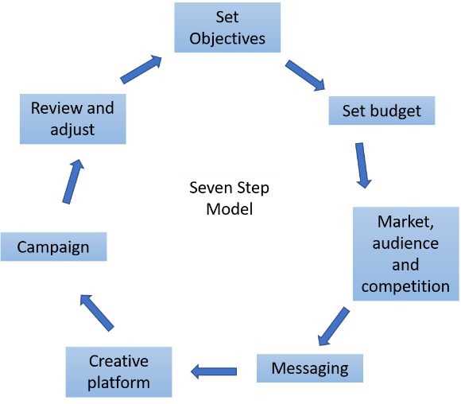
Demographic
Duncan (2019) explains that campaigns use demographics to target a specific target audience to make sure they get their awareness across correctly. For the demographic audience to be targeted correctly, the campaigners need to consider the audiences they are aiming for would be the individuals;
- Age
- Sex/gender
- Generation
- Sexual orientation
- Marital status
- Nationality
- Income
- Education level
- Occupation
- Religion
Duncan (2019) explains that with all these factors being put into account means that the campaign will be more effective.

Approaches
Encyclopedia (2019) states that public health campaign has different types of communication strategies to make sure that their point is being put across to make people aware. The campaigns also have different activities that the specialists in the campaign put together which is relevant to the health information they are promoting to the correct groups of people.
The Health Communication Unit (2007) explains that their three main approaches should be used when trying to communicate the campaign to promote it effectively and that all three approaches link together.
The first approach The Health Communication Unit (2007) discusses is the media. This is because the campaign can get across to the reader in an interpersonal communication which has been found to be the most effective way. With this, individuals can have the option to send messages and can share with others their problems and what they have learned and helping others.
Another approach is interpersonal communication. This would require more participation and feedback. Interpersonal communication is when there is information being shared between many different people. With this communication, it helps to understand how people use verbal and non-verbal ways to be able to complete their goals. For the campaigns, this approach would be more audio-visual and would serve as a better aid. Multimedia could be used to employ this approach. [The Health Communication Unit (2007)]
Lastly, the other approach being events for the campaign, this type of approach will reach a large amount of people in one place to learn and discuss the subject of the campaign all with the same interest and opportunities for the targeted audience to be involved. To be able to promote this approach, the campaigners would use media to promote that the event is going on, when and where, and the interpersonal communication will also help to be able to promote the event.
Tones (1986) explains that the goal of these approaches to promote health education would be persuading. With this goal being met, it would mean that the campaign can persuade individuals that their lifestyles are affecting the health issue. The campaign can also persuade that there are ways to overcome the issue to make their health and lifestyle better.

Problems and how to solve them
Reality Check Team (2018) has done research on four different campaigns to see if their promotion is working or not.
Adult Obesity in England
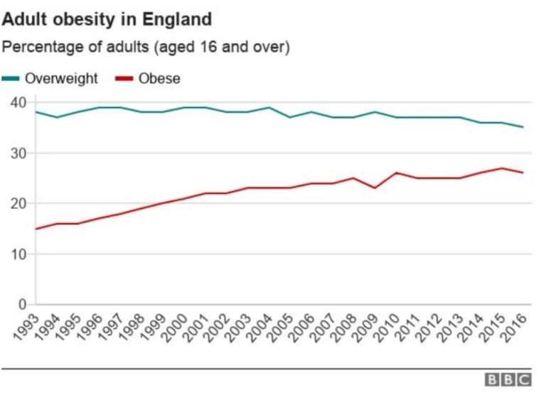
Figure 6: Adult Obesity in England
Reality Check Team (2018) explains that the chart above shows the percentage of adults from the age of 16 and over, who are either overweight or obese. This chart shows 5% of people who are classed overweight percentage has not changed much in the 23 years [1993-2016]. However, the percentage of adults who are obese has increased within this period by 11%. This chart explains that two-thirds [61%] of the population who are living in England are either overweight or obese. Since 1993 the percentage has gone up by 53%. Even though everyone is aware of this health issue, the campaigns have not worked to tackle this problem.
Adults Five-a-day
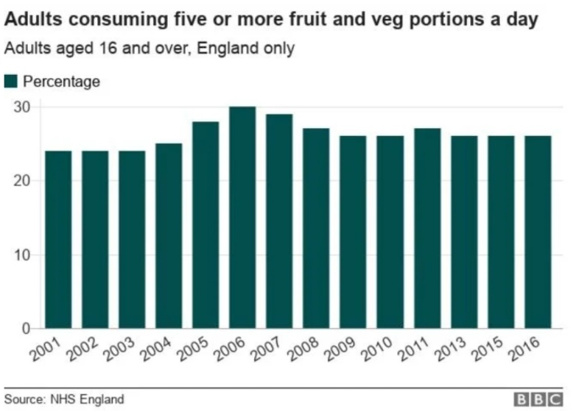
Figure 7: Adults five-a-day
Reality Check Team (2018) explains that the chart above shows that this campaign has been working slightly to spread awareness. The government has been urging individuals to have their five portions of fruit and vegetables since 2003. Looking at this chart you can see then between 2005-2009, mainly 2006, people were taking it seriously as the percentage increased by roughly 6%, however, since then it has decreased slightly by 4% but it is still higher than what it was 13 years ago (2016). Reality Check Team (2018) states that with this statistic, three out of four individuals are not eating their 5 a day every day. The public has been listening to this campaign, but not as effective as it was planned to be.
150 Minutes a week
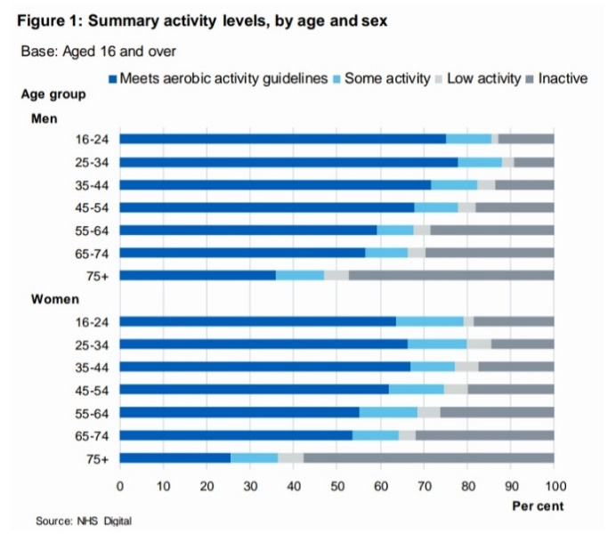
Figure 8: 150 Minutes a week Adults
Reality Check Team (2018) explains that the chart above shows that during 2016, men between the age of 25-34 were the ones who exercised the most throughout the year. However, this chart shows that during 2016, 66% of men over the age of 19 were meeting the guideline suggestions of exercise a week, which is no different from the results that were in 2012. Reality Check Team (2018) also explains that during 2016, the same age group but in women who were meeting the guideline suggestions were at 58% which has gone up by 2% since 2012. Again, this shows that the campaigns are not being listened too.
Smoking
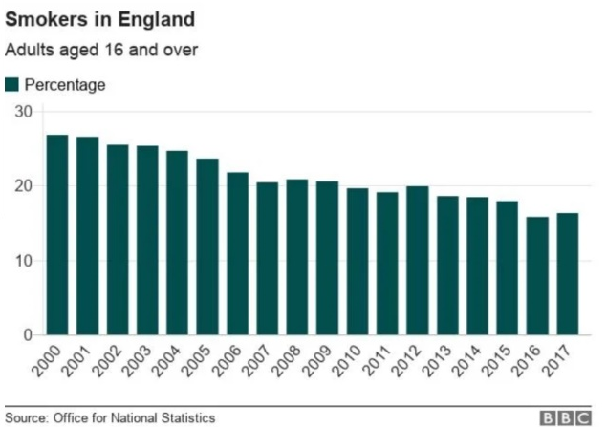
Figure 9: Adults Smoking in England
Reality Check Team (2018) explains this campaign is the more successful campaign out of the four that were looked at. This is mainly due to when in 2007 the government banned smoking in and workplaces and enclosed public places. Within the 17 years of this chart, it shows that smokers in England have decreased by roughly 10%. This shows that this campaign is working, this being due to the ban in certain areas and the awareness of all the ill health complications they can get from smoking, again it has not changed by much as they wanted but it is slowly getting there.

Solving the problems of these campaigns and issues
To tackle these problems, the campaigns should work harder to show awareness, even starting at early age children. The children will know from the start all the health risks they could face if they became obese, smoked, did not eat their 5 a day and if they do not get their recommendation time of exercise a week.
Another way to tackle these problems could be that the government puts bans on smoking in more areas. Increasing the price of cigarettes and fast foods so that smokers think more about spending so much money on them and maybe quit smoking, and for the fast food to be more expensive so people think more if they really need the food or if they are just buying and eating it for the convince of it

Behavioural models
There are 4 different types of behavioural change models stated by Taylor et al (2006) which are known as the Health Belief Model (HBM), Theory of Reasoned Action (TRA), Theory of Planned Behaviour (TPB) and Trans-Theorical Model (TTM).
Health Belief Model (HBM)
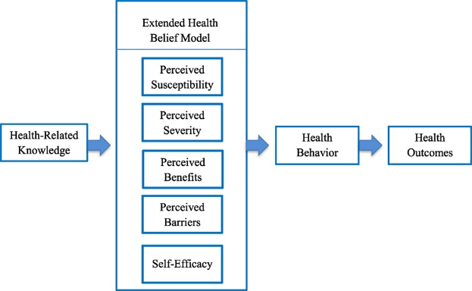
Figure 10: Health Belief Model
Rosenstock et al (1998) explain that the Health Belief Model has three classes of factors put into place so that the health-related issue depends on these. The three being;
- The existence of enough motivation to make health issues noticeable or relevant.
- The individual is vulnerable to health issues. This is often seen as a threat. How serious the problem is.
- This belief helps with recommendations on how to prevent the health issue and shows how to overcome the barriers that need to be met in order to recover.
Theory of Reasoned Action (TRA)
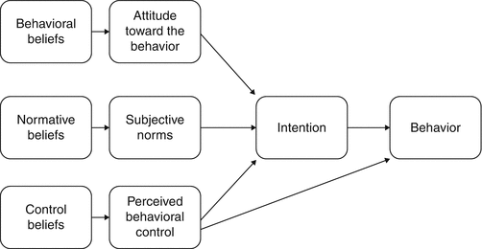
Figure 11: Theory of Reasoned Action
Luxton (2016) explains that the Theory of Reasoned Action is an individual’s behaviour is caused due to their intention to perform the behaviour themselves. There are three things that determined due to the individual’s behaviour, this being their;
- Attitude towards a specific behaviour
- The subjective norms
- Perceived behavioural control
Luxton (2016) explains that the more positive attitude the individual has towards the subjective norms and that’ll mean the greater the individual’s perceived control, meaning the intention of the individual’s behaviour will be stronger.

Theory of Planned Behaviour (TPB)’s behaviour
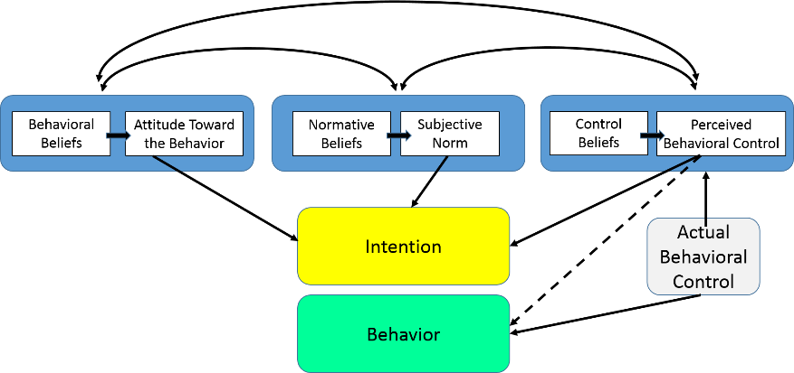
Figure 12: Theory of Planned Behaviour
LaMorte (2019) explains that there are six different concepts that have an individual will actual control on their own behaviour, such as:
- Attitudes: the performance of the individual behaviour will be considered due to them being interested or not at the time.
- Behavioural intention: this is to do with the motivational influence on the individual.
- Subjective norms: this is the approve or disapprove and to whether their peers and beliefs and how important it is.
- Social norms: this is due to the group of people individuals are part of, and what is seen as a social norm.
- Perceived power: this is to do with the facilitate or impede performing.
- Perceived behavioural control: this is to do with the ease or difficulty to preform the behaviour of interest.
Trans-Theorical Model (TTM)
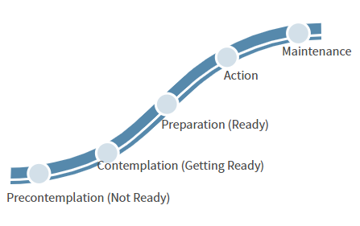

Figure 13: Trans-Theorical Model
Pro-Change Behavior System, Inc (2020) explains that the Transtheoretical Model uses the Stages of Change to make sure that the processes of the behavioural change. In the Stages of Change, there are 5 different stages that need to be followed to be able to succeed.
Pro-Change Behavior System, Inc (2020) explains these steps;
- Precontemplation, which is when there are no intentions to act in the foreseeable future, normally is measured within six months.
- Contemplation, is the time where individuals try to change within this six-month period, where they are also aware of the pros and cons of changing.
- Preparation, is where the individuals will plan and intend to take the action within the next month.
- Action, is the action stage where the individuals make specific alterations within their lifestyles from the past six months.
- Maintenance, is the stage where individuals have made their adjustments and working on a way so that they do not prevent the relapse of it happening again to them.

References
Change4Life. (2020). About Change4Life. https://www.nhs.uk/change4life/about-change4life Accessed January 2020
Duncan, A. (2019). Definition of Demographic and Used in Advertising. https://www.thebalancecareers.com/what-are-demographics-and-how-are-they-used-38513 Accessed January 2020
Encyclopedia. (2019). Public Health Campaigns. https://www.encyclopedia.com/media/encyclopedias-almanacs-transcripts-and-maps/public-health-campaigns Accessed January 2020
LaMorte, W. (2019). The Theory of Planned Behavior. http://sphweb.bumc.bu.edu/otlt/MPH-Modules/SB/BehavioralChangeTheories/BehavioralChangeTheories3.html Accessed January 2020
LiveLifeWell. (2020). Campaigns & Events. https://www.livelifewell.org.uk/campaigns-and-events/ Accessed January 2020
Luxton, D, D. (2016). Artificial Intelligence in Behavioral and Mental Health Care. Acedemic Press: Oxford
NHS. (2020). Why Quit? https://www.nhs.uk/smokefree/why-quit Accessed January 2020
Public Health England. (2020). One You – Drink Less. https://campaignresources.phe.gov.uk/resources/campaigns/44-one-you Accessed January 2020
Public Health England. (2020). One You – Sexual Health. https://www.nhs.uk/oneyou/for-your-body/sexual-health/ Accessed January 2020
Mind. (2020). A history of mind. https://www.mind.org.uk/about-us/what-do/our-mission/a-history-of-mind/ Accessed January 2020
Pro-Change Behavior Systems, Inc. (2020). The Transtheoretical Model. https://www.prochange.com/transtheoretical-model-of-behavior-change Accessed January 2020
Reality Check Team. (2018). Reality Check: Are public health campaigns working? https://www.bbc.co.uk/news/health-4609728 Accessed January 2020
Springston, J, K. (2005). Encyclopedia of Public Relations. Sage Publications, Inc: London
Taylor, d., Bury, M., Campling, N., Carter, S., Garfield, S., Newbould, J., and Rennie, T. (2006). A review of the use of the Health Belief Model (HBM), the Theory of Reasoned Action (TRA), the Theory of Planned Behaviour (TPB), and the Trans- Theoretical Model (TTM) to study and Predict health related behavioural change. https://nice.org.uk/guidance/ph6/resources/behaviour-change-taylore-et-almodels-review2&ved=2ahUKEwi7nvk8jnmAhWUecAKHXw7BYMQFjAOegQIAHAB&usg=AOvVaw1m7ygNjNeHWOIaF-CwMqTo Accessed January 2020
The Health Communication Unit. (2007). Overview of health communication campaigns workbook. Toronto, ON: the University of Toronto, Dalla Lana School of Public Health.
Tones, B, K. (1986). Health education and the ideology of health promotion: a review of alternative approaches. Health Education Research. Theory and Practise 1(1) 3-12
Upp B2B. (2017). 7 Simple steps to campaign planning. https://www.uppb2b.co.uk/insights/strategy/7-simple-steps-campaign-planning/ Accessed January 2020
Williams, G. (1984) Health Promotion – caring concern or sick salesmanship? Journal of Medical Ethics. (10) 191-195
World Health Organization. [WHO]. (2020). Your World Health Day Campaign – step-by-step planning. https://www.who.int/world-health-day/2012/toolkit/campaign_planning/en/ Accessed January 2020

Figure references
Figure 1: SmokeFree – https://www.google.com/search?q=smokefree+nhs&source=lnms&tbm=isch&sa=X&ved=2ahUKEwjP59romvnmAhVrQkEAHSPeDV0Q_AUoAnoECAsQBA&biw=958&bih=959#imgrc=4_B1si8lsmEKBM: Accessed January 2020
Figure 2: One You – Drink Less: https://www.google.com/search?biw=958&bih=959&tbm=isch&sa=1&ei=rYUYXqaYDrGWjLsPiKuB6AE&q=one+you+drink+less&oq=one+you+drink+less&gs_l=img.3..0i24.141976.144460..144562...0.0..3.643.5202.5j1j2j1j2j5......0....1..gws-wiz-img.......0j0i8i30j0i67j0i5i30.UvFKJgeNByo&ved=0ahUKEwjmovrtmvnmAhUxC2MBHYhVAB0Q4dUDCAc&uact=5#imgrc=qgRwhj71zVEoJM: Accessed January 2020
Figure 3: Mind: https://www.google.com/search?biw=958&bih=959&tbm=isch&sa=1&ei=oYYYXvyzGtCHjLsPzp2Q-Ac&q=mind+campaign&oq=mind+campai&gs_l=img.3.0.0j0i5i30j0i8i30j0i24l2.1533.2411..3947...0.0..0.79.459.9......0....1..gws-wiz-img.......0i67.o8l7ADCUJ48#imgrc=JafkGfd9mI6vTM: Accessed January 2020
Figure 4: One You – Sexual Health: https://www.google.com/search?biw=958&bih=959&tbm=isch&sa=1&ei=poYYXv7UA5C2UtmtqoAG&q=one+you+sexual+health&oq=one+you+sexual+health&gs_l=img.3...84131.91057..91172...6.0..1.260.2922.20j7j3......0....1..gws-wiz-img.......0j0i7i30j0i8i30j0i24j0i67j0i10.76aujivYSTc&ved=0ahUKEwj-v83km_nmAhUQmxQKHdmWCmAQ4dUDCAc&uact=5#imgrc=qgRwhj71zVEoJM: Accessed January 2020
Figure 5: Change4Life: https://www.google.com/search?biw=958&bih=959&tbm=isch&sa=1&ei=AYcYXs24Mf6fjLsP7Yyo-AQ&q=change4life&oq=change4life&gs_l=img.3..0l10.71009.75215..75344...0.0..4.519.3587.18j1j2j2j2j1......0....1..gws-wiz-img.....0..0i67j0i131j0i131i67.mgwW7hagVXo&ved=0ahUKEwiNva2QnPnmAhX-D2MBHW0GCk8Q4dUDCAc&uact=5#imgrc=sbqWh8lB3vYxiM: Accessed January 2020
Figure 6: Adult obesity in adults: https://www.bbc.co.uk/news/health-4609728 Accessed January 2020
Figure 7: Adults five-a-day: https://www.bbc.co.uk/news/health-4609728 Accessed January 2020
Figure 8: 150 minutes a week: https://digital.nhs.uk.uk/data-and-information/publications/statistical/health-survey-for-england/health-survey-for-england-2016 Accessed January 2020
Figure 9: Adults smoking in England: https://www.bbc.co.uk/news/health-4609728 Accessed January 2020
Figure 10: Health Belief Model https://www.google.com/search?q=health+belief+model&rlz=1C1GCEB_enGB883GB883&source=lnms&tbm=isch&sa=X&ved=2ahUKEwiHt__4nPnmAhXLa8AKHYDfCSEQ_AUoAXoECBQQAw&biw=958&bih=959#imgrc=MAFP5EnHgUe2ZM: Accessed January 2020
Figure 11: Theory of Reasoned Action. https://www.google.com/search?q=theory+of+reasoned+action%5D&rlz=1C1GCEB_enGB884&source=lnms&tbm=isch&sa=X&ved=2ahUKEwiHqtmvwIXnAhVTolwKHU5IAqgQ_AUoAXoECBMQAw&biw=896&bih=959#imgrc=SnPzmVNhcISbDM: Accessed January 2020
Figure 12: Theory of planned behaviour. http://sphweb.bumc.bu.edu/otlt/MPH-Modules/SB/BehavioralChangeTheories/BehavioralChangeTheories3.html accessed January 2020
Figure 13: Trans-Theorical Model. https://www.prochange.com/transtheoretical-model-of-behavior-change Accessed January 2020

