

Programme:
Master of Business Administration
Module:
Financial Management [Module code: LCMB7002]
Module Lecturer:
Dr. Shengfeng Mei
Assignment Title:
Strategic CFO Challenge[Financial Report]
Company Name:
Toyota Motor Corporation
Submitted by:
[Muhammed Salim]
Student ID: [2518573]
Submission Date: 24 April 2026

Contents
Introduction 4
Section 1: Financial Health Check 5
1.1 Overview of Financial Performance 5
Revenue Trends 5
Profit Trends 5
1.2 Ratio Analysis 6
a) Profitability Ratios 6
b) Liquidity Ratios 6
c) Efficiency Ratios 7
d) Gearing (Leverage) Ratios 7
e) Investment Ratios 8
f) Cash Flow Analysis 8
1.3 Trend Analysis 8
Strengths 8
Weaknesses 9
Threats 9
SECTION 2: Working Capital Management 10
2.1 Cash Operating Cycle 10
2.2 Evaluation of Efficiency 10
2.3 Improvement Strategies 11
a) Hybrid inventory model 11
b) Supplier Renegotiation 12
c) Faster Receivables Collection 12
2.4 Financing Options 12
Short-Term Financing 13
Long-Term Financing 13
Comparison: Cost, Risk, and Flexibility 14
SECTION 3: Strategic Financial Restructuring Plan 15
3.1 Identified Problems 15
3.2 Recommended Strategies 15
a) Divestiture 16
b) Equity Injection 16
c) Debt Restructuring 16
d) Strategic alliances / Mergers 17
3.3 Impact Analysis 17
a) Shareholder Value 17
b) Debt Structure 18
c) Operational Flexibility 18
3.4 International & Ethical Considerations 18
a) Currency Risk: 18
b) Inflation: 19
c) Taxation: 19
ESG and CSR Reflection: 19
SECTION 4: Investment Appraisal & Capital Budgeting 20
4.1 Overview of Projects 20
4.2 Calculation Methods 20
4.3 Project Evaluation 21
4.4 Recommendation of One Project 22
4.5 Capital Rationing Decision (£100m Limit) 22
4.6 Non-Financial Factors 23
Conclusion 24
Reference 25
Appendices 29
Appendix A: (Income statement) 29
Appendix B: (Balance Sheet) 30
Appendix C: Cash Flow Statement 30
Appendix D: Ratio Calculations 31

Introduction
Toyota Motor Corporation is a company that manufactures automotive products on a global scale, with a rich brand name and a hybrid motor technology. Toyota operates in several continents, and over the years, it has managed to maintain the same financial results because of its ability to prioritize efficiency, cost leadership, and technological reliability (Mahtani, and Sunil, 2020).
The automotive industry of the world is now in the transition phase of structural change due to the swift transition to electric vehicles (EVs). Governments all over the world are implementing tougher emissions laws, and rival companies are speeding up the investment in EVs. Other firms like Tesla and BYD have achieved a high market share and are increasing competition. Toyota and hybrid technology, despite leading the way in hybrid technology, have also been criticized as being comparatively slower in hybrid to fully electric vehicle conversion, casting doubt on its long-term status in the EV market (Toyota, 2025).
The purpose of this report is to assess the financial health of Toyota during the last five years (2021-2025) based on the financial statement, balance sheet and cash flow statement as attached in Appendix A, B and C respectively, by evaluating ratio analysis. The analysis reveals the main strengths and weaknesses in the level of profitability, liquidity, efficiency, and capital structure. Moreover, there are strategic financial restructuring options that are proposed in the report to increase competitiveness and sustainability. Lastly, investment appraisal methods are used to evaluate future decisions on capital allocation, and make sure that the proposed strategies are in line with maximising shareholder value and long-term financial stability.

Section 1: Financial Health Check

1.1 Overview of Financial Performance

Revenue Trends
The total revenue of Toyota rose to 317,042 million in 2025 compared to 255,817 million in 2021, indicating that it has grown steadily over the long term, even though short-term income patterns vary unpredictably. In 2023, revenue declined slightly, to $274,942m due to disruptions in the global supply chains, especially semiconductor shortages, it bounced back strongly in 2024 and 2025.

Profit Trends
Net Income rose from $21,105m (2021) to $31,450m (2025), though it experienced volatility, particularly a decline in 2023 ($18,140m). Gross Profit rose to 63, 215m (2025) and 45,424m (2021), indicating better cost management and pricing policies. EBIT also followed a similar trend, growing from $20,658m (2021) to $31,651m (2025), with a notable incline in 2023 (Toyota, 2025a).
The drop in 2023 may be explained by:
• Supply chain disruptions
• Rising input costs
• Global economic uncertainty
Nevertheless, the recovery in 2024-2025 implies the efficiency of operations and stabilisation of demand.

1.2 Ratio Analysis

a) Profitability Ratios
The profitability ratios of Toyota show that there is a fairly good, yet fluctuating performance, over the five years. The gross profit margin improved overall from 17.76% in 2021 to 19.94% in 2025, despite a noticeable dip to 16.99% in 2023. This reduction can be attributed to high production costs, especially with the global supply chain disruption and escalated prices of raw materials. Nevertheless, the year 2024 and 2025 recovery indicates that Toyota has been able to put in place cost control measures and pricing strategies (Table 1).
The operating margin (EBIT margin) is no exception and drops to 7.33% in 2023 and then increases dramatically to 11.87% in 2024 and 9.99% in 2025. This shows increased efficiency in operations and control of operating costs following a difficult period (Macro Trends, 2025).
The net profit margin is also resilient, as it shows that in 2021, the net profit margin was 8.25% and in 2025, the net profit margin was 9.92%, with a temporary decline in 2023. This implies that Toyota is very profitable even when it is externally pressured.
ROA and ROE are improving significantly, especially in 2024-2025, with respect to returns. In 2024, ROE reached its highest point of 14.03%, which shows good returns to shareholders. On the whole, Toyota has good profitability, which is backed by effective operations and good positioning in the market (TOYOTA, 2024).

b) Liquidity Ratios
The liquidity situation of Toyota has been improving continuously throughout the period, which means that the company has become more financially stable in the short term. Compared to the current ratio of 1.06 in 2021, the current ratio of this year stands at 1.26, indicating that the company has continued to enhance its short-term liquidity (Table 2).
The quick ratio, which does not include inventory, also rose from below 1 in previous years to above 1 in 2024 and 2025. This shows that Toyota does not depend on inventory to finance its short-term liabilities, thus having a better liquidity position (Toyota, 2024).

c) Efficiency Ratios
Efficiency ratios reveal the efficiency with which Toyota uses its assets and operates. Inventory turnover ratio improved tremendously from 2022 to 2025, with 6.65 times to 8.37, respectively. This means enhanced inventory flow and efficiency in production, which is essential in the automotive industry, where inventory holding costs are high (Table 3).
The receivables days dropped to about 132 days in 2021 to 117 days in 2025, which represented better credit control and quicker cash collection. This promotes liquidity and decreases the risk of bad debts (Toyota, 2025b).
The payables days, however, dropped to approximately 38 days in 2025 as compared to approximately 47 days in 2021. Although it might be an indication of lower supplier relations, it also means that Toyota is paying suppliers faster, and that may strain the cash flows.

d) Gearing (Leverage) Ratios
Toyota has a stable gearing with a debt-to-equity ratio of 1.49 to 1.56, which implies a balanced capital structure and moderate financial risk (Table 4). The company is not over-reliant on debt, which keeps it financially flexible. The interest coverage ratio is very high with a company, between 61 and 111 times, which is very high compared to the normal level (Trading Economics, 2025). This indicates that Toyota is able to make enough operating income to comfortably pay interest. In spite of the fact that the ratio decreased slightly after 2022, it is very high, indicating low default risk. On the whole, the leverage position of Toyota is more than stable, and it allows the company to afford large-scale investments, especially in the development of electric vehicles, without affecting financial stability.

e) Investment Ratios
The earnings per share (EPS) of Toyota demonstrate an overall positive trend, with an increase in earnings per share to 23.73 in 2025, although the earnings per share decreased in 2023 because of the low profitability. This implies a long-term value creation to the shareholders (Table 5). The price-to-earnings (P/E) ratio is very volatile, with a high of 195.07 in 2023, and it indicates high expectations of investors despite the poor earnings (Fusion Media Limited, 2026). The following decrease in 2024 and 2025 portrays a more stable market feeling in line with better financial performance. All in all, Toyota is also a good investment option, as its earnings have been steadily increasing.

f) Cash Flow Analysis
Toyota has a good operating cash flow, with the highest in 2022 and a steady trend since then, which reflects that it has good cash generation in its core business (Table 6). Nonetheless, there is a considerable decrease in the free cash flow, which is expected to hit its lowest point of 1,437 million in 2025 as a result of higher capital expenditure (Yahoo Finance, 2025). This is indicative of high investment in long-term growth projects, such as EV development. Cash flow adequacy ratio is low (0.13- 0.20), indicating that operating cash flow is not adequate to meet capital expenditure, debt, and dividends.

1.3 Trend Analysis

Strengths
Toyota is one company that has a high and solid profitability as one of its strengths. The company has been able to achieve high returns on equity and healthy margins despite the intermittent blips. Secondly, Toyota shows strong creation of cash flow, which contributes to the fact that it can afford to make big investments without relying too heavily on external funding (Nkomo, 2019).

Weaknesses
One of the weaknesses is the variability in profitability, especially the significant drop in 2023. This means that it has been sensitive to external shocks like supply chain disruptions and inflation of costs (Xinyao et al, 2023).
Also, the reduction in days outstanding payables indicates that Toyota is paying its suppliers at a quicker rate, which can adversely affect its cash flow. The pressure caused by high capital expenditure is also evident in the relatively low free cash flow in the year 2025.

Threats
Toyota is exposed to major external threats, especially in the form of increasing competition in the EV market. Other companies like Tesla and BYD are quickly developing their EV models, which may eat away at the market share of Toyota.
The other significant risk is the increase in the cost of production, both in raw materials and energy prices, which can squeeze profit margin. Also, there are further risks of global economic uncertainty, fluctuations in the currency, and regulatory pressure on environmental standards.

SECTION 2: Working Capital Management

2.1 Cash Operating Cycle
Working capital management is also important in evaluating the financial efficiency of the firm in the short-term, especially in terms of the cash operating cycle (Table 7). The cash conversion cycle (CCC) is a measure of the period that a company requires to turn investments in its inventory and other inputs used in its operations into cash inflows as a result of sales.
In Toyota Motor Corporation, the five-year performance of the components of the CCC indicates significant improvements. The inventory days decreased to 43.62 days compared to 54.9 days in 2022, which shows better inventory management and quicker turnover. In the same manner, the days of receivables dropped to 131.85 days in 2021 and 116.65 days in 2025 as an indicator of better customer payment collection. Nevertheless, the value of payables days dropped to 38.34 days in 2025 (compared to 46.68 days in 2021), indicating that Toyota is paying its suppliers faster (Bhattacheryay, 2023).
The CCC, which is the sum of inventory days and receivables days divided by payables days, has been increasing over the years, reaching its highest point of 136.18 days in 2022 and then dropping to 121.93 days in 2025.

2.2 Evaluation of Efficiency
The working capital efficiency of Toyota has been improving slowly, though in some areas, it still needs improvement. The decrease in inventory days is an indication of improved production planning and inventory management, which is especially significant in the automotive sector, where excess inventory can be quite expensive. This enhancement indicates that Toyota has optimized its supply chain and demand forecasting.
In the same way, the decrease in the receivables days is a sign of better credit management and quicker payment of outstanding receivables. This has a positive effect on liquidity since it guarantees faster cash flows (Minh, 2023).
The decrease in payables days, however, might not be totally positive. Although paying suppliers early may help build relationships and may negotiate more favourable terms, it also means that Toyota does not have as much time to use supplier credit, which can strain cash flows.
Overall, the CCC trend is improving and has reduced to 121.93 days in 2025. In spite of this development, the cycle is still quite long, and it means that a lot of capital is still invested in operations. Toyota can also optimise its working capital cycle further as compared to industry expectations.

2.3 Improvement Strategies
To become much more efficient in working capital, Toyota Motor Corporation should focus on more strategic, innovation-driven approaches that would transcend the conventional ones:

Hybrid inventory model
Toyota needs to shift towards a hybrid inventory model that balances efficiency with resilience of the supply chain. Global disruptions (e.g., semiconductor shortages) in the recent past have highlighted risks of ultra-lean systems. Thus, Toyota is able to undertake a strategic buffer stock of critical parts and lean on non-critical parts. Also, AI-driven supply chain risk analytics can be used to predict disruptions and proactively change inventory levels. By incorporating supplier information into a real-time online environment, it would also be possible to make dynamic adjustments in inventory throughout the regions. It helps to minimize the risks of stockout and does not tie up capital in excess, enhancing efficiency and operational stability (Mácsay and Bányai, 2017).

Supplier Renegotiation
Toyota may follow a supply chain financing (SCF) approach, in which suppliers receive funds on Toyota's behalf early, but Toyota repays later. This will enable suppliers to stay in a liquidity position as Toyota enhances its cash position. Also, Toyota can implement performance-based payment systems where suppliers who are cost-efficient, sustainable, or innovative are given better terms. This forms a win-win ecosystem, as opposed to a transactional relationship. Toyota can also consolidate its supplier base to have improved bargaining power since it has a stronger position in the market. Such tactics enhance cash flow without hurting the long-term relationships with suppliers (Wilhelm and Sydow, 2018).

Faster Receivables Collection
Toyota can go beyond the simple credit control and adopt dynamic receivables management systems. An example is the segmentation of customers according to payment behaviour using data analytics to offer individualised credit terms and collection strategies. The high risk customers can be moved to shorter credit periods and the reliable customers are allowed to have flexibility. Moreover, Toyota has the option of securitisation or factoring of receivables, meaning converting receivables into cash instantaneously without having to go through the payment cycles. An increase in the application of blockchain invoicing systems may also enhance transparency and lower uncertainty, speeding up payments. These innovative methods boost liquidity, minimise credit risk, and greatly decrease the cash conversion cycle (Bennet et al., 2011).

2.4 Financing Options
Managing working capital effectively requires not only operational efficiency but also a choice of financing sources. These may be mainly categorized into short-term and long-term, having various implications of cost, risk, and flexibility (Cheng et al., 2014).

Short-Term Financing
Bank Overdrafts
- Flexible and fit short-term requirements, but they are usually charged with variable and comparatively high interest rates.
- Excessive use of overdrafts can cause financial strain and indicate poor cash flow management, and it is only appropriate to serve as an additional source of finance.
Trade Credit
- Trade credit is also one of the major elements of working capital financing, enabling the company to postpone payments to suppliers without explicit interest costs.
- It must thus be handled strategically to achieve a balance between the liquidity gains and the stability of the supply chain.

Long-Term Financing
Bonds (Debt Financing)
- Bonds are a means of reaching massive funding at comparatively fixed and frequently reduced rates of interest as compared to short-term borrowing.
- This type of financing is especially applicable to capital-intensive and long-term investments like technological development or expansion projects.
- It leads to higher fixed financial commitments and interest rate risk that needs to be carefully managed to enable the firm not to become over-levered.

Equity Financing
- Equity financing is a process of raising funds by issuing shares, which becomes a long-term source of funds without the need to pay back.
- Minimizes the financial risk and enhances the balance sheet strength of the company.
- Dilutes current ownership and decreases earnings per share, which can impact shareholder perceptions.
- Equity financing is therefore best suited to strategic investments where long-term growth is a priority more than short-term dilution issues.

Comparison: Cost, Risk, and Flexibility
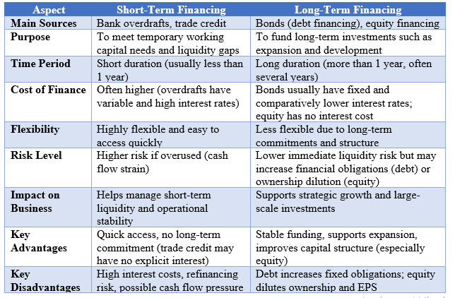

SECTION 3: Strategic Financial Restructuring Plan

3.1 Identified Problems
Toyota is strategically challenged by several financial problems, despite its good financial performance, which may impact its competitiveness in the long run. Among the significant problems is high capital expenditure, which has been on the rise in recent years, to almost 23 billion in 2025. Although this indicates investment in growth, especially in electrification, it has contributed to the decline in free cash flow, which strains short-term liquidity (Andrews et al., 2011).
The second significant barrier is the cost of electric vehicles (EVs) switching. Toyota has historically focused on hybrid technology as compared to other competitors who have been aggressive in their implementation of the EV strategy. This gradual conversion requires huge investment in research and development, battery technology, and manufacturing facilities, which is a burden on the financial resources.
Moreover, Toyota is under pressure on its profit margin due to the escalation of cost of inputs, including raw materials and energy prices, and the global supply chain disruption. The volatility of 2023 shows how the company is exposed to external shocks. Additionally, the adequacy ratio of cash flows is not very good, which shows that operating cash flows are insufficient to finance the investment and financial needs, which increases the reliance on external financing.

3.2 Recommended Strategies
To address these problems, Toyota would have to implement an elaborate financial restructuring strategy, which would result in efficiency, better liquidity, and long-term growth.

a) Divestiture
Toyota should consider divesting non-core or poor businesses to free up cash. This can include the selling of less profitable subsidiaries, redundant manufacturing plants or strategic investments. The cash flows generated through divestiture would be available instantly and can be diverted to high growth opportunities such as EV development and digital innovations (Ushijima, 2009).
Investing in the key competencies can assist Toyota in improving the efficiency of operations and reducing the unnecessary expenses. However, it should be critically examined to ensure that the divestitures will not impact negatively on the strategic positioning in the long term.

b) Equity Injection
The new share issue can provide Toyota with additional finances to invest in the transition to electric mobility. Equity financing will help reduce debt and financial risk, which is particularly essential due to the large financial obligations of the company already (Okanga, 2022).
Equity injection will dilute the existing shareholders, yet it will inflate the balance sheet and raise financial flexibility. It is particularly appropriate when it comes to financing projects that are both large-scale and long-term, like battery manufacturing and EV infrastructure, whose benefits might not be realised in the short term.

c) Debt Restructuring
Toyota can optimise its debt position by refinancing its expensive debt with lower-interest debt. With its good credit profile and interest coverage ratio, the company can negotiate favourable terms of borrowing (Mehri, 2012).
Restructuring of debts can help to lower interest, increase cash flow, and improve financial stability. Furthermore, the maturity of debts can be extended to minimize the short-term repayment pressures and to match financing with long-term investment horizons. Nevertheless, there should be no overdependence on debt to have a balanced capital structure.
d) Strategic alliances / Mergers
The collaboration with other firms can significantly reduce the financial burden of EV development. Toyota can also form strategic alliances with technology companies, battery makers, or even other automobile makers to share the costs, risk and expertise (Takeuchi et al, 2023).
Such partnerships can accelerate the innovation process, enlarge the economies of scale and competitiveness in the dynamic EV market. It may prove particularly handy in battery production or charging systems joint ventures. This strategy will see Toyota not bear all the transformation costs by itself.

3.3 Impact Analysis
It is believed that the financial restructuring strategies will enhance the financial health of Toyota Motor Corporation by enhancing efficiency, lowering financial risk, and sustaining long-term growth.

Shareholder Value
The strategies will probably increase the shareholder values by increasing the profitability and securing sustainable growth. Operational efficiency and returns can be enhanced by divestitures of non-core assets and cost optimisation. Meanwhile, further investment in electric vehicle (EV) technology prepares the company for the future market. Equity financing, though, can dilute the ownership of the existing shareholders in the short run, but it minimizes financial risk and enhances long-term value creation by enhancing the capital base of the firm (Toma et al., 2018).

Debt Structure
The restructuring of the debt, together with the equity injection, will aid in developing a more balanced and sustainable capital structure. Refinancing of high-interest debt would reduce interest costs and enhance cash flow. The moderate level of leverage enables the firm to enjoy the tax benefits but not to take too much risk. This moderating strategy boosts financial stability without reducing the availability of funds to invest in the future (Kim, 2013).

Operational Flexibility
The restructuring plan will enhance the operational flexibility by enhancing liquidity and releasing resources. Divestiture is a source of funds to invest in core operations; strategic alliances allow entry into new markets and technologies. This is critical in the flexibility of adjusting to the swift technological and regulatory changes in the automotive market (Mokudai, 2020).

3.4 International & Ethical Considerations
Being a company with a global footprint in the automotive industry, Toyota Motor Corporation is exposed to a very diverse economic and regulatory landscape, which translates into an intricate financial risk as well as raising ethical demands on the part of stakeholders.

Currency Risk:
The international presence of Toyota also renders it very sensitive to the exchange rate volatility especially due to the changes in the Japanese yen against the major currencies like the US dollar and the euro. In addition to the conventional hedging instruments such as forward contracts and swaps, Toyota can implement a natural hedging approach by synchronizing production and sales in the same regions. As an example, manufacturing in major markets can be localised, minimising the reliance on currency flows. Also, real-time currency pricing strategies can be used to stabilise margins. A well-distributed geographic revenue base will also decrease the risk of concentration and increase financial resilience (Yuan, 2025).

Inflation:
High inflation (notably for raw materials like lithium and steel) is a structural issue. Toyota can consider vertical integration and extended contracts with suppliers to stabilise the input prices rather than resorting to cost-cutting only. Dependency on volatile resources can also be minimized through investing in alternative materials and battery innovation. Furthermore, dynamic pricing models and operational efficiency by automation would be useful to manage the cost pressures and remain competitive.

Taxation:
By conducting business in different jurisdictions, Toyota faces different tax regimes and regulatory requests. Instead of just concentrating on reducing taxation, Toyota must be open and responsible in terms of taxation in accordance with international practices. These involve loyalty with the global structures and transparency in disclosure to achieve stakeholder trust. Ethical tax behaviour is coming to be considered as an element of corporate responsibility and may affect investor confidence and brand reputation (Sallee, 2011).

ESG and CSR Reflection:
Sustainability is now the focus of long-term strategy. Although Toyota is moving towards electric vehicles, it needs to also tackle the presence of concealed environmental and social costs in its supply chain, including ethical sourcing of battery minerals. Environmental impact can be decreased by developing circular economy projects such as battery recycling and reuse. Additionally, increasing transparency by means of ESG reporting and investing in community-oriented projects will increase the stakeholder trust. An active stance toward ESG does not only reduce risk but also generates competitive edge in a market oriented towards sustainability.

SECTION 4: Investment Appraisal & Capital Budgeting

4.1 Overview of Projects
Toyota Motor Corporation is currently looking at three mutually exclusive investment projects, each of which would come with a 50 million starting capital. The cash flow patterns, risk exposure and potential returns of these projects are very different and a good financial analysis is required.
The description of project A is that it has moderate and fluctuating cash inflows over a period of five years, and returns profile is rather stable and uncertain. Project B, in contrast, has estimated and consistent annual cash inflows of 11m and is therefore less risky but might not be as broad as far as growth is involved. The cash flow of project C is lumpy as the returns in the first years are low and in the third and fourth years are high. This structure suggests a riskier, more lucrative investment option which is likely to be linked with long term strategic projects such as innovation or expansion (Bhandari, 2009).

4.2 Calculation Methods
To test the financial feasibility of the projects, different common methods of investment appraisal have been applied (Table 8). Payback Period (PBP) is the time taken by a firm to break even on the initial investment and provides an insight into liquidity and risk. Profitability is calculated based on accounting profits, and the rate of accounting profits is known as the Accounting Rate of Return (ARR), which offers a simple rate of return compared to investment (Brief and Lawson, 2014).
The Net Present Value (NPV) method calculates the present value of the estimated future cash inflows at a discounted rate of 10 percent, which is the time value of money. This is further reduced in this analysis through the Profitability Index (PI), which is a ratio of discounted cash inflows to initial investment, or the value created per unit of investment. Finally, the Internal rate of return (IRR) is the rate at which the NPV would be equal to zero and is used to compare the project returns with the required rate.
Everything is calculated at a discount of 10%, and straight-line depreciation has been used to ensure that all the forms of evaluation are identical.

4.3 Project Evaluation
The financial analysis findings are significant in the comparison of the performance of the three projects. According to the Net Present Value (NPV) standard, all project values are written in the negative, with Project A having a value of -8.69 million, Project B having a value of -8.31 million, and Project C having a value of -2.00 million. This shows that the projects are not able to generate the necessary rate of return of 10%. Project C, however, has the lowest negative NPV, which implies that it is the one that would give the required return and thus is relatively more appealing (Shou, 2022).
When it comes to Payback Period as shown in (Table 9), Project C is the best project, as it recovers its initial investment in 3.6 years as compared to 4.5 years and 4.55 years of Project A and B, respectively. The shorter payback period minimizes risk since the invested capital is recovered sooner, hence this is especially crucial in a volatile economic environment.
The Accounting Rate of Return (ARR) as shown in Table 10 also supports the superiority of Project C as it has a higher rate of 6.00% as compared to the 2.00% of Project B and 1.60% of Project A. This implies that Project C makes greater accounting returns than the amount it cost to invest.
Equally, the Profitability Index (PI) indicates that Project C, which has 0.96, is better than Projects A and B, which have PI of 0.83. Though all the values are less than 1, which means that the projects do not generate the necessary value at the necessary discount rate, Project C once again turns out to be the most advantageous option.
Lastly, the outcomes of the Internal Rate of Return (IRR) indicate that Project C has an IRR of 8, which is higher than 4.5 with Project B and 4 with Project A. Although none of the projects meets the necessary 10% requirement, Project C is the one that is the nearest, which supports its relative appeal.
Project C, in general, is more profitable, has less payback time, and higher returns in all of the evaluation processes compared to the other options.

4.4 Recommendation of One Project
Project C is the best choice of investment based on the overall financial analysis. Although all the projects have negative NPV, Project C provides the best overall performance based on profitability, risk, and generation of cash flow.
Project C offers the greatest returns as it has the best ARR and IRR, and also allows quicker recovery of the initial investment as the payback period is shorter than that of the other projects. Also, its higher cash inflows later in life indicate higher long-term value addition, which is especially significant to strategic investments.
The financial position of Toyota is yet another recommendation that supports this recommendation. The company is highly profitable but is experiencing some challenges, such as decreasing free cash flow, high capital expenditure, and low adequacy of cash flow. In this regard, it will be crucial to focus on the projects that will give faster cash back and better returns.
Strategically, Project C will possibly be an investment in new technologies, including electric vehicles or battery innovation. Considering the growing international demand for sustainable mobility and the necessity of Toyota to reinforce its stance in the EV market, this project is closely related to the long-term strategic goals of the company.

4.5 Capital Rationing Decision (£100m Limit)
With a capital limit of £100 million, Toyota would only be able to implement two out of the three projects. Under these circumstances, capital rationing involves choosing the portfolio of projects that would yield the best returns, and the risk must be tolerable (Beraldi et al, 2012).
According to the NPV and Profitability Index, Project C is the most attractive one, then Project B, and then Project A. The best possible combination, therefore, is Project C and Project B.
The combination provides the highest combined NPV among other alternatives. Whereas Project C offers good growth potential and better returns, Project B offers predictable and reliable cash flows, thereby minimizing the overall risk of investment. Conversely, Project C, coupled with Project A, would add more variability without a significant increase in returns.
The combination of project C and project B thus brings about a good balance between risk and reward. It enables Toyota to enjoy both growth and safe investments and has the ability to improve financial performance within the capital constraint.

4.6 Non-Financial Factors
Besides financial analysis, there are other non-financial relationships that should be taken into consideration during investment decision-making.
The political risk factor is a major factor, especially in the automotive industry, where government policies and regulations may directly affect the viability of the project. Costs and returns may be influenced by changes in environmental regulations, subsidies on electric vehicles, or trade policies (Eneizan, 2016).
Another very important factor is market demand. The world is moving towards electric vehicles, and this trend is gaining pace due to environmental issues and technological developments. The investments in EV-related technologies are very appealing, and projects that are in line with this trend have a high chance of success.
One of the strengths of Toyota is its brand loyalty. A good reputation and loyal client base of the company minimizes the risk of the market and contribute to the successful introduction of new products and technologies. This gives a competitive edge in initiating new ventures.
Lastly, there is the uncertainty in technology. The technological change in EVs is fast, which implies that the investments that are presently made will become outdated if new technologies are developed. This is risky for long-term projects, especially those with high research and development levels.

Conclusion
Toyota Motor Corporation has good financial performance, which is characterised by stable profitability, improving liquidity, and efficient operations. Nonetheless, the company is facing several critical issues, such as excessive capital spending, deteriorating free cash flow, and mounting pressure on the global shift to electric vehicles.
The financial analysis indicates that Toyota has good operating cash flows and low financial risks, but its adequacy in cash flows is weak because of high investment and debt commitments. It is a pointer to the necessity of cautious financial organization and strategic reorganization.
The suggested reorganisation plans, such as divestitures, equity financing, debt optimisation, and strategic alliances, will help Toyota to improve its financial position as well as long-term growth. The strategies increase the shareholder value, boost operational flexibility, and promote sustainable development in a highly competitive industry.
Project C is the best viable decision in terms of investment decisions, since it performs better than others in all the evaluation methods. Project B and Project C combined will be the optimal one in terms of profitability and risk under capital rationing.
All in all, Toyota is poised to grow in the future, but it should also be cautious of its financial assets and change its strategy to fit the changing automotive and electric vehicle market.

Reference
Andrews, A.P., Simon, J., Tian, F. and Zhao, J., 2011. The Toyota crisis: an economic, operational and strategic analysis of the massive recall. Management Research Review, 34(10), pp.1064-1077.
Bhattacheryay, S., 2023. Multinational working capital management a study on Toyota Motor Corporation. International Journal of Finance & Economics, 28(1), pp.236-256.
Brief, R.P. and Lawson, R.A., 2014. The role of the accounting rate of return in financial statement analysis. In The continuing debate over depreciation, capital and income (RLE accounting) (pp. 235-250). Routledge.
Bhandari, S.B., 2009. Discounted payback period-some extensions. Journal of Business and Behavioral Sciences, 21(1), pp.28-38.
Beraldi, P., Bruni, M.E. and Violi, A., 2012. Capital rationing problems under uncertainty and risk. Computational Optimization and Applications, 51(3), pp.1375-1396.
Bennet, E., Selvam, M. and Perumal, N., 2011. Receivable Management of Indian Automakers in a Revived Scenario. Available at SSRN 1791942.
Cheng, H.T., Cheong, K.H., Fok, C.H., Li, Y.T., Sze, W.Y. and Wong, W.C., 2014. Capital structure analysis of Toyota Motor Corporation.
Eneizan, B., 2016. Effects of green marketing strategy on the financial and non-financial performance of firms: A conceptual paper. Arabian Journal of Business and Management Review.
Fusion Media Limited (2026). Toyota Motor Corp Dividend History (7203). [online] Investing.com. Available at: https://www.investing.com/equities/toyota-motor-corporation-dividends.
Kim, W., 2013. The evolution of a corporate system: The case of production and employment structures in the Toyota Group. The Kyoto Economic Review, pp.31-58.
Mácsay, V. and Bányai, T., 2017. Toyota production system in milkrun based in-plant supply. Journal of Production Engineering, 20(1), pp.141-146.
Macro Trends (2025). Toyota Balance Sheet 2005-2021 | TM. [online] www.macrotrends.net. Available at: https://www.macrotrends.net/stocks/charts/TM/toyota/balance-sheet.
Macro trends (2019). Toyota Financial Statements 2005-2019 | TM. [online] Macrotrends.net. Available at: https://www.macrotrends.net/stocks/charts/TM/toyota/financial-statements.
Mahtani, and Sunil (2020). Toyota Motor Corporation | EBSCO. [online] EBSCO Information Services, Inc. | www.ebsco.com. Available at: https://www.ebsco.com/research-starters/business-and-management/toyota-motor-corporation.
Mehri, D., 2012. Restructuring in the Toyota keiretsu during the Asian financial crash: A case study of liberal market reforms and Japanese welfare corporatism. Journal of Organizational Ethnography, 1(2), pp.138-157.
Minh, N.D., 2023. Toyota's production efficiency improvement management: best practice for productivity evaluation and operation improvement. Journal of Advances in Management Research, 20(3), pp.385-408.
Mokudai, T., 2020. Strategic flexibility in shifting to electrification: a real options reasoning perspective on Toyota and Nissan. International Journal of Automotive Technology and Management, 20(2), pp.137-155.
Nkomo, T., 2019. Analysis of Toyota Motor Corporation [online]
Okanga, B., 2022. Radical and incremental innovations as critical leveragers of a firm's financial performance: Best practices from Tesla and Toyota. Universal Journal of Financial Economics, 2(2), pp.1-22.
Sallee, J.M., 2011. The surprising incidence of tax credits for the Toyota Prius. American Economic Journal: Economic Policy, 3(2), pp.189-219.
Shou, T., 2022, July. A literature review on the net present value (NPV) valuation method. In 2022 2nd International Conference on Enterprise Management and Economic Development (ICEMED 2022) (pp. 826-830). Atlantis Press.
Toyota (2024). Annual Report. [online] Sec.gov. Available at: https://www.sec.gov/Archives/edgar/data/1094517/000119312525142326/d925022d20f.htm#rom925022_73 [Accessed 22 Apr. 2026].
Toyota (2025a). 2025 TOYOTA INDUSTRIES CORPORATION. [online] Available at: https://www.toyota-industries.com/investors/item/2025_annual_financial_report_E.pdf.
Toyota (2025b). Toyota Goodwill and Intangible Assets 2010-2025 | TM. [online] Macrotrends.net. Available at: https://www.macrotrends.net/stocks/charts/TM/toyota/goodwill-intangible-assets-total.
Toyota (2025c). Toyota Motor Corporation Official Global Website. [online] Toyota Motor Corporation Official Global Website. Available at: https://global.toyota/en/.
TOYOTA (2024). INTEGRATED REPORT 2024. [online] Available at: https://www.annualreports.com/HostedData/AnnualReports/PDF/NYSE_TM_2024.pdf.
Trading Economics (2025). Toyota Motor | TM - Interest Expense On Debt. [online] Tradingeconomics.com. Available at: https://tradingeconomics.com/tm:us:interest-expense-on-debt [Accessed 22 Apr. 2026].
Takeuchi, I.Y., Ohmae, H.T. and Ichijo, K.K., 2023. Navigating Competition through Alliances: An Analysis of Toyota's Strategy in the Japanese Auto Industry. Journal of Strategic Management, 7(6), pp.1-12.
Toma, S.G.I., Marinescu, P. and Grădinaru, C., 2018. Creating Shared Value in the 21st Century: The Case of Toyota Motor Company. In Value Sharing for Sustainable and Inclusive Development (pp. 155-184). IGI Global.
Ushijima, T., 2009. R&D intensity and acquisition and divestiture of corporate assets: Evidence from Japan. Journal of Economics and Business, 61(5), pp.415-433.
Wilhelm, M. and Sydow, J., 2018. Managing coopetition in supplier networks–a paradox perspective. Journal of Supply Chain Management, 54(3), pp.22-41.
Xinyao, D., Wen, X., Jingjing, X., Xiaohui, W. and Loang, O.K., 2023. Financial and Non-Financial Analysis of Toyota and Ford: A Comparative Study. Journal of Islamic, Social, Economics and Development, 8(52), pp.203-214.
Yahoo Finance (2025). Toyota Motor Corporation (TM) Stock Historical Prices & Data - Yahoo Finance. [online] finance.yahoo.com. Available at: https://finance.yahoo.com/quote/TM/history/.
Yuan, Y., 2025. Toyota Motor’s Exchange Rate Risk Management: Residual Risk and Response Strategies after Forward Hedging. Highlights in Business, Economics and Management, 65, pp.152-157.

Appendices

Appendix A: (Income statement)
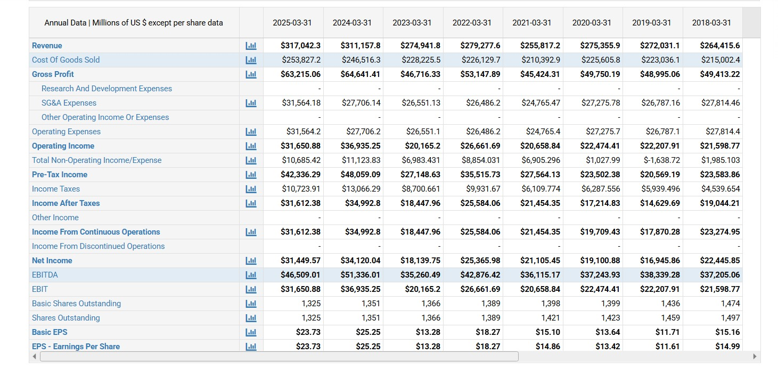

Appendix B: (Balance Sheet)
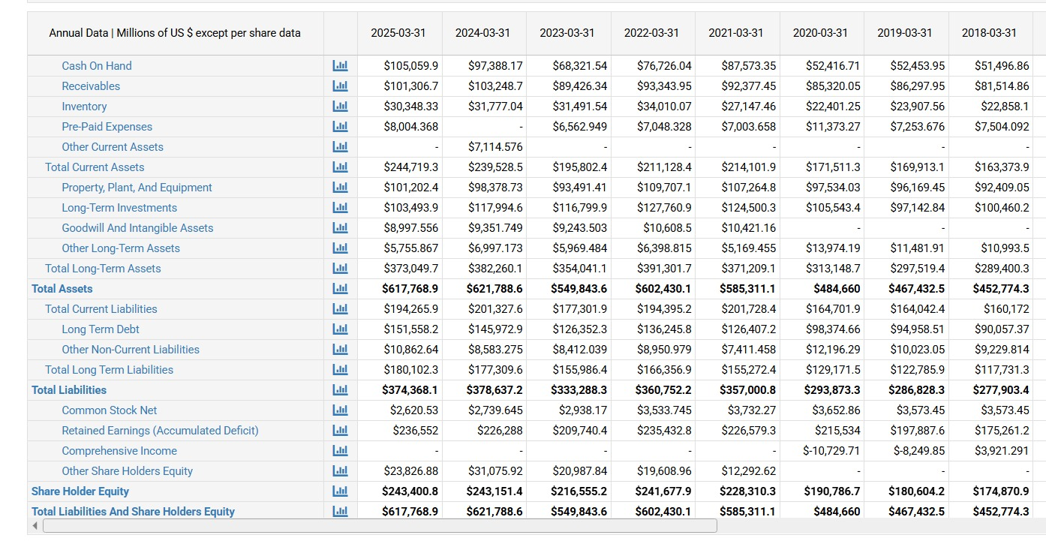

Appendix C: Cash Flow Statement
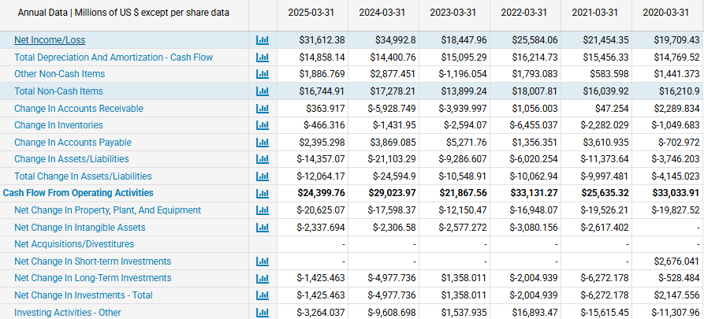
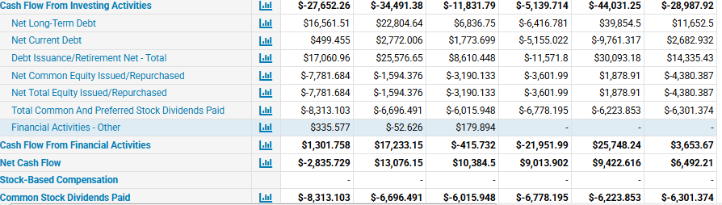

Appendix D: Ratio Calculations
Table 1 Profitability ratios
 | 2025 | 2024 | 2023 | 2022 | 2021
Gross margin ratio | 19.94% | 20.78% | 16.99% | 19.03% | 17.76%
Net profit margin ratio | 9.92% | 10.97% | 6.60% | 9.08% | 8.25%
Return on assets ratio | 5.09% | 5.49% | 3.30% | 4.21% | 3.61%
Return on Equity ratio | 12.92% | 14.03% | 8.38% | 10.49% | 9.24%

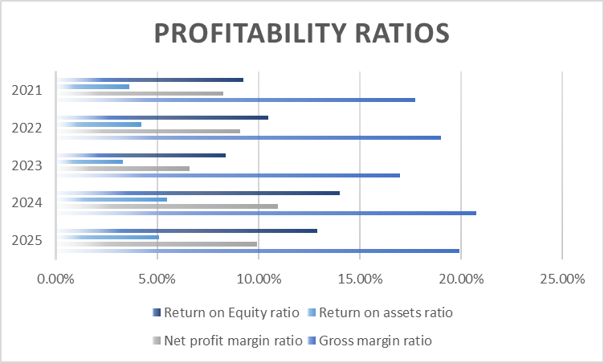
Figure 1 Profitability ratios

Table 2 Liquidity ratios
 | 2025 | 2024 | 2023 | 2022 | 2021
Current ratio | 1.26 | 1.19 | 1.1 | 1.09 | 1.06
Quick Ratio | 1.1 | 1.03 | 0.93 | 0.91 | 0.93

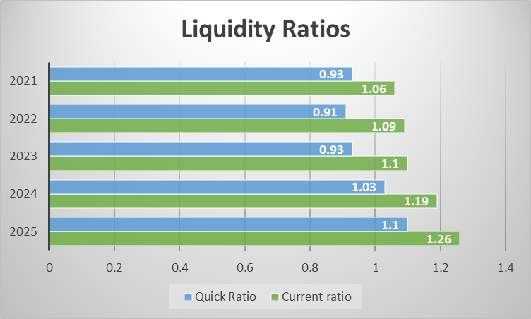
Figure 2 Liquidity ratios

Table 3 Efficiency ratio
 | 2025 | 2024 | 2023 | 2022 | 2021
Inventory Turnover ratio | 8.37 | 7.76 | 7.25 | 6.65 | 7.75
Account receivable turnover ratio | 3.13 | 3.01 | 3.07 | 2.99 | 2.77
Asset turnover ratio | 0.51 | 0.5 | 0.5 | 0.46 | 0.44
payable payment period | 38.34 days | 38.53 days | 45.98 days | 40.86 days | 46.68 days

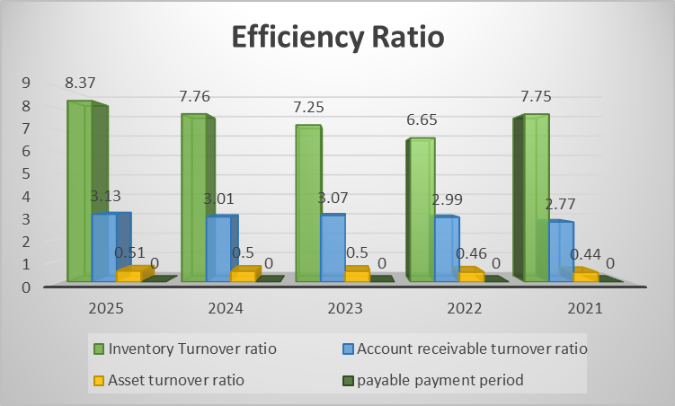
Figure 3 Efficiency ratio

Table 4 Leverage/Gearing ratio
 | 2025 | 2024 | 2023 | 2022 | 2021
Debt to equity ratio | 1.54 | 1.56 | 1.54 | 1.49 | 1.56
Interest coverage ratio | 61.10 | 93.27 | 61.48 | 110.63 | 63.37

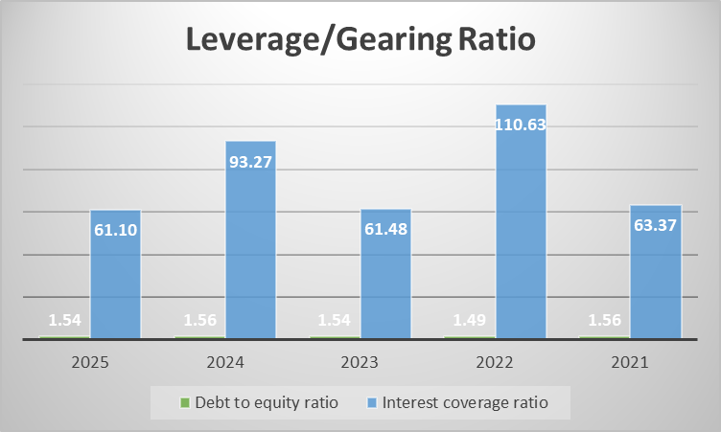
Figure 4 Leverage/Gearing ratio
Table 5 Investment ratio
Investment ratio | 2025 | 2024 | 2023 | 2022 | 2021
Earnings per share | 23.73 | 25.25 | 13.28 | 18.27 | 15.1
Price/Earnings ratio | 141.4 | 124.6 | 195.1 | 99.2 | 139.4

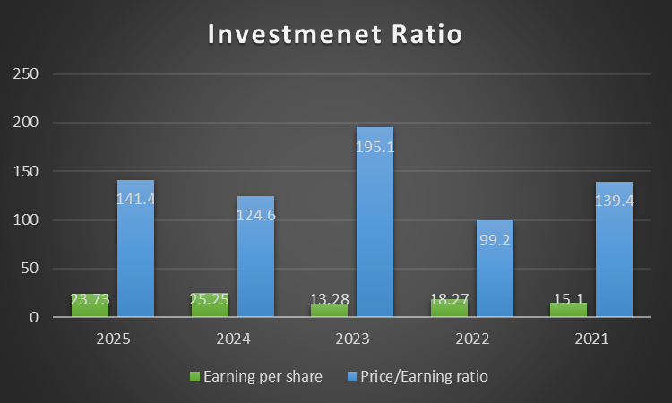
Figure 5 Investment ratio

Table 6 Cash Flow Analysis
Cash Flow Analysis | 2025 | 2024 | 2023 | 2022 | 2021
Operating cash flow | 24400 | 29024 | 21868 | 33131 | 25635
Free cash flow | 1437 | 9119 | 7140 | 13103 | 3491
Cash flow adequacy | 0.13 | 0.17 | 0.15 | 0.2 | 0.17

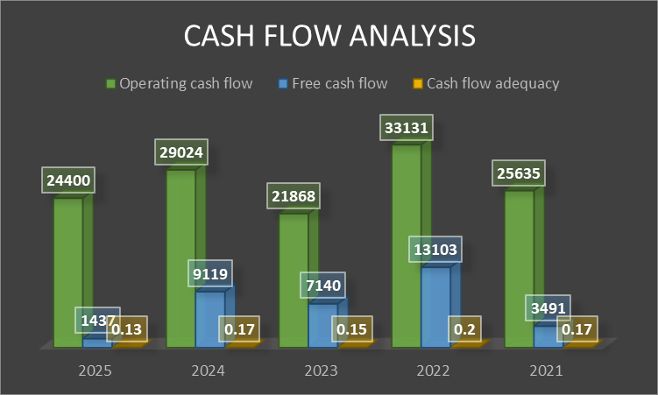
Figure 6 Cash Flow Analysis

Table 7 Working Capital Management
 | 2025 | 2024 | 2023 | 2022 | 2021
Inventory Days | 43.62 | 47.03 | 50.3 | 54.9 | 47.09
Receivable Days | 116.65 | 121.03 | 118.67 | 122.14 | 131.85
Payables Days | 38.34 | 38.53 | 45.98 | 40.86 | 46.68
CCC | 121.93 | 129.53 | 123 | 136.18 | 132.26

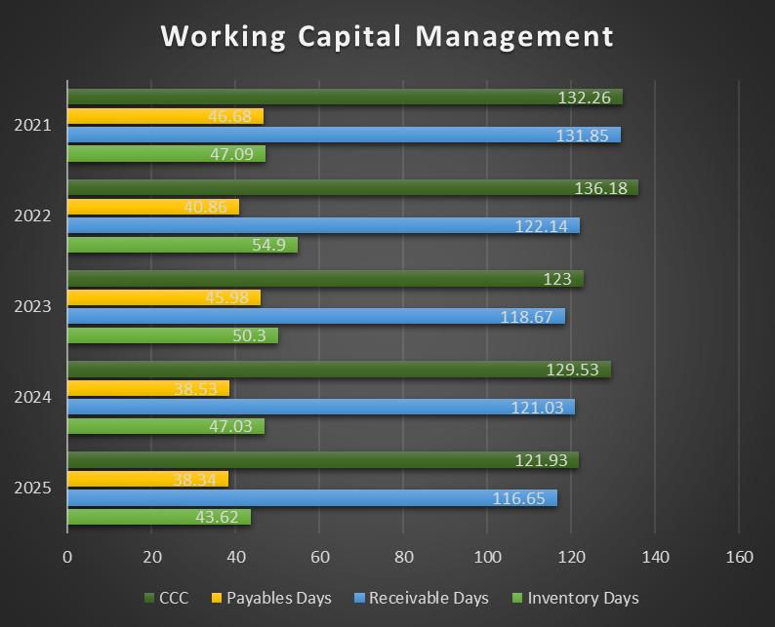
Figure 7 Working Capital Management

Table 8 Investment appraisal and capital budgeting
NPV
Year | Discount Factor (10%) | Cash flow of Project A | Present value | Cash flow of Project B | Present value | Cash flow of Project C | Present value
0 | 1 | 50 | 50 | 50 | 50 | 50 | 50
1 | 0.909 | 10 | 9.09 | 11 | 9.999 | 5 | 4.545
2 | 0.826 | 12 | 9.912 | 11 | 9.086 | 10 | 8.26
3 | 0.751 | 14 | 10.514 | 11 | 8.261 | 20 | 15.02
4 | 0.683 | 10 | 6.83 | 11 | 7.513 | 25 | 17.075
5 | 0.621 | 8 | 4.968 | 11 | 6.831 | 5 | 3.105
Total Present Value |  |  | 41.314 |  | 41.69 |  | 48.01
NPV |  |  | -8.686 |  | -8.31 |  | -2.00

Table 9 Payback Period
Payback Period
Year | Cash flow of Project A | Cum. Cash flow | Cash flow of Project B | Cum. Cash flow | Cash flow of Project C | Cum. Cash Flow
1 | 10 | 10 | 11 | 11 | 5 | 5
2 | 12 | 22 | 11 | 22 | 10 | 15
3 | 14 | 36 | 11 | 33 | 20 | 35
4 | 10 | 46 | 11 | 44 | 25 | 60
5 | 8 | 54 | 11 | 55 | 5 | 65
Payback period |  | 4.5 |  | 4.55 |  | 3.6

Table 10 ARR
ARR
Project | Total Cash Flow | Avg Cash Flow | Profit (–10 dep) | ARR
A | 54 | 10.8 | 0.8 | 1.60%
B | 55 | 11 | 1 | 2.00%
C | 65 | 13 | 3 | 6.00%

Table 11 Profitability Index
Profitability Index
Project | PV | PI
A | 41.31 | 0.83
B | 41.69 | 0.83
C | 48.01 | 0.96

Table 12 IRR
IRR
Project | IRR
A | 4%
B | 4.50%
C | 8%

