Student Self Evaluation Form

This section repeats in brief the common assessment criteria detailed on previous pages. The extent to which these are demonstrated by you determines your mark. Using these criteria, tick the box that best indicates the level of achievement you feel you have achieved with regard to each of them.
Common Assessment Criteria Applied
Common Assessment Criteria Applied | REFER |  | D |  | C |  | B | A
 | OUTRIGHT FAIL | UNSATISFACTORY | SATISFACTORY | GOOD |  | VERY GOOD |  | EXCELLENT
1. Subject Knowledge and Understanding (which includes using research-informed literature and knowledge and understanding of the subject)
2. Intellectual Skills (Analysis)
3. Pedagogic and Professional Applications (Practical Application and Deployment)
4. Key Transferable Skills
PLEASE COMMENT ON AREAS IN WHICH YOU FEEL THAT YOU HAVE PERFORMED WELL | PLEASE COMMENT ON AREAS you feel that you need TO DEVELOP
Used info well. Written well. | More reading, More detail on developing history and science. More linking things together (didn’t have enough words to do the latter two)
Student’s Name | Alyssa Parr | Date | 30/5/18
Student’s Signature | A.Parr

Supporting pupil progress: a detailed analysis of one child’s holistic development, with justification for the next steps in learning.

This study aims to analyse a child’s learning and development and identify the next steps for the child in school. The subjects that will be looked at are Maths, Language, History and Science, and the child’s wellbeing will be looked into too in order to show a holistic view of the child and their learning and development. It is important to use a holistic approach about the development of children because The child in question is a Year 6 pupil in a two form city school in the Swansea district. At the end of 2017 the school was educator to 514 pupils of which 42.5% were entitled to free school meals and 74.5% reached the expected level at the end of KS2 (Mylocalschool.wales.gov.uk, 2017).

The child is in a class of 27 children. The main reasons that this child was chosen for the study is because they were one of the only children that fit the criteria of good attendance in school and being in the trainee’s class for Maths, which is set by ability. As of September 2017 and in terms of additional learning needs, the child’s regular class is made up of one more able and talented (MAT) child, nine children eligible for free school meals, two EAL children, two statemented children (one of which only attends school for a half day per week), four A band and two B band children.

In maths, which takes place for three hour-long sessions per week, the Year 6 classes are split into two sets, and the child is in the lower set which has 22 pupils. The small class size is a benefit for the learning of the pupils, with Princeston University professor Alan Krueger predicting that a smaller class size can lower the achievement gap by over 38% (Haimson, 2010). The child does not have any known additional learning needs and is not eligible for free school meals, but being in a class with so many children that do fit these characteristics will of course have an impact on the child’s learning in terms of the delivery of lessons and classroom management.

Data Collection
Three main methods of data collection will be used in this study. The first is data collected from a short interview with the child, in which they were asked about wellbeing, different teaching styles, activities and resources that they have seen in school and which ones they thought helped them learn the most and the least. This was deemed an appropriate method of data collection as the trainee encourages the children in the class to take responsibility for their learning as much as possible, and although teacher and trainee observations can be very important and show a lot, it is useful to get the child’s perspective on what they think helps them learn, and what they enjoy or do not enjoy in the classroom. The best sort of class is a class where children and adults work together and learn together, about teaching, learning and about each other. A limitation of using a child interview, or “conferencing” as it is referred to by Professor Peter Moss (Moss and Coram, n.d.), as a method of data collection is that the child might not be completely honest through fear of offending the teacher or trainee, and also they might think in their answers less about what helps them learn and more about what they enjoy in the classroom.

The second method of data collection are observations made by the trainee on the child whilst teaching and marking. Observations from lessons were recorded after the lessons, and provide an insight into how the child works during class, which activities they seem more engaged with and how much of the child’s work is independent. Observations were also made on the child’s mood and any aspects of wellbeing were recorded. This method is important as it shows the child’s learning from the viewpoint of an educator, but a limitation of using this method is that during a lesson there are many things going on and many other children to observe, so anything noted in these observations are snapshots of the child’s learning rather than the whole picture. The third data collection method is the annotation of the child’s work. The use of the child’s work provides written evidence of what the child does in class, and can show any progress that is made. The child’s work has also been levelled by the trainee according to the KS2 level descriptors in each of the chosen subjects.

The use of the three data collection methods falls in line with the mosaic approach, which was developed by Alison Clarke and Peter Moss. The mosaic approach includes a variety of different data collection including pupil voice, teacher voice, visible listening and self reflection, all of which can be seen during this study (Clark and Moss, 2011). Each of the methods used has both strengths and limitations, and used alone the data would only scratch the surface of analysing the child’s learning and development, especially on a holistic scale. When used together, the data collected showcases a more rounded view of the child, including the child’s perspective, their educator’s perspective, and examples of the child’s work to support this.

Every effort was made during this study to be as ethical as possible. The child’s name, gender and school are all anonymous and consent was gained by the child and the child’s usual class teacher for them to be used in the study. The study and what would take place was explained in simple terms and language to the child and they were told on many occasions that it was entirely optional, and should they change their mind about taking part that was completely acceptable and they would not be treated any differently as a result of it. It was also explained to the child that they would be kept completely anonymous throughout the study so that they would never be identified by anyone that might read it. After detailing all of this to the child, they wrote on a consent form to show that they understood the anonymity and that a short interview would take place, and that their work would be annotated and used in the study. This can be found in Appendix E.

Analysis of learner

Wellbeing
In order to see a holistic view of the child’s development it is essential to look at the child’s wellbeing in and out of school. Wellbeing is a necessity in order for a child to learn, and it can be observed in a number of ways. For this study, wellbeing has been recorded via classroom observations and from talking to the child. Every morning the class has circle time and the children rate their mood from one to ten, which is really helpful in determining who is not happy at the start of the day, any circumstances that the teacher or class need to be made aware of and how best to work through it and lift the child’s mood. Other observations that were taken in class relate to who the child is friends with, if there is anybody that they do not get on with, and which school tasks they seem to like and dislike.

From these observations, it is clear that the child really enjoys reading, singing and drawing, and often reads or draws during lessons if paper is not taken away beforehand. They are quite shy and quiet and will rarely put their hand up in lesson to answer a question. When chosen to choose a word in Hangman and to be “on” in the game Granny’s Knickers in the past the child has expressed reluctance to play such an up-front role. The child sits on a table with six other children and seems to be good friends with four of them. Their shared interests include drawing. When asked if they are happy in school, the child replied that they enjoy being with their friends but that they get frustrated with other children in the class’s behaviour. Their favourite subject is art, and they enjoy taking part in art related activities such as making posters, timelines and drawing illustrations. In the trainee observations the child has always seemed to be quite content, although they were extremely tired on one occasion after a long night of watching television (8th May), and the occasional “5” being given during check-in when asked to rate how they were feeling from 1-10.

Maths

In maths the child has been levelled as an overall 3a, although with more evidence on topics not yet covered by the trainee there might be arguments to support the child at level 4c. Levelling has been achieved using the national curriculum level indicators, which can be found below. As the trainee has not taught the class for very long there are gaps in the skills that have been observed. The child has demonstrated a variety of skills in maths, but they are also failing to show some important ones such as using their own ideas to find solutions, finding examples and checking that results are reasonable. An example of this in the child’s work, which can be found in Appendix A is that in the work dated 16th May 2018 on multiplying fractions the child had two different answers for 6 x 4, both of which were incorrect.
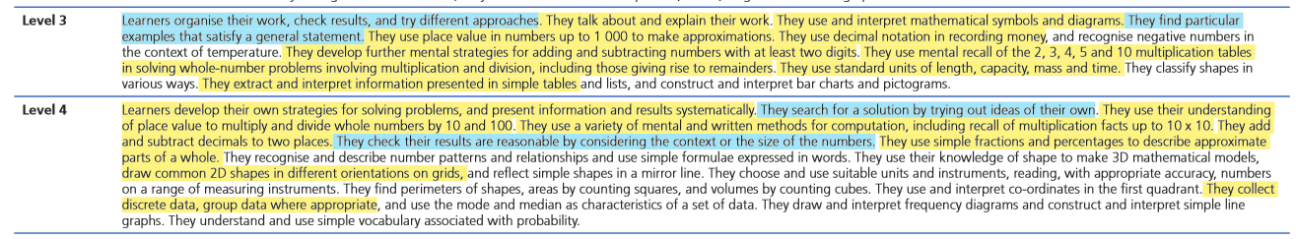
Yellow | The child has demonstrated these skills to the trainee either written or verbally.
Blue | The child has not yet demonstrated these skills to the trainee when given the opportunity.
Blank | These topics have not been covered to the trainee so there is no evidence either way.

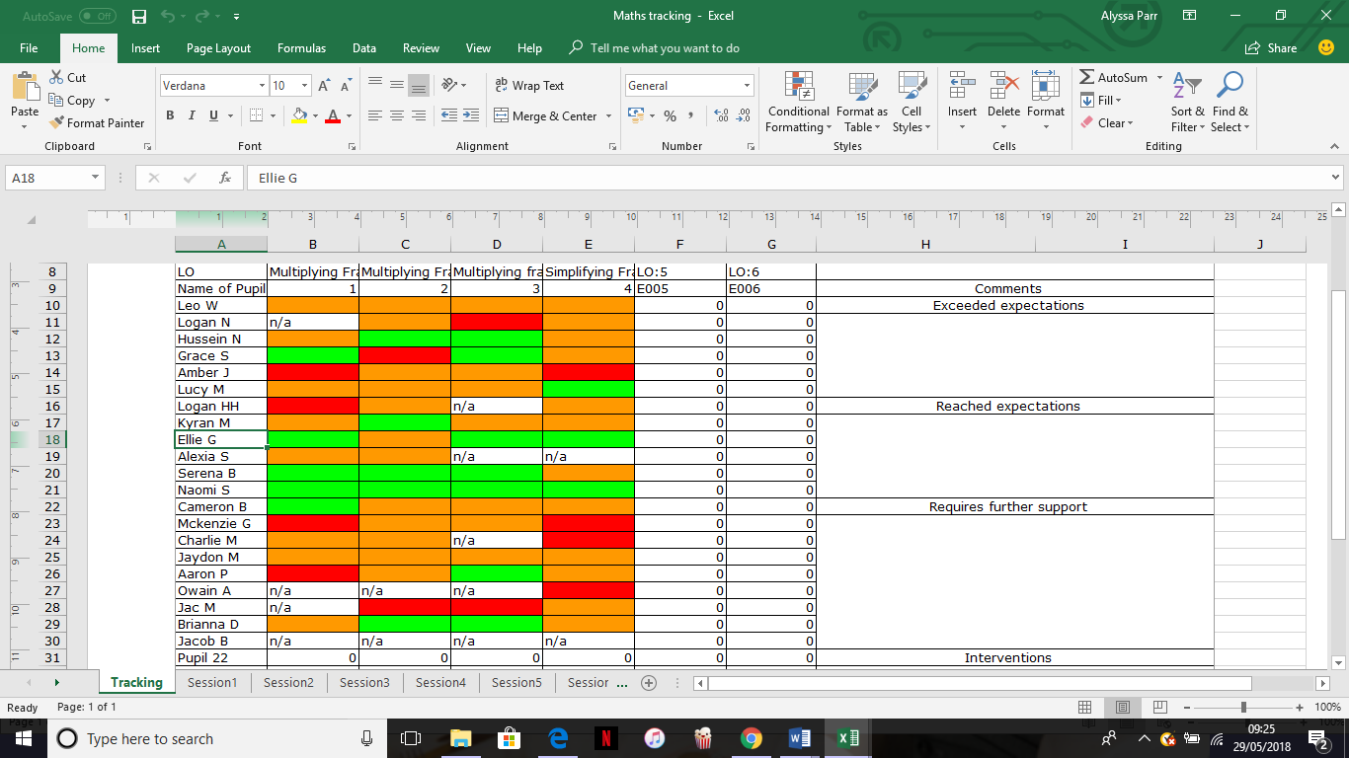
As can be seen by the tracking for the child’s progress in Maths the child exceeds expectations for the majority of these sessions. The tracking indicator show a box for each session, or for carousel sessions there is a box for each task. In these, a green box signifies where the child has exceeded expectations, amber means that the child reached expectations and red means that the child will need extra support to meet the expectations from that session. The four sessions listed were to do with multiplying and simplifying fractions, and the next steps for the child in these sessions was to simplify their answers. In the session that the child did not exceed expectations, they were a part of a focus group on simplifying fractions whilst other children continued on from the previous day’s work. The child found simplifying fractions hard, although they did go back and simplify fractions from the previous lesson successfully. In maths, the child is one of the higher achievers of the lower set. They sit on a table with one other child, who also sits on their table during other lessons. They are quiet but very hard working and picks up different methods of work quite easily but so far has not used previous knowledge to think of their own approaches to methods, but waits for the teacher or other children to talk through it. As with the majority of the class, the attitude of the child towards maths is very negative. If the child comes across something new, they automatically seem to think that it is too hard for them, although with support they usually manage to grasp different concepts and usually gets all work correct, aside from small mistakes such as adding or multiplying the wrong answer. In these cases, the child would benefit from checking their work. During the interview, one of the things that the child mentioned they find helpful is when they are shown “easy ways to work things out” and given tips to make things more simple.

Language
Oracy – 4c
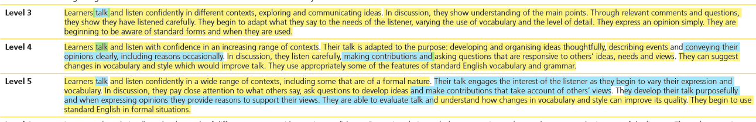
Writing – 4b
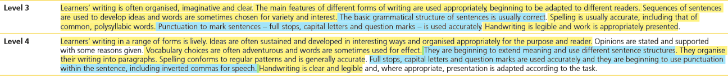
Reading – 5b
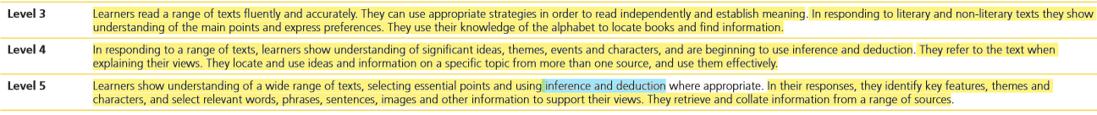
The child’s writing is generally of a good standard across all subjects, with the main target to improve being general improvements such as the correct use of capital letters and punctuation, and to improve spelling of more low frequency words. Generally, handwriting is clear and legible although it is not joined, and sentence structure is usually sound although throughout the retelling of the story Alien Landing (as seen in Appendix B) this is not always the case. The child’s reading is also of a high standard, with the main target to achieve higher being to infer meaning and increase comprehension of different texts. When reading aloud the child uses good expression, and the child can answer different questions about the text and use the text to support their answers. As for oracy, the child struggles with confidence in speaking in front of the class as well as having a quiet voice. The child seems more confident in this if they are doing group work with friends, but can stand on the sidelines during planning with more vocal and assertive children.
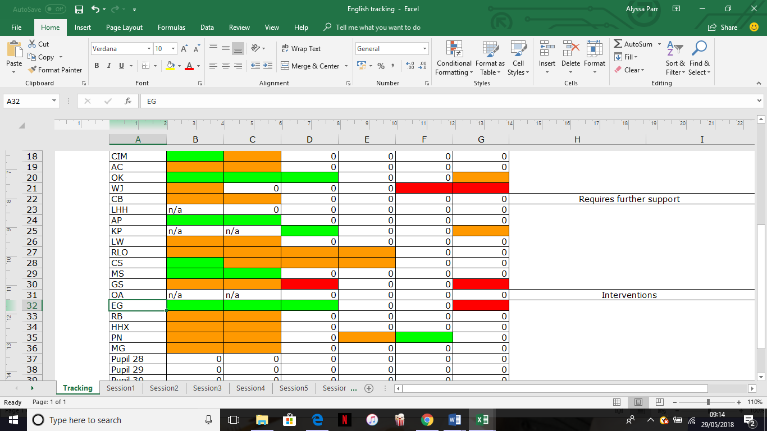

This is the child’s tracking from English. The last four activities were a part of a carousel, so although the work from session 4 and 5 have not been marked yet, the child has completed them. From memory, the child reached expectations on both tasks, which were a plan for the innovation of a story and to complete a spidergramme of key words to describe a new setting for their innovation. It is clear that the child exceeds expectations in some tasks but in others fell below expectations. For the second session, the child’s next step was to work on the correct use of capital letters and punctuation, which is a consistent target for the them. Session 6 was a task on text marking nouns, adjectives and nouns and the child clearly struggled with this. When asked what each of the word classes were the child would answer correctly, for example they would say that a verb is a doing word, but then the child would have trouble applying that knowledge.

History
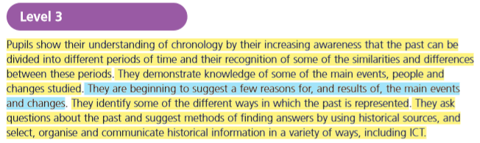
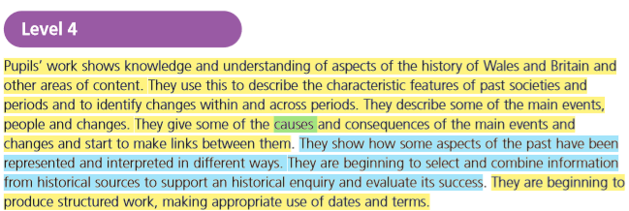
The child has been graded as a 4b in History, and so far has shown a sound understanding of history in their work. Some skills that the child has not demonstrated fully are the ones that show a more in depth analysis of sources and events, for example where the child can recount main events that happened during the WW2 topic currently being covered, they do not yet think about the causes of these events. Similarly, where the child can describe some ways that the past might be represented, i.e. through writing or through images, they do not yet recognise that different aspects of the past might be interpreted in different ways.
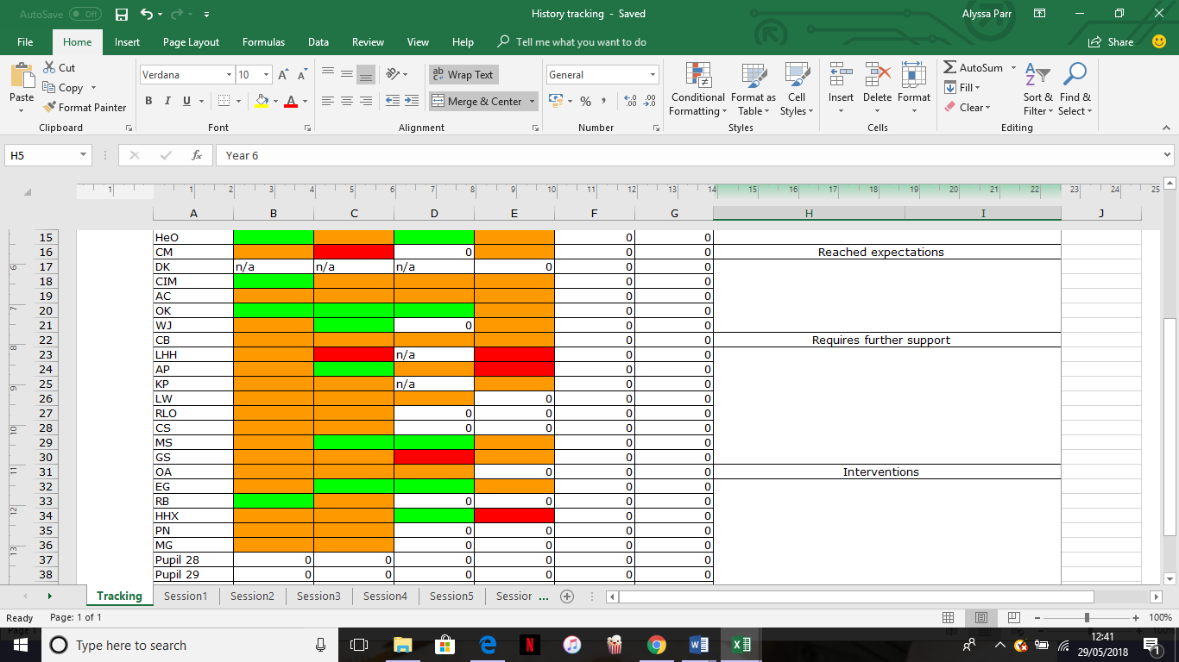

In their written work for history the child does work hard with their peers and tries to be the best that they can be. An example of this is that during session 1 shown in the tracking the child chose the more difficult option of using the atlas to find ally, axis and neutral countries on a blank map of Europe, rather than choosing a map with the countries already listed as most of the class did. In taking control of their own learning and choosing to challenge themselves, the child was able to develop skills that other children in the class might not have developed, and the challenge was able to keep the child motivated and encouraged to do their best. Both the first and second task included creative and artistic skills such as drawing and colouring, which the child enjoys a lot. The third session included research on the Blitz and the child was one of the only children in the class to write in more depth about what happened during the Blitz, showing once again the child’s work ethic.

Science
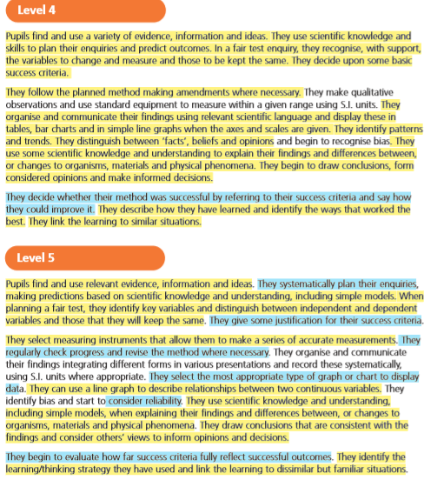
There is missing evidence in the trainee’s work with the child to show certain skills in Science, and these are shown on the level indicator as having no highlight. Some of the skills that have been evidenced will not be found in the Appendix as they were seen in work prior to the trainee’s placement in the class, but certain skills have been noted by the trainee. The child’s level in Science is a 4a, as there is not quite enough evidence to support a level 5.

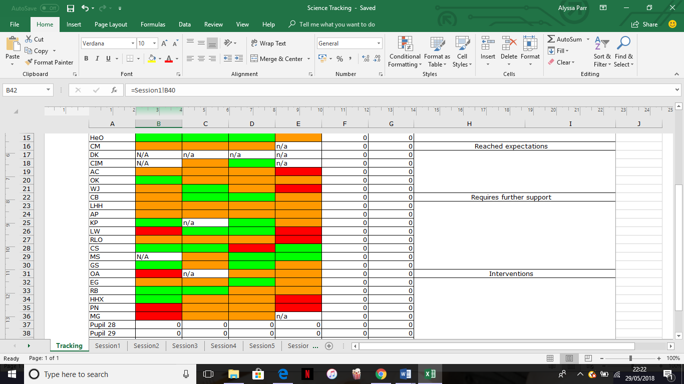
The child has reached expectations in all of their science work since Easter, which has included work on animal adaptation, insect hotels and outdoor learning, food chains and the use of keys. During the first session, the children were asked to research how different animals of their choice were adapted to their habitat, before designing an animal of their own creation and describing what features it might have to adapt to a specific environment. The child researched well, but copied websites word for word rather than trying to put it into their own words. When the child made their own creature the justification and description of different features could have been more detailed, and this happened again during the designing of insect hotels in session 3. When asked to write why the child had chosen to use certain materials in their insect hotel the child wrote that they “chose it because [they] like the design”, rather than trying to justify and explain the use of the different materials.

Next steps
.
A general target for the child in all of their work is to be more independent. As mentioned before, the child is generally very quiet and shy, and can be reluctant to play leadership roles in lessons or do any tasks that will put them in the spotlight. Many of the child’s friends, on the other hand, are full of confidence and can be very vocal, so the child needs to make sure that their work is independent and that even when taking part in group work the child needs to play a role rather than taking a step back and letting others naturally lead. It has been observed more than once that work completed by that table has been very similar.

The child can be supported with their confidence in a number of ways. In maths, as the child is one of the more able children of the class, the child’s confidence can be increased by allowing them to peer tutor other children, or even to bring in children from the higher attainment set to peer tutor the children in the class. The child enjoys working with peers, as was confirmed during the interview, and the Teaching and Learning Toolkit by the Sutton Trust rated the practice as high impact low cost. The peer tutor way of learning has been shown in studies to increase motivation and social engagement, and has been seen to have a large impact on urban settings and low socio-economic areas (Reading Rockets, 2004) such as the area that this particular school is in. It will benefit all children involved, as the peer tutors will consolidate knowledge by explaining and the peer tutees will have another angle to learn the skills, all whilst building key relationships within the classes. This could be stretched across a number of subjects, with different children being the “tutor” for different topics, therefore increasing the confidence of everyone involved.
The peer tutor approach can be used as an intervention strategy in a structured way, or during lesson if a child has finished the work as a more unstructured extension task. It would be nice to use it as an intervention in the form of Peer-Assisted Learning Strategy (PALS), which acts as a half hour intervention thrice weekly for mainly Maths and reading, especially comprehension which is one of the child’s main targets. PALS uses a points system alongside peer assisted learning for extra motivation (Reading Rockets, 2004). As the child has mentioned that they enjoy working with other pupils, this seems like a really good idea to help them improve.

Another thing that would support the child’s learning across the curriculum would be to increase the feedback given to the child. Currently, feedback can be given to the child verbally during class or written in books during marking. Children that do not reach expectations can be asked to redo work with the support from a teacher or trainee. The main outlet for communicating next steps with the children is usually written feedback, although it was made clear in the interview that the child does not look at this written feedback unless they have specifically been told to during a lesson. During lessons led by the trainee, and during lessons that the trainee has observed being taught by other staff, this does not happen very often.

Feedback, according to the Teaching and Learning Toolkit, is the strongest form of aiding learning, being low cost and having a very high effect, and works best in Maths, English and Science (Sutton Trust, 2012). As well as pointing the child towards written feedback much more, another way to use feedback to support the child’s learning more is to make it much more specific to the learning objective and the task. The types of written feedback usually given include error-flagging, which is pinpointing error without giving the correct answer, hints, cues and prompts, which gives a clue as to why errors have occurred but again does not give the correct answer, and informative tutoring, which gives feedback as well as error-flagging and hints (Shute, 2007). It would also be useful to give the children more immediate feedback during lessons, but that is not always possible.

The main targets for supporting the child’s development in maths specifically are to help with times tables, problem solving and making maths more practical and relatable. Although the child is competent with most times tables up to 10x10, they do struggle with using mental methods to work out times tables, especially the 6 and 8s. In class there is already a ten-minute slot at the start of each maths lesson where the children practice their times tables. This includes games on the iPads such as Times Tables Rockstars and J2Blast, as well as multiplication grid timed challenges and class games of Splat and Buzz, all of which the child expressed enjoyment in doing during the interview. The class focuses at the moment are the six and eight times tables as they are the ones that most of the class struggle with the most.
Once the child is confident and able to instantly recall times tables up to 10 x 10 then other work in maths will become that much easier, as the child will not spend so much effort on simple multiplications. Although for some children in the class intervention in terms of catch up time with an additional adult for times tables is needed, that is not the case for this child as judging by their progress so far, the practice already taking place in class should support their development well.

Another target for the child in maths is to improve problem solving skills by using their own ideas and also by learning to check that their answers are reasonable. This is a problem area for the whole class. At the moment the system in place is for the children to explain how they achieve their answers during class discussions on the work, but the children in the class seem to be resigned to the fact that they will be given a method by the trainee or teacher. This attitude is part of a fixed mindset, and although the school is starting to encourage growth mindset it is not yet established enough in the children’s heads. A way to improve this attitude with the target child as well as the rest of the class would be to do some independent, open-ended reasoning activities during class. With more than one right answer to open ended questions the children would not be as worried about getting the wrong answer, which causes big changes in attitudes to the children in this class. It also might encourage children to work as individuals rather than with friends to solve problems and work out answers, as the current pattern in class is that if a child does not understand a question their friends will cover that up by giving them the answer.
In literacy three next steps have been chosen; one for reading, writing and oracy respectively. The next step chosen for the child in oracy is to have more confidence, first with contributing to class and group discussions followed by increased confidence in performance. This has been covered already when mentioning general steps that the child needs to take to benefit their learning. The next step for reading is to increase inference skills, as inference is needed much more across the curriculum in order to reach high order thinking. This is also a target for the child in history and science, where some skills that the child has not reached yet would be made more accessible if the child was more in tune to inference. The child has shown in that they can predict things, be it the outcome of a science experiment or the next part of a story during guided reading, so the next step is to develop the inference skills. By developing inference techniques, the child will also be developing the following skills: storing memory, reasoning and accessing prior knowledge (Kispal, 2008). A way to increase inference and reading comprehension for the child, and for the whole class as it is something that the majority of the children do have trouble with, would be to take time once or twice a week during smaller time slots after register or after assembly to have the class practice comprehension tasks. First the children would need detailed explanations of what inference really means and how to develop those skills, but once it starts to come naturally then other skills will start to follow.

For writing, the child’s next step is to hone in on the use of correct capitalisation, punctuation and spelling patterns. The child can describe correctly when to use capital letters and which types of punctuation should be used in different scenarios, so if the child can be encouraged to use this knowledge consistently when writing then their work would largely increase in quality. An effective way to encourage the child and others to do so is to give points for correctly using different types of punctuation, with higher values attached to more explicit punctuation, that the children can peer or self assess at the end of a piece of work (Mitchell, 2012). During the interview the child expressed delight towards the prizes that the children receive for good behaviour, so a small prize to the winner of “punctuation points” each week would be good motivation for the child to not only use correct punctuation but also would encourage children to self assess and edit their writing.

The next steps for history and science are quite similar in that they are both connected to developing their higher level thinking skills. For history the target is to think more about how sources can be interpreted, which would link to the comprehension targets mentioned previously, and the next step for science is to justify arguments and methods. Both of these targets can be used cross curricularly. Higher level thinking would begin to push the child into level 5, and might be achieved by asking different sorts of questions and asking the child to expand more. This can be done using verbal feedback as mentioned previously. It can also be developed using brainstorming techniques more often with the child, and giving more thinking time before them answering a question or beginning a task (Thomas and Thorne, 2009).

Conclusions
This study has shown that although there are targets and next steps in every part of every subject throughout the entirety of the child’s development and learning journey, many of them do interlink and often a target that seems to be specific to one subject can be manipulated to improve learning across the curriculum. It has also shown that small things that might not be seen as such an important aspect of the child’s development might actually affect learning far in the future across different subjects, and also might affect the development of certain skills. Where it might be seen that a child can read well because they use expression and can decode the words, they might not be able to retain what they read or infer from that knowledge. As well as this, where it might seem to be OK that a child can complete work and get all answers correct, they might not actually be able to take the skills that they are developing and use them in an outside school context. The study has proved the importance of a holistic and cross curricular look at development, even if it is just to see whether children can use skills that they learn in one subject in a variety of situations. Children can take a small amount of time to make sure that they use and improve a skill that they have developed but might not use in order to make their work much more high quality than it might have been without the use of that specific skill, so moving up levels might not take as much work as teachers, children and parents might think.

References
Clark, A. (2001). How to listen to very young children: The mosaic approach. Child Care in Practice, 7(4), pp.333-341.
Clark, A. (2011). Ways of seeing: using the Mosaic approach to listen to young children’s perspectives. [ebook] Available at: http://learningaway.org.uk/wp-content/uploads/RL56-Extract-the-Mosaic-Approach-EARLY-YEARS.pdf [Accessed 26 May 2018].
Haimson, L. (2010). The Benefits of Smaller Classes. [ebook] Class Size Matters. Available at: https://www.classsizematters.org/wp-content/uploads/2011/04/benefits-of-CSR-6-10.pdf [Accessed 28 May 2018].
Kispal, A. (2008). Effective Teaching of Inference Skills for Reading - Literature Review. [ebook] National Foundation for Educational Research. Available at: https://www.nfer.ac.uk/publications/EDR01/EDR01.pdf [Accessed 29 May 2018].
Kokotsaki, D., Coe, R. and Higgins, S. (2012). Teaching and Learning Toolkit. [ebook] Education Endowment Foundation. Available at: https://v1.educationendowmentfoundation.org.uk/uploads/pdf/Teaching_and_Learning_Toolkit_(July_12).pdf [Accessed 29 May 2018].
Mitchell, D. (2012). Punctuation Points. [online] @DeputyMitchell. Available at: http://deputymitchell.com/punctuation-points/ [Accessed 29 May 2018].
Moss, P. and Coram, T. (n.d.). Listening to young children – beyond rights to ethic. [online] Available at: http://file:///C:/Users/alyss/AppData/Local/Packages/Microsoft.MicrosoftEdge_8wekyb3d8bbwe/TempState/Downloads/Listening%20to%20Young%20Children.pdf [Accessed 26 May 2018].
Mylocalschool.wales.gov.uk. (n.d.). Townhill Primary School. [online] Available at: http://mylocalschool.wales.gov.uk/School/6702063?lang=en [Accessed 26 May 2018].
Reading Rockets. (2004). Using Peer Tutoring to Facilitate Access. [online] Available at: http://www.readingrockets.org/article/using-peer-tutoring-facilitate-access [Accessed 29 May 2018].
Reading Rockets. (2018). Inference | Classroom Strategy | Reading Rockets. [online] Available at: http://www.readingrockets.org/strategies/inference [Accessed 29 May 2018].
Shute, V. (2007). Focus on Formative Feedback. [ebook] Princeton: ETS. Available at: http://www.ets.org/Media/Research/pdf/RR-07-11.pdf [Accessed 29 May 2018].
Thomas, A. and Thorne, G. (2009). How To Increase Higher Level Thinking | Center for Development and Learning. [online] Cdl.org. Available at: http://www.cdl.org/articles/how-to-increase-high-order-thinking/ [Accessed 30 May 2018].

Appendix A - Maths



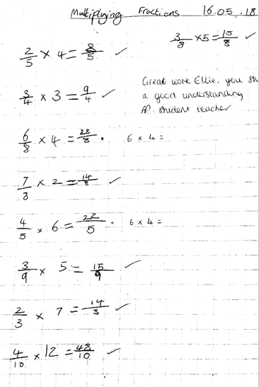



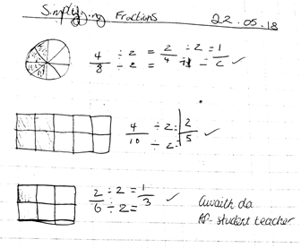

Appendix B - Language

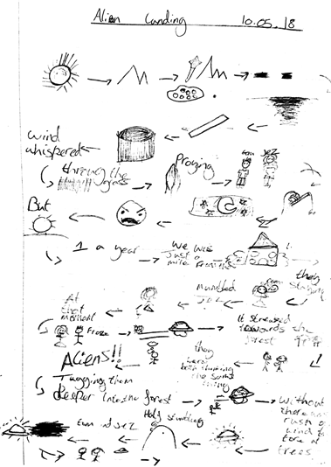

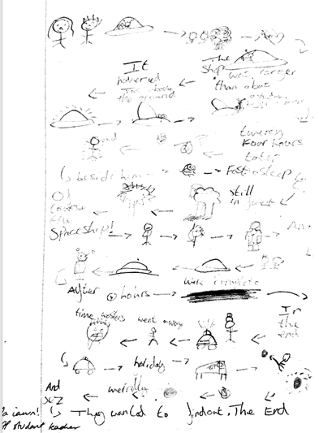

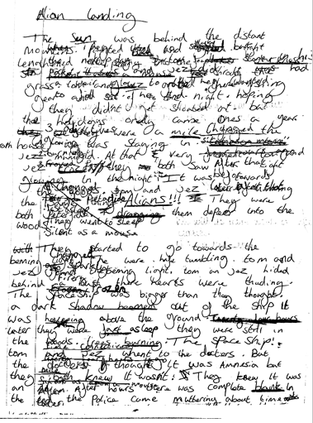

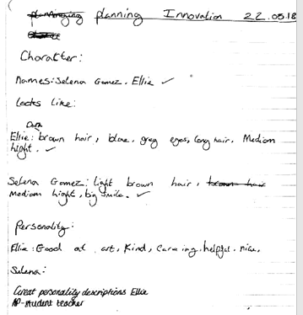



Appendix C – History

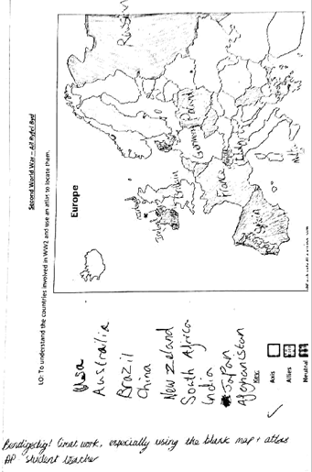

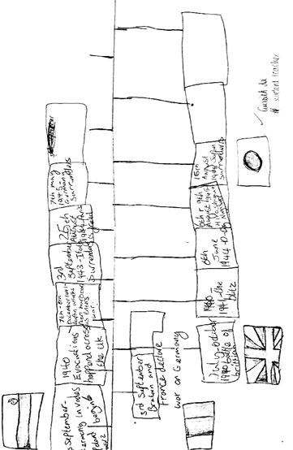

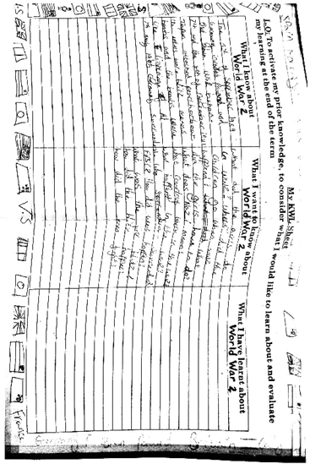

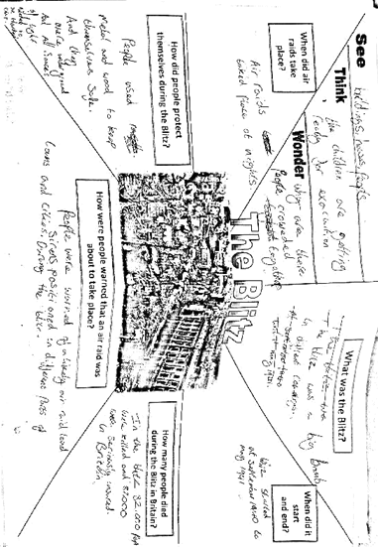

Appendix D – Science

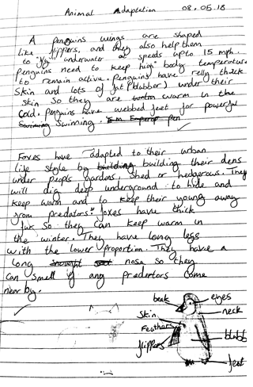

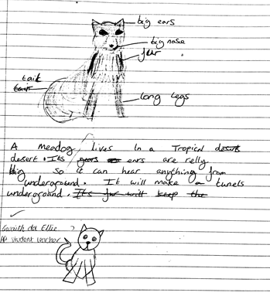
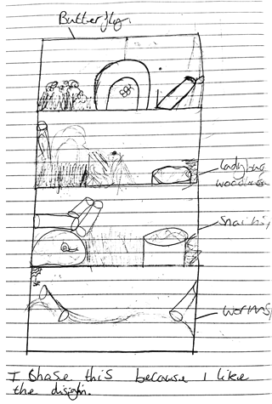

Appendix E – Consent form





