
Report Case Study:
A Comprehensive Analysis of InterContinental Hotels Group (IHG): Organizational Structure, Culture, Strategic Direction, and Change Initiatives


Name: Andreea Serban
Student ID: 2212423
Module title: Management & Organisational Behaviour BMIH5004
Lecturer: Ernest Wavei
Word count: 2196

Executive Summary
This report provides a comprehensive analysis conducted on Intercontinental Hotels Group (IHG), focusing on its organizational structure, culture, goals, recent change initiatives, strategic direction, strengths, weaknesses, and future prospects.
Key Findings:
- Organizational structure and culture: IHG maintains a hierarchical organizational structure with clear lines of authority and fosters a customer-centric culture emphasizing innovation and continuous improvement.
- Goals and change initiatives: IHG's primary goal is to uphold its market leadership by enhancing operational efficiency and adapting to market trends through technology-driven change initiatives.
- Impact of change initiatives: The change initiatives have significantly enhanced operational efficiency, customer engagement, and market competitiveness for IHG.
- Strategic direction: IHG's strategic direction focuses on global expansion, revenue growth, brand loyalty, sustainability, and corporate social responsibility.
- Strengths: IHG's strengths include a strong brand portfolio, customer-centric culture, innovation focus, and strategic partnerships.
- Weaknesses: Vulnerability to economic fluctuations, intense industry competition, and dependence on third-party hotel owners are key weaknesses.
- Future prospects: IHG's commitment to innovation, sustainability, and customer-centricity positions it well for future growth despite challenges in the dynamic hospitality industry landscape.

Table of Contents

Executive Summary 2
1. Introduction 4
1.1 Who is InterContinental Hotels Group (IHG) 4
2. Organizational Structure 7
2.1 Overview of the Divisional Model 7
2.1.1 Advantages of Decentralization 7
2.2.2 Challenges and Coordination Issues 7
2.2 Corporate and Individual Unit Levels 8
3. Organizational Culture 9
3.1 Mullin’s Theory of Organizational Culture 9
3.2 Emphasis on Customer-Centricity 9
3.3 Innovation and Integrity 9
3.4 Employee Engagement and Development 10
3.5 Challenges in Cultural Alignment 10
4. Goals and Objectives 10
4.1 Sustainable Growth and Profitability 10
4.2 Environmental Sustainability and Social Responsibility 10
4.3 Strategic Objectives 11
5. Recent Change Initiatives 11
5.1 Portfolio Optimization 11
5.2 Digital Transformation 11
5.3 Operational Efficiency Programs 12
5.4 Sustainability Initiatives 12
6. Impact of Change Initiatives 13
6.1 Positive Outcomes 13
6.2 Challenges and Resistance 13
7. Strategic Direction 14
7.1 Adapting to Industry Trends 14
7.2 Technological Innovation 14
7.3 Market Expansion 15
7.4 Brand Enhancement 15
7.5 Sustainability Leadership 15
7.6 Theoretical Frameworks - PESTEL Analysis 17
8. Future Prospects 18
8.1 Leveraging Brand Strength and Operational Expertise 18
8.2 Focus on Digital Innovation 18
8.3 Expansion in High-Growth Markets 18
8.4 Sustainability and Social Responsibility 18
8.5 Adapting to Market Dynamics 19
Conclusion 19
Reference list 21

1. Introduction
This report provides a comprehensive assessment of InterContinental Hotels Group (IHG), focusing on its organizational structure, culture, goals, recent change initiatives, and strategic direction. By evaluating IHG at both corporate and individual unit levels, the report identifies key strengths, weaknesses, and future prospects, offering strategic recommendations to enhance IHG's market position and drive sustainable growth.

1.1 Who is InterContinental Hotels Group (IHG)
According to IHG (2024), InterContinental Hotels Group (IHG) is a global leader in the hospitality industry, managing a portfolio of well-known brands across various market segments. Founded in 2003, IHG has expanded significantly, now operating in nearly 100 countries. The company operates hotels through franchising, management, and ownership/leasing models, focusing on mainstream, upscale, and luxury segments of the hotel industry.
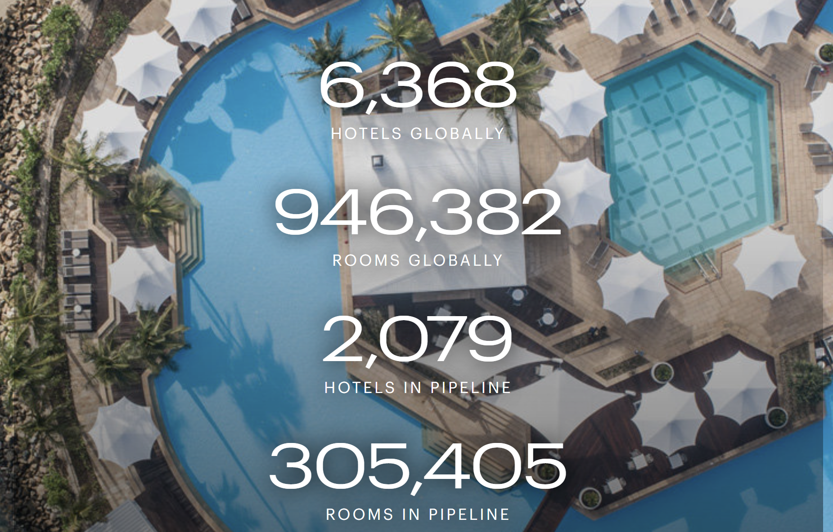Source: IHG Hotels & Resorts, 2024
As per Statista (2024), IHG had over 6,000 hotels globally in 2022, with the majority being franchised. IHG (InterContinental Hotels Group) encompasses a portfolio of 19 hotel brands. These brands cater to a wide range of travel needs and preferences, from luxury resorts to practical and comfortable accommodations for business or leisure travel such as:
Luxury and Lifestyle Collection:
- Six Senses
- Regent
- InterContinental
- Vignette
- Kimpton
- Hotel Indigo
Premium Collection:
- Voco
- Hualuxe
- EvenHotels
- Crowne Plaza
Essentials Collection:
- Holiday Inn Express
- Holiday Inn
- Avid
- Garner

Suites Collection:
- Atwell Suites
- Staybridge Suites
- Holiday Inn Club Vacations
- Candlewood Suites
Holiday Inn Express and Holiday Inn were the most prominent brands within IHG.
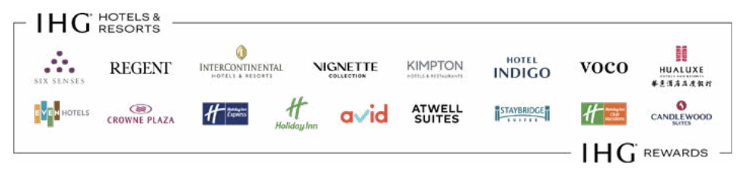
Source: IHG Hotels & Resorts, 2024

2. Organizational Structure

2.1 Overview of the Divisional Model
According to IHG Development (2024), IHG operates through a decentralized organizational structure characterized by a divisional model. As per Kenton (2024) and Cuofano (2024), this model allows IHG to organize its operations into distinct business units, each responsible for specific brands or geographic regions. This structure enables each division to tailor strategies and operations to local market conditions, ensuring agility and responsiveness.

2.1.1 Advantages of Decentralization
According to Quain (2019) the decentralized structure has several advantages:
- Agility and responsiveness: Each division can quickly adapt to market changes and customer preferences, leading to more effective and efficient operations.
- Local market focus: Divisions can develop strategies tailored to the specific needs and opportunities of their respective markets.
- Empowerment: Local managers have the autonomy to make decisions, fostering innovation and accountability.

2.2.2 Challenges and Coordination Issues
However, as per Park et al (2024), the decentralized structure also presents challenges:
- Coordination difficulties: Ensuring alignment and coordination across divisions can be complex, potentially leading to inconsistencies in brand experience.
- Duplication of efforts: Independent operations across divisions might result in duplicated efforts and inefficiencies.
- Integration: Integrating initiatives and policies across diverse regions and brands can be challenging, impacting the overall coherence of the organization's strategy.
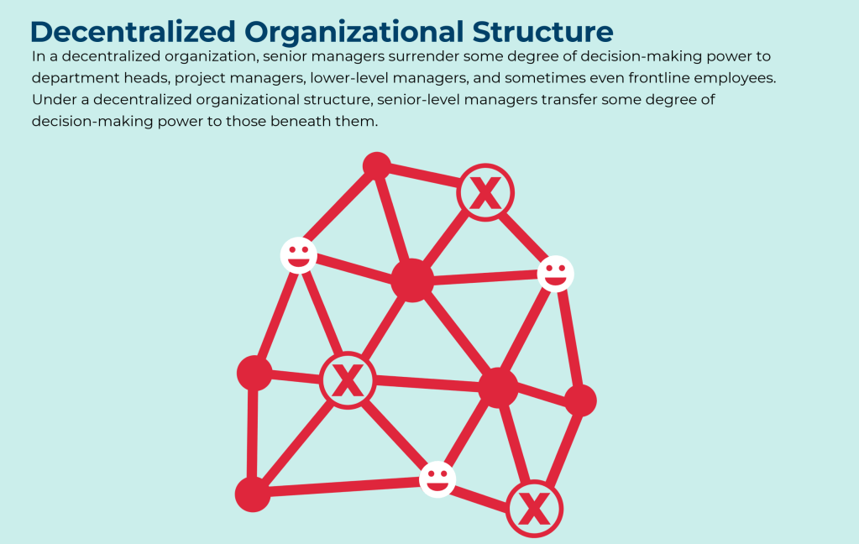
Source: FourWeekMBA, 2024

2.2 Corporate and Individual Unit Levels
At the corporate level, as per IGH (2024), IHG’s executive committee, led by the CEO, sets overall strategic direction and policy. Individual hotel units operate with considerable independence, guided by the brand standards and corporate policies but with the flexibility to adapt to local conditions. This balance between central guidance and local autonomy is a key strength of IHG’s organizational structure.

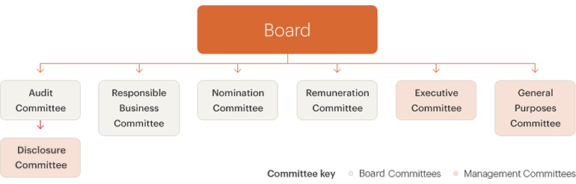
Source: IHG Hotels & Resorts, 2024

3. Organizational Culture

3.1 Mullin’s Theory of Organizational Culture
According to Mullin’s theory, organizational culture can be understood through various dimensions such as values, beliefs, and norms. As per IHG (2024), the group’s culture aligns well with this theory, emphasizing values like integrity, respect, and teamwork. These cultural elements are reinforced through training programs, employee recognition initiatives, and a strong emphasis on corporate social responsibility.

3.2 Emphasis on Customer-Centricity
As per IHG Hotels & Resorts (2021), IHG's organizational culture emphasizes a customer-centric approach, aiming to deliver exceptional experiences across its brands. The company prioritizes understanding and anticipating customer needs, fostering loyalty and satisfaction.

3.3 Innovation and Integrity
According to IHG’s Annual report (2023), innovation and integrity are core to IHG's culture. The company encourages innovation in service delivery, leveraging technology to enhance guest experiences. Integrity underpins IHG's commitment to ethical practices and social responsibility.

3.4 Employee Engagement and Development
As suggested by IHG’s Annual Reports for 2021 and 2023, IHG places a strong emphasis on employee engagement and development. The company invests in training and development programs, fostering a culture of continuous learning and improvement. Employee satisfaction and retention are critical to maintaining high service standards.

3.5 Challenges in Cultural Alignment
Despite these strengths, IHG faces challenges in achieving cultural alignment across its diverse geographic regions and business units. As noted by IHG (2014), ensuring consistent cultural values and service standards across a global workforce is complex, impacting the uniformity of brand experiences.

4. Goals and Objectives

4.1 Sustainable Growth and Profitability
According to IHG’s 2023 Annual Report, IHG's primary goal is to drive sustainable growth and profitability. As per Hospitality ON (2024) and Salesforce (2024), the group aims to expand its global footprint, enhance brand relevance, and leverage technology to deliver personalized guest experiences.

4.2 Environmental Sustainability and Social Responsibility
As stated in their Responsible Business Report (2022), IHG is committed to advancing environmental sustainability and social responsibility. The company's initiatives focus on reducing carbon emissions, conserving resources, and promoting responsible sourcing practices. These efforts align with growing consumer demand for environmentally and socially responsible businesses.

4.3 Strategic Objectives
- Market expansion: Growing presence in key markets such as China and India.
- Digital transformation: Investing in technology to enhance operational efficiency and guest engagement.
- Sustainability leadership: Leading the industry in sustainable practices.
- Brand enhancement: Strengthening brand portfolios to cater to diverse customer segments.

5. Recent Change Initiatives

5.1 Portfolio Optimization
As per IHG’s press release (2023) and IHG (2024), IHG has undertaken several initiatives to optimize its brand portfolio. This includes acquisitions, divestitures, and repositioning of brands to align with market trends and consumer preferences. Notable initiatives include the acquisition of Kimpton Hotels & Restaurants, enhancing IHG's presence in the luxury segment.

5.2 Digital Transformation
As per Escobar (2009), IHG has significantly invested in digital transformation to enhance guest experiences and operational efficiency. The rollout of IHG Concerto, a comprehensive cloud-based platform, is a key initiative. This platform integrates various systems, including reservations, revenue management, and guest loyalty programs, providing a seamless experience for both guests and employees.
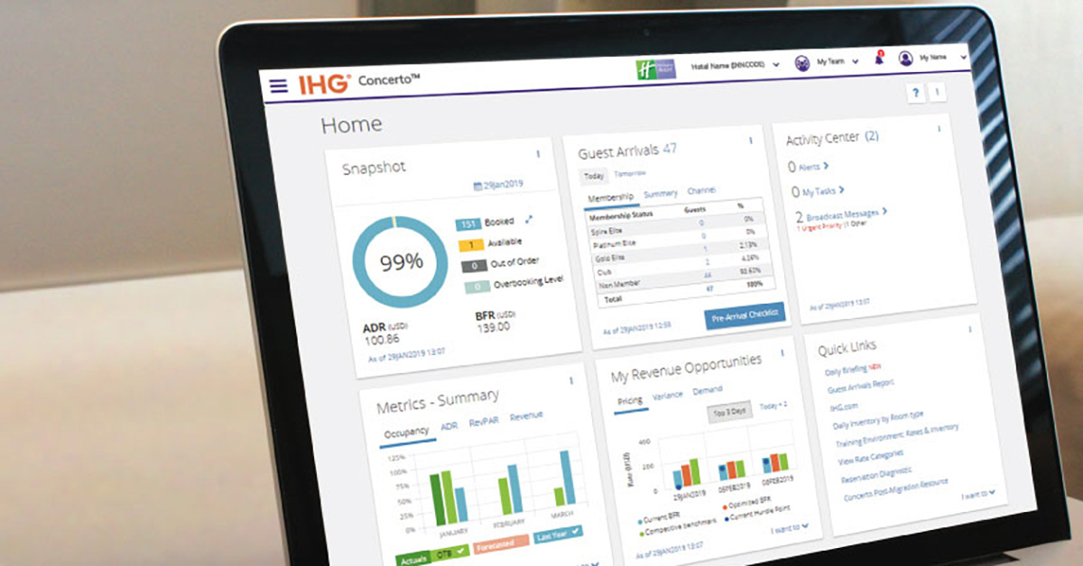
Source: Gerardwillis.com (2024)

5.3 Operational Efficiency Programs
As per IHG (2021), operational efficiency programs have been implemented to streamline processes, reduce costs, and improve service delivery. These programs focus on optimizing resource utilization, enhancing productivity, and driving consistency across operations.

5.4 Sustainability Initiatives
As per IHG (2024), the group has intensified its focus on sustainability through initiatives such as the IHG Green Engage system, which helps hotels manage their environmental impact. The company has set ambitious targets for reducing carbon emissions, water usage, and waste, aligning with global sustainability goals.

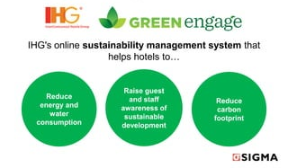
Source: Gomm, S. and Wissink, S. (2011)

6. Impact of Change Initiatives

6.1 Positive Outcomes
According to Gill (2024), IHG Development (2024) and Hertzfeld (2024), several change initiatives have yielded positive outcomes:
- Revenue growth: Portfolio optimization and market expansion have contributed to revenue growth.
- Enhanced customer satisfaction: Digital transformation initiatives have improved guest experiences, driving customer satisfaction and loyalty.
- Operational efficiency: Efficiency programs have resulted in cost savings and improved service consistency.

6.2 Challenges and Resistance
However, certain initiatives have faced challenges:
- Implementation challenges: Rolling out new technology platforms can encounter resistance from franchisees and operational disruptions, impacting overall performance.
- Integration issues: Integrating acquisitions and aligning diverse brands under a unified strategy remains complex.
- Employee adaptation: Ensuring employees adapt to new systems and processes requires significant training and change management efforts.

7. Strategic Direction

7.1 Adapting to Industry Trends
According to the Annual Report (2023), IHG's strategic direction is influenced by emerging trends in the hospitality industry, including technological innovation, changing consumer preferences, and sustainability imperatives. The company is focused on several key strategic priorities:

7.2 Technological Innovation
- IHG is investing in digital capabilities to enhance operational efficiency, guest engagement, and personalized experiences. Initiatives include:
- IHG Concerto: A comprehensive platform integrating various systems to streamline operations and enhance guest experiences.
- Mobile Solutions: Expanding mobile capabilities for reservations, check-ins, and personalized services.
- Data Analytics: Leveraging data analytics to gain insights into customer preferences and optimize marketing strategies.

7.3 Market Expansion
As per IHG’s press release (2024) and Hospitalitynet (2024), expanding presence in high-growth markets, such as China and India, is a strategic priority for IHG. The company aims to capitalize on the increasing demand for hospitality services in these regions through targeted investments and partnerships.

7.4 Brand Enhancement
- IHG is focused on strengthening its brand portfolio to cater to diverse customer segments. This includes:
- Luxury segment: Expanding the presence of luxury brands such as InterContinental and Kimpton.
- Midscale and economy segments: Enhancing offerings in the midscale and economy segments to capture a broader customer base.

7.5 Sustainability Leadership
IHG is committed to leading the industry in sustainability practices. Key initiatives include:
- Carbon reduction: Implementing measures to reduce carbon emissions and achieve net-zero targets.
- Water conservation: Promoting water conservation practices across properties.
- Waste management: Reducing waste through recycling and sustainable sourcing practices.

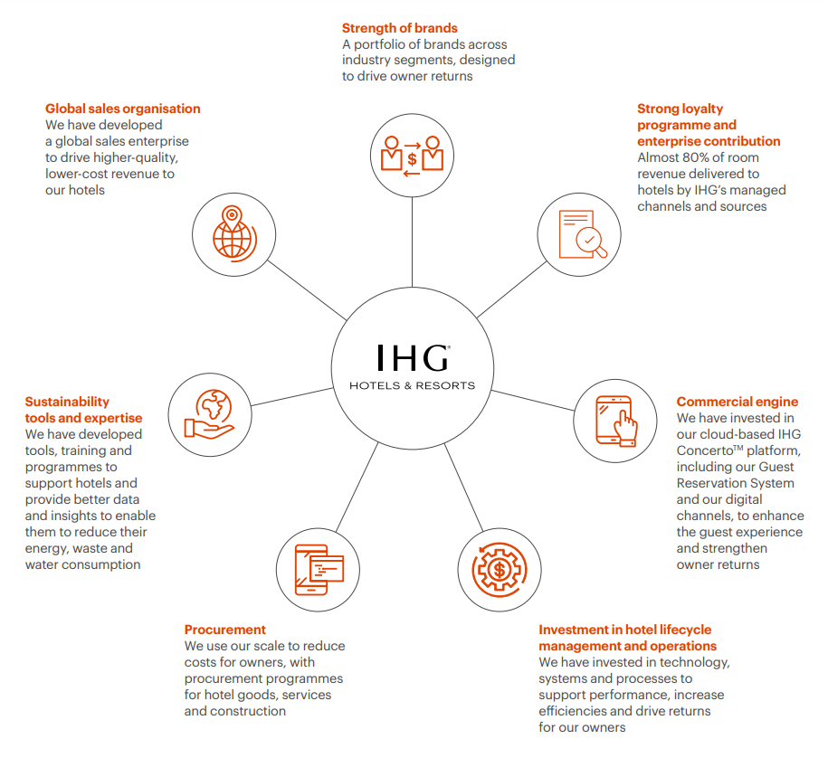

Source: IHG Development, 2024

7.6 Theoretical Frameworks - PESTEL Analysis
Factor | Description
Political Factors | Political stability in key markets, government policies related to tourism and hospitality, and international relations. Regulatory changes, such as visa policies and safety regulations.
Economic Factors | Economic conditions including GDP growth, inflation rates, and disposable income levels. IHG's geographic diversification and focus on operational efficiency.
Social Factors | Social trends including increasing travel among millennials and Gen Z, health and wellness preferences, and demand for sustainable travel. Emphasis on sustainability and personalized guest experiences.
Technological Factors | Technological advancements like mobile technology, artificial intelligence, and data analytics. Investments in digital platforms and data-driven insights.
Environmental Factors | Commitment to reducing carbon footprint, conserving water, and promoting sustainable practices. Meeting regulatory requirements and expectations of environmentally conscious guests.
Legal Factors | Compliance with labour laws, health and safety standards, and environmental regulations. Robust compliance framework to minimize legal risks and enhance reputation.

8. Future Prospects

8.1 Leveraging Brand Strength and Operational Expertise
Despite the challenges, IHG is well-positioned to capitalize on emerging opportunities in the hospitality industry. The company's extensive brand portfolio and global reach provide a strong foundation for growth. By leveraging its brand strength, operational expertise, and strategic partnerships, IHG can drive sustainable growth and value creation for its stakeholders.

8.2 Focus on Digital Innovation
IHG's continued investment in digital innovation will be critical to its future success. Enhancing digital capabilities can drive direct bookings, improve guest engagement, and streamline operations. Initiatives such as the IHG Concerto platform and expanded mobile solutions will play a key role in delivering personalized and seamless guest experiences.

8.3 Expansion in High-Growth Markets
Expanding IHG's presence in high-growth markets, particularly in Asia-Pacific regions like China and India, presents significant growth opportunities. These markets are experiencing increasing demand for hospitality services due to economic growth and rising travel trends. Targeted investments and strategic partnerships can help IHG capture market share and drive revenue growth in these regions.

8.4 Sustainability and Social Responsibility
As sustainability becomes increasingly important to consumers and regulators, IHG's commitment to environmental and social responsibility will be a key differentiator. By advancing its sustainability initiatives, such as reducing carbon emissions and promoting responsible sourcing, IHG can enhance its reputation and meet the expectations of socially conscious consumers.

8.5 Adapting to Market Dynamics
The hospitality industry is dynamic, influenced by changing consumer preferences, technological advancements, and economic conditions. IHG must remain agile and adaptive to market dynamics. This includes staying ahead of industry trends, continuously innovating its service offerings, and enhancing its operational efficiency to maintain a competitive edge.

Conclusion
This comprehensive report has provided an in-depth analysis of IHG's organizational structure, culture, goals, recent change initiatives, and strategic direction. By evaluating the company, key insights into its strengths, weaknesses, and future prospects have been identified.
IHG's decentralized organizational structure, while offering agility and local market focus, presents challenges in coordination and cultural alignment. The company's culture emphasizes customer-centricity, innovation, and integrity, with a strong focus on employee engagement and development. However, achieving consistent cultural values across a global workforce remains complex.
IHG's goals and objectives centre on driving sustainable growth, enhancing brand relevance, and advancing environmental sustainability. Recent change initiatives, such as portfolio optimization, digital transformation, and operational efficiency programs, have delivered mixed results. While some initiatives have driven revenue growth and improved customer satisfaction, others have faced implementation challenges and integration issues.
IHG's strategic direction is influenced by emerging industry trends, including technological innovation, changing consumer preferences, and sustainability imperatives. The company is focused on expanding its presence in high-growth markets, enhancing digital capabilities, and leading the industry in sustainability practices.
IHG remains well-positioned to capitalize on emerging opportunities in the hospitality industry. By leveraging its brand strength, operational expertise, and strategic partnerships, IHG can drive sustainable growth and value creation for its stakeholders. Key areas of focus include digital innovation, market expansion, and sustainable practices, which will enable IHG to maintain its leadership position in the global hospitality market.
IHG must continue to adapt to evolving market dynamics, leverage its core competencies, and embrace innovation to sustain its competitive advantage and drive long-term success in the dynamic hospitality industry.

Reference list
Cuofano, G. (2024) Decentralized Organizational Structure. Available at: https://fourweekmba.com/decentralized-organizational-structure/ (Accessed: 26 May 2024).
Escobad, M. C. (2019) At IHG, All Roads Lead Back to Concerto. Available at: https://hospitalitytech.com/ihg-all-roads-lead-back-concerto (Accessed: 26 May 2024).
Gill, R. (2024) IHG boosted by improving business travel volumes. Available at: https://www.businesstravelnewseurope.com/Accommodation/IHG-boosted-by-improving-business-travel-volumes (Accessed: 26 May 2024).
Gomm, S., Wissink, S. (2011) IHG Green Engage. Available at: https://www.slideshare.net/slideshow/ihg-green-engage-camp-digital/8223403 (Accessed: 26 May 2024).
Hertzfeld, E. (2024) IHG Hotels & Resorts 1Q revenues up 2.6% Available at: https://www.hotelmanagement.net/operate/ihg-hotels-resorts-1q-revenues-26 (Accessed: 26 May 2024).
Hospitality ON (2024) HG strengthens its presence in Germany through a key agreement with NOVUM Hospitality. Available at: https://hospitality-on.com/en/development/ihg-strengthens-its-presence-germany-through-key-agreement-novum-hospitality (Accessed: 26 May 2024).
HospitalityNet (2024) IHG Hotels & Resorts to double presence in India with 100 operating hotels in 5 years. Available at: https://www.hospitalitynet.org/news/4121623.html (Accessed: 26 May 2024).
IGH (2024) Corporate governance. Available at: https://www.ihgplc.com/en/investors/corporate-governance (Accessed: 26 May 2024).
IHG (2014) Celebrating difference at IHG. Available at: https://careers.ihg.com/media/pkrdlbed/diversity-and-inclusion-policy-global-1.pdf (Accessed: 26 May 2024).
IHG (2024) Development. Available at: https://development.ihg.com/sites/ihgplc/files/Screenshot%202024-03-06%20104927.png (Accessed: 26 May 2024).
IHG (2024) IHG Green Engage™ system. Available at: https://www.ihg.com/content/gb/en/support/green-engage (Accessed: 26 May 2024).
IHG (2024) IHG Remains its Growth Momentum in Greater China with 24 New Signings. Available at: https://www.ihgplc.com/en/news-and-media/news-releases/2024/ihg-remains-its-growth-momentum-in-greater-china-with-24-new-signings (Accessed: 26 May 2024).
IHG Hotel Development (2024) A powerful loyalty programme. Available at: https://development.ihg.com/hotel-development/owner-value/powerful-loyalty-programme (Accessed: 26 May 2024).
IHG Hotels & Resorts (2021) Responsible Business Report. Available at: https://development.ihg.com/sites/ihgplc/files/IHG/A%20sustainable%20business/I-H-G-R-B-R-Interactive-280222.pdf (Accessed: 26 May 2024).
IHG Hotels & Resorts (2022) Responsible Business Report 2022. Available at: https://www.ihgplc.com/~/media/Files/I/Ihg-Plc/investors/annual-report/ihg-responsible-business-report-2022.pdf (Accessed: 26 May 2024).
IHG Hotels & Resorts (2023) Annual Report and Form 20-F 2023. Available at: https://www.ihgplc.com/~/media/Files/I/Ihg-Plc/investors/annual-report/2023/annual-report-2023.pdf (Accessed: 26 May 2024).
IHG Hotels & Resorts (2023) InterContinental Hotels & Resorts Unveils a Distinctive Global Brand Evolution. Available at: https://digital.ihg.com/is/content/ihg/220923-InterContinental-Announces-International-Brand-Evolution-SummaryVersionFINAL (Accessed: 26 May 2024).
IHG Hotels & Resorts (2024) Annual Report 2023. Available at: https://www.ihgplc.com/ (Accessed: 26 May 2024).
IHG Hotels & Resorts (2024) IHG Hotels & Resorts Strengthens Leading Position in the Luxury & Lifestyle Segment. Available at: https://www.ihgplc.com/en/news-and-media/news-releases/2024/ihg-hotels-and-resorts-strengthens-leading-position-in-the-luxury-and-lifestyle-segment (Accessed: 26 May 2024).
Kenton, W. (2024) Organizational Structure for Companies With Examples and Benefits. Available at: https://www.investopedia.com/terms/o/organizational-structure.asp (Accessed: 26 May 2024).
Park, K., Sen, S., Griffiths, D. (2024) Addressing the challenges of decentralisation. Available at: https://www2.deloitte.com/content/dam/Deloitte/uk/Documents/risk/deloitte-uk-tpr-decentralisation.pdf (Accessed: 26 May 2024).
Quain, S. (2019) Advantages & Disadvantages When Companies Decentralize. Available at: https://smallbusiness.chron.com/advantages-disadvantages-companies-decentralize-11938.html (Accessed: 26 May 2024).
Salesforce Press Release (2024) IHG Hotels & Resorts Aims to Boost Guest Loyalty with Salesforce. Available at: https://investor.salesforce.com/press-releases/press-release-details/2024/IHG-Hotels--Resorts-Aims-to-Boost-Guest-Loyalty-with-Salesforce/default.aspx (Accessed: 26 May 2024).
Statista Research Department (2024) InterContinental Hotels Group - statistics & facts. Available at: https://www.statista.com/topics/1905/intercontinental-hotels-group/#topicOverview (Accessed: 26 May 2024).

