ASSIGNMENT DETAILS AND FEEDBACK

SOUTH WEST WALES CENTRE OF TEACHER EDUCATION

Sections marked with * should be completed by module lead
Student name: | Hannah Smethurst | Student number: | 1500124
Programme: | BA Primary Education with QTS
Module: * | Pedagogy in Practice 2 – Assessment for Learning | Module Level (4, 5, 6): | 6
Module code: * | ECAD6004/C | Contribution to Overall  Module Assessment (%): * | 50%
Module Lead:* | Mr T. Cox
Start date:* | 3/10/17 | Assignment No (x of x):* | 1 of 1
Submission deadline:* | 15/12/17 | Return date of provisional marks & written feedback:* | 26/1/18
Assignment Title:* | Critically evaluate your creativity and enterprise dispositions in terms of the Entrecomp frame work and how you might develop these to the next level and demonstrate progression.
Referencing: | In the main body of your submission you must give credit to authors on whose research your work is based. Append to your submission a reference list that indicates the books, articles, etc. that you have read or quoted in order to complete this assignment (e.g. for books: surname of author and initials, year of publication, title of book, edition, publisher: place of publication).
Submission: | All assignments must be submitted to Turnitin unless otherwise instructed by the Lecturer.  Note: the Turnitin version is the primary submission and acts as a receipt for the student. Late submission of the electronic version of the assignment will result in a late penalty. Penalties for late submission: Up to one week late, maximum 40%. Over one week late will be recorded as a non-submission. Late submission penalties may be lifted only with the approval of the Extenuating Circumstances Panel. | Date: | 15/12/17

Module lead to tick to indicate if a hard copy version of the assignment must be submitted.* | YES
 | NO | X

Student Self Evaluation Form

Common Assessment Criteria Applied | Level of Achievement
Common Assessment Criteria Applied | REFER |  | 3rd | 2:2 | 2:1 | 1st | 1st
 | OUTRIGHT FAIL | UNSATISFACTORY | SATISFACTORY | GOOD | VERY GOOD | EXCELLENT | EXCEPTIONAL
1. Subject Knowledge and Understanding (which includes using research-informed literature and knowledge and understanding of the subject) | 0-29% | 30-39% | 40-49% | 50-59% | 60-69% | 70-79% | 80-100%
2. Intellectual Skills (Analysis) | 0-29% | 30-39% | 40-49% | 50-59% | 60-69% | 70-79% | 80-100%
3. Pedagogic and Professional Applications  (Practical Application and Deployment) | 0-29% | 30-39% | 40-49% | 50-59% | 60-69% | 70-79% | 80-100%
4. Key Transferable Skills | 0-29% | 30-39% | 40-49% | 50-59% | 60-69% | 70-79% | 80-100%
PLEASE COMMENT ON AREAS IN WHICH YOU FEEL THAT YOU HAVE PERFORMED WELL | PLEASE COMMENT ON AREAS you feel that you need TO DEVELOP
I feel that I have been able to give evidence to support my reasoning and have used authors and research well to support my arguments. | I feel that I could have further developed my critical analysis with regards to my personal development.
Student’s Name | Hannah Smethurst | Date | 14.12.17
Student’s Signature | H.Smethurst

Critically evaluate your creativity and enterprise dispositions in terms of the Entrecomp Framework and how you might develop these to the next level and demonstrate progression.

The following essay will critically evaluate personal creativity and enterprise dispositions with regards to the Entrecomp Framework and will demonstrate how these can be developed and progression can be shown.

The Entrecomp Framework aims to bridge connections between education and work and to initiate the fostering of entrepreneurial and enterprise learning (Bagcigalupo et al., 2016). Within the framework are a set of competences that are ‘needed for personal development, social inclusions, active citizenship and employment’ (Bagcigalupo et al., 2016:2). This can be reflected in Donaldson’s review of the curriculum, in which he recommends that the curriculum should allow children and young people to be able to develop into ‘enterprising, creative contributors, ready to play a full part in life and work’ (Donaldson, 2015:29), reinforcing the importance of these skills.

Enterprise education is defined as ‘the process of equipping students with an enhanced capacity to generate ideas and the skills to make them happen’ (QAA, 2012:2). It also combines skills such as ‘creativity, ideas development and problem solving with expression, communication and practical action’ (QAA, 2012:8), showing that the skills can be applied across many different areas of education (QAA, 2012).

There are many different definitions of creativity, thus showing that it is ‘a very elusive concept to define’ (Joubert 2001:29 cited in Desailly, 2012:3). The National Advisory Committee on Creative and Cultural Education define creativity as being an imaginative activity where the outcomes are valuable and original (NACCCE, 1999). However, contrary to this is the view that creativity is broader than just an imaginative activity, but rather the core is a wide range of thinking skills (Craft, 2000). In relation to creative teaching, these teachers can be described as those who go against the flow. However, it is acknowledged that this can be difficult in today’s ‘climate of prescriptive practice’ (Wragg, 2005:193, cited in Grigg, 2010). As practitioners, it is important to be creative in all aspects of teaching and learning as this can help to inspire children in their learning. Having said this, it can be hard to understand how to successfully achieve creativity (Thorne, 2007) and so we need to be able to learn how we can develop our own creativity.

One of the principles of the curriculum design is to allow children and young people to become ‘enterprising, creative contributors’ (Donaldson, 2015: 29). Therefore, showing the importance of enterprise and creativity within education. This view is further supported by the QAA (2012), who believe that the attributes of enterprise and creativity are combined and that the skills learned through these aspects are essential (QAA, 2012). The DfCSF are also in support of this, as they are of the belief that it leads to ‘confident, financially mature and self-sufficient young people who can progress through to adulthood to be able to recognise and grasp any opportunity that comes their way’ (DfCSF, 2010:6) They believe that the role of the practitioner in this is of vital importance and so therefore should not be underestimated (DfCSF, 2010).

Therefore, as practitioners, it is important to be able to develop our dispositions in these areas. To be able to help the children to develop in these competencies, we must first be confident in our own performance and understanding of them. One argument is that being able to identify and develop one’s own creativity is to ‘become a highly effective teacher’ (Desailly, 2012:4).

The chosen competences to evaluate are creativity and learning through experience. Within each competence, there are a number of threads, and the focus will be on one of these. Each thread has levels and I will evaluate my performance against them.

Creativity is described in the framework as developing a number of ideas and opportunities ‘to create value, including better solutions to existing and new challenges’ (Bagcigalupo et al., 2016:12). Within this is exploring and experimenting of innovation and combining both knowledge and resources that allow the achievement of valuable effects (Bagcigalupo et al., 2016). This is further supported by Fisher and Williams, who believe that creativity is ‘generating outcomes that are original and of value’ (2004:1). The thread that I will be focusing on is being curious and open. Of the six levels within this thread, I would identify my current performance at level four.

Level one states that I can show curiosity about new things (Bagcigalupo et al., 2016). This is something that I feel very confident in as I believe that I am a naturally curious person. In new environments I question different elements to familiarize myself with it. For example, at the beginning of a new placement, I will ask the teacher and support staff questions about the class environment, and take pictures. Therefore, familiarizing myself with the new environment (see appendix 1). Curiosity and inquisitiveness are said to be characteristics of creative people (Fisher and Williams, 2004; Desailly, 2012). However, being inquisitive and curious takes confidence, which I can lack in some situations therefore limiting my performance in this competence.

Level two states that ‘I can explore new ways to make use of existing resources’ (2016:24). I feel I am confident in this and have demonstrated examples throughout my time on placements. One example of this is in a year one class, for a maths session about coin values. I was told by my mentor the area to cover and was shown the resources available. From these resources, I created my own. (see appendix 2). It could be said that this is not being fully creative as the initial idea was not my own, and copying through reproduction is not creativity (Duffy, 2006). Having said that, I made it my own by adding value for the learners through differentiation and allowing the children to make a real life connection through the different layout. This is acknowledged by Desailly who believes part of creativity is when the ideas are not new but the presentation of them are new and original. (Desailly, 2012).

The third level expresses the experimentation of skills in new situations (Bagcigalupo et al., 2012), and I feel that I have had a lot of practice of this particular skill in my teaching experiences, as I have to adapt my skills into each class that I am in to best engage with the pupils and make the learning experience beneficial. For example, when I was asked to create a series of music lessons in year 3 on the theme of World War II, I had to adapt both my teaching and music skills to create lessons that were relevant and enjoyable for the pupils. The ways in which I adapted my skills included setting the lessons at the right levels for the children and being able to incorporate the theme into them. The composition activity was completed in mixed ability groups and this is something that I had not had much experience in previously, and this was a new situation for me. (see appendix 3).

Level four states that ‘I can actively search for new solutions that meet my needs’ (Bagcigalupo et al., 2016:24). An example of putting this skill into practice can be seen within a Year One class. To begin with I struggled with behaviour management and therefore needed to search for a solution. After discussions with the class teacher, and personal research I was able to create my own behaviour management strategy in which I would have 2 ‘stars of the session’ at the end of the lesson. This creative idea was proven to be very effective, as shown thorough the response from the children and comments in my formative assessments. (see appendix 4).

The level in which I will next progress to in my personal development is level 5. It states ‘I can actively search for new solutions that improve the value-creating process’ (Bagcigalupo et al., 2016:24). One way in which to achieve this could be to collaborate with other people. Thorne is pro collaboration and states that in excellent schools ‘creative and innovative people are supported by others who can help them explore their ideas and people who can help take an idea to the next stage of making it happen’ (2007:13). Within this type of environment, people with different mind sets and ways of thinking can in essence bounce ideas off each other (Thorne, 2007). Having another person view the problem in a different way can be a great benefit to our own creative thinking. I would need to assess what my needs are for a certain situation, which can be done personally. However, when actively searching for new solutions, collaboration can help to generate ideas and improve the of process value-creating. Therefore, I will need to create opportunities for this to happen. I will know that I have achieved this as I will have experienced this, and will have practical evidence from exploring ideas with others that have improved the value-creating process.

The framework describes learning through experience as being able to use initiatives, learn alongside others and reflect and learn from successes and failures. (Bagcigalupo et al., 2016). The thread that I will be focusing on will be reflecting. Reflection is being concerned with our ‘experiences, actions, feelings, and responses, and then interpreting or analysing them in order to learn from them’ (Atkins and Murphy, 1994; Boud et al., 1994 cited in Open University 2013:1). Reflection is highly important as if effective, we can learn from experiences and build upon them (Open University, 2013). I would currently assess my performance in this area as level five with regards to the Framework.

Level one states that ‘I can find examples of great failures that have created value’ (Bagcigalupo et al., 2016:34). I have evidence of this in my ARC reflections from teaching experience, where I have been able to identify areas of my lessons that have not gone to plan. One example of this is a carousel activity where I was able to identify that the transitions between activities did not run smoothly impacting the work completed by the pupils. Therefore, this failure did not necessarily create value as not all the activities were completed (see appendix 5). It can be difficult to reflect our own work as being the sole focus may not feel comfortable (Open University, 2013). It could be said that reflecting upon something is not a real skill, but if you can use the reflection to inform further practice and to learn from it is a greater skill (Thompson and Thompson, 2008).

Level two states that ‘I can provide examples of temporary failure that have led to valuable achievements’ (Bagcigalupo et al., 2016:34). An example of this is during one of my teaching experiences in a Year one class. After my first few lessons I was able to identify with the class teacher that my class management skills were not very effective, and therefore were a temporary failure. However, from this we were able to create an AfL strategy that I implemented. We later found this to be successful and at the end of the placement when I reflected upon the time in the class I identified this as a valuable achievement. (See appendix 6). This process of being reflective and acting upon it helped to expand my personal development and to maintain my professional expertise (Pollard, 2014), therefore a valuable experience.

Moving on, level three states ‘I can reflect on failures (mine and other people’s), identify their causes and learn from them’ (Bagcigalupo et al., 2016:34). This is something that I do often when teaching, especially following a lesson. I would complete an ARC reflection form, in which I reflect upon the good aspects of the lesson and the less successful aspects. This reflection allows me to then identify the cause of the problems and to suggest ways in which to improve upon them (See appendix 7). Thus learning from the experience and informing my teaching practice, which is a characteristic of reflective professionals. (Pollard, 2014). However, I have not had the experience of reflecting upon other people’s failures, which may limit my competence in this area.

The fifth level states that I am able to ‘reflect on my (or my team’s) achievements and temporary failures as things to develop so as to learn and improve my ability to create value’ (Bagcigalupo et al., 2016:34), and this is the level that I would place myself at currently. As discussed previously, my ARC reflections show that I am able to reflect on my achievements and failures and use these to develop and learn upon. With regards to being able to improve my ability to create value, this could at times be subjective but by being able to reflect and address what needs to be improved upon, allows the following lesson to become more valuable for the pupils in their learning (see appendix 8).

The level in which I will progress to next is level six, where I will be able to ‘help others reflect on their achievements and temporary failures by providing honest and constructive feedback’ (Bagcigalupo et al., 2016:34). Reflecting is normally something that is personal and I have not had the opportunity to help others in reflections by providing feedback. Therefore, to progress this is something that I can try to do in the future. Bassot believes that reflection should not be a solitary activity as this can lead to us becoming ‘immersed in our own point of view, seeing things only from our perspective, which inevitably is narrow, limited and biased’ (Bassot, 2016:5). Thus suggesting that reflection as a group can be highly beneficial as it can help us ‘to sharpen our thinking and critique our ways of working’ (Bassot, 2016:8) which is at the heart of reflection. Many believe in the value of being able to reflect in groups (Pollard, 2014; Thompson and Thompson, 2008). ‘The value of engaging in reflective activity is almost always enhanced if it can be carried out in association with other colleagues’ (Pollard, 2014:26). There are many models of reflection, and these could also be used to help to develop my own personal reflectiveness and helping others to reflect. For example, Gibbs reflective cycle. This goes through a series of questions to help reflect upon an experience (see appendix 9). Using a tool such as this could help to structure the reflection process and make it more beneficial. Therefore, in the future to progress in my reflection abilities I will create opportunities to reflect in groups, for example during professional teaching experiences or in university, and use structures to aid my reflection. I will know that I have reached this level because I will be confident to help others in their reflection process, and have a better knowledge of how to structure reflection.

To conclude, both creativity and enterprise are important and relevant within education and can be seen through the Entrecomp Framework. As practitioners we need to be able to be confident in these dispositions, so that we can provide the best opportunities and experiences for our pupils for them to be ‘ready to play a full part in life and work’ (Donaldson, 2015:29). There are different ways in which we can assess our own personal competence in these dispositions. After assessing my own competence in both creativity and learning through experience, I would place myself at a level four for being curious within creativity and level five for reflection within learning through experience. From this, I have been able to identify the areas in which I can progress to and ways in which I can achieve this. It is important to continually evaluate these competences as this is what will aid us to be able to progress in them to a higher standard, as this is part of our continuous professional development. This will lead us to be able to manage our own lives and careers and to begin initiatives that are value-creating (Bagcigalupo et al., 2016).

Word Count: 2642.

Reference List:

Bagcigalupo, M., Kampylis, P., Punie, Y. and Van den Brande, G. (2016) ‘EntreComp: The Entrepreneurship Competence Framework’ Available at: http://moodle.uwtsd.ac.uk/pluginfile.php/111407/mod_resource/content/1/Entrecomp%20Framework.pdf [Accessed: 15th November].

Bassot, B. (2016) The reflective practice guide: an interdisciplinary approach to critical reflection. Oxon: Routledge.

Craft, A. (2000) Creativity across the primary curriculum framing and developing practice. Oxon: Routledge.

Desailly, J. (2012) Creativity in the primary classroom. London: Sage.

DfCSF (2010) ‘A guide to Enterprise Education: For Enterprise Coordinators, teachers and leaders at schools’ Available at: http://www.readyunlimited.com/wp-content/uploads/2015/09/Guide_to_Enterprise_Education-DCSF.pdf [Accessed: 5th December].

Donaldson, G. (2015) Successful Futures Independent Review of Curriculum and Assessment Arrangements in Wales. Cardiff: Crown

Duffy, B. (2006) Supporting Creativity and Imagination in the Early Years. (2nd ed.) Buckingham: Open University Press

Fisher, R. and Williams, M. (2004) Unlocking creativity teaching across the curriculum. Oxon: David Fulton Publishers.

Grigg, R. (2010) Becoming an outstanding primary school teacher. Oxon: Routledge.

NACCCE (1999) ‘All Our Futures: Creativity, Culture and Education’ Available at: http://www.tracscotland.org/sites/default/files/Creativity%20Culture%20and%20Education%20intro%20and%20summ..pdf [Accessed: 25th November 2017].

Open University. (2013) ‘What is reflection?’ Available at: www.open.edu/openlearn/ocw/mod/resource/view.php?id=13992 [Accessed: 2nd December 2017].

Oxford Brookes University (unknown date) ‘Reflective writing: About Gibbs reflective cycle’ Available at: https://www.brookes.ac.uk/students/upgrade/study-skills/reflective-writing-gibbs/ [Accessed: 8th December].

Pollard, A. (2014) Reflective teaching in schools. (4th ed.) London; New York: Bloomsbury.

QAA. (2012) ‘Enterprise and entrepreneurship education: Guidance for UK higher education providers’ Available at: http://www.qaa.ac.uk/en/Publications/Documents/enterprise-entrepreneurship-guidance.pdf [Accessed: 20th November 2017].

Thompson, S. and Thompson, N. (2008) The Critically Reflective Practitioner. Basingstoke; New York: Palgrave Macmillan.

Thorne, K. (2007) Essential Creativity in the classroom. Abingdon: Routledge.

Appendix

Appendix 1:

These are pictures taken of the different areas within a Nursery Class.

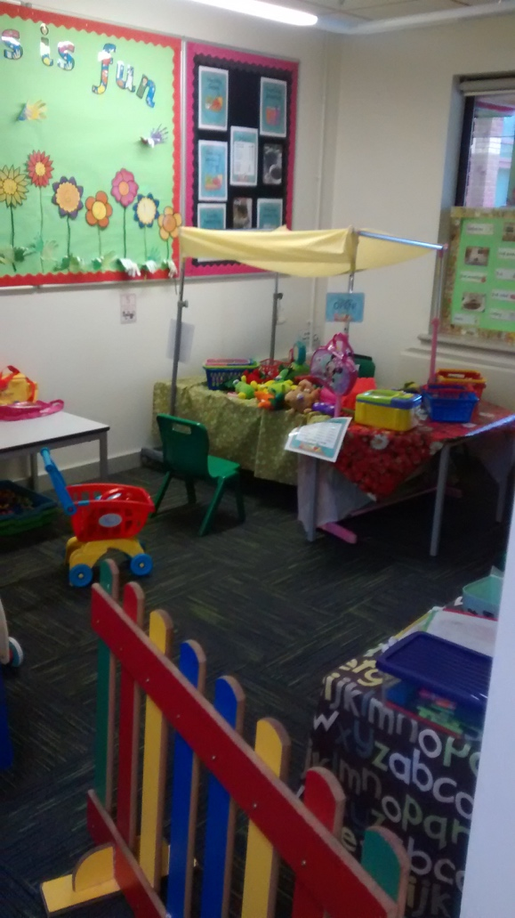
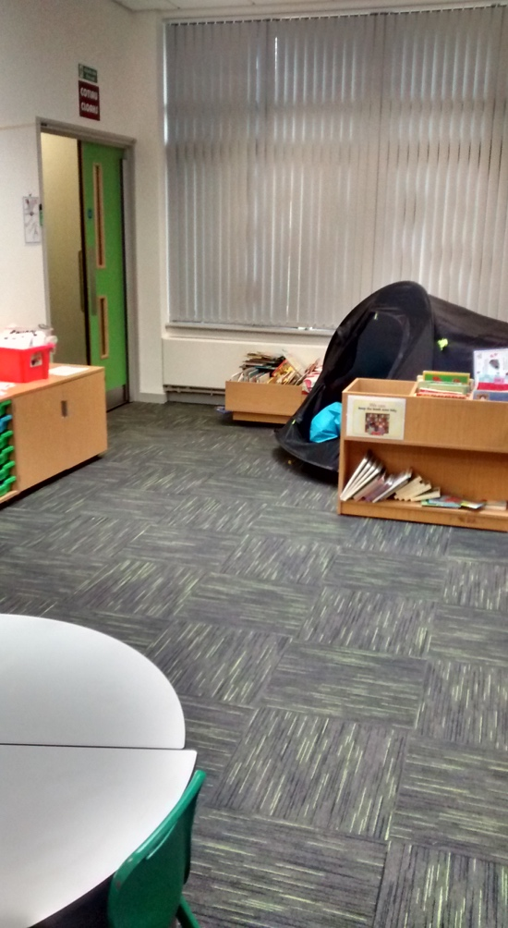

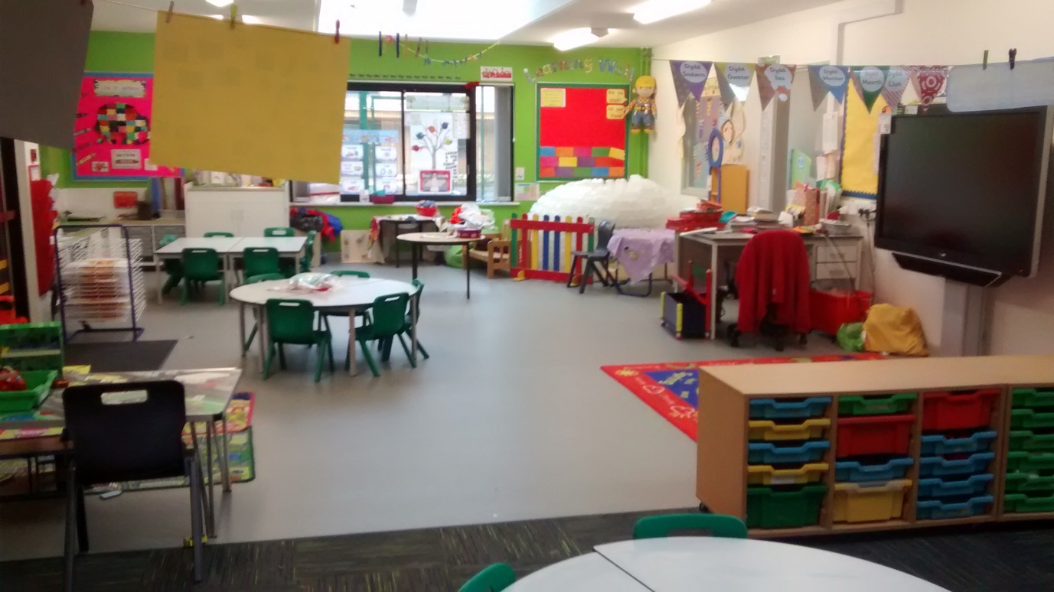
Appendix 2:

This was one of the available resources that was shown to me.
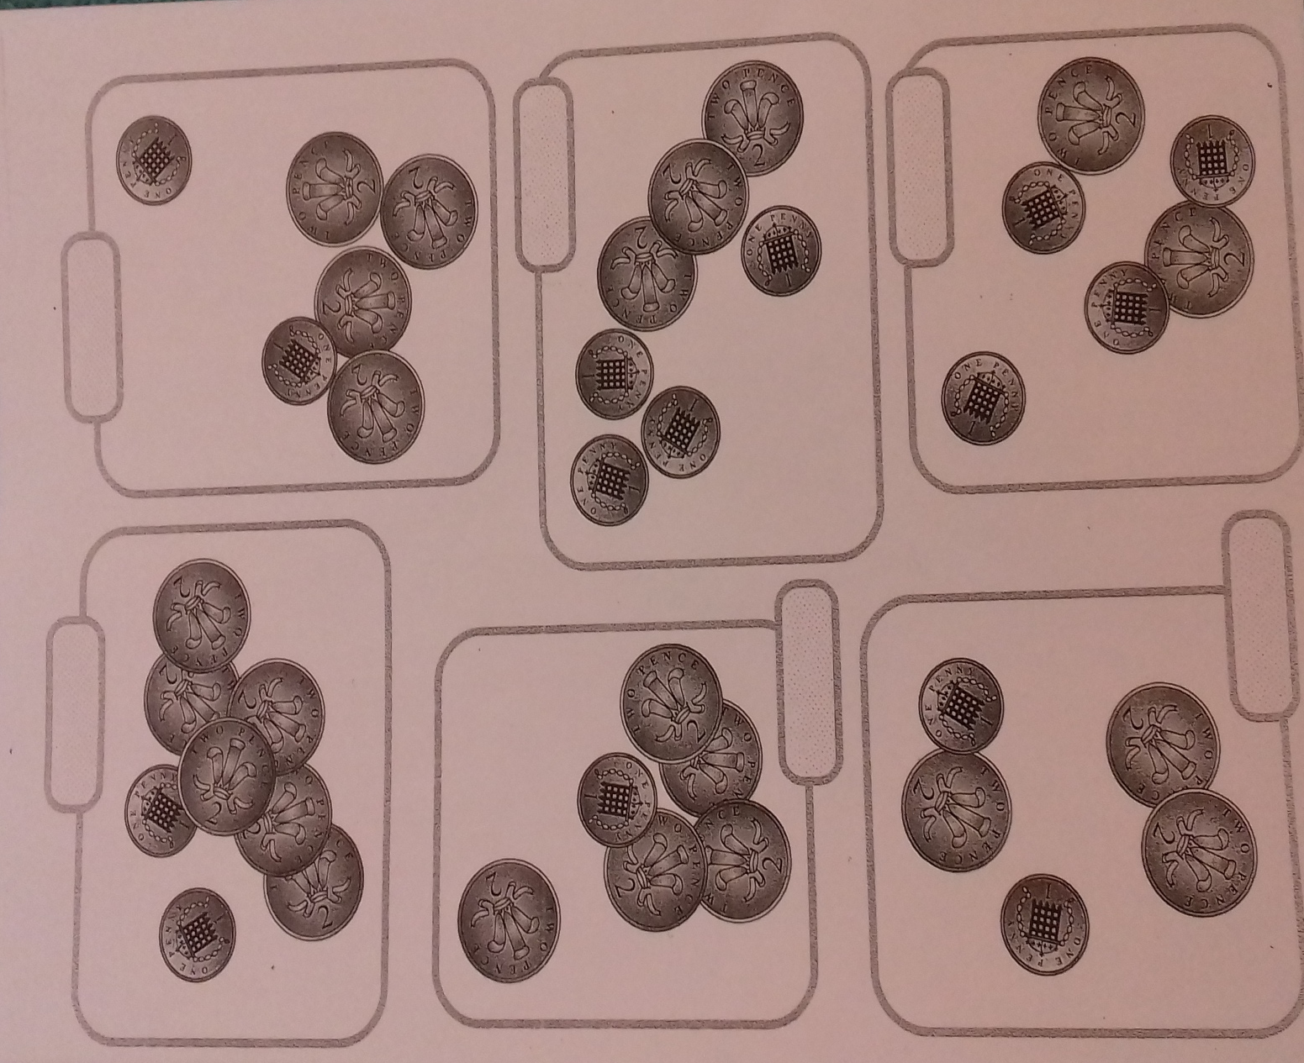

This was what I created from the original resource. This added value to the learning through differentiation for the different abilities and also having the money in purses allowed the children to make a real life connection with the activity.

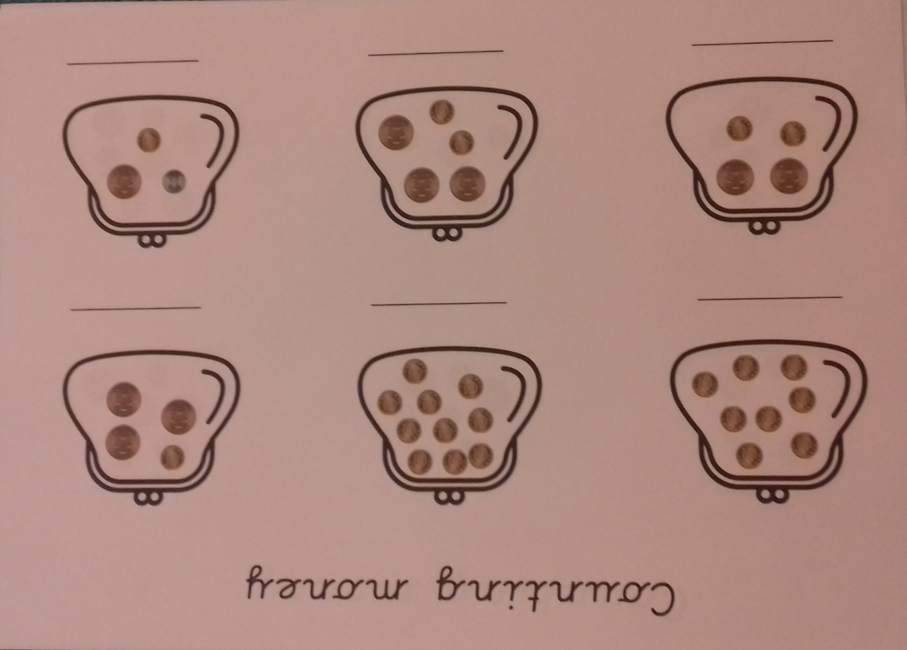

Appendix 3:

This is a mind map I completed with ideas for the series of lessons.

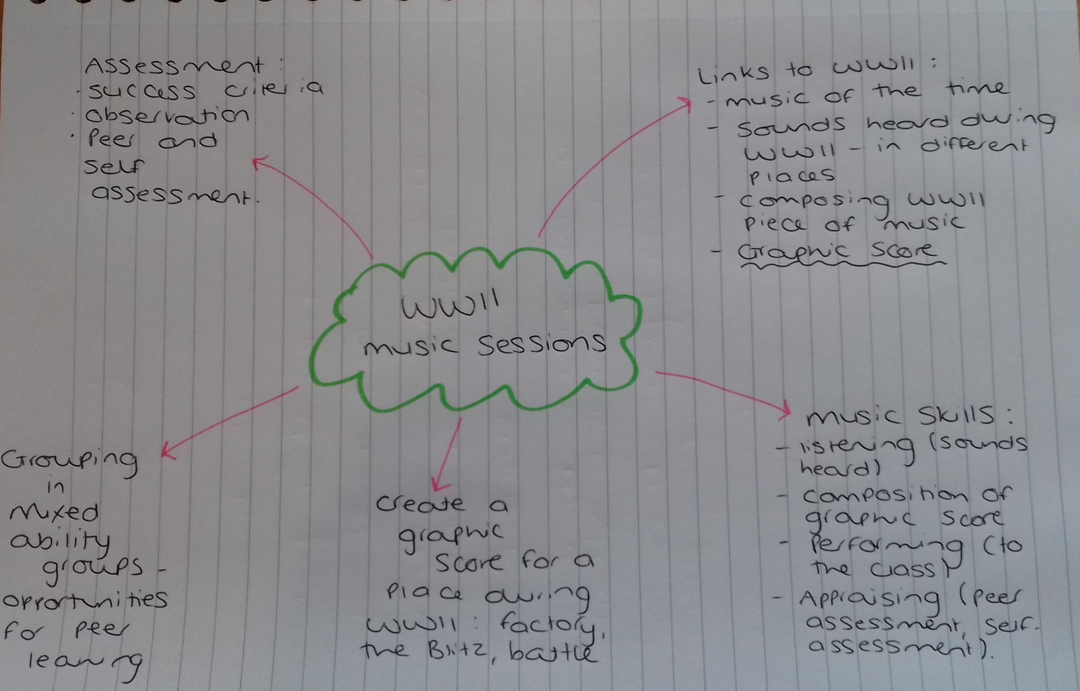

This is the first lesson plan in the series of lessons:
Name of trainee: Session ref: 60317(4)

Personal target(s) in relation to QTS:
To use more incidental Welsh in the classroom.
Year group: 4 | No. of learners: 20 |  | ALN: Dyslexia  ADHD
Additional adults: 0
Learning objective(s):  To be able to compose a short graphic score in groups to represent the sounds of WWII and to perform it. |  |  | Success criteria:  - I can list sounds that would have been heard during WWII.  - I can describe the sounds using the musical elements.  - I can choose appropriate instruments to represent the sounds.  - I can create a short graphic score for our group composition.  - I can perform our composition to the class.  - I can take part as a group.
Links to previous learning:
Term topic - WWII
Curriculum coverage (range, skills)
- Appraising – listen to and appraise music, make distinctions between the musical elements, recognise and describe musical characteristics.
Literacy(LNF)  - Collaboration and discussion: contribute to group discussion and help everyone take part.  - Speaking: explain information and ideas using supportive resources. |  | Numeracy (LNF)
ICT | Thinking  Group work and collaboration. | ESDGC |  | YCC  I will use Welsh throughout the lesson and will encourage the children to use Welsh. See Promoting Welsh planning sheet.
Key vocabulary(English/Welsh):
- World War II
- Composition
- Sounds
- Musical elements
- Grandewch
- Dim siarad
- Edrychwch ar y bwrdd
- Dwylo I fyny

Time | Session activities, organisation and management | Key questions & Assessment for Learning opportunities
10 mins | Introduction  I will start by explaining that we will be doing a short project in music and that over the next 4 sessions we will be composing a graphic score to represent WWII. I will share the the learning objective for the following music sessions and what I will expect at the end by using the success criteria – this will stay the same over the 4 sessions and I will explain this to the children. I will ask the children to get into groups of 4 or 5 and this will be the group they will stay in. | - Success Criteria  - What sounds would you hear?  - Why might you hear those sounds?  - Can you describe the sounds?  - Think, pair, share  - Look back at success criteria and think of next steps
30 mins | Main activities  I will show the children a picture of a scene from WWII. I will ask them in their groups to talk about the types of sound they might hear if they were in that particular scene. In the groups they will brainstorm these sounds for each scene. I will get each group to feedback about each scene and ask them to explain why they may hear that sound.  Once we have done this, I will ask the children to think about some of the sounds and using the musical elements, describe the sound. They can do this by discussion and then we will feedback as a class.
10 mins | Plenary  We will look back at our success criteria to see how far we have got with it and how they felt they did in each element of it, and think about their next steps for the next session. I will explain what we will do next session.

Appendix 4:

This comment shows the result of actively searching for a new solution to meet my needs.
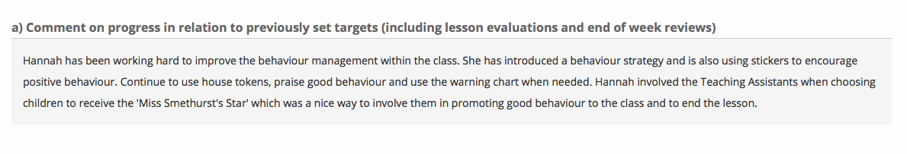

Appendix 5:

This ARC shows how I was able to identify a failure within a lesson.

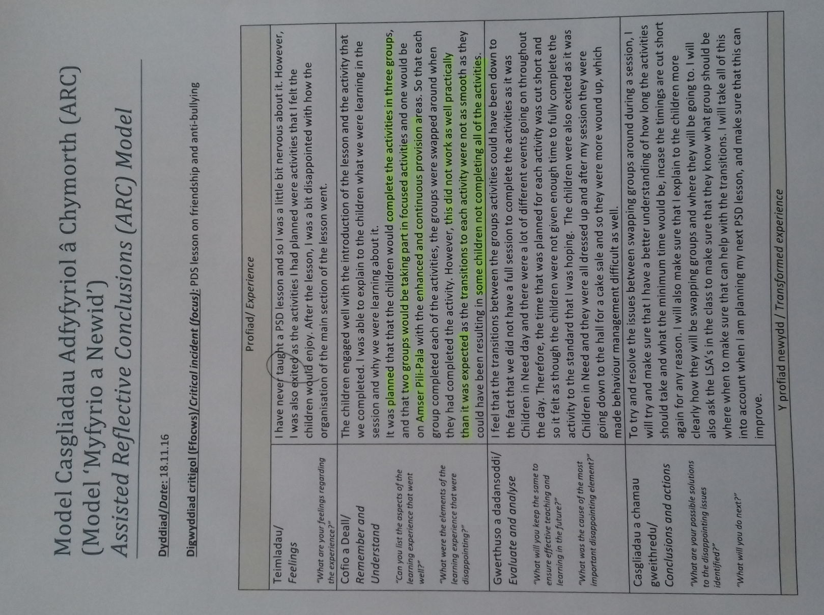

Appendix 6:

These are comments made in my formative assessments with regards to my behaviour management strategy.

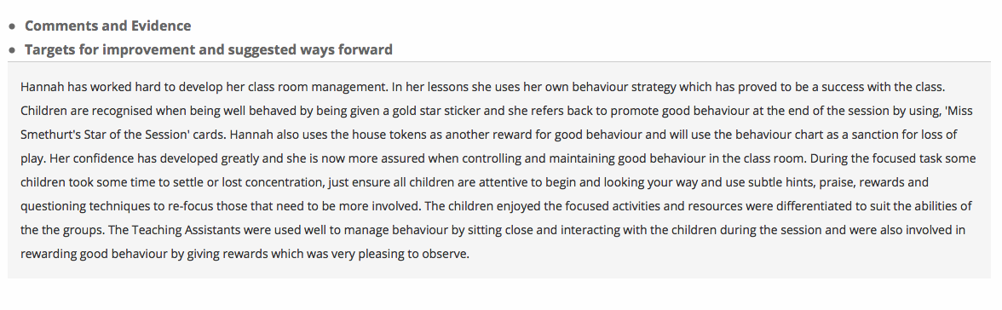

Appendix 7:

The ARC reflections shows my identification of behaviour management as a disappointing aspect, and the formative assessment comments show how it became a valuable achievement.

Profiad/ Experience

Teimladau/  Feelings  “What are your feelings regarding the experience?” | As this was my first time teaching in the class, I was nervous to start. However, as I started teaching I felt that I became more confident and comfortable. I feel that overall it went well and was pleased with the first time teaching the class. I enjoyed the teaching experience overall and the children enjoyed the different activities.
Cofio a Deall/  Remember and Understand  “Can you list the aspects of the learning experience that went well?”  “What were the elements of the learning experience that were disappointing?” | The children engaged well with the different activities and all joined in well. I had good feedback from the LSA who was leading the other focused task during the session. They completed the activities to a good standard with some guidance when they needed. However, the higher ability group that I was working with finished the activity quicker than I had anticipated. I was able to give them an extension task to complete afterwards however they also completed this relatively quickly and so started to loose interest towards the end of the activity.  The aspect of the learning experience that was disappointing was when the children were all together for the introduction and plenary. I was able to go through my introduction, however, there was a bit of noise disruption and I had to keep stopping for the children to listen.  The overall feedback from my class teacher was positive, and she gave me good advice of how to improve and thins to include for next time such as to implement more class management strategies.
Gwerthuso a dadansoddi/  Evaluate and analyse  “What will you keep the same to ensure effective teaching and learning in the future?”  “What was the cause of the most important disappointing element?” | I will keep the layout of the session the same, as it worked well for the children to go off into small groups to complete their activities. The focused tasks were practical tasks and I found that this worked well as the children remained engaged throughout.  The most disappointing element of the session was the behavior management as I felt that I could have been more effective, however, as it was my first time teaching the class I could have lacked confidence.
Casgliadau a chamau gweithredu/  Conclusions and actions  “What are your possible solutions to the disappointing issues identified?”  “What will you do next?” | With regards to class management, I will need to work on different strategies that may be effective. I will familiarise myself more with the strategies that area already in place and make sure that I know them well enough to be able to use them effectively. Also I will try to create my own behavior management strategy.
Y profiad newydd / Transformed experience

Appendix 8:

This ARC reflection shows the identification of a disappointing aspect, why this could have happened and how I will learn from it to improve. The comments show how my reflections inform my teaching.

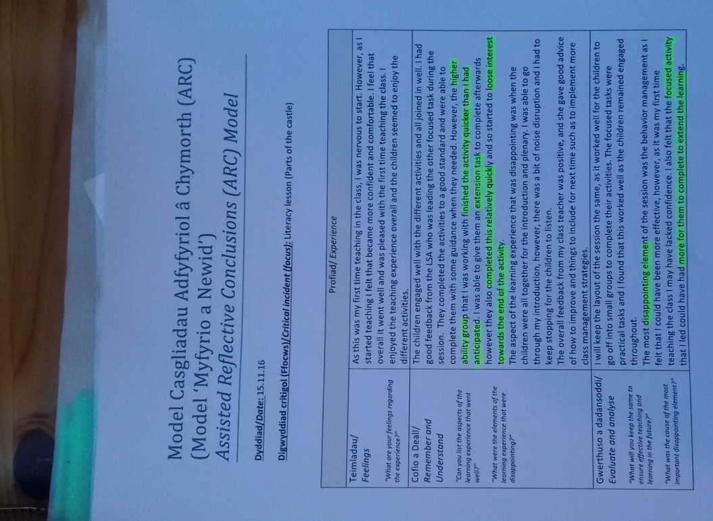

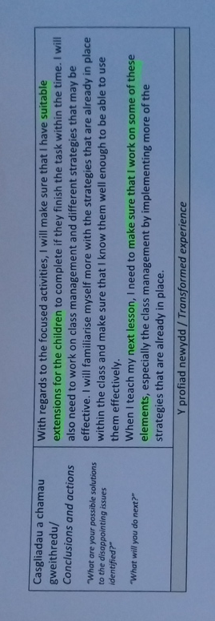

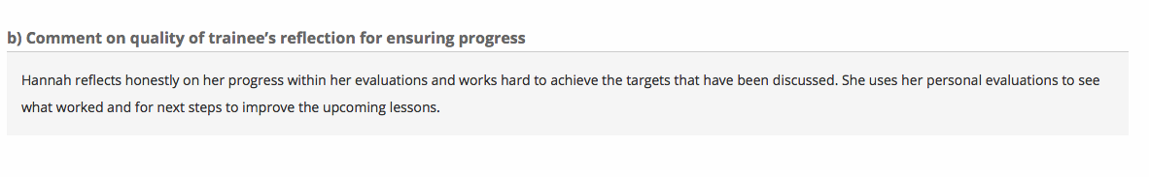
Appendix 9:

This shows Gibbs cycle of reflection and the questions used to structure personal and group reflection.



(Oxford Brookes University, unknown date)

