

Analytical Assessment of Engine Internal Components

Tamzin Cooper
2300764
BEng Motorsport Engineering
22/03/2026
ACHA6006 Contemporary Powertrain
Andrew Noble
Word Count: 2746

Contents
Chapter 1 – Introduction 3
Chapter 2 – Engine Forces 4
2.1 Inertia Forces 4
2.2 Gas Forces 4
2.3 Net Force 5
Chapter 3 – Analysing Components 7
3.1 Midpoint of Connecting Rod 7
3.1.1 Connecting Rod cap 8
3.2 Gudgeon Pin 9
3.3 Connecting Rod Bolt 10
3.3.1 Connecting Rod bolt at 6000 RPM with gas forces 12
Chapter 4 – Connecting Rod Bolt redesign 13
4.1 Geometric Consideration 14
4.2 Material Consideration 16
Chapter 5 – Torque Generation 18
5.1 Instantaneous Torque Generation 18
5.1.1 Standard Crankshaft Configuration 18
5.1.2 Cross-Plane Crankshaft Configuration 19
5.1.3 Comparison of gas and inertia torque 20
5.1.4 Crank Torque 20
5.2 Mean Torque Comparison 21
Chapter 6 – Conclusion 22
References 23
Appendix 25

Chapter 1 – Introduction
Fatigue is a critical design consideration in internal combustion engines due to the severe cyclic loading experienced (Yang et al., 2017). This report analyses the forces acting within the Ford 1.6 GDTi EcoBoost engine and evaluates the fatigue life of key bottom-end components.
Fatigue safety factors (FSF) assess resistance to cyclic loading, as alternating tensile and compressive stresses can lead to crack initiation. (Mahle GmbH, 2016). Additionally, excessively high FSFs may indicate overdesign, resulting in increased mass and cost, highlighting the need for optimisation (Hwang, 2024).

Chapter 2 – Engine Forces

2.1 Inertia Forces
Using the piston acceleration and the reciprocating component masses (piston, pin, rings and 1/3 of the connecting rod), the inertia forces (equation 1) within the engine can be calculated using Newton’s 2nd law.
Equation 1 - Inertia force.
$$F_{inertia}= m_{rec}×(Rω^{2}cosθ+\frac{R^{2}}{L}ω^{2}cos2θ)$$
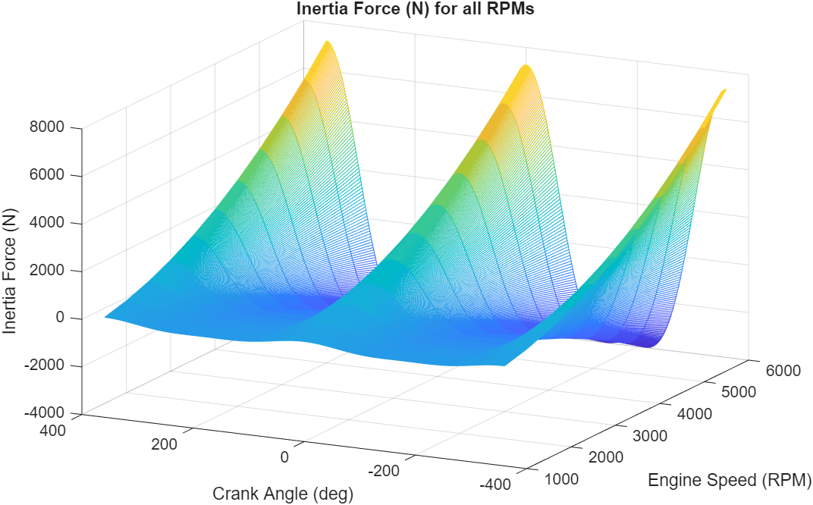
Figure 1 - Engine Inertia forces at all RPMs.

Figure 1 shows the peak inertia forces occurring at crank angles representing top dead centre (TDC). This is due to piston acceleration being highest here due to the change in direction of motion (Heywood, 2019). The graph indicates that as engine speed increases, inertia forces are greater, this is due to inertia being proportional to the square of angular velocity (equation 1). This results in higher tensile and compressive stresses being applied to engine components.

2.2 Gas Forces
Equation 2 - Gas force.
$${Force}_{gas}= P_{cyl }×Area$$

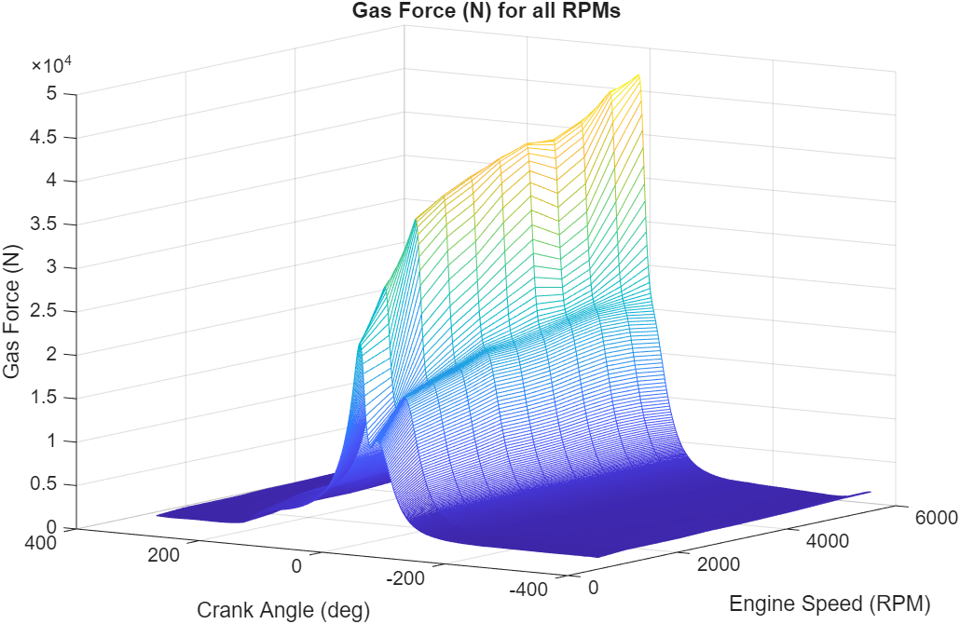
Figure 2 - Engine gas forces across all RPMs.
From figure 2, gas forces peak shortly after TDC, as cylinder pressure reaches its maximum after ignition due to flame propagation (Heywood, 2019). As the piston moves towards BDC, increasing cylinder volume reduces pressure and therefore gas force. Since gas force is directly proportional to cylinder pressure (equation 2), peak gas forces increase with engine speed, reaching almost 50,000 N. These forces are significantly larger than the inertia forces shown in figure 1, as gas forces are governed by high in-cylinder pressures while inertia forces depend only on reciprocating mass and acceleration (Stone, 2012).

2.3 Net Force
The net force is calculated to show the combined effect of gas and inertia force acting on the piston. The negative forces show the compressive force acting on the piston, whereas the positive values represent tensile loading.

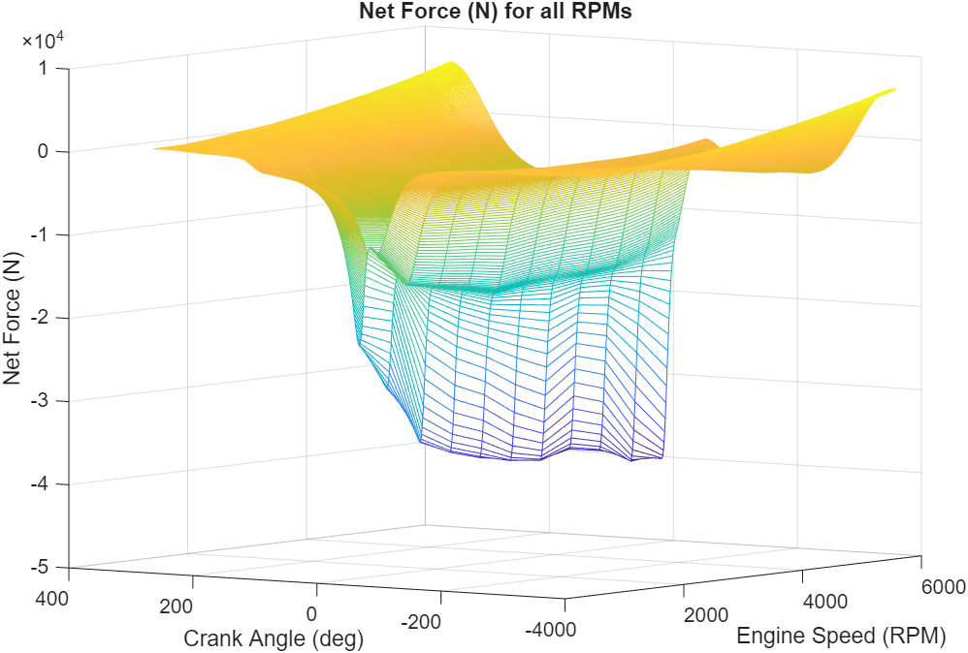
Figure 3 - Net force (N) across all engine speeds.
Figure 3 confirms that inertia forces dominate tensile loading on the piston and subsequent components due to positive net forces near TDC where acceleration is highest. Whereas gas forces produce the dominant compressive loading due to large negative forces during combustion/beginning of the expansion stroke.

Chapter 3 – Analysing Components

3.1 Midpoint of Connecting Rod
As expressed by Witek (2019), the connecting rod is a critical structural component in the engine (as shown in figure 4 by Mahle GmbH, 2016) that converts the reciprocating motion of the piston to rotational motion of the crankshaft. Due to this, the connecting rod is subjected to alternating compressive and tensile stresses during each engine cycle.
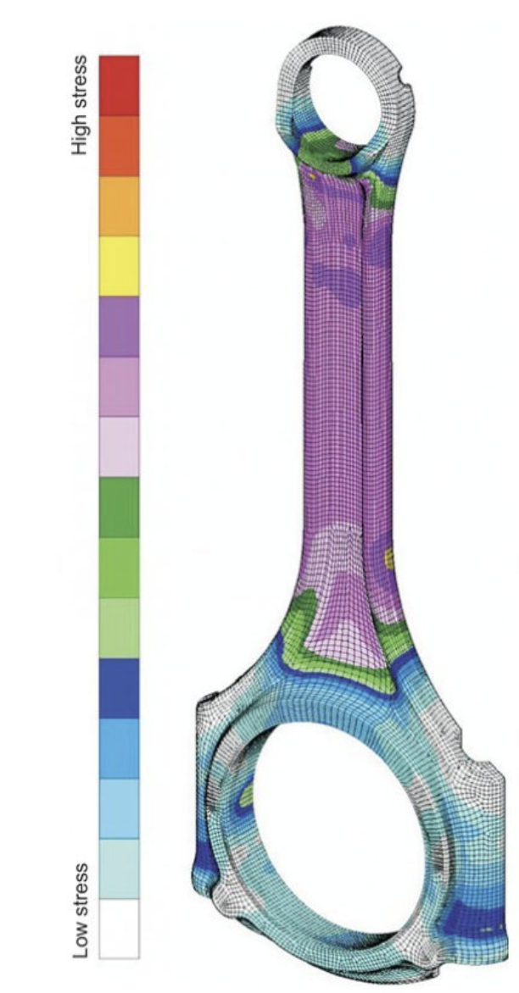
Figure 4 - FEA analysis of the connecting rod during TDC fired. (Mahle GmbH, 2016)
To understand the stresses the connecting rod withstands, the connecting rod force is calculated using the connecting rod angle at each degree of crank angle. From this, using $F= σA$, the minimum and maximum stresses are found to produce the representative goodman diagram.
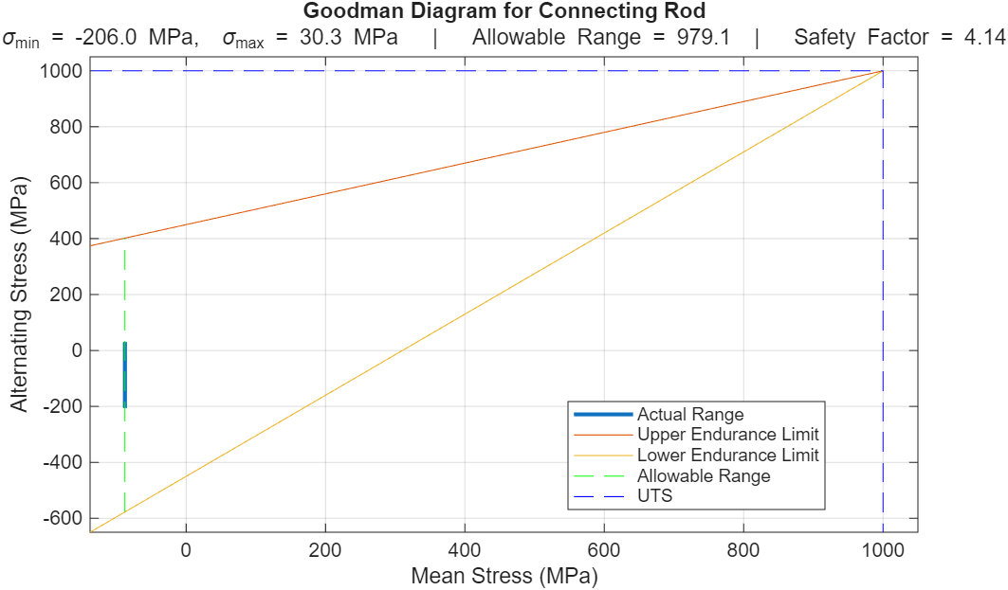
Figure 5 - Goodman diagram of the midpoint of the connecting rod.
From figure 5, the connecting rod midpoint operates well within the allowable stress limits, with a fatigue safety factor of 4.14, indicating a highly conservative condition. The connecting rod is a critical structural component, and its failure would result in catastrophic engine damage, therefore conservative designs are applied. However, the high FSF at the midpoint is not solely due to overdesign. At this location, the rod experiences minimal bending or torsional stress, resulting in low alternating stress (Heywood, 2019). The stress is further reduced by the large cross-sectional area of the rod shank and the lack of geometric discontinuities, meaning stress concentrations are minimal. Additionally, the negative mean stress indicates compressive forces during combustion dominate, improving fatigue resistance.

3.1.1 Connecting Rod cap
A fatigue safety factor calculation was conducted on the connecting rod cap to compare stresses relative to the midpoint. As supported by figure 4 (Mahle GmbH, 2016), the cap is subjected to lower stresses, resulting in a higher fatigue safety factor of 7.5819 (Goodman diagram in appendix). This is expected because rod bolts apply a large clamping preload that keeps the cap in compression during operation. As a result, the cap experiences small cyclic stress variations as it is not part of the primary cyclic load path and its main role is to maintain crankshaft alignment (Budynas and Nisbett, 2020). The cap also has a larger cross-sectional area than the rod midpoint. The midpoint of the cap was selected for analysis as this region has a larger radius and is less susceptible to stress concentrations.

3.2 Gudgeon Pin
The gudgeon pin is a critical component which is subject to bending and shear stresses during engine operation. These combine to produce a resultant stress which is used to calculate the fatigue safety factor of the pin.
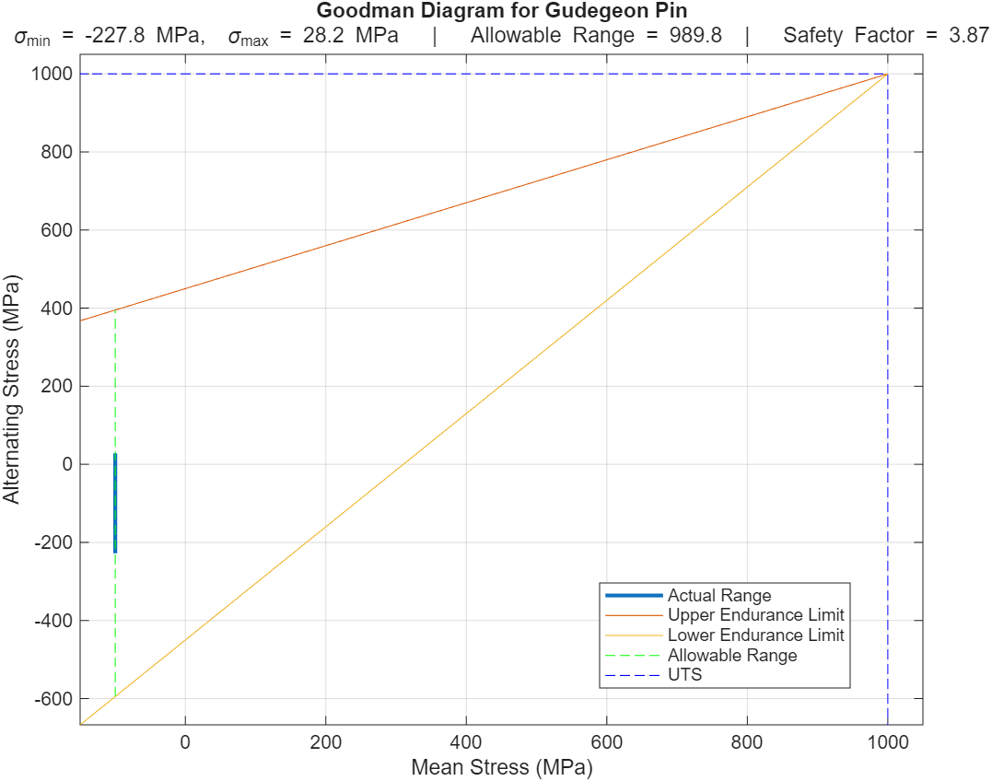
Figure 6 - Goodman diagram for the gudgeon pin.
Figure 6 shows the gudgeon pin experiences more compressive stress due to the mean stress being concentrated around -94 MPa. This is explained by its role of transmitting combustion forces from the piston to the connecting rod. (Stone, 2012) Figure 6 clearly shows the gudgeon pin operating within its stress limits via the actual range sitting within a small region of the allowable range. This is supported by the fatigue safety factor calculated as 3.8676, implying the pin can withstand the cyclic loading.
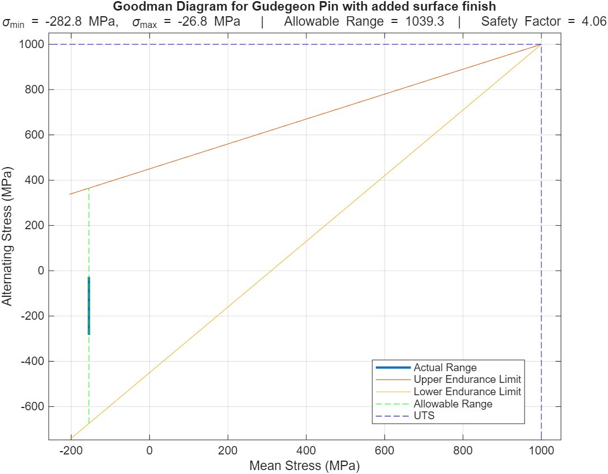
Figure 7 - Goodman diagram for the gudgeon pin with added surface finish.
As discussed by Mahle GmbH (2016), it is common practice to apply surface coating to gudgeon pins to improve wear resistance and friction behaviour. A surface treatment is particularly important for gudgeon pins as fatigue cracks often initiate on the surface where bending stresses are highest. Therefore, after conducting research, a compressive residual stress of −55 MPa was applied to the model to represent a surface finish. As shown in figure 7, this shifts the mean stress to -154 MPa. This improves fatigue life as Stephens (2001) explains cracks begin to initiate more commonly in tensile loading and so adding compressive stresses delays fatigue. As expected, the fatigue factor of safety increased to 4.0610 when applying the surface finish, supporting the theory that tensile stress increases the pins susceptibility to fatigue failure. The conservative FSF is due to the pin relying heavily on surface finishes to reduce crack initiation, and due to this being uncertain and difficult to control precisely, engineers compensate by increasing the FSF.

3.3 Connecting Rod Bolt
The connecting rod bolts are used to clamp the big end cap to the connecting rod. Due to the tightening of the bolts, the preload increases tensile stress on the bolts, demonstrating the importance of analysing their fatigue safety factor. (Heywood, 2019) A tightened bolt undergoes elastic deformation, generating an axial preload force that clamps the surfaces together. The preload was estimated by assuming the bolt is tightened to 90% of its yield strength, with the axial stress taken as approximately 60% of the UTS. This is a common assumption used to approximate preload. However, in reality, the achieved preload is highly dependent on thread friction, lubrication, and tightening methods. (Petersen, 1974)
Initially, the fatigue safety factor of the bolt was 10.38, which suggests an over-engineered bolt. Therefore, a stress concentration factor, $Kt$, (as shown in the appendix), was added to the 8x0.75mm bolt to improve realism. Bolts contain geometric discontinuities including threads and fillets which prove vulnerable to stress raisers and as explained by Petersen (1974), fatigue cracks initiate at these locations. So $Kt$ is used to account for the local stress region increase from the radius change.
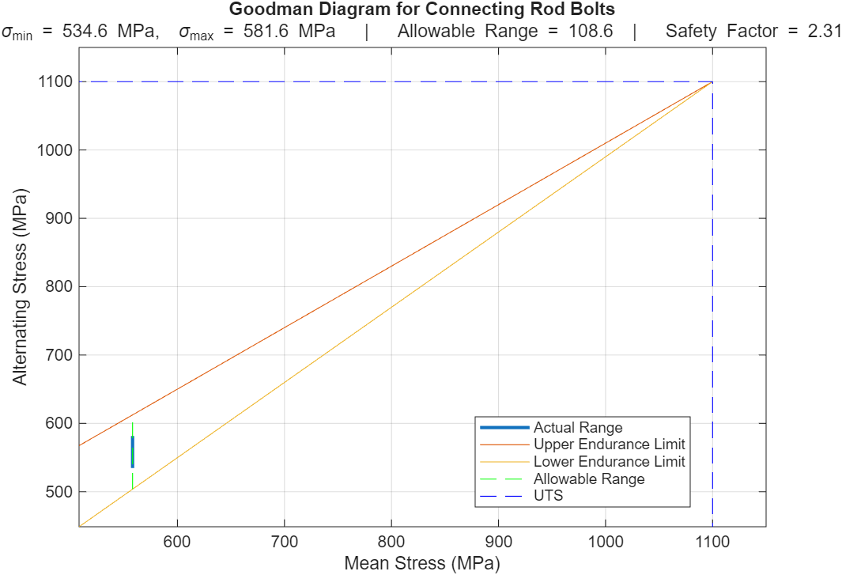
Figure 8 - Connecting rod bolt goodman diagram (with no gas forces and an added stress concentration factor).
From figure 8, the safety factor with the added $Kt$ reduces to 2.31 representing a more realistic value as supported by Jia et al (2025) that connecting rod bolts often present an FSF of 1.5-2. Figure 8 clearly shows the bolt is predominately subjected to tensile loading due to the positive mean stress range. This is explained by the preload on the bolt required to clamp the big-end cap, as well as additional tensile loading from inertia forces during engine operation. (Budynas and Nisbett, 2020) The graph shows a very small alternating stress range, showing less room for stress fluctuations. This is due to the Goodman theory as expressed by Altair (2026), that as mean tensile stress increases, the allowable alternating stress must decrease.

3.3.1 Connecting Rod bolt at 6000 RPM with gas forces
To further improve the model, the gas forces within the engine were added to analyse their effect on the bolt.
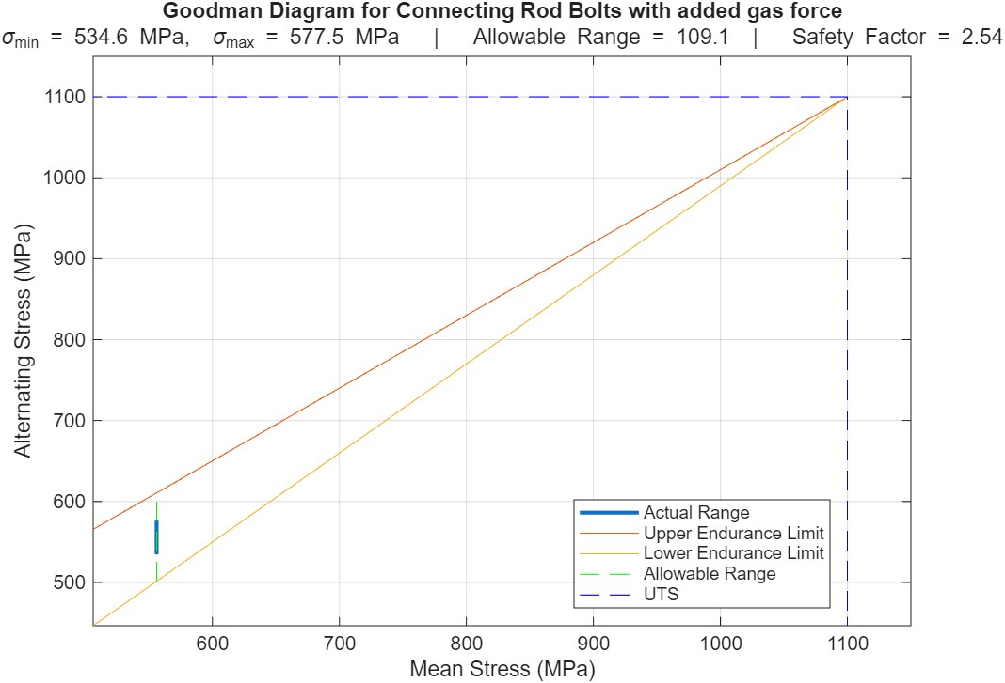
Figure 9 - Goodman diagram for the connecting rod bolt with added gas forces.
From figure 9, the fatigue safety factor increases by 0.2 with the added gas forces. This is expected as the addition of compressive forces relieve some of the tension from the bolt as it is acting in the opposite direction to inertia forces. (Bolt Science, 2025) Figure 9 shows an increased allowable range as the mean stress has decreased, supporting the Goodman theory explained by Altair (2026) and resulting in a larger safe operating region. The lower fatigue safety factor of the bolt compared to the connecting rod is expected due to their replaceability and serviceability. Furthermore, Heywood (2019) explains that rod bolts operate closer to their fatigue limits compared to the connecting rod because their small size and geometric constraints limit the ability to significantly increase their cross-sectional area, as they must fit within the big-end geometry of the connecting rod assembly.

Chapter 4 – Connecting Rod Bolt redesign
To analyse the effect of increased stress on the connecting rod bolt, the engine speed was extended from 6000 RPM, which is what the bolt is designed for, to 9000 RPM as shown in figure 10. This is done by engineers to assess component robustness under extreme operating conditions. Figure 10 shows the use of linear interpolation to approximate gas forces at 9000 RPM, however, in a turbocharged engine, gas forces vary non-linearly with RPM due to changes in boost pressure and airflow.
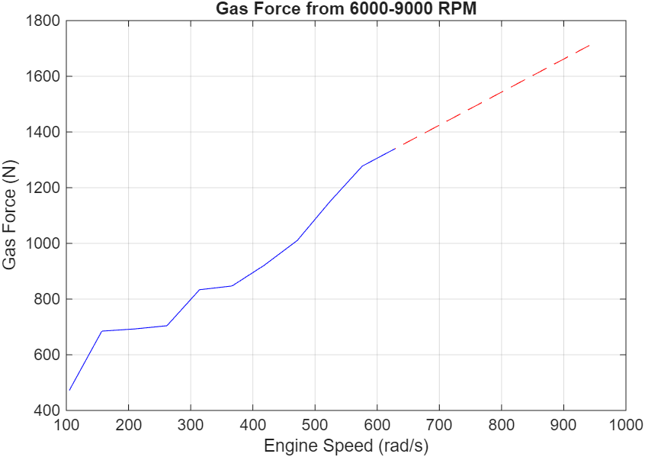
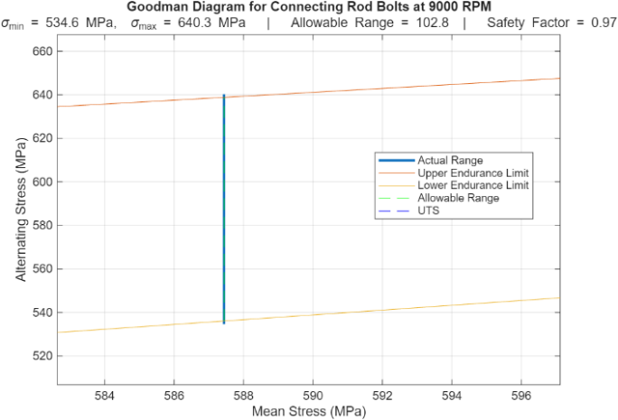
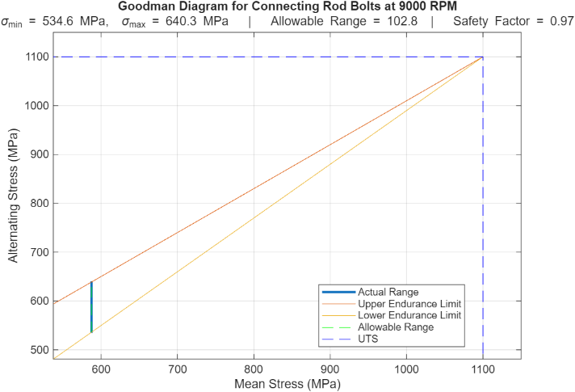
Figure 10 - Peak gas force interpolation from 6000 RPM to 9000 RPM.
Figure 11 - Goodman diagram representing the bolt at extended RPM range.
Figure 12 - Section view of the goodman diagram representing the allowable range of the bolt.

Figures 11 and 12 clearly show the stresses applied to the bolt exceed the limits of operation. This is confirmed by the fatigue safety factor being below 1, confirming the bolt will likely fail under cyclic loading at increased RPM. As mentioned in chapter 2.1, inertia force is directly proportional to the square of speed and so the increased RPM range results in a higher inertia force amplitude. Consequently, the maximum stress increases from 570 MPa at normal operating speeds to 640 MPa at 9000 RPM, resulting in the bolt reaching its fatigue limit.
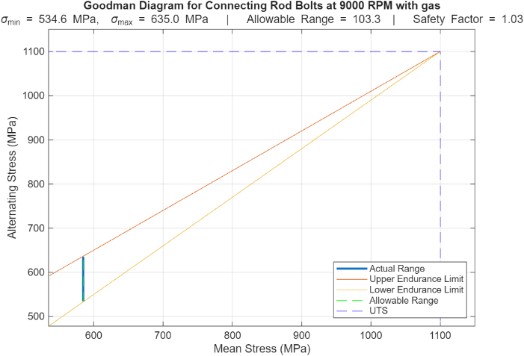
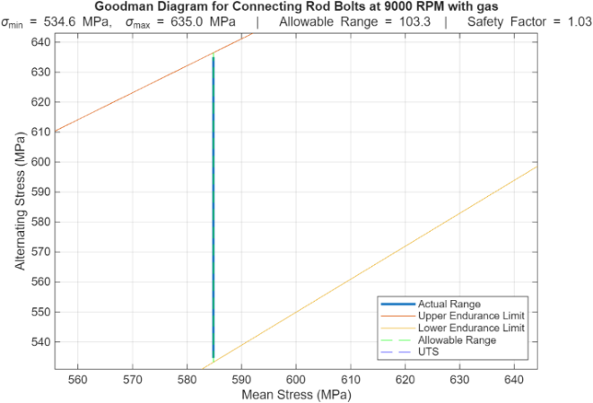 Figure 14 - Section view of the goodman diagram for the connecting rod with extended RPM range and added gas force.
Figure 13 - Goodman diagram for connecting rod at extended RPM range with added gas forces.

To improve the model, gas forces were added at 9000 RPM. Similarly to the normal RPM range, the fatigue safety factor improved due to the compressive stresses ofsetting tensile loading on the bolt. Figures 13 and 14 show the bolt is operating on the limit of its fatigue life, showing its vulnerability to failure. A limitation of using gas forces is the reliance on cylinder pressure data, which may not fully capture transient combustion effects, cycle-to-cycle variation, or peak pressure spikes. The inclusion of gas forces may artificially reduce the predicted tensile stresses and lead to a non-conservative estimation, therefore, from a design perspective, it may be more appropriate to consider only inertia forces, as this neglects the beneficial compressive effects of gas forces and ensures the bolt is designed against worst-case conditions.

4.1 Geometric Consideration
To improve the bolt under the extended RPM range, the wasted shank section was investigated. By reducing the diameter of the wasted shank, the area of the bolt reduces and subsequently reduces the overall stiffness. This in turn improves bolt compliance and improves the fatigue factor of safety due to the bolts ability to absorb more deformation and reduce cyclic stress amplitude. (LF-BJMB, 2026)
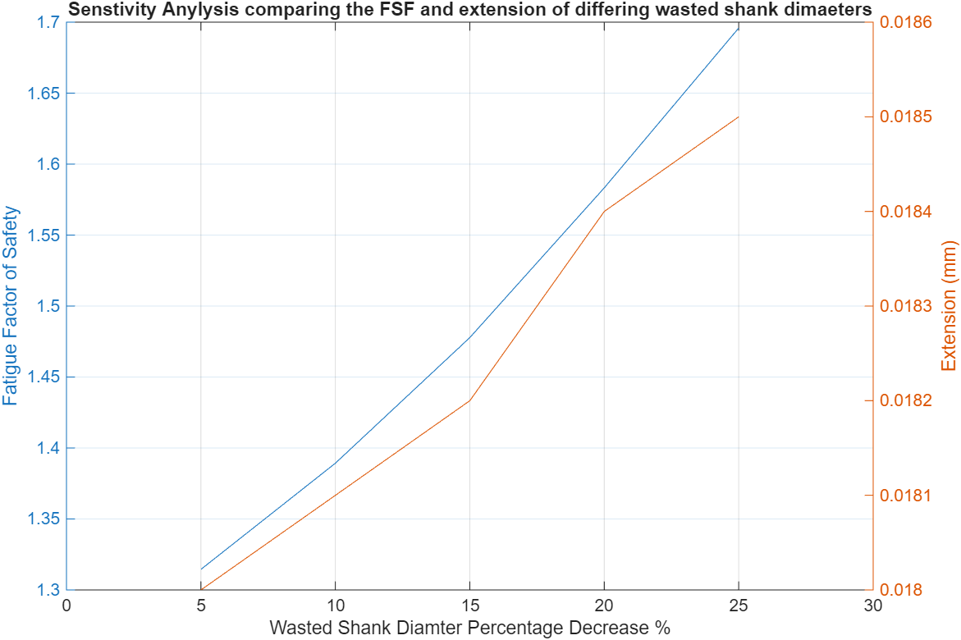
Figure 15 – Sensitivity Analysis of connecting rod bolt optimised wasted shank diameters.
Figure 15 shows that decreasing the wasted shank diameter increases both fatigue safety factor and bolt extension. The improvement in fatigue performance compared to figure 13 is attributed to a reduction in the joint stiffness factor, meaning a greater proportion of the load is distributed to the connecting rod cap rather than the bolt. However, as explained by Barrett (1990), reducing the stiffness of the bolt makes it more flexible and more susceptible to stretching which can affect the bearing clearance.
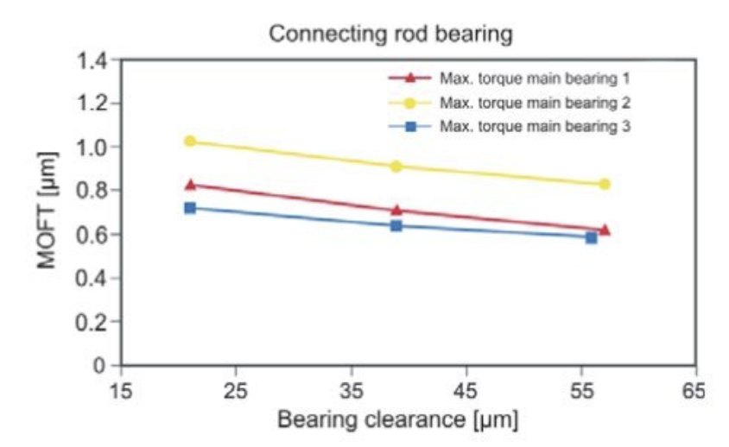
Figure 16 - Connecting rod bearing clearance investigation. (Mahle GmbH, 2016)
At a 25% reduction in shank diameter, bolt extension increases from 0.0159 mm to 0.0185 mm, representing an increase of 2.6 μm. This can be compared to typical connecting rod bearing clearances, which are approximately 20–60 μm from figure 16 (Mahle GmbH, 2016). This 2.6 μm increase represents approximately 13% of the clearance range using the worst-case scenario from figure 16. This suggests the effect is relatively small but not negligible and should be considered when altering the wasted shank diameter to avoid potential impacts on bearing performance.

4.2 Material Consideration
Research was conducted to investigate alternative materials to improve the FSF at higher engine speeds. Alloys Int. (2024) explains that 8740 Chromium-Molybdenum Alloy Steel is often used for aerospace fasteners. With an increased UTS, yield strength and modulus of elasticity compared to the original material, the fatigue factor of safety improved to 1.73.
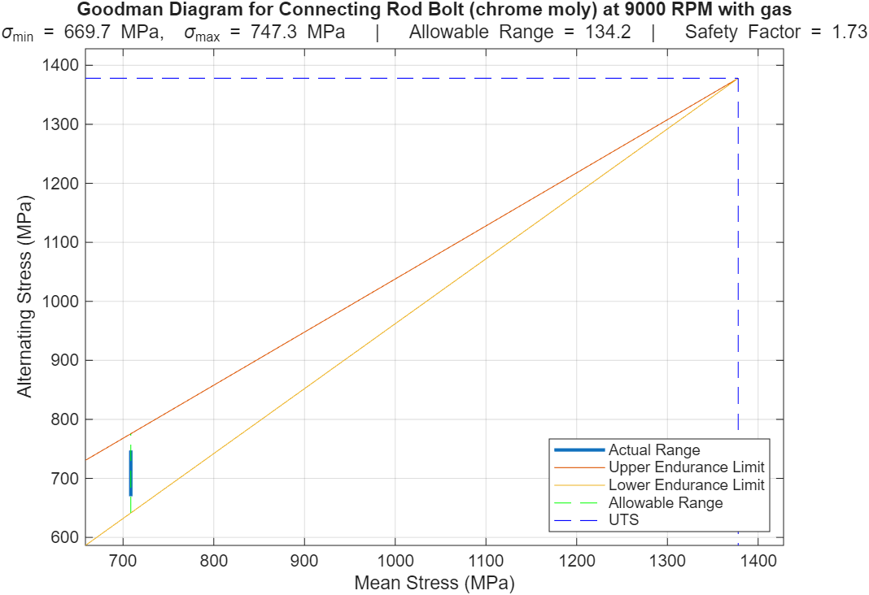
Figure 17 - Goodman diagram for the bolt with optimised wasted shank and alternative Chrome Moly Alloy steel material.
By changing the material of the bolt, this doesn’t reduce cyclic stresses but focuses on improving the bolts’ ability to withstand them. This comes from the increased UTS value of the material and therefore its increased endurance limit, resulting in a larger allowable stress range as shown in figure 17. The increase in maximum stress seen compared to figure 13 with no optimisation can be explained from the increase in yield strength, which is used to calculate axial preload force, increasing tensile load on the bolt. It must be considered that increasing the UTS allows higher preload to be applied, which requires a change in tightening torque. This can increase the initial tensile stress in the bolt and influence its fatigue behaviour. The extension of the bolt increased to 0.0222mm, however, according to figure 16 by Mahle GmbH (2016), this is still a relatively small change and so unlikely to have an impact on bearing clearance.
From the design considerations both the material and wasted shank changes provided a successful increase in FSF, however, material optimisation provides greater fatigue improvement. This is because enhanced material properties increase the allowable stress limits of the bolt, whereas geometric modifications mainly reduce the applied stress without altering the material’s inherent strength.

Chapter 5 – Torque Generation
This section investigates how crankshaft configuration affects the instantaneous torque fluctuations produced.

5.1 Instantaneous Torque Generation

5.1.1 Standard Crankshaft Configuration Torque Inertia
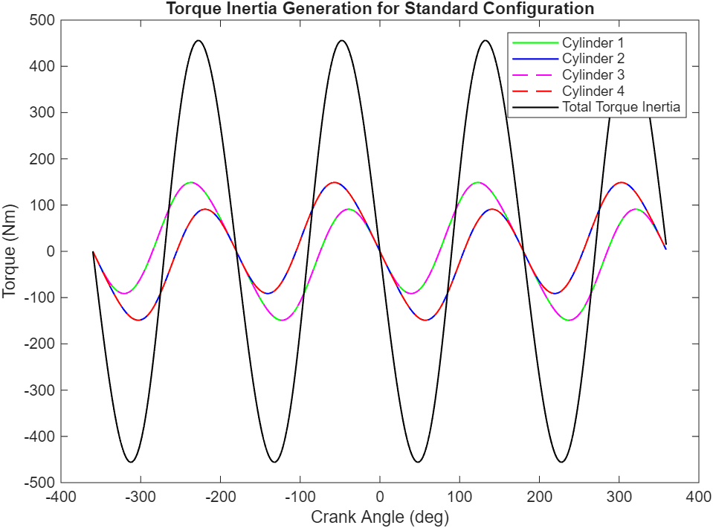
Figure 18 - Torque inertia of standard configuration with cylinder realignment.
Figure 18 illustrates the torque generation of each cylinder in a standard crankshaft configuration. The offset in cylinder torque peaks is due to the firing order in the crankshaft geometry, demonstrating the variation in torque generation across the cycle. Wan (2017) explains that the order of firing is to help reduce end-to-end vibration as it ensures the expansion strokes occur at evenly spaced crank intervals, which reduces vibration and produces smoother torque delivery.

5.1.2 Cross-Plane Crankshaft Configuration
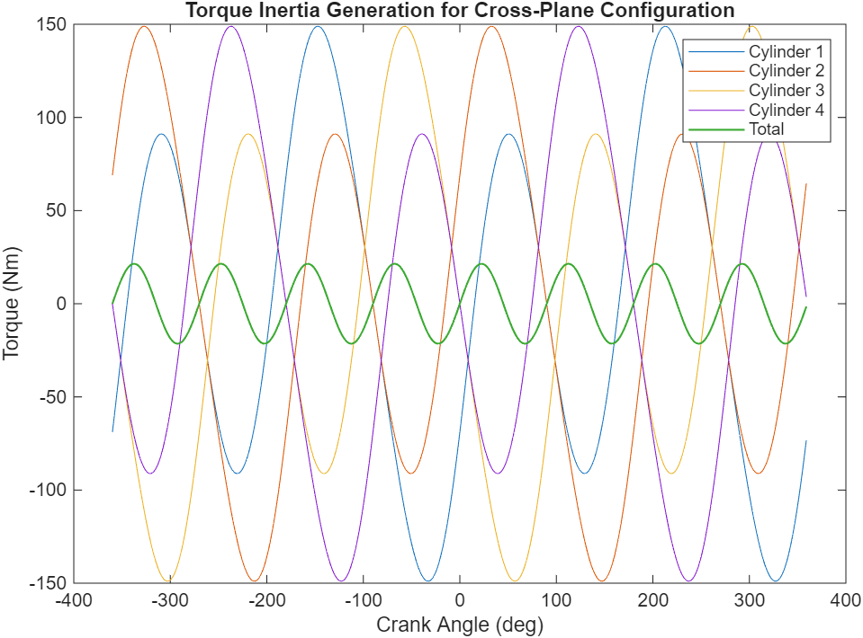
Figure 19 - Torque inertia of cross-plane configuration with cylinder realignment.
Figure 19 shows the altered crankshaft phasing in a cross-plane configuration which causes the individual torque waves to overlap more, resulting in a smaller inertia torque fluctuation. Each cylinder produces differing torque magnitudes alternating from smaller to larger peaks due to the variation in effective crank radius throughout rotation. (Heywood, 2019).

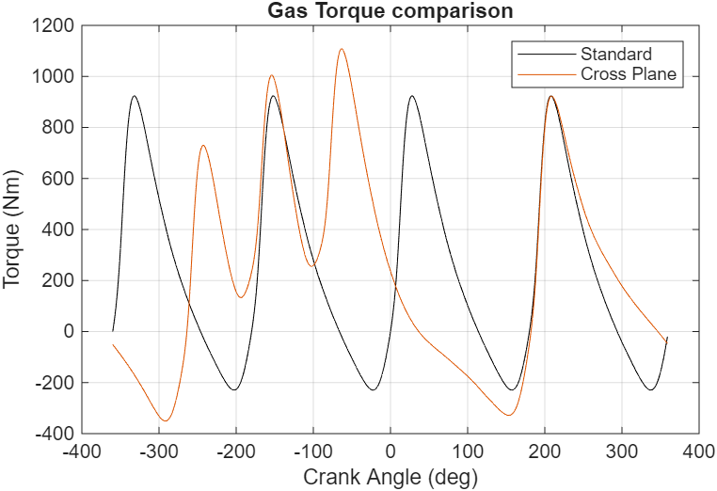
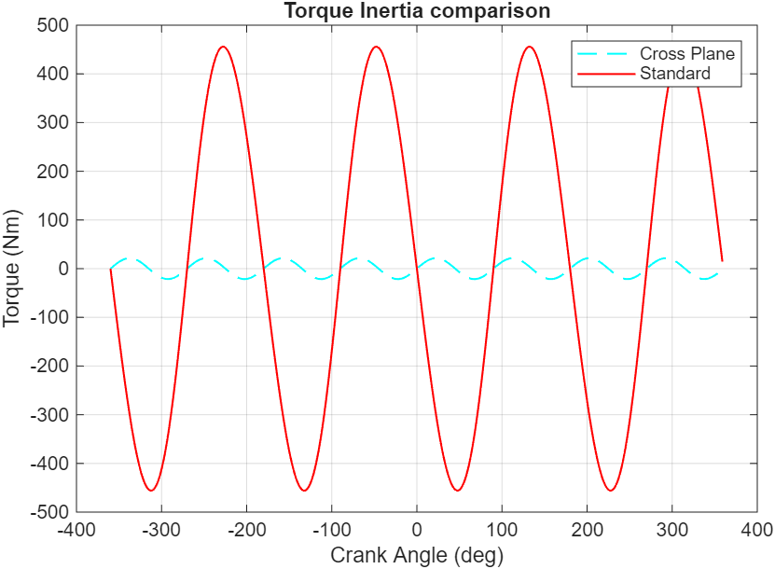
5.1.3 Comparison of gas and inertia torque
Figure 21 - Comparison between gas torque from the standard vs cross- plane configurations.
Figure 20 - Comparison between the total inertia torque generation from a standard vs cross-plane configuration

Figures 20 and 21 show that the standard crankshaft produces evenly distributed gas torque due to uniform firing intervals, resulting in regular combustion pulses (Heywood, 2018). However, it exhibits larger inertia torque oscillations, as it does not cancel secondary inertial forces due to pistons moving in pairs. (Pulkrabek, 2004). The cross-plane configuration generates uneven gas torque due to irregular firing intervals but significantly reduces inertia torque oscillations through improved dynamic balance.

5.1.4 Crank Torque
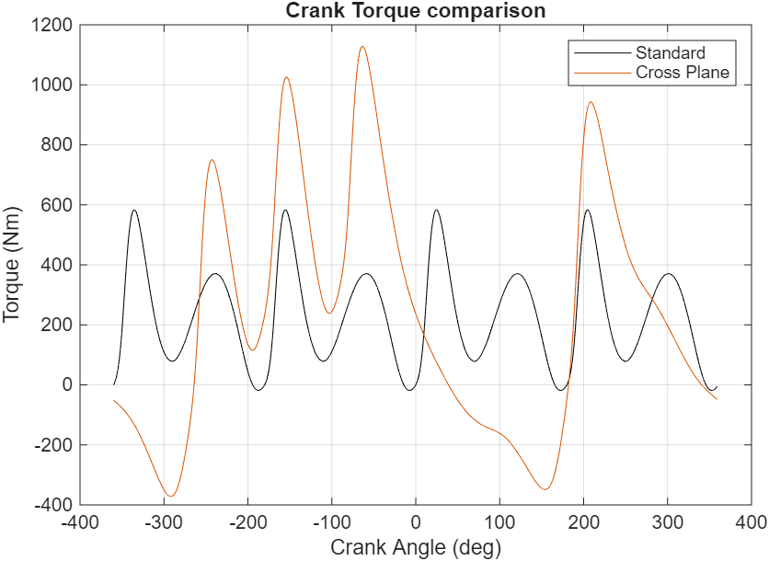
Figure 22 - Comparing crank torque between standard and cross-plane configurations.

Although the cross-plane configuration shows increased crank torque variation in figure 22, this does not account for flywheel or drivetrain smoothing. The cross-plane crankshaft reduces inertia oscillations (figure 20) through improved dynamic balance, resulting in lower vibration levels and improved NVH characteristics (Stone, 2012). It provides smoother overall engine operation and is commonly used in road applications. Conversely, the standard flat-plane crankshaft is preferred in high-performance engines due to its lower mass and ability to operate at higher engine speeds due to larger instantaneous torque range compared to cross-planes, despite producing greater vibration (Wan, 2017).

5.2 Mean Torque Comparison
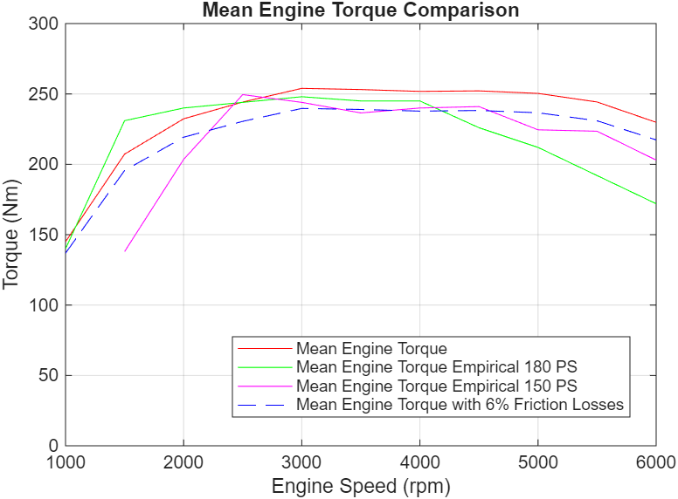
Figure 23 - Comparing engine torque curves (with and without frictional losses) with empirical data.
Using the crank torque calculation from the standard flat plane configuration, the engine torque was calculated. Figure 23 shows reasonable agreement with empirical data, with similar trends. Including frictional losses improves this agreement by providing a more realistic representation of brake torque. However, the model only considers ring and piston frictional losses which Heywood (2019) explains only accounts for 40-50% of the overall frictional losses, explaining the small 6% reduction. From figure 23, the deficit from empirical data increases as engine speed increases, suggesting the main inaccuracy comes from speed dependent losses. This can be attributed to omitting bearing and valvetrain friction losses which increase with RPM.

Chapter 6 – Conclusion
The analytical model provides a reasonable representation of the stresses experienced by the engine components, with calculated results showing good agreement with expected engine behaviour. The analysis provides a useful estimate of the fatigue safety factors, however, several assumptions were made. The analysis does not account for thermal loading or lubrication effects, both of which influence stress distribution and fatigue life. (Heywood, 2019 The model assumes ideal combustion and neglects pressure variations due to knock and cycle-to-cycle combustion variability, resulting in loading conditions that are not fully representative of real engine operation. It must be noted that the calculated fatigue safety factors are sensitive to assumptions regarding endurance limits, surface finish factors and stress concentration factors. Small variations in these significantly influence the predicted fatigue life of the components.

References
Alloys Int. (2024) Alloy steel 8740, Alloys International Inc. Available at: https://alloysintl.com/inventory/alloys-steels-supplier/alloy-steel-8740/.
Altair (2026) Altair SimSolid, Mean stress correction. Available at: https://help.altair.com/ss/en_us/topics/simsolid/analysis/fatigue_mean_stress_test_r.htm.
Barrett, R. (1990) Fastener Design Manual, NASA Reference Publication. Available at: https://ntrs.nasa.gov/api/citations/19900009424/downloads/19900009424.pdf.
Bolt Science (2025) The Effect of a Compressive External Force, The effect of a compressive external force on a bolted joint. Available at: https://www.boltscience.com/pages/basics7.htm.
Budynas, R.G. and Nisbett, J.K., 2020. Shigley’s Mechanical Engineering Design. 11th ed. New York: McGraw-Hill Education.
Heywood, J.B. (2019) Internal Combustion Engine Fundamentals. New York: McGraw-Hill Education.
Hwang (2024) Analysing safety factors and predicting fatigue life of weak points in an electrically driven, multi-purpose cultivation tractor, MDPI. Available at: https://www.researchgate.net/publication/378750234_Analyzing_Safety_Factors_and_Predicting_Fatigue_Life_of_Weak_Points_in_an_Electrically_Driven_Multi-Purpose_Cultivation_Tractor
Jia, D., Song, X., Deng, W., Deng, X., Ji, H. and Lei, J. (2025) Analysis of the influence of geometric accuracy on the preload, stress distribution and fatigue safety factor of connecting rod bolts, Scientific Reports, 15, Article number: 11903795. Available at: https://pmc.ncbi.nlm.nih.gov/articles/PMC11903795/
LF-BJMB (2026) How to enhance bolted joint strength?, Bolt Joint Modular Building. Available at: https://www.cnxzlf.com/news/how-to-enhance-bolted-joint-strength/#:~:text=When%20the%20maximum%20stress%20on,rings%20is%20a%20superior%20choice.
Mahle GmbH (2016) Cylinder components: Properties, applications, materials. Wiesbaden: Springer Vieweg.
Peterson, R.E., 1974. Stress Concentration Factors. Wiley.
Pulkrabek, W.W. (2004) Engineering Fundamentals of the Internal Combustion Engine. 2nd ed. Pearson.
Stone, R., 2012. Introduction to Internal Combustion Engines. 4th ed. London: Palgrave Macmillan.
Stephens, R.I., Fatemi, A., Stephens, R.R., Fuchs, H.O. (2001). Metal Fatigue in Engineering. Wiley.
Wan, M. (2017) Engine Configuration and Smoothness, AutoZine Technical School. Available at: https://www.autozine.org/technical_school/engine/Smoothness1.html.
Witek, L. (2019) Stress and failure analysis of the connecting rod of diesel engine - sciencedirect, Science Direct. Available at: https://www.sciencedirect.com/science/article/abs/pii/S1350630718312378
Yang, D. et al. (2017) Fatigue analysis of engine connecting rod based on Workbench, Atlantis Press. Available at: https://www.atlantis-press.com/proceedings/mcei-17/25887580

Appendix
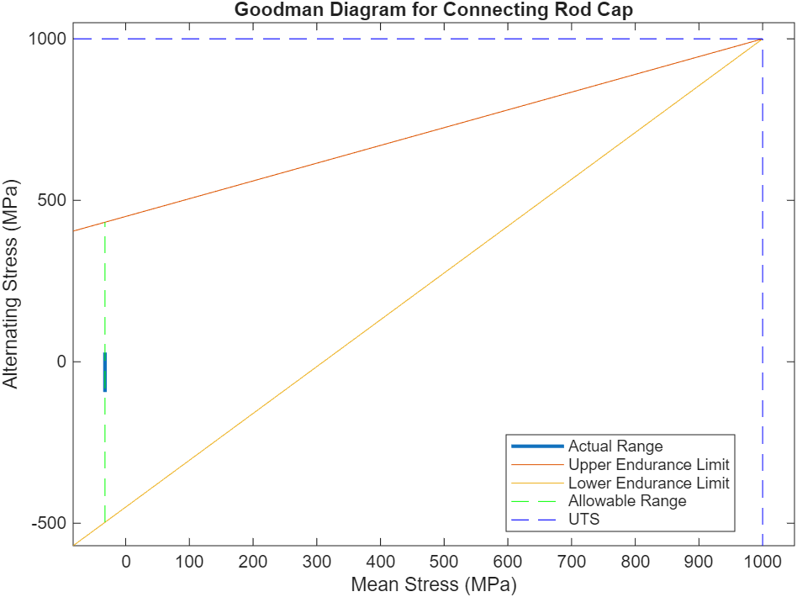
Figure A1 – Goodman diagram for the connecting rod cap.
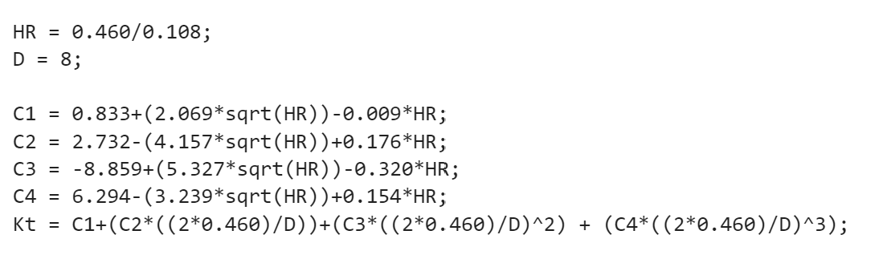
Figure A2 – Stress concentration factor calculation applied to the bolt using 8x0.75mm dimensions.
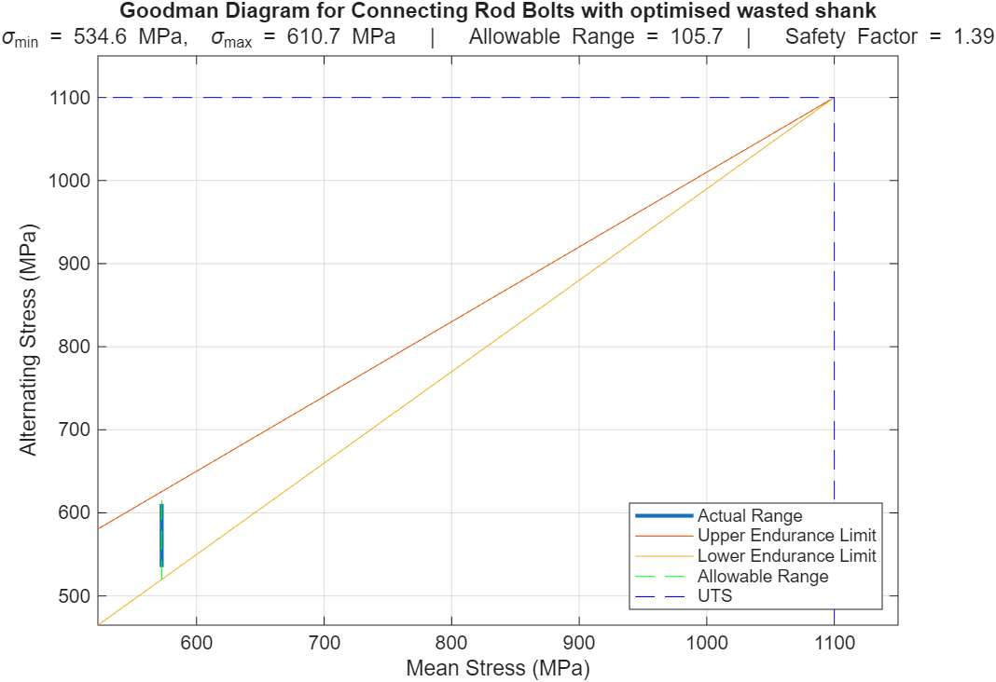
Figure A3 – Goodman diagram of 10% reduction in wasted shank diameter.

