Pursuing a Career as a Health Care Support Worker
Module: BSc Health and Social Care
Module Code: BMHP5015
Component 2: Written Assignment (Report)
Word Count: Approx. 2,000 words

Table of Contents
1. Introduction 2
2. Job Description and Person Specification 2
3. Employability Skills Required 3
4. Self‑Assessment of My Skills 4
5. Experience and Qualifications to Date 5
6. Building My Personal Brand and Professional Identity 5
7. Value I Can Add to the Role 6
8. Action Plan and Timeline 6
9. Resources Needed 7
10. Communicating My Skills to Employers 8
11. Building a Network 8
12. Personal Development and Resilience 8
13. Conclusion 9
14. Reference List 10

1. Introduction
I am currently a BSc Health and Social Care student in the UK and I want to work as a Health Care Support Worker in the future. Health Care Support Workers (also called care assistants or support workers) provide direct care to people who may have learning disabilities, mental health difficulties or long‑term conditions. They help people with daily living activities, support them to live independently and promote their wellbeing. The National Careers Service explains that care workers support vulnerable people with their daily activities and help them live as independently as possible According to the job description from University Hospitals Bristol and Weston NHS Trust, a health care support worker is a core member of the team delivering personal care to patients under the supervision of a registered practitioner and must provide compassionate care to agreed quality standards This report analyses the skills required for this role, evaluates my current skills and experience, and sets out an action plan to prepare me for a future career as a Health Care Support Worker.

2. Job Description and Person Specification
NHS Jobs listed a Leeds and York Partnership NHS Foundation Trust Support Worker position. The Specialised Supported Living Service prioritises those with learning challenges, according to the ad (Leeds and York Partnership, 2026). The Trust seeks compassionate, experienced support workers who share its values of care, integrity, and simplicity. This permanent (Band 3) position pays £24,937 to £26,598 per year and requires working shifts, including nights, weekends, and public holidays (Leeds and York Partnership, 2026). Candidates should have experience with learning disabilities and assisted living, work independently and collaboratively, and hold or be willing to pursue a Level 2 or Level 3 Diploma/NVQ in Health and Social Care.According to the University Hospitals Bristol and Weston job description, health care support professionals perform non-clinical chores, execute support plans, encourage independence, maintain correct records, and communicate effectively with team members and families.
Main duties of the job include:
- Assisting with daily living activities such as personal care, meal preparation and household tasks (Arora Group, 2025)
- Supporting individuals to access community activities and services
- Following individual support plans and promoting independence
- Providing emotional support, companionship and encouraging social interaction
- Supporting people with healthcare interventions and positive behaviour support plans
- Maintaining accurate records and communicating effectively with the team and families (University Hospitals Bristol and, 2023)
Person specifications highlight important skills and capabilities. Essential abilities include teamwork, time management, prioritisation, compassion for patients and relatives, written and vocal communication, basic IT skills, and a willingness to learn (Laurent, 2025). Job requires Level 2 certificate in Health and Social Care, such as a QCF Diploma or NVQ GCSEs in English and Mathematics. Experience in delivering care in a health or social care context is preferred but not required (University Hospitals Bristol and, 2023). The job is physically hard and demands flexibility to work different shifts (University Hospitals Bristol and, 2023).

3. Employability Skills Required
Health care support workers need many employability skills. These skills enable workers to provide high-quality care, collaborate securely, and communicate effectively (Leeds and York Partnership, 2026). This role's important employability skills are evaluated below.
Skill | Why it is important
Communication | Effective verbal and written communication ensures that care instructions are understood, records are accurate and patients feel listened to. The National Careers Service notes that care workers need good communication skills, including understanding non‑verbal methods like Makaton or PECS (Leeds and York Partnership, 2026).
Teamwork | Support workers collaborate with nurses, therapists and families. Being able to work as part of a team and share information improves patient care and safety (Arora Group, 2025).
Empathy and compassion | Caring attitudes help to build trust and provide emotional support to people who may be anxious, distressed or unwell (National Healthcareer Association, 2025).
Time management | Support workers have to prioritise tasks and manage their time during busy shifts (National Healthcareer Association, 2025).
Flexibility | The role involves working a variety of shifts, adapting to changing situations and supporting individuals with diverse needs (Laurent, 2025).
Record‑keeping and IT skills | Maintaining accurate notes and using electronic records systems ensures continuity of care and legal compliance (Laurent, 2025).
Physical stamina | The job can be physically demanding and may involve moving and handling patients and equipment (Arora Group, 2025).
Commitment to training | A willingness to undertake training, such as completing the Care Certificate and NVQ Level 2/3, ensures workers maintain competencies and develop professionally (National Healthcareer Association, 2025).

4. Self‑Assessment of My Skills
I'm learning several health care support worker skills as a student. I listen closely, ask clarifying questions, and summarise knowledge well in writing and speech. I often organise and include everyone in university group assignments (Laurent, 2025). Health and social care require empathy and compassion, which I appreciate. I value dignity and independence for all. Volunteering at a community center in Al Farwaniyah has enhanced my confidence in aiding the elderly and connecting with diverse individuals (University Hospitals Bristol and, 2023).I must improve in some areas. I have limited direct experience working with people who have learning disabilities or complex behavioural needs. Managing time can be difficult when I have numerous assignments due. To fill these deficiencies, I will employ self-assessment tools (Arora Group, 2025). The NHA career guide recommends self-assessment of communication, collaboration, and attention to detail to identify areas for improvement. I will use a self-assessment worksheet and seek feedback from tutors, classmates, and supervisors. I will also record my communication and time management successes and failures in a reflective diary. This will help me identify patterns and improve.Peer and mentor feedback is also useful. I'll ask my professors and placement supervisors for performance evaluations and improvement tips. Friends and relatives may spot my attributes I ignore when we discuss my strengths and weaknesses. A 360-degree critique will provide a balanced assessment of my skills.

5. Experience and Qualifications to Date
My academic and extracurricular experiences have prepared me for a profession in health and social care. I am in my second year of BSc Health and Social Care, studying anatomy, physiology, safeguarding, person-centred care, mental health, and social policy. These programs taught me about human growth, health disparities, and empowerment. I have first aid, protecting adults, and basic life support certifications (National Careers Service, 2026). I helped at a care home during summer break, helping with lunch service, group exercises, and companionship (Arora Group, 2025). This event improved my patience, communication, and empathy.I also worked on a university student health awareness campaign. The research, planning, and clear presentation improved my organization and presentation skills. However, I have not yet completed the Care Certificate or Level 2 Diploma in Health and Social Care, which are necessary for the position. My action strategy addresses these.

6. Building My Personal Brand and Professional Identity
In a competitive employment market, a personal brand helps companies understand you and your values. The Arora Group emphasizes that your personal brand conveys your values, work style, and value to a team, rather than self-promotion. Starting a personal brand requires defining your strengths and values (National Healthcareer Association, 2025). According to the essay, you should focus on your best moments and utilize coworker input to build your professional identity.Empathy, active listening, adaptability, and cultural knowledge are my skills. My Kuwaiti upbringing taught me to respect cultural differences and converse with varied individuals. Like the NHS, I cherish integrity, learning, and kindness. My professional LinkedIn profile will highlight my qualifications, volunteer experiences, languages, and values to construct my brand. My CV will be updated and tailored to each job application. I will join appropriate professional groups and write about mental health and social care.Maintaining consistency is crucial. The Arora Group stresses that your application materials and behavior should reflect dependability and collaboration (Laurent, 2025). I will ensure that my online presence reflects the caring, professional image I want employers to see. I'll cultivate relationships with supervisors and mentors who can promote me and provide recommendations.

7. Value I Can Add to the Role
Each applicant has something special. Cultural competency and English-Arabic bilingualism are my selling points. Healthcare for various patients is crucial in the NHS (Arora Group, 2025). Effective communication and cultural awareness can make Arabic-speaking patients feel valued and heard (University Hospitals Bristol and, 2023). Moving to the UK for education showed me tenacity and adaptation. I'm passionate about mental health and will help patients and families with empathy and communication.

8. Action Plan and Timeline
In order to become a health care support worker, I have created a five-year action plan. This plan details my efforts to acquire the relevant skills, experience, and credentials (Arora Group, 2025).
Key actions and timeline:
- April 2026 - September 2026: Finish BSc Health and Social Care degree modules, focusing on care, communication, and ethics (Arora Group, 2025).
- June 2026 - December 2026: Join a weekly volunteer program in a Leeds care home or hospital to gain experience supporting individuals with learning difficulties (University Hospitals Bristol and, 2023).
- From September 2026 to January 2027: Complete the Care Certificate to acquire support worker skills (National Careers Service, 2026).
- Start a Level 2 or Level 3 Diploma/NVQ in Health and Social Care from April to August 2027. Attend practical workshops and complete assignments while working part-time (National Careers Service, 2026).
- From August to December 2027: Improve communication, leadership, and record-keeping abilities through short courses and workshops (Arora Group, 2025).
- In 2028, January to June: Royal College of Nursing student membership and Skills for Care communities are professional networks. Attend webinars and conferences.
- From September 2028 to June 2029: Apply for NHS health care support worker vacancies. Customize CV and cover letter for each application and prepare for values-based interviews (University Hospitals Bristol and, 2023).
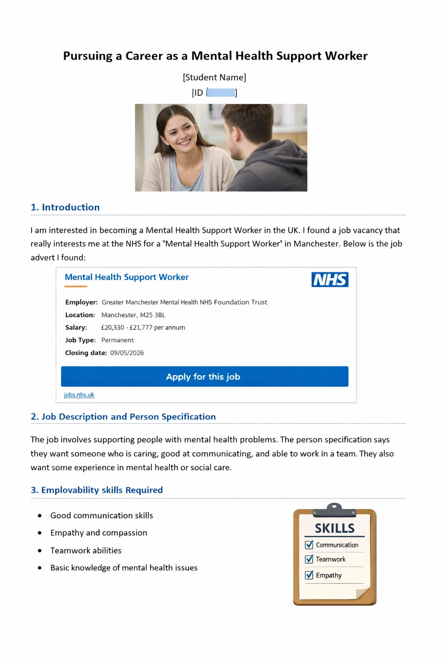

9. Resources Needed
Several resources will help me grow. I must enroll with a recognized training provider to complete the Care Certificate and NVQ Level 2/3 (University Hospitals Bristol and, 2023). Many NHS trusts and colleges offer apprenticeships and flexible programs. For this role, the National Careers Service recommends college courses, apprenticeships, volunteering, or direct application (Laurent, 2025). I aim to enroll in a Level 2 Diploma college course and apply for an apprenticeship if possible. I will continue volunteering and explore for NHS England or local charity chances to build experience. I will also take online time management, communication, and digital skills courses and use the university's career service for CV comments and practice interviews.

10. Communicating My Skills to Employers
Communicating my expertise to employers is crucial. I will write a brief CV highlighting my qualifications, volunteer experience, and transferable abilities. My LinkedIn profile will feature a professional photo, a synopsis of my goals and values, and my accomplishments. The Arora Group blog advocates using LinkedIn to stay visible and reinforce your message. I will also write a brief personal statement for job applications that shows how my beliefs match the employer's (Arora Group, 2025). I may practice introducing myself and talking about my strengths at networking events (Arora Group, 2025). I can prepare for values-based interviews by researching the Trust's values and using examples from my volunteering experience to demonstrate my qualities (Arora Group, 2025).

11. Building a Network
Career advancement relies on networking. The Arora Group reports that networking fills up to 80% of jobs, rather than advertising. Maintaining professional connections can lead to mentorship and new opportunities. Build my network My students, professors, and placement supervisors are my immediate circle. I will also visit healthcare conferences and workshops to meet specialists. LinkedIn lets me interact with healthcare experts globally and join relevant organisations (National Careers Service, 2026). I'll find a mentor through university or professional programs to get advice and network. Joining professional organisations and serving on committees will boost my credibility. Finally, networking is reciprocal, so I will listen and enable others to create trust and partnerships.

12. Personal Development and Resilience
Health and social care are gratifying and emotionally draining. Support workers may face unanticipated scenarios with distressed, ill, and bereaved patients and families. Developing personal resilience and self-care are crucial for professional growth. My ability to deliver compassionate treatment depends on my own health. My university and local NHS trust will offer stress management and resilience training. Mindfulness, peer support, and reflective writing help me cope and avoid burnout.CPD extends beyond formal education. It involves reviewing practise, learning from peers, and following best practise. Since the job description emphasises safeguarding, equality, diversity, and infection control, I will frequently examine NHS values and policies (Laurent, 2025). Trust and infection prevention rules I can deliver safe care and protect patients' rights by staying current on policy. I will study articles, attend webinars, and join online forums to learn about dementia care and positive behaviour support.Personal development also involves ethical awareness. As a health care support worker, I must get consent before providing care, protect confidentiality, and act within my competence. I will read the Code of Conduct for Health Care Support Workers and Assistant Practitioners and discuss ethical issues with my mentors. I will also do Mental Health First Aid training to help colleagues and service users in crisis (National Healthcareer Association, 2025).In conclusion, I will practise reflection. I will provide a brief reflection on what went well, what may be better, and how I felt after each placement or volunteering session. Reflective practice promotes experience-based learning and improvement. This helps me understand how my actions affect service users and provide person-centred care (University Hospitals Bristol and, 2023). With formal training, resilience, ethical awareness, and reflective practice will make me a confident and competent health care support worker.

13. Conclusion
This study explored the function of a health care support worker, the skills needed, and my strengths and growth needs. Support staff must communicate, empathise, collaborate, and be flexible to offer vital care. I will prepare for a support worker role by finishing my degree, gaining practical experience, earning the Care Certificate and NVQ, and creating a strong personal brand and network. By continuously reflecting and developing my abilities, I can provide compassionate, person-centred care and positively impact UK health and social care services.

14. Reference List
Arora Group (2025) "How to Create a Personal Brand as a Healthcare Professional", The Arora Group blog, 13 August. Available at: https://www.aroragroup.com/2025/08/13/how-to-create-a-personal-brand-as-a-healthcare-professional-2/ (Accessed: 2 April 2026).
Laurent, F. (2025) "Why Personal Branding and Networking Are Your Superpowers in 2025", American Nurse, 10 June. Available at: https://www.myamericannurse.com/why-personal-branding-and-networking-are-your-superpowers-in-2025/ (Accessed: 2 April 2026).
National Careers Service (2026) "Care Worker", National Careers Service. Available at: https://nationalcareers.service.gov.uk/job-profiles/care-worker (Accessed: 2 April 2026).
University Hospitals Bristol and Weston NHS Foundation Trust (2023) "Band 2 Health Care Support Worker Job Description & Person Specification", UHBW Careers. Available at: https://www.uhbwcareers.nhs.uk/wp-content/uploads/2023/09/B2-Healthcare-Support-Worker-Job-Description.pdf (Accessed: 2 April 2026).
Leeds and York Partnership NHS Foundation Trust (2026) "Support Worker" job advert, NHS Jobs. Available at: https://beta.jobs.nhs.uk/candidate/jobadvert/C9173-26-0129 (Accessed: 2 April 2026).
National Healthcareer Association (2025) "A Self‑Assessment to Help You Improve Your Healthcare Career", NHA blog. Available at: https://info.nhanow.com/blog/the-single-most-important-person-in-advancing-your-healthcare-career (Accessed: 2 April 2026).
Arora Group (2025) "How to Network Effectively to Advance Your Healthcare Career", The Arora Group blog, 26 February. Available at: https://www.aroragroup.com/2025/02/26/how-to-network-effectively-to-advance-your-healthcare-career/ (Accessed: 2 April 2026).

