Name : Mariana Ionela Popa
Student ID : 2122750
Module Code : LCBB4004
Module Title: Marketing Fundamentals
Assignment: Assessment 1 Blogging to communicate
Date: 02.09.2022
Name of Lecturer: Tushara Balendran

Blog 1:

Introduction
Need to have a glance at Unilever?
https://www.unilever.com/
The blog is about the Unilever Company. Unilever is multinational consumer goods company, based in Britain. The company offers a range of products, including food, beauty, personal care, cleaning agents, OMO, ice cream, and condiments The company has its headquarters in London, England. According to the world business statistic, it is the largest producer of soap in the world, and its products are also available in more than one hundred and seventy countries the company operates in. the current CEO of the company is Alan jope, who has been the CEO from 2019. This company was founded in 1929 . Overall, Unilever has more than 168 012 employees across the globe. The company also has subsidiaries that include Hindustan Unilever, Ben &Jerry. These products sold by the company are organized into three main divisions: personal care, home care, beauty, and lastly and food. Established one hundred years ago, the brand and the company have been on top of providing consumers with the best available choices.
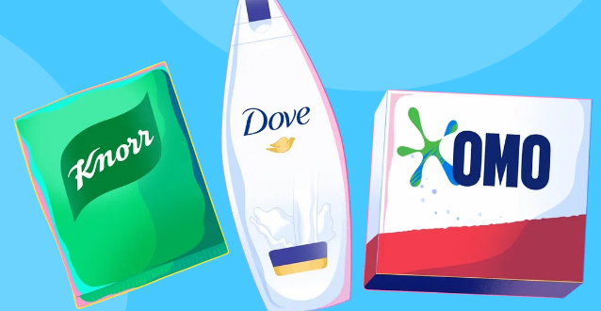
TITLE: the process of segmentation, targeting, and positioning.
https://embapro.com/frontpage/marketingstpcoanalysis/17565-unilever
Blog 2
Segmentation
The company uses three main forms of segmentation. This includes psychological; segmentation, democratic segmentation, geographical segmentation, and behavioral segmentation. First is the psychological segmentation. This segmentation method considers the consumers' thoughts, feelings, and actions. It provides an all-encompassing basis for the marketing strategy by dissecting the myriad psychological factors in consumer decisions .Solid data on what makes customers choose the brand over competitors or visit a certain store helps the company fine-tune its marketing strategy to better appeal to the target audience. Demographic segmentation has overtaken other forms of divisions because of its extensive application and several benefits. Age, gender, income, country of origin, and employment are just a few of the many observable traits that can be used to divide the population into distinct groups. Through customer segmentation, Unilever maximizes its advertising budget by narrowing it in on specific demographics of clients. Lastly is geographic segmentation. Using geographic segmentation, the company directs its marketing efforts toward certain regions. They consider factors like customer preferences and only post advertising in locations where they anticipate a positive response. This allows them to avoid squandering resources on low-return sectors to pursue other, more lucrative goals.

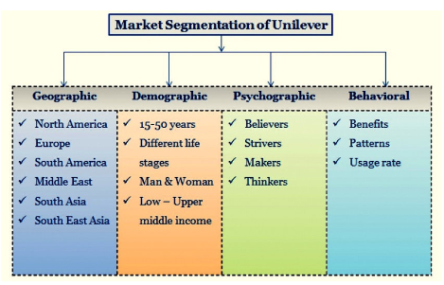

Blog 3:
Targeting
Unilever targets consumers of all ages, from young people to youths and old. Their main objective is to provide high-quality commodities to the general public so that individuals have what they need to survive and improve their living standards .Unilever has done this by expanding into new markets with its wide range of products in the personal care, food, beverage, and home care industries. In addition, they have successfully appealed to health-conscious consumers by meeting their need for high-quality, nutrient-dense choices. Nearly every home in the world has some sort of Unilever product in regular rotation. Therefore, the target demographic for Unilever's products comprises everyone who can afford to buy them.

Blog 4:
Positioning
The company uses a competitive positioning strategy. A major issue for Unilever is the availability of cheaper, locally made substitutes. This means that Unilever must spend more on advertising and marketing to maintain consumer interest in their products. Achieving a solid positioning requires in-depth familiarity with the competition and application of that knowledge to fine-tune the product for the target market (https://panmore.com/unilever-generic-strategy-intensive-growth-strategies ). Unilever puts a lot of money into marketing and advertising and is always adaptable to the needs of its customers. Products are more likely to sell well and attract buyers if they stand out from the competition in ways consumers’ value. Over the years, Unilever has built a loyal customer base because of its devotion to producing high-quality goods. Unilever has a strong grasp on all the tenets of positioning, including but not limited to: pricing, quality, service, packaging, and distribution.

MARKETING MIX
Blog post 5
Products
There is a range of products available at Unilever. These products are used by more than 3.4 billion people across the globe. We have known products that include the magnum and Hellmann's, ice screen, heart brand, walls, OMO, Persil, ben and jerry's, Rexona, sunlight, lux, Knorr, dove, lifebuoy, and spun silk. In addition to these, there is food and refreshments product. Nissin Culinary Solutions, a division of Unilever, manufactures a wide variety of food items, including the Best Foods line of mayonnaises, Knorr stock cubes which is also known as the sandwich spreads and lastly the company also has sauces. Some examples of the refreshing items that may be found here include Heart brand ice creams and Brook Bond teas. Unilever offers a variety of home care products, including the well-known detergent for washing dishes and Surf laundry detergent. The company's personal care division distributes products including Close-Up toothpaste, Vaseline lotion, and shampoo. With a string of strategic acquisitions, the company has expanded into previously unexplored subsectors of the consumer-goods industry. The firm acquired the best food products in 2000. (https://panmore.com/unilever-organizational-structure-product-innovation ).
Need to explore more about these products?

https://www.unilever.com/brands/
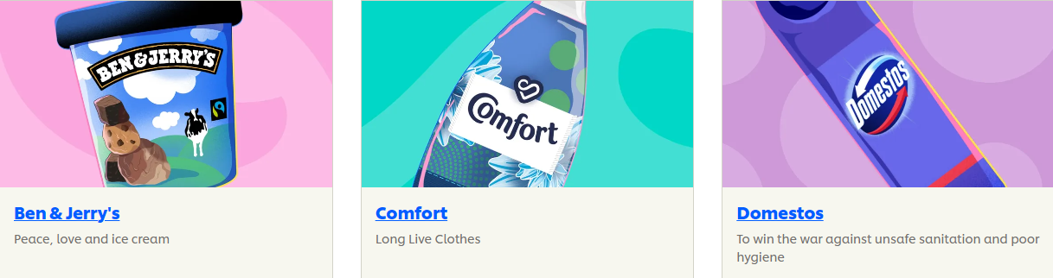
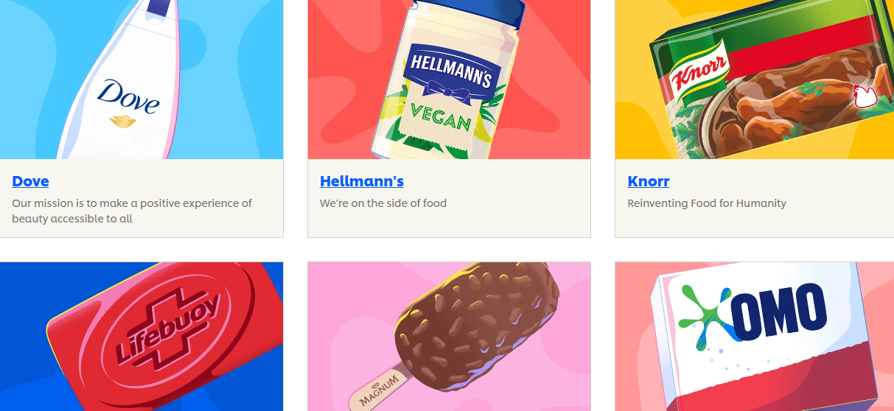
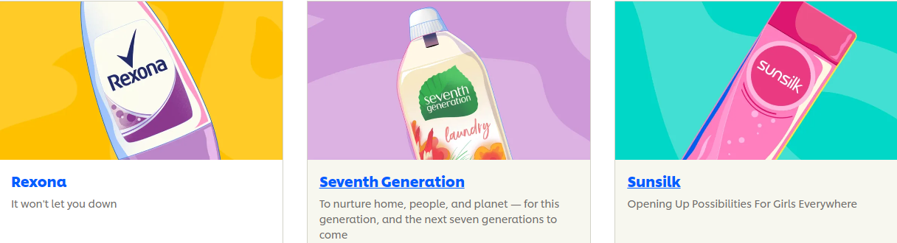

Blog post 6
Price
Unilever uses three main pricing strategies. This includes market - optimeter pricing strategy, premium pricing strategy, and the product bundle pricing strategy. A market-oriented pricing strategy bases retail prices on market forces. For example, Unilever studies the pricing charged by its competitors before deciding on its own. In contrast, premium pricing involves setting prices higher than the going rate and attracting more affluent clients. Unilever must charge somewhat more for the Dove brand because of the superior quality of the product. the corporation seasonally offers cheap packages of products e.g. buy one get one for free .We can see from this example how Unilever's marketing strategies are as diverse as the company's product catalog and the kind of consumers it aspires to serve.
Blog post 7
Promotion
Competition for consumer goods is fierce globally; thus, Unilever must push its products aggressively to succeed .Here, the marketing mix spells out in finer detail the many approaches the company will take to get the word out about its offerings to its target audience. This includes advertising, sales promotion, public relations, personal selling, and direct marketing. Unilever relies heavily on advertisements to spread the word about its wares .Commercials for the company's products can be seen regularly on both traditional and online media. The corporation also occasionally employs promotional sales strategies like discounts and packages .Buying three Dove soap bars instead of one pack will save you money. Efforts funded by the Unilever Foundation increase the company's and its brands' visibility and prestige in the marketplace. (Read: https://panmore.com/unilever-corporate-social-responsibility-stakeholders ). At other times, such as around the holidays, the company will team up with stores to operate kiosks designed solely for face-to-face sales. Direct marketing ranks low on Unilever's list of priorities compared to TV, radio, and print ads. Businesses may use this method to promote the right products to the right audiences. In the context of the marketing mix, advertising stands out as one of the primary tactics that Unilever uses to influence consumers' perceptions of its products.
Blog posts 8
Place/distribution in Unilever
https://panmore.com/unilever-generic-strategy-intensive-growth-strategies
The company has a global reach, with it having more than 190 countries across the globe. It uses retailers, kiosks, and stores. Unilever's operations globally shows how the company deepens its roots in providing the basic and homecare consumer products industry. In place or the distribution marketing mix, the company's touchpoints with its customers and prospective buyers are highlighted. Unilever places a strong emphasis on retailers when it comes to product distribution. Walmart is one of the top retailers that play a role in getting these items to consumers. Unilever sometimes uses kiosks in addition to human salespeople when presenting products to customers. Through these kiosks, the corporation and local shops offer limited goods.
Additionally, several Unilever products, including Ben & Jerry's, can be purchased in local retailers. The company can cut costs by using a global production and delivery system—Unilever's extensive network of retail and direct sales locations. Items are transported by C&F agents from warehouses to distributors and then from distributors to retailers. The Ben & Jerry's Scoop Shop and T2 have authorized Unilever retailers. Big-box stores, grocery stores, cash-and-carry warehouses, neighborhood stores, and even the internet all stock its products. Each of these distribution channels plays a critical role in delivering the company's products to customers.
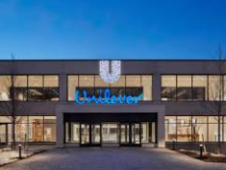

Blog post 9
conclusion
Unilever is a British multinational consumer goods company. Unilever offers a range of products that includes food, beauty, personal care, cleaning agents, OMO, ice cream, and condiments. Includes psychological segmentation and demographic segmentation geographical segmentation. Unilever employs the three main pricing strategies. This includes market - optimeter pricing strategy, the product bundle pricing strategy and premium pricing strategy, and The company has a global reach, with it having more than 190 countries across the globe. Unilever targets consumers of all ages, from young people to youths and old. It uses retailers, kiosks, and stores. It uses advertising, sales promotion, public relation, personal selling, and direct marketing. The company uses a competitive positioning strategy.

References
Davis, J.A., 2017. Measuring marketing. In Measuring Marketing. De Gruyter.
Groucutt, J. and Hopkins, C., 2017. Marketing. Bloomsbury Publishing.
Murphy, P.E. and Murphy, C.E., 2018. Sustainable living: unilever. In Progressive Business Models (pp. 263-286). Palgrave Macmillan, Cham.
Nacchia, F. and Massaro, V., 2017. A JOINT LINGUISTIC-MARKETING ANALYSIS OF BRAND AND PRODUCT NAMES: The case of Unilever. Lingue e Linguaggi, 22.
Reza, M.H., 2020. Marketing Strategy and Sustainable Plan of Unilever.

